International Transparent Participative Electoral Mapping

Summary.

The delimitation of electoral boundaries is among the most frequently manipulated and least transparent processes in democratic governance. The process of selecting electoral boundaries offers opportunities for manipulation to favor parties, politicians, elites, and racial groups, especially when this process is not subject to public view. Building on award-winning open source, cloud software previously used for participative redistricting in the United States, we will enable greater public participation in other countries. We will increase transparency, awareness, participation, and strengthen democratic processes. Our project will increase the transparency and participation in the process of creating international districts by making data and analysis tools for electoral boundaries available to the public and the press, and engaging a wider audience in commenting on the process and in proposing electoral maps.

The Problem.

When citizens vote for representatives in legislative assemblies they are often unaware that important decisions have already been made affecting their choices. Redistricting, the periodic redrawing of district boundaries, is one of the most influential of the hidden forces shaping representation. The ostensible purpose of redistricting is to rebalance changing district populations since the last redistricting, to follow objective criteria to promote good governance, such as respecting municipal boundaries, and to protect racial and ethnic minority representation and other communities of interest. In the United States, redistricting is deeply politicized, and often synonymous with “gerrymandering” -- the manipulation of boundaries to promote the goals of parties, incumbents, and racial groups.
Electoral mapping is a legally and technically complex process. There are over one hundred and fifty countries that use geographical electoral delimitation for substantial portions of their elections. Each country has its own specific requirements for their electoral boundaries. In the United States, for example, districts must abide by federal requirements of equal population and minority representation goals articulated in the Voting Rights Act. Local electoral authorities impose additional criteria, including that districts be compact, follow existing political boundaries, respect communities of interest, or be competitive. Additional criteria used in across the world include transportation time, communication routes and costs, geographical size, natural and administrative boundaries, ethnic heterogeneity, continuity of geographic representation (overlap with previous district) boundaries, and many other variations.
In many countries, the creation of electoral boundaries is an opaque process, conducted by parties or bureaucracies with little public participation or transparency. The result is that the legislature is systemically politically biased.To create legal redistricting plans, and even to evaluate plans that others have proposed, outside observers need to acquire the geographic, demographic and political data, and apply costly geographic information systems software to sift through the tremendous amount ta to ensure districts satisfy the complex legal requirements. Public access to redistricting authorities’ software may be limited or non-existent. Further, a redistricting authority may not provide the information necessary to fully evaluate, for example, if a redistricting plan is politically fair – a fact a redistricting authority may not wish the public to know. Restricting access to redistricting software thus furthers politicians’ interests above those of the public.

The Proposed Solution.

We propose to enable widespread public district analysis and web-based “do-it-yourself” redistricting internationally, through open source software, cloud computing, and gamification.
This builds on successful work conducted in the US. During the recent United States redistricting two of the principals of this project -- Drs. Altman and McDonald -- created open-source web-accessible redistricting software called DistrictBuilder (www.districtbuilder.org). Governments and advocacy groups successfully used this tool in six states and five localities to enable thousands of users to generate hundreds of legal redistricting plans. Helped by redistricting competitions, the software garnered widespread national and local media exposure. DistrictBuilder is the only open source system that supports public redistricting, and was recognized by Politico as one of the top-ten political innovations of 2011, honored by awards from the American Political Science Association, the Strata Innovation award in 2012, and is the 2013 recipient of the Tides Pizzigatti prize for public interest software.
Once configured, and deployed for analysis the redistricting websites created by the system can be replicated, tailored, and deployed to sub-national redistricting processes at minimal cost using the Amazon cloud computing environment.

Demonstration.

To demonstrate how the DistrictBuilder software can be used internationally, we have deployed demonstration software for the State of Mexico that shows how the software can use Mexico’s official cartographic information. With support from the Sloan Foundation, we are currently enhancing the software to add additional districting criteria that encompass all of Mexico’s federal and state redistricting requirements. This demonstration is available at: ec2-75-101-220-101.compute-1.amazonaws.com/. This demonstration site is unfunded and we are currently using it to support a student class mapping project as a proof of concept. We therefore request limited test use by interested persons.

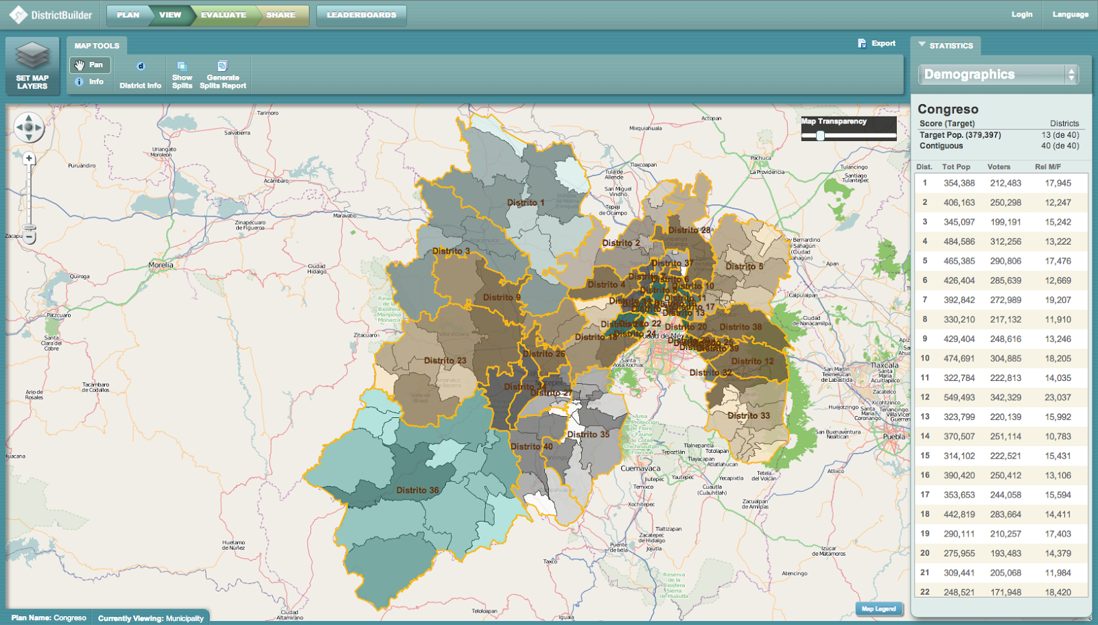 DistrictBuilder: Demonstration of Redistricting for the State of Mexico

A video demonstrating the DistrictBuilder software can be found here: http://www.youtube.com/watch?v=ckKYTVGVlqo . Instructional videos are available here: http://www.youtube.com/user/PublicMapping .

Execution.

Electoral delimitation occurs at different time throughout the world. For example, the national redistricting process in the United States is essentially complete (although a number of legal challenges remain); the process in Canada is largely near completion; Mexico’s redistricting is scheduled to occur this summer; and Argentina’s is likely to occur within the next eighteen months. In addition, state and local boundary delimitations occur frequently -- so there are multiple delimitation processes ongoing in the world at any particular time.
For feasibility, we plan to stage the project in three phases. Phase 1 focuses on a single country, Mexico. We will use this deployment both to increase the openness of politics in Mexico, and to test the general process for international deployment of the system.

Phase I Deployment in Mexico

Mexico’s federal redistricting is implemented nationwide through an algorithm devised by the Instituto Federal Electoral (IFE) in consultation with political parties. This has reduced outright partisan gerrymandering, at the cost of public participation and transparency. The IFE system purports to produce plans that are optimal on chosen criteria. However, Mexico’s districting process is closed to both public participation and inspection. The software is, in practice, restricted to the bureaucracy and parties, so the performance cannot be verified independently. Parties and actors selected by parties are explicitly included in the redistricting process, but there is no public analysis of the partisan effects of district lines or of the prior selection of the districting criteria. Thus, while the algorithm and criteria are nominally neutral, the results are subject to substantial political influence.
Furthermore, in the state legislative assemblies, redistricting is conducted at the whim of state legislatures and local electoral authorities. In the populous State of Mexico, for example, opposition parties have accused the ruling party (PRI) of blocking the redistricting process for the last decade. Failure to redistrict creates malapportionment, whereby slow-growing rural areas have more representation than fast-growing urban areas. According to INEGI (responsible for Mexico’s Census), two urban districts have over 450,000 people while a rural district has only 55,000 -- both far from the ideal of 337,000. The result is that the legislature is systemically biased in favor of rural interests.
With Knight’s support, we will publicly deploy the system in Mexico, using Amazon’s commercial computing cloud. Simultaneously, we will translate and adapt education material, create a project website to disseminate information about Mexico’s redistricting, hold three public forums at ITAM in Mexico City, work with the media to develop editorials and stories about Mexico’s redistricting process, and organize a public redistricting competition. Similar forums held in the United States were highly successful in bringing together politicians, academics, media, and advocates. The first forum will be held at end of May 2013, at the start of federal redistricting, to engage public participation. The second forum will further engage the media by focussing on the immediate outcomes of the 2013 redistricting. A final forum, held a year later, will engage scholars and think tanks to analyze Mexico’s experience critically analyzed and compared it with other countries.

Phase II The International Public Redistricting Portal

With the Knight Foundation’s support we will create an information portal for international redistricting that will serve as a focal point for non-governmental organizations interested in advocating around this important democratic process. The portal will disseminate information such as a catalog of key dates for electoral boundary delimitation worldwide and information about core redistricting processes and criteria in multiple translations. This information will update and complement the general information available through the existing Ace portal. Furthermore, the international public redistricting portal will link to known publicly available data, provide information on how to configure DistrictBuilder for use in that country, provide translated and customized press kits, and provide information targeted specifically at NGOs who wish to support electoral delimitation in that area.

Through our experiences with deployment in the United States, we have found that local advocacy partners are a key ingredient for success to public mapping advocacy efforts.Similarly we have discovered that media engagement is another key ingredient. We will invite NGOs and journalists through the portal to submit proposals for public mapping assistance in their countries and provide resources to facilitate success. These resources include how-to manuals for NGO’s describing data needs, software setup, dissemination and media plans, and how to run redistricting competitions. To further encourage submissions, we will set up an NGO challenge fund, and short application process for assistance where NGO’s can apply for help with gathering data, configuration and installation of the software, ongoing hosting, public redistricting competitions, and expert electoral consulting (the latter will be provided pro-bono by the project key personnel).

Extensions to DistrictBuilder System

The DistrictBuilder software is already ‘internationalized’ and capable of supporting any language, when supplied with appropriate translations for on-line documentation and the software’s textual user-interface elements. Localizations of the system are currently available in Spanish, English, and (as a demonstration) in French and Japanese.
With the Knight Foundation’s support we will be prepared to translate the user-interface into additional languages, as needed and to develop measures for additional core legal redistricting criteria in other countries not currently supported by DistrictBuilder. Much of these extensions will occur in parallel with Phase II -- many core extensions and core languages can be identified in advance, others extensions will be made in response to the specific needs of a localized NGOs deployment.

Key Personnel.

Dr. Micah Altman is Director of Research at the MIT LIbraries, and a Non-Resident Senior Fellow at the Brookings Institution. He is known for his work on computational models of electoral redistricting and for his contributions to the research methodology of social sciences, especially data curation and statistical computing. Dr. Eric Magar is Associate Professor of Political Science (and former Chair of the Department) at ITAM, Mexico’s leading University. Dr. Michael P. McDonald is Associate Professor of Government and Politics in the Department of Public and International Affairs at George Mason University and a Non-Resident Senior Fellow at the Brookings Institution. He has extensive experience in creating and evaluating redistricting plans. Alejandro Trelles is currently enrolled in a doctoral program at the University of Pittsburgh -- he worked at IFE during the last Mexican federal redistricting and who has published extensively on Mexico’s redistricting process.

Expected Outcomes.

In Phase I, we will deploy the DistrictBuilder system to support public oversight of the Mexico federal and state redistricting processes. Our United States experience is that the media warmly received the software to aid their observation of redistricting. Through these and other social media dissemination activities, we expect thousands of persons to view plans or draw their own. If a member of the public draws a plan that fares better on the required federal criteria than IFE’s computer program, we will present such plans to IFE for their consideration.
In Phase II and III, we will continue to build on our successes in the United States and Mexico to move the project globally. We will create a resource to educate NGOs about redistricting advocacy efforts and will provide a mechanism to further provide tools to those who wish to execute advocacy efforts in their countries. And we extend the core software system and supporting documentation to enable the NGO’s and even independent citizens to adapt and use the software independently.
In a broader sense, we will facilitate greater transparency in the redistricting process, greater public awareness of the issue, and greater public participation. Fostering such transparency will enable government officials to evaluate and compare proposed plans in a public context and thus facilitate adoption of clear and consistent redistricting criteria and rules.

Budget.

We ask $500,000 USD to conduct the activities described in this proposal.

Selected Bibliography

Ace Electoral Knowledge Network, 2013. Web Resource: http://aceproject.org/about-en/copyright

Altman, M., Mann, T. E., McDonald, M. P., & Ornstein, N. J., 2010. Principles for Transparency and Public Participation in Redistricting. http://www.brookings.edu/opinions/2010/0617_redistricting_statement.aspx

Altman, M., & MCDONALD, M. 2010. The Promise and Perils of Computers in Redistricting. Duke J Const Law Pub Poly, 5, 69–159. Duke Journal of Constitutional Law & Public Policy. http://www.law.duke.edu/journals/djclpp/?action=downloadarticle&id=167

Associated Press, Nov 25, 2011, “Public, students show NY redistricting can be fair”, Wall Street Journal, Wall Street Journal. http://online.wsj.com/article/AP9f404ebb685047f7bc5296b31aed313c.html

Handley, Lisa, 2006, Delimitation Equity Project, Resource Guide, Center for TRansitional and Post-Conflict Governance, USAID. ISBN 1-931459-13-4

Howard, Alex, Dec 12, 2011, “There’s a Map For That”, O’Reilly Radar,
http://radar.oreilly.com/2011/12/redistricting-software-open-source-government.html

Kurtzleben, Danielle Mar 9, 2011, “Technology Gives Citizens a Say in Redistricting”, U.S. News and World Report. http://www.usnews.com/news/articles/2011/03/09/technology-gives-citizens-a-say-in-redistricting

Mann, Thomas E. and Norman J. Ornstein, Mar 18, 2011, “The Rigged Redistricting Process”, Washington Post.
http://www.washingtonpost.com/opinions/the-rigged-redistricting-process/2011/03/18/ABmFxAs_story.html

Norquist, Grover et al, Dec 6, 2011, “Best policy innovations of 2011”, Politico.
http://www.politico.com/news/stories/1211/69812.html

Sieber, Renee, 2006, ”Public participation geographic information systems: A literature review and framework, Annals of the Association of American Geographer 96(3): 491-507.

Keywords

Open Source, Open Government, Transparency, Public Participation, Mapping, GIS, Information Visualization, Media Engagement, NGO, Elections, Redistricting

