OAS Electoral Observation Mission to the United States

Electoral Boundaries

Final Report

by

Eric Magar

Nov. 27, 2020

I report on electoral boundaries to the General Secretariat of the Organization of American States' Electoral Observation Mission for the General Elections in the United States, which took place on November 3rd, 2020. Of many races that concurred that date, this report places the focus in the election of 435 Representatives to the Congress of the United States, with brief mentions to the electoral college that elects the President of the United States. Senators, which are elected within boundaries that do not change (the states), and all sub-national races are left out.

1. Boundary delimitation

Redistricting is the process of partitioning a territory into electoral constituencies from which representatives are elected. Electoral boundary delimitation has been, and remains, a hotly contested issue, not just in recent decades but throughout American history. The term *gerrymandering*, referring to the manipulation of boundaries for partisan gain, dates from the year 1812.

Due to an esoteric appearance, and arguments that are often coined in technical terms, redistricting receives much less attention than it deserves, especially outside the United States. In fact, it is a very important subject. Because members of the House of Representatives of the United States Congress are elected in mutually-exclusive geographic units, how lines are drawn in the map will affect the fundamental nature of representation.[1] Overrepresenting some group at the expense of others directly impacts the partisan control of Congress, and therefore the distribution of benefits and costs that flow from policy.

2. Timing of events

Federal redistricting in the United States takes place the year after the population census, which is conducted every decade in years ending in zero since 1790. Therefore the last redistricting for the United States Congress was conducted in 2011. The next will take place in 2021. So unlike evaluations of electoral organization or mail-in ballots, which actually observe what took place in the 2020 electoral process, looking at redistricting involves inspecting actions which took place almost a decade ago, when the current map was drawn, and actions that will take place in the future, when it is redrawn.

3. Reapportionment

A step prior to boundary delimitation proper is the **apportionment** of seats for each state in the House of Representatives of Congress. The Reapportionment Act of 1929 capped the number of House seats at 435, which Congress must distribute among the 50 states according to their relative populations (and no state gets less than one seat). Unfortunately, there is no mathematical formula achieving a distribution of seats in exact accordance to states' populations. Some states inevitably receive more seats than they constitutionally deserve by size, other less. And different formulas not only change which states win and which lose, but their effect on the composition of Congress can be dramatic.[2]

Congress has adopted the Huntington-Hill method of equal proportions for apportionment since 1941.[3] If this method were used again in 2021, as is likely, population projections give an idea of the states that will win and the states that will lose seats in the House of Representatives, reported in Table 1. (This will also impact their weights in the electoral college towards the 2024 presidential election.) In general, western and southern states are bound to accrue their delegations in the lower house of Congress, with Texas and Florida expecting the most gains. Since apportionment is a constant-sum game, what these states gain midwestern and eastern states must lose. The exact balance will be known on or before December 31, 2020, when the Census Bureau must communicate official population counts to Congress.

|  |  |
| --- | --- |
| **States espected to lose seats (change)** | **States expected to win seats (change)** |
| Alabama (–1) California (no change or –1) Illinois (–1) Michigan (–1) Minnesota (no change or –1) New York (–2) Ohio (–1) Pennsylvania (–1) Rhode Island (–1) West Virginia (–1) | Arizona (+1) Colorado (+1) Florida (+2) Montana (+1) North Carolina (+1) Oregon (+1) Texas (+3) |

Table 1. States expected to win and lose seats in the 2021 reapportionment of the U.S. House of Representatives, based on population projections. Source: Kimball W. Brace, “Arizona Gains Rhode Island’s Seat With New 2018 Census Estimates; But Greater Change Likely by 2020”, *Election Data Services*, December 19, 2018 ([www.electiondataservices.com](http://www.electiondataservices.com/)).

4. Redistricting authority

U.S. Constitution Article 1, Section 4.

The Times, Places and Manner of holding Elections for

Senators and Representatives, shall be prescribed in each

State by the Legislature thereof; but the Congress may at

any time by Law make or alter such Regulations, except as

to the Places of chusing Senators.

The Congress shall assemble at least once in every Year, and

such Meeting shall be on the first Monday in December,

unless they shall by Law appoint a different Day.

The U.S. Constitution grants authority to conduct federal elections to the state assemblies. While not explicitly stated, this includes boundary delimitation, which is mandated by federal law after each decennial census. Congressional redistricting last took place in 2011, when the district maps that were used for the 2020 House of Representatives elections (and in 2012, 2014, 2016, and 2018). Boundary delimitations will be again re-drawn next year for the 2022 midterm elections.

With exceptions, discussed below, congressional redistricting is conducted in the regular legislative process. That is, the state assembly draws a map of the state’s congressional districts, which it passes as any other statute of law. This bill is then sent to the governor for a signature. If the governor objects to the map, the assembly can override the veto with supermajority support of the district boundaries.

With this structure, the partisan makeup of state governments mediates the ease with which a map is drawn, and whether the interests of one or both parties are served by district lines. A party with unified control of the elected branches needs to make no concessions to the out party. Split control of the branches or the chambers of the assembly, open room for bipartisan negotiation – and, presumably, neater representation.

x. Over- and under-representation

Figure 1 shows how votes translated into seats in the last four congressional elections. Each point in the plot reports whether the Republican party received more or less seats than the votes it won in the state (and Democrats are the mirror image). Bigger points correspond to states sending larger delegations to the House of Representatives (states do so in proportion to their population). Republicans in states above the red line were overrepresented – they received a bigger percentage of the state’s delegation to the House than the percentage of votes they won across the state’s congressional races. To the contrary, states below the red line saw Republicans underrepresented, Democrats overrepresented.

Positions along the horizontal axis show how strong a showing Republicans had in the state that year. It is plain in the plots that the party with the most votes statewide tends to get more seats than it deserves – but, critically, not always. This “winner’s bonus” was routinely granted to the *losing* party in between three and eight states, depending on the year. Cases where a tiny vote margin translates into more than 10 percent advantage are also quite frequent.

Some contend that maps intentionally distort representation. Others retort that other forces, such as geographical features and turnout differences between the parties, also plays a large role. A formidable obstacle for reform is that separating these effects is far from straightforward.[4]

|  |  |
| --- | --- |
|  |  |
|  |  |

Figure 1. State delegations to the House of Representatives with the current district maps. Each point in a diagram is a state, diameter proportional to the number of representatives it sends to Congress. Prepared with data from the Federal Elections Commission and [ballotpedia.org](http://ballotpedia.org/).

3. Judicialization

Parties believe that redisticting matters. Proof is the degree to which boundary delimitation is a contentious issue in the U.S. Another exceptional trait of redistricting in the U.S. is judicialization. Parties who feel left out of the map challenge in court. (This will be elaborated in the final report.)

4. Modes of boundary delimitation

Cross-national perspective offers insight into redistricting in the U.S. Despite patchy knowledge of boundary delimitation practices worldwide, other democracies draw electoral constituencies differently. I pay attention to two dimensions of divergence from the modal process in the U.S.: whether or not the process is decentralized and whether or not it is politicized.

Some federal systems, like the U.S. and Canada, naturally leave redistricting authority at the subnational level, more or less unbounded by federal law. Others, however, emulate unitary systems by centralizing that authority. Such is the case in Australia, Germany, and Mexico, where national bodies draw maps for all states/*länder*. Centralization allows to unify criteria that all districts must meet.

The other dimension is politicization: are elected officeholders, with direct interests in the districts’ features, in charge of boundary delimitation? They are in France, as in most U.S. states. Others, such as Mexico, Canadian provinces, the United Kingdom, and even seven U.S. states, give redistricting authority to an expert board. Table 1 summarizes.

|  |  |  |
| --- | --- | --- |
|  | politicized | independent commission |
| centralized | France | Australia, Germany, Mexico, United Kingdom |
| decentralized | 36 U.S. states | 7 U.S. states 10 Canadian provinces |

Table 1. Redistriting processes in two dimensions. Prepared with information from Handley and Grofman (2008, see fn. 1); Trelles, Alejandro et al. (2016) Datos abiertos, transparencia y redistritación en México, *Política y Gobierno* vol. 23, num. 2; and [aceproject.org](http://aceproject.org/) .

Some U.S. states have reformed, de-politicizing redistricting in recent years. Table 2 lists three groups of states. The first group consists of the seven smallest, electing a unique member of the House of Representatives. The whole state serves as a district-at-large, and therefore requires no boundary delimitation. The second group is modal, with 36 states more or less following the process described above. The third group relies on bipartisan commissions for redistricting.

|  |  |  |  |
| --- | --- | --- | --- |
| **State** | **Redistricting mode** | **State government in 2021** | **Congressional House seats** |
| Alabama | Legislative process | Unified Republican | 7 |
| Alaska | No redistricting | Unified Republican | 1 |
| Arizona | Bipartisan commission (since 2000) | Unified Republican | 9 |
| Arkansas | Legislative process | Unified Republican | 4 |
| California | Bipartisan commission (since 2010) | Unified Democratic | 53 |
| Colorado | Bipartisan commission (since 2018) | Unified Democratic | 7 |
| Connecticut | Legislative process | Unified Democratic | 5 |
| Delaware | No redistricting | Unified Democratic | 1 |
| Florida | Legislative process | Unified Republican | 27 |
| Georgia | Legislative process | Unified Republican | 14 |
| Hawaii | Bipartisan commission (since 1992) | Unified Democratic | 2 |
| Idaho | Bipartisan commission (since 1994) | Unified Republican | 2 |
| Illinois | Legislative process | Unified Democratic | 18 |
| Indiana | Legislative process | Unified Republican | 9 |
| Iowa | Legislative process | Unified Republican | 4 |
| Kansas | Legislative process | Split between the parties | 4 |
| Kentucky | Legislative process | Split between the parties | 6 |
| Louisiana | Legislative process | Split between the parties | 6 |
| Maine | Legislative process | Unified Democratic | 2 |
| Maryland | Legislative process | Split between the parties | 8 |
| Massachusetts | Legislative process | Split between the parties | 9 |
| Michigan | Bipartisan commission (since 2018) | Split between the parties | 14 |
| Minnesota | Legislative process | Split between the parties | 8 |
| Mississippi | Legislative process | Unified Republican | 4 |
| Missouri | Legislative process | Unified Republican | 8 |
| Montana | No redistricting | Unified Republican | 1 |
| Nebraska | Legislative process | Unified Republican | 3 |
| Nevada | Legislative process | Unified Democratic | 4 |
| New Hampshire | Legislative process | Unified Republican | 2 |
| New Jersey | Legislative process | Unified Democratic | 12 |
| New Mexico | Legislative process | Unified Democratic | 3 |
| New York | Legislative process | Unified Democratic | 27 |
| North Carolina | Legislative process | Split between the parties | 13 |
| North Dakota | No redistricting | Unified Republican | 1 |
| Ohio | Legislative process | Unified Republican | 16 |
| Oklahoma | Legislative process | Unified Republican | 5 |
| Oregon | Legislative process | Unified Democratic | 5 |
| Pennsylvania | Legislative process | Split between the parties | 18 |
| Rhode Island | Legislative process | Unified Democratic | 2 |
| South Carolina | Legislative process | Unified Republican | 7 |
| South Dakota | No redistricting | Unified Republican | 1 |
| Tennessee | Legislative process | Unified Republican | 9 |
| Texas | Legislative process | Unified Republican | 36 |
| Utah | Legislative process | Unified Republican | 4 |
| Vermont | No redistricting | Split between the parties | 1 |
| Virginia | Bipartisan commission (since 2020) | Unified Democratic | 11 |
| Washington | Bipartisan commission (since 1983) | Unified Democratic | 10 |
| West Virginia | Legislative process | Unified Republican | 3 |
| Wisconsin | Legislative process | Split between the parties | 8 |
| Wyoming | No redistricting | Unified Republican | 1 |

Table xx. The 2021 congressional redistricting processes. Prepared with information from [https://redistricting.lls.edu](https://redistricting.lls.edu/), [wikipedia.org](http://wikipedia.org/), and state governments’ web pages.

|  |  |
| --- | --- |
| Congressional redisticting process | States |
| No redistricting (elects one House Representative only) | Alaska, Delaware, Montana, North Dakota, South Dakota, Vermont, and Wyoming. |
| Politicized process (follows the legislative process) | Alabama, Arkansas, Connecticut, Florida, Georgia, Iowa, Illinois, Indiana, Kansas, Kentucky, Louisiana, Maine, Massachusetts, Maryland, Mississippi, Minnesota, North Carolina, Nebraska, New Hampshire, New Jersey, New Mexico, Missouri, Nevada, New York, Ohio, Oklahoma, Oregon, Pennsylvania, Rhode Island, South Carolina, Tennessee, Texas, Utah, Virginia, Wisconsin, and West Virginia. |
| Bipartisan commission | Arizona (since 2000), California (2010), Colorado (2018), Hawaii (1992), Idaho (1994), Michigan (2018), and Washington (1983). |

Table 2. Congressional redistricting in the 50 U.S. states. Prepared with information from [https://redistricting.lls.edu](https://redistricting.lls.edu/) and [wikipedia.org](http://wikipedia.org/).

NEW STUFF

|  |  |  |  |  |
| --- | --- | --- | --- | --- |
|  | N states | Democratic seats | Republican seats | Total |
| Politicized process |  |  |  |  |
| - Republican trifecta | 17 | 46 | 116 | 162 |
| - Democratic trifecta | 9 | 58 | 20 | 78 |
| - split | 9 | 40 | 40 | 80 |
| Bipartisan commission | 8 | 75 | 33 | 108 |
| At large district (no redistricting) | 7 | 1 | 6 | 7 |
| Total | 50 | 220 | 215 | 435 |

Table xx. States and Congressional seats by party and 2021 redistricting process

5. Stakeholders

I plan to interview stakeholders to get a better grip of the present situation in the U.S. The idea is to gauge the main challenges that independent commissions anticipate on the eve of the 2021 redistricting, and to get a feeling of the problems that independent commissions solved in their states. Interviews will be carries fater Nov. 3. Possible interviewees include:

- Prof. Bernard Grofman (UC-Irvine) – among the leading scholars on redistricting in the U.S., should offer interesting information on how California adopted its Citizens Redistricting Commission in 2010.

- Dr. Lisa Handley – has extensive experience in electoral missions worldwide, specializing in boundary dlimitation.

- Prof. Erik Engstrom (UC-Davis) – authority in the study of gerrymandering throughout U.S. history.

- Some member of an independent commission.

- Advocates of more participatory redistricing processes (e.g. Allison Riggs of the Southern Coalition for Social Justice or Rebecca Theobald of the Colorado Geographic Alliance).

- Dr. Marta Zertuche (Instituto Nacional Electoral) – has participated in the last three automated redistricting processes in Mexico.

6. Preliminary recommendations

a) While it is extremely unlikely that the U.S. will nationalize boundary delimitation like Mexico did in 2014, federal legislation (such as the Voting Rights Act of 1965) and court rulings offer potential to set a minimum requirements that congressional districts must comply with in every state.

b) More states should embrace reform, delegating redistricting to bipartisan commissions instead of state legislators. Successful reform cases (such as California or Michigan) offer insights to make reform possible.

c) Make processes more trasparent and accountable. Open data and open code should be encouraged in all 50 states. Moreover, technology now exists making anyone interested to participate, in redistricting, even without technical training, able to participate at the click of a mouse (e.g. [www.districtbuilder.org](http://www.districtbuilder.org/) ).

Appendix 1: Votes and seats in the 2012-2020 period

I report year-by-year plots of votes and seats. Taken together, these plots consolidate into Figure xx.

For 2012

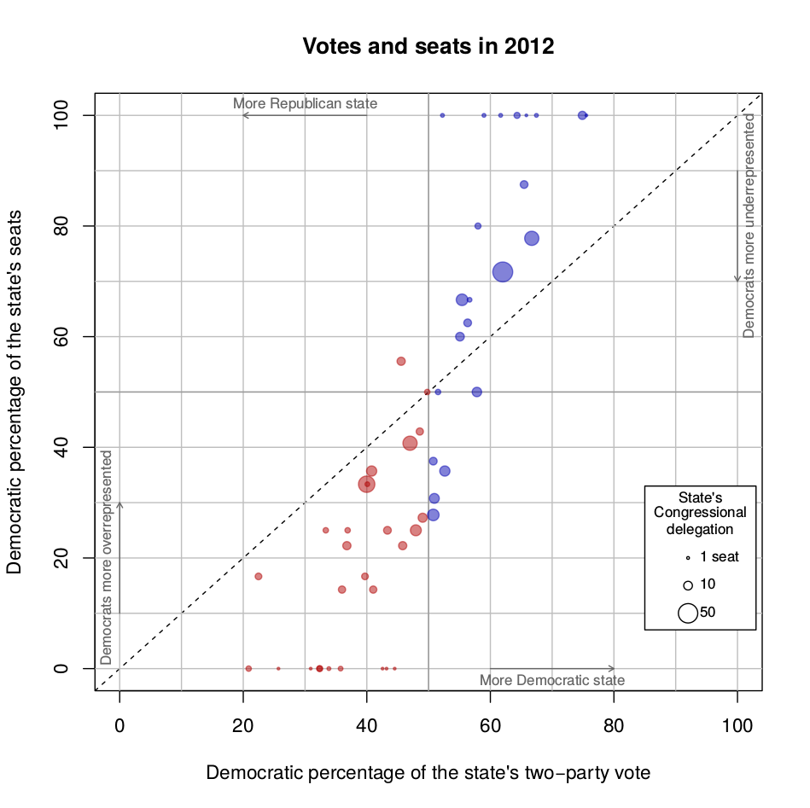

For 2014

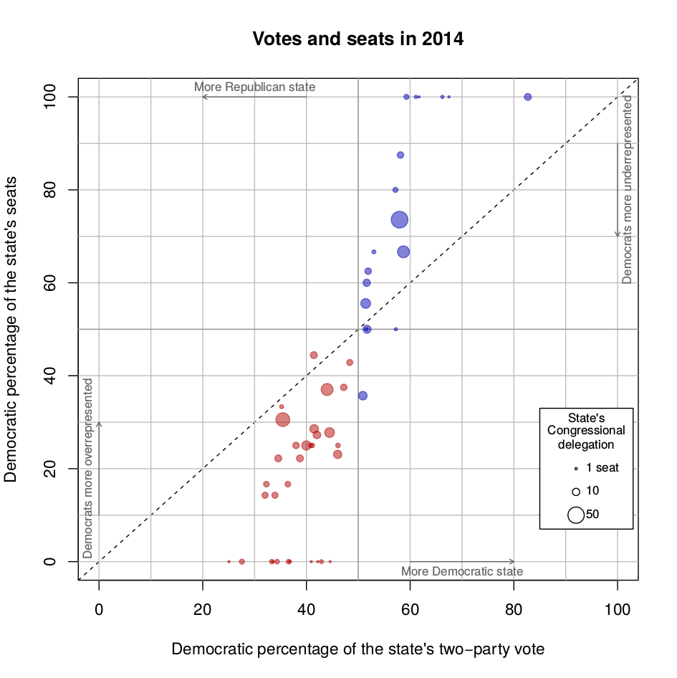

For 2016

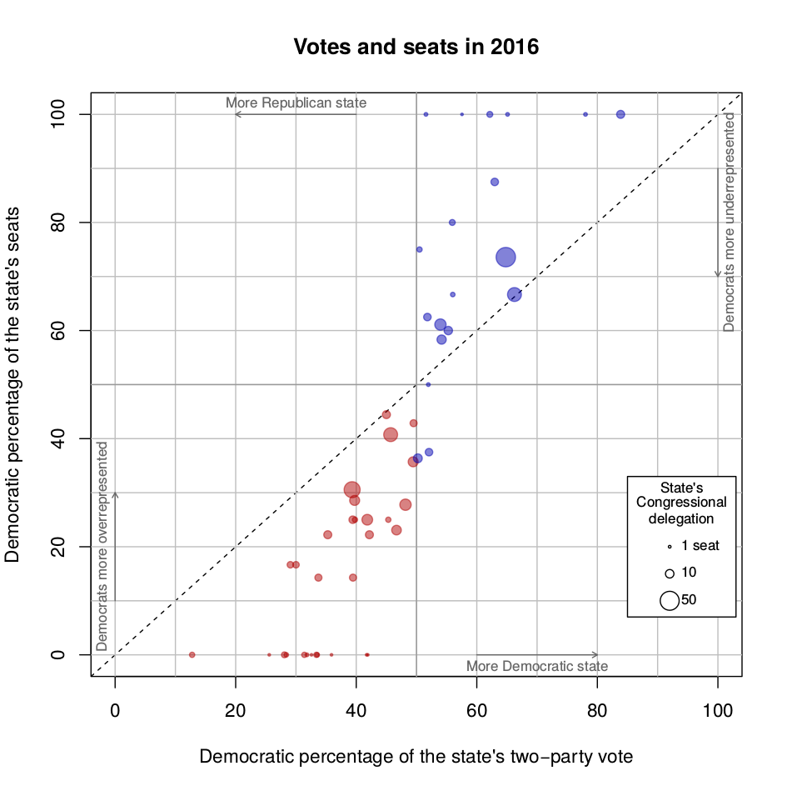

For 2018

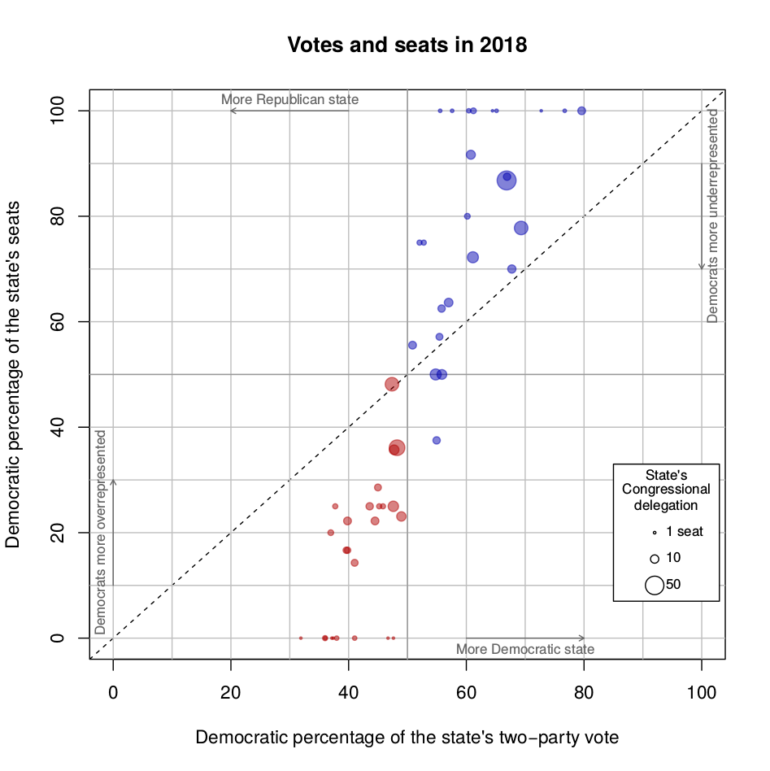

For 2020

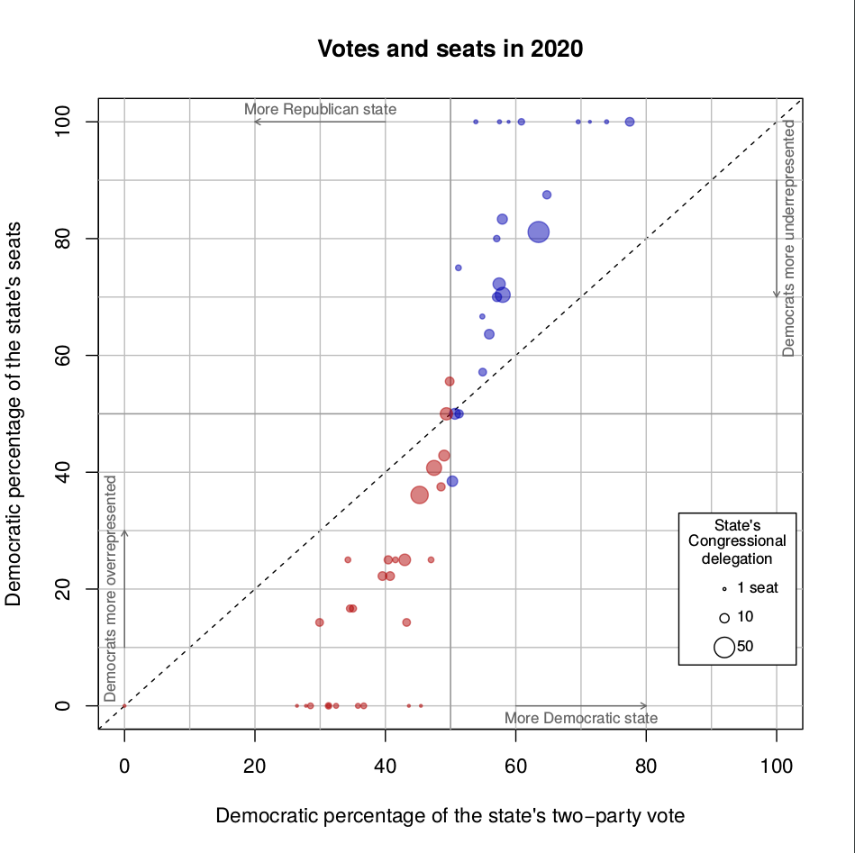

Appendix 2:

1. Handley, Lisa and Bernard Grofman (2008). *Redistricting in Comparative Perspective*. Oxford: Oxford University Press.
2. Michel L. Balinski and H. Peyton Young (2001). *Fair representation: Meeting the ideal of one man, one vote* 2nd edition. Washington D.C.: Brookings. See also George G. Szpiro (2010). *Numbers Rule: The Vexing Mathematics of Democracy from Plato to the Present*. Princeton NJ: Princeton University Press.
3. The method divides population by 435, equal how many people each representative ought to represent (called the divisor). In turn, dividing a state's poplation by the divisor yields how many representatives the state deserves by size. The obstacle to fair distribution are decimals: should they be rounded up or down? The Huntington-Hill makes it slightly likelier that small states are rounded up and larger ones rounded up. See <https://math.libretexts.org/Bookshelves/Applied_Mathematics/Book%3A_Math_in_Society_(Lippman)/04%3A_Apportionment/4.05%3A_Huntington-Hill_Method>.
4. Grofman, Bernard, William Koetzle, and Thomas Brunell (1997). An Integrated Perspective on the Three Potential Sources of Partisan Bias: Malapportionment, Turnout Differences, and the Geographic Distribution of Party Vote Shares, *Electoral Studies* vol. 16, num. 4.