OAS Electoral Observation Mission to the United States

Electoral Boundaries

**Final Report**

**by**

**Eric Magar**

**Dec. 1, 2020**

I report on electoral boundaries to the General Secretariat of the Organization of American States' Electoral Observation Mission for the General Elections in the United States, which took place on November 3rd, 2020. Of many races that concurred that date, this report places the focus in the election of 435 Representatives to the Congress of the United States, with brief mentions to the electoral college that elects the President of the United States. Senators, which are elected within boundaries that do not change (the states), and all sub-national races are left out.

**1. Boundary delimitation**

Redistricting is the process of partitioning a territory into electoral constituencies from which representatives are elected. Electoral boundary delimitation has been, and remains, a hotly contested issue, not just in recent decades but throughout American history. The term *gerrymandering*, referring to the manipulation of boundaries for partisan gain, dates from the year 1812.

Due to an esoteric appearance, and arguments that are often coined in technical terms, redistricting receives much less attention than it deserves, especially outside the United States. In fact, it is a very important subject. Because members of the House of Representatives of the United States Congress are elected in mutually-exclusive geographic units, how lines are drawn in the map will affect the fundamental nature of representation.[1] Overrepresenting some group at the expense of others directly impacts the partisan control of Congress, and therefore the distribution of benefits and costs flowing from policy.

**2. Timing of events**

Federal redistricting in the United States takes place the year after the population census, which is conducted every decade in years ending in zero since 1790. Therefore the last redistricting for the United States Congress was conducted in 2011. The next will take place in 2021. So unlike evaluations of electoral organization or mail-in ballots, which actually observe what took place in the 2020 electoral process, looking at redistricting involves inspecting actions which took place almost a decade ago, when the current map was drawn, and actions that will take place in the future, when it is redrawn.[2]

**3. Reapportionment**

A step prior to boundary delimitation proper is the apportionment of seats for each state in the House of Representatives of Congress. The Reapportionment Act of 1929 capped the number of House seats at 435, which Congress must distribute among the 50 states according to their relative populations (and no state gets less than one seat). Unfortunately, there is no mathematical formula achieving a distribution of seats in exact accordance to states' populations. Some states inevitably receive more seats than they constitutionally deserve by size, others less. And different formulas not only change which states win and which lose, but their effect on the composition of Congress can be dramatic.[3]

Congress has adopted the Huntington-Hill method of equal proportions for apportionment since 1941.[4] If this method were used again in 2021, as is likely, population projections give an idea of the states that might win and the states that might lose seats in the House of Representatives, reported in Table 1. (Reapportionment will also impact states’ relative weights in the electoral college towards the 2024 presidential election.) In general, western and southern states are expected to accrue their delegations in the lower house of Congress, with Texas and Florida expecting the most gains. Since apportionment is a constant-sum game, what these states gain midwestern and eastern states must lose. The exact balance will be known on or before December 31, 2020, the date when the Census Bureau must communicate official population counts to Congress.

|  |  |
| --- | --- |
| States espected to lose seats (change) | States expected to win seats (change) |
| Alabama (–1) California (no change or –1) Illinois (–1) Michigan (–1) Minnesota (no change or –1) New York (–2) Ohio (–1) Pennsylvania (–1) Rhode Island (–1) West Virginia (–1) | Arizona (+1) Colorado (+1) Florida (+2) Montana (+1) North Carolina (+1) Oregon (+1) Texas (+3) |

Table 1. States expected to win and lose seats in the 2021 reapportionment of the U.S. House of Representatives, based on population projections. Source: Kimball W. Brace, “Arizona Gains Rhode Island’s Seat With New 2018 Census Estimates; But Greater Change Likely by 2020”, *Election Data Services*, December 19, 2018 ([www.electiondataservices.com](http://www.electiondataservices.com/)).

**4. Redistricting authority**

U.S. Constitution Article 1, Section 4.

The Times, Places and Manner of holding Elections for

Senators and Representatives, shall be prescribed in each

State by the Legislature thereof; but the Congress may at

any time by Law make or alter such Regulations, except as

to the Places of chusing Senators.

The Congress shall assemble at least once in every Year, and

such Meeting shall be on the first Monday in December,

unless they shall by Law appoint a different Day.

The U.S. Constitution grants authority to conduct federal elections to the state assemblies. While not explicitly expressed, this includes boundary delimitation, which federal law mandates after each decennial census. Congressional redistricting last took place in 2011, when the district maps that were used for the 2020 House of Representatives elections (and in 2012, 2014, 2016, and 2018). Boundary delimitations will be again re-drawn next year for the 2022 midterm elections.

**5. Modes of boundary delimitation**

With exceptions, discussed below, congressional redistricting is conducted in the regular legislative process. That is, the state assembly draws a map of the state’s congressional districts, which it passes as any other statute of law. This bill is then sent to the governor for a signature. If the governor objects to the map, the assembly can override the veto with supermajority support. Otherwise, lawmakers must accommodate the governor’s objections.

With this structure, the partisan makeup of state governments mediates the ease with which a map is drawn, and whether the interests of one or both parties are served by district lines. A party with unified control of the elected branches needs to make no concessions to the out party. Split control of the branches or the chambers of the assembly, open room for bipartisan negotiation – and, presumably, neater representation.

Some U.S. states have reformed, de-politicizing redistricting in recent years. Table 2 lists the mode of redistricting of the 50 states. There are three general groups. The first group consists of the seven smallest, electing a unique member of the House of Representatives (Alaska, Delaware, Montana, North Dakota, South Dakota, Vermont, and Wyoming). The whole state serves as a district-at-large, and therefore requires no boundary delimitation. The second group relies on bipartisan commissions for redistricting instead of the legislative process (Arizona, California, Colorado, Hawaii, Idaho, Michigan, Virginia, and Washington). Experts, instead of politicians, are responsible for boundary delimitation. The third group is modal, with the remainder 35 states redistricting through the legislative process. There are some states within this group that follow a process more or less different from that described above: the governor in two states has no authority to veto the map, which is drawn by lawmakers only (Connecticut and North Carolina); and the governor’s veto can be overridden by a majority – presumably the same one that drew the map – in five more states (Alabama, Indiana, Kentucky, Tennessee, and West Virginia).

|  |  |  |  |
| --- | --- | --- | --- |
| **State** | **Redistricting mode** | **State government in 2021** | **Congressional House seats** |
| Alabama | Legislative process (weak gub. veto) | Unified Republican | 7 |
| Alaska | No redistricting | Unified Republican | 1 |
| Arizona | Bipartisan commission (since 2000) | Unified Republican | 9 |
| Arkansas | Legislative process | Unified Republican | 4 |
| California | Bipartisan commission (since 2010) | Unified Democratic | 53 |
| Colorado | Bipartisan commission (since 2018) | Unified Democratic | 7 |
| Connecticut | Legislative process (no gub. veto) | Unified Democratic | 5 |
| Delaware | No redistricting | Unified Democratic | 1 |
| Florida | Legislative process | Unified Republican | 27 |
| Georgia | Legislative process | Unified Republican | 14 |
| Hawaii | Bipartisan commission (since 1992) | Unified Democratic | 2 |
| Idaho | Bipartisan commission (since 1994) | Unified Republican | 2 |
| Illinois | Legislative process | Unified Democratic | 18 |
| Indiana | Legislative process (weak gub. veto) | Unified Republican | 9 |
| Iowa | Legislative process | Unified Republican | 4 |
| Kansas | Legislative process | Split between the parties | 4 |
| Kentucky | Legislative process (weak gub. veto) | Split between the parties | 6 |
| Louisiana | Legislative process | Split between the parties | 6 |
| Maine | Legislative process | Unified Democratic | 2 |
| Maryland | Legislative process | Split between the parties | 8 |
| Massachusetts | Legislative process | Split between the parties | 9 |
| Michigan | Bipartisan commission (since 2018) | Split between the parties | 14 |
| Minnesota | Legislative process | Split between the parties | 8 |
| Mississippi | Legislative process | Unified Republican | 4 |
| Missouri | Legislative process | Unified Republican | 8 |
| Montana | No redistricting | Unified Republican | 1 |
| Nebraska | Legislative process | Unified Republican | 3 |
| Nevada | Legislative process | Unified Democratic | 4 |
| New Hampshire | Legislative process | Unified Republican | 2 |
| New Jersey | Legislative process | Unified Democratic | 12 |
| New Mexico | Legislative process | Unified Democratic | 3 |
| New York | Legislative process | Unified Democratic | 27 |
| North Carolina | Legislative process (no gub. veto) | Unified Republican | 13 |
| North Dakota | No redistricting | Unified Republican | 1 |
| Ohio | Legislative process | Unified Republican | 16 |
| Oklahoma | Legislative process | Unified Republican | 5 |
| Oregon | Legislative process | Unified Democratic | 5 |
| Pennsylvania | Legislative process | Split between the parties | 18 |
| Rhode Island | Legislative process | Unified Democratic | 2 |
| South Carolina | Legislative process | Unified Republican | 7 |
| South Dakota | No redistricting | Unified Republican | 1 |
| Tennessee | Legislative process (weak gub. veto) | Unified Republican | 9 |
| Texas | Legislative process | Unified Republican | 36 |
| Utah | Legislative process | Unified Republican | 4 |
| Vermont | No redistricting | Split between the parties | 1 |
| Virginia | Bipartisan commission (since 2020) | Unified Democratic | 11 |
| Washington | Bipartisan commission (since 1983) | Unified Democratic | 10 |
| West Virginia | Legislative process (weak gub. veto) | Unified Republican | 3 |
| Wisconsin | Legislative process | Split between the parties | 8 |
| Wyoming | No redistricting | Unified Republican | 1 |

Table 2. The 2021 congressional redistricting processes. Prepared with information from [https://redistricting.lls.edu](https://redistricting.lls.edu/), [wikipedia.org](http://wikipedia.org/), and state governments’ web pages.

Looking at the House of Representatives’ apportionment instead of the states themselves offers perspective on the political landscape in which redistricting will take place in 2021. (This paragraph assumes the seats apportioned to each state in 2011; these may change, as seen in Section 3.) Table 3 shows the advantage that Republicans will enjoy in redistricting. Republicans will draw the electoral boundaries of 175 seats, of which they currently control 124. Democrats will draw 78 districts, of which 58 are now in their hands. To the extent that political influences intervene, manipulation will involve twice as many Republican than Democratic seats for attempted partisan gain.

|  |  |  |  |  |
| --- | --- | --- | --- | --- |
|  | Num. states | Democratic seats | Republican seats | Total |
| Politicized process |  |  |  |  |
| - Republican trifecta | 18 | 51 | 124 | 175 |
| - Democratic trifecta | 9 | 58 | 20 | 78 |
| - split | 8 | 35 | 32 | 67 |
| Bipartisan commission | 8 | 75 | 33 | 108 |
| At-large district (no redistricting) | 7 | 1 | 6 | 7 |
| Total | 50 | 220 | 215 | 435 |

Table 3. States and Congressional seats by party and 2021 redistricting process. Trifectas are states where the governor and majorities in both chambers of the legislature are from the same party (and include two cases where the governor cannot veto the redistricting, regardless of the governor’s party). Sources: Same as table 2 and [nytimes.com/interactive/2020/11/03/us/elections/results-house.html](https://www.nytimes.com/interactive/2020/11/03/us/elections/results-house.html).

**6. Over- and under-representation**

A standard assessment of district boundary maps is by means of votes and seats plots. Such diagrams capture nicely how congressional district boundaries convert votes into seats by systematically comparing the vote percentage that the Democratic party received and the share of House seats it won across states. (By virtue of the two-party system, Republicans are the mirror image of Democrats.)

Figure 1 is the votes and seats plot for 2012-2020, the full period during which electoral boundary maps remained unchanged. Each point in the plot is one state in a given year. States appears five times in the diagram, once for every congressional election conducted in the period (black circumferences identify the 2020 races). Point size increased with the number of seats apportioned to the state in Congress. So California, with 53 seats in the House, has the largest points (visible in the upper right quadrant), whereas Montana, with a single seat, has tiny points (situated in the bottom line). And points are colored blue for state-years where Democrats won a vote majority, red when Republicans did.

The dotted, diagonal line in the plot shows what a seat distribution that is perfectly proportional to votes won would look like. Even if exceptions exist – such as New York in 2016, when Democrats won 67 percent of seats with 66 percent of votes – no one expects the distribution in the United States to approximate this ideal dotted line. It is well documented that simple plurality elections in single-member districts grant a substantial seat bonus to the winning party.[5]

What is anomalous is the group of blue points *below* the dotted line. Democrats in these state-years were awarded between 28 and 38 percent of seats despite receiving between 51 and 55 percent of votes---i.e., these are cases granting Republicans a seat majority, often with sizeable margins, in spite of their minority status in the electorate. Cases in this group include Pennsylvania, North Carolina, Michigan, and Wisconsin, with a joint apportionment of 53 seats.

And adding the large red group that stands just across the 50-percent vertical line, with similar underrepresentation of Democrats, reveals the advantage that Republicans enjoy in votes-to-seats conversion in congressional elections. There are also cases overrepresenting Democrats with a slight vote advantage---Nevada, for instance---but they are far fewer and control a tiny fraction of seats apportioned.

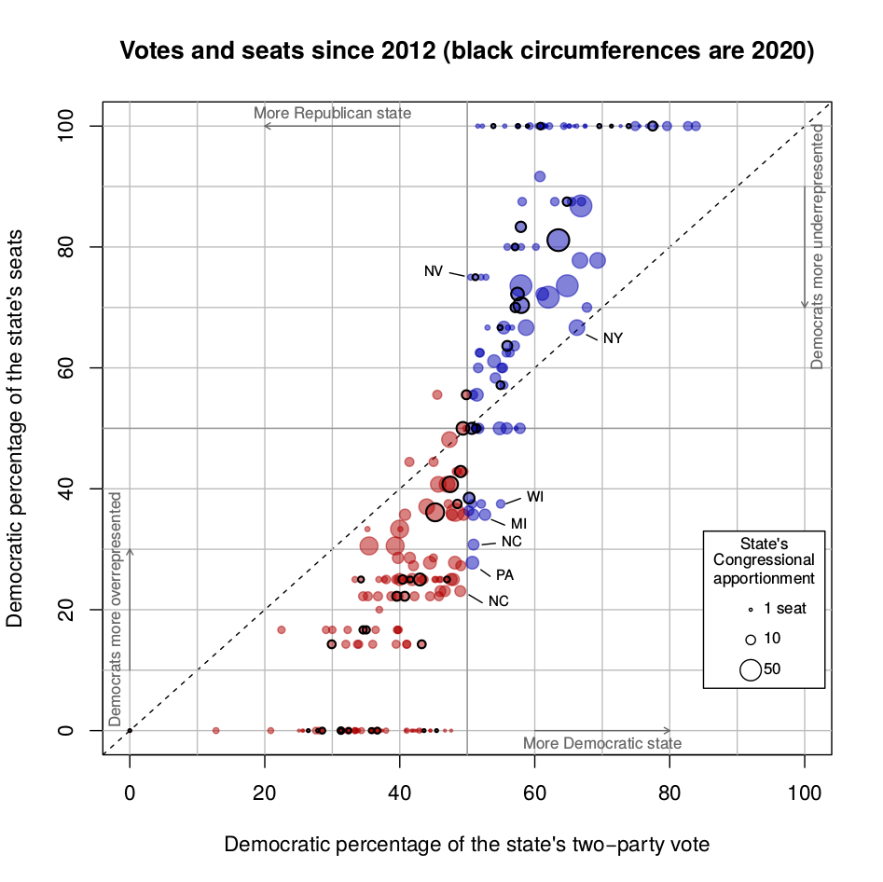

Figure 1. State delegations to the House of Representatives in five election years held with the current district maps. Each point in a diagram is a state in one even year between 2012 and 2020, inclusive. Point diameters are proportional to the number of representatives the state sent to Congress in the period. Prepared with data from the Federal Elections Commission, [ballotpedia.org](http://ballotpedia.org/), [electproject.org](http://www.electproject.org/), and [nytimes.com/interactive/2020/11/03/us/elections/results-house.html](https://www.nytimes.com/interactive/2020/11/03/us/elections/results-house.html).

**7. The role of gerrymandering**

Understanding distorsions in votes to seats conversion passes through the concept of vote wasting. A party's votes are wasted when they are not being converted into seats. One way the problem arises is when the party wins a seat by too large a margin and those extra votes could help elect another candidate if they could be counted in her district. Thus, from the party's perspective, they are wasted. The problem also arises when the party's support is spread too thin across several districts, amounting to no victories unless they could somehow be grouped in a single constituency. Vote wasting leads parties to fewer seats than they potentially could have won.

Vote wasting can be intentional, accidental, or both.[6] It is intentional through partisan gerrymandering, by manipulating district lines so as to target vote wasting towards the opposition, denying it of seats it could otherwise have won. It is accidental when it arises by where voters live.

Geographic concentration of voters breeds vote wasting not attributable to partisan agency. People who think alike tend to live together. Democrats are often overwhelmingly concentrated in metropolitan downtown areas, whereas Republicans have enclaves in suburbia and in rural dwellings.[7] These patterns inevitably distort representation when drawing contiguous electoral boundaries. In cities, Democrats usually overwhelm Republican enclaves, winning inner-city seats by enormous margins. In the suburbs, and especially the rural areas, that balance reverts. This source of bias in representation is not attributable to partisan agency, but driven by wider social and economic forces. The same can be said of different turnout propensities between voters of the parties, another source of partisan bias.

In the end, separating how much gerrymandering and other factors that occur simultaneously each skew against fair representation is far from straightforward. This is not to say that a significant reduction or removal of political manipulation of electoral boundaries is not desirable. But it serves as a reminder that even the most public-spirited independent map maker will find it near impossible to remove every source of bias in electoral boundary maps in first past the post systems.

**8. Judicialization**

Another distinctives aspect of electoral boundary delimitation in the United States is judicialization. Actors who oppose the electoral boundaries routinely challenge them, or the process itself, in court. Judicial supervision can serve as an important check to undue influence in politicized redistricting.

There is no guarantee of this.

The case of Arizona's independent redistricting commission in 2011 is revealing. The Republican party – who would have controlled redistricting in the absence of the commission – attempted a removal Chairwoman Colleen Coyle Mathis, whom they accused of covert sympathy for Democrats. Frictions began even before the redistricting process started. The conflict grew larger, Republican commissioners systematically voting against Mathis. Before the commissions plan was adopted, the governor and Republican state Senate impeached her. The state's Supreme Court unanimously re-instated her in the job, and the commissions' election boundaries were adopted and eventually upheld by the United States Supreme Court.[8]

Judges sided with the commission and against the party in Arizona. But had this incident taken place in a state more clearly dominated by one party (Arizona has been a battleground state for a while), judges might have opted to avoid ruling against politicians in a domain where their presence is fraught with controversy.[9]

**9. Decentralization**

Cross-national perspective offers insight into redistricting in the U.S. Despite patchy knowledge of boundary delimitation practices worldwide, other democracies draw electoral constituencies differently. I pay attention to two dimensions of divergence from the modal process in the U.S.: whether or not the process is decentralized and whether or not it is politicized.

Some federal systems, like the U.S. and Canada, naturally leave redistricting authority at the subnational level, more or less unbounded by federal law. Others, however, emulate unitary systems by centralizing that authority. Such is the case in Australia, Germany, and Mexico, where national bodies draw maps for all states/*länder*. Centralization allows to unify criteria that districts must meet across states.

The other dimension is politicization: are elected officeholders, with direct interests in the districts’ features, in charge of boundary delimitation? They are in France, as in most U.S. states. Others, such as Mexico, Canadian provinces, the United Kingdom, and some states in the U.S., give redistricting authority to an expert board. Table 4 summarizes.

|  |  |  |
| --- | --- | --- |
|  | Politicized | Independent commission |
| Centralized | France | Australia, Germany, Mexico, United Kingdom |
| Decentralized | 35 U.S. states | 8 U.S. states 10 Canadian provinces |

Table 4. Redistriting processes in two dimensions. Prepared with information from Handley and Grofman (2008, see fn. 1); Alejandro Trelles (2015) Drawing Electoral Boundaries in Mexico: International Transparent Participative Mapping around the Globe, in The Weakest Links: Risks Arising during the Electoral Cycle, ed. Ferrán Martínez i Coma, Pippa Norris, and Richard W. Frank, Oxford: Oxford University Press; and [aceproject.org](http://aceproject.org/) .

**10. Recommendations**

* Independent redistricting boards. Bipartisan commissions, and not elected officeholders, should be in charge of consultative processes in all states to establish new election boundaries. This question should be addressed as soon as possible, in order to be implemented in 2021, when redistricting will take place. Failure to act will imply another decade of politicized redistricting in most states. Successful reform cases (such as Arizona in 2000, California in 2010, or Virginia in 2020) offer insights to make reform possible.
* Centralization. While it is extremely unlikely that the United States will nationalize electoral boundary delimitation, federal legislation (such as the Voting Rights Act of 1965) and court rulings offer the potential to set a minimum requirements that congressional districts must comply with in every state.
* Transparency and Accountability. Redistricting processes should be encouraged to operate with full transparency in all 50 states, giving the public and any interested actor continuous access to proposed plans, data, analyses, software tools, and records of public input. Open data and open code will translate into certainty to all actors involved (political parties, organized interests, advocacy groups, and so forth) by providing all inputs needed evaluate, replicate, compare, observe and follow different plans in a public context. It also allows local authorities, communities, minorities, and citizens more generally to assess electoral boundary maps and, if needed, react before they are adopted. Moreover, technology now exists making anyone capable of participating in map-making, even without technical training, with the click of a mouse (e.g. www.districtbuilder.org).
* Collaborative commissions. When independent redistricting commissions are inaugurated---especially those adopted by ballot initiative---and before they are institutionalized, having pressure valves to defuse inevitable tension with the parties is desirable. Transparency in map making, by letting parties get constant updates and render the whole process verifiable, should serve as one such valve. So would the adoption of formal mechanisms for parties to offer observations to the expert map drawers. Mexico's redistricting since 1996 offers an interesting experience worth taking into account. This will contribute for commission members to work more as teams who trust each other despite differences, instead of irreconcilable adversaries in an inherently political process.

11. Appendix: Votes and seats in the 2012-2020 period

I report year-by-year plots of votes and seats. Taken together, these plots consolidate into Figure 1.

For 2012

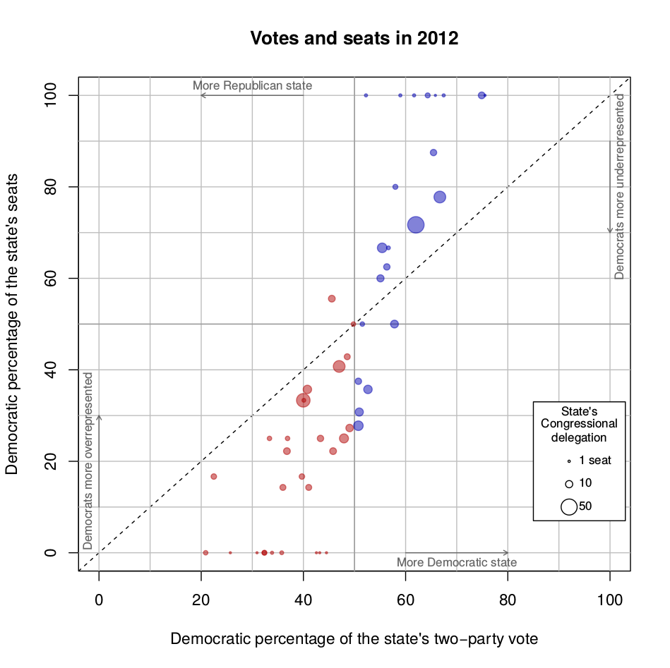

For 2014

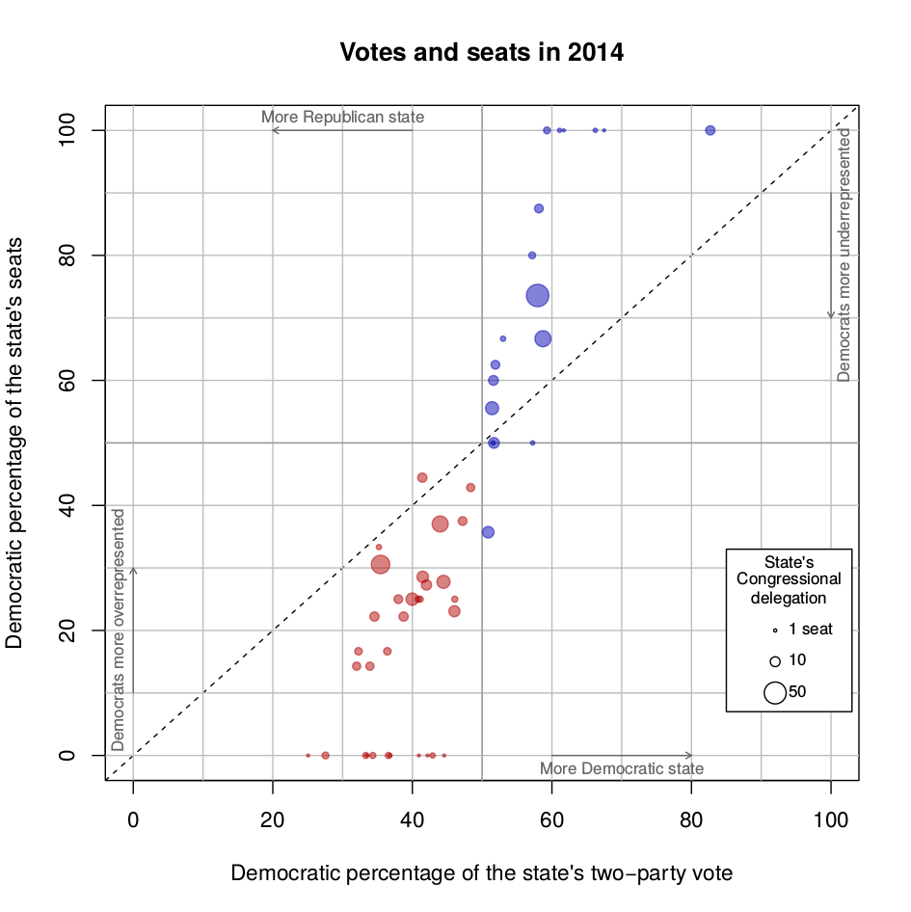

For 2016

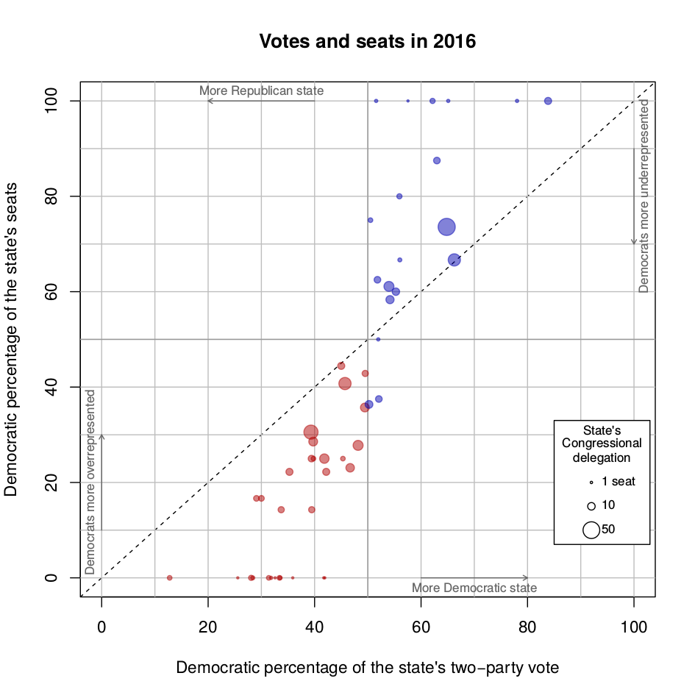

For 2018

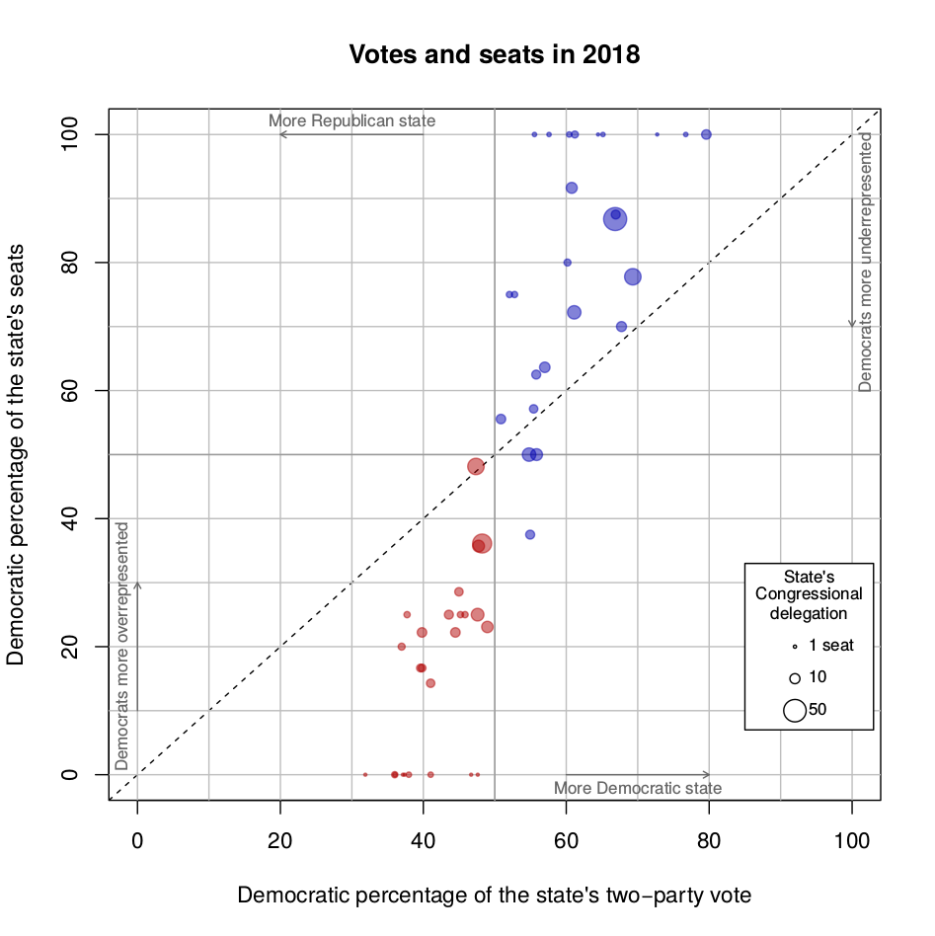

For 2020

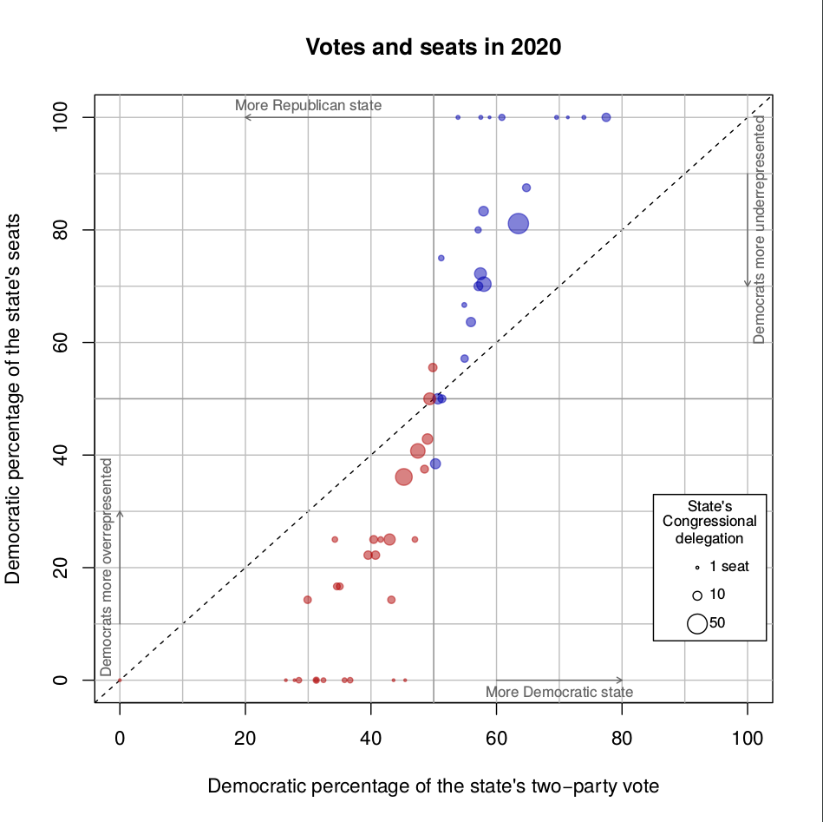

Appendix 2:

1. Handley, Lisa and Bernard Grofman (2008). *Redistricting in Comparative Perspective*. Oxford: Oxford University Press.
2. I sought stakeholder opinions by Alejandro Trelles of Brandeis University; Allison Riggs of the Southern Coalition for Social Justice; Martha Zertuche of the Dirección de Cartografía Electoral del Registro Federal de Electores at Mexico’s Instituto Nacional Electoral; Matt Vasilogambros of Pew Council’s stateline; Michael P. McDonald of ElectProject; and Rebecca Theobald of the Colorado Geographic Alliance. I am grateful to those who responded my emails (as this mission, in the midst of a pandemic, involved no travel).
3. Michel L. Balinski and H. Peyton Young (2001). *Fair representation: Meeting the ideal of one man, one vote* 2nd edition. Washington D.C.: Brookings. See also George G. Szpiro (2010). *Numbers Rule: The Vexing Mathematics of Democracy from Plato to the Present*. Princeton NJ: Princeton University Press.
4. The method divides population by 435, equal how many people each representative ought to represent (called the divisor). In turn, dividing a state's poplation by the divisor yields how many representatives the state deserves by size. The obstacle to fair distribution are decimals: should they be rounded up or down? The Huntington-Hill makes it slightly likelier that small states are rounded up and larger ones rounded up. See <https://math.libretexts.org/Bookshelves/Applied_Mathematics/Book%3A_Math_in_Society_(Lippman)/04%3A_Apportionment/4.05%3A_Huntington-Hill_Method>.
5. Edward R. Tufte (1973). The Relationship between Seats and Votes in Two-Party Systems. *American Political Science Review* 67:540-554; Rein Taagepera (1973). Seats and Votes: A generalization of the cube law of elections. *Social Science Research* 2(3):257-275.
6. Bernard Grofman, William Koetzle, and Thomas Brunell (1997). An Integrated Perspective on the Three Potential Sources of Partisan Bias: Malapportionment, Turnout Differences, and the Geographic Distribution of Party Vote Shares, *Electoral Studies* 16(4).
7. See <https://projects.fivethirtyeight.com/republicans-democrats-cities/>
8. See Matt Vasilogambros (2019) The Tumultuous Life of an Independent Redistricting Commissioner (https://www.pewtrusts.org/en/research-and-analysis/blogs/stateline/2019/11/26/the-tumultuous-life-of-an-independent-redistricting-commissioner).
9. Nicholas Stephanopoulos, <http://www.iconnectblog.com/2012/10/our-electoral-exceptionalism/>