# Oscillatory Breathing Detection

**Written by**: Emanuele Magliozzi

**Last Updated:** 23/01/2012

## Description

This document describes how to use the Oscillatory Breathing Detection program and how the program analyzes the signal.

## Install LabView Run-Time 2011

In order to use the Oscillatory Breathing Detection program is necessary to install the LabView Run-Time 2011 by using the setup.exe file in the folder LabView RunTime.

The default settings are recommended.

## Oscillatory Breathing Detection program

Oscillatory Breathing Detection program detects and calculates the amplitude and the duration of the oscillations based on threshold and width settings in the exercise phase.

This program uploads the data from a text file that is composed by a column that describe the phase of test (B = rest phase, E = exercise phase, R = recovery phase), a column of time whose data format is HH.mm.ss and a column of ventilation expressed in L/min.

The executable file *OscillatoryBreathingDetection.exe* is located in the folder Oscillatory Breathing Detection.

The graphic interface is shown in the following picture:

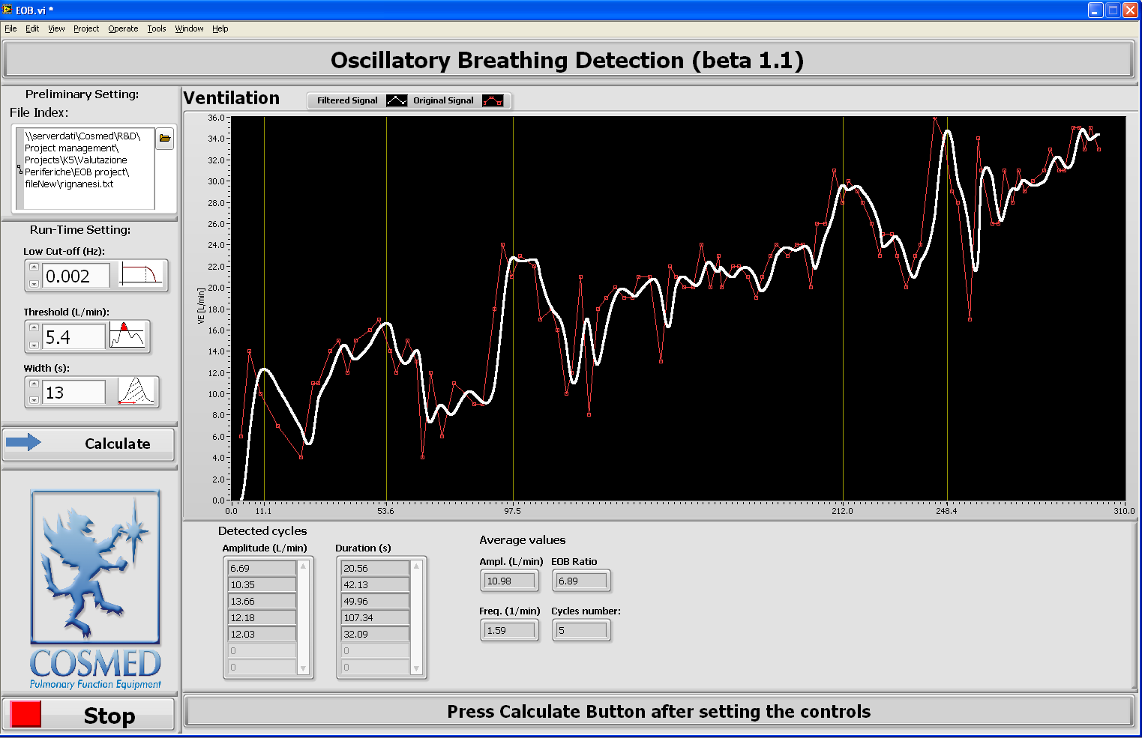

When the program is launched for the first time, a pop up message is shown requiring to choose the data file. This procedure occurs at each program run only if the file path is not present into File Index box.

In order to run the program it is necessary to press the button with a white arrow in the upper left side of the screen. If the stop button doesn’t work, abort execution by pressing the red circle button close to white arrow. The signal of each phase has been interpolated with a six order curve to find the best signal approximation. After interpolating, the signal has been filtered with a low pass with a cut-off frequency set from the user by means of Low Cut-Off control shown in the figure.

From the rest phase the default width for each patient has been detected. According to guide lines the width of the EOB oscillations in the exercise phase has to be 15% greater than the width of the highest oscillations in the rest phase, so the default width has been calculated in this way. The default threshold has been set like the 15% of the range of signal in the exercise phase. After showing in the status bar the message “Wait..default values calculation in progress...”, the default values have been upgraded in the respective controls.

Only the exercise phase is shown: the original signal is represented on red curve, the filtered signal is in white color and the yellow vertical lines indicate the max of the oscillations detected.

Below the Low cut-off frequency buttons there are two controls which allow the user to regulate the Threshold and the Width of oscillations. By means of the first button all the oscillations that have the amplitude less than the threshold will be filtered, while the second button is used to detect only the oscillations with the set duration or more. The choice of the width is critical because large widths can reduce the apparent amplitude of peaks and shift the apparent location. Also the value should be no more than about of the half-width of the oscillation.

After setting this controls, press the Calculate Button to obtain the results: Amplitude and Duration of each oscillations detected.

Beside the average results are: average amplitude; average frequency, that it is calculated as the mean of the frequency of all oscillations; the cycles number, that is the number of oscillations; finally the EOB ratio, that it is calculated as the average amplitude divided by the average frequency. It is possible to change the Run-Time Settings and obtain new results after pressing the Calculate Button again. At the end of the analysis press the Stop Button and, if necessary, upload another file.