UAV-BASED VEHICLE DETECTION AND TRAJECTORY
ANALYSIS FOR IMPROVING HIGHWAY TRAFFIC SAFETY
PROJECT REPORT
Submitted by
ERIC JOSE
University Reg. No: TVE25CEGI05
To
A P J. Abdul Kalam Technological University
in partial fulfilment of the requirements for the award of the Degree
of
Master of Technology
in
Geoinformatics

DEPARTMENT OF CIVIL ENGINEERING
COLLEGE OF ENGINEERING TRIVANDRUM
OCTOBER 2026
DECLARATION
I hereby declare that the project report titled “UAV-Based Vehicle Detection and Trajectory Analysis for Improving Highway Traffic Safety”, submitted in partial fulfilment of the requirements for the award of the degree of Master of Technology at APJ Abdul Kalam Technological University, Kerala, is the original work carried out by me under the supervision of Prof. Aparna V.
I confirm that this report is the result of my independent efforts and that all sources of information used have been appropriately acknowledged. I have maintained academic honesty and integrity throughout the preparation of this report and have neither fabricated data nor presented others’ work as my own without proper citation.
I understand that any breach of academic ethics, such as plagiarism or data falsification, may lead to disciplinary proceedings by the institute and/or the University. I also affirm that this report has not been submitted previously for the award of any degree, diploma, or other qualification at any other institution.

Place: Trivandrum ERIC JOSE
Date: ____ / ____ / 2026

DEPARTMENT OF CIVIL ENGINEERING
COLLEGE OF ENGINEERING TRIVANDRUM
CERTIFICATE
This is to certify that this project report entitled “UAV-Based Vehicle Detection and Trajectory Analysis for Improving Highway Traffic Safety” is a bonafide record of the project work presented by ERIC JOSE (University Reg. No: TVE25CEGI05) to the APJ Abdul Kalam Technological University for the award of the Degree of Master of Technology in Geoinformatics, Civil Engineering, during the academic year 2026-2027, carried out under my guidance and supervision. This report has not been submitted to any other university or institute for any purpose.

Internal Supervisor |  | Project Coordinators
Prof. Aparna V.  Department of Civil Engineering  College of Engineering, Trivandrum |  | Prof. Sabu P.  Department of Civil Engineering  College of Engineering, Trivandrum
Head of Department | PG Coordinator | Dr. Anu P. Alex  Department of Civil Engineering
Dr. Priyadarsini R. S  College of Engineering, Trivandrum | Dr. Smitha M. S.  Department of Civil Engineering  College of Engineering, Trivandrum
ACKNOWLEDGEMENT
I would like to take this opportunity to express my sincere gratitude to my internal supervisor, Prof. Aparna V., Assistant Professor, Department of Civil Engineering, College of Engineering Trivandrum, for the valuable guidance, advice, constructive criticism, and constant encouragement throughout the course of my project work.
I am deeply grateful to Dr. Priyadarsini R. S., Head of the Department, Department of Civil Engineering, College of Engineering Trivandrum, for the keen interest, encouragement, and overall support.
I would also like to express my profound thanks to Prof. Sabu P. and Dr. Anu P. Alex, Project Coordinators, Department of Civil Engineering, College of Engineering Trivandrum, for providing the necessary facilities and their sincere cooperation.
My heartfelt thanks extend to all the faculty members and staff of the Department of Civil Engineering, as well as to my family and friends, whose continuous support and motivation were instrumental in completing this endeavour.
Above all, I thank God Almighty and my parents, whose blessings and unwavering support have been my greatest source of strength throughout this journey.

ERIC JOSE
ABSTRACT
Road traffic safety assessment increasingly needs vehicle-level information on how vehicles move and interact. Conventional crash records, manual surveys and fixed sensors are retrospective, costly or limited in coverage. Unmanned Aerial Vehicles (UAVs) provide a flexible bird’s-eye view from which vehicle trajectories can be extracted over a road section. This study proposes an improved YOLO-based vehicle detection and trajectory analysis framework for traffic safety monitoring, crash risk assessment and accident hotspot identification on mid-block highway sections in Thiruvananthapuram.
A review of 17 studies shows that UAV trajectories can support time-to-collision (TTC), post-encroachment time (PET) and extreme-value-based crash risk estimation, while small vehicles, camera motion and mixed traffic remain open problems. The study develops a locally annotated five-class vehicle dataset and an improved YOLO-based detection and tracking workflow for mid-block highway safety analysis. A preliminary National Highway 48 (NH-48) video was also processed: an assumed 3.50 m lane width was used to estimate image scale, yielding metric trajectories and exploratory traffic and conflict measures. These NH-48 measurements are provisional until the road width is physically checked. The earlier sample-video test remains a separate pixel-coordinate pilot. The report presents the methodology, the two distinct video analyses and the work still required for the Thiruvananthapuram field study.
The work so far includes two separate video analyses. A sample UAV video produced 19,133 tracking records for 614 track IDs in pixel coordinates. A separate 601-frame NH-48 video produced 22,031 preliminary metric trajectory points across 126 sustained trajectories, using an assumed 3.50 m lane width. The NH-48 scale has not been physically verified, so its speeds, distances, density and safety measures remain exploratory. The DJI Neo 2 has not been purchased and Thiruvananthapuram study sections remain unselected; field collection and on-site road-width measurement are pending.
Keywords: UAV, Vehicle Detection, YOLO, Small-Object Detection, Multi-Object Tracking, ByteTrack, Vehicle Trajectory, Road-Width Calibration
CONTENTS
1 INTRODUCTION 2
1.1 GENERAL 2
1.2 NEED FOR THE STUDY 3
1.3 PROBLEM STATEMENT 3
1.4 OBJECTIVES 3
1.5 SCOPE OF THE STUDY 4
1.6 SIGNIFICANCE OF THE STUDY 4
2 LITERATURE REVIEW 5
2.1 REVIEW OF LITERATURE 5
2.2 SUMMARY OF LITERATURE 10
2.3 IDENTIFIED RESEARCH GAPS 10
2.3.1 Generic detectors instead of small-object-optimised YOLO 10
2.3.2 Computational cost of two-stage detectors 11
2.3.3 Lack of evaluation on Indian mixed vehicle classes 11
2.3.4 Detection and safety analysis treated separately 11
2.3.5 Mid-block sections largely unexplored 11
2.4 RESEARCH CONTRIBUTION 11
2.5 CONCLUSION OF LITERATURE REVIEW 11
3 STUDY AREA 13
3.1 GENERAL 13
3.2 LOCATION AND EXTENT 13
3.3 SELECTION OF MID-BLOCK STUDY SECTIONS 14
3.4 PRELIMINARY NH-48 TEST CORRIDOR 14
3.5 RELEVANCE OF THE STUDY AREA 14
3.6 SUMMARY 15
4 DATA AND SOFTWARE USED 16
4.1 GENERAL 16
4.2 DATA REQUIRED 16
4.2.1 UAV Video 16
4.2.2 Measured Road-Width Reference 17
4.2.3 Annotated Vehicle Dataset 17
4.2.4 Road and Lane Geometry 17
4.2.5 Reference and Validation Data 17
4.2.6 Sample UAV Video 17
4.2.7 NH-48 UAV TEST VIDEO 17
4.3 UAV PLATFORM 18
4.4 DATA PRE-PROCESSING 18
4.5 SOFTWARE USED 19
4.5.1 UAV TRAFFIC STUDIO SOFTWARE PLATFORM 19
4.6 DATA LIMITATIONS 19
5 METHODOLOGY 21
5.1 GENERAL 21
5.2 OVERALL METHODOLOGICAL FRAMEWORK 21
5.3 SELECTION OF MID-BLOCK STUDY SECTIONS 22
5.4 UAV FLIGHT PLANNING AND ROAD-WIDTH CALIBRATION 22
5.5 VIDEO AND IMAGE ACQUISITION 23
5.6 FRAME EXTRACTION, STABILISATION AND IMAGE-SCALE CALIBRATION 24
5.7 CVAT ANNOTATION OF FIVE VEHICLE CLASSES 24
5.8 BASELINE YOLO TRAINING 25
5.9 IMPROVED SMALL-OBJECT YOLO 26
5.10 MULTI-OBJECT TRACKING AND TRAJECTORY EXTRACTION 27
5.11 METRIC SCALING OF TRAJECTORIES 28
5.12 COUNT, SPEED AND DENSITY 29
5.13 SURROGATE SAFETY MEASURES: TTC AND PET 30
5.13.2 LONGITUDINAL AND LATERAL CONFLICT GRAPHS 31
5.13.1 KINEMATIC STOPPING DISTANCE DEFICIT 32
5.14 CRASH RISK ESTIMATION AND PREDICTION 32
5.15 HOTSPOT, LOS AND BENCHMARKING 33
6 WORK DONE AND EXPECTED RESULTS 35
6.1 WORK COMPLETED AND EXPECTED RESULTS 35
6.2 WORK COMPLETED TO DATE 35
6.3 PIPELINE TESTING ON THE SAMPLE VIDEO 35
6.4 VEHICLE DETECTION OBSERVATIONS 36
6.5 MULTI-OBJECT TRACKING OUTPUT 37
6.6 PIXEL-COORDINATE PILOT OUTPUT 37
6.7 RELIABILITY CHECK OF A SECOND PRETRAINED MODEL 38
6.8 LIMITATIONS OF EXISTING METHODS 38
6.9 TRAJECTORY GENERATION: CURRENT STATUS 39
6.10 DISCUSSION 39
6.11 NH-48 DATASET AND PRELIMINARY CALIBRATION 39
6.12 VEHICLE DETECTION AND PRETRAINED MODEL LIMITATIONS 39
6.13 TRACKING AND METRIC TRAJECTORY EXTRACTION 41
6.14 MACROSCOPIC TRAFFIC FLOW PARAMETERS 41
6.15 MICROSCOPIC SURROGATE SAFETY MEASURES 42
6.16 KINEMATIC STOPPING DISTANCE DEFICIT AND CRITICAL EVENTS 43
6.17 SPATIAL CONFLICT HOTSPOTS 44
6.18 UAV TRAFFIC STUDIO 45
6.19 EXPECTED RESULTS AND DELIVERABLES 46
7 CONCLUSIONS AND WORK PLAN 47
7.1 GENERAL 47
7.2 SUMMARY OF WORK DONE 47
7.3 EXPECTED OUTCOMES 47
7.4 CHALLENGES AND NEXT STEPS 48
7.5 SCHEDULE OF WORK 48
7.6 CONCLUSION 49

LIST OF TABLES
TABLE NO. TITLE PAGE NO.
3.1 Proposed criteria for selecting mid-block sections 14
4.1 Data requirement and status 16
4.2 Specifications of DJI Neo 2 18
5.1 Vehicle classes used for annotation 24
5.2 Evaluation metrics adopted at each stage 34
6.1 Details of the sample video and processing environment 36
6.2 Structure of the tracking output table 37
6.3 First five records of the tracking output (pixel coordinates) 37
6.4 NH-48 video and trajectory dataset characteristics 39
6.5 Automated NH-48 vehicle classification 40
6.6 Preliminary macroscopic traffic parameters 42
6.7 Ten highest-ranked NH-48 conflict events 43
6.8 Conflict counts by 20 m NH-48 corridor zone 44
7.1 Schedule of work 49
LIST OF FIGURES
FIGURE NO. TITLE PAGE NO.
3.1 Study Area 13
4.1 DJI Neo 2 (planned UAV platform) 18
5.1 Methodology flowchart 21
5.2 Conceptual longitudinal and lateral TTC graphs with provisional critical limit 31
6.1 Sample frame showing detection and tracking output (class, confidence and track ID) 36
6.2 Output of the second pretrained model on a sample video (two-wheelers not identified) 38
6.3 Preliminary NH-48 road-plane view after image-scale calibration 39
6.4 Automated NH-48 vehicle classification chart 40
6.5 Space-time diagram of NH-48 vehicle trajectories 41
6.6 Preliminary NH-48 speed distribution 42
6.7 Distribution of preliminary microscopic TTC events 43
6.8 Annotated frame for the highest-ranked conflict 44
6.9 Conflict counts and preliminary hotspots across NH-48 45

1 INTRODUCTION

1.1 GENERAL
Road traffic safety is a major concern at highway junctions and mid-block sections, where congestion, speed differences, lane changing and unsafe driving contribute to accident risk. Safety studies have traditionally depended on crash records, manual observations, roadside sensors and fixed cameras. Crash records are retrospective and sparse, while manual surveys and fixed sensors are costly and observe only the stretch of road within their range. For proactive safety analysis, the ability to reconstruct how every vehicle moves before a conflict occurs is particularly valuable.
Unmanned Aerial Vehicles (UAVs) offer a low-cost and flexible platform for capturing high-resolution traffic imagery over a wide road stretch. From the bird’s-eye view of a UAV, several lanes and many interacting vehicles appear in the same frame, so that vehicle trajectories can be extracted rather than only point measurements such as flow or speed at a detector location. Trajectories of this kind can be converted into traffic parameters such as vehicle count, speed and density, and into surrogate safety measures such as time-to-collision (TTC) and post-encroachment time (PET). Because conflicts can be evaluated before a crash occurs, surrogate safety measures reduce the dependence on long crash histories (Arun et al., 2021).
Deep learning object detectors such as YOLO, combined with multi-object tracking, now make it possible to process long UAV videos automatically. Vehicles seen from a UAV, however, occupy only a few pixels, and two-wheelers are the smallest of them. This is a serious difficulty for Indian highways, where two-wheelers, three-wheelers, passenger cars, light commercial vehicles and heavy vehicles share the carriageway without strict lane discipline. A detector that is reliable on benchmark data may therefore not be reliable on local traffic.
This study proposes an improved YOLO-based vehicle detection and trajectory analysis framework for traffic safety assessment, crash-risk indicators and conflict hotspot identification on mid-block highway sections in Thiruvananthapuram. Five vehicle classes will be manually annotated in extracted UAV video frames using CVAT running in Docker. The annotations will train and evaluate a small-object detector, which will later be packaged in a Docker inference workflow. Measured road or lane width provides the pixel-to-metre scale needed for speed and other distance-based measures; orthomosaic generation is not required. This project report presents the study plan, annotation and model-development work, preliminary pipeline checks and expected outputs.

1.2 NEED FOR THE STUDY
The increasing volume and diversity of traffic on urban highways has created a need for safety assessment that does not wait for crashes to accumulate. In the absence of detailed vehicle-level data:
- Manual surveys and fixed roadside sensors remain costly and limited in spatial coverage
- Interactions between neighbouring vehicles, such as lane changes and sudden braking, cannot be observed
- Detectors trained on international UAV benchmarks may fail on small two-wheelers and three-wheelers in local traffic
- Speed and distance cannot be computed reliably from pixel movement until the image scale is calibrated using a measured road or lane width.
In Thiruvananthapuram there is no locally annotated, metric-scaled UAV vehicle dataset

1.3 PROBLEM STATEMENT
Existing UAV-based traffic studies rely mainly on generic detectors, optical-flow or clustering methods, and rarely pair a small-object-optimised detector with trajectory-level crash risk analysis. The challenge lies in detecting all five vehicle classes reliably from high-altitude UAV imagery, converting detections into metric-scaled trajectories, and using them to estimate safety measures on mid-block highways under heterogeneous traffic.

1.4 OBJECTIVES
- To acquire UAV imagery of highway segments and construct an annotated five-class vehicle dataset, with metric scale established from measured road or lane width
- To implement a baseline YOLO detector
- To derive vehicle count, speed and traffic density from the detected and tracked vehicles
- To evaluate microscopic surrogate safety measures, time-to-collision and post-encroachment time, using metric-scaled UAV trajectories
- To develop a crash prediction model and rank the severity of potential collisions based on the evaluated surrogate safety measures

1.5 SCOPE OF THE STUDY
The study is limited to mid-block road sections in Thiruvananthapuram city (the sections are yet to be selected) and focuses on:
- Five vehicle classes: two-wheeler, three-wheeler, car, LCV and HCV
- A single UAV (DJI Neo 2, planned) operated in nadir view, with road or lane width measured on site to establish image scale
- A baseline YOLO detector and an improved small-object YOLO detector, compared with Faster R-CNN and RT-DETR
- Multi-object tracking, metric-scaled trajectories, and vehicle count, speed and density
- Time-to-collision, post-encroachment time, crash risk estimation, hotspot and level-of-service analysis

1.6 SIGNIFICANCE OF THE STUDY
This study contributes to:
- A locally relevant, metric-scaled UAV vehicle dataset for Thiruvananthapuram traffic, calibrated using measured road geometry
- Evidence on how far pretrained detectors can be trusted for two-wheeler-heavy mixed traffic
- Trajectory-level safety evidence for mid-block sections, a setting that remains largely unexplored
- A reproducible workflow from UAV video to crash risk and hotspot maps that can be used by highway safety managers

2 LITERATURE REVIEW

2.1 REVIEW OF LITERATURE
1. Ke et al. (2017)
Ke et al. (2017) proposed a framework that combines a KLT tracker with k-means clustering to separate traffic streams from moving-camera UAV video. From the separated streams the method estimates speed, density and volume of each traffic stream in real time. The authors reported accuracies of 96% for average speed and 87% for vehicle count.
The study represents an early stage in the development of UAV traffic analysis: it showed that aerial video can supply traffic-flow parameters and not only visual records. It is relevant to the present work because the count, speed and density estimates planned in this study follow the same logic, and because comparison with reference counts and speeds is used for validation.
2. Khan et al. (2017)
Khan et al. (2017) reviewed the literature on UAV-based traffic studies and proposed a universal guiding framework of seven components: scope definition, flight planning, flight implementation, data acquisition, data processing and analysis, data interpretation, and optimised traffic application. The authors treated a UAV study as a complete data-acquisition system and not merely as video recording.
They emphasised that flight altitude, camera orientation, weather, lighting and battery limits all affect the quality of the final trajectories. For the present study this means that flight planning has to be designed around trajectory accuracy and not only around visual coverage.
3. Xu, Y. et al. (2017)
Xu et al. (2017) extended the Faster R-CNN framework to detect cars in low-altitude UAV imagery at signalised intersections. The study demonstrated robustness to changes in illumination and to in-plane rotation of vehicles, and observed that detection speed stayed nearly constant regardless of the number of vehicles in a frame.
Faster R-CNN is a two-stage detector in which a Region Proposal Network first generates candidate regions that a second stage classifies and localises. It can give strong localisation, but its computational cost is a concern for long UAV videos. In the present study it serves as a two-stage benchmark against which the proposed YOLO detectors are compared.
4. Du et al. (2018)
Du et al. (2018) introduced UAVDT, a vehicle-focused aerial benchmark for object detection and tracking. The benchmark highlights high object density, small objects, camera motion and real-time constraints as the central challenges of UAV vision.
The study showed that generic object detectors can lose performance under UAV-specific conditions. UAVDT is valuable for pretraining and benchmarking, but it cannot substitute for a locally annotated dataset, which is the reason a site-specific five-class dataset is planned in this study.
5. Liu et al. (2020)
Liu et al. (2020) proposed UAV-YOLO, which modifies the YOLOv3 Darknet backbone to enlarge the receptive field and enrich spatial information for small objects seen from a UAV. The authors also built a dedicated UAV-viewed training dataset and a training method suited to it.
This is one of the foundational works on small-object detection tailored to the UAV viewpoint. It supports the view that the detector architecture should be adapted to the scale distribution of UAV imagery and informs the small-object head proposed in this study.
6. Outay et al. (2020)
Outay et al. (2020) reviewed the applications of UAVs in road safety, traffic monitoring and highway infrastructure management. The review discussed computer vision methods for traffic flow analysis, risk assessment and damage assessment, and identified the barriers to wide-scale UAV deployment, such as regulations, flight limitations and data processing demands, together with countermeasures.
The review provides the overall context for the present study and confirms the analytical opportunities of UAV data as well as the practical constraints, such as permissions, that must be cleared before field acquisition.
7. Arun et al. (2021)
Arun et al. (2021) carried out a systematic mapping review of 549 studies on surrogate safety assessment using traffic conflict techniques and developed a broad framework for it. They stressed the need for clearer relationships between conflicts and crashes and for a better understanding of how individual measures should be used.
The review shows that conflicts can be evaluated before a crash occurs, reducing dependence on long crash histories. It also cautions that surrogate measures identify conflict conditions and not confirmed crashes, so any crash model developed in this study is presented as estimated risk.
8. Aharon et al. (2022)
Aharon et al. (2022) proposed BoT-SORT, a tracker that combines motion and appearance information for data association and includes camera-motion compensation. Camera-motion compensation is important for UAV video, where even a small camera movement shifts all vehicles in the image.
A tracker that assumes a stationary camera may confuse camera motion with vehicle movement. BoT-SORT is therefore one of the trackers to be compared on identity continuity in this study.
9. Zhang et al. (2022)
Zhang et al. (2022) proposed ByteTrack, which associates every detection box, including low-confidence ones, instead of discarding them. This helps to recover partially occluded objects whose detector confidence temporarily drops, a situation common for small vehicles seen from above.
ByteTrack is the tracker used in the pipeline test on the sample video reported in Chapter 6, where it maintained vehicle identities across frames.
10. Zong et al. (2022)
Zong et al. (2022) combined deep-learning-based vehicle tracking with time-to-collision analysis on UAV video at road intersections. The study demonstrated UAV-derived trajectories as a practical tool for proactive collision risk assessment and highlighted the advantage of UAV observation in overcoming the occlusion that affects conventional tracking equipment.
The work is a direct example of the detection–tracking–safety chain that the present study aims to build, and it highlights the value of such analysis for urban road agencies and traffic safety management.
11. Wang et al. (2023)
Wang et al. (2023) proposed UAV-YOLOv8, a modification of YOLOv8 for small-object detection in UAV aerial photography scenarios. The work belongs to the recent line of YOLO research that focuses on preserving fine spatial information for tiny targets.
It supports adapting the detector architecture to the scale distribution of UAV imagery instead of using a generic model, which is the principle behind the improved detector of this study.
12. Berghaus et al. (2024)
Berghaus et al. (2024) built a drone-based trajectory dataset of over 8,000 trajectories on a German highway, covering an off-ramp, an on-ramp and congested traffic. The pipeline used YOLOv5 detection with three-dimensional camera calibration to project vehicles onto the road surface, followed by post-processing of the trajectories.
The derived speed and acceleration were compared with independent sources, and the data were applied to traffic-flow and accident-risk analysis. The study shows that calibration and quality assessment must be planned as part of the measurement chain, and that a trajectory dataset is a research output in its own right.
13. Xu, L. et al. (2024)
Xu et al. (2024) improved YOLOv8n with multi-scale feature fusion, conditionally parameterised convolutions and the Wise-IoU loss for small-object detection in UAV images. The model achieved state-of-the-art accuracy on the VisDrone benchmark for small, partially occluded objects.
It outperformed other lightweight YOLO variants and Faster R-CNN on small-object accuracy while remaining lightweight. The multi-scale fusion and Wise-IoU components are among the changes to be tested in the improved detector of this study.
14. Zhao et al. (2024)
Zhao et al. (2024) proposed RT-DETR, a real-time end-to-end transformer detector that removes the non-maximum suppression post-processing step. The RT-DETR-R50 model reached 53.1% AP on COCO at 108 frames per second on a T4 GPU, outperforming advanced YOLO detectors in both speed and accuracy.
RT-DETR serves, together with Faster R-CNN, as a comparison detector against which the proposed detector is benchmarked.
15. Fonod et al. (2025)
Fonod et al. (2025) developed a multi-drone pipeline for extracting georeferenced vehicle trajectories, demonstrated over 20 intersections. Vehicle detections were used during image registration so that moving vehicles do not dominate the estimation of camera motion, and trajectories were stabilised before being georeferenced through orthophoto and master-frame alignment.
The study demonstrates that trajectory extraction and georeferencing should be considered together, and it supports the DGPS georeferencing step and the frame-stabilisation approach planned in this study.
16. Kumar and Sarkar (2025)
Kumar and Sarkar (2025) collected UAV-based vehicle trajectory data at the Panipat Toll Plaza on NH-44, an Indian highway toll plaza with heterogeneous, lane-changing traffic. Lane-Changing Time-to-Collision, a surrogate safety measure, was combined with Extreme Value Theory (EVT) to estimate crash risk.
The authors found a negative relationship between vehicle size and conflict involvement across vehicle categories. The study is closely aligned with the present work because it connects UAV data, heterogeneous Indian traffic, lane changing and crash-risk estimation, and it shows why class-wise analysis is essential.
17. Maji and Ghosh (2025)
Maji and Ghosh (2025) extracted trajectories from high-resolution drone video at roundabouts under non-lane-based mixed traffic. TTC and maximum Delta-V were used as surrogate safety measures, and Extreme Value Theory was applied for conflict analysis, moving beyond simple threshold-based conflict counting.
The study is important for Indian applications because road-user interactions do not always follow strict lane-based assumptions, and it supports the use of statistical modelling of extreme conflicts in this study.

2.2 SUMMARY OF LITERATURE
The reviewed studies show that UAVs are well established as a low-cost, flexible platform for road safety, traffic monitoring and highway infrastructure surveys (Outay et al., 2020; Khan et al., 2017). Classical tracking and clustering methods (KLT with k-means) and two-stage detectors (Faster R-CNN) have both demonstrated accurate traffic parameter and vehicle-count estimation from aerial video (Ke et al., 2017; Xu et al., 2017).
Standard YOLO detectors are fast, but recent studies (UAV-YOLO, UAV-YOLOv8, YOLOv8n with multi-scale fusion) show that unmodified YOLO underperforms on small, high-altitude vehicle objects, and benchmarks such as UAVDT confirm that generic detectors lose accuracy under UAV conditions (Liu et al., 2020; Wang et al., 2023; Xu et al., 2024; Du et al., 2018). Tracking methods such as ByteTrack and BoT-SORT address identity continuity, and BoT-SORT adds camera-motion compensation that is relevant to UAV video (Zhang et al., 2022; Aharon et al., 2022).
UAV-derived vehicle trajectories have been used successfully with surrogate safety measures such as time-to-collision to assess crash and conflict risk at intersections, toll plazas and roundabouts, including on Indian roads (Zong et al., 2022; Kumar and Sarkar, 2025; Maji and Ghosh, 2025). Trajectory datasets and georeferencing pipelines show that calibration, post-processing and independent validation are essential (Berghaus et al., 2024; Fonod et al., 2025). Very few studies, however, combine an improved YOLO-based detector with trajectory-level crash risk and hotspot analysis for Indian mixed-traffic conditions.

2.3 IDENTIFIED RESEARCH GAPS
Based on the review of literature, the following research gaps have been identified:

2.3.1 Generic detectors instead of small-object-optimised YOLO
Existing UAV traffic studies rely mainly on generic detectors, optical-flow or clustering methods rather than modern small-object-optimised YOLO architectures.

2.3.2 Computational cost of two-stage detectors
Two-stage detectors such as Faster R-CNN achieve good small-object accuracy but are computationally heavy for near real-time, highway-scale processing.

2.3.3 Lack of evaluation on Indian mixed vehicle classes
Recent small-object YOLO improvements have not been evaluated on Indian mixed vehicle-class highway traffic (two-wheeler, three-wheeler, car, LCV, HCV).

2.3.4 Detection and safety analysis treated separately
UAV-trajectory-based crash risk and surrogate safety studies exist, but are rarely paired with an improved, small-object-optimised detector or extended into hotspot and LOS-based safety applications.

2.3.5 Mid-block sections largely unexplored
UAV-based, trajectory-level traffic safety analysis for mid-block sections remains largely unexplored.

2.4 RESEARCH CONTRIBUTION
The present study addresses the identified gaps through the following contributions:
- Acquisition of UAV imagery and construction of an annotated, metric-scaled vehicle dataset with five vehicle classes
- A baseline YOLO detector and an improved small-object-optimised YOLO detector, benchmarked against Faster R-CNN and RT-DETR on the same local test set
- Multi-object tracking and metric-scaled trajectories from which vehicle count, speed and density are derived and validated
- Surrogate safety measures (TTC and PET) and a crash prediction model with severity ranking of potential collisions
- Accident hotspot identification and level-of-service assessment presented through GIS visualisation

2.5 CONCLUSION OF LITERATURE REVIEW
The literature establishes that UAV imagery, deep-learning detection, multi-object tracking and surrogate safety measures can be combined into a complete workflow from video to crash risk. It also shows that small and partially occluded vehicles, camera motion, mixed traffic, trajectory noise and georeferencing remain open challenges, and that local annotated data are needed because models do not transfer reliably between locations.
The present study builds on these methods while addressing the gaps through a locally annotated, DGPS-referenced five-class dataset, a small-object-optimised detector and trajectory-level safety analysis. Its evaluation covers not only detector accuracy but also the quality and safety relevance of the resulting trajectories.

3 STUDY AREA

3.1 GENERAL
The study is set in Thiruvananthapuram city, Kerala, India. Thiruvananthapuram is the capital of the state of Kerala and a rapidly urbanising centre with a mix of residential, commercial, institutional and administrative land uses. This land-use mix, together with major road corridors, produces a traffic stream in which two-wheelers, three-wheelers, cars, light commercial vehicles and heavy commercial vehicles all share the road. This mixed vehicle composition makes the city a suitable setting for testing UAV-based detection and trajectory analysis under heterogeneous traffic.

3.2 LOCATION AND EXTENT
Thiruvananthapuram Corporation is located in the southern part of Kerala and serves as the administrative and economic centre of the region. The corporation covers an area of approximately 214.86 square kilometres, is divided into 100 wards, and is bounded by the Arabian Sea on the west. Figure 3.1 shows the location of Thiruvananthapuram Corporation within Kerala and India.
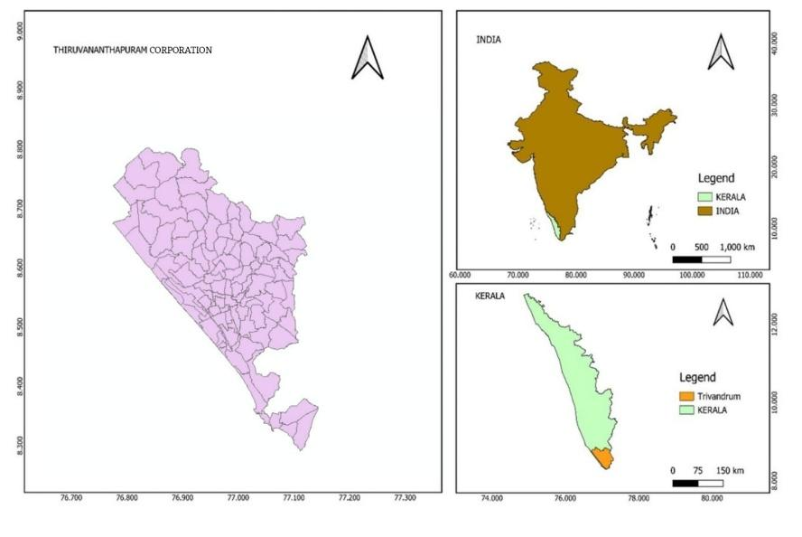
Figure 3.1: Study Area

3.3 SELECTION OF MID-BLOCK STUDY SECTIONS
The survey will be carried out on mid-block road sections of the city. No mid-block road section has been shortlisted or confirmed so far. Selecting the sections is the first pending step because flight planning, measurement of a visible road or lane width and data collection all depend on it. The sections will be chosen using the criteria in Table 3.1.
Table 3.1: Proposed criteria for selecting mid-block sections
Criterion | Requirement
Mixed traffic | 2W, 3W, cars, LCV and HCV all present
Steady flow | Adequate, consistent volume during the survey
Simple geometry | Straight, level mid-block with clear lane markings
Safety relevance | Lane changes, speed differences and sudden braking
UAV feasibility | Open sky, safe take-off point and room for ground control points
Permissions | Aviation, institutional and privacy clearance

UAV data acquisition with on-site road-width measurement will follow once the sections are selected and the UAV (DJI Neo 2) is purchased.

3.4 PRELIMINARY NH-48 TEST CORRIDOR
A separate NH-48 UAV video was used to extend the pipeline test beyond the original sample-video pilot. This corridor is an analytical test dataset and is not the planned Thiruvananthapuram study site. It provides preliminary results for detection, metric trajectory extraction, traffic-flow analysis and safety measures. Its scale was estimated from an assumed 3.50 m lane width; the values must be treated as provisional until checked against a physically measured width. The NH-48 results demonstrate the workflow and do not replace field data collection at the selected mid-block sections.

3.5 RELEVANCE OF THE STUDY AREA
Thiruvananthapuram is considered suitable for the study for the following reasons:
- Mixed vehicle composition that includes all five vehicle classes of interest
- Diverse land use, which generates varied traffic demand along the road network
- Mid-block sections where lane changing, speed differences and sudden braking are the main conflict mechanisms
- A need for a local, metric-scaled dataset because published Indian studies of this kind are few

3.6 SUMMARY
The study area is Thiruvananthapuram city. The mid-block sections are still to be selected using the criteria in Table 3.1, and all field activities depend on this selection.

4 DATA AND SOFTWARE USED

4.1 GENERAL
The accuracy of UAV-based traffic analysis depends on the quality of the imagery, the measured road-width reference and the annotations.

4.2 DATA REQUIRED
Table 4.1 summarises the data. Datasets marked “To be collected” cannot be obtained until the UAV is purchased and the mid-block sections are selected.
Table 4.1: Data requirement and status
Data | Type / technical details | Source | Status
UAV video of mid-block sections | MP4 video, nadir view; DJI Neo 2 records up to 4K/100 fps | Field survey using DJI Neo 2 | To be collected (UAV not yet purchased; sections not yet selected)
measured road-width calibration points | Point coordinates (X, Y, Z) of GCPs marked on the road surface | Field DGPS survey | To be collected
Annotated vehicle dataset | Bounding boxes, 5 classes (2W, 3W, car, LCV, HCV), YOLO format | CVAT annotation of UAV frames | To be prepared after acquisition
Road and lane geometry | Vector shapefiles / raster calibrated video frames | Digitised from UAV calibrated video frames | To be prepared after acquisition
Reference counts, speeds, crash / conflict records | Tabular data for validation | Manual counts from video; local records | To be collected
Sample UAV video | MP4, about 1280 × 736 px, 24–25 FPS, 477 frames | Existing sample video | Available; used for pipeline testing
Sample tracking output | Pixel-coordinate table (frame, time, track ID, class, confidence, box); 19,133 records, 614 track IDs | YOLO + ByteTrack on the sample video | Generated (pixel domain; not georeferenced)

4.2.1 UAV Video
Nadir (top-down) video of the selected mid-block sections will be recorded with the DJI Neo 2 at a fixed altitude. The video is the primary input for detection, tracking and trajectory extraction. A measured road or lane width visible in the video will be used to establish the pixel-to-metre scale; no orthomosaic is required.

4.2.2 Measured Road-Width Reference
The physical width of a clearly visible road or lane section will be measured on site and recorded as the reference distance for image-scale calibration. The selected reference should lie on the same road plane as the tracked vehicles and be visible in the nadir video. Additional width checks at separate locations can be used to assess scale consistency.

4.2.3 Annotated Vehicle Dataset
Frames extracted from the UAV video will be labelled in CVAT with bounding boxes for the five vehicle classes and exported in YOLO format. This dataset is used to train and test the baseline and improved detectors.

4.2.4 Road and Lane Geometry
Lane lines, road edges and centrelines will be identified from the video frames and measured road geometry. They will support lane assignment, trajectory checks and conflict-location summaries in a local road coordinate system.

4.2.5 Reference and Validation Data
Manual vehicle counts and speeds taken from the same video, and local crash or conflict records where available, are used to validate the estimated count, speed, density and safety measures.

4.2.6 Sample UAV Video
A sample UAV video, available before field acquisition, was used to test the detection and tracking pipeline. Its use and results are described in Chapter 6.

4.2.7 NH-48 UAV TEST VIDEO
The additional NH-48 video contains 601 frames at 30 frames per second, with a resolution of 1608 × 908 pixels and a duration of 20.03 seconds. The analysed corridor spans approximately 160 m and includes eastbound and westbound traffic. The preliminary calibration used an assumed 3.50 m lane width rather than a field-measured reference, so reported speeds, distances, densities and stopping margins are exploratory and require verification. The original sample video described in Section 4.2.6 remains a separate pilot dataset.

4.3 UAV PLATFORM
The planned platform is the DJI Neo 2 (Figure 4.1). The drone has not yet been purchased, so UAV data acquisition and on-site road-width measurement have not yet taken place.
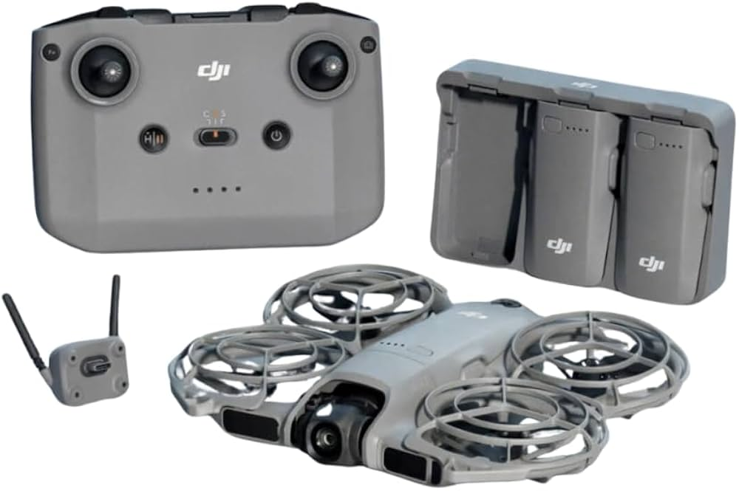
Figure 4.1: DJI Neo 2 (planned UAV platform)
Table 4.2: Specifications of DJI Neo 2
Parameter | Specification
Weight | 151 g (160 g with O4 transceiver)
Camera | 12 MP, 1/2-inch CMOS sensor
Video | Up to 4K/100 fps, 2-axis mechanical gimbal with EIS
Flight time | Approximately 19 minutes
Max transmission range | 6 km (CE) / 10 km (FCC)
Obstacle sensing | Omnidirectional: vision, LiDAR and infrared

4.4 DATA PRE-PROCESSING
The following pre-processing steps are planned once the field data are available:
- Extraction of every k-th frame for annotation to avoid near-duplicate images
- Stabilisation of the video to a reference frame, and removal of blurred or unusable frames
- Measurement of a visible road or lane width and calibration of pixel distances to metres
- Export of annotations in YOLO format, with train, validation and test sets split by sortie or location
- Expression of calibrated positions in a local metric road coordinate system, with the longitudinal axis aligned to the road

4.5 SOFTWARE USED
The following software and computing environment were used in the sample-video test, or are planned for later stages:
- Google Colab with an NVIDIA Tesla T4 GPU for model inference, with the video stored on Google Drive
- Python, PyTorch and OpenCV for video handling and processing
- Ultralytics YOLO (YOLOv8) for detection, and ByteTrack for multi-object tracking
- pandas for building the trajectory table from the tracker output
- CVAT for annotation of the five vehicle classes (planned)
- GIS software for mapping and hotspot or LOS summaries (to be finalised); photogrammetric orthomosaic processing is not part of the required workflow

4.5.1 UAV TRAFFIC STUDIO SOFTWARE PLATFORM
A standalone UAV Traffic Studio application was developed as a research interface for the NH-48 analysis. Its Python backend uses PyTorch, Ultralytics YOLOv8, OpenCV, NumPy, SciPy and pandas. A Python REST service exposes status, metrics, conflicts, critical distances, hotspots, trajectories and pipeline execution endpoints. The browser interface uses HTML5, CSS3 and Apache ECharts and provides trajectory playback, space-time exploration, adjustable stopping parameters, conflict replay, pipeline logs and data export. The reported implementation includes eight workspaces: Overview, Video Player, Traffic Flow Theory, Trajectory Studio, Critical Distance Safety Inspector, Spatial Hotspots, Automated Pipeline Runner and Data Exports. The platform is described in the source report as implemented; its operational status should be supported by a reproducible software demonstration.

4.6 DATA LIMITATIONS
The study currently faces the following limitations related to data:
- The UAV has not been purchased, so the planned field imagery and on-site road-width measurements are not yet available
- The mid-block sections are not yet selected, so site-specific flight planning cannot be finalised
- Only a sample video is available; its results cannot be generalised to the study sections
- Flight time of about 19 minutes per battery limits the length of each observation
- Cars are expected to outnumber heavy vehicles in the annotated data, which will lead to class imbalance
These limitations are to be addressed by selecting the sections first, purchasing the UAV, planning sorties across peak and off-peak periods, and using class weights or oversampling during training.

5 METHODOLOGY

5.1 GENERAL
The methodology is a UAV-based workflow that moves from field acquisition to detection, tracking, metric-scaled trajectories and finally to traffic parameters and crash risk. Each step uses data from the previous one, so errors in an early stage can propagate: a missed vehicle breaks a trajectory, an identity switch joins two vehicles, and a coordinate error changes the relative position of two vehicles and therefore their TTC or PET. Detection, tracking, metric scaling and post-processing are therefore treated as one connected system. The sample-video and NH-48 tests reported in Chapter 6 are separate pipeline tests and do not replace the planned field study.

5.2 OVERALL METHODOLOGICAL FRAMEWORK
The study follows the sequence of nine stages shown in Figure 5.1, preceded by the selection of the mid-block sections and followed by crash prediction, hotspot and LOS analysis and benchmarking against Faster R-CNN, RT-DETR and manual counts.
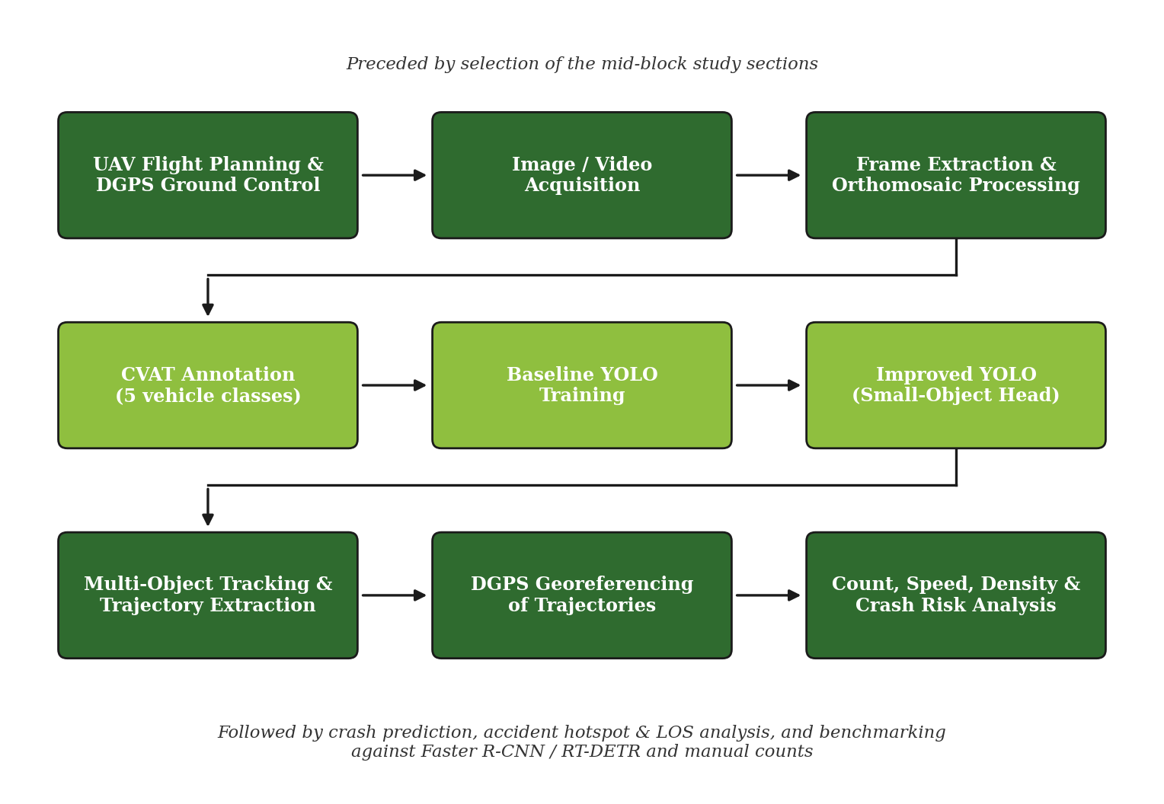
Figure 5.1: Methodology flowchart
The twelve methodological steps described in this chapter are:
- Selection of the mid-block study sections (Section 5.3)
- UAV flight planning and road-width calibration (Section 5.4)
- Video and image acquisition (Section 5.5)
- Frame extraction, stabilisation and image-scale calibration (Section 5.6)
- CVAT annotation of five vehicle classes (Section 5.7)
- Baseline YOLO training (Section 5.8)
- Improved small-object YOLO (Section 5.9)
- Multi-object tracking and trajectory extraction (Section 5.10)
- Metric scaling of trajectories using measured road width (Section 5.11)
- Count, speed and density (Section 5.12)
- Surrogate safety measures: TTC and PET (Section 5.13)
- Crash risk estimation and prediction, hotspot, LOS and benchmarking (Sections 5.14 and 5.15)

5.3 SELECTION OF MID-BLOCK STUDY SECTIONS
The flight plan can be fixed only after a section is chosen, because it depends on road width, traffic density and the expected vehicle classes. Sections are shortlisted using the criteria of Table 3.1 (mixed traffic, steady flow, simple geometry, safety relevance, UAV feasibility and permissions). Aviation, institutional and privacy permissions are verified before any flight.

5.4 UAV FLIGHT PLANNING AND ROAD-WIDTH CALIBRATION
The flight altitude is set from the ground sampling distance (GSD), so that the smallest class, the two-wheeler, still spans enough pixels. A higher flight covers more road but makes vehicles smaller, while a lower flight improves object size at the cost of coverage and more perspective distortion (Khan et al., 2017). The GSD is
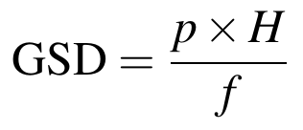
Where:
- GSD = ground distance covered by one image pixel
- p = physical size of one sensor pixel
- H = flight height above the road surface
- f = focal length of the camera
A nadir (top-down) view is used, with the UAV hovering over the road centreline, to limit perspective distortion; the view must keep every vehicle in frame long enough to form a trajectory. A clearly visible road or lane width is measured on site and used as the metric reference. This calibration supports speed and distance calculations without requiring an orthomosaic or DGPS coordinates. Berghaus et al. (2024) and Fonod et al. (2025) show that calibration and trajectory quality checks must be planned as part of the measurement chain.

5.5 VIDEO AND IMAGE ACQUISITION
Nadir 4K video is recorded with the DJI Neo 2 at a fixed altitude, in good light and low wind. A position is recorded once per frame, so the movement between two frames equals speed divided by frame rate:
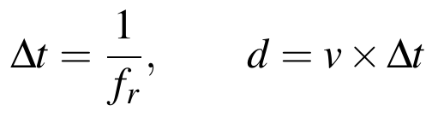
Where:
- Δt = time between two frames (s)
- f_{r} = video frame rate (frames per second)
- d = distance moved by a vehicle between two frames (m)
- v = vehicle speed (m/s)
A low frame rate gives large jumps that amplify noise in speed and acceleration, whereas a high frame rate raises storage and inference cost. IoU-based tracking also needs consecutive boxes to overlap. For two equal boxes of length l along the direction of motion that are shifted by d, the overlap is
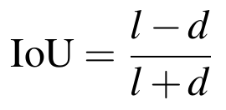
For example, at 60 km/h a vehicle moves 0.67 m per frame at 25 fps and 0.33 m at 50 fps. With assumed sizes, a 4.5 m car keeps about 74% overlap at 25 fps, whereas a 2 m two-wheeler keeps only 50%, rising to 71% at 50 fps. Short vehicles such as two-wheelers therefore lose overlap fastest, which favours a higher frame rate. Because the flight time is about 19 minutes per battery, several sorties are planned across peak and off-peak periods, and altitude, time and weather are logged for each. The output is raw MP4 video per sortie plus selected frames for annotation and image-scale calibration; overlapping stills for an orthomosaic are not required. Ke et al. (2017) showed that speed, density and volume can be estimated from aerial video.

5.6 FRAME EXTRACTION, STABILISATION AND IMAGE-SCALE CALIBRATION
Every k-th frame is extracted for annotation to avoid near-duplicate images, whereas detection and tracking run on the complete video, as in the sample-video test. To stop camera motion from being mistaken for vehicle motion, features are matched between consecutive frames, a homography is estimated with RANSAC and every frame is warped to a reference frame. Detected vehicles are masked out of the feature matching so that moving traffic does not bias the camera-motion estimate, the approach followed by Fonod et al. (2025).
The measured road or lane width is used to calibrate pixel displacement to metres. Blurred or unusable frames are removed before annotation; no orthomosaic is needed for the speed calculation.

5.7 CVAT ANNOTATION OF FIVE VEHICLE CLASSES
Five vehicle classes are used (Table 5.1). Each vehicle receives a tight bounding box, with the rider included for two-wheelers, and written rules for partly visible and occluded vehicles are fixed before labelling starts. Annotations are exported in YOLO format, one line per box with normalised coordinates. Vehicle category matters for conflict analysis in Indian traffic (Kumar and Sarkar, 2025), so class-wise labels are essential.
Table 5.1: Vehicle classes used for annotation
Code | Class | Typical examples
2W | Two-wheeler | Motorcycle and scooter, rider included
3W | Three-wheeler | Auto-rickshaw
Car | Car | Passenger car
LCV | Light commercial vehicle | Small goods vehicle and van
HCV | Heavy commercial vehicle | Truck and bus

The train, validation and test sets are split by sortie or location, not by random frame, because neighbouring frames are near-duplicates and would leak into the test set. Cars will outnumber heavy vehicles, so class weights or oversampling are used and results are reported class by class. A second person re-checks a sample of the labels; agreement of boxes is measured by IoU and agreement of classes by Cohen’s kappa:
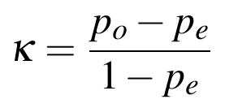
Where:
- p_{o} = observed agreement between the two annotators
- p_{e} = agreement expected by chance
Current work is focused on preparing the local training set. CVAT is being run through Docker, and video frames extracted from the UAV footage are being labelled manually with bounding boxes for two-wheelers, three-wheelers, cars, light commercial vehicles and heavy commercial vehicles. The annotations will be checked for class and box consistency, then split by video or location into training, validation and held-out test sets. The labelled frames will be exported in YOLO format and used to fine-tune the detector, with special attention to recall and average precision for small vehicles. After evaluation, the trained weights are intended to be packaged in a Docker-based inference workflow to detect small vehicles in new video frames.

5.8 BASELINE YOLO TRAINING
A YOLOv8 model (Ultralytics), the family used in the sample-video test, starts from pretrained weights and is fine-tuned on the local five-class dataset. The baseline fixes the reference accuracy against which the small-object model is judged on the same held-out test set. Training uses an input size of around 960 px (as in the sample test, to be tuned), data augmentation and early stopping on validation mAP, and all hyper-parameters are logged. The total training loss is the weighted sum of a box regression loss, a classification loss and a distribution focal loss:
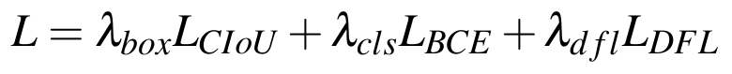
The box loss uses the complete IoU (CIoU), which adds a centre-distance term and an aspect-ratio term to the overlap term:
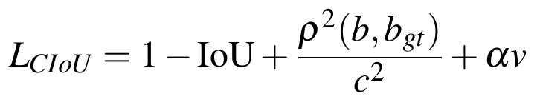
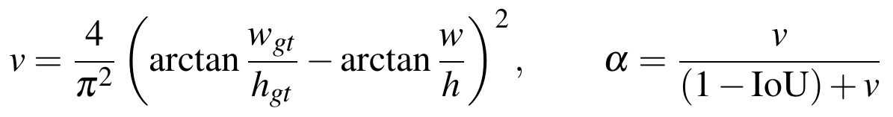
Where:
- IoU = Area(A ∩ B) / Area(A ∪ B), the overlap between predicted box A and ground-truth box B
- ρ = distance between the centres of the predicted box b and ground-truth box b_gt
- c = diagonal length of the smallest box enclosing both boxes
- w, h = width and height of the predicted box (subscript gt for the ground truth)
Detection performance is reported using precision, recall, F1 score and mean average precision (mAP), together with the confusion matrix, class-wise AP and inference speed in frames per second:
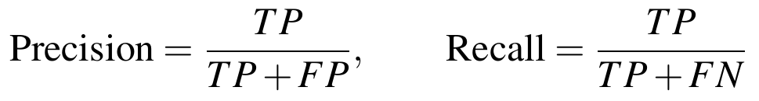
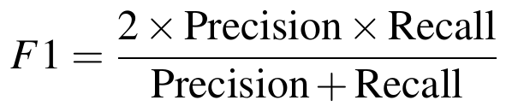
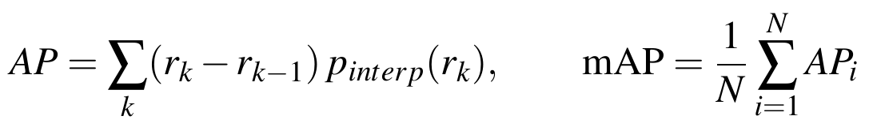
Where:
- TP, FP, FN = true positives, false positives and false negatives (a detection is a true positive when its IoU with a ground-truth box exceeds the chosen threshold)
- p_{interp} = interpolated precision at recall r
- N = number of classes

5.9 IMPROVED SMALL-OBJECT YOLO
A feature-map cell at stride s covers s × s pixels of the image, so a small vehicle fills only a small fraction of one cell and its features are lost. For an object of width w and height h pixels, the fraction of one cell it covers is
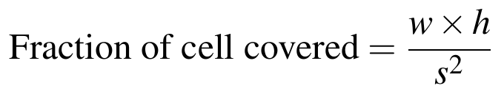
For example, a two-wheeler 16 px wide and 16 px tall at stride 32 fills only 256/1024 = one quarter of a cell. The following changes are tested to improve small-vehicle detection:
- A high-resolution stride-4 (P2) detection head
- Multi-scale feature fusion
- The Wise-IoU box loss, which weights the IoU loss according to the quality of each box (Xu et al., 2024)
- Scale and mosaic augmentation
An ablation is carried out in which one change is added at a time to show which one raises small-vehicle AP. The baseline and improved models use the identical held-out local test set, and both accuracy and speed are reported. The improved model is also compared with Faster R-CNN and RT-DETR. Liu et al. (2020) enlarged the receptive field for small UAV objects, and Xu et al. (2024) used multi-scale fusion and Wise-IoU on YOLOv8n.

5.10 MULTI-OBJECT TRACKING AND TRAJECTORY EXTRACTION
The tracker takes the per-frame boxes, class labels and confidence scores from the detector. A Kalman filter for each vehicle predicts its box in the next frame, assuming constant velocity, and is corrected by the matched detection. With state vector x (box centre, box size and their velocities) and measurement z, the prediction and update steps are:
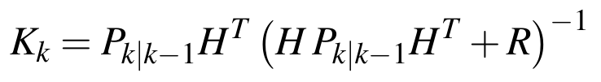
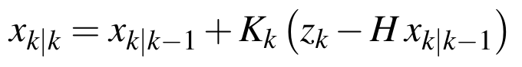
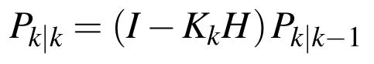
Where:
- F = state transition matrix (constant-velocity model)
- H = measurement matrix
- Q, R = process and measurement noise covariances
- K_{k} = Kalman gain at frame k
In ByteTrack (Zhang et al., 2022), high-confidence detections are matched to the predicted tracks first, using an IoU-based cost and the Hungarian algorithm. Leftover tracks are then matched to low-confidence detections, which recovers partly occluded vehicles. The cost of matching track i to detection j, and the assignment, are:
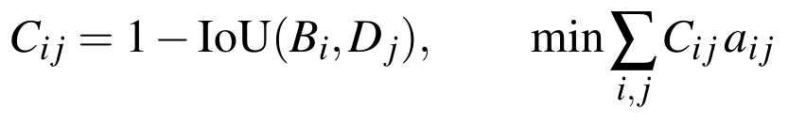
Where:
- B_{i} = predicted box of track i (from the Kalman filter)
- D_{j} = detected box j
- a_{ij} = 1 if track i is assigned to detection j, otherwise 0 (each track and detection used at most once)
ByteTrack, DeepSORT and BoT-SORT are compared on identity continuity; BoT-SORT adds camera-motion compensation (Aharon et al., 2022). Each persistent ID gives a time-ordered sequence of positions. Short, fragmented or physically impossible tracks are repaired or rejected, because raw tracker output should not automatically be treated as the final trajectory. The anchor point of each box is its bottom centre, the point where the vehicle touches the road:
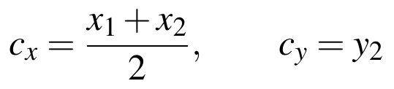
Where:
- x₁, y₁, x₂, y₂ = top-left and bottom-right corners of the bounding box (pixels)

5.11 METRIC SCALING OF TRAJECTORIES
Metric scale is needed before speed, distance, TTC or PET can be interpreted, because pixel movement alone has no physical units. A measured road or lane width visible in the nadir video provides the reference distance for converting pixel displacement to metres. The NH-48 analysis used an assumed 3.50 m lane width and is therefore provisional; the field study will use an actual measured width.
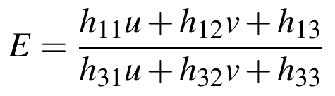
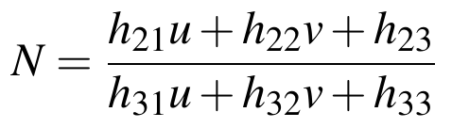
For a near-nadir view with limited perspective distortion, the pixel-to-metre scale is calculated as s = W_m / W_px, where W_m is the measured road or lane width in metres and W_px is its width in pixels in the stabilized frame. A pixel displacement d_px is converted to distance by d_m = s × d_px, and vehicle speed is v = d_m / Δt. If perspective variation is material, a planar homography may be estimated from visible road-marking correspondences; the measured width fixes its metric scale. Repeated width measurements at separate locations are used to check consistency. Absolute projected coordinates and independent DGPS control points are not required for the speed objective.
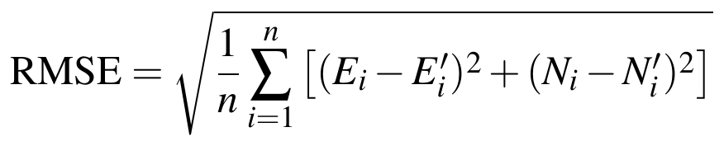
Where:
- W_m = measured road or lane width in metres; W_px = corresponding width in pixels
- s = pixel-to-metre scale; d_px = image displacement in pixels; d_m = calibrated distance in metres
- Δt = frame interval in seconds; v = estimated speed in metres per second
Trajectories are also checked against the lane boundaries identified in the video and measured road geometry.
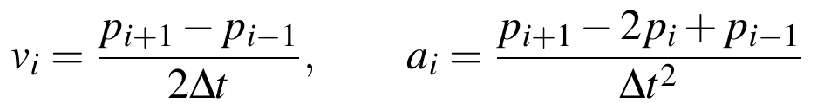
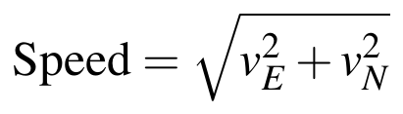
The output is a table of ID, time, image position (u, v), local metric position, class, speed, acceleration and lane.

5.12 COUNT, SPEED AND DENSITY
A virtual line across each lane counts every track ID once. Counts by class give the vehicle composition and the flow q. The speed of each vehicle comes from the smoothed, georeferenced trajectories. Space-mean speed (total distance over total time), and not the plain average of spot speeds, is used in flow relations. For a section of length L observed for time T, with N vehicles counted:
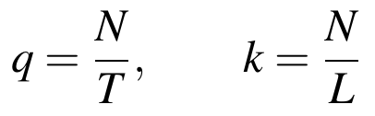
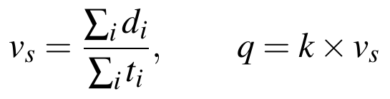
Where:
- q = flow (vehicles per hour)
- k = density (vehicles per km), measured directly from the UAV view
- v_{s} = space-mean speed
- d_{i}, t_{i} = distance travelled and time spent by vehicle i within the section
Edie’s generalised definitions use the whole space–time region L × T, with flow q equal to the sum of the distances travelled divided by L × T and density k equal to the sum of the times spent divided by L × T. Lane assignment and lane changes follow from the digitised lane geometry. PCU factors can be applied to the counts for the level-of-service analysis. Estimates are compared with manual counts and speeds from the same video using the percentage error:
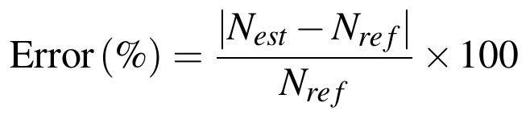

5.13 SURROGATE SAFETY MEASURES: TTC AND PET
Safety measures are computed for leader–follower pairs in the same lane or path. Lane-change and merging interactions are handled separately. TTC is the time to collision if both vehicles keep their current speeds; it is defined only when the follower is faster than the leader. It is computed every frame, and the minimum of each interaction is kept as its severity:
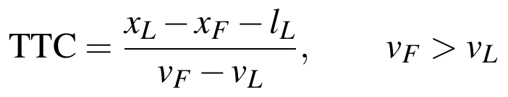
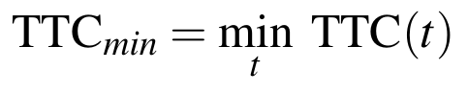
Where:
- x_{L}, x_{F} = positions of the leader and the follower along the direction of travel
- v_{L}, v_{F} = speeds of the leader and the follower
- l_{L} = length of the leader
For crossing or merging paths, post-encroachment time (PET) is the gap between the first vehicle leaving the conflict point and the second vehicle arriving at it. As an optional complement, the deceleration rate to avoid a crash (DRAC) gives the deceleration the follower needs:
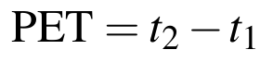
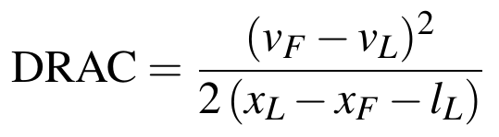
Where:
- t₁ = time at which the first road user leaves the conflict point
- t₂ = time at which the second road user arrives at the conflict point
No single threshold is universal, so the thresholds of TTC and PET are tested over a range and the sensitivity of the conflict counts is reported. Conflicts are ranked by minimum TTC and PET, by vehicle-class pair and by location. TTC should be interpreted within a defined prediction horizon and not as a universal crash predictor. The measures follow Arun et al. (2021), and UAV trajectories were used with TTC-type measures by Zong et al. (2022) and Kumar and Sarkar (2025).

5.13.2 LONGITUDINAL AND LATERAL CONFLICT GRAPHS
Longitudinal conflicts are assessed when a following vehicle closes on a leader. Longitudinal TTC is the bumper-to-bumper gap divided by the closing speed, when the follower is faster than the leader. The planned graph plots TTC against time and marks 1.5 s as a provisional critical screening limit. The FHWA Surrogate Safety Assessment Model uses 1.5 s as a configurable TTC conflict threshold [18, 19]. It is a screening convention, not a universal boundary; the analysis will compare 1.0 s, 1.5 s and 2.0 s thresholds.
Lateral conflicts are assessed during lane changes or crossing paths with a two-dimensional TTC: the predicted time until the moving vehicle footprints first overlap under their estimated velocities. A second graph plots lateral or two-dimensional TTC against time with the same provisional 1.5 s line for comparison. Because lateral conflict thresholds depend on geometry and manoeuvre type, the line is an initial screening limit and will be checked through threshold sensitivity analysis rather than treated as a validated local crash boundary.
Critical distance is reported alongside TTC. For longitudinal following, the available distance is the bumper-to-bumper gap g; the required stopping distance is d_safe = v_f t_r + v_f²/(2a_f) − v_l²/(2a_l). The stopping-distance deficit is Δd = g − d_safe; a negative value means the available gap is shorter than the modelled safe distance under the selected reaction and braking assumptions. For a lateral or crossing conflict, critical distance is the along-path distance from each vehicle to the projected conflict point. Its time-to-conflict is that distance divided by the speed component directed toward the point. Distances, thresholds and parameter assumptions will be reported together.
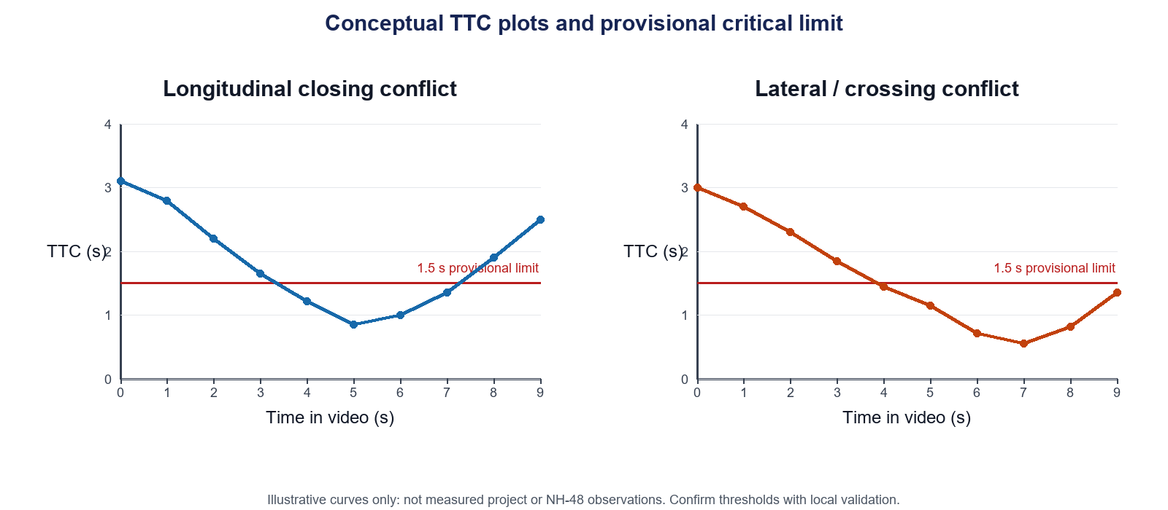
Figure 5.2: Conceptual longitudinal and lateral TTC graphs with a provisional 1.5 s screening limit. Curves are illustrative, not measured results.

5.13.1 KINEMATIC STOPPING DISTANCE DEFICIT
TTC assumes constant speeds and can become uninformative when a follower and leader travel at similar speeds despite having very little clearance. The NH-48 analysis therefore added a kinematic stopping-distance check. The required clearance for the following vehicle is estimated as:
d_safe = v_f t_r + v_f²/(2a_f) − v_l²/(2a_l)
The safety deficit is Δd = d_clear − d_safe, where d_clear is the bumper-to-bumper clearance; v_f and v_l are follower and leader speeds; t_r is perception-reaction time; and a_f and a_l are their assumed braking decelerations. A negative Δd indicates that the follower’s calculated stopping requirement exceeds the available clearance under the selected assumptions. Results depend on calibration and parameter choices and should be interpreted as conflict indicators, not confirmed crashes.
The preliminary NH-48 analysis used t_r = 1.5 s, a_f = 3.4 m/s² and a_l = 6.0 m/s², with sensitivity ranges for reaction time and braking deceleration. These are analysis assumptions; the final study should report sensitivity to them.

5.14 CRASH RISK ESTIMATION AND PREDICTION
Crashes are rare, so risk is estimated from the extreme tail of the conflict distribution using Extreme Value Theory. Minimum TTC values are negated so that the most severe conflicts become the maxima, Y = −TTCmin. In the block-maxima approach, the most severe value in each time block is fitted with a Generalised Extreme Value (GEV) distribution:
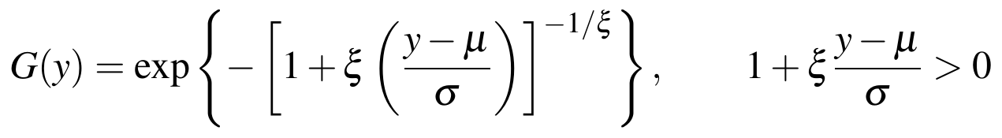
Where:
- μ = location parameter
- σ = scale parameter (σ > 0)
- ξ = shape parameter (ξ = 0 gives the Gumbel distribution)
As an alternative, a Generalised Pareto distribution is fitted to the values beyond a threshold u (peaks over threshold):
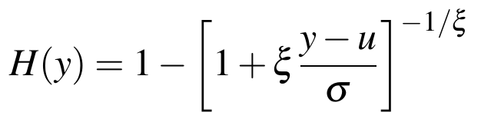
The risk is the probability that the extreme passes zero (TTC ≤ 0, which is a collision), reported by vehicle class and location:
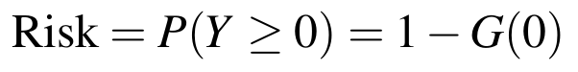
Kumar and Sarkar (2025) combined lane-changing TTC with EVT on UAV data from an Indian toll plaza, and Maji and Ghosh (2025) used EVT for mixed-traffic roundabouts. A binary logistic regression model is also developed to predict conflict-prone events from the speed difference, density, minimum gap and class pair, and is used only if enough conflicts are observed:
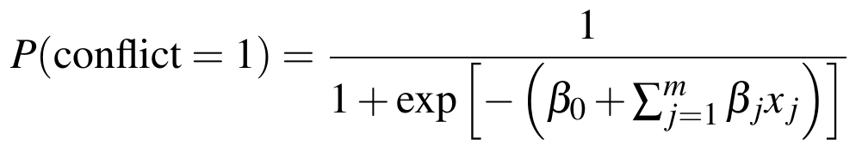
Where:
- β₀, β_{j} = intercept and regression coefficients
- x_{j} = explanatory variables (speed difference, density, minimum gap, vehicle-class pair)
The model is checked with a confusion matrix and the area under the ROC curve (ROC-AUC). Its output is estimated risk from surrogate indicators and is not a prediction of individual crashes. Conflicts are also ranked into severity classes by minimum TTC and PET to rank the severity of potential collisions.

5.15 HOTSPOT, LOS AND BENCHMARKING
Each conflict keeps its (E, N) location and is stored in GIS with lane geometry, section and vehicle-class attributes. Kernel density estimation shows where conflicts concentrate:
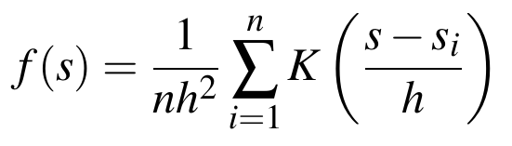
Where:
- f(s) = estimated conflict density at location s
- K = kernel function
- h = bandwidth
- s_{i} = location of conflict i
The Getis–Ord Gi* statistic tests whether the clusters are statistically significant:
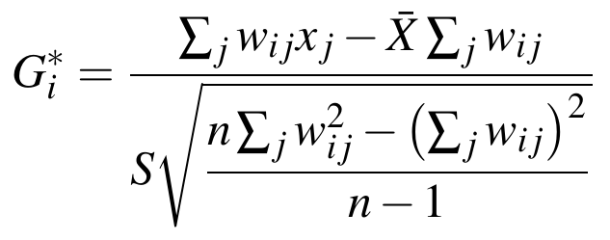
Where:
- x_{j} = conflict count in spatial unit j
- w_{ij} = spatial weight between units i and j
- X̄, S = mean and standard deviation of x over all n units
Level of service (LOS) is obtained from the volume-to-capacity ratio in PCU and from density, using the applicable guideline classes (to be confirmed):
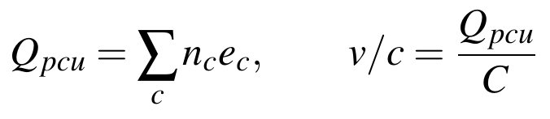
Where:
- n_{c} = number of vehicles of class c
- e_{c} = PCU factor of class c
- C = capacity of the section (PCU per hour)
Finally, the improved YOLO is benchmarked against the baseline YOLO, Faster R-CNN (Xu et al., 2017) and RT-DETR (Zhao et al., 2024) on the same test set using mAP and FPS, and counts and speeds are compared with manual reference values. An end-to-end check is made that better detection gives better tracks, trajectories, safety measures and hotspots, with each link evaluated (Table 5.2).
Table 5.2: Evaluation metrics adopted at each stage
Stage | Metrics
Detection | Precision, recall, F1, mAP, class-wise AP and confusion matrix, inference speed (FPS)
Tracking | Identity switches, track fragmentation and continuity; MOTA and IDF1
Trajectory | Positional error (RMSE on check points), speed error, plausibility of acceleration, continuity
Traffic parameters | Count error, speed error and density error against manual reference values
Safety | Agreement of TTC and PET conflicts with manually interpreted conflicts, stability of risk classification, spatial consistency

6 WORK DONE AND EXPECTED RESULTS

6.1 WORK COMPLETED AND EXPECTED RESULTS
This chapter presents the part results obtained so far. Field work has not started: the UAV has not been purchased and the mid-block sections have not been selected. All results therefore come from a sample UAV video that was used to test the detection and tracking pipeline before field deployment. The results are discussed in order, from the work completed, through detection and tracking, to the reliability check of a second pretrained model and the current status of trajectory generation.

6.2 WORK COMPLETED TO DATE
- The literature on UAV-based detection, tracking, georeferencing and surrogate safety measures has been reviewed (17 studies, Chapter 2)
- The UAV platform has been identified (DJI Neo 2) but not purchased, so the planned UAV data acquisition and on-site road-width measurement have not yet taken place
- The mid-block study sections have not yet been selected, so site-specific flight planning and ground control cannot be finalised
- A detection and multi-object tracking pipeline has been implemented and tested on a sample video to validate the workflow
- A second pretrained model, run on a sample video, could not identify motorcycles, showing that such models are not reliable for local traffic
- The initial sample-video trajectories remain in pixels; a separate NH-48 analysis generated preliminary metric trajectories using an assumed lane width

6.3 PIPELINE TESTING ON THE SAMPLE VIDEO
Before field deployment, the detection and tracking pipeline was tested on a sample UAV video to validate the overall workflow. About 98 representative frames were extracted for visual inspection only, which is distinct from the video data used for detection and tracking: the complete video was used for detection and tracking. The details are given in Table 6.1.
Table 6.1: Details of the sample video and processing environment
Item | Detail
Video resolution | Approximately 1280 × 736 pixels
Frame rate | Approximately 24–25 FPS
Total frames | Approximately 477
Frames extracted for visual inspection | About 98 representative frames (inspection only)
Computing environment | Google Colab with NVIDIA Tesla T4 GPU
Software | Python, PyTorch, OpenCV, Ultralytics YOLO and ByteTrack
Data storage | Video stored on Google Drive

6.4 VEHICLE DETECTION OBSERVATIONS
Detection used a pretrained DroneFlow / VisDrone vehicle-detection model based on YOLOv8, loaded through the Ultralytics framework. The confidence threshold was set to 0.35 and the inference image size to 960 pixels. The vehicle classes observed in the output were cars, vans, trucks, motorcycles and buses. For every frame the output consists of the bounding boxes, class labels and confidence scores of the detected vehicles. Figure 6.1 shows one frame of the output, with the detections and the tracking IDs described in the next section.
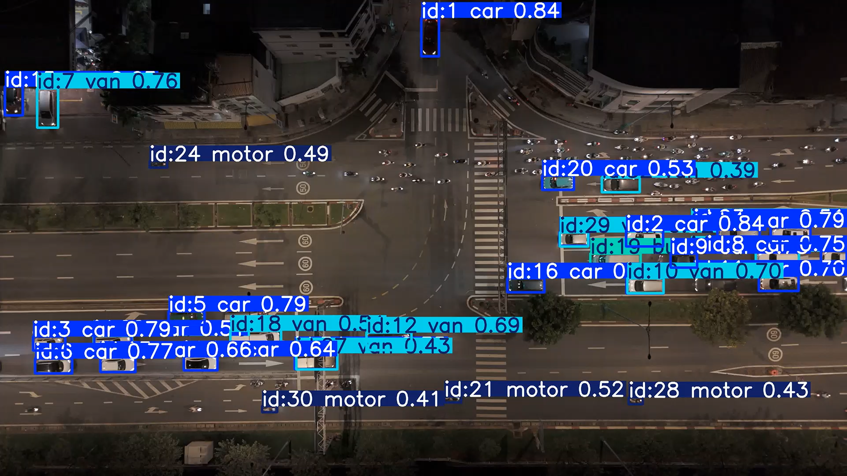
Figure 6.1: Sample frame showing detection and tracking output (class, confidence and track ID)

6.5 MULTI-OBJECT TRACKING OUTPUT
Tracking used ByteTrack (bytetrack.yaml) to maintain the identity of each vehicle across frames. The workflow was: vehicle detection, bounding boxes, ByteTrack, persistent vehicle IDs and vehicle movement paths. About 470 of the 477 frames were successfully processed during tracking, with GPU acceleration on the Tesla T4. The output video shows the bounding boxes, class labels, confidence values and persistent tracking IDs for frame-by-frame vehicle movement, as in Figure 6.1.

6.6 PIXEL-COORDINATE PILOT OUTPUT
The tracker output was collected into a table with one record per vehicle per frame. The table holds 19,133 records and 614 unique vehicles (track IDs). Its columns are listed in Table 6.2, and the first five records are shown in Table 6.3.
Table 6.2: Structure of the tracking output table
Column | Meaning
frame | Frame number in the video
time_sec | Time of the frame in seconds
track_id | Persistent identity assigned by ByteTrack
class_id | Class label index from the detector
confidence | Detection confidence score
cx, cy | Anchor point of the box in image pixels (cx is the box centre in x; cy equals the bottom edge y2)
x1, y1, x2, y2 | Top-left and bottom-right corners of the bounding box in image pixels

Table 6.3: First five records of the tracking output (pixel coordinates)
frame | time_sec | track_id | class_id | confidence | cx | cy | x1 | y1 | x2 | y2
1 | 0.033367 | 1 | 0 | 0.836275 | 909.82 | 1681.20 | 831.41 | 1615.15 | 988.24 | 1681.20
1 | 0.033367 | 2 | 0 | 0.833226 | 535.16 | 1689.86 | 455.08 | 1617.11 | 615.24 | 1689.86
1 | 0.033367 | 3 | 0 | 0.824054 | 223.97 | 1595.78 | 152.48 | 1526.33 | 295.45 | 1595.78
1 | 0.033367 | 4 | 0 | 0.816103 | 244.28 | 1695.93 | 159.00 | 1623.77 | 329.56 | 1695.93
1 | 0.033367 | 5 | 0 | 0.814664 | 3071.04 | 1215.17 | 2982.47 | 1150.58 | 3159.60 | 1215.17

The first record corresponds to track 1 of Figure 6.1, a car detected with a confidence of 0.84. The positions are image coordinates in pixels and carry no metric meaning, so they cannot be reported as distance or speed until they are converted to ground coordinates (Section 6.9).

6.7 RELIABILITY CHECK OF A SECOND PRETRAINED MODEL
A second pretrained vehicle-detection model was run on a sample video to check its reliability on local mixed traffic. It failed to identify motorcycles and other two-wheelers, which form a dominant class in Indian traffic. In the output crop in Figure 6.2, labels appear only on the larger vehicles, whereas the small two-wheelers visible in the scene are left without boxes.
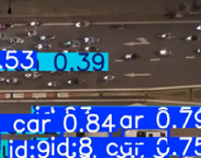
Figure 6.2: Output of the second pretrained model on a sample video (two-wheelers not identified)

6.8 LIMITATIONS OF EXISTING METHODS
The sample-video tests show that pre-existing methods, applied as they are, are not accurate enough for mixed Indian traffic:
- A second pretrained model could not identify motorcycles and other two-wheelers
- In the output of the first model (Figure 6.1), the motorcycle detections carry confidence scores of about 0.41–0.52, which are generally lower than those of cars (up to 0.84), consistent with the difficulty of detecting small objects
- The classes observed (cars, vans, trucks, motorcycles and buses) do not follow the five-class scheme of this study, and three-wheelers are not among them
- The initial sample-video tracking worked only in the pixel domain; without a measured scale those results have no physical distance or speed
These observations are visual. Quantitative accuracy will be reported only after the local dataset has been annotated. They nevertheless support the need for a small-object-optimised detector trained on a local five-class dataset, which is the approach proposed in the methodology, and agree with the benchmark evidence that generic detectors lose accuracy under UAV conditions (Du et al., 2018).

6.9 TRAJECTORY GENERATION: CURRENT STATUS
Vehicle detection and tracking in the pixel domain have been completed on the sample video. Metric scale for that pilot is still unavailable, while the separate NH-48 analysis used an assumed lane width and remains provisional.

6.10 DISCUSSION
The sample-video work shows that the detection and tracking part of the workflow can be run end to end:

6.11 NH-48 DATASET AND PRELIMINARY CALIBRATION
A separate 601-frame NH-48 sequence (1608 × 908 pixels, 30 fps, 20.03 s) was processed over an approximately 160 m corridor. The pipeline generated 22,031 metric trajectory points across 126 sustained corridor trajectories from 160 track IDs. Metric scaling used an assumed 3.50 m lane width. These derived values are preliminary because the width was not physically measured for this analysis; they should not be presented as verified field measurements. The principal measurement requirement for the planned study is a reliable road or lane width in the UAV scene, which supplies the pixel-to-metre scale for speed estimation.
The average concurrent vehicle load was reported as 28.02, with a peak of 48 vehicles.
The original sample-video pilot remains separate: it produced 19,133 pixel-coordinate tracking records for 614 track IDs and has no metric calibration. The different frame counts and tracking totals describe two datasets and must not be combined.
Table 6.4: NH-48 video and trajectory dataset characteristics
Parameter | NH-48 preliminary result
Video resolution and frame rate | 1608 × 908 pixels at 30 fps
Duration and frames | 20.03 s; 601 frames
Analysed corridor length | Approximately 160 m
Traffic direction | Eastbound and westbound streams
Track IDs and sustained trajectories | 160 IDs; 126 sustained corridor trajectories
Metric trajectory points | 22,031
Calibration basis | Assumed 3.50 m lane width; not field-verified
Figure 6.3: Preliminary road-plane view of the NH-48 corridor after image-scale calibration

6.12 VEHICLE DETECTION AND PRETRAINED MODEL LIMITATIONS
The NH-48 test used off-the-shelf YOLOv8s-VisDrone weights. The model was not trained or fine-tuned by the author. The detection output contained 48 unique vehicles: 31 passenger cars, 8 vans or light delivery vehicles, 7 buses, 1 heavy commercial truck and 1 motorcycle. The observed motorcycle share was 2.1%. This is an indication of small-object under-detection in the tested video, but the automated class distribution is not a reliable estimate of true traffic composition because the detector itself missed objects. The source documents report higher detection confidence for larger vehicles and lower confidence for the few motorcycle detections. The result motivates local annotation and small-object model training; it does not establish the true traffic share of each class.
Table 6.5: Automated NH-48 vehicle classification from the pretrained model
Vehicle class | Detected count | Share | Reported observation
Passenger cars | 31 | 64.6% | Mean confidence 0.84
Vans / light delivery | 8 | 16.7% | Stable boundaries
Buses | 7 | 14.6% | Large bounding footprint
Heavy commercial trucks | 1 | 2.1% | Localized in outer lane
Motorcycles / two-wheelers | 1 | 2.1% | Severely under-detected
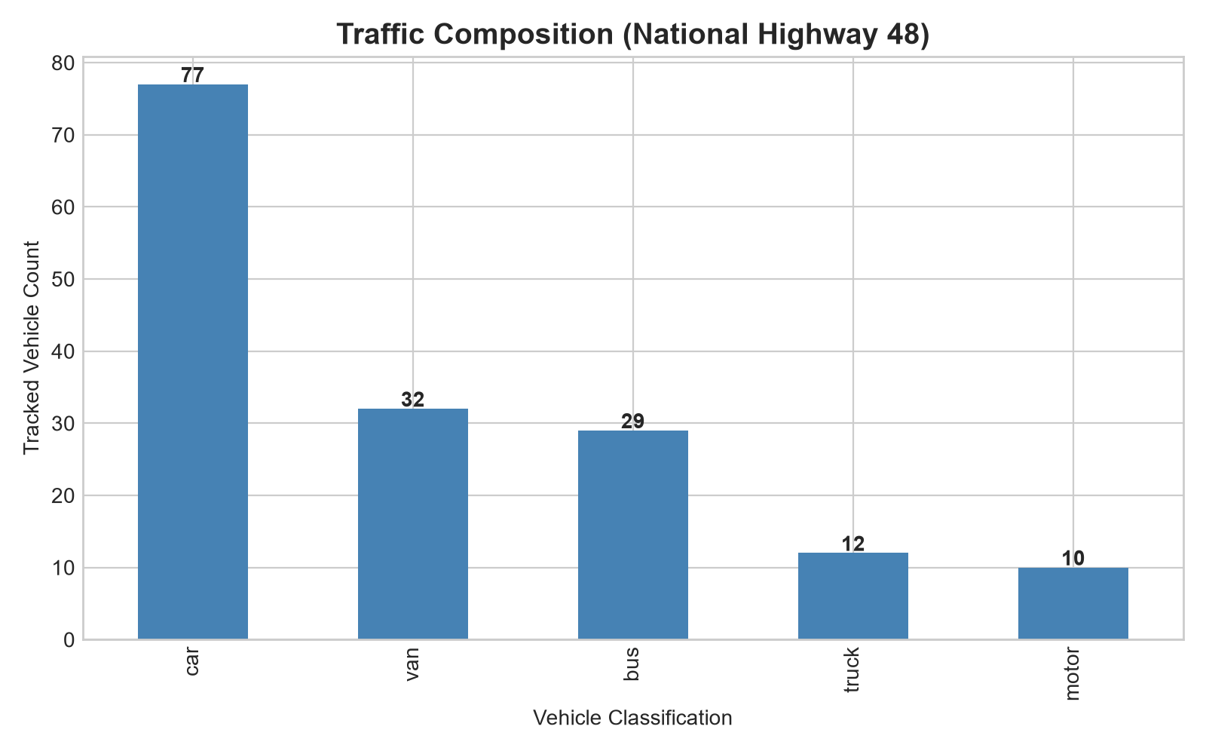
Figure 6.4: Automated vehicle classification chart showing the pretrained model output
The source documents attribute the failure to small image size at UAV altitude, domain differences between benchmark data and Indian mixed traffic, and low-confidence filtering. They report motorcycle confidence values in the approximate 0.25–0.48 range. These explanations are hypotheses from the analysis, not independently isolated causal effects. The planned custom detector will test a stride-4 P2 head, multi-scale feature fusion and Wise-IoU against the baseline on the same locally annotated test set.
The earlier analysis estimates that, at a GSD of about 8–10 cm per pixel, a 1.8 m × 0.7 m two-wheeler occupies roughly 18 × 7 pixels. It attributes missed detections to loss of fine features during stride-32 downsampling, a domain gap between VisDrone pretraining and Indian traffic, and low-confidence proposals (reported around 0.25–0.42) being filtered by non-maximum suppression. The 30–50% two-wheeler share cited in that source is contextual background, not a measured share for this video. These are explanations to test, not separately validated causal findings.

6.13 TRACKING AND METRIC TRAJECTORY EXTRACTION
ByteTrack processed the 601 frames and produced 160 track IDs, of which 126 sustained trajectories traversed the analysed corridor. The source documents report 22,031 metric trajectory points. One report describes forward-backward Savitzky–Golay smoothing and another describes a moving-average filter; the exact filter configuration should be confirmed against the processing code before the method is finalized. The preliminary calibration used the assumed lane width noted in Section 6.11.
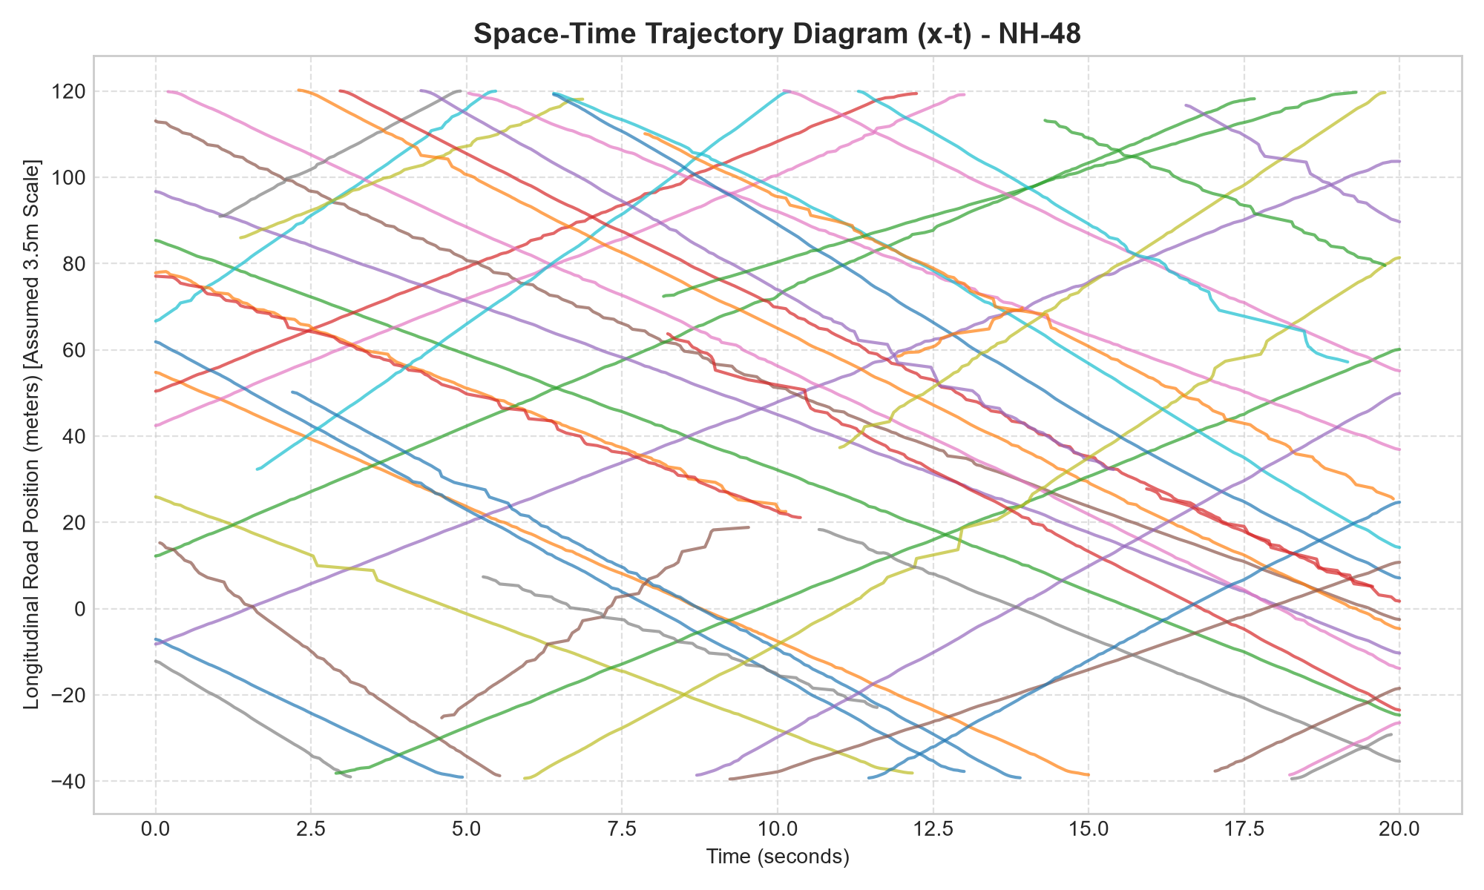
Figure 6.5: Space-time diagram of vehicle trajectories on the NH-48 corridor

6.14 MACROSCOPIC TRAFFIC FLOW PARAMETERS
The NH-48 trajectory output was used to estimate flow, density and speed. The source reports total bidirectional flow of 8,625.6 veh/h, comprising 5,031.6 veh/h westbound and 3,594.0 veh/h eastbound. Reported density was 175.1 veh/km; time-mean speed was 26.59 km/h; space-mean speed was 25.44 km/h; speed standard deviation was 5.42 km/h; and the 85th-percentile speed was 31.67 km/h. Reported minimum and maximum speeds were 16.0 and 44.5 km/h. The values are preliminary because they depend on the assumed 3.50 m scale.
The source also reports Wardrop’s inequality, with time-mean speed greater than space-mean speed. However, reported total flow, density and space-mean speed do not reconcile directly under q = k u_s: 175.1 × 25.44 is approximately 4,454 veh/h, not 8,625.6 veh/h. The aggregation basis (direction, lane or corridor) must be checked before claiming a flow-theory validation.
The source’s lane-equivalent calculation reports q = k × u_s = 175.1 × 25.44 ≈ 4,454 veh/h, while its separate total bidirectional throughput is 8,625.6 veh/h. These may use different aggregation bases, but the directional and lane definitions need to be documented before the figures are compared.
Table 6.6: Preliminary macroscopic traffic parameters reported for NH-48
Parameter | Reported value
Total bidirectional flow | 8,625.6 veh/h
Westbound flow | 5,031.6 veh/h (58.3%)
Eastbound flow | 3,594.0 veh/h (41.7%)
Traffic density | 175.1 veh/km
Time-mean speed | 26.59 km/h (7.39 m/s)
Space-mean speed | 25.44 km/h (7.07 m/s)
Speed standard deviation | 5.42 km/h
85th-percentile speed | 31.67 km/h
Observed speed range | 16.0–44.5 km/h
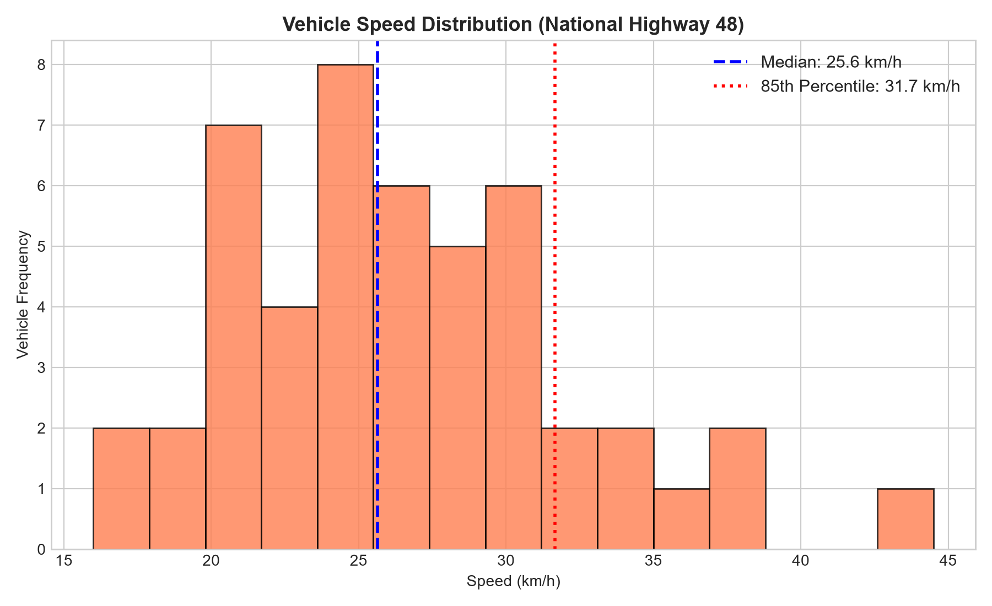
Figure 6.6: Preliminary speed distribution and 85th-percentile speed on NH-48

6.15 MICROSCOPIC SURROGATE SAFETY MEASURES
Across 3,668 evaluated car-following instances, 2,391 had TTC ≤ 1.50 s; the reported mean for these critical TTC instances was 0.43 s. A further 380 instances were reported in the 1.50–2.50 s range. Of 413 encroachment instances, 209 had PET ≤ 1.00 s, with a median PET of 0.97 s. The analysis also reported 1,169 instances with DRAC greater than 3.40 m/s². These are event or frame counts from the preliminary video analysis and should not be interpreted as independent crashes or a site-wide crash rate.
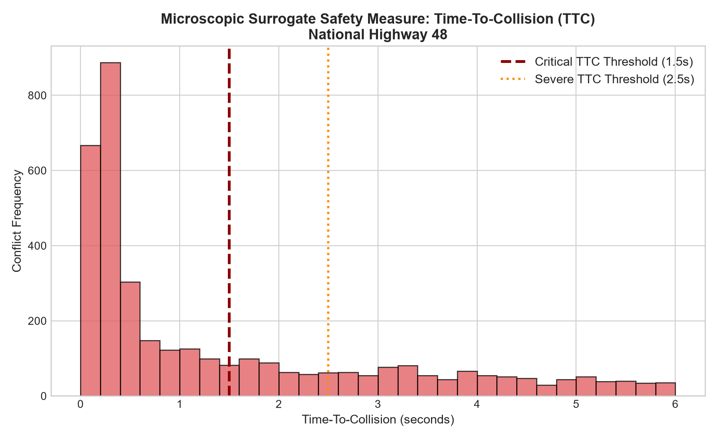
Figure 6.7: Distribution of preliminary microscopic TTC events

6.16 KINEMATIC STOPPING DISTANCE DEFICIT AND CRITICAL EVENTS
The stopping-distance formulation was applied to 195 leader–follower conflict pairs using t_r = 1.5 s, a_f = 3.4 m/s² and a_l = 6.0 m/s². The source reports 147 Tier 1 pairs with Δd < 0 m, 21 Tier 2 pairs with 0 ≤ Δd < 10 m, and 27 Tier 3 pairs with Δd ≥ 10 m. The most severe listed case is frame 341: Van #3 followed Bus #946 with 0.50 m clearance, a reported safe distance of 17.39 m, deficit of −16.89 m, TTC of 0.11 s and DRAC of 19.80 m/s². This ranking depends on the preliminary image scale and selected driver/braking assumptions.
The two updated source reports disagree on several vehicle IDs and measurements in ranks 6–10 of their top-ten tables. The table below uses values from the full updated report; those rows should be checked against the raw analysis output before final submission.
Table 6.7: Ten highest-ranked NH-48 conflict events in the full updated report
Rank | Pair (frame) | Clearance (m) | Safe distance (m) | Deficit (m) | TTC / DRAC / tier
1 | #3 Van → #946 Bus (341) | 0.50 | 17.39 | −16.89 | 0.11 s / 19.80 m/s² / 1
2 | #946 Bus → #933 Car (369) | 1.21 | 10.60 | −9.39 | 0.28 s / 7.91 m/s² / 1
3 | #945 Van → #946 Bus (210) | 0.80 | 8.85 | −8.05 | 0.35 s / 6.42 m/s² / 1
4 | #943 Motor → #942 Truck (26) | 0.42 | 8.35 | −7.93 | 0.23 s / 9.94 m/s² / 1
5 | #935 Car → #947 Truck (270) | 0.62 | 6.70 | −6.08 | 0.42 s / 5.34 m/s² / 1
6 | #933 Car → #934 Car (132) | 0.85 | 6.22 | −5.37 | 0.51 s / 4.45 m/s² / 1
7 | #947 Truck → #946 Bus (244) | 1.10 | 6.15 | −5.05 | 0.62 s / 3.92 m/s² / 1
8 | #934 Car → #945 Van (417) | 0.95 | 5.80 | −4.85 | 0.58 s / 4.15 m/s² / 1
9 | #942 Truck → #935 Car (8) | 1.30 | 5.75 | −4.45 | 0.71 s / 3.62 m/s² / 1
10 | #946 Bus → #945 Van (3) | 1.45 | 5.50 | −4.05 | 0.80 s / 3.48 m/s² / 1
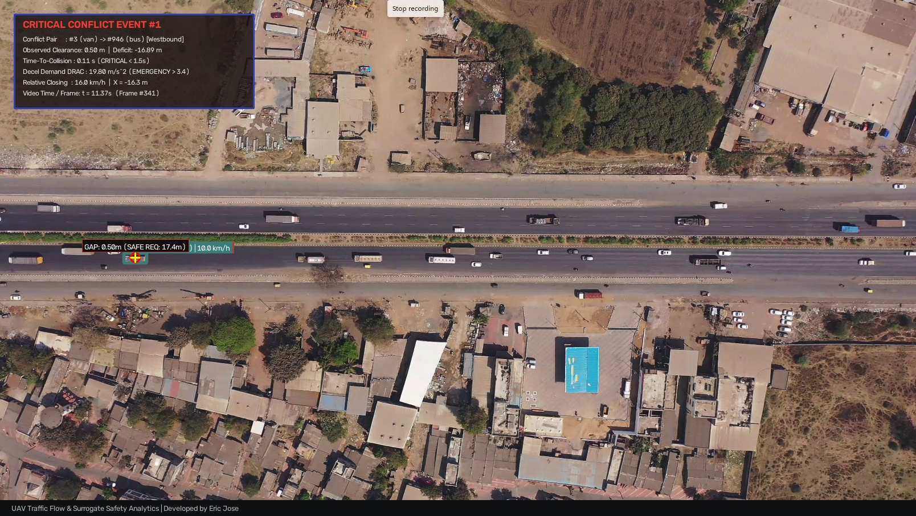
Figure 6.8: Annotated frame for the highest-ranked conflict at frame 341

6.17 SPATIAL CONFLICT HOTSPOTS
The 160 m NH-48 corridor was divided into 20 m longitudinal zones. The highest reported count was 37 conflicts in [0 m, 20 m], described as the primary merge or lane-drop bottleneck. A secondary zone at [80 m, 100 m] contained 32 conflicts. Counts for the remaining zones are listed below. These are preliminary conflict concentrations from one short video and do not establish crash hotspots.
Table 6.8: Conflict counts by 20 m NH-48 corridor zone
Longitudinal zone (m) | Conflict count | Source interpretation
−40 to −20 | 19 | Entry zone; initial deceleration
−20 to 0 | 24 | Pre-bottleneck compaction
0 to 20 | 37 | Primary merge / lane-drop zone
20 to 40 | 27 | Bottleneck propagation
40 to 60 | 20 | Intermediate recovery
60 to 80 | 24 | Secondary weave compression
80 to 100 | 32 | Secondary friction zone
100 to 120 | 11 | Free-flow dispersal
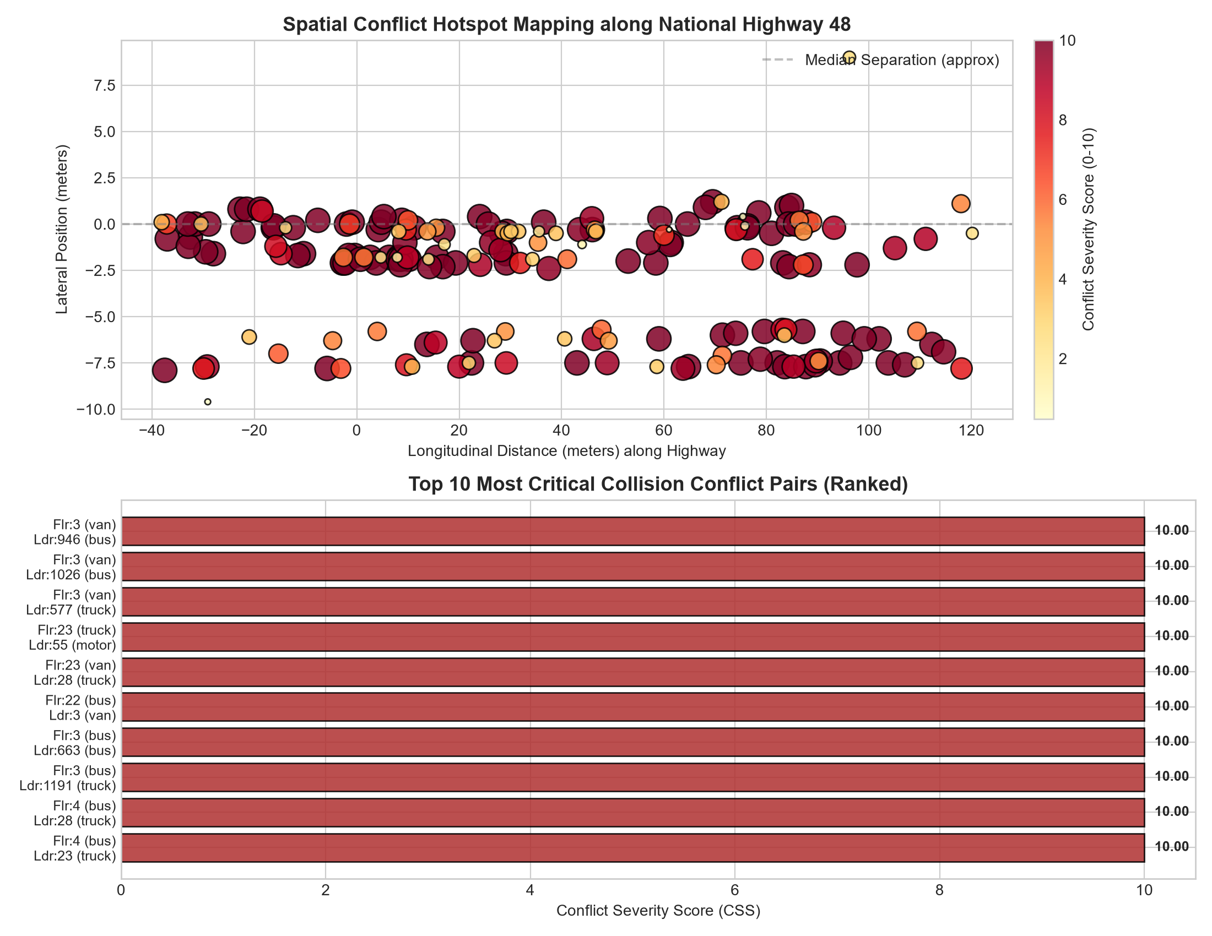
Figure 6.9: Conflict counts and preliminary hotspots across the NH-48 corridor

6.18 UAV TRAFFIC STUDIO
UAV Traffic Studio provides a browser-based interface for exploring the preliminary analysis. Reported features include 60 fps trajectory animation with bounding boxes, velocity vectors and path histories; adjustable reaction-time and deceleration controls that rerank stopping-distance events; replay of annotated frames such as the frame 341 conflict; and a REST-triggered pipeline for video ingestion, homography transformation and safety scoring. The interface also includes live pipeline logs and data exports. The software is a research deliverable; its analytical outputs retain the calibration and data limitations described above.
The reported REST endpoints are /api/status, /api/metrics, /api/conflicts, /api/critical-distances, /api/hotspots, /api/trajectories, /api/pipeline/status and POST /api/pipeline/run. The source report also describes Warm Cream, Clean Light and Dark Analytics themes, optional liquid-glass backdrop blur and a dedicated Python service at app/server.py on port 8080.

6.19 EXPECTED RESULTS AND DELIVERABLES
The expected outcome is a locally annotated five-class UAV image dataset and a fine-tuned detector that improves small-vehicle detection, particularly two-wheelers, relative to the pretrained baseline on a held-out test set. Performance will be reported with class-wise precision, recall, F1 score, average precision and inference speed; improvement will be assessed from the measured test results, not assumed in advance.
The complete workflow is expected to connect manually labelled CVAT frames, YOLO model training, Docker-based inference, multi-object tracking, measured-width metric scaling and traffic-safety analysis. Outputs will include vehicle counts, speed and density summaries, longitudinal and lateral TTC graphs with provisional critical-limit lines, PET and DRAC summaries, critical-distance and stopping-distance-deficit tables, and spatial conflict maps. These are planned outputs; the Thiruvananthapuram field results will be reported after site selection, data collection and scale verification.
The current work includes two distinct video analyses: an initial pixel-domain pilot (19,133 records for 614 track IDs) and a preliminary NH-48 analysis (22,031 metric trajectory points across 126 sustained trajectories, based on an assumed 3.50 m lane width). The NH-48 traffic, safety and hotspot values are exploratory, and the traffic-flow aggregation and conflicting top-ten table entries require verification before they are treated as final findings.

7 CONCLUSIONS AND WORK PLAN

7.1 GENERAL
This project report presents the progress of the project on UAV-based vehicle detection and trajectory analysis for improving highway traffic safety. It summarises the work completed, the results from the sample video, the expected outcomes and the plan for the remaining work.

7.2 SUMMARY OF WORK DONE
- A review of 17 studies on UAV traffic monitoring, vehicle detection, tracking, georeferencing and surrogate safety measures was completed, and the research gaps were identified
- The objectives, data requirements and a detailed methodology covering twelve steps, with the governing equations, were defined
- A detection and tracking pipeline was tested on a sample UAV video, producing a pixel-coordinate tracking table of 19,133 records for 614 tracked vehicles
- A second pretrained model failed to identify motorcycles, which shows that existing pretrained models are not reliable for local two-wheeler-heavy traffic
- Metric trajectories for the initial sample-video pilot have not been generated; the separate NH-48 test produced preliminary metric estimates using an assumed lane width
A separate NH-48 sequence was analysed (601 frames; 160 track IDs; 126 sustained trajectories; 22,031 preliminary metric points). Its scale depends on an assumed 3.50 m lane width and remains unverified.
The off-the-shelf YOLOv8s-VisDrone model recorded only one motorcycle among 48 detected vehicles (2.1%), indicating severe under-detection in this video.
Preliminary NH-48 results include flow, density, speed, TTC, PET, DRAC and stopping-distance deficit estimates; the bidirectional flow aggregation requires reconciliation.
A 20 m zone summary identified 37 conflicts in [0 m, 20 m] and 32 in [80 m, 100 m]; these are exploratory conflict concentrations from one short video.
UAV Traffic Studio was developed with REST endpoints for pipeline execution, trajectory review, safety scoring and hotspot exploration.

7.3 EXPECTED OUTCOMES
- An annotated, metric-scaled UAV vehicle dataset representative of Thiruvananthapuram traffic conditions
- A small-object-optimised YOLO model with measurable accuracy gains over baseline YOLO for high-altitude vehicle detection
- Validated vehicle count, speed and traffic density estimates for the surveyed mid-block sections
- A crash prediction model derived from UAV-based trajectory data and surrogate safety measures
- Identification of accident hotspots and level-of-service assessment at the study locations, presented through visualisation of the derived traffic safety metrics

7.4 CHALLENGES AND NEXT STEPS
- Select and finalise the mid-block study sections in Thiruvananthapuram (not yet selected), using the proposed criteria
- Purchase the UAV (DJI Neo 2), carry out the field survey and measure a reliable road or lane width for image-scale calibration
- Annotate vehicle classes in CVAT on imagery from the finalised locations
- Train and evaluate the baseline and improved small-object YOLO detectors on the local dataset
- Generate trajectories from the tracking output as time-ordered coordinate sequences
- Apply road-width-based metric scaling, then compute TTC, PET and the crash prediction model

7.5 SCHEDULE OF WORK
The plan for the remaining work is given in Table 7.1. “Done” marks work carried out till date and “Plan” marks work still to be done, by month.
Table 7.1: Schedule of work
Activity | Aug | Sep | Oct | Nov | Dec | Jan | Feb | Mar | Apr
Topic Finalisation | Done
Literature Review | Done | Done | Plan | Plan
UAV Data Acquisition |  |  | Plan | Plan
Preprocessing |  | Done | Done | Plan | Plan
CVAT Annotation |  | Done |  |  | Plan | Plan
Model Training |  | Done |  |  |  | Plan | Plan
Tracking & Trajectory |  |  |  |  |  |  | Plan | Plan
Safety & LOS Analysis |  |  |  |  |  |  |  | Plan | Plan
Report Writing & Review |  |  |  |  |  |  |  |  | Plan

7.6 CONCLUSION
The study aims to show that UAV imagery, a small-object-optimised detector, multi-object tracking and road-width-based metric calibration can be combined
The remaining work depends on selecting the sections, purchasing the UAV and measuring a reliable road or lane width in the video scene.
REFERENCES
[1] N. Aharon, R. Orfaig, and B.-Z. Bobrovsky, “BoT-SORT: Robust associations multi-pedestrian tracking,” arXiv preprint arXiv:2206.14651, 2022.
[2] A. Arun, M. M. Haque, A. Bhaskar, S. Washington, and T. Sayed, “A systematic mapping review of surrogate safety assessment using traffic conflict techniques,” Accident Analysis & Prevention, vol. 153, p. 106016, 2021.
[3] M. Berghaus, S. Lamberty, J. Ehlers, E. Kalló, and M. Oeser, “Vehicle trajectory dataset from drone videos including off-ramp and congested traffic: Analysis of data quality, traffic flow, and accident risk,” Communications in Transportation Research, vol. 4, p. 100133, 2024.
[4] D. Du, Y. Qi, H. Yu, Y. Yang, K. Duan, G. Li, W. Zhang, Q. Huang, and Q. Tian, “The unmanned aerial vehicle benchmark: Object detection and tracking,” in Proc. European Conference on Computer Vision (ECCV) Workshops, 2018.
[5] R. Fonod, H. Cho, H. Yeo, and N. Geroliminis, “Advanced computer vision for extracting georeferenced vehicle trajectories from drone imagery,” Transportation Research Part C: Emerging Technologies, vol. 178, p. 105205, 2025.
[6] R. Ke, Z. Li, S. Kim, J. Ash, Z. Cui, and Y. Wang, “Real-time bidirectional traffic flow parameter estimation from aerial videos,” IEEE Transactions on Intelligent Transportation Systems, vol. 18, no. 4, pp. 890–901, 2017.
[7] M. A. Khan, W. Ectors, T. Bellemans, D. Janssens, and G. Wets, “UAV-based traffic analysis: A universal guiding framework based on literature survey,” Transportation Research Procedia, vol. 22, pp. 541–550, 2017.
[8] P. Kumar and D. R. Sarkar, “Conflict-based crash risk estimation of heterogeneous lane-changing traffic at the Panipat Toll Plaza (NH-44, India) using surrogate safety measures and UAV-based trajectory data,” IATSS Research, vol. 49, no. 4, pp. 580–592, 2025.
[9] M. Liu, X. Wang, A. Zhou, X. Fu, Y. Ma, and C. Piao, “UAV-YOLO: Small object detection on unmanned aerial vehicle perspective,” Sensors, vol. 20, no. 8, p. 2238, 2020.
[10] A. Maji and I. Ghosh, “Advanced traffic conflict analysis for safety evaluation at roundabouts under mixed traffic using extreme value theory,” Accident Analysis & Prevention, vol. 206, p. 108108, 2025.
[11] F. Outay, H. A. Mengash, and M. Adnan, “Applications of unmanned aerial vehicle (UAV) in road safety, traffic and highway infrastructure management: Recent advances and challenges,” Transportation Research Part A: Policy and Practice, vol. 141, pp. 116–129, 2020.
[12] G. Wang, Y. Chen, P. An, H. Hong, J. Hu, and T. Huang, “UAV-YOLOv8: A small-object-detection model based on improved YOLOv8 for UAV aerial photography scenarios,” Sensors, vol. 23, no. 16, p. 7190, 2023.
[13] L. Xu, Y. Zhao, Y. Zhai, L. Huang, and C. Ruan, “Small object detection in UAV images based on YOLOv8n,” International Journal of Computational Intelligence Systems, vol. 17, p. 223, 2024.
[14] Y. Xu, G. Yu, Y. Wang, X. Wu, and Y. Ma, “Car detection from low-altitude UAV imagery with the Faster R-CNN,” Journal of Advanced Transportation, vol. 2017, Art. no. 2823617, 2017.
[15] Y. Zhang, P. Sun, Y. Jiang, D. Yu, F. Weng, Z. Yuan, P. Luo, W. Liu, and X. Wang, “ByteTrack: Multi-object tracking by associating every detection box,” in Proc. European Conference on Computer Vision (ECCV), 2022, pp. 1–21.
[16] Y. Zhao, W. Lv, S. Xu, J. Wei, G. Wang, Q. Dang, Y. Liu, and J. Chen, “DETRs beat YOLOs on real-time object detection,” in Proc. IEEE/CVF Conference on Computer Vision and Pattern Recognition (CVPR), 2024, pp. 16965–16974.
[17] S. Zong, S. Chen, M. Alinizzi, and S. Labi, “Leveraging UAV capabilities for vehicle tracking and collision risk assessment at road intersections,” Sustainability, vol. 14, no. 7, p. 4034, 2022.
[18] Federal Highway Administration, Surrogate Safety Assessment Model (SSAM): Validation of SSAM, FHWA-HRT-08-051, 2008.
[19] Federal Highway Administration, Surrogate Safety Measures from Traffic Simulation Models, FHWA-RD-03-050, 2003.

