
Re: SR565656; Hardware Issue
3 messages

Leo Antony <leoantony20015@gmail.com> To: Leo Antony <leo.antony@tacbot.com>

I'm checking on the complications.

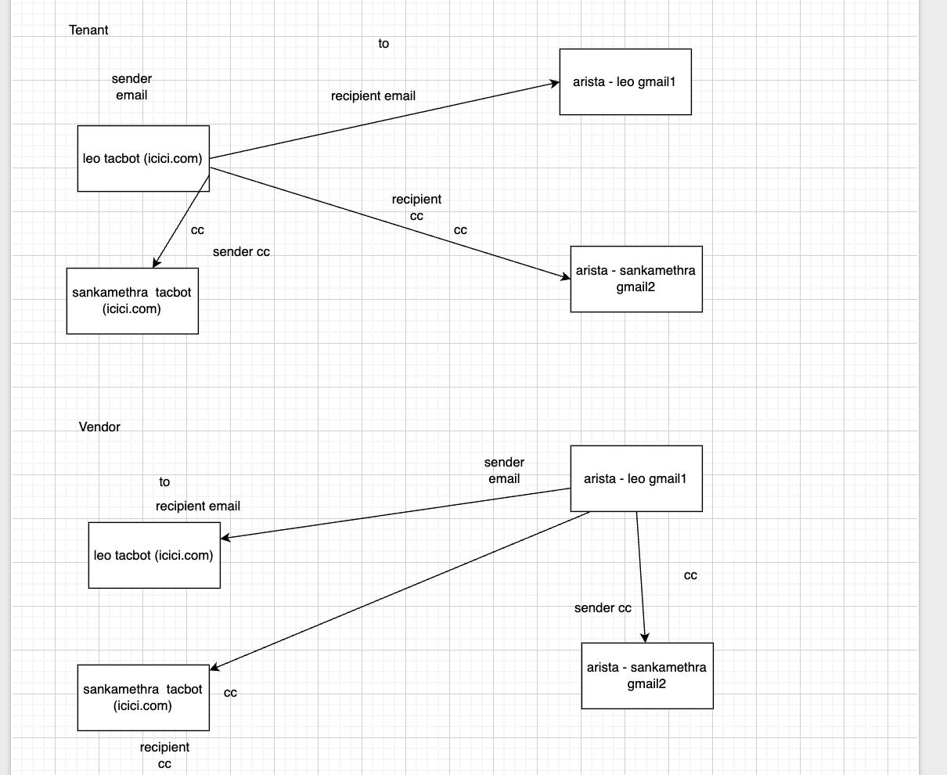

It shows the metadata of the hardware. will work on it. Thanks.
On Wed, 17 Dec 2025 at 12:56, Leo Antony <leo.antony@tacbot.com> wrote: Hi,

Hardware 235478 is not working. Please fix ASAP. Thanks.
Leo Antony <leo.antony@tacbot.com>
To: Leo Antony <leoantony20015@gmail.com> Thank you for the analysis.



We look forward to getting this work done.

Thanks.
[Quoted text hidden]
Leo Antony <leo.antony@tacbot.com>

Wed, Dec 17, 2025 at 1:00 PM

Wed, Dec 17, 2025 at 1:02 PM


aws
�

Amazon_Web_Services_Logo.png
35K

Leo Antony <leoantony20015@gmail.com> To: Leo Antony <leo.antony@tacbot.com>

Issue resolved.
Wed, Dec 17, 2025 at 1:04 PM

Thanks.
[Quoted text hidden]

