**1. Introduction**

This document presents a detailed analysis of the software requirements for the Recipe Website, using an iterative approach to identify and design the necessary web pages. The design tool **Figma** has been used to create prototypes of these pages, aligning with the functional requirements of regular users and administrators. Below, I outline the analysis of each requirement alongside the corresponding Figma designs.

**2. User Requirements**

**2.1 Login/Register**

The first user requirement is to allow users to log in or register. Below is the final design for both pages:

**Login Page Design:**

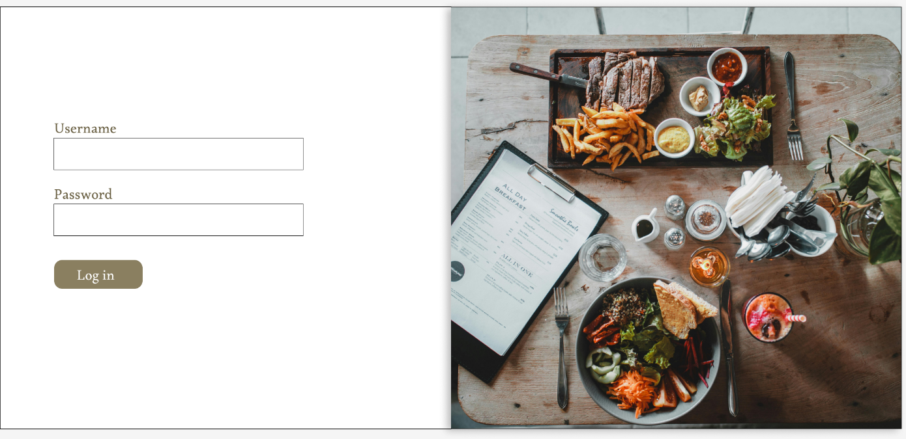

The page is clean and simple, with coherent design elements matching the website theme.

**Registration Page Design:**

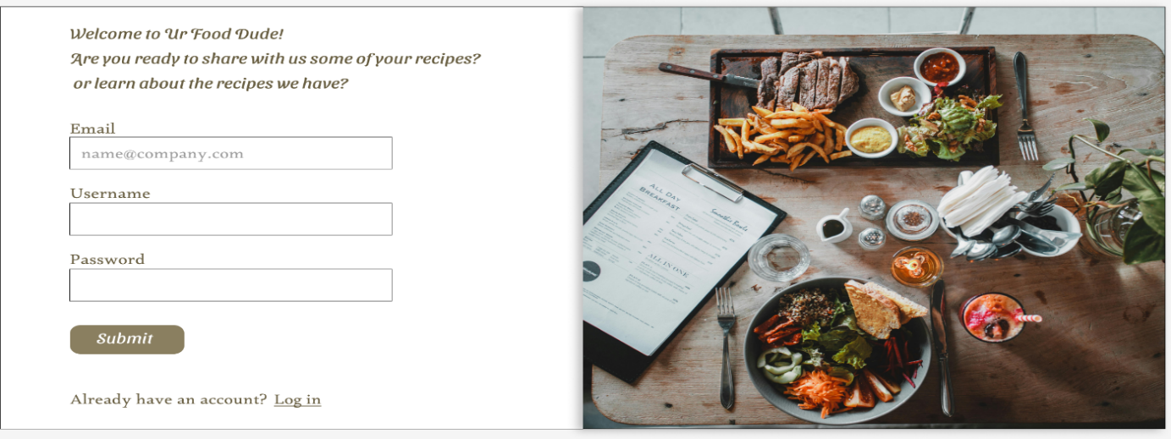

The registration page is like the login page, ensuring consistency across user flows. It allows users to create an account by filling out basic information such as username, password, and email.

**2.2 Profile Management**

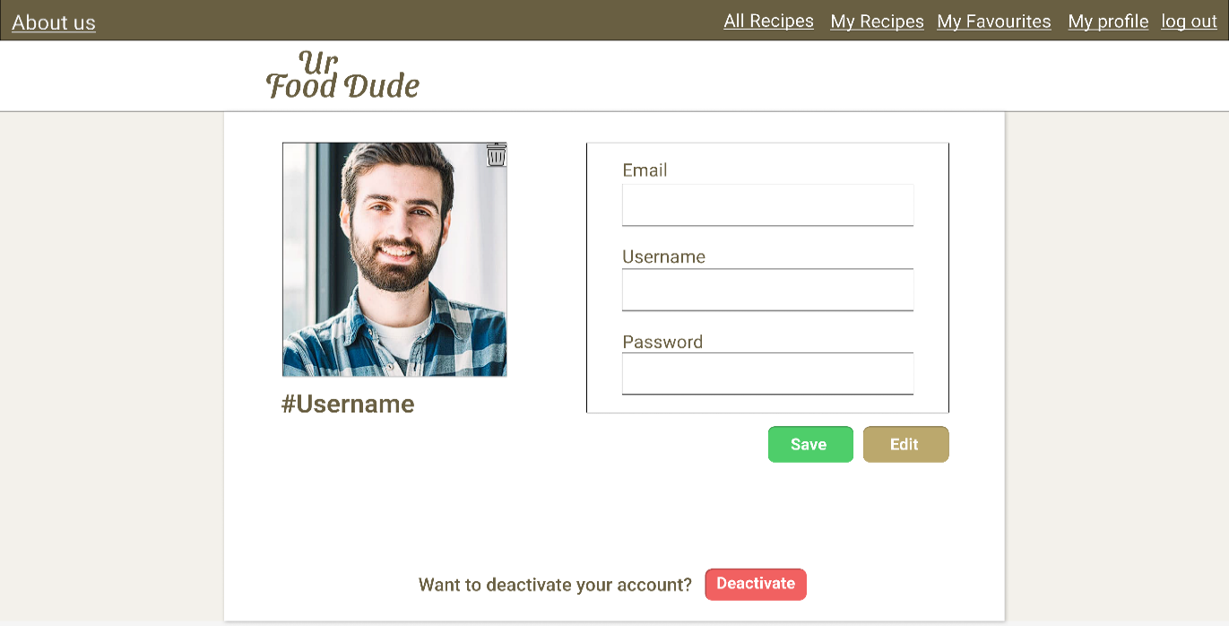Users need the ability to manage their personal information, including changing their username, password, and image. Below is a prototype of the Profile Management Page:

The user can update their username (if it’s unique) and change their password. There’s also an option for users to deactivate their account if needed.

**2.3 Recipe Creation and Management**

One of the key functionalities is for users to create, edit, and manage recipes. To address this, I have developed four pages:

* **Create Recipe Page**:

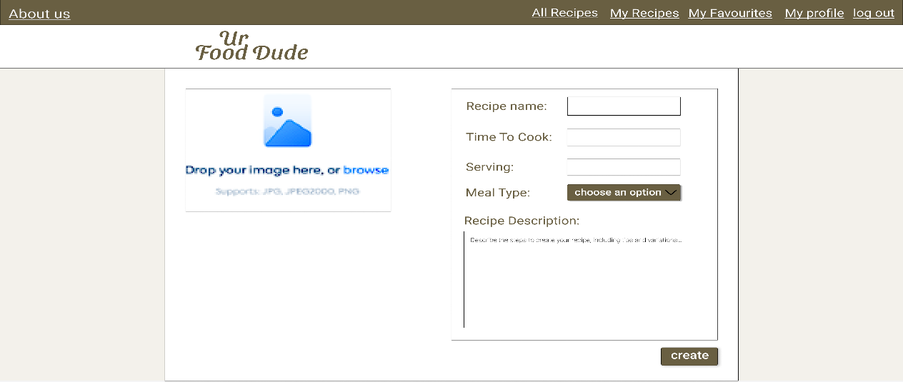Users can create a new recipe by providing details such as name, cooking time, servings, and a description of the preparation steps.

* **Edit Recipe Page:**

This page allows users to modify their recipes. Once the user clicks the edit button, the relevant fields become editable. The ‘Edit’ button then changes to ‘Save’, ensuring a smooth transition. The user can also delete a recipe by clicking the ‘Delete’ button.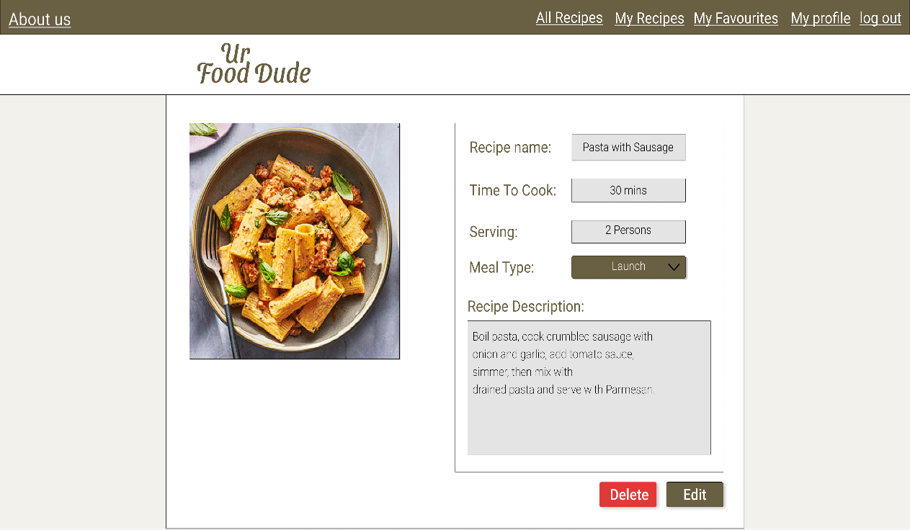

* **Show Recipe Page:**

This page displays the recipe details to the user. It is used when a user wants to view the full recipe, without the ability to edit it (even if it is him the owner, he should navigate to the ‘My Recipes’ page).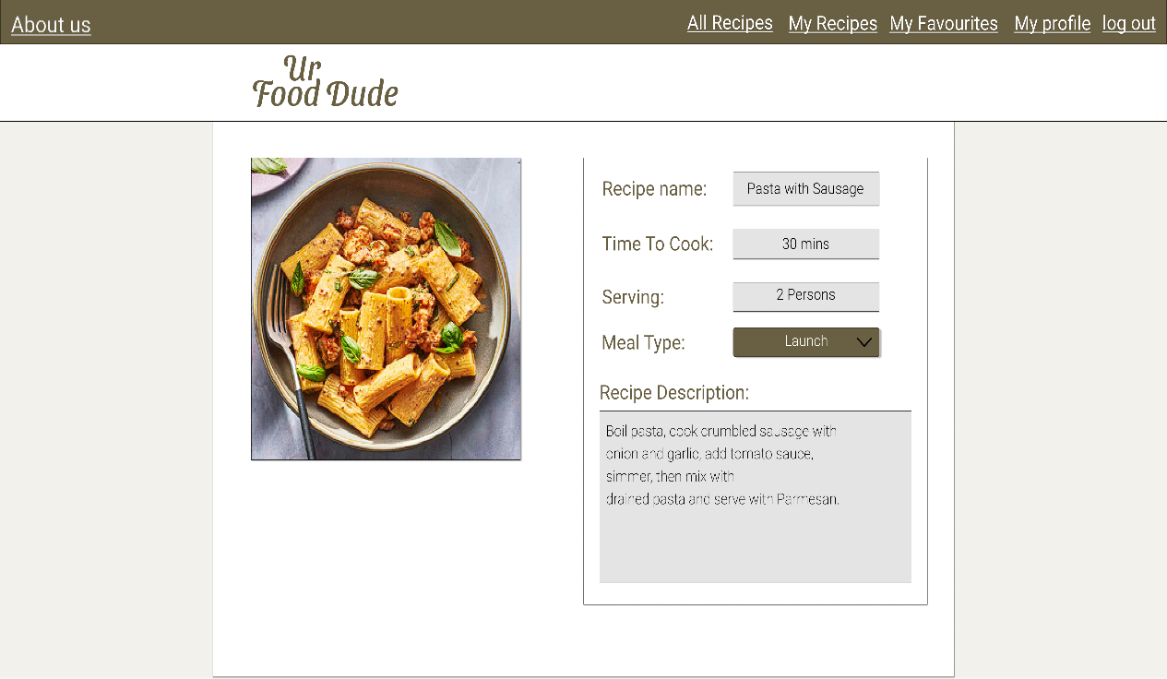

* **My Recipes Page:**

A list of all recipes created by the user is shown here, with options to either create a new recipe or edit an existing one.

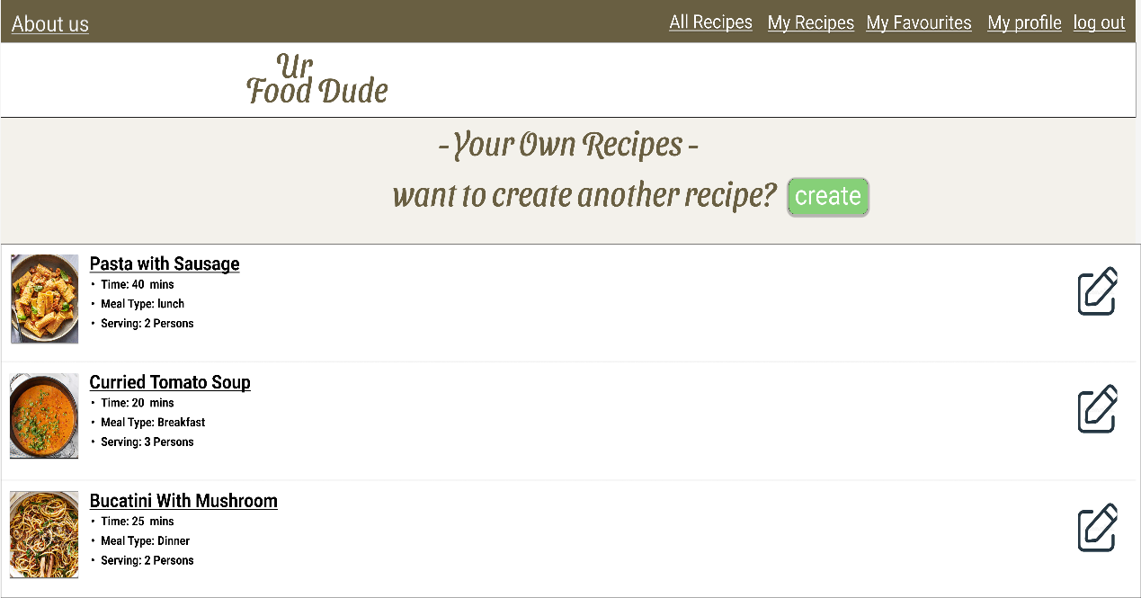

**2.4 Favorites Management**

Users can manage their favorite recipes by adding or removing them from the “Favorites” section. Below is the design for the **Favorites Management Page,** where users can view and manage their saved recipes:

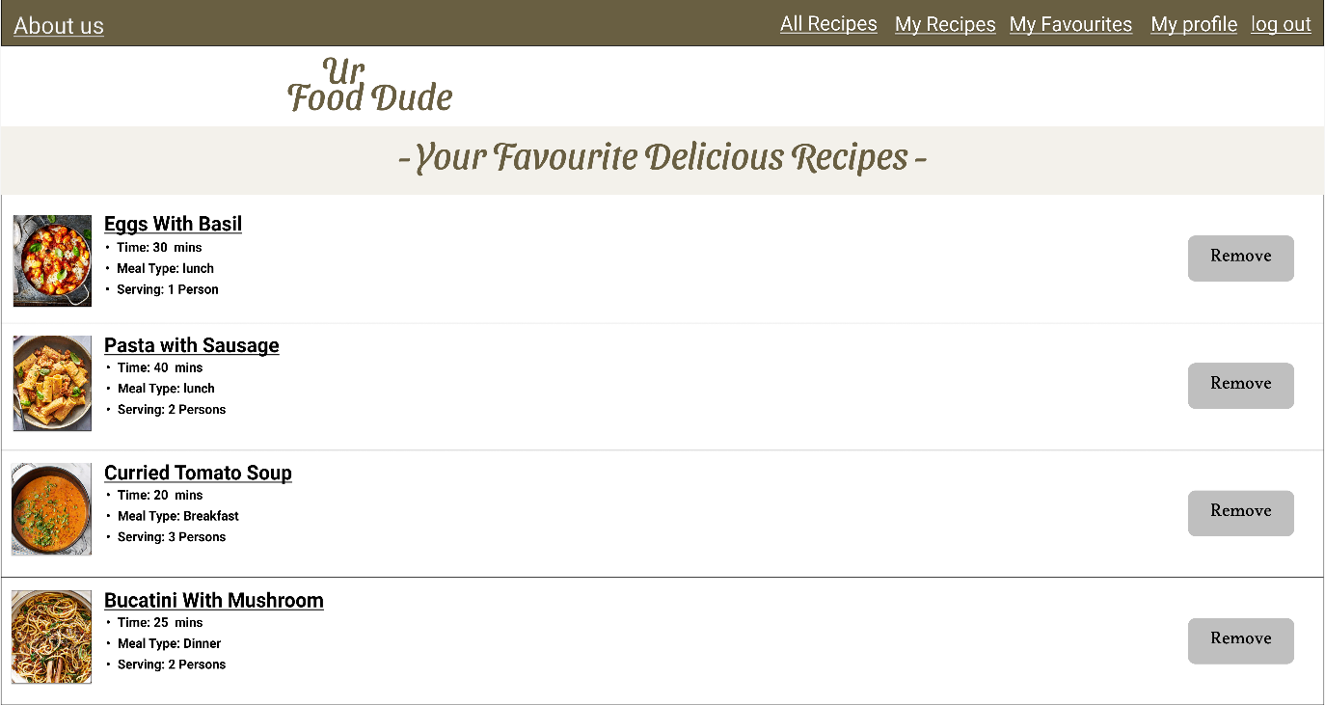

The design ensures that users can quickly navigate and manage their favorite recipes.

**2.5 Recipe Viewing**

This requirement is already satisfied with the ‘Show Recipe’ page.

**2.6 Recipe Filtering and Search**

This is one of the most important features; to enhance the user experience, filtering options are available on the **All-Recipes Page.** Users can filter based on meal type (breakfast, lunch, dinner), Serving (3 persons, 2 persons), and preparation time (e.g., quick meals, slow-cooked). There’s also a search functionality where users can search for recipes using the recipes’ names.

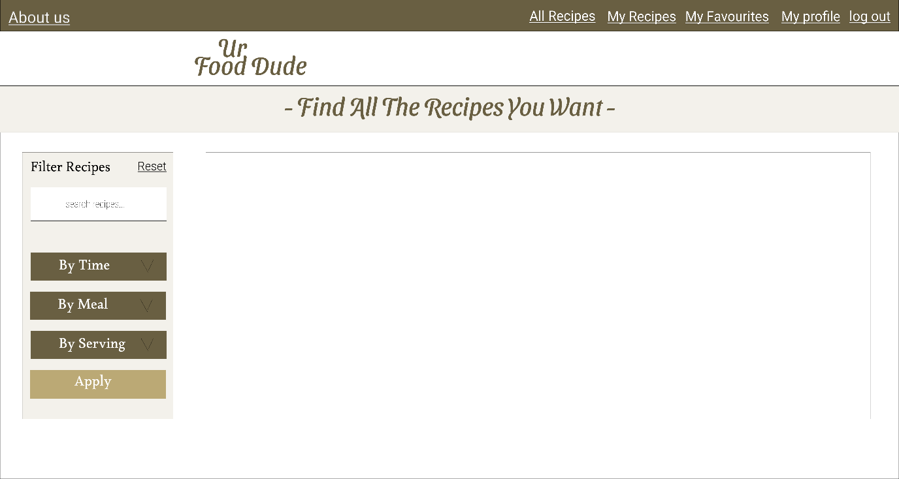

**3. Admin Requirements**