**Technical Structure**

* Three Layered Standard Architecture (extensible)
* GUI Layer (GuessTheAnimal): Presentation Layer for Interface to User
* Business Layer(BusinessLayer): Primarily used for keeping the business logic and a middle layer in between GUI and DB Layer
* DataBase Layer(Database Layer): Dedicated layer to interact with Database: here: XML File
* Unit Test(GTAUT: GuessTheAnimalUnitTest): Keeps unit tests for the project encouraging TDD approach

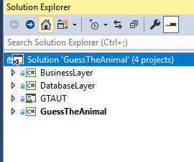

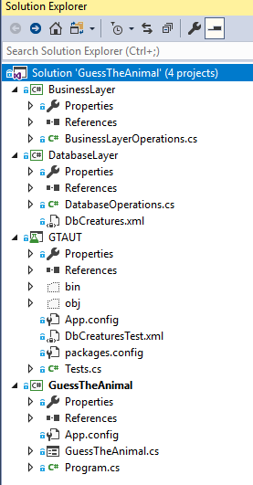

* Windows form application developed as can be developed very quickly as compared to Web
* Exception handling implemented
* TDD approach taken with Unit Test
* No patterns used seeing the time limits as Design Patterns increases complexity a well else could implement Singleton patter with Logger implementation: very tiny example
* DataTable preferred at the very moment to get the Grid Edit operations getting done without extra buttons for Add/Edit/Delete
* Database choosen as XML for Quick Setup and CRUD operations, path to the file configurable in the App.Config File
* 