Algorithms for Coding Interview / Coding Interview Bootcamp (Roht Bardwaj)

Time complexity Space complexity

|  |  |  |
| --- | --- | --- |
| Algorithm | Time complexity | Space complexity |
| Linear Search | O(n) | O(n) |
| Binary Search | O ($\log{n}$) | O(1) |
| Selection sort | O(n²) | O(1) |
| Merge sort | O ($\operatorname{nlog}{n}$) | O(n) |

Big O is a notation which denotes performance in terms of time and space complexity.

Linear Search – O(n) from performance point of view.

Binary Search – Algorithm works on a sorted array (pre-requisite)

O ($\log{n}$)

About 10 because 1000 < 1024 = 210

<https://github.com/rohitbhardwaj/algorithms/tree/main>

<https://leetcode.com/problems/peak-index-in-a-mountain-array/description/>

[ttps://leetcode.com/problems/intersection-of-two-arrays/description/](https://leetcode.com/problems/intersection-of-two-arrays/description/)

[**https://docs.google.com/document/d/1PkH_1-aJeVVsILxs_xkSrLuNU_sfxkyXADOPwvZcG6w/edit?tab=t.0**](https://docs.google.com/document/d/1PkH_1-aJeVVsILxs_xkSrLuNU_sfxkyXADOPwvZcG6w/edit?tab=t.0)

**https://leetcode.com/discuss/interview-question/750543/Wave-Array(Google-Adobe-Amazon)-:-How-to-do-it-O(n)-time**

**Synthetic Data Generation (useful sites)**

[**https://www.mockaroo.com/help/scenarios**](https://www.mockaroo.com/help/scenarios)

[**https://generatedata.com/generator**](https://generatedata.com/generator)

[**https://visualgo.net/en/sorting**](https://visualgo.net/en/sorting)

<https://regexr.com/>

[**https://www.bigocheatsheet.com/**](https://www.bigocheatsheet.com/)

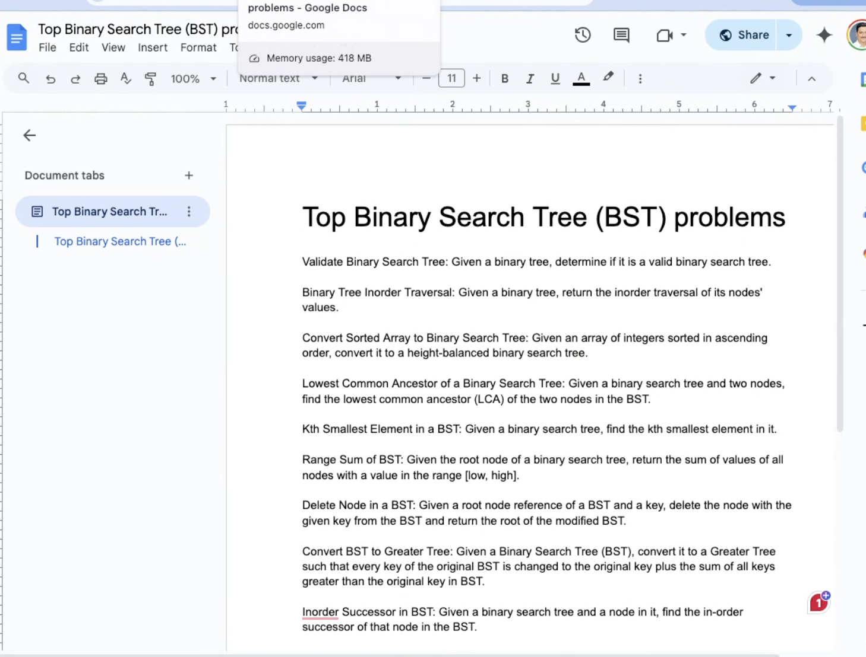

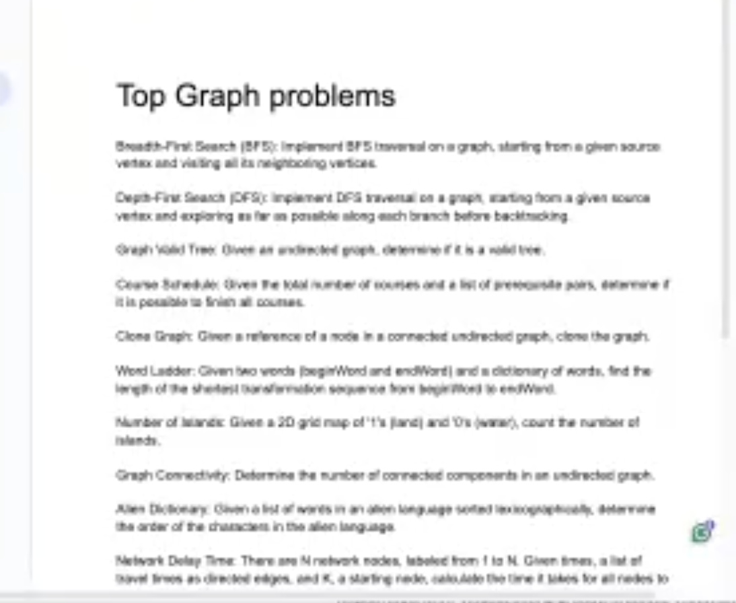

[**https://planner.myrouteonline.com/route-planner/**](https://planner.myrouteonline.com/route-planner/)

[**https://visualgo.net/en**](https://visualgo.net/en)

[**https://algorithm-visualizer.org/greedy/kruskals-minimum-spanning-tree**](https://algorithm-visualizer.org/greedy/kruskals-minimum-spanning-tree)