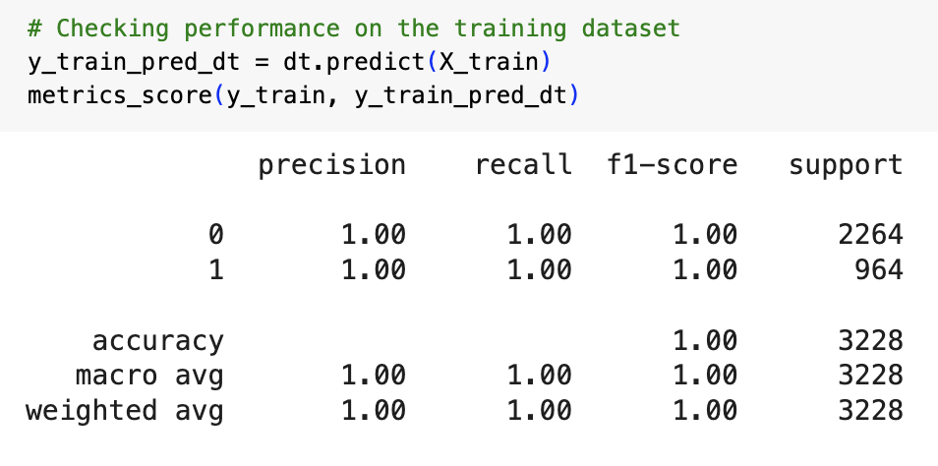

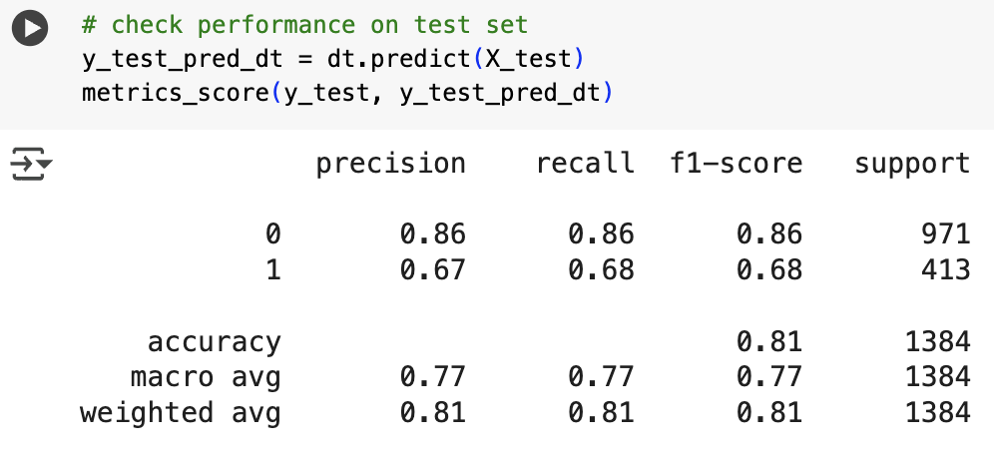

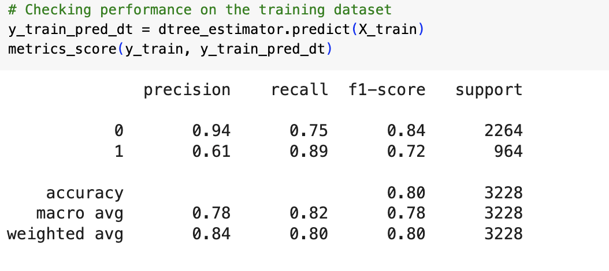

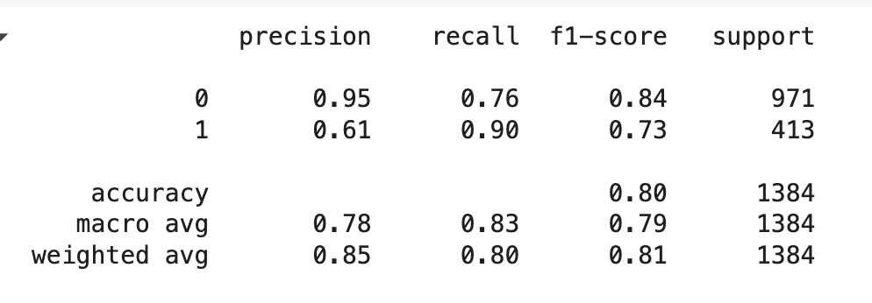

Decision Trees:

* Recall score has improved with tuned model compared to untrained model which resulted in overfitting.
* Precision and f1-score value of decision tree also have got improved.
* Based on tuned model (Decision Trees) engagement with the leads is critical.
* Time spent and interaction of leads with website, profile completion are vital factors of conversion.
* Other features of less priority are converse of leads over phone, website and age.

Random Forest:

* Recall score difference between train and test is significantly high thus overfitting.
* Above is applicable for precision and f1-score metric as well.
* Important features are time spent on website, profile completed, first interaction using website and then mobile app.

AdaBoost Classifier

* Performance of the model is good.
* Model is able to generalize better with the recall score.

Gradient Boosting

* Gradient Boosting model performance is good.
* Model is able to generalize better with the recall score.

--

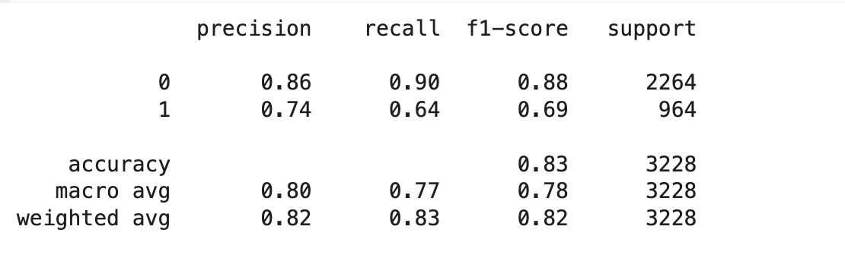

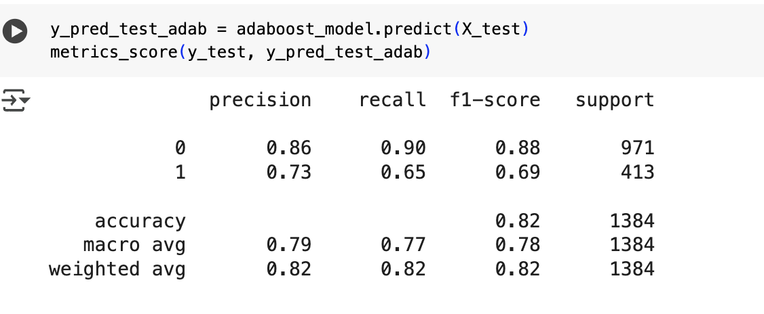

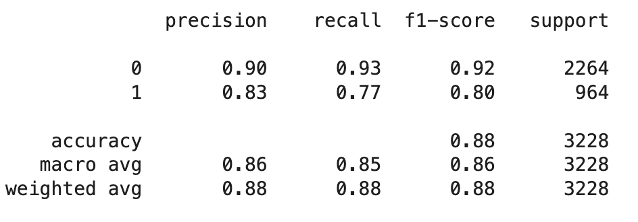

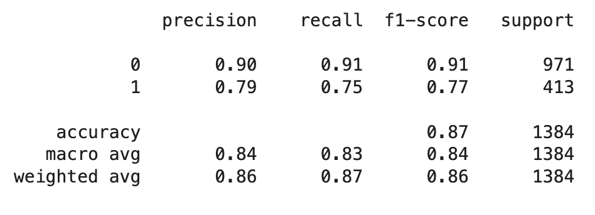

XGBoost

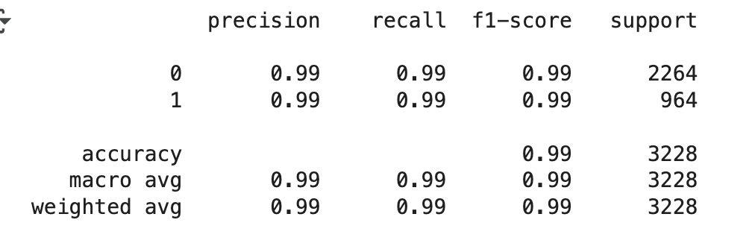

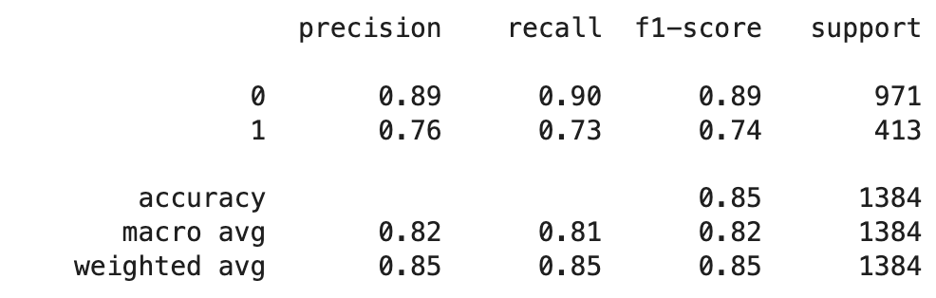

Observations:

Model is overfitting in training compared to testing.

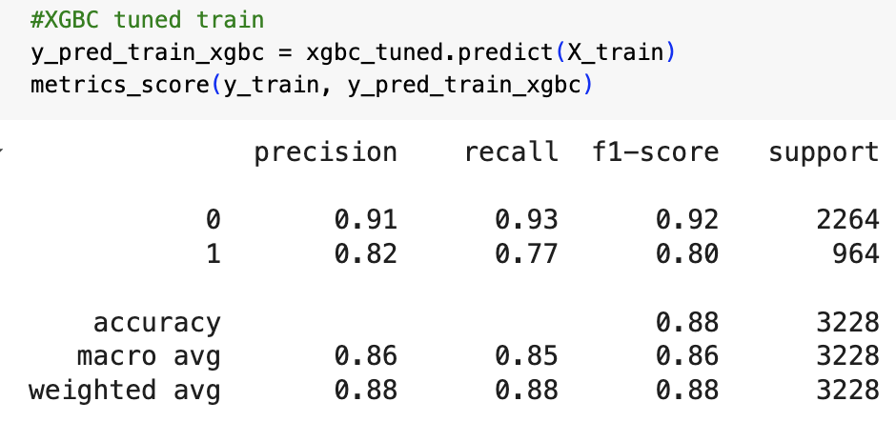

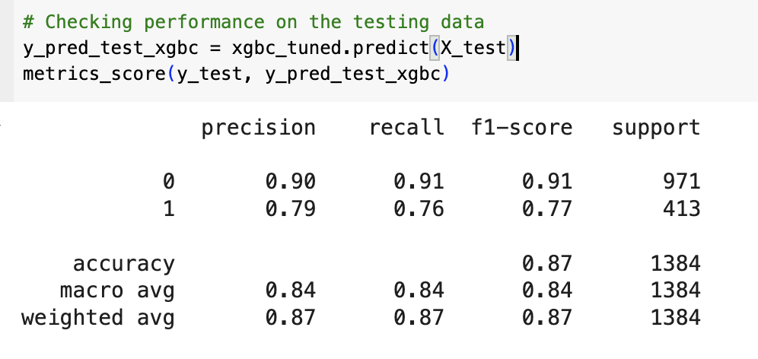

Top 5 feature importance

first_interaction

last_activity

profile_completion

current_occupation

time_spent