**Adjacency Matrix**

An adjacency matrix is the matrix representation of a graph/network, depicting the connections between the nodes in the graph merely as numbers of a matrix. This equivalence between graphs and matrices is an important part of modern graph theory.

**Directed Graph**

Let’s consider a directed graph:

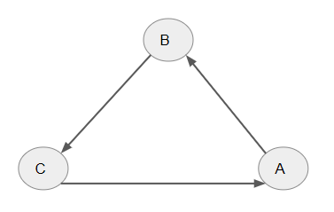  
In the above directed graph, LaTeX: A\longrightarrow B, LaTeX: B\longrightarrow C and LaTeX: C\longrightarrow A are the directed connections observed.

Its adjacency matrix can be given as:

 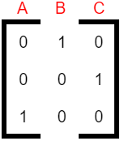

* The graph shows that LaTeX: A\longrightarrow B, i.e., A is linked to B. Hence, the entry in the 1st row (row A) and 2nd column (column B) of the Adjacency Matrix is 1.
* The graph shows that LaTeX: B\longrightarrow C, i.e., B is linked to C. Hence, the entry in the 2nd row (row B) and 3rd column (column C) of the Adjacency Matrix is 1.
* The graph shows that LaTeX: C\longrightarrow A, i.e., C is linked to A. Hence, the entry in the 3rd row (row C) and 1st column (column A) of the Adjacency Matrix is 1.
* There are no other connections in the graph. Hence, all other entries of the Adjacency Matrix are 0.

**Undirected Graph**

Now let’s consider an undirected graph:  
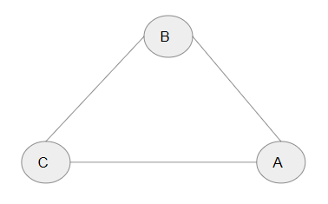

An undirected graph has no specific direction for the link/edge, hence if A and B are linked then we consider the relation as LaTeX: A\longrightarrow B or LaTeX: B\longrightarrow A. The adjacency matrix for this graph is as below:

  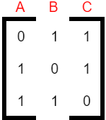

* The graph shows that A is linked to both B and C. Hence, the entries in the 2nd (column B) and 3rd (column C) elements of the 1st row (row A) are 1 in the Adjacency Matrix.
* The graph shows that B is linked to both C and A. Hence, the 1st (column A) and the 3rd (column C) elements of the 2nd row (row B) are 1 in the Adjacency Matrix.
* The graph shows that C is linked to both A and B. Hence, the 1st (column A) and 2nd (column B) elements of the 3rd row (row C) are 1 in the Adjacency Matrix.
* There are no other connections in the graph. Hence, all other entries of the Adjacency Matrix are 0.

**Weighted Adjacency Matrix**

We use the weighted adjacency matrix in the case of a weighted directed or weighted undirected graph.

A weighted graph is a type of graph where each link/edge is also given a numerical weight.

**Weighted Directed Graph**

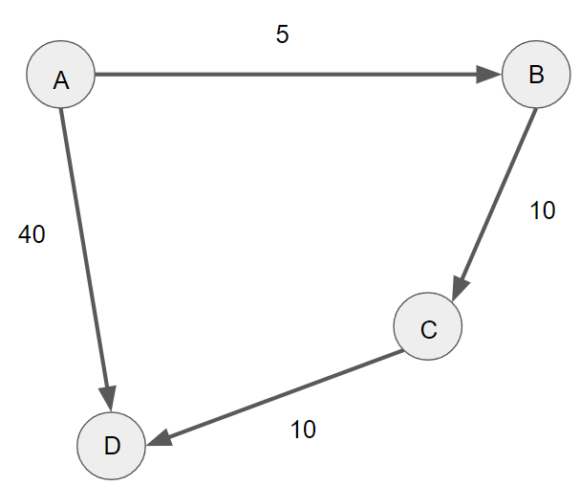

The graph above is a directed weighted graph and has four nodes/vertices: A, B, C & D. Each link/edge has a certain weight associated with it.

The weighted adjacency matrix is the same as the adjacency matrix we have seen in the beginning, the only difference is that instead of representing the connections/links as 1 we enter the weights of the links/edges.

The weighted adjacency matrix for this weighted directed graph can be given as:

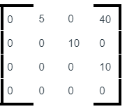

By looking at the given graph, we can say that LaTeX: A\longrightarrow B,\:A\longrightarrow D,\:B\longrightarrow C,\:and\:C\longrightarrow D have links/edges with weights as 5, 40, 10, and 10 respectively.

**Weighted Undirected Graph**

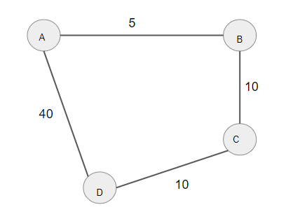  
The graph above is a weighted undirected graph with four nodes/vertices A, B, C & D, where each link/edge has a certain weight associated with it.

The weighted adjacency matrix for this graph can be given as:

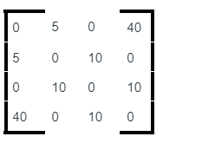

Since the graph is undirected, the connections in the graph: LaTeX: A\longrightarrow B,\:B\longrightarrow A,\:A\longrightarrow D,\:D\longrightarrow A,\:B\longrightarrow C,\:C\longrightarrow B , LaTeX: C\longrightarrow D,\:D\longrightarrow C have links/edges with weights as 5, 5, 40, 40, 10, 10, 10, and 10 respectively.