**Graph Theory** is the study of graphical structures that model relations between two variables or objects. Structurally, graphs are merely a collection of nodes inter-connected by edges in various ways.

Graphs are used by various algorithms in machine learning to perform tasks like clustering, classification, and regression.

A graph is usually represented using nodes (or vertices) and edges (or links).

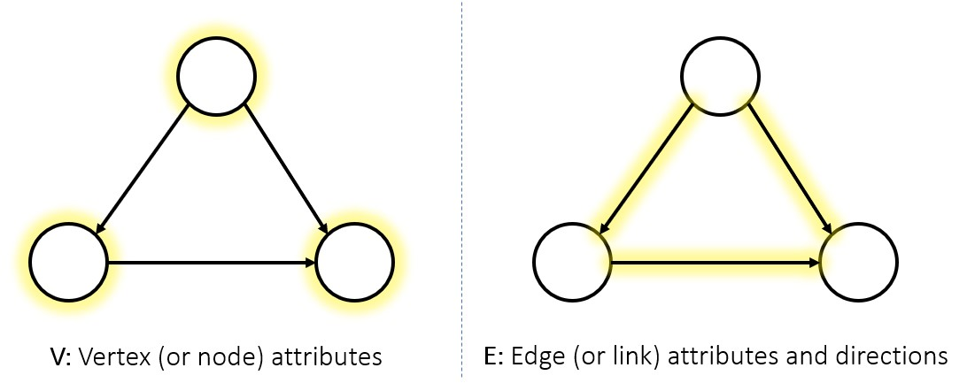

A graph is usually represented using nodes (or vertices) and edges (or links).

Mathematically, graphs are sometimes represented as:

**G = (V,E)**

where **V** is the number of vertices and **E** is the number of edges in the graph.

Graphs can either be directed or undirected.

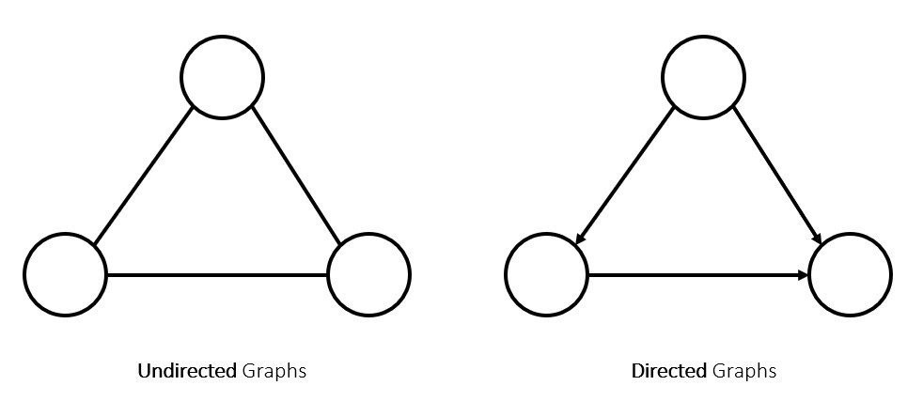

In an undirected graph, the path between 2 nodes is merely a connection between them, and has no inherent source/target, while in a directed graph, every edge is a clear path from one node to another.

**Graph Theory** is the study of graphical structures that model relations between two variables or objects. Structurally, graphs are merely a collection of nodes inter-connected by edges in various ways.

Graphs are used by various algorithms in machine learning to perform tasks like clustering, classification, and regression.

A graph is usually represented using nodes (or vertices) and edges (or links).



A graph is usually represented using nodes (or vertices) and edges (or links).

Mathematically, graphs are sometimes represented as:

**G = (V,E)**

where **V** is the number of vertices and **E** is the number of edges in the graph.

Graphs can either be directed or undirected.



In an undirected graph, the path between 2 nodes is merely a connection between them, and has no inherent source/target, while in a directed graph, every edge is a clear path from one node to another.