Know Your Faculty

[Previous](https://olympus.mygreatlearning.com/courses/120930/modules/items/7268794?pb_id=18129)

[Next](https://olympus.mygreatlearning.com/courses/120930/modules/items/7268796?pb_id=18129)

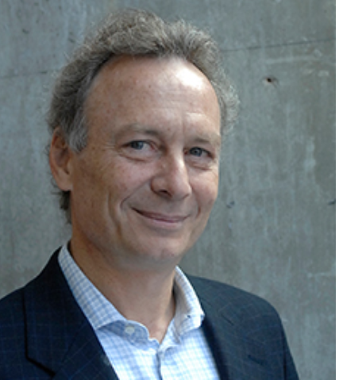

**Dr. John Tsitsiklis**

**Clarence J. Lebel Professor, MIT Department of Electrical Engineering and Computer Science**

**Research Departments: MIT Institute for Data, Systems, and Society (MIT IDSS); MIT Laboratory of Information and Decision Systems (MIT LIDS), and the MIT Operations Research Center (MIT ORC)**

John Tsitsiklis received a BS degree in mathematics (1980), and a BS (1980), MS (1981), and Ph.D. (1984) degrees in electrical engineering, all from the Massachusetts Institute of Technology. During the academic year 1983-84, he was an acting assistant professor of electrical engineering at Stanford University. Since 1984, he has been with the department of Electrical Engineering and Computer Science at MIT, where he is currently a Clarence J. Lebel Professor of Electrical Engineering. He has served as acting co-director (Spring 1996 and 1997), co-associate director (2008-2013) and director (2017-2020) of the Laboratory for Information and Decision Systems, and as a co-director of the Operations Research Center (2002-2005) and Associate Director of the Institute for Data, Systems, and Society (2015-2020).

He is a member of the National Academy of Engineering and holds an honorary doctorate from the Université Catholique de Louvain. He has served, in Greece, in the National Council on Research and Technology (2005-2007) and as the Chair of the Council of the Harokopio University (2013-2016).

* Professional website: <https://idss.mit.edu/staff/john-tsitsiklis/>

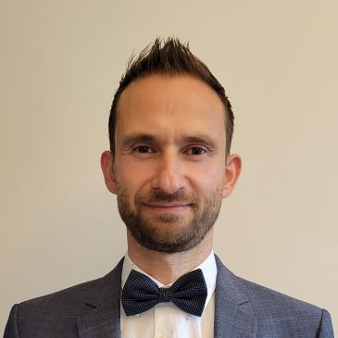

**Dr. Georg Huettenegger**

**Specialist Leader, Conversational AI**

Dr. Georg Huettenegger holds a Master’s and Doctorate degree (Ph.D.) in computer science from the Vienna University of Technology. He is a published author with over 20 years of industry experience. Since 2016 he has been focused on Conversational AI, driving transformative change in big enterprises working for relevant vendors, professional services companies, and users. He has also been a Great Learning industry mentor.

LinkedIn: <https://www.linkedin.com/in/georg-huettenegger/>