Now, Let’s go through some of the common functions used in this LVC implemented through the Statsmodels library

**Statistical functions:**

The Stats model contains classes and functions for time series analysis. Autoregressive models (AR), vector autoregressive models (VAR), and autoregressive moving average models (ARMA)are examples of basic models. Markov switching dynamic regression and autoregression are examples of non-linear models. It also includes time series descriptive statistics such as autocorrelation, partial autocorrelation function, and periodogram, as well as the theoretical properties of ARMA or related processes. Methods to work with autoregressive and moving average lag-polynomials are also included.

Statsmodels can be installed more easily as a part of the cross-platform Anaconda distribution, which is designed for scientific computing and data analysis.

**Installation:**

pip install statsmodels

**After the installation of the statsmodels library, restart the jupyter kernel once and import the library into the working environment.**

**To import a statsmodels library, run the following command in a Jupyter notebook.**

import statsmodels

**i) ACF and PACF Plotting**

An ACF is used to indicate how similar a value is to the previous value within a given time series. (Or) it helps to measure the degree of similarity between a given time series and the lagged version of that time series observed at various intervals.

**Importing an ACF method**

from statsmodels.graphics .tsaplots import plot_acf

statsmodels.graphics.tsaplots.plot_acf(x, ax=None, lags=None, *, alpha=0.05, use_vlines=True, adjusted=False, fft=False, missing='none', title='Autocorrelation', zero=True, auto_ylims=False, bartlett_confint=True, vlines_kwargs=None, **kwargs)

**Parameters:**

  x = array_like

               Array of time-series

lag= {int, array_like}, optional

An int or array of lag values, used on the horizontal axis. uses np.arange(lags) when lags is an int. If not provided, lags=np.arange(len(corr)) is used.

You can refer to the documentation for a better understanding of the parameters and attributes [link](https://www.statsmodels.org/dev/generated/statsmodels.graphics.tsaplots.plot_acf.html)

**PACF**

It always displays the sequence's correlation with itself with some number of time units per sequence order in which only the direct effect is displayed and all other intermediary effects are removed from the given time series.

**Importing a PACF**

from statsmodels.graphics .tsaplots import  plot_pacf

statsmodels.graphics.tsaplots.plot_pacf(x, ax=None, lags=None, alpha=0.05, method='ywm', use_vlines=True, title='Partial Autocorrelation', zero=True, vlines_kwargs=None, **kwargs)

**Parameters:**

  x=array_like

               Array of time-series

lag= {int, array_like}, optional

You can refer to the documentation for a better understanding of the parameters and attributes link

**Below we can  find the function implementation in the Bitcoin_Price_Prediction case study:**

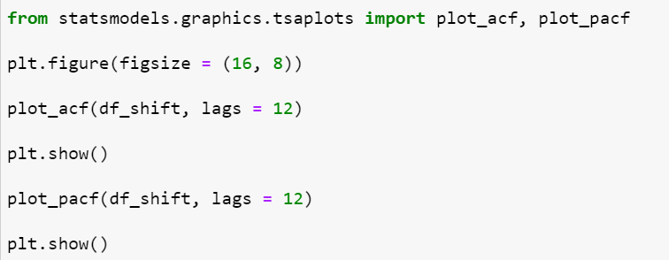

**ii) Augmented Dickey-Fuller (ADF):**

The Augmented Dickey-Fuller test can be used to test for a unit root in a univariate process in the presence of serial correlation.

**To import the required method, run the following command in a Jupyter notebook.**

from statsmodels.tsa.stattools import adfuller

statsmodels.tsa.stattools.adfuller(x, maxlag=None, regression='c', autolag='AIC', store=False, regresults=False)

**Parameters:**

**x =**array_like,1d

The data series to test.

**Maxlag:**{None,int}

Maximum lag which is included in the test, default value 12*(nobs/100)^{¼ } is used when None

**Below we can find the function implementation in the Bitcoin_Price_Prediction case study:**

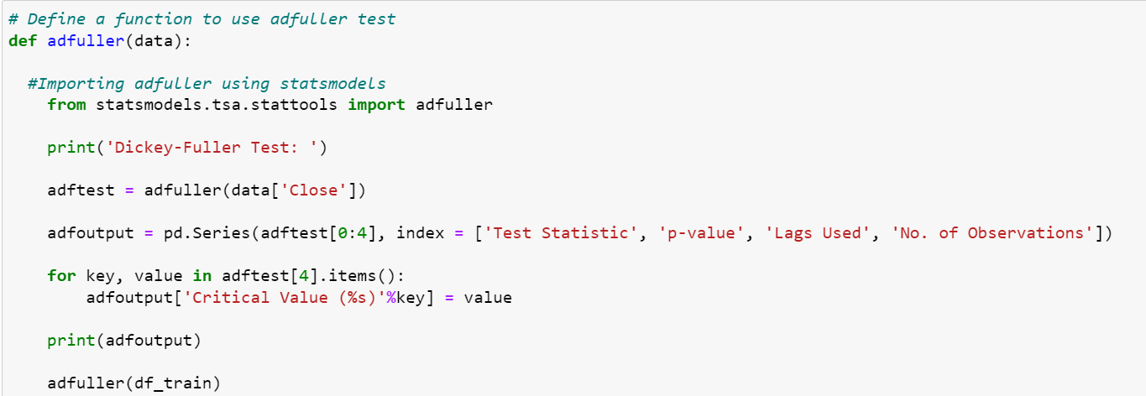

You can refer to the documentation for a better understanding of the parameters and attributes [link](https://www.statsmodels.org/dev/generated/statsmodels.tsa.stattools.adfuller.html)

**iii) Decomposing the time-series components into a trend, seasonality, and residual**

**To import a necessary method, run the following command in a Jupyter notebook.**

form statsmodels.tsa.seasonal import seasonal_decompose

statsmodels.tsa.seasonal.seasonal_decompose(x, model='additive', filt=None, period=None, two_sided=True, extrapolate_trend=0)

**Parameters:**

 x: array_like,

Time series, Individual series are in columns if 2d. x must have two complete cycles.

Period: int,optional

Period of the series.Must be used if x is not a Pandas object or if the index of x does not have a frequency. Overrides default periodicity of x if x is pandas object with a time series index.

**Below we can find the function implementation in the Bitcoin_Price_Prediction case study:**

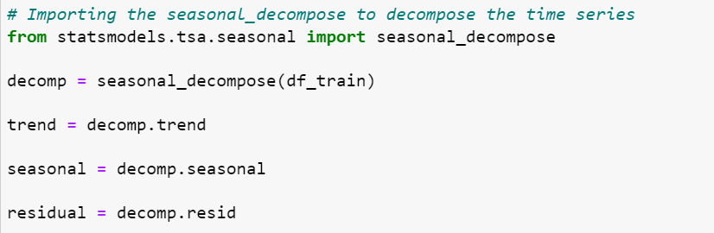

 You can refer to the documentation for a better understanding of the parameters and attributes [link](https://www.statsmodels.org/dev/generated/statsmodels.tsa.seasonal.seasonal_decompose.html)

**iv) Auto Regressive Model:**

The Autoregressive model is a type of random process. The model's output is linearly dependent on its own previous value, which is some number of lagged data points or past observations.

**To import the required method, run the following command in a Jupyter notebook.**

from statsmodels.tsa.ar_model. AutoReg

statsmodels.tsa.ar_model. AutoReg(endog, lags, trend='c', seasonal=False, exog=None, hold_back=None, period=None, missing='none', *, deterministic=None,old_names=False)

**Parameters:**

**endog: array_like**

The dependent variable

**lags: {None,int,list[int]}**

The number of lags to include in the model is an integer or the list of lag indices to include. For example, [1, 4] will only include lags 1 and 4, while lags = 4 will include lags 1, 2, 3, and 4. None excludes all AR lags and behaves identically to 0.

**Below we can find the function implementation in the Bitcoin_Price_Prediction case study:**

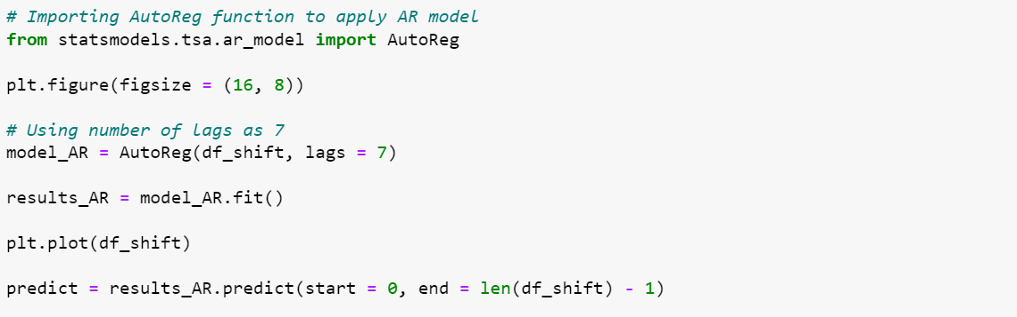

You can refer to the documentation for a better understanding of the parameters and attributes [link](https://www.statsmodels.org/dev/generated/statsmodels.tsa.ar_model.AutoReg.html)

**V) ARIMA**

An Auto regressive integrated moving average model is a generalization of a simple ARMA model. Both of these models are used to forecast or predict future time-series data points.

**The ARIMA model is generally denoted as ARIMA(p, d, q) and the parameters p, d, q are defined as follows:**

p: the lag order or the number of time lag of autoregressive model AR(p)

d: degree of differencing or the number of times the data have had subtracted with past value

q: the order of moving average model MA(q)

* **autoregressive models:** AR(p)
* **moving average models:** MA(q)
* **mixed autoregressive moving average models:** ARMA(p, q)
* **integration models:** ARIMA(p, d, q)
* **regression with errors that follow one of the above ARIMA-type models**

**To import an ARIMA model, run the following command in a Jupyter notebook**

from statsmodels.tsa.arima.model import ARMIA

statsmodels.tsa.arima.model. ARIMA(endog, exog=None, order=(0, 0, 0), seasonal_order=(0, 0, 0, 0), trend=None, enforce_stationarity=True, enforce_invertibility=True, concentrate_scale=False, trend_offset=1, dates=None, freq=None, missing='none', validate_specification=True)

**Parameters:**

**endog: array_like, optional**

The observed time-series process y

**Exong: array_like, optional**

   Array of exogenous regressors

**Below we can find the function implementation in the Bitcoin_Price_Prediction case study:**

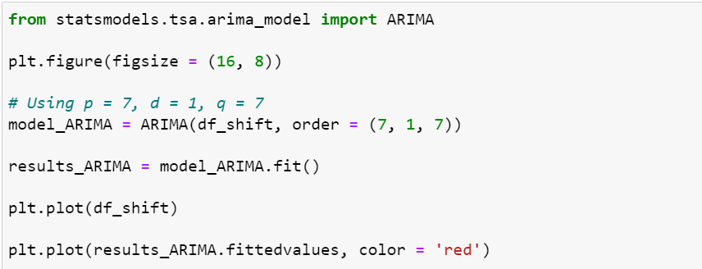

You can refer to the documentation for a better understanding of the parameters and attributes [link](https://www.statsmodels.org/dev/generated/statsmodels.tsa.arima.model.ARIMA.html)

**Happy Learning!**