Quiz Assessment - Deep Learning

**Question 1**

Correct Answer

Marks: 3/3

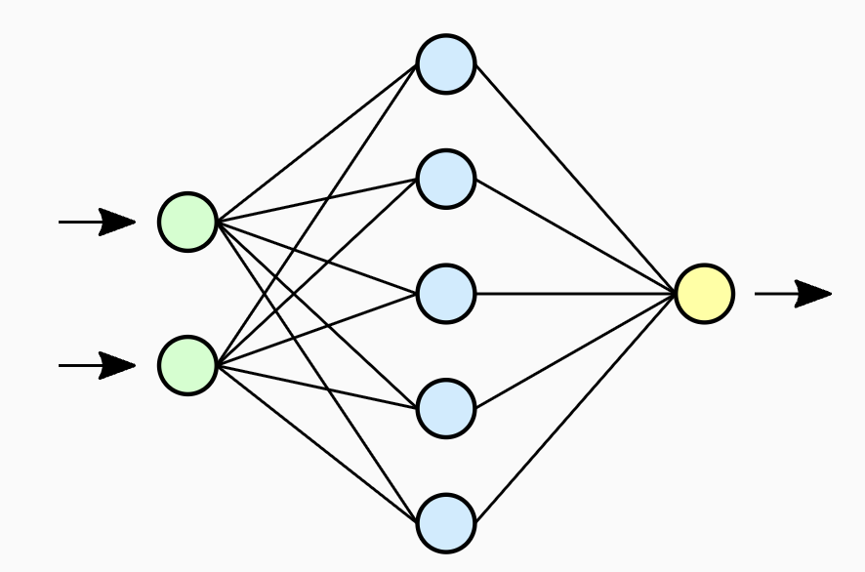

In the above diagram of a Neural Network, the layer with blue-colored nodes is called the ______.

Input layer

Hidden layer

You Selected

Output layer

None of the above

Green circles - Input layer

Blue circles - Hidden layer

Yellow circle - Output layer

**Question 2**

Correct Answer

Marks: 3/3

Which of the following statements is/are true about the activation function?

A) An activation function is one of the critical components that give neural networks the ability to deal with complex problems

B) We can use Sigmoid, Tanh, or ReLU as an activation function in NN

C) The activation function introduces non-linearity into the neural network

Only A and B

Only A and C

Only B and C

A, B, and C

You Selected

Activation functions are the component that help neural networks deal with complex problems. There are a number of options for activation functions like Tanh, ReLU, Sigmoid, and Linear Activation which can be used in NNs. Activation functions introduce non-linearity into the system.

**Question 3**

Incorrect Answer

Marks: 0/3

Which of the following statements is/are true about the Gradient Descent Algorithm?

A) For the non-convex loss function, there is a possibility to get stuck in local minima during optimization

B) Different initializations can lead to different outcomes

C) If the step size is too small, the progress in loss function optimization will also be very slow

D) Step size does not affect the Gradient Descent Algorithm

Only A and B

Only C and D

Only A, B, and C

Correct Option

A, B, C, and D

You Selected

1. In non-convex functions, instead of converging to the global minimum, gradient descent would stop at the local minimum.
2. Outcomes are dependent on the initializations as a too-large initialization leads to exploding gradients and too-small initialization leads to a vanishing gradient.
3. A step size that is too large can cause the model to converge too quickly to a suboptimal solution, whereas a learning rate that is too small can cause the weights to be updated very slowly, which makes the training process slow. Therefore step size heavily affects the rate of Gradient Descent Algorithm.

**Question 4**

Correct Answer

Marks: 3/3

Which of the following is/are the challenge(s) associated with training a neural network?

A) Exploding/Vanishing gradients

B) Computationally Expensive

A and B

You Selected

Only A

Only B

Neither A nor B

If weights are small/large, then the product can be too small/too large, which results in a vanishing/exploding gradient problem that occurs due to the chain rule of the derivatives.  
Due to the process of forward and back-propagation, and the high number of learnable parameters (multiple nodes and layers), training a neural network can become computationally expensive.

**Question 5**

Correct Answer

Marks: 3/3

Which of the following statements best explains the use of max-pooling in Convolutional Neural Networks (CNNs)?

It is used to convert images to vectors

It is used to increase the size of the image

It is very helpful in retaining the dominant attributes of the image and results in less computational needs

You Selected

None of the above

Pooling layers are used to reduce the parameters in the feature map. It is very helpful in retaining the dominant attributes of the image by calculating the value in each patch of the feature map based on the type of pooling technique. As a result, the number of parameters to learn and the amount of computation in the network are both reduced.

**Question 6**

Correct Answer

Marks: 3/3

Do pooling layers have any parameters to learn?

Yes

No

You Selected

Pooling extracts the value in each patch of each feature map. It doesn't have any parameters to learn, calculates the value based on the type of pooling (max, average, and min).

**Question 7**

Correct Answer

Marks: 3/3

Which of the following statements is/are true?

A) Resizing an image to a lower size results in loss of information

B) By applying pooling, we can increase the size of the image

C) CNNs tend to perform better if the input dataset is augmented with the rotated versions of the images

Only A and B

Only B

Only A and C

You Selected

A, B, and C

Resizing an image to a lower size will reduce the pixel quality of the image, compress the data and lead to loss of information.

Pooling layers are used to reduce the dimensions of the feature maps. It will reduce the number of parameters to be learned and size of the image as well.

CNN will work well with more data, able to learn more features from different Geometry of the images

**Question 8**

Correct Answer

Marks: 3/3

Which of the following is/are the application(s) of Computer Vision?

Image Segmentation

Face Detection

Object Detection

All of the above

You Selected

Computer vision is one of the trending technology that has various applications like Image Segmentation, Face detection, Object detection, etc.

**Question 9**

Incorrect Answer

Marks: 0/3

Which of the following statements is/are true about Transfer Learning?

A) It is useful because generating a huge amount of labeled data is very expensive

B) It is computationally less expensive than training a large neural network from scratch

C) We use weights of some pre-trained model and fine-tune that model according to the problem at hand

Only A and B

Only B

You Selected

A, B, and C

Correct Option

Only A and C

Transfer Learning is useful because generating huge amounts of labeled data is very expensive. Since we use weights of some pre-trained models and fine-tune them based on the problem on hand, transfer learning is computationally less expensive than training a large neural network from scratch.

**Question 10**

Correct Answer

Marks: 3/3

Which of the following is not a component of the transformer architecture?

Encoder

Decoder

Predictor

You Selected

Multi-Head Attention

In the transformer architecture, there is no distinct component called a "Predictor"; the encoder and decoder modules, along with multi-head attention, are the primary components responsible for processing and predicting sequences.