OCI Gen. AI Professional: Hands-on Workshop (2025)

Activity Guide

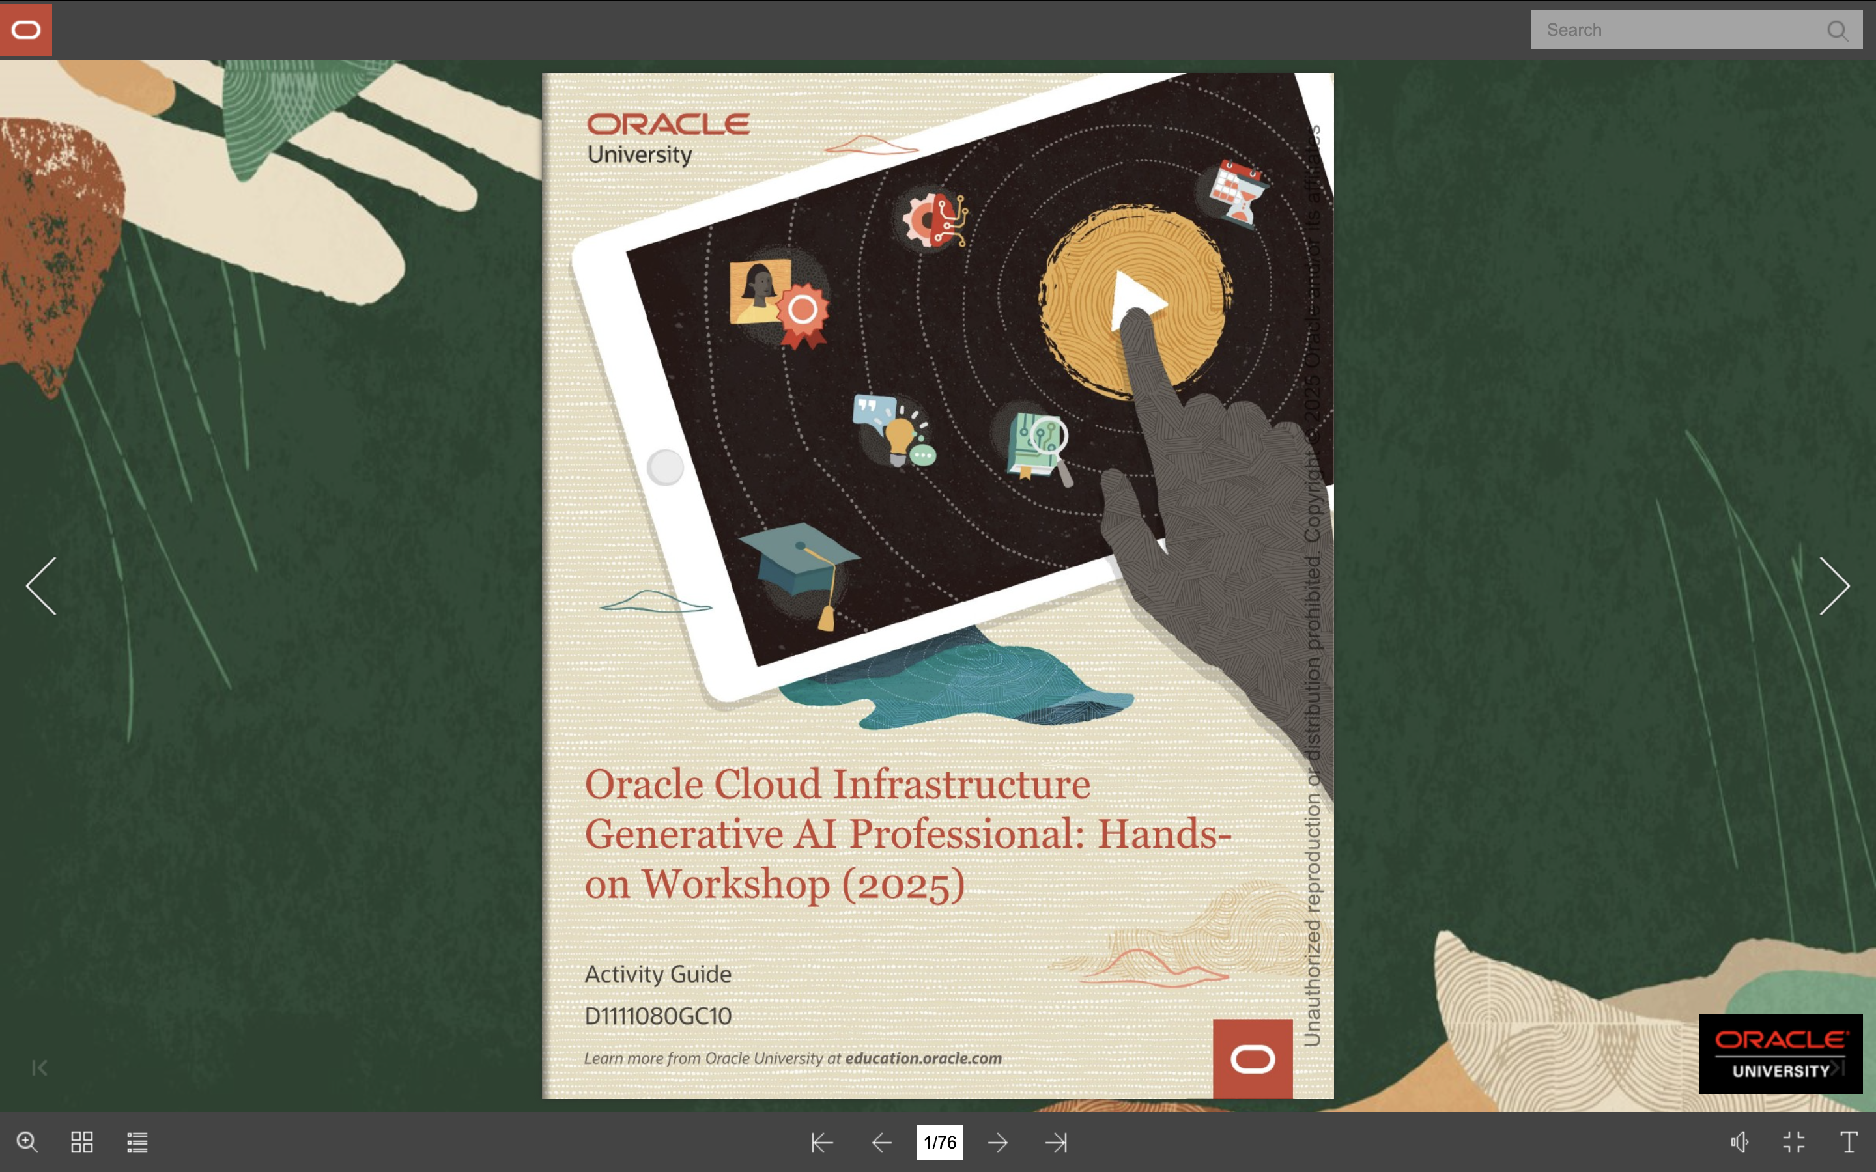

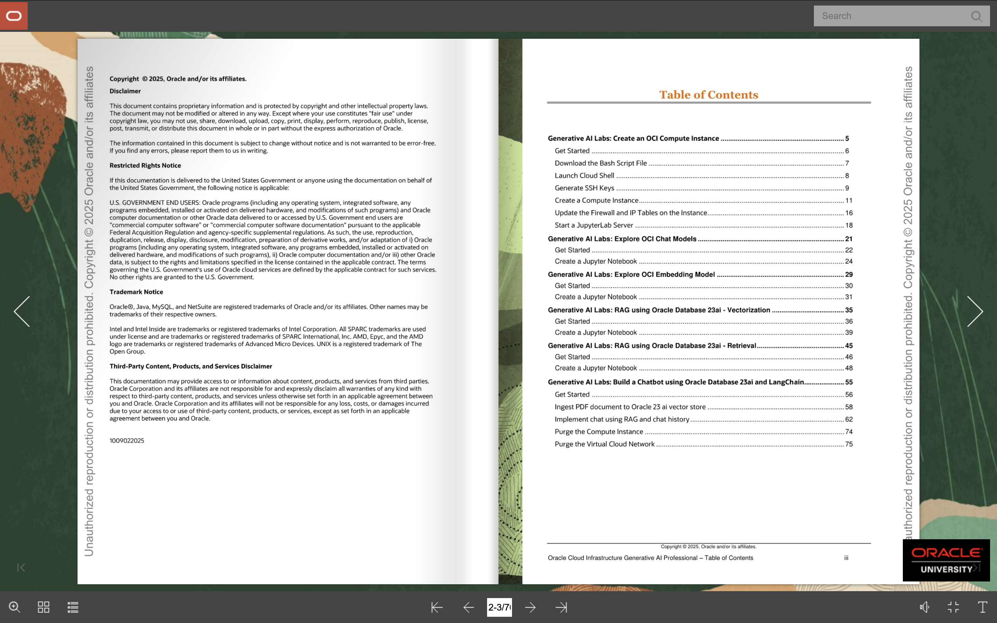

Pre-Req knowledge:

Text-Based Model

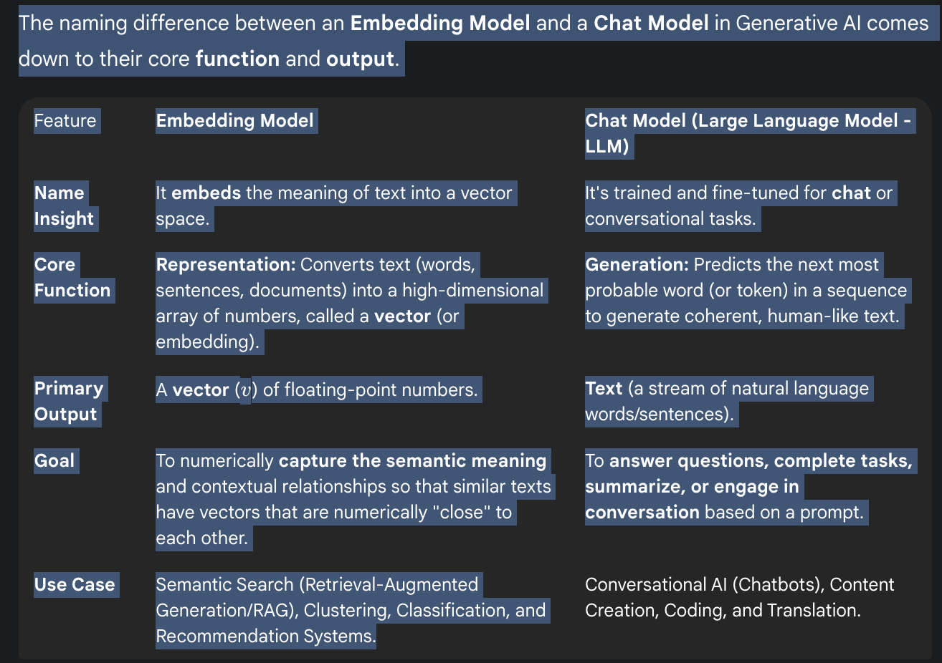

Feature | Embedding Model | Chat Model (Large Language Model - LLM)
Name Insight | It embeds the meaning of text into a vector space. | It's trained and fine-tuned for chat or conversational tasks.
Core Function | Representation: Converts text (words, sentences, documents) into a high-dimensional array of numbers, called a vector (or embedding). | Generation: Predicts the next most probable word (or token) in a sequence to generate coherent, human-like text.
Primary Output | A vector (v) of floating-point numbers. | Text (a stream of natural language words/sentences).
Goal | To numerically capture the semantic meaning and contextual relationships so that similar texts have vectors that are numerically "close" to each other. | To answer questions, complete tasks, summarize, or engage in conversation based on a prompt.
Use Case | Semantic Search (Retrieval-Augmented Generation/RAG), Clustering, Classification, and Recommendation Systems. | Conversational AI (Chatbots), Content Creation, Coding, and Translation.
Export to Sheets

- Query successful
Try again without apps
Generative AI models are a diverse group of deep learning architectures designed to create new, original content. Beyond the chat models (Large Language Models or LLMs) and embedding models you mentioned, the other major types are distinguished by how they are structured and the specific generation task they excel at, such as images, audio, or synthetic data.

Major Types of Generative AI Models

Model Type | Core Mechanism | Primary Output & Use Cases
Generative Adversarial Networks (GANs) | Two neural networks (Generator and Discriminator) compete in an adversarial "game" to produce highly realistic data. | Realistic Images & Video (e.g., deepfakes, photorealistic synthetic data, art generation, image-to-image translation).
Diffusion Models | A two-step process: (1) gradually adding noise to data (like an image) until it's pure noise, and (2) learning to reverse the noise process to generate a clean, new sample. | High-Quality Images, Video, & Audio (e.g., DALL-E, Midjourney, Stable Diffusion—they are the current state-of-the-art for visual creation).
Variational Autoencoders (VAEs) | An Encoder compresses the input data into a continuous, probabilistic representation (latent space), and a Decoder reconstructs it. New content is created by sampling from this latent space. | Novel Synthetic Data (e.g., generating new molecular structures for drug discovery, data compression, anomaly detection).
Autoregressive Models | Generates content sequentially, predicting the next element (word, pixel, etc.) based on all the preceding elements. | Coherent Sequences (e.g., text generation, such as the underlying architecture of many early LLMs like GPT, or generating music/audio one step at a time).

Key Generative AI Application Areas
These model types are often categorized by the type of content they are designed to generate:
- Text and Code Generation: Primarily powered by Transformer-based models (the architecture behind Chat Models/LLMs) that predict the next token. They are used for writing, summarization, translation, and code completion (like GitHub Copilot).
- Image Generation: Dominated by Diffusion Models and GANs to create images from scratch (text-to-image) or modify existing images (image-to-image translation).
- Video Generation: Increasingly achieved through advanced Diffusion and Transformer-based models that can maintain spatial and temporal coherence to produce a sequence of frames.
- 3D Content Generation: Emerging models, like Neural Radiance Fields (NeRFs), use neural networks to construct a 3D scene from a set of 2D images, enabling the generation of novel viewpoints and 3D assets.

Generative AI Lab: Create an OCI Compute Instance

Lab 0-01 Practices

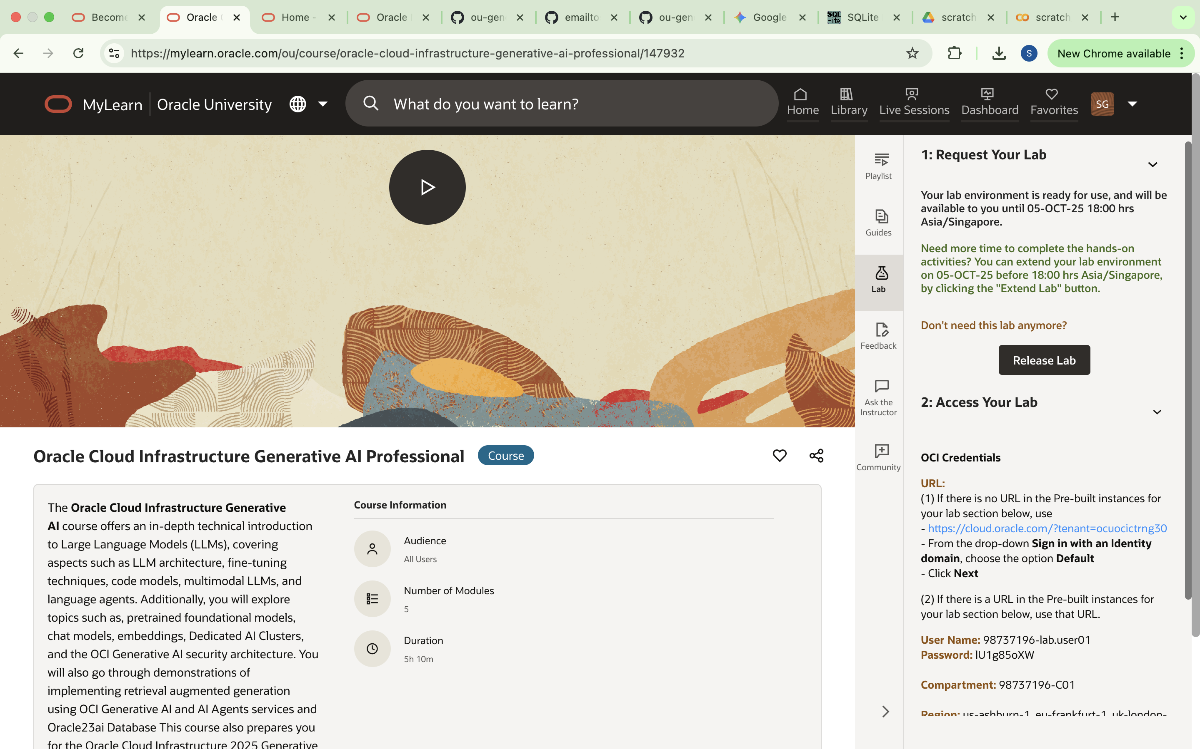
Region (applicable): us-ashburn-1, eu-frankfurt-1, uk-london-1, us-phoenix-1

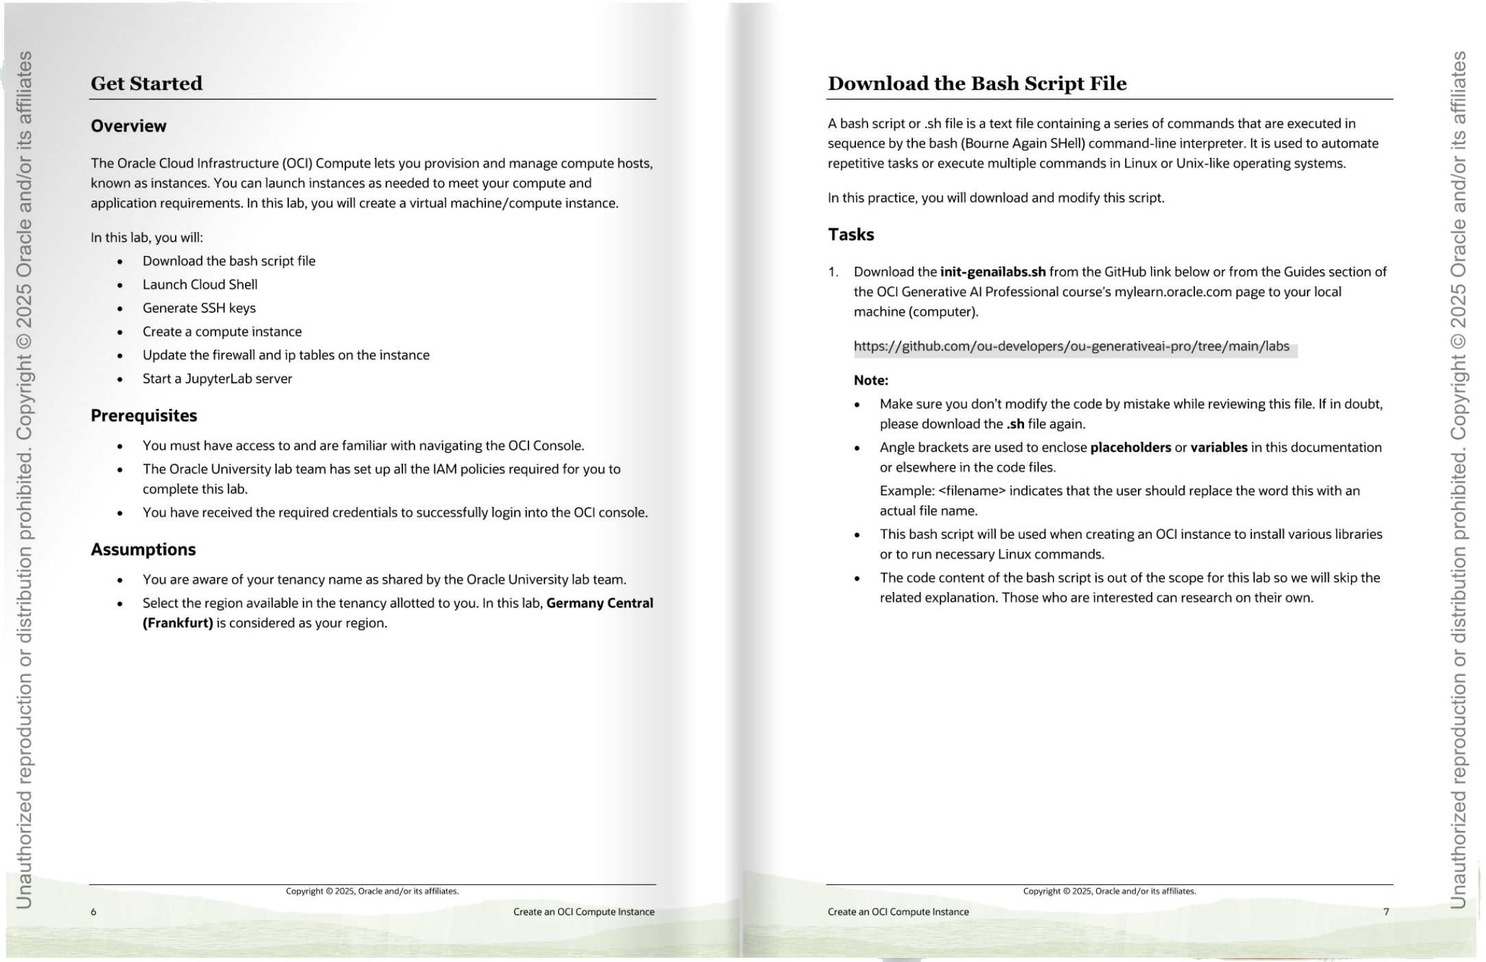

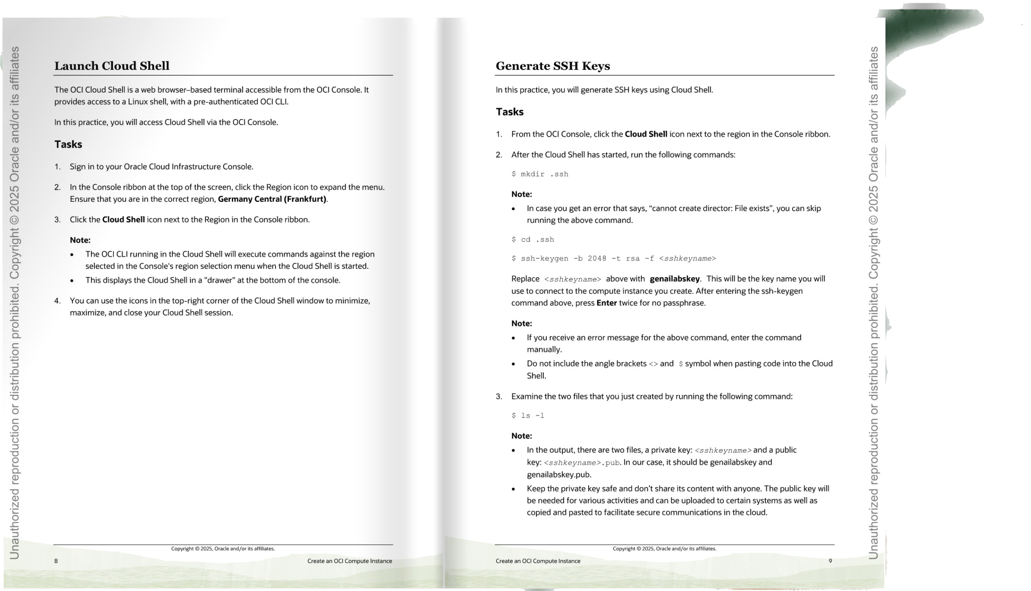


OCI Login- on click of next asks for user and password as given above

Oracle OCI console login
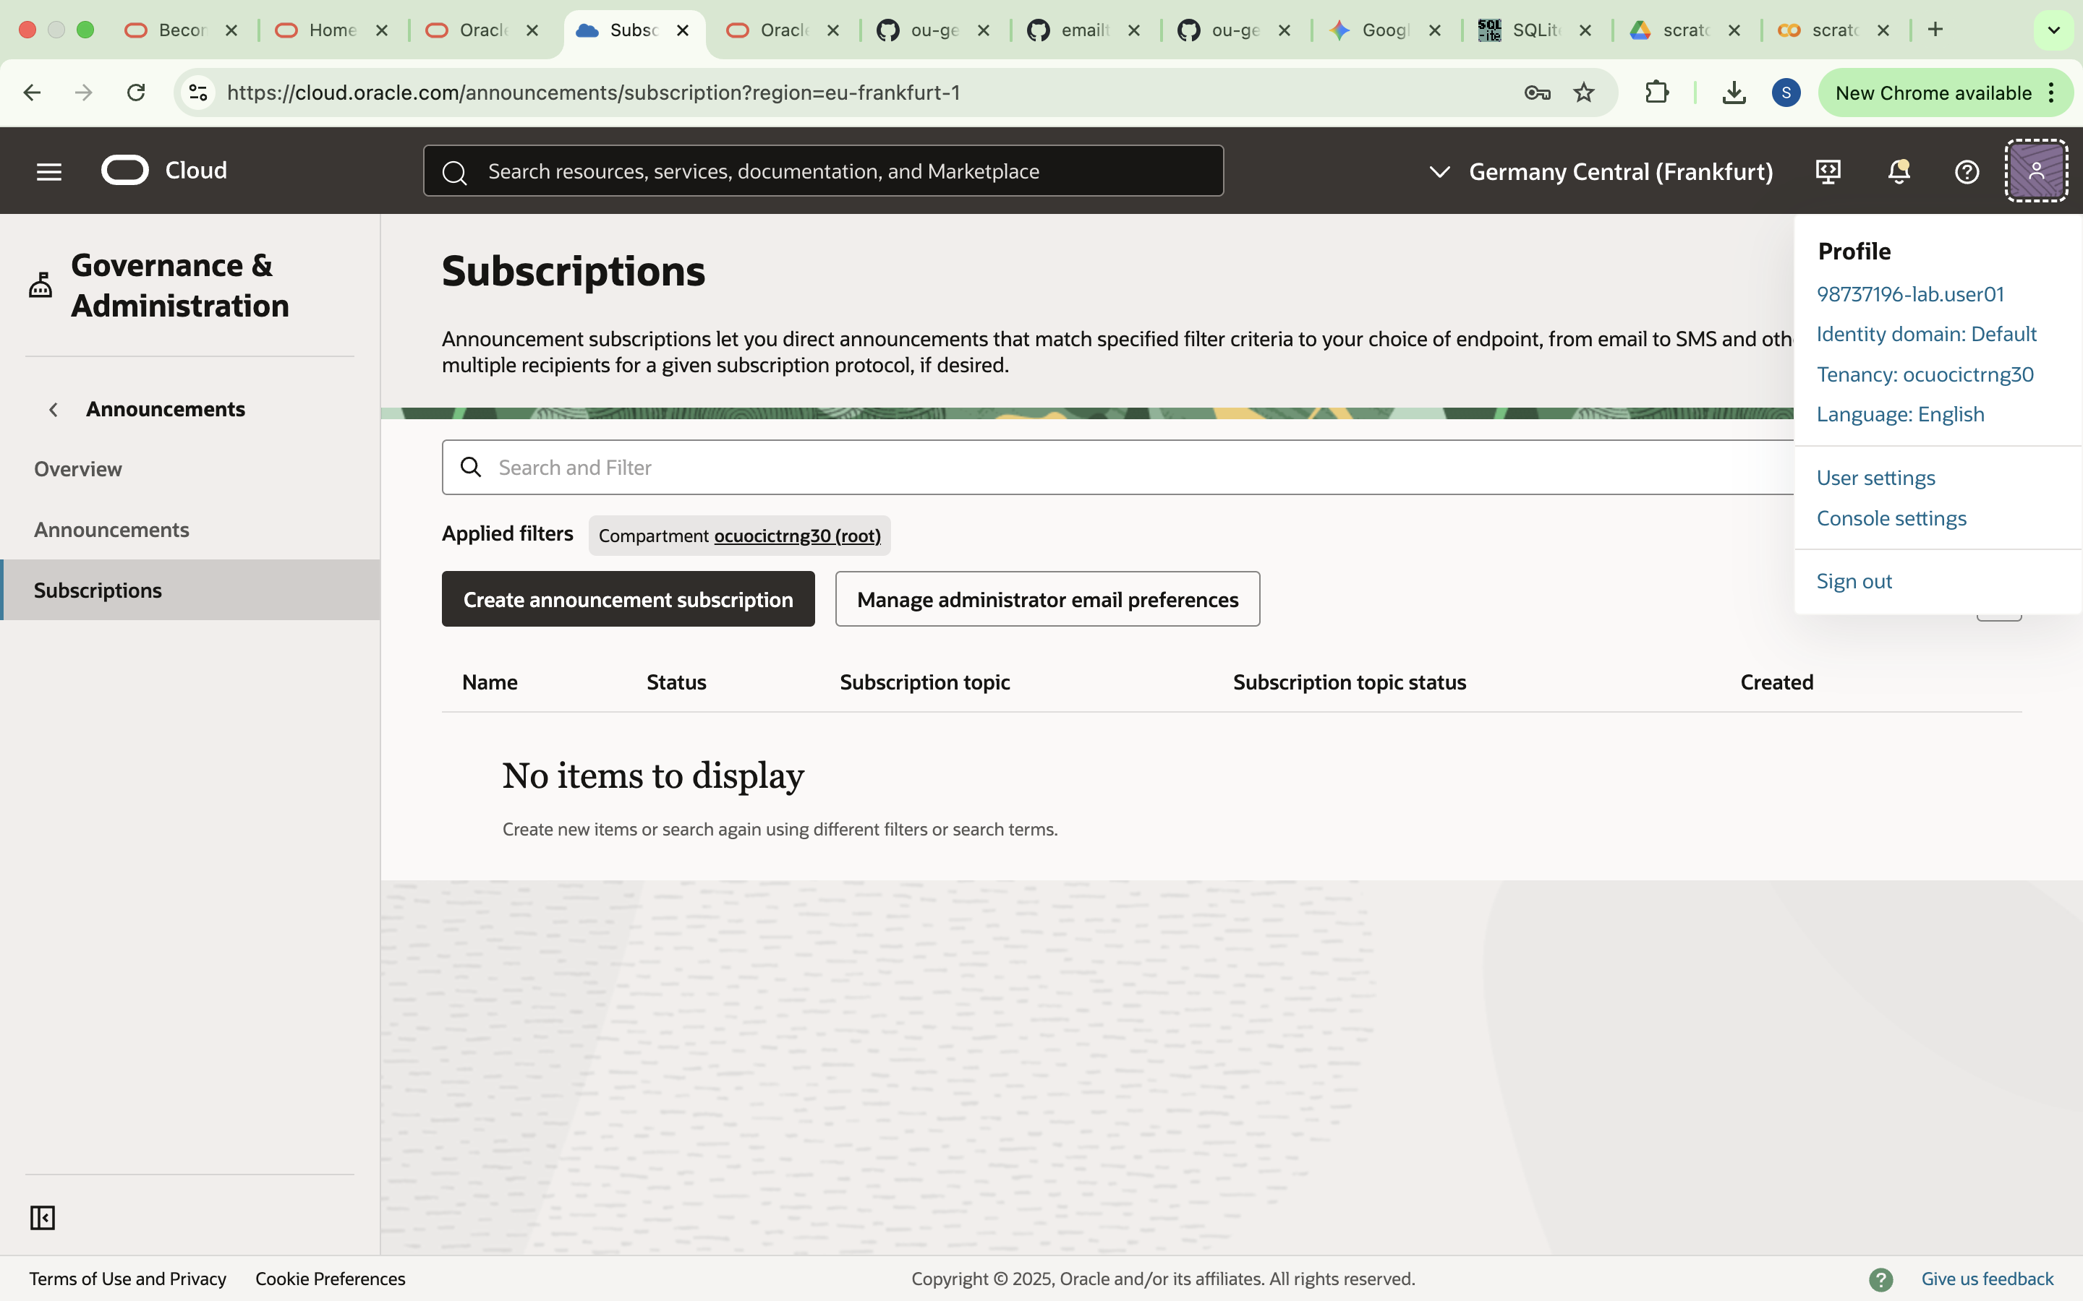

References / Resources Links

https://github.com/ou-developers/ou-generativeai-pro/tree/main/labs

