ACCESSING eCOMMERCE

Each site will have a landing page that a user will initially go to. From there, users will have a navigation menu at the top right of their screen giving displaying different options of access. A user can either **Log In** or **Register**.

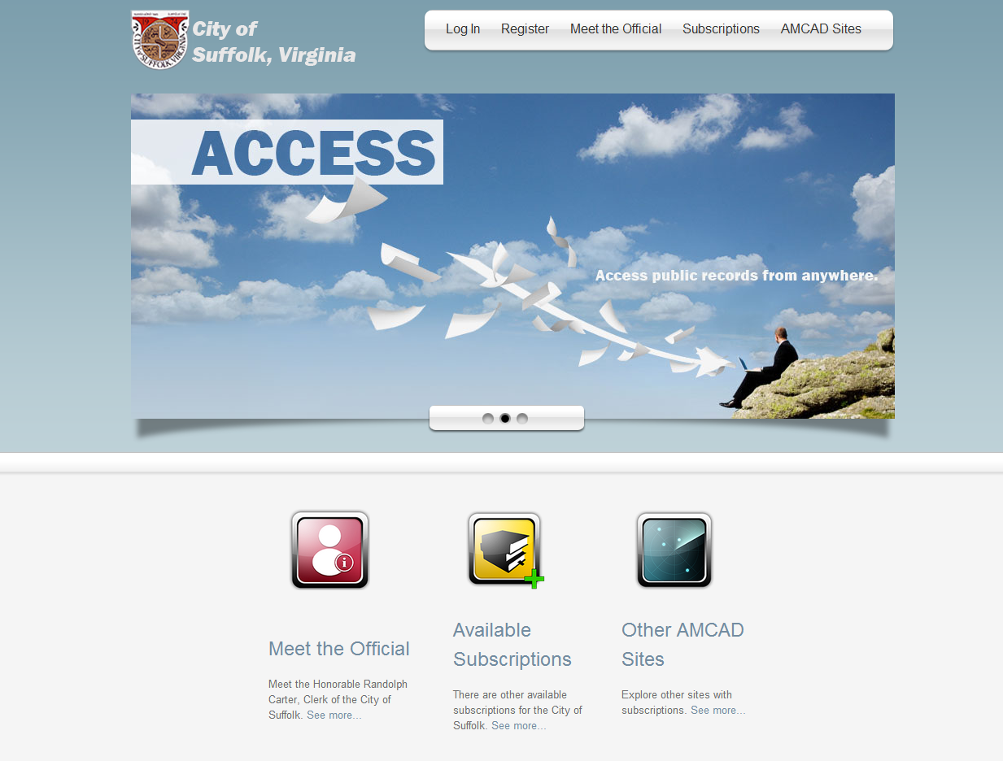

To **Log In**, users will need to provide the e-Mail and Password they registered with. New users can click on the **Register** tab in order to sign up.

Here users can also retrieve their password, in case they forgot it or Resend their Activation Email, in case they did not receive one during the Registration process.

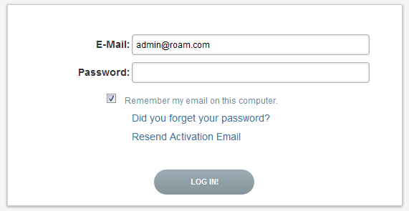

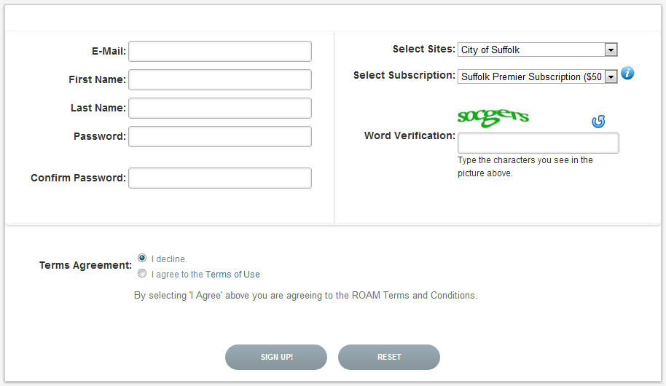

**CREATING A NEW ACCOUNT**

To create a new account, use the **Register tab** from the navigation menu.

The user will be taken to a Registration screen where the following information must be provided:

* **E-Mail** (User Name)
* **First Name**
* **Last Name**
* **Password**
* **Confirm Password**
* **Agreement to** **Terms of Use**
* **Select Sites**: Site which the user wants to subscribe to.
* **Select Subscription**: Here the user can select what type of subscription they would like to have to the Site chosen above. Different Subscriptions will have a different cost. To view the Details of each of these Subscriptions, click the Information  button on the right of the drop down menu.
* **Word Verification**

When all of the required information is provided, submit the filled out form by clicking the **Sing up!** button at the bottom of the screen.

There is also a **Reset** button at the bottom of the screen which clears the form data.

When the account is created successfully, the user will be directed to a new screen where instructions on how to activate the account appear. An e-Mail will be sent to the email used during registration, providing an Activation Link. The user must go to their email and follow the instructions in order to activate the account. If the user tries to log in before they have activated their account through their e-Mail, they will not be able to gain access.

**Resend Activation e-Mail:**

If a user did not receive an Activation e-Mail, the user can request to have another one sent by going to the main **Log In** screen and clicking the Resend Activation Email link at the bottom. The user will be asked to provide the e-Mail address they registered with and submit the form using the  button. The user will receive an e-Mail with instructions on how to activate their account.

**Resetting Password:**

In case a user has forgotten their password, they can simply go to the main **Log In screen** and click the Did you forget your password? link. The user will be asked to prove the e-Mail address they used to register. Once a request is submitted by clicking the button, an email will be sent to the provided e-mail with a Reset Password link. For security purposes, the link will only be valid for 24 hours. When a user clicks the Reset Password link, they will be taken to a new screen where they will be asked to type in and confirm the new password and submit the form using the Change Password button at the bottom. From here the user will be redirected to the main Log In screen automatically or they can click the link provided to return to the main Log In screen.

**AUTHORIZATION**

Some websites may require authorization before a user can continue on to payment and site usage. Registration instructions will be provided on the main landing page, in cases of required authorization. If authorization is required, a user will be notified once they log in. Users will not be able to make a payment until they are authorized by the administrative branch of that site.

After log in, a user will see the Subscription Details screen. Under the Authorization Status column, they will be able to see what their authorization status is.

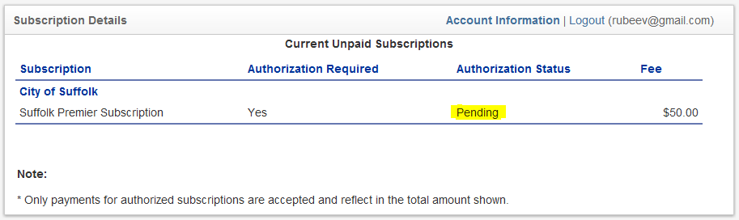

**PAYMENT**

Once a new user logs in, they are redirected to a payment page where they will be able to view **Subscription Details** , the **Subscription Fee** and the **Authorization Status**. To the right, there is an **Add Credit Card to your Account** button which takes the user to the credit card information section.

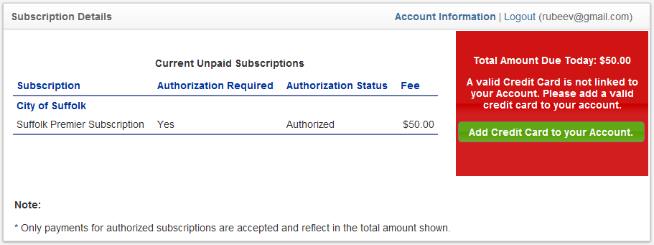

In order to add a credit card to the account, the user has to provide the following, required information:

* Name on Card
* Card Number
* Expiration Month and Year
* Security Code
* Address Line 1 and 2
* City
* State/Province/Region
* Zip
* Phone Number

Once the required information is filled in the user can submit the form using the **Update** button at the bottom of the screen. In case a user wants to exit the credit card update form, they can simply click the **Cancel** link.

Once the credit card has been updated successfully, a message will be displayed notifying the user. To proceed to payment, click the **Return to Account Information** link at the very bottom of the screen.

From the Subscription Details screen, users can click the **Proceed to Payment** button on the right side of the screen.

Users will be redirected to the **Payment Information** screen. Here, users can make a payment using their existing payment information or updating/changing their credit card information by clicking the **Update Credit Card** **Information** link at the top left of the page. 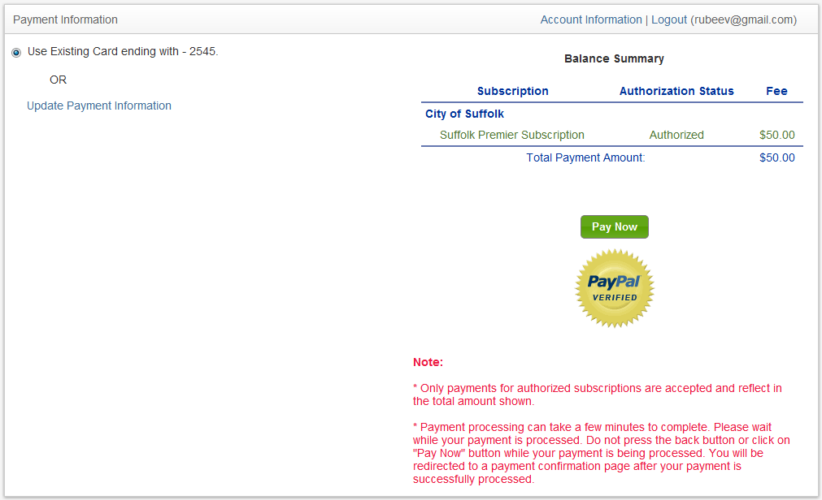

Before making a payment, users can verify their subscription and its cost by looking at the information table provided on the right side of the screen. To continue with the payment, simply click the button.

Once payment is processed successfully, users will be taken to the Payment Confirmation screen where users will be provided with a receipt, transaction number and can print their payment confirmation by clicking the **Print Confirmation** link. From here, users can begin using the search page by clicking the **Continue to Search Page** link or they can return back to their account info screen by clicking the **Return to Account Information** link.

**ACCOUNT INFORMATION**

In the Account Information screen, details regarding a user’s account can be found. Here, a user can **Change Their Password** by clicking the Update link on the right of the Password field. The user can also **change/update their Credit Card** information by clicking the Update link on the right of the Card on File field.

**Terms of Use** can also be viewed on this page as well as **Last Log In Date**, **Amount Due**, **Current Subscriptions**, etc.

**Current Subscriptions**: In the Current Subscriptions table, a user can view the details of the current subscriptions associated with their account. Here they can manage those subscriptions by clicking the Manage link under the Actions column.

**Manage Subscriptions Screen**: Users can **Cancel their current subscriptions** or **Upgrade/Downgrade** them.

To **Cancel** a subscription, simply click the button. The subscription will then be marked for cancellation and an email will be sent to the user notifying them of this change. Note the Subscription Status field. When a subscription is cancelled, the status will automatically change to Inactive. Users retain access to the cancelled subscription until the end the billing cycle, as these subscriptions are non-refundable.

To **Re-active** a valid cancelled subscription, use thebutton. An email will be sent to confirm re-activation.

To **Change** a subscription, use the button. Select the desired subscription by selecting the corresponding radio button on the left of the subscription name and click Change Subscription.

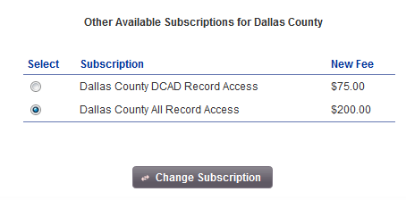

The user will be asked to verify whether they want to change the subscription by a pop up window. If everything is correct, continue with the subscription change by clicking the Yes button on the right of the message, otherwise click the No button on the left of the message to Cancel.

The user will then be redirected to a new screen showing the **Change Subscription Confirmation Details.**

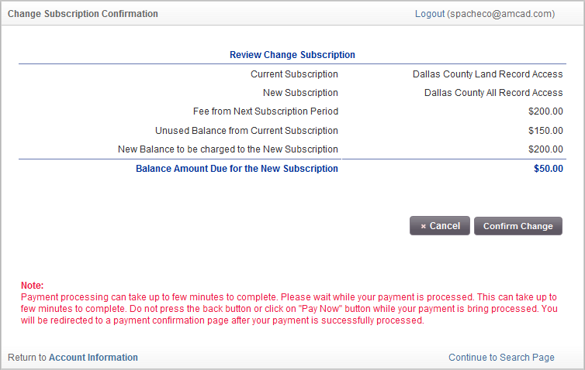**REVIEW CHANGE SUBSCRIPTION**

**Current Subscription:**

This is the current subscription associated with the account. This is also the subscription which is being changed.

**New Subscription:**

This is the new subscription the account is being upgraded/downgraded to.

**Fee from Next Subscription Period:**

This is new the subscription fee which will be billed the following cycle.

**Unused Balance from Current Subscription:**

This amount is calculated by subtracting the unused days of the old subscription from the day the subscription was created to the day the subscription is changed. This dollar amount now becomes the unused balance. If a subscription is being downgraded, there will be a downgrade fee which will be deducted from the unused balance.

**New Balance to be charged to the New Subscription:**

This dollar amount is what the new subscription will cost.

**Balance Amount Due for the New Subscription:**

This amount corresponds to the **New Balance to be charged to the New Subscription** minus the **Unused Balance from Current Subscription**.

If the balance is Positive, the Credit/Debit Card on the account will be charged for the amount. If the value is negative, the amount will be refunded back to the card.

To proceed, simply click the button. To cancel, use the  button to go back to the Account Information screen.

After a successful transaction, the user will be redirected to a **Change Subscription Confirmation** screen. The details of the previous transaction will be displayed as well as a Transaction Reference Number. A Confirmation email will also be sent to the user affirming a successful upgrade/downgrade.

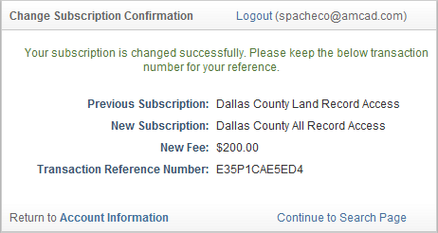

From here, a user can navigate back to their **Account Information** screen or **Continue to the Search Page**.

­­­­­­­­­­­­­­­­In the **Account Information** screen, a user also has the option of **Adding a New Subscription** and **Viewing their Payment History**.

**ADD SUBSCRIPTION** To add a new subscription, click the link at the bottom of the screen. On the Add Subscription screen, the user can find a list of the available subscriptions. To select a subscription to add, simply click the check box on the left of the subscription name. Here, the user can also find the fee for the desired subscription and the subscription type. To view subscription rules, click the icon below the subscription list.

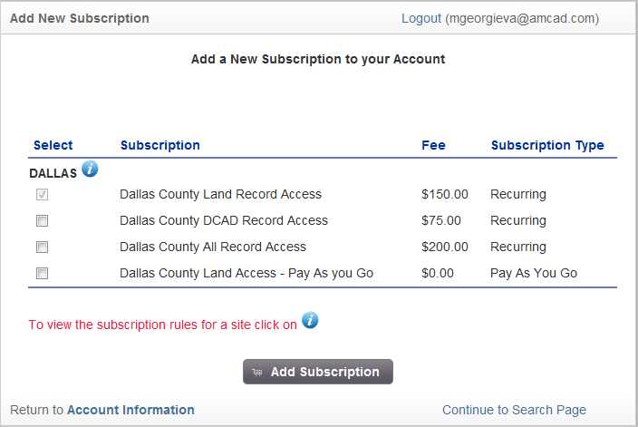

After choosing a new subscription to add, click the button to submit the additions. A confirmation pop-up will appear, prompting the user to confirm the requested changes.

When a subscription is added successfully, the user will be redirected to the **Add Subscription – Success** screen where details of the change will be viewable. Here, the user will also be notified of the fees associated with the newly added subscription.

**VIEW PAYMENT HISTORY** To view the payment history on an account, use the **View Payment History** link to access the payment history screen. Here, a list of all payments, recurring and individual, will be displayed. The user can view transaction details for each payment such as Transaction Reference Number, Site and Access, Card Charged, Amount Charged, etc. To export the document as a PDF, use the  icon above the payment history table.