eCOMMERCE ADMINISTRATION

There are two (2) types of users in eCommerce: **AMCAD Users** and **County Users**. Within these two groups, there are 4 levels of access:

|  |  |  |  |  |  |  |  |
| --- | --- | --- | --- | --- | --- | --- | --- |
| Admin Type | Site Details | User Management | Reporting | Refunds | Admin User Management | Site Configuration | Check Printing |
| General Admin | C:\Users\mgeorgieva\AppData\Local\Microsoft\Windows\Temporary Internet Files\Content.IE5\M6BZS0IY\MC900441310[1].png |  |  |  |  |  |  |
| User Admin | C:\Users\mgeorgieva\AppData\Local\Microsoft\Windows\Temporary Internet Files\Content.IE5\M6BZS0IY\MC900441310[1].png | C:\Users\mgeorgieva\AppData\Local\Microsoft\Windows\Temporary Internet Files\Content.IE5\M6BZS0IY\MC900441310[1].png |  |  |  |  |  |
| Transaction Admin | C:\Users\mgeorgieva\AppData\Local\Microsoft\Windows\Temporary Internet Files\Content.IE5\M6BZS0IY\MC900441310[1].png |  | C:\Users\mgeorgieva\AppData\Local\Microsoft\Windows\Temporary Internet Files\Content.IE5\M6BZS0IY\MC900441310[1].png | C:\Users\mgeorgieva\AppData\Local\Microsoft\Windows\Temporary Internet Files\Content.IE5\M6BZS0IY\MC900441310[1].png |  |  |  |
| Super Admin | C:\Users\mgeorgieva\AppData\Local\Microsoft\Windows\Temporary Internet Files\Content.IE5\M6BZS0IY\MC900441310[1].png | C:\Users\mgeorgieva\AppData\Local\Microsoft\Windows\Temporary Internet Files\Content.IE5\M6BZS0IY\MC900441310[1].png | C:\Users\mgeorgieva\AppData\Local\Microsoft\Windows\Temporary Internet Files\Content.IE5\M6BZS0IY\MC900441310[1].png | C:\Users\mgeorgieva\AppData\Local\Microsoft\Windows\Temporary Internet Files\Content.IE5\M6BZS0IY\MC900441310[1].png | C:\Users\mgeorgieva\AppData\Local\Microsoft\Windows\Temporary Internet Files\Content.IE5\M6BZS0IY\MC900441310[1].png | C:\Users\mgeorgieva\AppData\Local\Microsoft\Windows\Temporary Internet Files\Content.IE5\M6BZS0IY\MC900441310[1].png | C:\Users\mgeorgieva\AppData\Local\Microsoft\Windows\Temporary Internet Files\Content.IE5\M6BZS0IY\MC900441310[1].png |

To become an **eCommerce Administrator**, an account must be created, just like you would a regular user. From the **Log In** screen, click the **Create Your Accoun**t link to begin.

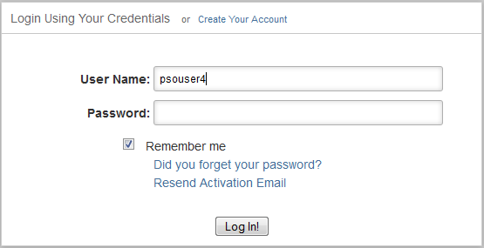

**Create New Account**:

To create an account, the user must provide the following required information:

* User Name
* First Name
* Last Name
* Password and Confirm Password
* Agreement to the Terms of Use
* Select Site to access
* Word Verification

Once these fields are filled in correctly, the user can submit the form by clicking the  button. If the user desires to clear the filled out form, simply click the  button.

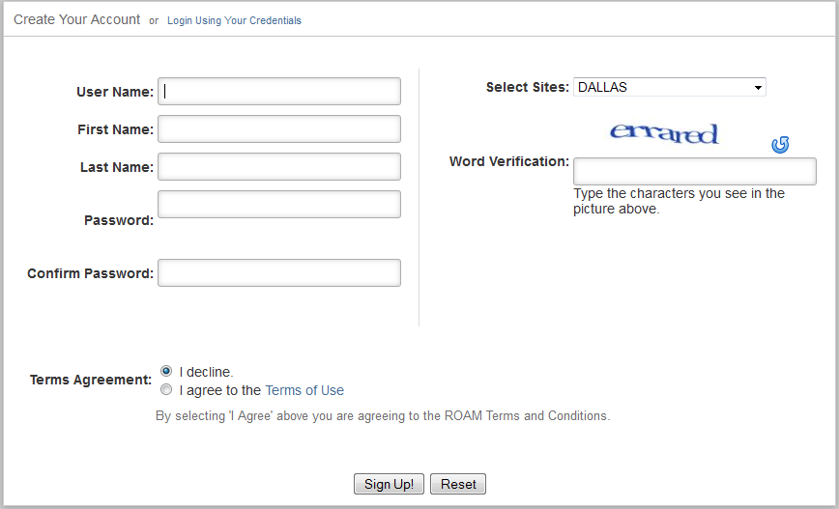

An activation e-Mail will be sent to the provided user email with an activation link. Follow the instructions on the email to set up the account. Once the user has clicked on the **Activate My Account** link provided in the e-Mail, they should be shown a **Your Account has been Created Successfully** page.

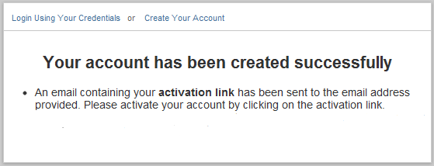

**LOGGING IN:**

When a user tries to Log In for the first time, after activating their account, they will be denied access and an **Account Locked** message will appear. Based on requirements, a user has to first verify their identity with the Administrative Brach of the site they are trying to access by providing the requested information. Once a user is verified, their account will be Unlocked by an AMCAD Administrator and their access level will be set.

When the account is Unlocked, the user will be able to access the Administration Module using their credentials.

**Administrators *Important Note\***

The following Administrator descriptions are general. AMCAD administrators can set specific user access in the **Admin User Management** section under the **Administration** tab.

To set an admin users’ specific access privileges, AMCAD admins can go to the Admin User Management section and select the user they wish to modify. By clicking on the  button at the far right of the user list table, the AMCAD admin will be taken to a User Information section where user details along with Assigned Accesses will be available. A Lock/Unlock feature is also available. To set the user site access, simply click the check box next to the functionality the user is authorized to view/use and **Save Settings**.

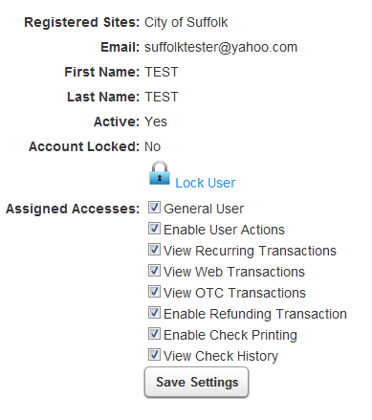

**AMCAD General Admin Dashboard**

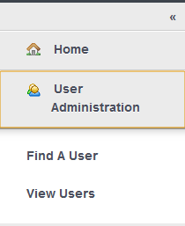**HOME TAB:** The **Home** screen on the General Admin Dashboard will display the List of Sites and their general details. To view more specific Details for a particular site, click on the Info  button all the way to the right.

* In the Site Detail section, an Admin can view the following things:
  + Interactive pie charts showing User Distribution for available subscriptions for that site.
  + Site Information
  + Site Fees
  + Available Site Subscriptions
    - In the column named **Has Additional Fees**, a green check mark will appear if the subscription has additional fees. By clicking on the green check mark, an Admin can view those fees and their details.
  + Merchant Fee Information
  + Check Details

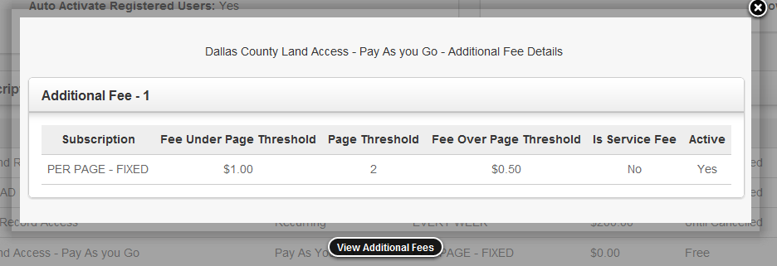

**USERS TAB:** Under the Users Tab, an Admin can either **Find a User** or **View a list of Users**.

* **Find a User**: There are three available boxes in which an Admin can search for a user, First Name, Last Name and User Name (e-Mail). An Admin can search for only one criteria at a time or a combination of the three. If an Admin is searching for all three of the criteria at the same time, the record must match the information in the input boxes exactly or no records will return.



* + Submit the form by clicking the  button and a list of matching users will display below.
  + The User Name will be displayed along with general information. If an Admin wants to view more details, like subscription information or update a credit card, they must click the Info  button. An Admin can also export a PDF or Excel spreadsheet.
    - **User Details Screen**: User details are broken up into three sections:
      * **User Details** such as e-Mail, Name, Active status, last four (4) digits of their credit card number and the card status
    - **Subscription Details** include the Site a user is subscribed to as well as Name and Type of Subscription, Fee, Status, Last Billing Date, Next Billing Date, etc.
    - **Recurring Payment History:** If a user has a Recurring Payment subscription, their recurring transactions will appear in this section. Details of each transaction such as Transaction Date, Transaction Number, Site, Subscription, PayPal ID, Last 4 digits of their Credit Card, Name, Amount, etc. are included.
    - **Web Payment History:** If a user has a Pay-As-You-Go subscription which allows them to purchase documents on an individual basis, their web transactions will appear in this section.
* **View Users**: Under the View Users section, a list of all the users, either Active or Inactive, will display with general details. If an Admin wants to view specific details on a user, they can use the Info  button. An Admin can also export the list into a PDF or Excel spreadsheet.

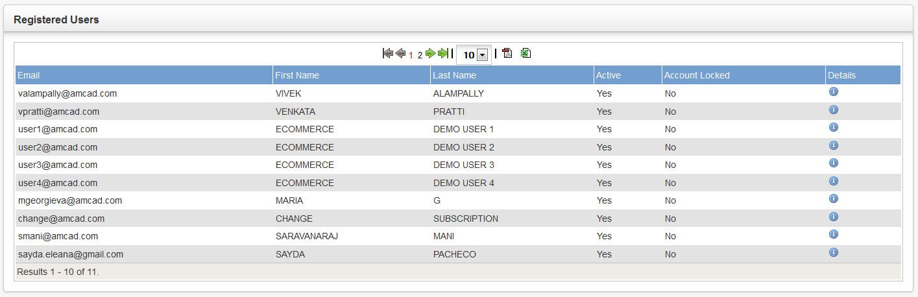

**AMCAD User Admin Dashboard**

**HOME TAB:** The **Home** screen on the General Admin Dashboard will display the List of Sites and their general details. To view more specific Details for a particular site, click on the Info  button all the way to the right.

* In the Site Detail section, an Admin can view the following things:
  + Interactive pie charts showing User Distribution for available subscriptions for that site.
  + Site Information
  + Site Fees
  + Available Site Subscriptions
    - In the column named **Has Additional Fees**, a green check mark will appear if the subscription has additional fees. By clicking on the green check mark, an Admin can view those fees and their details.
  + Merchant Fee Information
  + Check Details

**USERS TAB:** Under the Users Tab, an Admin can either **Find a User** or **View a list of Users**.

* **Find a User**: There are three available boxes in which an Admin can search for a user, First Name, Last Name and User Name (e-Mail). An Admin can search for only one criteria at a time or for all three. If an Admin is searching for all three of the criteria at the same time, the record must match the information in the input boxes exactly or no records will return.
  + Submit the form by clicking the **Submit** button and a list of matching users will display below.
  + The User Name will be displayed along with general information. If an Admin wants to view more details, like subscription information or update a credit card, they must click the Info  button. An Admin can also export a PDF or Excel spreadsheet.
    - **User Details Screen**: User details are broken up into three sections. Here, a User Administrator can Unlock non-admin users.
      * **User Details** such as e-Mail, Name, Active status, last four (4) digits of their credit card number and the card status. An **Update** link is available next to the card number where an Admin can go and update a user’s credit card.
        + When an Admin clicks the **Update** link, a pop up appears with the user’s stored card information. The Admin can make changes to any of the card information including the Name on the card, card number or address of the card holder.
        + Once the changes are made, the Admin can submit the changes by clicking the **Update** button where the information is sent to be verified.
        + To **Unlock** a non-admin user (who has previously been locked at the site level), the Admin must use the Unlock User link below the user information box. When the Admin clicks the Unlock link, the user’s Account Locked status will automatically change.
* **Subscription Details** include the Site a user is subscribed to as well as Type of Subscription, PayPal ID, Fee, Status, Last Billing Date and Next Billing Date.
  + - **Recurring Payment History:** If a user has a Recurring Payment subscription, their recurring transactions will appear in this section. Details of each transaction such as Transaction Date, Transaction Number, Site, Subscription, PayPal ID, Last 4 digits of their Credit Card, Name, Amount, etc. are included.An Admin can click the Transaction Number link to view specific details of that particular transaction.
    - **Web Payment History:** If a user has a Pay-As-You-Go subscription which allows them to purchase documents on an individual basis, their web transactions will appear in this section. An Admin can click the Transaction Number link to view specific details of that particular transaction.
* **View Users**: Under the View Users section, a list of all the users, either Active or Inactive, will display with general details. If an Admin wants to view specific details on a user or lock/unlock them, they can use the Info  button. An Admin can also export a PDF or Excel spreadsheet.

**AMCAD Transaction Administrator**

**HOME TAB:** The **Home** screen on the General Admin Dashboard will display the List of Sites and their general details. To view more specific Details for a particular site, click on the Info  button all the way to the right.

* In the Site Detail section, an Admin can view the following things:
  + Interactive pie charts showing User Distribution for available subscriptions for that site.
  + Site Information
  + Site Fees
  + Available Site Subscriptions
    - In the column named **Has Additional Fees**, a green check mark will appear if the subscription has additional fees. By clicking on the green check mark, an Admin can view those fees and their details.
  + Merchant Fee Information
  + Check Details

**USERS TAB:** Under the Users Tab, an Admin can either **Find a User** or **View** a list of Users.

* **Find a User**: There are three available boxes in which an Admin can search for a user, First Name, Last Name and User Name (e-Mail). An Admin can search for only one criteria at a time or a combination of all three. If an Admin is searching for all three of the criteria at the same time, the record must match the information in the input boxes exactly or no records will return.
  + Submit the form by clicking the **Submit** button and a list of matching users will display below.
  + The User Name will be displayed along with general information. If an Admin wants to view more details, like subscription information or update a credit card, they must click the Info  button. An Admin can also export the list of users to a PDF or Excel spreadsheet.
    - **User Details Screen**: User details are broken up into three sections:
      * **User Details** such as e-Mail, Name, Active status, last four (4) digits of their credit card number and the card status.
    - **Subscription Details** include the Site a user is subscribed to as well as Type of Subscription, Fee, Status, Last Billing Date, Next Billing Date and so forth.
    - **Recurring Payment History:** If a user has a Recurring Payment subscription, their recurring transactions will appear in this section. Details of each transaction such as Transaction Date, Transaction Number, Site, Subscription, PayPal ID, Last 4 digits of their Credit Card, Name, Amount, etc. are included.An Admin can click the Transaction Number link to view specific details of that particular transaction.
    - **Web Payment History:** If a user has a Pay-As-You-Go subscription which allows them to purchase documents on an individual basis, their web transactions will appear in this section. An Admin can click the Transaction Number link to view specific details of that particular transaction.
* **View Users**: Under the View Users section, a list of all the users, either Active or Inactive, will display with general details. If an Admin wants to view specific details of a user, they can use the Info  button. An Admin can also export the list as a PDF or Excel spreadsheet.

**REPORTS TAB:** There are five (5) sections under the Transaction Administration tab: **Recurring Transactions**, **Over the Counter Transactions**, **Web Transactions**, **Grand Total Report** and **Transaction Lookup**. Here a Transaction Admin can search and view both over the counter and web transactions, as well refund transactions.

* **Recurring, Over the Counter** and **Web Transactions**: In these three (3) sections, an Admin can generate detailed reports for each of these types of transactions.
  + To generate these reports, an Admin must select the **Date Range** they wish to view as well as the **Site** and **Transaction Type** (charge, refund or both).

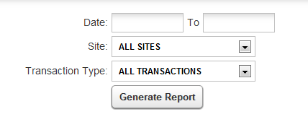

* + Once the Admin has filled in the necessary information, they can search by clicking the **Generate Report** button. Below the input boxes, a window will appear containing the Summary Report. By default, the report will be displayed in HTML mode. If a user is having trouble viewing the Summary Report in HTML, they should try using the Switch to Advanced Viewer link at the top right of the screen, which would display the report in JAVA mode.
    - **Summary Report**: To save, print, scroll thought pages and zoom in/out of a document, the Admin can use the controls available to them above the document window. The report can also be exported to PDF, Excel and Word document, if desired, by clicking the icons.
      * The Summary Report contains detailed information about the transactions the Admin chooses to view. The report includes transaction date, transaction number, last four (4) digits of the card charged, name on card, transaction type, machine name, service fee, amount charged/refunded, etc. The final column tallies up the report amount and provides a grand total for that site and transaction type. AMCAD administrators will be able to see the AMCAD share column, while clients will not.
      * The Total amounts displayed at the end of the report will be broken down into
* **Grand Total Report**: In this section, Administrators can generate grand total reports
  + To view these reports, an Admin must select the **Date Range** and **Site** they wish to view.

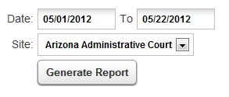

* + Once the Admin has filled in the necessary information, they can search by clicking the **Generate Report** button. Below the input boxes, a window will appear containing the Summary Report. If a user is having trouble viewing the Summary Report (powered by JAVA), they should try using the View in HTML Mode link at the top right of the screen, which would display the report in plain HTML text.
    - **Grand Total Report**: To save, print, scroll thought pages and zoom in/out of a document, the Admin can use the controls available to them above the document window. The report can also be exported to PDF, Excel and Word document, if desired, by clicking the icons.
      * The Grand Total Report contains detailed information about the total transactions per site per selected date range. The report includes a list of subscriptions under the selected site, total amount for each of those subscriptions as well as a breakdown of the Fees, Transactions Totals, Net Profit, Client Share and AMCAD Share for the site and subscriptions.
      * The Transaction # column will appear as a link, which, when clicked, will take the admin to the Transaction Lookup tab (see below for a more detailed explanation about Transaction Lookup).
* **Transaction Lookup**: To look up a transaction, a Transaction Admin will need to provide one or more of the available criteria plus the **Payment Type** (over the counter, web or recurring) in order to search.

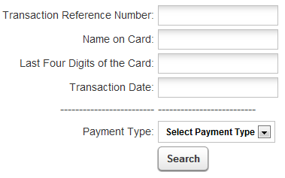

* Once the necessary information is filled in, remember the Payment Type must be selected, the Admin can run the search by pressing the **Search** button. If there is a matching record(s), it will appear below the search boxes.
  + **Transactions list**: Contains transaction details like reference number, date, last four (4) digits of credit card number, name on card, transaction amount and transaction type. To view further details of a particular transaction, click the  button in the View Details column.
  + **View Details:** Within this, an Admin will see three sections**: Transaction Information, Payment Details** and **Additional Transaction Information.**
    - **Transaction Information:** Details such as Transaction Reference Number, Transaction Date, Transaction Type and Site Name are viewable here.
    - **Payment Details:** This section contains the last four (4) digits of the credit card number used, the name on the card, the amount of the transaction and a Refund Entire Transaction link. To refund a transaction fully, click the provided link.
      * 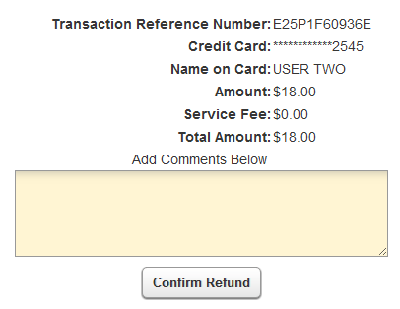**Refund Entire Transaction:** In order to do a refund, an Admin will have to add a comment as to why the refund is being made. To do this, simply type in the comment into the blank text box provided below the transaction information. To complete the refund, click the button.
        + When a refund is complete, the admin will get a message confirming the successful refun as well as a Refund Transaction Reference Number, Original Transaction Reference Number and the Amount Refunded.
      * **Partial Refund**: Administrators have the option of doing a partial refund on a transaction. Partial refunds will almost always apply to Web Transactions, as users can purchase more than one item at a time. To do a partial refund, ther Admin must click the Refun Item link located in the Action column inside the **Web Purchase Details** screen. Type a comment into the blank text box provided below the transaction information and complete the refund by clicking the button.
        + When a refund is complete, the admin will get a message confirming the successful refun as well as a Refund Transaction Reference Number, Original Transaction Reference Number and the Amount Refunded.
        + The refund will then appear in the Web Purchases Details section under the Purchases table, as Refunds. The refund transaction will be listed as well as its details and comments.
    - **Web Purchase Details**: Within the Web Purchase Details section, purchases and refunds dealing with web transactions will be listed along with their details and the option to refund, where applicable. To do a partial refund on a single item, click the the Refun Item link located in the Action column.
    - **Additional Transaction Information**: Additional information pertaining to the user and/or transactions will be listed here. Info like the Client Machine Name (IP Address) can be found here.

**AMCAD Super Administrator**

**HOME TAB:** The **Home** screen on the General Admin Dashboard will display the List of Sites and their general details. To view more specific Details for a particular site, click on the Info  button all the way to the right.

* In the Site Detail section, an Admin can view the following things:
  + Interactive pie charts showing User Distribution for available subscriptions for that site.
  + Site Information
  + Site Fees
  + Available Site Subscriptions
    - In the column named **Has Additional Fees**, a green check mark will appear if the subscription has additional fees. By clicking on the green check mark, an Admin can view those fees and their details.
  + Merchant Fee Information
  + Check Details

**USERS TAB:** Under the Users Tab, an Admin can either **Find a User** or **View** a list of Users.

* **Find a User**: There are three available boxes in which an Admin can search for a user, First Name, Last Name and User Name (e-Mail). An Admin can search for only one criteria at a time or a combination of all three. If an Admin is searching for all three of the criteria at the same time, the record must match the information in the input boxes exactly or no records will return.
  + Submit the form by clicking the **Submit** button and a list of matching users will display below.
  + The User Name will be displayed along with general information. If an Admin wants to view more details, like subscription information or update a credit card, they must click the Info  button. An Admin can also export the list of users to a PDF or Excel spreadsheet.
    - **User Details Screen**: User details are broken up into three sections:
      * **User Details** such as e-Mail, Name, Active status, last four (4) digits of their credit card number and the card status.
    - **Subscription Details** include the Site a user is subscribed to as well as Type of Subscription, Fee, Status, Last Billing Date, Next Billing Date and so forth.
    - **Recurring Payment History:** If a user has a Recurring Payment subscription, their recurring transactions will appear in this section. Details of each transaction such as Transaction Date, Transaction Number, Site, Subscription, PayPal ID, Last 4 digits of their Credit Card, Name, Amount, etc. are included.An Admin can click the Transaction Number link to view specific details of that particular transaction.
    - **Web Payment History:** If a user has a Pay-As-You-Go subscription which allows them to purchase documents on an individual basis, their web transactions will appear in this section. An Admin can click the Transaction Number link to view specific details of that particular transaction.
* **View Users**: Under the View Users section, a list of all the users, either Active or Inactive, will display with general details. If an Admin wants to view specific details of a user, they can use the Info  button. An Admin can also export the list as a PDF or Excel spreadsheet.

**ADMINISTRATION TAB (AMCAD users only):** Under the Administration Tab, the Super Admin can manage the **Site Configurations**, **Administrative Users,** view the **Error Log** and **Refresh the cached data**.

* **Configuration**: Under the Configuration tab, a Super Admin can configure both **Nodes** and **Sites**.
  + **Nodes**: Within in the nodes, an admin can configure the From e-Mail and Subject Line Text for all alert and email notification coming out of that particular node. The following emails/alerts can be configured:
    - **From Email, Reset Password Subject Line, User Activation Subject Line, Lock/Unlock User Account Notification Subject Line** and **Alert Notification Subject Line.**
  + **Sites:** Within in the nodes, an admin can configure the From e-Mail and Subject Line Text for all alert and email notification coming out of that particular site. The following emails/alerts can be configured:
    - **From Email, Change Subscription Confirmation Subject Line, Cancel Subscription Confirmation Subject Line, Reactivate Subscription Confirmation Email Subject Line, Recurring Payment Success Subject Line, Recurring Payment Failure Subject Line, Web Payment Confirmation Subject Line, Remove Subscription Confirmation Subject Line** and **Access Authorization Confirmation Subject Line.**

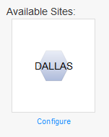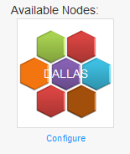

* + - To save changes to a field, the admin can simply click the  button at the bottom of the form.
* 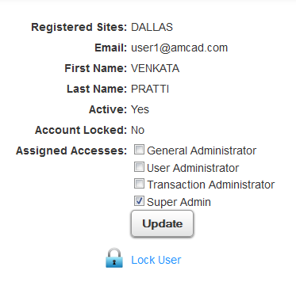**Admin User Management**: A list of users is available with general details. If a Super Admin wants to change the level of an administration of a particular user or lock/unlock them, they use can do this by clicking the Info  button under the Details column.
  + **Admin User Information**: Here the Super Admin can change the Assigned Access of other admin users by selecting one of the check boxes. The four(4) available accesses are:
    - General Administrator
    - User Administrator
    - Transaction Administrator
    - Super Administrator
    - A Super Administrator can also Lock and Unlock admin users by clicking the  Lock User/Unlock User link at the bottom of the user information box. A comment box will appear along with the option to notify the user if they are being locked/unlocked. When the Admin either clicks Notify or Do not Notify User, the user’s status will automatically change accordingly.
* **Error Log**: Super Admins can track errors in this section. To do so, they can either view logs by date or by user name. Simply input the desired criteria and click the **Submit** button. If there is an error, it will display the error text along with the user associated with it.
* **Refresh Cache Data**: After making changes to the site, like changing the Node Configuration, a Super Admin can refreshed all cached data available in the Cache List to make sure that all information displayed is the latest.

**REPORTS TAB:** There are five (5) sections under the Transaction Administration tab: **Recurring Transactions**, **Over the Counter Transactions**, **Web Transactions**, **Grand Total Report** and **Transaction Lookup**. Here a Transaction Admin can search and view both over the counter and web transactions, as well refund transactions.

* **Recurring, Over the Counter** and **Web Transactions**: In these three (3) sections, an Admin can generate detailed reports for each of these types of transactions.
  + To generate these reports, an Admin must select the **Date Range** they wish to view as well as the **Site** and **Transaction Type** (charge, refund or both).



* + Once the Admin has filled in the necessary information, they can search by clicking the **Generate Report** button. Below the input boxes, a window will appear containing the Summary Report. By default, the report will be displayed in HTML mode. If a user is having trouble viewing the Summary Report in HTML, they should try using the Switch to Advanced Viewer link at the top right of the screen, which would display the report in JAVA mode.
    - **Summary Report**: To save, print, scroll thought pages and zoom in/out of a document, the Admin can use the controls available to them above the document window. The report can also be exported to PDF, Excel and Word document, if desired, by clicking the icons.
      * The Summary Report contains detailed information about the transactions the Admin chooses to view. The report includes transaction date, transaction number, last four (4) digits of the card charged, name on card, transaction type, machine name, service fee, amount charged/refunded, etc. The final column tallies up the report amount and provides a grand total for that site and transaction type. AMCAD administrators will be able to see the AMCAD share column, while clients will not.
      * The Total amounts displayed at the end of the report will be broken down into
* **Grand Total Report**: In this section, Administrators can generate grand total reports
  + To view these reports, an Admin must select the **Date Range** and **Site** they wish to view.



* + Once the Admin has filled in the necessary information, they can search by clicking the **Generate Report** button. Below the input boxes, a window will appear containing the Summary Report. If a user is having trouble viewing the Summary Report (powered by JAVA), they should try using the View in HTML Mode link at the top right of the screen, which would display the report in plain HTML text.
    - **Grand Total Report**: To save, print, scroll thought pages and zoom in/out of a document, the Admin can use the controls available to them above the document window. The report can also be exported to PDF, Excel and Word document, if desired, by clicking the icons.
      * The Grand Total Report contains detailed information about the total transactions per site per selected date range. The report includes a list of subscriptions under the selected site, total amount for each of those subscriptions as well as a breakdown of the Fees, Transactions Totals, Net Profit, Client Share and AMCAD Share for the site and subscriptions.
      * The Transaction # column will appear as a link, which, when clicked, will take the admin to the Transaction Lookup tab (see below for a more detailed explanation about Transaction Lookup).
* **Transaction Lookup**: To look up a transaction, a Transaction Admin will need to provide one or more of the available criteria plus the **Payment Type** (over the counter, web or recurring) in order to search.



* Once the necessary information is filled in, remember the Payment Type must be selected, the Admin can run the search by pressing the **Search** button. If there is a matching record(s), it will appear below the search boxes.
  + **Transactions list**: Contains transaction details like reference number, date, last four (4) digits of credit card number, name on card, transaction amount and transaction type. To view further details of a particular transaction, click the  button in the View Details column.
  + **View Details:** Within this, an Admin will see three sections**: Transaction Information, Payment Details** and **Additional Transaction Information.**
    - **Transaction Information:** Details such as Transaction Reference Number, Transaction Date, Transaction Type and Site Name are viewable here.
    - **Payment Details:** This section contains the last four (4) digits of the credit card number used, the name on the card, the amount of the transaction and a Refund Entire Transaction link. To refund a transaction fully, click the provided link.
      * **Refund Entire Transaction:** In order to do a refund, an Admin will have to add a comment as to why the refund is being made. To do this, simply type in the comment into the blank text box provided below the transaction information. To complete the refund, click the button.
        + When a refund is complete, the admin will get a message confirming the successful refun as well as a Refund Transaction Reference Number, Original Transaction Reference Number and the Amount Refunded.
      * **Partial Refund**: Administrators have the option of doing a partial refund on a transaction. Partial refunds will almost always apply to Web Transactions, as users can purchase more than one item at a time. To do a partial refund, ther Admin must click the Refun Item link located in the Action column inside the **Web Purchase Details** screen. Type a comment into the blank text box provided below the transaction information and complete the refund by clicking the button.
        + When a refund is complete, the admin will get a message confirming the successful refun as well as a Refund Transaction Reference Number, Original Transaction Reference Number and the Amount Refunded.
        + The refund will then appear in the Web Purchases Details section under the Purchases table, as Refunds. The refund transaction will be listed as well as its details and comments.

**\*\*Note**: If a refund on a recurring subscription is made, it is up to the administrative user to go and remove access to the subscription immediately. Otherwise, the refunded user will still have access until it is removed.

* + - **Web Purchase Details**: Within the Web Purchase Details section, purchases and refunds dealing with web transactions will be listed along with their details and the option to refund, where applicable. To do a partial refund on a single item, click the the Refun Item link located in the Action column.
    - **Additional Transaction Information**: Additional information pertaining to the user and/or transactions will be listed here. Info like the Client Machine Name (IP Address) can be found here.

**CHECK PRINTING TAB:**  From the Check Printing Tab, Super Admins can **Print Checks**, **View Check History**, view a **Check Details Report** and generate a **Check Reconciliation Report**.

* **Print Check**: To print a check, an admin must fill in/select the following three criteria: Date Range, Site and Transaction type (recurring, over the counter or web). Once the required fields are filled in, click the Generate Check button. A check will display below, showing the Date, Name of Site the check is being generated for, amount, check number, bank name and other related information.
  + An admin can print the check by clicking the printer icon at the top left of the report.
* **View Check History**: This report enables administrators to track checks for their site. Select the **date range** and **site** desired and click the **Get Check History** button. A report will display below with the following details: Check Number, Check Date, Site, Bank Name, Payment Type, Total Transactions, Voided (Y/N), the IP Address of the person who generated the check, User ID/eMail of the person who generated the check, Comments, Check Amount and a link to Void the check .
  + **Check Details**: To view check details, an admin can click on the check number link inside the first column of the report. This will generate a Check Detail report which will show the check information in full. The check details show the individual transactions and their respective information that make up the total amount for the check. From here, an admin can go to specific transactions by clicking the transaction number link located under the Transaction # column.
  + **Void Check**: Click the red link under the Void column. This will take the admin to a Check Details Screen where details about the check the admin is trying to void will be available. Once the admin has verified that it is the correct check, they can simply click the Confirm Check Void button to void the check. A comments pop up will appear. An admin must enter a reason or they will not be able to complete the void. When comments have been added, click the **Add Comments and Void** button to finish. The Voided column will automatically update to reflect the check status.
* **Check Detail Report**: An Admin can see specific transactions that are part of a check in this section. To generate a details report, simply fill in the date range and site desired or the specific check number and click the Generate Report button. This will generate a Check Detail report which will show the check information in full. The check details show the individual transactions and their respective information that make up the total amount for the check. From here, an admin can go to specific transactions by clicking the transaction number link located under the Transaction # column.
* **Check Reconciliation Report (AMCAD only)**: To generate a report, input the date range desired and click the Generate Report button. A report will display below. To navigate use the arrows provided at the top of the report. To export to PDF, Excel or Word doc, click the available icons at the top left.
  + **Grand Total Report**: The grand total reconciliation report contains information regarding all generated checks for all sites. Here, Super admins can track check and account deposits. The account number as well as check number, transaction type (credit: funds deposited into the AMCAD account or debit: funds taken out of the AMCAD account), description, transaction date, posted date, verified/matched check and transaction amount are all available.
    - To view the details of a specific check, the admin can click on the check number link under the Check Number column. This will take them to Check Details.