PSEUDOCODE FOR STORE CHECKOUT AFTER PURCHASE

START

INPUT customer_name
INPUT item_name
INPUT quantity
INPUT price

COMPUTE total = quantity * price

PRINT customer_name
PRINT item_name
PRINT quantity
PRINT price
PRINT total

PRINT “Thank you for shopping with us!”
STOP

STORE CHECKOUT MORNING ROUTINE
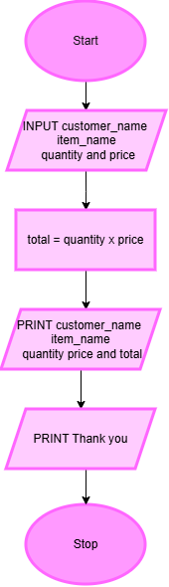
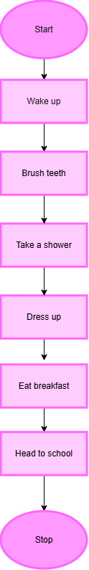

ALGORITHM TO SWAP AGES
Step 1 : START
Step 2 : INPUT name1
INPUT age1
Step 3: INPUT name2
INPUT age2
Step 4: temp = age1
age1 = age2
age2 = temp
Step 5: PRINT name1, age1
PRINT name2, age2
Step 6: STOP

