

**Make you ideal fun**



CH34XUSB-SERIAL DRIVER INSTALLATION INSTRUCTIONS

**Version:V2.0**

SupportSystem:

OSX10.9andabove

InstallationProcess:

Extract the contents of the zip file to a local installation directory Double-clickCH34x_Install.pkg

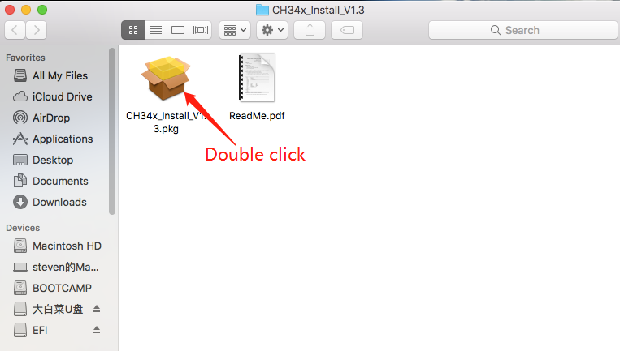

Install according to the installation on procedure

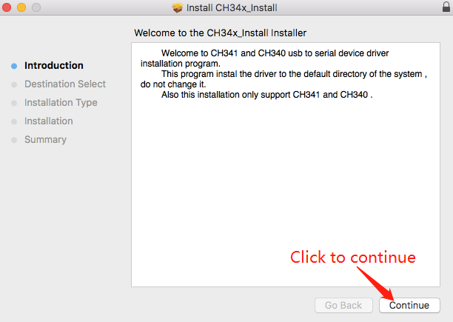

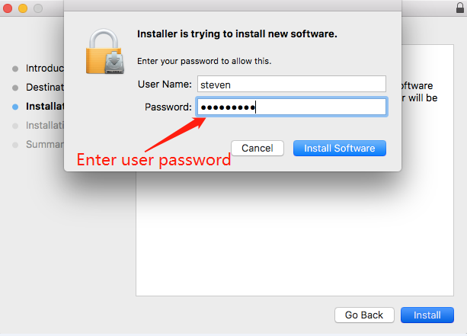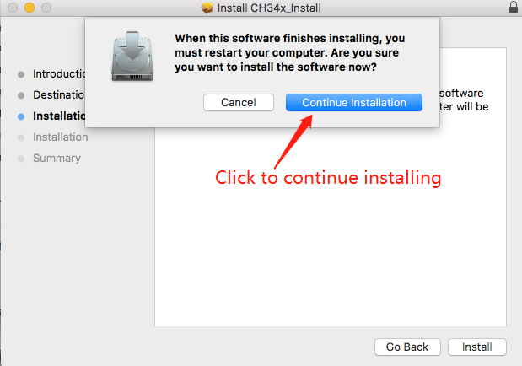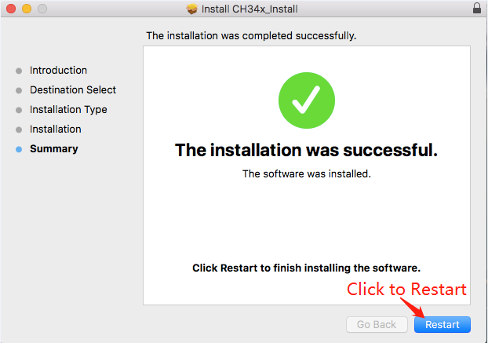Restart after finishing installing

After the installation is completed, you will find serial device in the device list(/dev/tty.wchusbserial*) ,and you can access it by serial tools.

If you can’t find the serial port then you can follow the steps below:

Step1: Open terminal and type ‘ls/dev/tty*’ and see is there device like tty.wchusbserial;

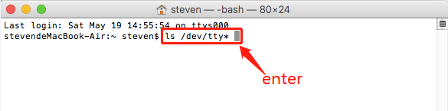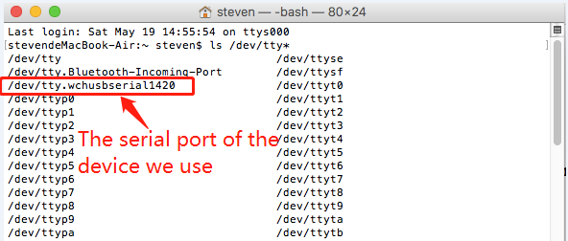

Step2: Open ‘System Report’->Hardware->USB, on the right side “USB Device Tree” there will Be device named “Vendor-Specific Device” and check if the Current is normal.

If the step supper don’t work at all, please try to install the package again.

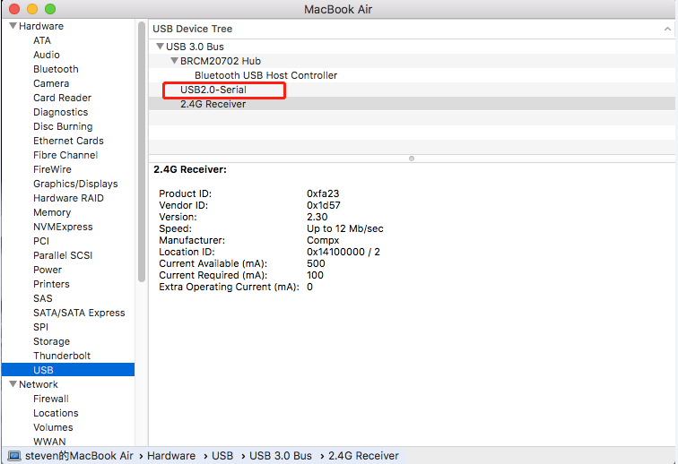

Note:

Please enter “System Preferences”->”Security & Privacy”->”General”, below the

title” Allow apps downloaded from: ”you should choose the choice2->” Mac App Store and identified developers ” so that our driver will work normally.

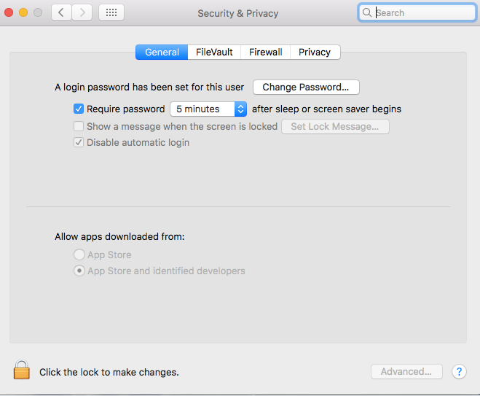

1