**Preparing the environment for running tests.**

The following software must be installed and configured:

* PHP 5.4.0 or later (can be downloaded from <http://www.wampserver.com/en/> with Apache and MySQL)
* PHPUnit 3.7.34 or later
* Composer
* Java Run-time Environment (JRE) 1.7 or later
* Selenium Webdriver 2.43 or later
* Web browsers: (Mozilla Firefox, Google Chrome, Internet Explorer)

**Downloading and Installing Composer, PHPUnit, Selenium Webdriver**

* Download and install composer from <https://getcomposer.org/download/>.
* Open the command line window, go to framework folder where ‘*composer.json’* file is located and run the following: *composer install*

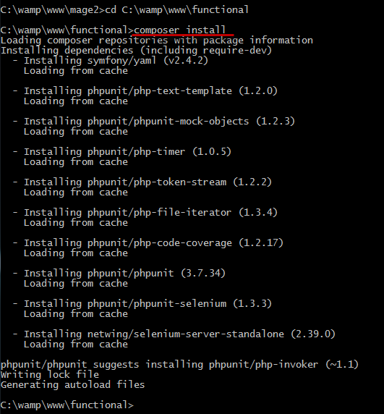

* For launching Selenium Webdriver run command line:
  + Go to *vendor\netwing\selenium-server-standalone* folder
  + Run command: *java -jar selenium-server-standalone-2.43.0.jar*
  + Confirm that the expected output is produced:

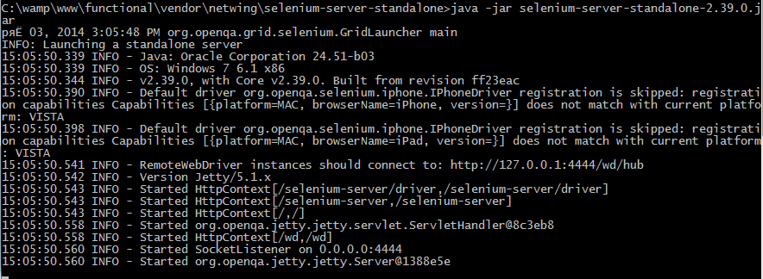

**Selenium Client Configuration**

To configure the Selenium Client, you should use the **config.yml** file. File is located in the **config** sub-folder.

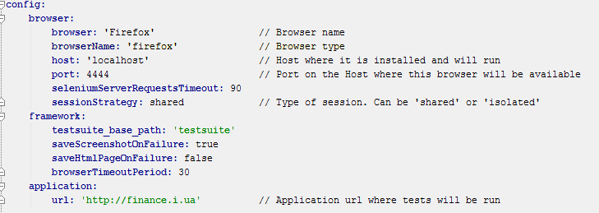

**PHPUnit Configuration**

* **phpunit.xml** contains the list of test scripts (test cases) to be run. (*..\phpunit.xml*)  
  **phpunit.xml** is the standard PHPUnit configuration file. The file defines a test suite (the list of test scripts/test cases) to be run. In other words, it contains the suite’s name, a list of suffixes, and a list of directories that the necessary PHP files will be run from. For example:

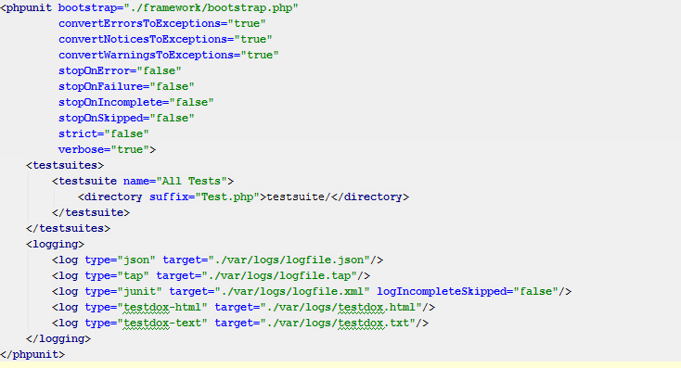

Where:

* *<testsuite name="All Tests">* is the name of the suite to be run
* *suffix="Test.php"* is the suffix for test files
* *testsuite* is the name of the directory from which the tests will be run

**Running tests:**

* Run command line and run command: *vendor\bin\phpunit --configuration phpunit.xml*

