CHITIPA EDUCATION CLUSTER
2019 MALAWI SCHOOL CERTIFICATE OF EDUCATION MOCK EXAMINATION

AGRICULTURE

Subject Number: M012/II
Wednesday, 27thMarch Time Allowed: 1 ½ hour sessions
08:00am onwards
PAPER II
(40 marks)

Question Number | Tick if answered | Do not write in these columns
1
2
3
4
Instructions

- This paper contains 5 printed pages. Please check.
- This paper hastwo sections, Aand B. Section A has two descriptive questions and section B has two questions on experiment.
- Answer all questions in the spaces provided. Marks are indicated against each part of the question.
- Write your Nameon all pages.
- In the table provided on this page, tick against the question number you have answered.
- At the end of the examination, hand in your paper to the invigilator.

©2019 CHITIPA EDUCATION LUSTER Turn Over

SECTION A (20 MARKS)
1. | Figure 1 is a diagram showing soil triangle. Study it and use it to answer questions that follow.  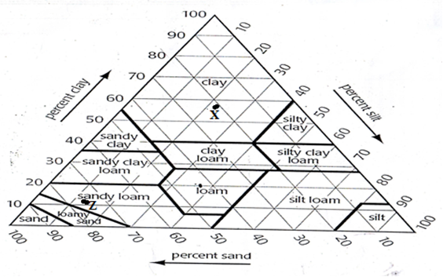
 | Figure 1
 | a. | Identify the type of soil which has the following proportion of soil particles:
 |  | (i) | 30% clay, 20% silt 50% sand  ________________________________________________________________________(1 mark)
 |  | (ii) | 12% clay, 24% silt and 64% sand  ________________________________________________________________________(1 mark)
 | b. | State the percentage of sand and clay at point Z.  _____________________________________________________________________________________  _____________________________________________________________________________________  (2 marks)
 | c. | (i) | Between soil X and soil Z, which one is likely to be more acidic?  ________________________________________________________________________(1 mark)
 |  | (ii) | Give a reason for your answer in c(i)  ________________________________________________________________________________  ________________________________________________________________________________  (2 marks)

Continued/ ….

1. | (Continued)
 | d. | State any three advantages of analysing soil samples to a farmer.  ______________________________________________________________________________________  ____________________________________________________________________________________________________________________________________________________________________________  (3 marks)
2. | Table 1 shows average results of an experiment conducted to find out the effect of duration of light on the number eggs laid in four separate “kholas”.  Table 1  Khola Duration of light (hours) Number of eggs laid  1 2 20  2 3 25  3 4 30  4 5 30
 | a. | Give three variables that were kept constant in the experiment.  (3 marks)
 | b. | Why was the increase in light duration not necessary beyond four hours?  (2 marks)
 | c. | What conclusion can be drawn from this experiment?  (2 marks)
 | d. | Give any three sources of energy that might have been used to provide light in the khola.  (3 marks)
Continued/ ….

SECTION B (20 MARKS)
3. | You are provided with specimen labelled R.
 | a. | Identify the specimen labelled R.  (1 mark)
 | b. | To which class of livestock feeds does this specimen belong?  (1 mark)
 | c. | State two characteristics of feeds which belong to the group mentioned above.  (2 marks)
 | d. | Explain two ways how specimen R controls soil erosion.  (4 marks)
 | e. | Give any one reason why specimen R is suitable for ruminant animals.  (2 marks)
4. | You are provided with two specimen labelled X and Y.
 | a. | (i) | Mention the vegetative planting materials from which specimen X was propagated.  _________________________________________________________________________________  (1 mark)
 |  | (ii) | State two disadvantages of using the vegetative planting material mentioned in a (i) above.  (2 marks)
Continued/ ….

4. | (Continued)
 | b. | (i) | Explain any one way in which specimen Y help to mitigate climate change.  (2 marks)
 | b. | (ii) | Give any one disease that attack specimen Y.  _____________________________________________________________________________  (1 mark)
 | c. | (i) | Calculate the price elasticity of demand for specimen X at Lufita market when the price changes from K100.00 per kilogramme to K120.00 per kilogramme resulting in a change in the quantity demanded from 1000 kilogramsto 800 kilograms.  (3 marks)
 |  | (ii) | What does the answer in c (i) tell you about the price elasticity of demand for X at Lufita market?  (1 mark)

END OF QUESTION PAPER

This paper contains 5 pages.

