BLANTYRE SYNOD SCHOOLS
2022 MALAWI SCHOOL CERTIFICATE OF EDUCATION MOCK EXAMINATIONS
PHYSICS
Subject Number: M164/II
Time allowed: 2 hour sessions
8:00 am onwards
Date:
PAPER II
(40 marks)
PRACTICAL

Instructions:
Question number | Tick if answered | Do not write in these columns
1
2
3
4
- This paper contains 7 printed pages. Please check.
- Before beginning, write your Examination number/Name at the top of each page of the question paper.
- Write your answers on the question paper.
- This paper contains two sections, A and B.
- Section A consists of two descriptive questions on practical work to be answered in 1 hour. Marks will be given for accurate and orderly presentation of facts supported by relevant diagrams.
- In section B there are two practical questions to be answered in 1 hour.
- Marks for section B will be given for observation, accuracy
and interpretation of results.
- You should spend 30 minutes on each question. The 30 minute
period allowed for each question includes 3 minutes to tidy up
the apparatus and have it checked by the supervisor.
- In the table provided on this page, tick against the question
number you have answered.

SECTION A (20 marks)

Question 1 (10 marks)
- State Ohm's law.
__________________________________________________________________________________________________________________________________________________________________
- Design an experiment you can carry out to verify Ohm’s law. In the description include; aim of the experiment, variables in the experiment, list of apparatus, labelled circuit diagram, procedure of the experiment, data to be collected and analysis of the data.

____________________________________________________________________________________________________________________________________________________________________________________________________________________________________________________________________________________________________________________________________________________________________________________________________________________________________________________________________________________________________________________________________________________________________________________________________________________________________________________________________________________________________________________________________________________________________________________________________________________________________________________________________________________________________________________________________________________________________________________________________________________________________________________________________________________________________________________________________________________________________________________________________________________________________________________________________________________________________________________________________________________________________________________________________________________________________________________________________________________________________________________________________________________________________________________________________________________________________________________________________________________
Question 2 (10 marks)

With the aid of a well labelled, describe an experiment you can conduct to verify if a body immersed in a liquid loses weight by an amount equal to the weight of the liquid displaced.

________________________________________________________________________________________________________________________________________________________________________________________________________________________________________________________________________________________________________________________________________________________________________________________________________________________________________________________________________________________________________________________________________________________________________________________________________________________________________________________________________________________________________________________________________________________________________________________________________________________________________________________________________________________________________________________________________________________________________________________________________________________________________________________________________________________________________________________________________________________________________________________________________________________________________________________________________________________________________________________________________________________________________________________________________________________________________________________________________________________________________________________________________________________________________________________________________________________________________________________________________________________________________________________________________________________________________________________________________________________________________________________________________________________________________________________________________________________________________________________________________________________

SECTION B (20 marks)

Question 3 (10 marks)
You are provided with the following materials: A spring balance, 500g mass, a metre rule, a bench or desk, a nail and a string.
- Set up the apparatus as shown in figure 1 below.
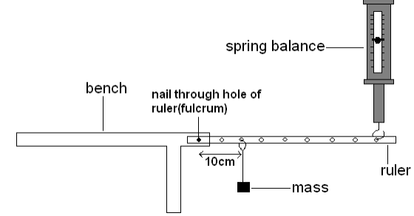
Figure 1
- Hook the mass 10 cm away from the fulcrum and note the reading on the spring balance.
- Record the spring balance reading in the table of results.
- Change the positions of the mass as indicated in the table results and record the readings on the spring balance in the spaces in the table.
- Table of results
Distance of the load from the fulcrum (cm) | Effort (the reading of the spring balance) (N)
10
20
30
40

- On a graph paper provided, plot a graph of effort against distance of the load from the fulcrum.


- From the graph determine the relationship between the two variables.
________________________________________________________________________________________________________________________________________________________________________

Question 4 (10 marks)
You are provided with a spring, clamp and clamp stand, stop watch and 4 masses (50 g, 100g, 150 g and
200 g).

- Arrange the apparatus as shown figure 2 below.
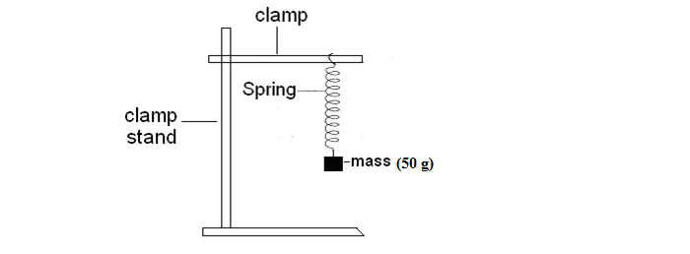
Figure 2
- Pull the mass downwards by a small amount and leave it to vibrate freely.
- Record the time taken to make 10 complete vibrations.
- Repeat steps b and c using 100 g, 150 g and 200 g masses, respectively.
- Complete the column for number of vibrations per second in the table.
Mass (g) | Time for 10 complete vibrations (sec) | Number of vibrations per second (frequency)
50

100

150

200

- Plot a graph of number of vibrations per second (frequency) against mass.


- Using the graph, determine how mass affects the number of vibrations per second.
_________________________________________________________________________________ _________________________________________________________________________________
END OF QUESTION PAPER
NB: This paper contains 7 printed pages.

