**CS 560 – FALL 2017**

**Mesh Renderer User Guide**

**By:**

**Esteban Enrique Maldonado Cabán**

**Before running the renderer:**

* **I’ve tested in school computers with both Win10 and Win 7 so it should work when being graded. If it doesn’t feel free to email me(**[**esteban.maldonado@digipen.edu**](mailto:esteban.maldonado@digipen.edu)**)**
* When you run the solution for the first time, you’ll probably get this screen:

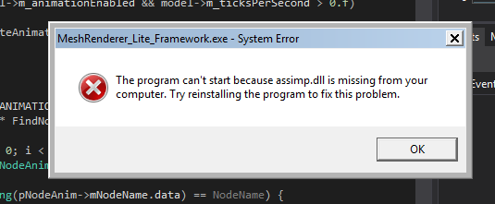

Like the screenshot shows, the assimp.dll is missing from the executable’s directory.

Copy the dll located at:

**MeshRenderer_Lite\MeshRenderer_Lite_Framework\MeshRenderer_Lite_Framework\Lib\Assimp\assimp.dll**

Copy that file to:

**MeshRenderer_Lite\MeshRenderer_Lite_Framework\x64\[Debug | Release]**

*\* These directories are relative to where the framework is downloaded \**