Sushant Adhikari(803874239)

TESTING THE APPLICATION:

Testing method: Manual Testing of the application.

Testing:

1. Test of Data Structures:

Project Name: DataStructuresGui

Linked List:

- Test for adding by using the add() method in the linked list.
E.g: add(5) should add the integer 5 into the linked list.
Test results in desired solution.

- Test for getting all the elements in the linked list.
getAll() results in spitting out all of the elements in the linkedlist.
It resulted in desired solution.

- Test for removing an element in the linked list.
removeNode(position) removes the requested positioned element in the linked list.
Result successful.

- Sorting of the linkedlist.
sort() method sorts the requested linkedlist in ascending order.
The result of the sort was successful.

HashMap:

- hashMap(int size). It initializes the hash map of size.

- Adding values
add(String key, String value) adds the key and value pair in form of string in the hashMap.

Test for adding of elements larger than the hash map bucket size:
- If elements added are more than the initial hash map size then the hash map’s bucket size automatically multiplies itself by 2.
The result for this test was successful as well.

- Getting values from the hash map
get(String key), the requested key for the hash map returns the value for the key in String format.

The results for all the respective methods are as expected.

BinaryTree:

- bTree is the class for binary tree.

Test for adding data.
- add(Object data) adds any form of data into the binary tree.
Test for getting data in binary tree:
- get(data) gets the specific data from the binary tree.
Every iteration in the binary tree decreases the remaining values by half.

Test for removing data in binary tree
- remove(data) removes the specific data in binary tree and adjusts itself to the child’s and parent’s nodes.
Node.parent prints out the current parent of the node.
Node.val prints the current value of the node.
Node.left prints the left child’s value of the current node.
Node.right prints the right child’s value of the current node.

All the corresponding output of the Data Structures are as expected.

GUI Test:

The GUI in the project tests all of the data structures and presents all of the data in unison. It also does all means of client’s input validation.

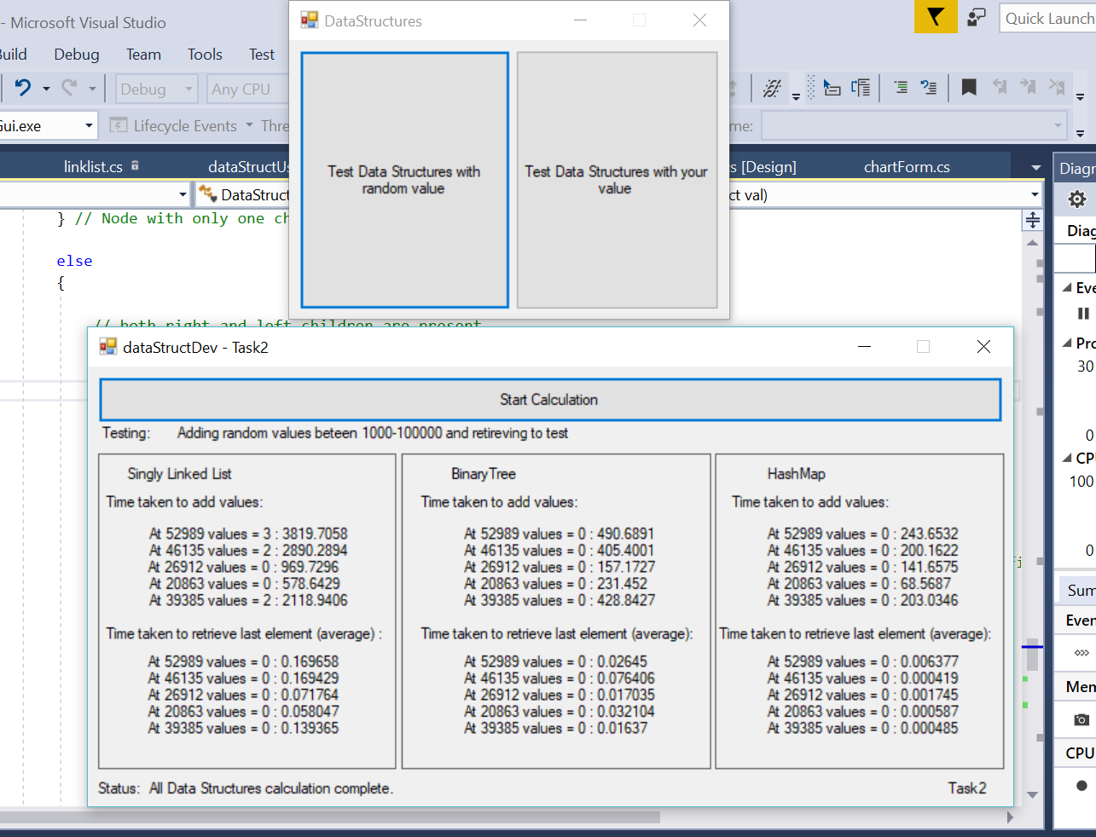

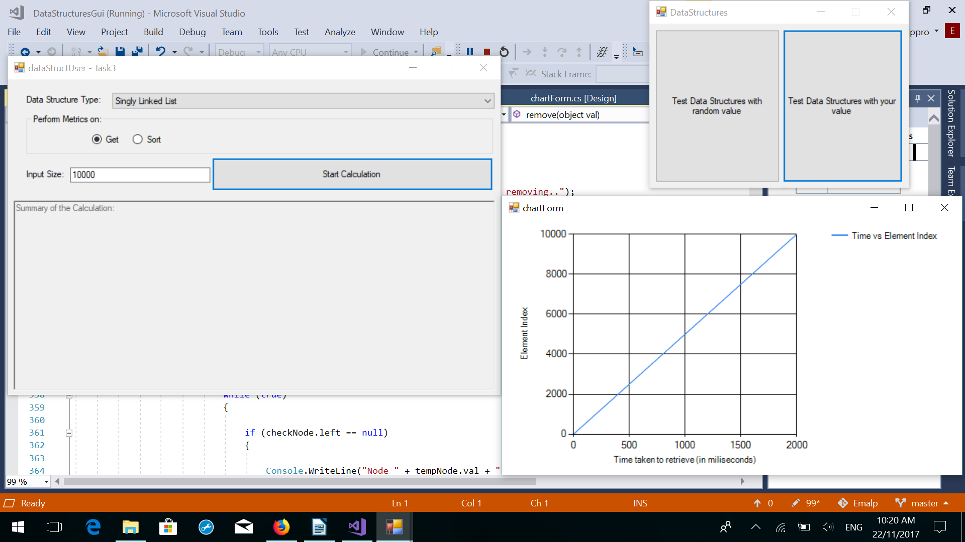

2. Test of sockets and user preferences.

Project Name: Blackjack

- Sockets can be tested by running the solutions blackJack Server and then blackJack Client to play the blackJack game. This project establishes connection between the client and server and does data transfer between them. This provides evidence for the socket connection.

- User preferences can be changed by changing themes present in the game.

