

# **Department of Computing**

**CS344: Web Engineering**

**Class: Spring 2024**

# **Lab 13: Web Development with MERN Stack**

## **Date: 19 Dec, 2024**

## **Time: 09:00 to 11:50/ 2:30 to 04:50**

# **Instructor: Dr Ayesha Hakim**

| **Group Members** | **CMS ID** |
| --- | --- |
| Eman Chaudhary | 429582 |
| Saleha Zainab | 404329 |
| Munazza Raees | 424756 |

**React server is running**

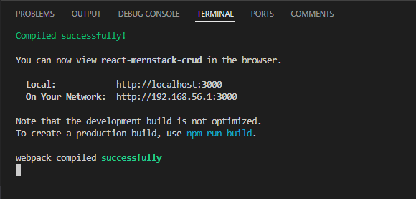

**Backend Server is running**

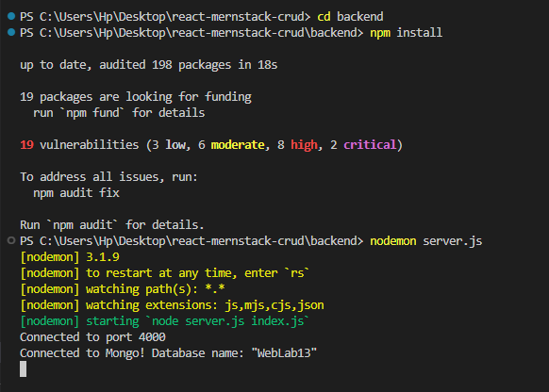

**Open other terminal run `mongod`**

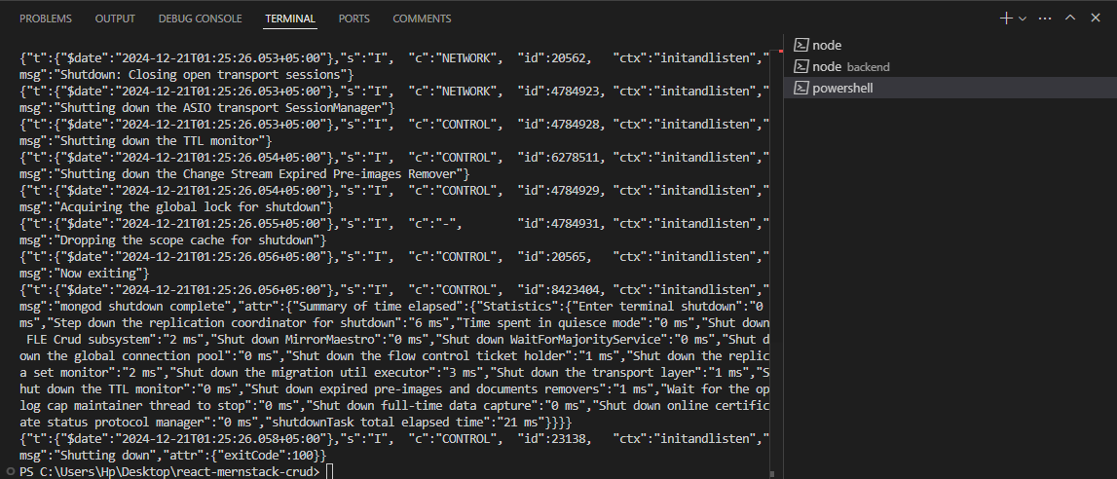

**MongoDB**

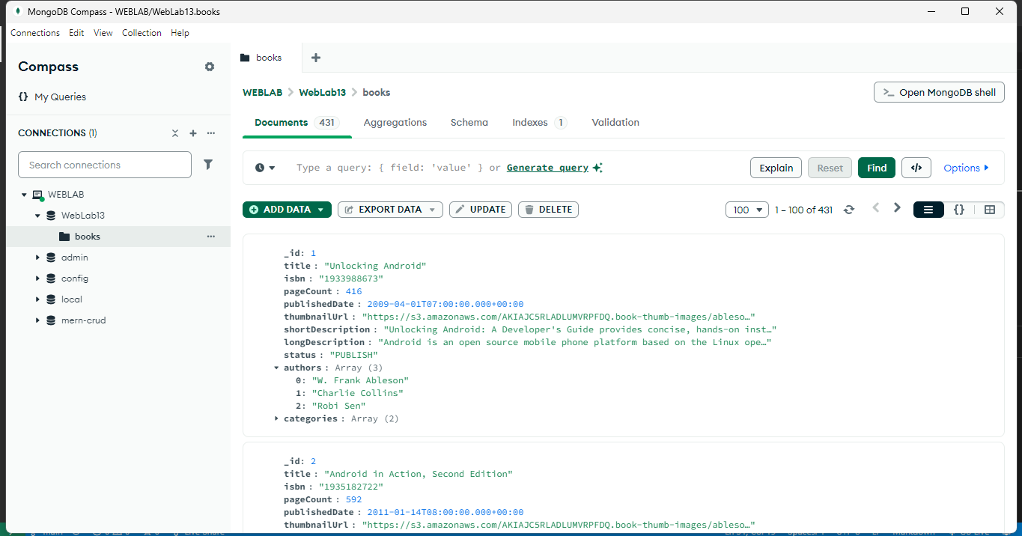

**Create and read**

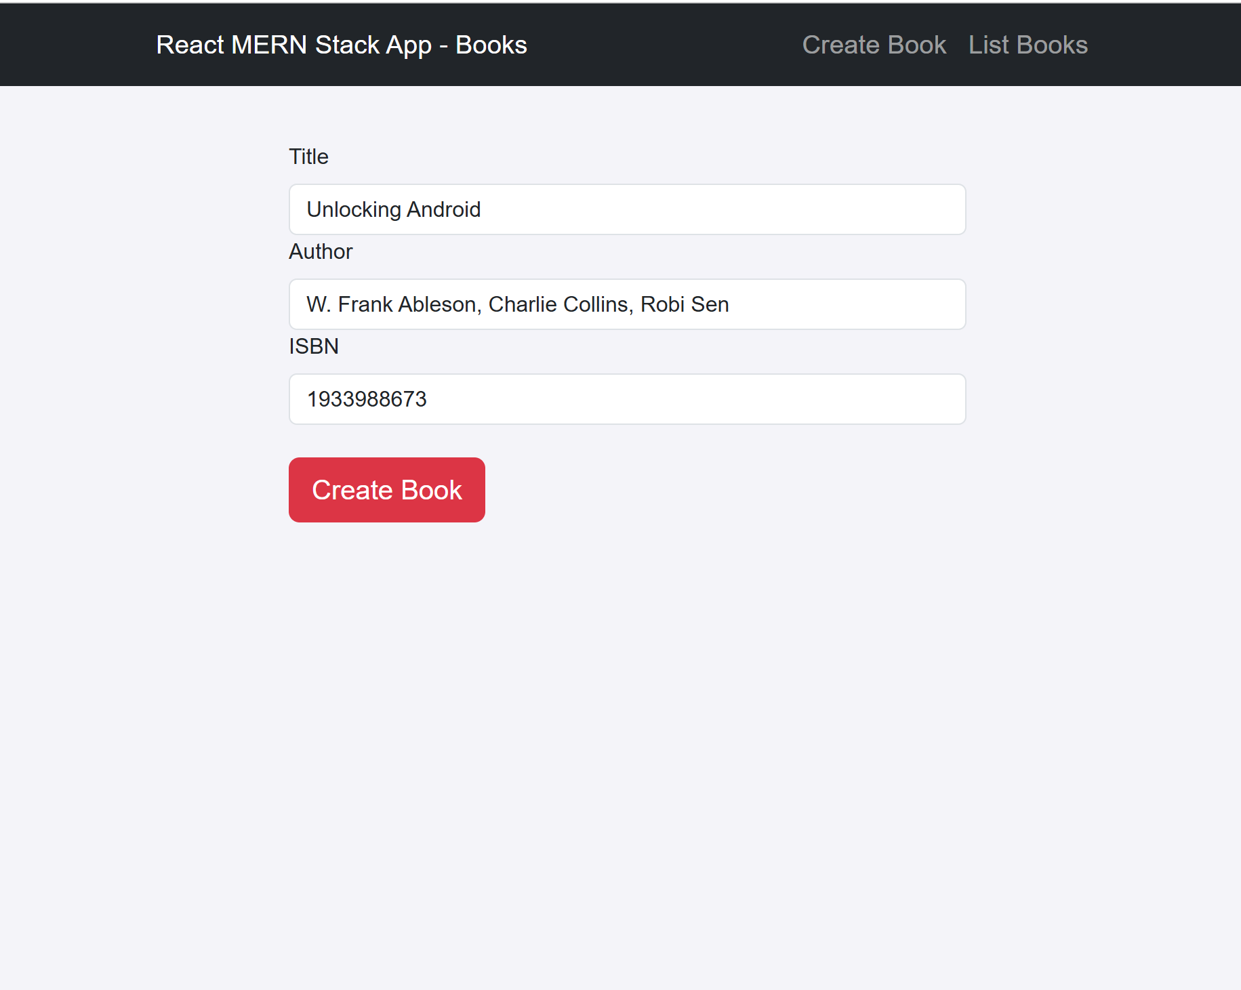

**Delete**

