BloodNet: AI-Powered Smart Blood Donation Network



Submitted By
Sunila Sami (S2023065093)
Ifreen Israr (S2023065047)
Eman Ayesha (S2023065062)
Minahil Murtaza (S2023065034)

Session
Spring 2023-2027

Project Supervisor
Dr. Muhammad Asad Arshad

Department of Software Engineering
School of Systems and Technology
University of Management and Technology
C-II Johar Town Lahore Pakistan

Dedication
To everyone who has sat in a hospital corridor waiting for a phone call about blood that has not yet arrived, this project was built with you in mind. We have watched friends and relatives search through group chats and social media posts for a donor with the right blood type, often losing precious hours in the process, and we have seen how much lighter that burden becomes the moment a willing donor is found in time. We dedicate this work to blood donors everywhere, whose small act of giving costs them little but can mean everything to someone else, and to the patients and families still waiting for that same kindness to reach them. We also carry with us the memory of those for whom help came too late, and we hope that even a small improvement in how quickly a donor can be found will spare another family that same loss. Finally, we dedicate this project to our families and to our supervisor, Dr. Muhammad Asad Arshad, for the patience and guidance that carried us from an idea to a working system.

Final Approval
LifeStream

Panel of Examiners

- Head of Department ______________________
Department of Software Engineering
University of Management and Technology
Lahore

- Program Director ( Final Year Projects) ______________________
Department of Software Engineering
University of Management and Technology
Lahore

- Supervisor ______________________
Department of Software Engineering
University of Management and Technology
Lahore

- Co-Supervisor ______________________
(If any)

- Documentation Evaluator ______________________

Acknowledgment

Project Title
Objective

Undertaken by

Supervised by
Starting Date

Completion Date

Tools Used
Operating System
Documentation

Plagairism Report

Declaration Form

I have carefully examined the documentation of the Final Year Project titled “Project title”; and I endorse that this documentation complies with the standards of an undergraduate level Final Year Project report.
The document has been checked for plagiarism through Turnitin software available in UMT Library. The similarities of the document are within acceptable range.
Moreover, the accompanying CDs contain PDF of the documentation, as well as the source code and binaries with user manual and installation guide.

FYP Supervisor Name: ______________________________

Signature: __________________ Date:___________________

Abstract
Access to safe and timely blood remains a persistent challenge in Pakistan, where patients and their families often rely on word of mouth, personal networks, and social media appeals to find a compatible donor during an emergency. This process is slow, unreliable, and offers no way to confirm that a donor is actually eligible to give blood. LifeStream: Smart Blood Donation Network was built to close this gap by giving donors, recipients, hospitals, and blood banks a single platform to register, search, and connect based on blood group, location, and real-time availability.
The system uses artificial intelligence to rank and recommend the most suitable donors for a given request, taking into account compatibility, distance, and donation history, so that recipients are matched with realistic options rather than an unfiltered list of names. An automated notification layer keeps donors and recipients informed at every stage of a request, from submission to fulfillment, and an escalation mechanism raises the priority of urgent cases that are not resolved within a set time. A chatbot assistant answers common donor and recipient questions, while an administrator dashboard gives staff the tools to monitor requests, manage user accounts, and flag suspicious or duplicate profiles.
The project was developed using an Agile, Scrum-based process, delivered across three sprints that incrementally built out identity and account management, donor and recipient workflows, AI-driven matching, and administrative oversight. Each sprint concluded with a review and retrospective to track what had been delivered against what had been planned, and the resulting backlog, sprint plans, and test cases are documented in full in this report.
By combining verified donor profiles with intelligent matching and proactive notifications, LifeStream aims to shorten the time it takes to connect a patient in need with a willing, eligible donor, while giving hospitals and blood banks better visibility into the donor pool they can call on. The broader goal is to demonstrate, through a working system, how established software engineering practices and applied AI can be brought together to address a real and recurring healthcare problem.

Table of Contents
Contents
Table of Contents 1
1. Introduction 2
1.1 Problem Statement 2
1.2 Objectives 2
1.3 Scope of the Project 3
1.4 Significance of the Project 3
1.5 Artificial Intelligence features 4
1.6 Project Deliverables 5
2. Domain Analysis 6
2.1 Customer 6
2.2 Stakeholders 6
2.3 Affected Groups with social or economic impact 7
2.4 Dependencies/ External Systems 7
2.5 Related Projects with feature comparison 8
2.5.1 Related Projects 8
2.5.2 Feature Comparison 9
2.6 Context Diagram 11
2.7 Data Flow Diagram Level 0 11
3. Requirements analysis 13
3.1 List of Actors 13
3.2 Product Backlog 13
3.3 Figma UI/UX Designs 62
4. Project Planning and Execution using Sprints 76
4.1 Jira 76
4.2 Slack 76
4.3 GitHub Repository 76
4.4 Sprint 1 76
4.4.1 Sprint 1 Planning Meeting Minutes 76
4.4.2 Sprint 1 Backlog 83
4.4.3 Sprint 1 Design Class Diagram 85
4.4.4 Sprint 1 Sequence Diagram 86
4.4.5 Sprint 1 Decision Tables 88
4.4.6 Sprint 1 Extended Test Cases 91
4.4.7 Sprint 1 Review Meeting 106
4.4.8 Sprint 1 Retrospective Meeting 109
4.5 Sprint 2 110
4.5.1 Sprint 2 Planning Meeting Minutes 110
4.5.2 Sprint 2 Backlog 117
4.5.3 Sprint 2 Design Class Diagram 120
4.5.4 Sprint 2 Sequence Diagram 121
4.5.5 Sprint 2 Decision Tables 123
4.5.6 Sprint 2 Extended Test Cases 126
4.5.7 Sprint 2 Review Meeting 138
4.5.8 Sprint 2 Retrospective Meeting 141
4.6 Sprint 3 143
4.6.1 Sprint 3 Planning Meeting 143
4.6.2 Sprint 3 Backlog 149
4.6.3 Sprint 3 Design Class Diagram 151
4.6.4 Sprint 3 Sequence Diagrams 151
4.6.5 Sprint 3 Decision Tables 153
4.6.6 Sprint 3 Extended Test Cases 155
4.6.7 Sprint 3 Review Meeting 168
4.6.8 Sprint 3 Retrospective Meeting 171

Introduction
The healthcare sector is one of the most critical domains where timely access to resources can directly impact human lives. Among these resources, blood donation plays a vital role in saving patients during emergencies, surgeries, and medical treatments. Despite advancements in technology, many regions still rely on informal and unstructured methods for finding blood donors, such as social media posts, phone calls, or personal networks. These methods are often unreliable, time-consuming, and lack proper verification.
Currently, there is no centralized and intelligent system that efficiently manages donor information and ensures quick matching between donors and recipients. Donor data is either scattered across different platforms or stored manually, making it difficult to track availability, eligibility, and donation history. As a result, patients and their families face unnecessary delays in critical situations.
Another major issue is the presence of inactive or fake donor profiles, which reduces the reliability of existing systems. In emergency cases, contacting multiple donors without knowing their real-time availability leads to frustration and loss of valuable time. Additionally, there is no proper mechanism to analyze historical data to predict demand or improve the matching process.
With the increasing use of data-driven technologies, there is a strong need for a smarter solution that can utilize stored datasets (such as CSV files) to automate and optimize donor matching. By integrating Artificial Intelligence and Generative AI concepts, the system can analyze patterns, recommend suitable donors, and continuously improve its performance based on past data.
The proposed Smart Blood Donation System aims to address these challenges by providing a centralized platform that maintains verified donor records, tracks availability, and enables fast and accurate matching. The system will also support data analysis and intelligent recommendations, reducing delays and improving overall efficiency. While external processes such as hospital management and blood bank operations may exist, the focus of this system is specifically on donor-recipient matching and data management. This will ultimately contribute to a more reliable and responsive blood donation network.

Problem Statement
Currently, there is no fast and reliable system to match donors with patients. People usually depend on social media or personal contacts, which is slow and risky in emergencies. Additionally, current systems do not properly check if a donor is healthy or eligible, for example, if they donated recently or have any disease. Fake donor profiles are another issue, which makes the system unreliable. Because of this, hospitals and patients face delays and problems in getting the right blood on time. So, a smart and automated system is needed to quickly find eligible donors, verify their health, and ensure safe and fast blood donation. This project belongs to the healthcare and technology field. It uses computers, web- and mobile-based applications, and AI to improve blood donation services and help patients in emergencies. In the past, blood donation records were maintained manually, which was slow and inefficient. Later, online systems and social media were used, but they are still not well-organized.

Objectives
The primary objectives of this project are:
- To build a system that matches blood donors with patients quickly and efficiently
- To utilize Artificial Intelligence for smart matching based on blood group, location, and donor availability
- To ensure that donors meet basic health and eligibility criteria before donation
- To reduce delays in emergency situations by minimizing the time required to find suitable donors

The secondary objectives of this project are:
- To store donor and patient data in one organized system.
- To detect fake donor profiles
- To send alerts and notifications to donors in emergencies.
- To maintain the history of donations.
- To help hospitals manage blood availability easily.
- To keep maintaining the security of user data.
- To motivate people to donate blood by offering some rewards.

Scope of the Project
Included in Scope:
- Development of a website for a blood donation system
- User signup and login for donors, patients, and admin
- Donor profile including blood group, location, and basic health information
- Smart matching of patients with the most suitable donor using AI
- Implementation of basic health and eligibility criteria for donation
- Notifications and alerts for blood requests
- Donation history tracking for users
- Admin can verify users, remove fake profiles, etc.Online payment or financial transactions.
- Data security
Out of Scope:
- Development of a full mobile application
- Integration with real hospital databases or government systems
- Conducting advanced medical tests for donors within the system
- Direct integration with ambulance or emergency services

Significance of the Project
This project will improve the blood donation process by making it faster, organized, and reliable. The system will quickly connect patients who need blood with suitable donors rather than depending on slow techniques like social media and personal contacts, helping save valuable time during emergencies. By verifying donor eligibility, keeping accurate records, and detecting fake or inactive users, it will increase trust and make the system safer for everyone. For hospitals, it manages blood requests and donor information in an easier and more structured way. Most importantly, it shows how AI techniques can be used to solve real-life healthcare problems.

Artificial Intelligence features
To enhance the functionality and operational efficiency of the Smart Blood Donation Network, Artificial Intelligence (AI) can be strategically integrated into the system. This integration enables intelligent decision-making, optimized resource utilization, and improved responsiveness during critical situations.
The following are four key AI-driven scenarios that are both relevant and beneficial for the proposed system:
1. Smart Matching
The system leverages AI algorithms to identify the most suitable blood donors based on multiple parameters such as blood type, geographic proximity, availability, and donation history.
Key Benefits:
- Enables identification of the most relevant donors to contact during emergencies
- Significantly reduces the time required to locate compatible donors
- Improves donor response rates by targeting appropriate individuals
2. Demand Prediction
By analyzing historical blood request data, the system can forecast future demand patterns for different blood types.
Key Benefits:
- Facilitates preparation for high-demand periods
- Enhances planning and ensures better blood availability
- Minimizes the risk of blood shortages
3. Fake Detection
The system employs AI-based behavioral analysis to detect fraudulent, inactive, or unreliable donors.
Key Benefits:
- Identifies and flags suspicious or inactive users
- Improves overall data accuracy and system reliability
- Strengthens user trust and confidence in the platform
4. Instant Alerts
Instead of broadcasting requests to all users, the system intelligently notifies only the most relevant and nearby donors.
Key Benefits:
- Reduces unnecessary notifications and system noise
- Increases the likelihood of rapid responses
- Enhances overall system efficiency and effectiveness

Project Deliverables
The following deliverables will be provided as part of this project:
- A functional web-based Smart Blood Donation System
- AI-based donor matching module using CSV dataset
- Centralized database for managing donor and recipient records
- User interface for donors, patients, and admin panel
- Donor verification and fake profile detection mechanism
- Emergency notification and alert system
- Sample dataset (CSV file) for testing and analysis
- Data analysis and prediction features using AI techniques
- Complete project documentation (FYP report)
- Test cases and system evaluation results
- Final project presentation and demonstration
- User guide for system usage
These deliverables ensure that the system is fully developed, tested, and ready for practical demonstration and evaluation.

Domain Analysis

Customer
Currently, the system is in the development phase and does not have a contracted client. The possible customers could be hospitals, blood banks, and health institutions. These institutions are responsible for blood donation, donor data, and emergency blood requests. This project will enable them to coordinate effectively and have blood available all the time.

Stakeholders
Table 1: List of Stakeholders
Stakeholder | Role in System
Blood Donors | Register and create profiles with blood group, location, and availability.  Receive notifications for blood requests and respond accordingly.  Update availability status and maintain donation history.  Participate in donation activities and contribute to emergency needs.
Patients / Requesters | Create blood requests with required details during emergencies.  View and select suitable donors suggested by the system.  Track request status such as pending, accepted, or completed.  Communicate with donors for coordination of donations.
Hospitals / Blood Banks | Verify donor identity and ensure medical eligibility for donation.  Manage blood requests and maintain donor records.  Monitor blood stock levels and update availability information.  Ensure safe, reliable, and regulated blood donation processes.
System Administrator / IT Support | Manage user accounts, roles, and system access permissions.  Detect and remove fake or inactive donor profiles.  Maintain system performance, security, and data integrity.  Provide technical support and ensure system availability.
NGOs / Health Organizations | Organize and manage blood donation campaigns and events.  Encourage donor participation and raise public awareness.  Use system data to improve outreach and engagement strategies.  Collaborate with hospitals and communities for better coordination.
Government / Health Authorities | Monitor healthcare standards and ensure regulatory compliance.  Use system data for public health planning and decision-making.  Enforce policies related to safe blood donation practices.  Review reports and ensure transparency in healthcare systems.

Affected Groups with social or economic impact
Patients and Their Families
Economic Impact: Helps reduce costs that arise from emergencies by locating the appropriate donor immediately without resorting to expensive and time-wasting solutions.
Social Impact: Avoids delay in emergencies by ensuring the quick identification of a compatible donor.
Blood Donors
Economic Impact: It helps reduce the effort people put into finding ways to donate and makes them more engaged because they get rewards, for taking part.
Social Impact: This approach helps create a community of donors who take responsibility by giving and making sure their donations are verified.
Hospitals and Blood Banks
Economic Impact: The system helps to make use of resources by keeping track of the blood stock. This means there is a waste. It also helps to manage donors in a way.
Social Impact: People will trust the system more because it makes sure that donors are trustworthy and that the donation process is safe. The system also makes sure that donation practices are safe.
Government / Health Authorities
Social Impact: This leads to monitoring and planning because it provides insights and predictions about blood shortages based on data.
Economic Impact: It helps healthcare systems by making emergency blood management more efficient, which reduces the burden on them.
NGOs / Health Organizations
Social Impact: More people get involved in the community because the system reaches the donors at the right time, which is good for community participation. The community participation increases when the system reaches the donors at the right time.
Economic Impact: The cost of running campaigns is lower because the system automatically finds the donors and helps with planning.
General Public / Society
Economic Impact: The healthcare system works better when we use healthcare solutions. This helps to reduce the costs that come with emergency management over time.
Social Impact: Digital healthcare solutions help people get the help they need on time. This creates a community that's aware of the importance of healthcare and trusts digital healthcare solutions.

Dependencies/ External Systems
SMS / Email Notification Services (e.g., Twilio, SendGrid)
Purpose: We use it to send alerts and notifications to donors about blood requests.
Interaction: The system helps get a response from donors during emergencies by sending them real-time alerts.
Cloud Hosting Platform (e.g., Google Cloud / AWS)
Purpose: Provides infrastructure for hosting the web application and database.
Interaction: Stores user data, manages system performance, and ensures availability of the platform.
Database Services (e.g., MongoDB / Google Sheets)
Purpose: This system helps store information, about donors, blood requests and other important data
Interaction: The system updates information to match donors with requests to track progress and analyze data for improvement.
Machine Learning Libraries (e.g., scikit-learn, Python Libraries)
Purpose: We use it to build AI models. These models help match donors predict eligibility and forecast demand.
Interaction: It processes data and gives predictions. These predictions help make decisions within the system.
Hospital / Blood Bank Information Systems
Purpose: Maintain verified medical records, donor eligibility, and blood stock information.
Interaction: The system may integrate or use verified data to ensure reliability and accuracy of donor and blood availability information.
Government Health Data / Public Datasets
Purpose: Provide data for analyzing blood demand trends and improving prediction models.
Interaction: Used to train AI models for predicting blood shortages and planning future needs.
QR Code Generation Systems
Purpose: Generate unique QR codes for digital donor cards.
Interaction: Each donor is assigned a QR code to store and access their donation history.
Voice / Language Processing APIs
Purpose: Support multi-language and voice interaction features.
Interaction: Enables users to interact with the system in different languages or through voice commands.

Related Projects with feature comparison

Related Projects
Online Blood Donation Platforms
Purpose: Provide platforms to connect blood donors with patients by allowing users to register as donors and search for blood based on group and location.
Examples: blood.pk, blood-connect.com, bdap.com, pakdonor.com
Relevance: These platforms support basic donor registration and search functionality. However, they rely mainly on manual communication and lack advanced features such as AI-based smart matching, donor verification, response tracking, and automated emergency handling. Therefore, they are less efficient in managing urgent blood requests compared to the proposed system.
Blood Donor Database Systems
Purpose: Maintain records of blood donors including contact details, blood group, and location for easy retrieval.
Examples: blood.pk, pakdonor.com
Relevance: These systems provide basic data storage and search capabilities but do not include intelligent filtering, real-time updates, or tracking of donor activity, which limits their effectiveness during emergencies.
Blood Donation Awareness Platforms
Purpose: Promote blood donation campaigns and encourage people to participate in donation activities.
Examples: bdap.pk, bloodconnect.com
Relevance: These platforms help raise awareness and increase donor participation but lack structured systems for managing blood requests, intelligent donor selection, and real-time emergency response.

Blood Donation Camp Integration Systems
Purpose: Support coordination between blood donation campaigns and blood request systems to address donor shortages.
Examples: Not commonly integrated in existing platforms
Relevance: Existing systems mainly focus on donor listings or awareness campaigns but do not integrate them with real-time emergency needs. They lack a mechanism to connect blood donation camps during urgent situations. The proposed system addresses this by linking nearby donation camps when there is a donor shortage. This helps improve availability, reduce delays, and provide a faster response in emergencies.

Feature Comparison
Table 2: Feature comparison of our product with competitors
Feature/System | blood-connect | blood.pk | pakdonor | Proposed System
Primary Focus | Donor connection & awareness campaigns | Donor search and listing | Basic donor database | AI-based smart blood donation system
Donor Registration | Yes | Yes | Yes | Yes
AI-Based Matching | No | No | No | Yes
Donor Verification (OTP/CNIC) | No | No | No | Yes
Response Tracking | No | No | No | Yes
Real-Time Alerts | Limited | Limited | Limited | Yes
Emergency Handling | No | No | No | Yes
Camp Integration | No | No | No | Yes
Data Prediction (Demand) | No | No | No | Yes
Automation Level | Low | Low | Low | High

Context Diagram
The context diagram represents the Smart Blood Donation System as a single entity and defines its interaction with external entities. It shows how the system communicates with blood donors, patients, hospitals, administrators, NGOs, and notification services. It illustrates the flow of data such as donor registration, blood requests, verification data, and notifications between the system and external entities.
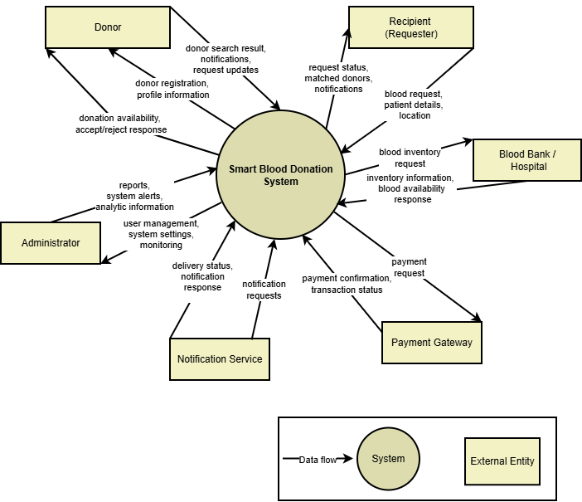
Figure 1: Context Diagram – Smart Blood Donation Network

Data Flow Diagram Level 0
The Level 0 Data Flow Diagram represents the Smart Blood Donation System by dividing it into major processes such as user management, blood request handling, donor matching, notification handling, verification, and campaign management. External entities including donors, patients, hospitals, administrators, and NGOs interact with these processes. Data stores are used to maintain donor information, blood requests, and response data. The diagram illustrates how data flows between processes, external entities, and data stores without showing internal implementation details.

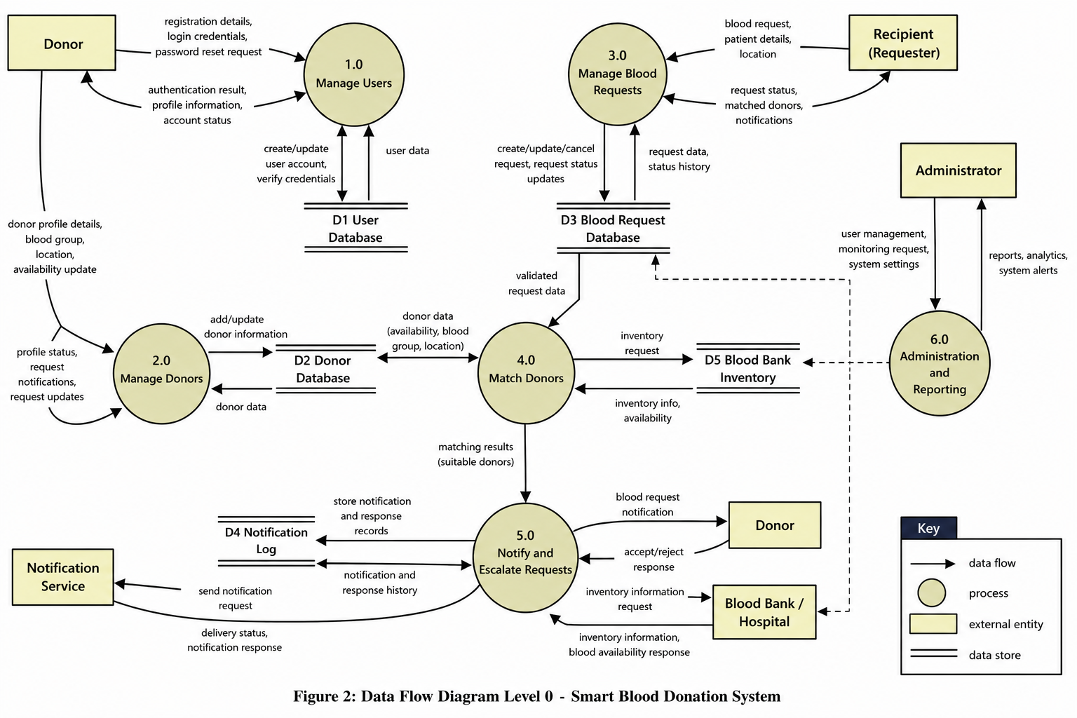
Figure 2: Data Flow Diagram – Smart Blood Donation Network8

Requirements analysis

List of Actors
The system includes the following actors who interact directly with it:
- Donor: A registered user who donates blood and responds to requests.
- Patient/Requester: A user who creates blood requests and searches for donors.
- Hospital/Blood Bank: Verifies donor eligibility and manages blood-related operations.
- System Administrator: Manages users, monitors system activity, and ensures system security.
- Visitor: An unregistered user who can view information and register in the system.
- Notification Service: An external system used to send alerts and notifications.
- AI Module: A system component responsible for donor matching, prediction, and analysis.

Product Backlog
This section presents the product backlog of the Smart Blood Donation Network. The backlog is organized into Epics, where each epic represents a major functional area of the system. Each epic is further divided into user stories describing specific system functionalities from the user’s perspective.
3.2.1: User and Identity Management
Epic Description:
This epic enables users to securely create an account, authenticate their identity, and manage login credentials to ensure safe access to the Smart Blood Donation Network.
PB-ID | User Story | Priority | Acceptance Criteria | Story Points | Status
UIM-01 | As a visitor, I want to register an account so that I can access the Smart Blood Donation Network. | High | • User enters all required information (name, email, password, role, etc.).  • System validates the entered information.  • Account is created successfully.  • Confirmation message is displayed. | 3 | Pending
UIM-02 | As a registered user, I want to log in using my credentials so that I can securely access my account. | High | • User enters valid credentials.  • System authenticates the user.  • User is redirected to the appropriate dashboard based on role.  • Invalid credentials display an error message. | 3 | Pending
UIM-03 | As a registered user, I want to log out of my account so that unauthorized users cannot access my session. | High | • User can log out from any page.  • Active session is terminated.  • User is redirected to the login page.  • Protected pages cannot be accessed after logout. | 2 | Pending
UIM-04 | As a registered user, I want to reset my password if I forget it so that I can regain access to my account. | High | • User requests a password reset.  • System sends a password reset link or OTP.  • Reset link expires after a specified time.  • User successfully creates a new password. | 5 | Pending
UIM-05 | As a registered user, I want to change my password while logged in so that I can maintain my account security. | Medium | • User enters the current password.  • User provides and confirms a new password.  • System validates password requirements.  • Password is updated successfully. | 3 | Pending
UIM-06 | As a registered user, I want to manage and update my profile information so that my personal details remain accurate. | Medium | • User can edit profile details.  • Required fields are validated.  • Changes are saved successfully.  • Updated information is displayed immediately. | 3 | Pending
UIM-07 | As a registered user, I want to verify my email address after registration so that my account is authenticated. | Medium | • Verification email is sent after registration.  • User can verify the account using the provided link or OTP.  • Account status changes to verified after successful verification.  • Unverified users are prompted to complete verification. | 3 | Pending
UIM-08 | As a system, I want to validate user registration data so that duplicate or invalid accounts cannot be created. | High | • Required fields are validated.  • Duplicate email addresses are rejected.  • Invalid input formats are detected.  • Appropriate validation messages are displayed. | 3 | Pending
UIM-09 | As a system, I want to authenticate users based on their assigned roles so that they are redirected to the appropriate dashboard after login. | High | • System identifies the authenticated user's role.  • Users are redirected to their respective dashboards.  • Unauthorized access to restricted pages is prevented.  • Role-based permissions are enforced throughout the system. | 5 | Pending
3.2.2: User Account and Role Management
Epic Description:
This epic enables the system to manage user accounts and roles, allowing administrators to control account status, assign permissions, and maintain secure access for different types of users.
PB-ID | User Story | Priority | Acceptance Criteria | Story Points | Status
UAM-01 | As a user, I want to select my role (Donor, Recipient, or both) so that I can access the appropriate features of the system. | High | • User can choose one or more roles.  • Selected role(s) are saved successfully.  • Appropriate features become accessible based on the selected role(s). | 3 | Pending
UAM-02 | As a user, I want to update my role preferences so that they reflect my current needs. | Medium | • User can add or remove roles.  • Changes are validated and saved.  • System updates permissions accordingly. | 3 | Pending
UAM-03 | As a user, I want to activate my account so that I can access all system functionalities after verification. | High | • Account can be activated after successful verification.  • User gains access to authorized features.  • Activation status is updated successfully. | 3 | Pending
UAM-04 | As a user, I want to temporarily deactivate my account so that I can stop using the system without losing my account information. | Medium | • User can deactivate the account from account settings.  • Account status changes to inactive.  • User cannot access protected features while the account is inactive.  • Account data is retained. | 3 | Pending
UAM-05 | As a user, I want to reactivate my account so that I can resume using the system whenever I choose. | Medium | • User authenticates successfully.  • Account status changes to active.  • Previous account data is restored.  • User regains access to authorized features. | 2 | Pending
UAM-06 | As a user, I want to permanently delete my account so that my personal information is removed from the system when I no longer wish to use it. | Medium | • System requests confirmation before deletion.  • User identity is verified.  • Personal information is deleted or anonymized according to the privacy policy.  • Deleted accounts cannot be recovered. | 5 | Pending
UAM-07 | As a user, I want to view my account status so that I know whether my account is active, inactive, or pending verification. | Low | • Current account status is displayed.  • Status updates automatically after account changes.  • User is informed of any restrictions associated with the current status. | 2 | Pending
UAM-08 | As an administrator, I want to activate or deactivate user accounts so that I can manage accounts that violate system policies or require administrative action. | High | • Administrator can activate or deactivate accounts.  • Changes are recorded in the audit log.  • Users are notified of the status change. | 5 | Pending
UAM-09 | As an administrator, I want to assign or modify user roles so that access permissions are managed according to user responsibilities. | High | • Administrator can assign, modify, or remove user roles.  • Role changes are saved successfully.  • System enforces updated permissions immediately.  • All changes are logged. | 5 | Pending

3.2.3: Donor Management
Epic Description:
This epic enables donors to manage their personal and health information, monitor their donation eligibility, and keep track of their donation activities within the Smart Blood Donation Network.
PB-ID | User Story | Priority | Acceptance Criteria | Story Points | Status
DM-01 | As a donor, I want to complete my donor profile so that I can participate in the blood donation network. | High | • Donor can enter personal information, blood group, contact details, and location.  • Required fields are validated.  • Profile is saved successfully. | 3 | Pending
DM-02 | As a donor, I want to update my donor profile so that my information remains accurate and up to date. | Medium | • Donor can edit profile information.  • Changes are validated and saved successfully.  • Updated profile is displayed. | 3 | Pending
DM-03 | As a donor, I want to update my health information so that the system can accurately determine my donation eligibility. | High | • Donor can update health-related information.  • Information is validated and stored securely.  • Eligibility checks use the latest health information. | 5 | Pending
DM-04 | As a donor, I want to manage my availability status so that I only receive donation opportunities when I am available. | High | • Donor can mark themselves as Available or Unavailable.  • Availability changes are saved immediately.  • Only available donors are considered during matching. | 3 | Pending
DM-05 | As a donor, I want to view my donation eligibility status so that I know whether I am currently eligible to donate blood. | High | • System evaluates eligibility using health information and donation history.  • Eligibility status is displayed.  • If ineligible, the reason and next eligible donation date are shown. | 5 | Pending
DM-06 | As a system, I want to enforce the mandatory donation interval so that donors cannot donate before the required recovery period has passed. | High | • System checks the donor's last donation date.  • Donations are restricted during the recovery period.  • Remaining waiting period is displayed.  • Eligibility is restored automatically after the interval expires. | 5 | Pending
DM-07 | As a donor, I want to view my donation history so that I can keep track of my previous blood donations. | Medium | • Donation history displays donation date, recipient/request reference, hospital or blood bank, and donation status.  • Records are searchable and ordered chronologically. | 3 | Pending
DM-08 | As a donor, I want to report temporary medical conditions so that the system can temporarily defer me from donating until I become eligible again. | Medium | • Donor can report temporary conditions (e.g., illness, surgery, pregnancy, vaccination).  • System records the condition and applies a temporary deferral.  • Donor is excluded from matching until eligible again. | 5 | Pending
DM-09 | As a donor, I want to specify my preferred donation locations so that I receive donation opportunities from convenient hospitals or blood banks. | Medium | • Donor can select one or more preferred donation locations.  • Preferences are saved successfully.  • Matching considers these preferences. | 3 | Pending
DM-10 | As a donor, I want to view my donation statistics so that I can monitor my contribution to the blood donation network. | Low | • Dashboard displays total donations, successful donations, last donation date, current eligibility status, and lives potentially helped.  • Statistics update automatically after completed donations. | 3 | Pending

3.2.4: Recipient Management
Epic Description:
This epic enables recipients to manage their medical information, create and monitor blood requests, and maintain their transfusion records to support timely blood assistance.
PB-ID | User Story | Priority | Acceptance Criteria | Story Points | Status
RM-01 | As a recipient, I want to complete my medical profile so that the system can maintain accurate medical information for my blood requirements. | High | • Recipient can enter personal and medical information, including blood group, medical condition, hospital, physician, and emergency contact.  • Mandatory fields are validated.  • Profile is saved successfully. | 5 | Pending
RM-02 | As a recipient, I want to update my medical profile so that my health information remains accurate and up to date. | High | • Recipient can modify medical information.  • Updated information is validated.  • Changes are saved successfully. | 3 | Pending
RM-03 | As a recipient, I want to upload supporting medical documents so that my blood requests can be verified when necessary. | High | • Recipient can upload prescriptions, laboratory reports, or medical certificates.  • Supported file formats are accepted.  • Documents are securely stored and linked to the recipient profile. | 5 | Pending
RM-04 | As a recipient, I want to create a blood request so that I can receive blood when needed. | High | • Recipient specifies blood group, blood component, units required, hospital, required date, and additional notes.  • Required fields are validated.  • Blood request is created successfully. | 5 | Pending
RM-05 | As a recipient, I want to edit my blood request before it is matched so that I can correct or update request information. | Medium | • Only pending requests can be edited.  • Updated information is validated.  • Changes are saved successfully. | 3 | Pending
RM-06 | As a recipient, I want to cancel my blood request so that unnecessary processing is avoided when I no longer require blood. | Medium | • Pending requests can be cancelled.  • Request status changes to "Cancelled".  • Cancelled requests are retained in history. | 3 | Pending
RM-07 | As a recipient, I want to schedule recurring blood requests so that I can automate requests for regular transfusions. | High | • Recipient can define recurrence frequency and expected blood requirements.  • System creates future requests according to the schedule.  • Schedule can be modified or removed. | 8 | Pending
RM-08 | As a recipient, I want to track the status of my blood requests so that I know whether they are pending, matched, in progress, completed, or cancelled. | High | • Current request status is displayed.  • Status updates automatically throughout the request lifecycle.  • Request timeline is available. | 3 | Pending
RM-09 | As a recipient, I want to view my transfusion history so that I can monitor my previous blood transfusions. | Medium | • Completed transfusions are recorded.  • History displays transfusion date, blood group, units received, hospital, and donor/request reference.  • Records are searchable. | 5 | Pending
RM-10 | As a recipient, I want to specify the urgency level of my blood request so that emergency cases receive higher priority during processing. | High | • Recipient can select an urgency level (Routine, Urgent, Emergency).  • Urgency is stored with the request.  • Request is prioritized accordingly. | 3 | Pending
RM-11 | As a recipient, I want to manage my recurring transfusion schedule so that I can update, pause, resume, or cancel my scheduled treatments. | Medium | • Recipient can modify recurrence frequency and schedule details.  • Recipient can pause, resume, or cancel recurring schedules.  • Changes are reflected in future scheduled requests. | 5 | Pending
RM-12 | As a recipient, I want to view my active and previous blood requests so that I can easily monitor my treatment history. | Medium | • System displays separate lists of active and historical requests.  • Each request includes blood group, request date, hospital, units requested, and current status.  • Requests can be searched and filtered. | 3 | Pending

3.2.5: Matching & Recommendation
Epic Description:
This epic enables the system to identify suitable donors for blood requests by considering compatibility, eligibility, location, urgency, and other relevant factors to improve the blood matching process
PB-ID | User Story | Priority | Acceptance Criteria | Story Points | Status
MR-01 | As a recipient, I want the system to recommend compatible donors so that I can quickly identify suitable donors for my blood request. | High | • System recommends donors based on blood compatibility, eligibility, availability, and location.  • Recommendations are displayed in ranked order.  • Only eligible donors are shown. | 8 | Pending
MR-02 | As a recipient, I want to view detailed information about recommended donors so that I can make an informed selection. | High | • Recipient can view donor information permitted by privacy settings.  • Information includes blood group, approximate location, availability, and reliability indicators.  • Sensitive personal information remains protected. | 5 | Pending
MR-03 | As a recipient, I want to select a recommended donor so that I can initiate the donation process. | High | • Recipient can select one recommended donor.  • Selected donor receives a donation request.  • Request status changes to "Pending Donor Response." | 5 | Pending
MR-04 | As a donor, I want to view blood requests that match my donor profile so that I can decide whether to donate. | High | • System displays compatible requests based on blood group, eligibility, location, and availability.  • Requests are ranked by priority.  • Donor can view request details. | 5 | Pending
MR-05 | As a donor, I want to accept or decline a matched blood request so that I can manage my donation commitments. | High | • Donor can accept or decline requests.  • System records the decision.  • Request status updates automatically. | 5 | Pending
MR-06 | As a system, I want to verify donor-recipient compatibility so that only medically suitable matches are recommended. | High | • Blood group compatibility is validated.  • Donor eligibility is verified.  • Incompatible donors are excluded from recommendations. | 8 | Pending
MR-07 | As a system, I want to rank compatible donors using predefined criteria so that recipients receive the most suitable recommendations first. | High | • Ranking considers blood compatibility, eligibility, availability, proximity, donor reliability, and previous successful donations.  • Rankings update automatically when data changes. | 8 | Pending
MR-08 | As a system, I want to recommend compatible blood requests to donors so that donors can quickly identify recipients needing their blood type. | High | • Compatible requests are recommended based on donor profile.  • Requests are prioritized by urgency and compatibility.  • Recommendations refresh automatically. | 8 | Pending
MR-09 | As a system, I want to automatically search both internal and approved external data sources for compatible donors so that recipient requests have a larger pool of potential matches. | Medium | • System searches configured internal and external sources.  • Duplicate donor records are handled appropriately.  • Retrieved matches satisfy compatibility requirements before recommendation. | 8 | Pending
MR-10 | As a system, I want to update recommendations whenever donor or recipient information changes so that recommendations remain accurate and relevant. | High | • Recommendations refresh after profile, eligibility, availability, or request updates.  • Outdated recommendations are removed automatically. | 5 | Pending
MR-11 | As a system, I want to automatically find alternative compatible donors when a donor declines or becomes unavailable so that recipient requests continue without unnecessary delays. | High | • Declined or unavailable donors are removed from recommendations.  • Alternative compatible donors are identified and ranked automatically.  • Request remains active until fulfilled or cancelled. | 5 | Pending
MR-12 | As a system, I want to prioritize emergency blood requests during matching so that critical patients receive donor recommendations before routine requests. | High | • Emergency requests receive higher ranking priority.  • Routine requests remain in the recommendation queue.  • Priority rules are consistently applied. | 5 | Pending

3.2.6 Notification Management
Epic Description:
This epic enables the system to send timely notifications and reminders about important events and updates while allowing users to manage their notification preferences and history.
PB-ID | User Story | Priority | Acceptance Criteria | Story Points | Status
NOT-01 | As a donor, I want to receive notifications when I am matched with a blood request so that I can respond promptly. | High | • Donor receives a notification when matched.  • Notification includes essential request details.  • Notification is delivered successfully. | 3 | Pending
NOT-02 | As a recipient, I want to receive notifications whenever my blood request status changes so that I know its current progress. | High | • Recipient is notified whenever request status changes.  • Status information is accurate and timely.  • Notification is stored in history. | 3 | Pending
NOT-03 | As a donor, I want to receive reminders when I become eligible to donate again so that I do not miss future donation opportunities. | Medium | • Eligibility reminders are sent according to system rules.  • Reminder includes the eligibility date.  • Duplicate reminders are prevented. | 3 | Pending
NOT-04 | As a recipient, I want to receive reminders for scheduled recurring transfusions so that I do not miss my appointments. | Medium | • Reminder is sent before the scheduled date.  • Reminder contains appointment details.  • Multiple reminders follow configured schedules. | 3 | Pending
NOT-05 | As a user, I want to receive notifications regarding important account activities so that I am aware of significant changes. | High | • Notifications are sent for account activation, deactivation, password changes, and email verification.  • Notification history is maintained. | 3 | Pending
NOT-06 | As a user, I want to receive chatbot follow-up notifications when requested information is unavailable immediately so that I know when additional information becomes available. | Low | • Follow-up notifications are generated only when applicable.  • Notification references the related chatbot interaction.  • Delivery is recorded successfully. | 3 | Pending
NOT-07 | As an administrator, I want to broadcast announcements so that all relevant users receive important system information. | Medium | • Administrator can target announcements by user role.  • Announcements are delivered successfully.  • Delivery status is recorded. | 5 | Pending
NOT-08 | As an administrator, I want to receive alerts when emergency requests remain unfulfilled so that timely intervention can be initiated. | High | • Alert is generated according to escalation policies.  • Alert includes emergency request details.  • Alert is recorded in notification history. | 5 | Pending
NOT-09 | As a user, I want to manage my notification preferences so that I receive only the notifications I want. | Medium | • User can enable or disable supported notification categories.  • Preferences are saved successfully.  • Future notifications respect configured preferences. | 3 | Pending
NOT-10 | As a user, I want to view my notification history so that I can review previous notifications. | Low | • Notification history displays previous notifications.  • Notifications are ordered chronologically.  • Users can search or filter notification history. | 3 | Pending
NOT-11 | As a user, I want to mark notifications as read or unread so that I can organize my notifications. | Low | • Users can update notification status.  • Read and unread states are reflected correctly.  • Status persists across sessions. | 2 | Pending
NOT-12 | As a user, I want to archive or delete notifications so that I can keep my notification list organized. | Low | • Selected notifications can be archived or deleted.  • Changes are reflected immediately.  • Notification history remains consistent. | 2 | Pending
NOT-13 | As a user, I want to receive notifications when the status of my complaint changes so that I know when it has been reviewed or resolved. | Medium | • Notifications are sent whenever complaint status changes.  • Notification includes the updated status.  • Notification is recorded in history. | 3 | Pending
NOT-14 | As a blood bank, I want to receive notifications about inter-bank blood inventory requests and their approval status so that I can respond promptly. | High | • Notifications are sent when inventory requests are received, approved, or rejected.  • Notification includes request details.  • Notification history is maintained. | 3 | Pending
NOT-15 | As a donor, I want to receive reminders for blood donation camps that I have registered for so that I do not miss the event. | Medium | • Reminder notifications are sent before the scheduled blood camp.  • Reminder includes camp details such as date, time, and location.  • Duplicate reminders are prevented. | 3 | Pending
NOT-16 | As a user, I want to receive a confirmation notification after submitting a blood request so that I know it has been received successfully. | High | • System sends a confirmation notification immediately after the request is submitted.  • Notification confirms that the request has been received.  • Notification is delivered successfully. | 3 | Pending
NOT-17 | As a user, I want to receive blood request status updates so that I remain informed about my request. | High | • System sends a notification whenever the blood request status changes.  • Notification reflects the most recent status accurately.  • User can view the update immediately. | 5 | Pending
NOT-18 | As a user, I want to receive emergency notifications for urgent blood requests so that I can respond quickly if eligible. | Highest | • System sends emergency notifications to eligible users based on matching criteria.  • Notification is sent immediately when an emergency request is created.  • Eligible user can respond directly from the notification. | 5 | Pending
NOT-19 | As a donor, I want to receive a notification when my donation request is accepted so that I know to proceed with the donation. | High | • Donor receives a notification immediately after the request is accepted.  • Notification confirms that the donor should proceed with the donation.  • Notification is delivered successfully. | 3 | Pending
NOT-20 | As a recipient, I want to receive a notification when a donor responds to my request so that I remain informed about the donation process. | High | • Recipient receives a notification whenever a donor accepts or declines the request.  • Notification reflects the donor's response accurately.  • Notification is delivered successfully. | 3 | Pending
3.2.7: Blood Bank Integration
Epic Description:
This epic enables blood banks to manage blood inventory, verify donations and transfusions, coordinate blood donation camps, and collaborate with other participating blood banks to improve blood availability.

PB-ID | User Story | Priority | Acceptance Criteria | Story Points | Status
BBI-01 | As a blood bank, I want to register my organization so that I can participate in the Smart Blood Donation Network. | High | • Blood bank submits organization details.  • Required information is validated.  • Registration request is submitted for administrative approval. | 5 | Pending
BBI-02 | As a blood bank, I want to manage my organization profile so that my information remains accurate and up to date. | Medium | • Blood bank can update contact details, address, operating hours, and services.  • Changes are saved successfully. | 3 | Pending
BBI-03 | As a blood bank, I want to manage my blood inventory so that current blood availability is accurately reflected in the system. | High | • Blood bank can add, update, and remove blood inventory.  • Inventory is categorized by blood group and blood component.  • Changes are saved successfully. | 8 | Pending
BBI-04 | As a blood bank, I want to update blood inventory after donations or transfusions so that stock levels remain accurate. | High | • Inventory is automatically or manually updated after confirmed donations and transfusions.  • Inventory history is maintained. | 5 | Pending
BBI-05 | As a blood bank, I want to verify completed blood donations so that donor records remain accurate. | High | • Blood bank verifies successful donations.  • Donor donation history is updated.  • Donation status changes to Completed. | 5 | Pending
BBI-06 | As a blood bank, I want to verify completed blood transfusions so that recipient records remain accurate. | High | • Blood bank verifies completed transfusions.  • Recipient transfusion history is updated.  • Blood request status changes to Completed. | 5 | Pending
BBI-07 | As a blood bank, I want to search and filter blood requests so that I can efficiently identify requests requiring available blood units. | Medium | • Blood requests can be filtered by blood group, blood component, urgency, location, and status.  • Search results are displayed accurately. | 5 | Pending
BBI-08 | As a blood bank, I want to reserve blood units for approved blood requests so that inventory is allocated before transfusion. | High | • Blood units can be reserved.  • Reserved units cannot be allocated to another request.  • Reservation status is tracked. | 5 | Pending
BBI-09 | As a blood bank, I want to release reserved blood units when a request is cancelled or expires so that inventory becomes available again. | Medium | • Reserved units are returned to available inventory.  • Inventory updates automatically.  • Reservation history is maintained. | 3 | Pending
BBI-10 | As a blood bank, I want to view inventory reports so that I can monitor stock levels and inventory movement. | Medium | • Reports display available units, blood group distribution, inventory movement, and reservation history.  • Reports can be filtered by date and blood group. | 5 | Pending
BBI-11 | As a system, I want to synchronize blood inventory with participating blood banks so that inventory information remains consistent across the network. | High | • Inventory synchronization updates inventory accurately.  • Duplicate records are handled appropriately.  • Synchronization maintains inventory consistency. | 8 | Pending
BBI-12 | As a blood bank, I want to mark blood units as expired or unsuitable for transfusion so that only safe blood is available for recipients. | High | • Blood units can be marked as expired, contaminated, or unsuitable.  • Such units are excluded from available inventory and matching.  • Status changes are recorded. | 5 | Pending
BBI-13 | As a blood bank, I want to request blood units from other participating blood banks so that urgent shortages can be addressed collaboratively. | High | • Blood bank can search participating blood banks for required blood groups and components.  • Blood unit requests are submitted successfully.  • Request status is tracked until fulfilled or cancelled. | 8 | Pending
BBI-14 | As a system, I want to exchange blood inventory information with external blood bank systems so that participating organizations maintain consistent inventory records. | Medium | • Inventory data is exchanged with authorized external systems.  • Data consistency is maintained.  • Synchronization follows configured integration rules. | 8 | Pending
BBI-15 | As a blood bank, I want to approve or reject blood unit requests from other participating blood banks so that blood inventory is allocated appropriately while maintaining sufficient local stock. | Medium | • Blood bank can review incoming blood unit requests from other participating blood banks.  • Blood bank can approve or reject each request based on inventory availability and organizational policies.  • Approved requests reserve the requested blood units and update inventory accordingly.  • Rejected requests record the reason for rejection.  • Request status is updated and synchronized across participating blood banks. | 5 | Pending
BBI-16 | As a blood bank, I want to create and publish blood donation camps so that I can promote upcoming donation events and attract potential donors. | High | • Blood bank can enter the camp name, venue, date, time, organizer, capacity, and description.  • Required fields are validated.  • The camp is published and becomes visible to visitors and donors. | 5 | Pending
BBI-17 | As a blood bank, I want to update or cancel blood donation camps so that participants always have accurate event information. | Medium | • Blood bank can modify or cancel an existing camp.  • Updated information is reflected immediately.  • Cancelled camps are marked accordingly while preserving registration records. | 3 | Pending
BBI-18 | As a blood bank, I want to view donors registered for my blood donation camps so that I can estimate attendance and prepare the necessary resources. | Medium | • Blood bank can view the list of registered donors.  • Registration statistics are available.  • Participant information is displayed according to privacy policies. | 5 | Pending

3.2.8: Emergency & Escalation Management
Epic Description:
This epic enables the system to handle emergency blood requests by prioritizing urgent cases, escalating unresolved requests, and supporting administrators in managing critical situations.
PB-ID | User Story | Priority | Acceptance Criteria | Story Points | Status
EEM-01 | As a recipient, I want to submit an emergency blood request so that my urgent medical needs receive immediate attention. | High | • Recipient can mark a blood request as an emergency.  • Emergency reason is provided.  • Request is assigned emergency priority. | 5 | Pending
EEM-02 | As a system, I want to classify emergency requests based on urgency so that the most critical cases receive the highest priority. | High | • System evaluates request urgency using predefined rules.  • Priority level is assigned automatically.  • Priority can be updated if request information changes. | 5 | Pending
EEM-03 | As a system, I want to escalate blood requests that remain unfulfilled so that alternative actions can be initiated. | High | • System identifies requests exceeding predefined waiting thresholds.  • Escalation status is assigned.  • Escalation history is maintained. | 8 | Pending
EEM-04 | As a recipient, I want to track the escalation status of my emergency request so that I know the current progress. | Medium | • Recipient can view escalation status and timeline.  • Status updates are displayed accurately. | 3 | Pending
EEM-05 | As a system, I want to initiate alternative fulfillment procedures for escalated requests so that additional sources of blood can be considered. | High | • Alternative fulfillment process is initiated for escalated requests.  • Escalation actions are recorded.  • Request status is updated accordingly. | 8 | Pending
EEM-06 | As an administrator, I want to monitor active emergency and escalated requests so that I can oversee critical cases requiring intervention. | High | • Administrator dashboard displays emergency and escalated requests.  • Requests can be filtered by urgency, location, and status.  • Real-time status is available. | 5 | Pending
EEM-07 | As an administrator, I want to manually escalate or de-escalate blood requests so that exceptional cases can be handled appropriately. | Medium | • Administrator can modify escalation level.  • Reason for escalation or de-escalation is recorded.  • Changes are reflected immediately. | 5 | Pending
EEM-08 | As a system, I want to close emergency cases once blood requirements have been fulfilled or the request is no longer active so that emergency records remain accurate. | Medium | • Emergency case is closed automatically or manually after completion.  • Closure reason is recorded.  • Case history remains available for auditing. | 3 | Pending
3.2.9 AI-Based Features
Epic Description:
This epic enables the system to use artificial intelligence to generate predictions, detect unusual activities, analyze historical data, and provide intelligent insights that support better decision-making.
PB-ID | User Story | Priority | Acceptance Criteria | Story Points | Status
AI-01 | As a system, I want to predict future blood demand so that blood shortages can be anticipated. | High | • AI analyzes historical donation and blood request data.  • Demand forecasts are generated for each blood group.  • Predictions are updated periodically. | 8 | Pending
AI-02 | As a system, I want to predict recurring blood transfusion schedules for recipients so that future blood requirements can be anticipated. | High | • AI analyzes recipient medical history and transfusion patterns.  • Predicted transfusion schedules are generated.  • Predictions are updated as new medical information becomes available. | 8 | Pending
AI-03 | As a system, I want to predict potential blood shortages by analyzing internal records and approved external data sources so that preventive actions can be initiated before shortages occur. | High | • AI analyzes historical donation, inventory, and blood request data.  • AI incorporates data from approved external data sources where available.  • Blood shortage forecasts are generated by blood group and region.  • Predictions are periodically updated. | 8 | Pending
AI-04 | As a system, I want to predict when donors will become eligible to donate again so that future donation opportunities can be planned proactively. | Medium | • AI evaluates donor age, donation history, health information, and eligibility rules.  • Predicted eligibility dates are generated.  • Predictions are updated whenever donor information changes. | 5 | Pending
AI-05 | As a system, I want to detect suspicious or potentially fraudulent blood requests so that administrators can review abnormal activities. | Medium | • AI analyzes request patterns and historical behavior.  • Suspicious requests are assigned a risk level.  • Flagged requests are submitted for administrator review. | 8 | Pending
AI-06 | As a system, I want to identify duplicate blood requests so that redundant requests do not affect system operations. | Medium | • AI compares recipient details, request information, and submission timing.  • Potential duplicate requests are identified.  • Duplicate detection results are recorded for review. | 5 | Pending
AI-07 | As a system, I want to analyze historical donation and transfusion trends so that healthcare organizations can better understand blood utilization patterns. | Medium | • AI analyzes historical donation and transfusion records.  • Trends are generated by blood group, location, and time period.  • Trend analysis is available for reporting. | 5 | Pending
AI-08 | As a system, I want to continuously improve donor recommendation models using historical matching outcomes so that donor recommendations become more accurate over time. | Medium | • AI learns from historical donor-recipient matching outcomes.  • Recommendation models are periodically retrained.  • Updated models improve future donor recommendations. | 8 | Pending
AI-09 | As a system, I want to generate regional blood demand insights so that blood banks can better plan blood collection activities. | Medium | • AI analyzes regional demand patterns.  • Insights are generated by blood group and geographic area.  • Insights are available for planning and reporting. | 5 | Pending
AI-10 | As an administrator, I want to view AI-generated predictions and insights so that I can support operational planning and decision-making. | Medium | • Administrator can view prediction summaries and AI insights.  • Historical prediction records are maintained.  • Results are presented through dashboards or reports. | 3 | Pending
AI-11 | As a system, I want to detect suspicious or fake user profiles using AI so that administrators can review potentially fraudulent accounts. | High | • AI analyzes profile information and user behavior.  • Suspicious profiles are assigned a risk score.  • Flagged profiles are submitted for administrator review.  • Review outcomes are recorded for future model improvement. | 8 | Pending

3.2.10 Administration
Epic Description:
This epic enables administrators to oversee system operations, manage users and configurations, review AI-generated alerts, and ensure the Smart Blood Donation Network operates efficiently and securely.
PB-ID | User Story | Priority | Acceptance Criteria | Story Points | Status
ADM-01 | As an administrator, I want to view a system dashboard so that I can monitor the overall status and performance of the Smart Blood Donation Network. | High | • Dashboard displays key system statistics.  • Summary of users, blood requests, donations, emergencies, and blood banks is available.  • Dashboard updates with current system data. | 5 | Pending
ADM-02 | As an administrator, I want to approve or reject blood bank registration requests so that only authorized organizations participate in the network. | High | • Administrator can review submitted registration requests.  • Administrator can approve or reject applications.  • Registration status is updated accordingly. | 5 | Pending
ADM-03 | As an administrator, I want to manage user accounts so that inappropriate or inactive accounts can be controlled. | High | • Administrator can view user accounts.  • Administrator can suspend, reactivate, or delete accounts according to system policies.  • Account status changes are recorded. | 8 | Pending
ADM-04 | As an administrator, I want to manage user roles and permissions so that users have appropriate access to system features. | High | • Administrator can assign, modify, or revoke user roles.  • Role permissions are enforced throughout the system.  • Changes take effect immediately. | 5 | Pending
ADM-05 | As an administrator, I want to review AI-flagged suspicious user profiles so that fraudulent accounts can be investigated. | High | • Administrator can view flagged profiles.  • Supporting evidence is displayed.  • Administrator can approve, suspend, or dismiss the flag.  • Review actions are recorded. | 5 | Pending
ADM-06 | As an administrator, I want to review AI-flagged suspicious blood requests so that fraudulent or abnormal requests can be investigated. | High | • Administrator can review flagged requests.  • Risk information is displayed.  • Administrator can approve, reject, or request further verification.  • Decision history is maintained. | 5 | Pending
ADM-07 | As an administrator, I want to manage system configuration settings so that operational parameters can be updated without modifying the application. | Medium | • Administrator can update configurable system settings.  • Changes are validated before being applied.  • Configuration changes are recorded. | 5 | Pending
ADM-08 | As an administrator, I want to manage blood group compatibility rules so that donor-recipient matching follows approved medical guidelines. | Medium | • Administrator can update compatibility rules where permitted.  • System validates rule consistency.  • Updated rules are applied to future matching operations. | 5 | Pending
ADM-09 | As an administrator, I want to configure emergency escalation policies so that emergency requests follow organizational procedures. | Medium | • Administrator can define escalation thresholds and policies.  • Updated policies are applied to new emergency cases.  • Policy changes are recorded. | 5 | Pending
ADM-10 | As an administrator, I want to view system audit logs so that important user and administrative activities can be monitored. | High | • Audit logs record significant system events.  • Logs can be searched and filtered.  • Audit records cannot be modified by unauthorized users. | 5 | Pending
ADM-11 | As an administrator, I want to monitor system health so that operational issues can be identified promptly. | Medium | • Administrator can view system status indicators.  • System health information is updated regularly.  • Critical issues are highlighted for review. | 5 | Pending
ADM-12 | As an administrator, I want to manage reference data so that standardized information used throughout the system remains accurate. | Low | • Administrator can manage configurable reference data (e.g., blood components, hospital lists, supported locations).  • Changes are validated before saving.  • Updated data is reflected throughout the system. | 3 | Pending

3.2.11 Reporting and Analytics
Epic Description:
This epic enables administrators and authorized organizations to generate, visualize, filter, and export reports that provide meaningful insights into donations, blood requests, inventory, system activities, and overall performance.
PB-ID | User Story | Priority | Acceptance Criteria | Story Points | Status
RPT-01 | As an administrator, I want to generate donation analytics reports so that I can evaluate donation trends and overall donation activities. | High | • Reports summarize completed donations by date, blood group, location, and blood bank.  • Reports include tables and graphical visualizations (e.g., charts and graphs).  • Reports can be filtered by multiple criteria. | 5 | Pending
RPT-02 | As an administrator, I want to generate blood request analytics reports so that I can evaluate recipient demand and request outcomes. | High | • Reports summarize request volume, urgency, fulfillment rate, and request status.  • Reports include statistical summaries and visualizations.  • Reports support filtering by date, blood group, and location. | 5 | Pending
RPT-03 | As an administrator, I want to generate blood inventory analytics reports so that I can monitor blood availability and inventory trends across participating blood banks. | High | • Reports summarize inventory by blood group and blood component.  • Inventory trends and movement are visualized.  • Reports support filtering by blood bank and reporting period. | 5 | Pending
RPT-04 | As an administrator, I want to generate emergency and escalation reports so that I can evaluate emergency response performance and escalation effectiveness. | Medium | • Reports summarize emergency requests, escalation cases, response times, and outcomes.  • Reports include trend analysis and visualizations.  • Reports support filtering by reporting period and location. | 5 | Pending
RPT-05 | As an administrator, I want to generate blood camp performance reports so that I can evaluate the effectiveness of blood donation campaigns. | Medium | • Reports summarize blood camps, participant registrations, attendance, and organizing blood banks.  • Reports include charts and statistical summaries.  • Reports support filtering by organizer and date. | 5 | Pending
RPT-06 | As an administrator, I want to generate blood bank performance reports so that I can evaluate the operational performance of participating blood banks. | Medium | • Reports summarize verified donations, completed transfusions, inventory utilization, and blood camp activities.  • Comparative charts between blood banks are available.  • Reports support filtering by blood bank and reporting period. | 5 | Pending
RPT-07 | As an administrator, I want to generate user activity reports so that I can monitor donor and recipient participation within the system. | Medium | • Reports summarize user registrations, donation activities, blood requests, and overall participation.  • Reports include graphical summaries and activity trends.  • Reports support filtering by user type and date range. | 5 | Pending
RPT-08 | As an administrator, I want to generate AI prediction and forecast reports so that I can evaluate AI-generated insights and prediction performance. | Medium | • Reports display blood demand forecasts, shortage predictions, regional demand insights, and prediction history.  • AI insights are presented using charts and statistical summaries.  • Reports support historical comparison. | 5 | Pending
RPT-09 | As an administrator, I want to export analytical reports so that I can share, archive, and present reporting data. | Medium | • Reports can be exported in supported formats (e.g., PDF, Excel, and CSV).  • Exported reports preserve tables, charts, and report formatting.  • Exported data accurately reflects the selected report. | 3 | Pending
RPT-10 | As an administrator, I want to customize report filters so that I can generate reports based on specific operational requirements. | Medium | • Reports can be filtered by date, blood group, location, blood bank, emergency level, request status, and user type.  • Applied filters are reflected consistently across report tables and visualizations.  • Customized reports can be generated and exported successfully. | 3 | Pending

3.2.12 Feedback & Rating
Epic Description:
This epic enables users to share ratings, feedback, complaints, and suggestions while allowing administrators to review and address them to improve the quality of the Smart Blood Donation Network.
PB-ID | User Story | Priority | Acceptance Criteria | Story Points | Status
FDB-01 | As a donor, I want to rate my donation experience so that I can share my level of satisfaction. | Medium | • Donor can submit a rating after a completed donation.  • Rating is recorded successfully.  • One rating is allowed per completed donation. | 3 | Pending
FDB-02 | As a recipient, I want to rate my blood request experience so that I can provide feedback on the service received. | Medium | • Recipient can submit a rating after a completed blood request.  • Rating is recorded successfully.  • Duplicate ratings are prevented. | 3 | Pending
FDB-03 | As a user, I want to submit written feedback so that I can share my experience and suggestions for improvement. | Medium | • User can submit comments together with optional ratings.  • Feedback is stored successfully.  • Submission date and user information are recorded. | 3 | Pending
FDB-04 | As a user, I want to submit complaints so that I can report issues encountered while using the system. | High | • User can submit complaints with supporting details.  • Complaint is assigned a tracking status.  • Complaint is available for administrative review. | 5 | Pending
FDB-05 | As a user, I want to submit suggestions so that I can recommend improvements to the system. | Low | • Suggestions can be submitted at any time.  • Suggestions are stored for administrator review.  • Submission confirmation is provided. | 3 | Pending
FDB-06 | As a user, I want to view the status of my submitted complaints so that I know whether they have been reviewed or resolved. | Medium | • Complaint status is displayed.  • Status changes are reflected accurately.  • Resolution information is available when applicable. | 3 | Pending
FDB-07 | As an administrator, I want to review and manage user feedback so that I can improve system quality and user satisfaction. | High | • Administrator can view all submitted ratings, feedback, complaints, and suggestions.  • Administrator can categorize and update review status.  • Administrative actions are recorded. | 5 | Pending
FDB-08 | As an administrator, I want to resolve user complaints so that reported issues are addressed efficiently. | High | • Administrator can update complaint status (e.g., In Progress, Resolved, Closed).  • Resolution details are recorded.  • Complaint history is maintained. | 5 | Pending
FDB-09 | As an administrator, I want to analyze user satisfaction so that I can identify areas requiring improvement. | Medium | • System summarizes ratings and feedback trends.  • Satisfaction statistics are displayed.  • Results support continuous service improvement. | 5 | Pending
3.2.13 Visitor Interaction
Epic Description:
This epic enables visitors to explore the Smart Blood Donation Network by accessing public information, learning about blood donation, viewing available services, and registering for an account.
PB-ID | User Story | Priority | Acceptance Criteria | Story Points | Status
VIS-01 | As a visitor, I want to browse the homepage so that I can understand the purpose and services of the Smart Blood Donation Network. | High | • Homepage displays system overview and key features.  • Public information is accessible without authentication.  • Navigation links function correctly. | 2 | Pending
VIS-02 | As a visitor, I want to search for participating blood banks so that I can locate nearby blood donation services. | High | • Visitor can search blood banks by location or name.  • Search results display relevant blood bank information.  • Only publicly available information is displayed. | 3 | Pending
VIS-03 | As a visitor, I want to view upcoming blood donation camps so that I can learn about available donation opportunities. | High | • Visitor can browse active blood donation camps.  • Camp details include organizer, location, date, and time.  • Cancelled or expired camps are not displayed. | 3 | Pending
VIS-04 | As a visitor, I want to learn about blood donation eligibility so that I can determine whether I am eligible to donate. | Medium | • Eligibility requirements are presented clearly.  • Educational information is accessible without login.  • Information is easy to navigate. | 3 | Pending
VIS-05 | As a visitor, I want to access educational resources about blood donation so that I can better understand the donation process and its benefits. | Medium | • Educational articles, FAQs, and guidance are available.  • Content is organized by topic.  • Resources are accessible without authentication. | 3 | Pending
VIS-06 | As a visitor, I want to submit general inquiries or contact support so that I can receive assistance before creating an account. | Medium | • Visitor can submit an inquiry through a contact form.  • Required information is validated.  • Inquiry is recorded successfully. | 3 | Pending
VIS-07 | As a visitor, I want to register for an account so that I can access donor or recipient services. | High | • Visitor can access the registration process.  • Registration information is validated.  • Account creation follows the User & Identity Management workflow. | 3 | Pending
3.2.14 Chatbot Assistance
Epic Description:
This epic enables users to interact with an AI-powered chatbot that provides guidance on system features, blood donation, medical reports, and general inquiries through natural conversations.
PB-ID | User Story | Priority | Acceptance Criteria | Story Points | Status
CB-01 | As a user, I want to ask questions about the Smart Blood Donation Network so that I can understand how to use its features. | High | • Chatbot answers questions related to system functionality.  • Responses are generated from approved system knowledge.  • Users receive understandable guidance. | 5 | Pending
CB-02 | As a user, I want to ask questions about blood donation so that I can better understand the donation process and eligibility requirements. | High | • Chatbot provides educational information about blood donation.  • Responses are based on trusted medical knowledge.  • Medical disclaimers are displayed where appropriate. | 5 | Pending
CB-03 | As a user, I want to upload my blood test or medical report so that the chatbot can explain medical terms and summarize the report in understandable language. | High | • User can upload supported medical reports.  • Chatbot summarizes report contents.  • Medical terminology is explained in plain language.  • The chatbot clearly states that it does not provide medical diagnoses. | 8 | Pending
CB-04 | As a user, I want the chatbot to identify abnormal values in my blood report so that I know which results may require medical attention. | High | • Chatbot compares report values with reference ranges where available.  • Abnormal values are highlighted and explained.  • Users are advised to consult a healthcare professional for diagnosis or treatment. | 8 | Pending
CB-05 | As a donor, I want to ask the chatbot about my donation eligibility so that I can understand the factors affecting my ability to donate. | Medium | • Chatbot explains eligibility requirements using donor profile information.  • Responses are consistent with system eligibility rules.  • Chatbot does not override eligibility decisions. | 5 | Pending
CB-06 | As a recipient, I want to ask the chatbot about my blood request status and next steps so that I can better understand the request process. | Medium | • Chatbot retrieves current request status.  • Chatbot explains request stages in understandable language.  • Responses reflect current system information. | 5 | Pending
CB-07 | As a user, I want the chatbot to recommend relevant resources and frequently asked questions so that I can quickly find useful information. | Medium | • Chatbot recommends related help articles and FAQs.  • Suggestions are relevant to the user's question.  • Resources are retrieved from the approved knowledge base. | 3 | Pending
CB-08 | As a system, I want the chatbot to maintain conversational context so that users can ask follow-up questions naturally. | Medium | • Chatbot remembers recent conversation context during a session.  • Follow-up questions are answered appropriately.  • Context is cleared when the session ends or expires. | 5 | Pending
CB-09 | As an administrator, I want to manage the chatbot's knowledge base so that responses remain accurate and up to date. | Medium | • Administrator can update approved knowledge sources.  • Changes are reflected in chatbot responses after processing.  • Knowledge updates are recorded. | 5 | Pending
CB-10 | As a system, I want to escalate conversations that exceed the chatbot's capabilities so that users are directed to appropriate support or healthcare professionals. | High | • Chatbot recognizes unsupported or high-risk queries.  • Users are informed of the chatbot's limitations.  • Appropriate support channels or healthcare professionals are recommended. | 5 | Pending
3.2.15 Non-Functional Requirements
Epic Description:
This epic defines the quality standards of the Smart Blood Donation Network, including security, performance, reliability, usability, scalability, and maintainability to ensure a dependable user experience.
NFR-ID | Requirement | Priority | Acceptance Criteria | Status
NFR-01 | The system shall authenticate and authorize users securely. | High | • Only authenticated users can access protected features.  • Role-based access control is enforced.  • Unauthorized access is prevented. | Pending
NFR-02 | The system shall protect sensitive user and medical data. | High | • Sensitive data is encrypted during transmission.  • Personal information is accessible only to authorized users.  • Privacy requirements are enforced. | Pending
NFR-03 | The system shall provide acceptable response times for user requests. | High | • Standard operations complete within an acceptable response time under normal system load.  • Long-running operations provide user feedback. | Pending
NFR-04 | The system shall maintain high availability and reliability. | High | • The application recovers gracefully from unexpected failures.  • Data integrity is maintained after system interruptions. | Pending
NFR-05 | The system shall support concurrent users without significant performance degradation. | High | • Multiple users can perform operations simultaneously.  • System performance remains stable under expected usage. | Pending
NFR-06 | The system shall provide a responsive and user-friendly interface. | High | • The interface is consistent across supported devices.  • Navigation is intuitive and accessible. | Pending
NFR-07 | The system shall maintain data integrity and consistency. | High | • Validation rules prevent invalid or duplicate data where applicable.  • Database transactions maintain consistent records. | Pending
NFR-08 | The system shall maintain auditability of critical operations. | Medium | • Critical administrative and security-related actions are logged.  • Audit records are retained for review. | Pending
NFR-09 | The system shall be maintainable and modular. | Medium | • System components are modular and loosely coupled.  • Future enhancements can be implemented with minimal impact on existing functionality. | Pending
NFR-10 | The AI-powered chatbot shall provide safe and reliable responses. | High | • Chatbot clearly indicates that medical information is informational only.  • High-risk medical queries are redirected to healthcare professionals.  • Responses are generated only from approved knowledge sources. | Pending
NFR-11 | The AI prediction models shall produce consistent and traceable results. | Medium | • Prediction outputs are reproducible for the same input and model version.  • Prediction results include confidence or supporting information where applicable. | Pending
NFR-12 | The system shall maintain compatibility with modern web browsers and supported mobile devices. | Medium | • All major features function correctly on supported browsers and responsive layouts.  • User experience remains consistent across devices. | Pending

Figma UI/UX Designs

Link of Figma Designs:
https://www.figma.com/proto/mborKuHAckothfcAEh6tD7/Smart-Blood-Donation-Network?node-id=2-2&t=gNhOMoVdYTY4mQjG-1&scaling=contain&content-scaling=fixed&page-id=0%3A1

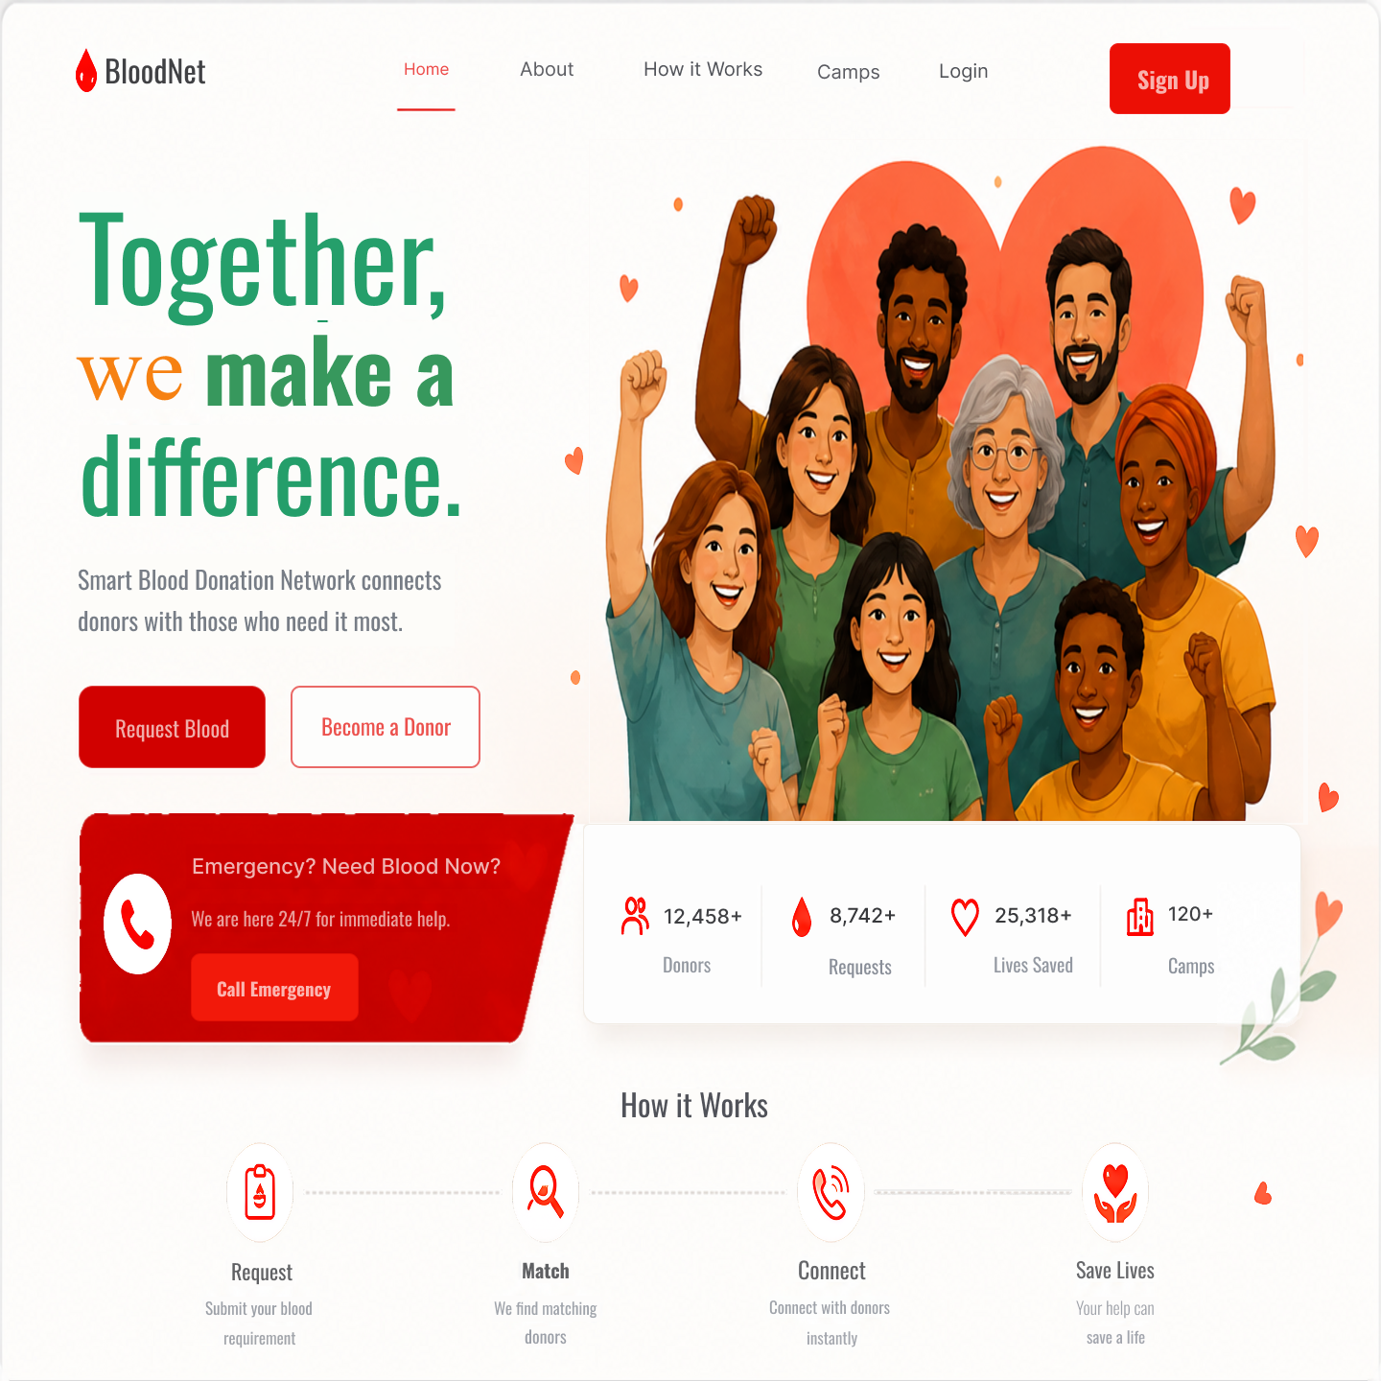
Figure 3: Prototype - PID1- Landing Page UI
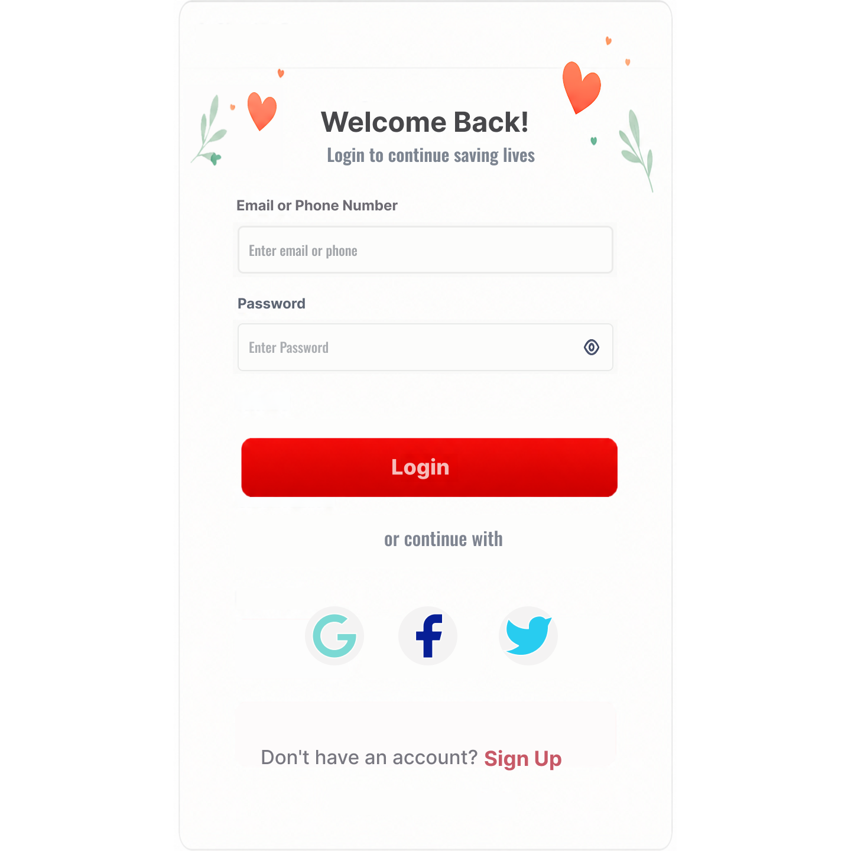
Figure 4: Prototype - PID2- login In Page UI
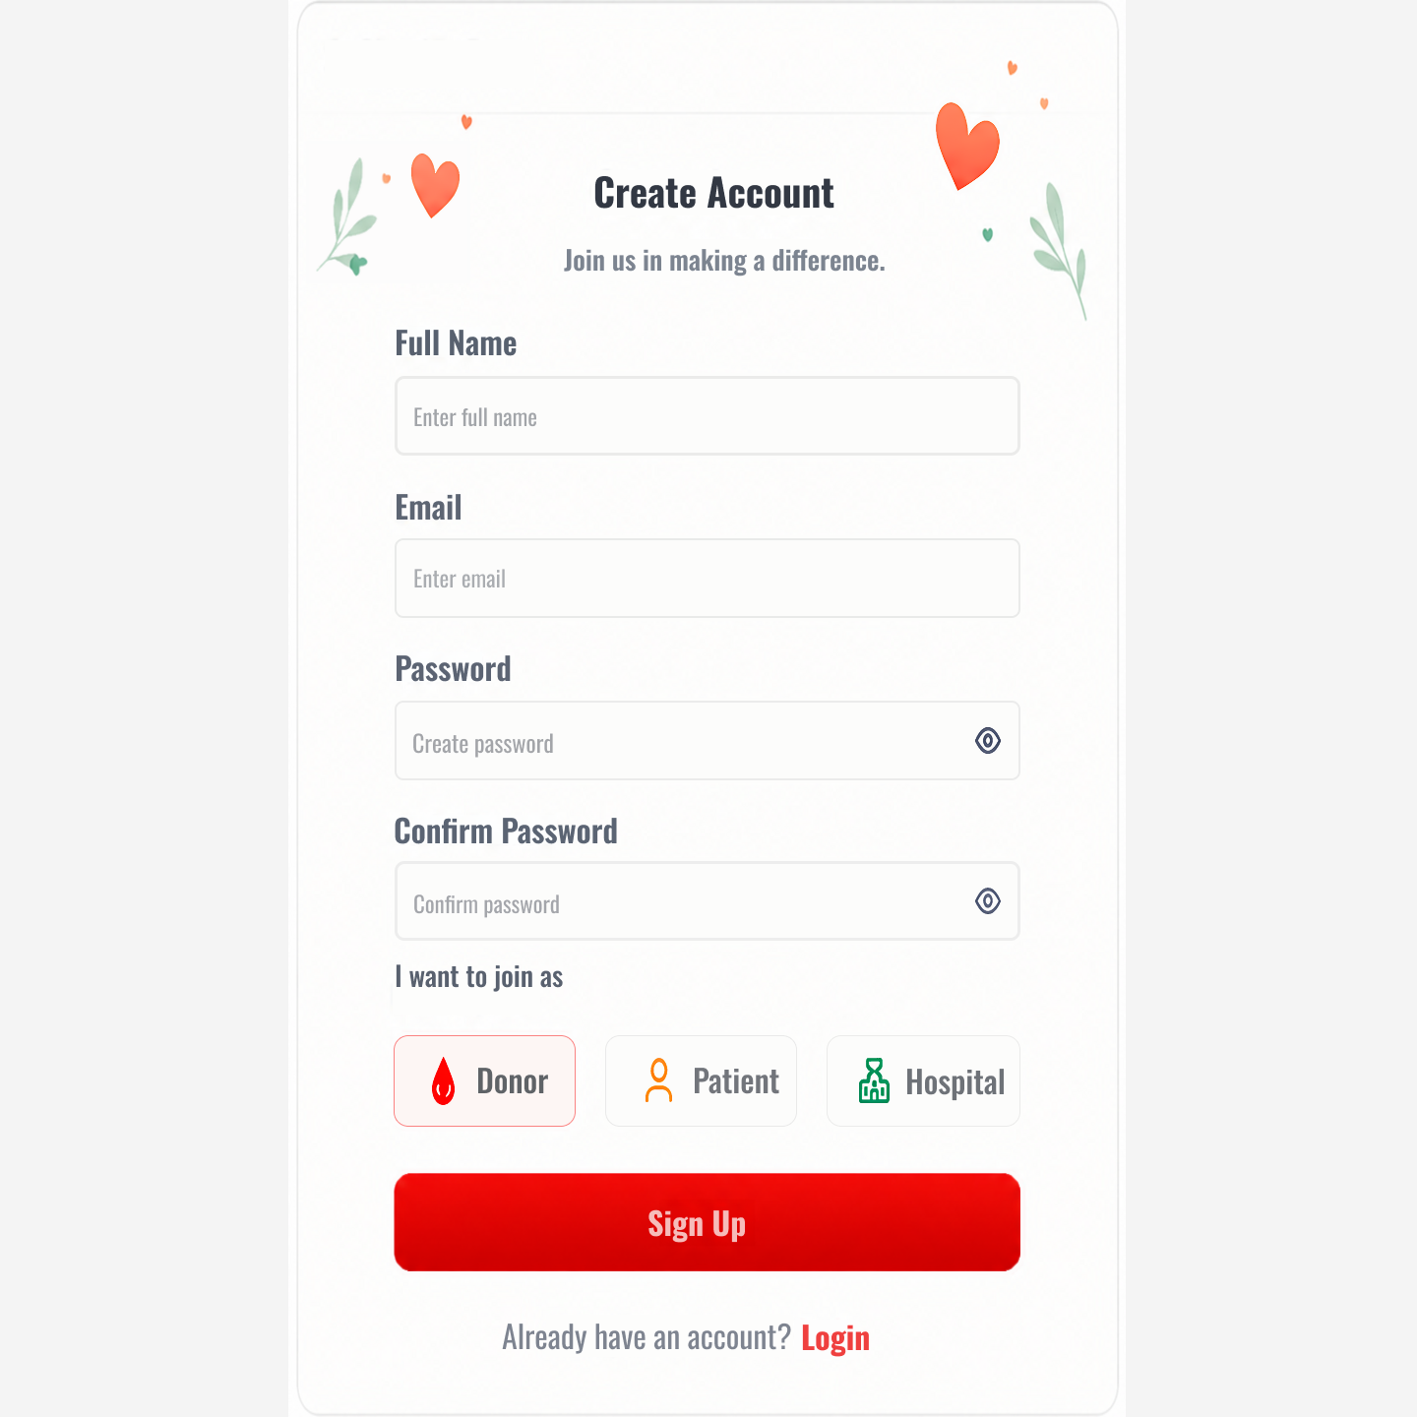
Figure 5: Prototype - PID3- Sign up Page

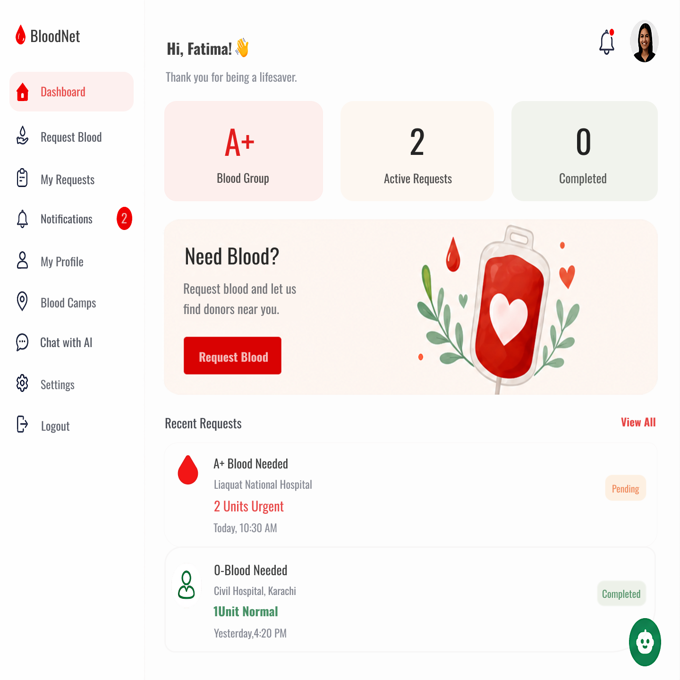
Figure 6: Prototype - PID4- Patient Dashboard Page
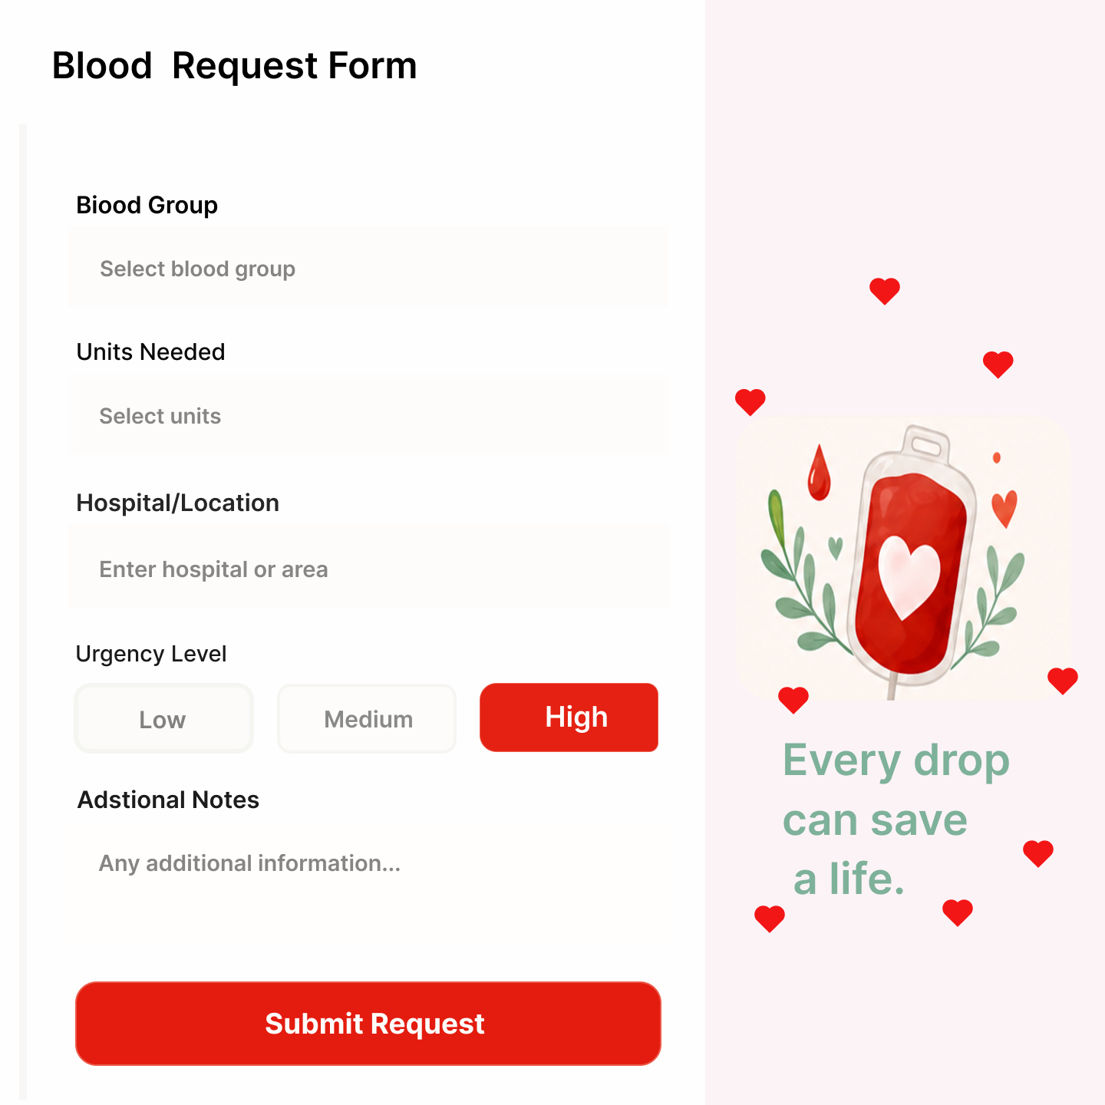
Figure 7: Prototype - PID5- Blood request form page
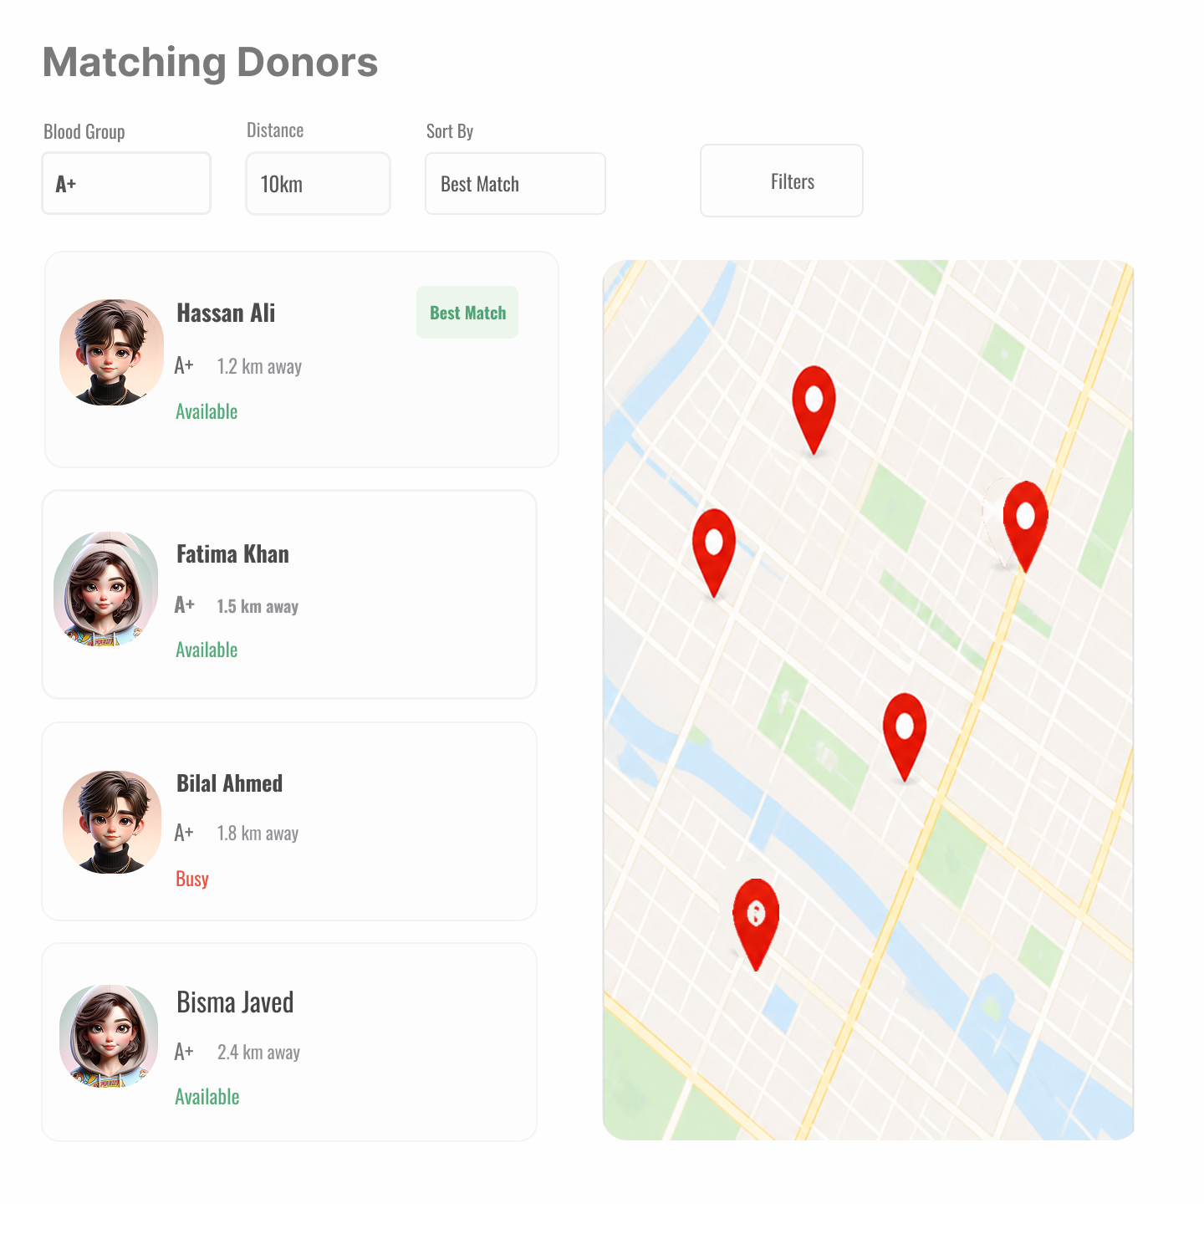
Figure 8: Prototype - PID6- Donor Matching Page

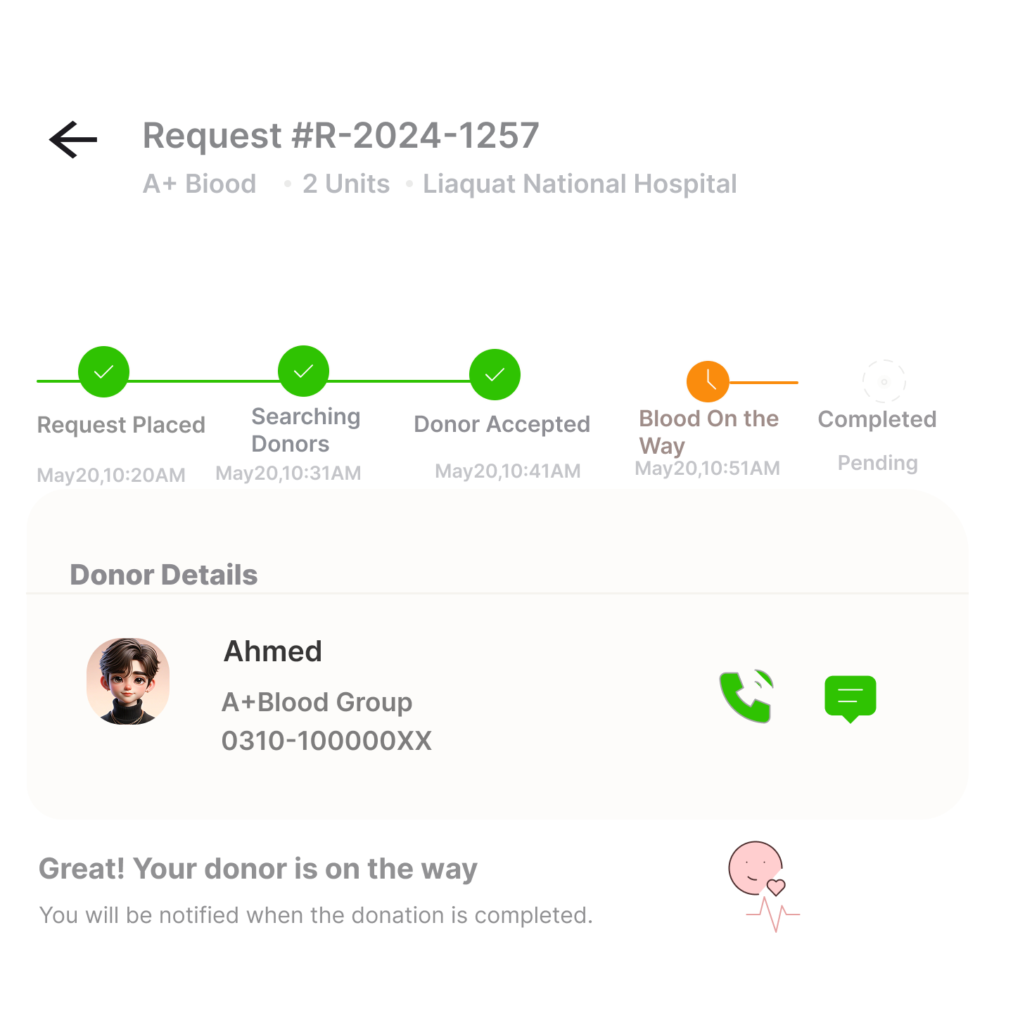
Figure 9: Prototype - PID7- Request Status Page

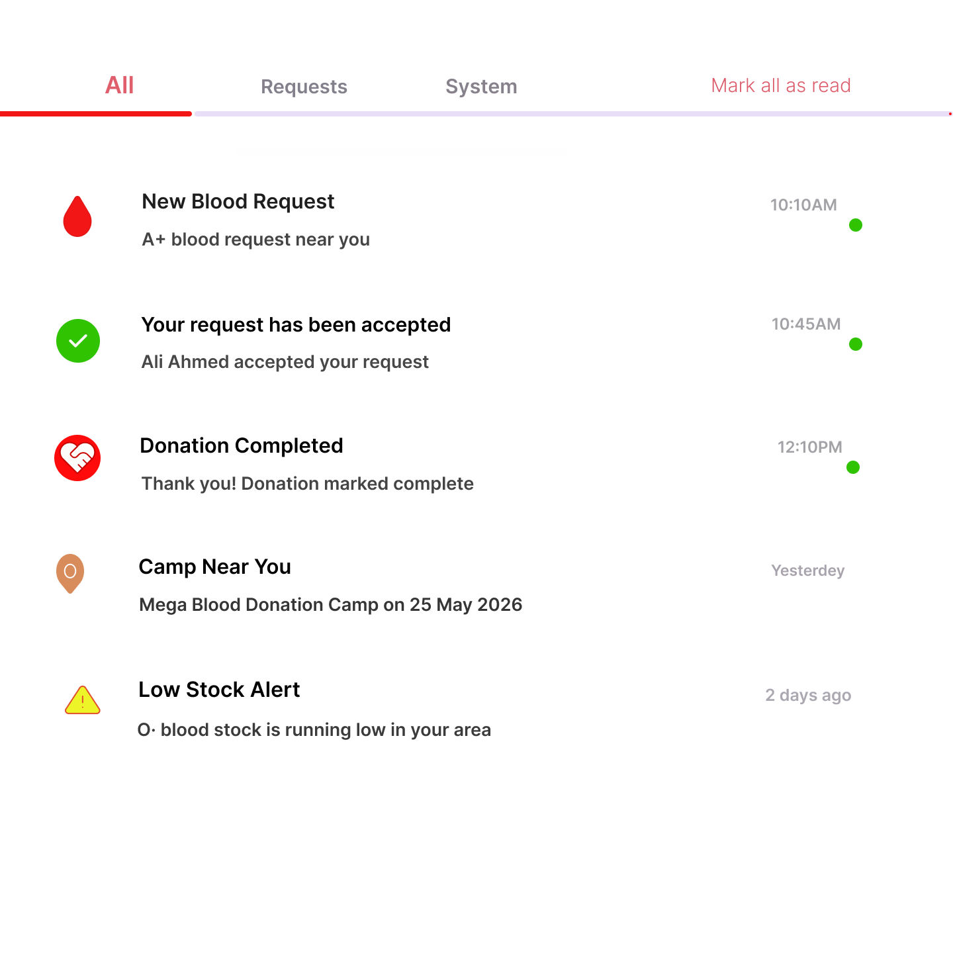
Figure 10: Prototype - PID8- Notifications Page
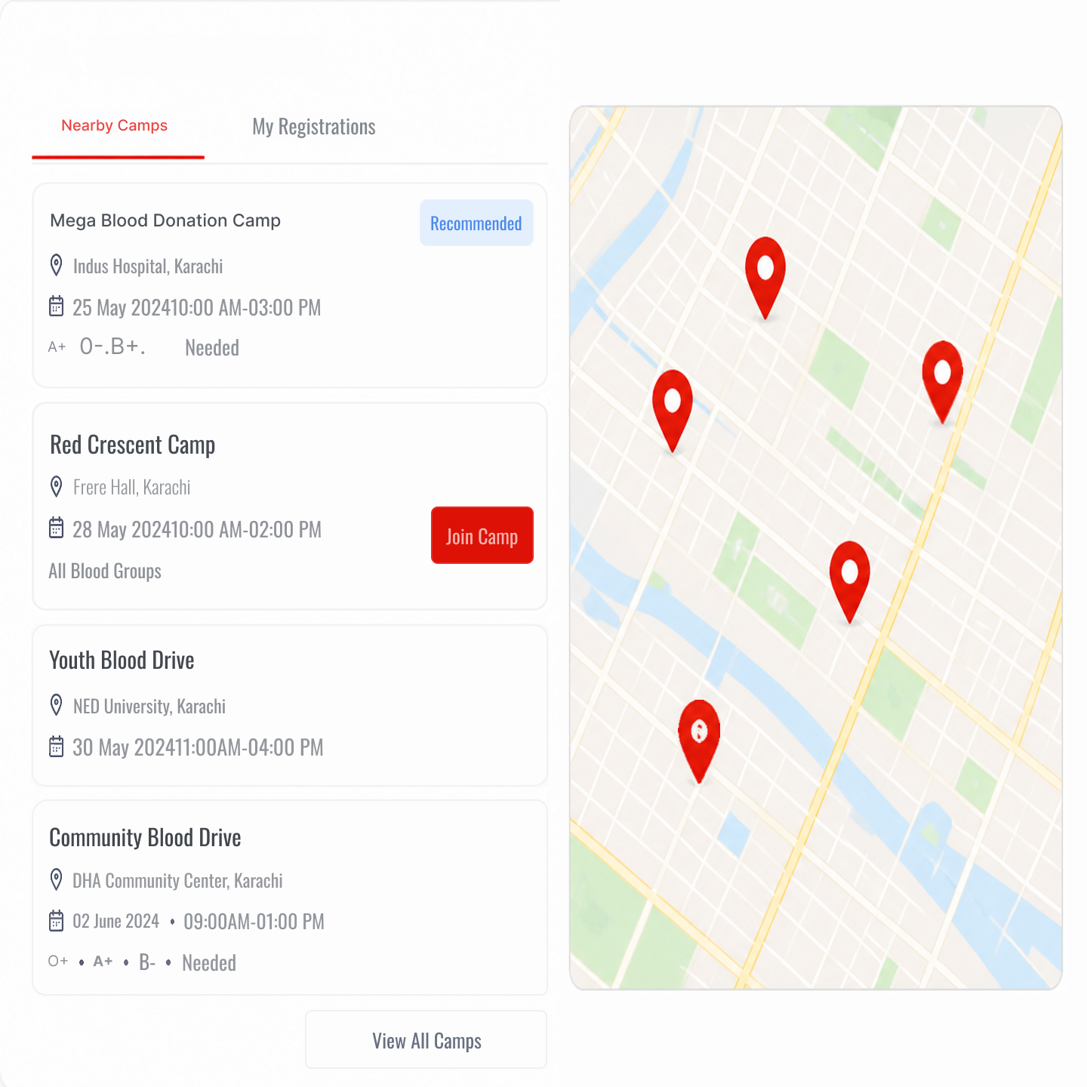
Figure 11: Prototype - PID9- Camp Page

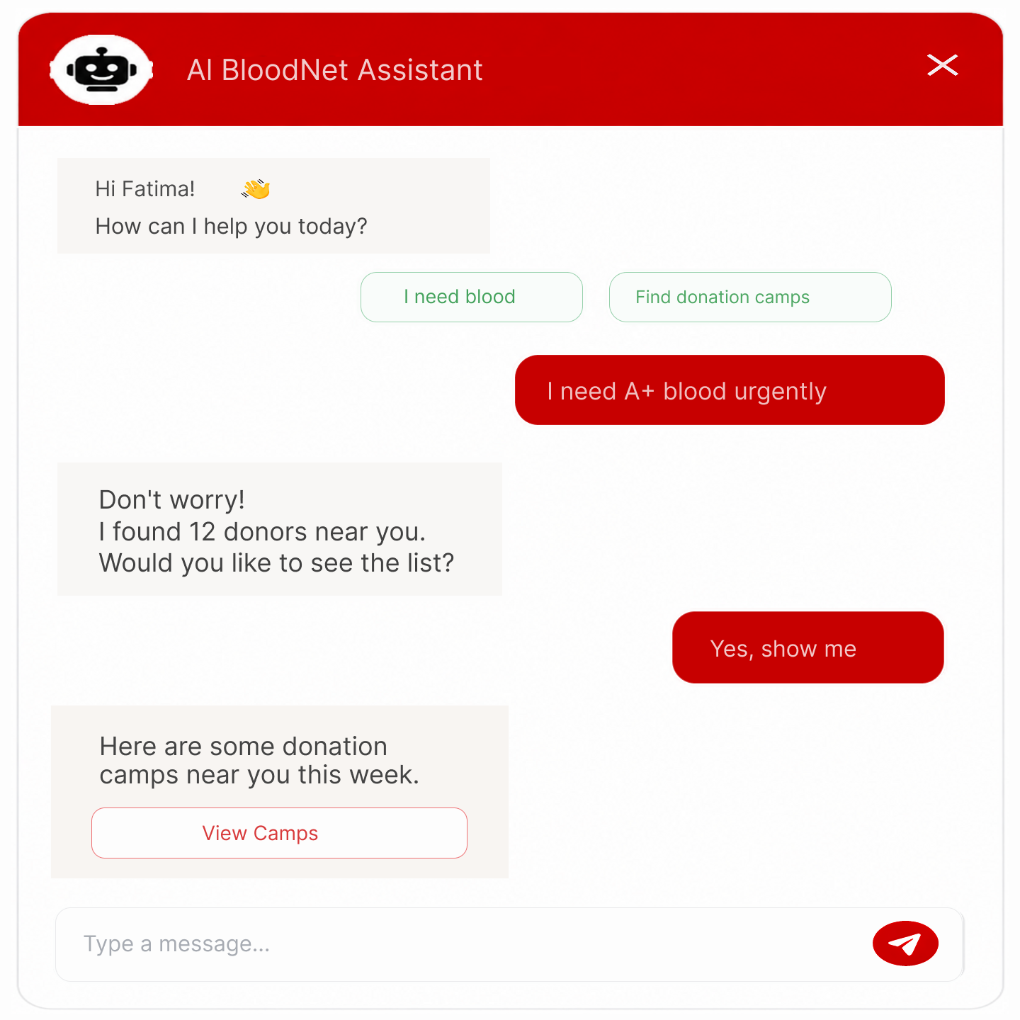

Figure 12: Prototype - PID10- AI chatbot UI

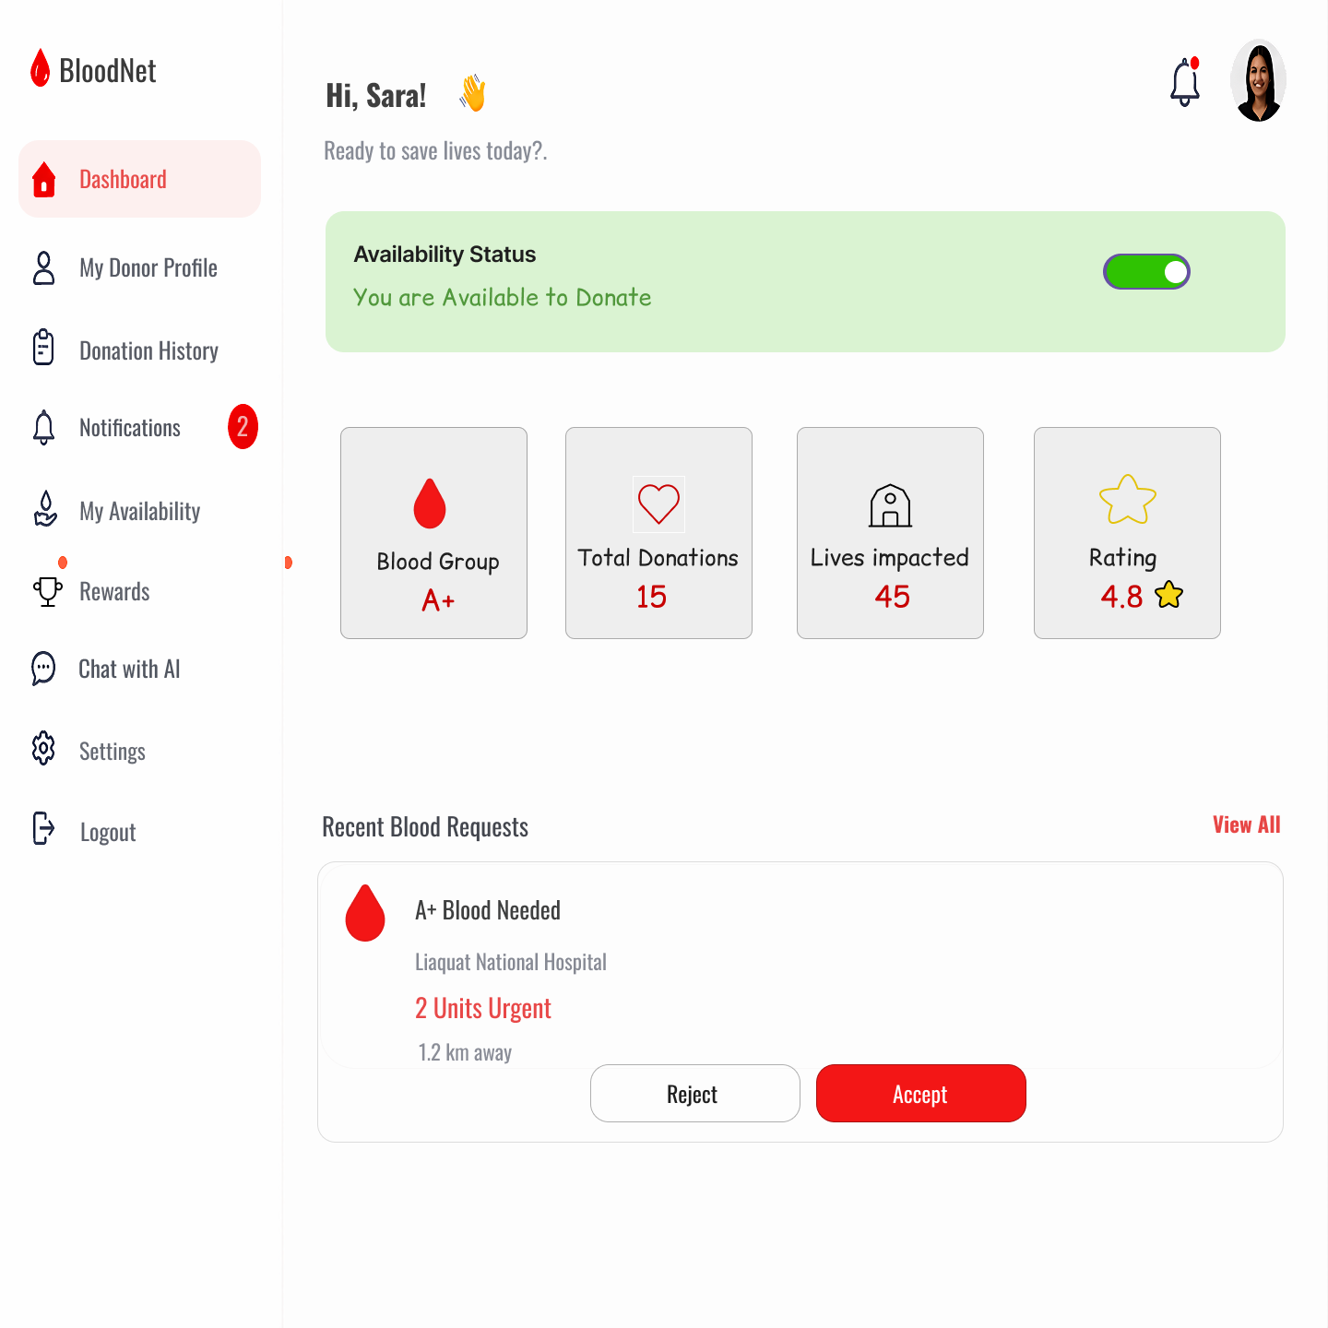

Figure 13: Prototype - PID11- Donor Dashboard

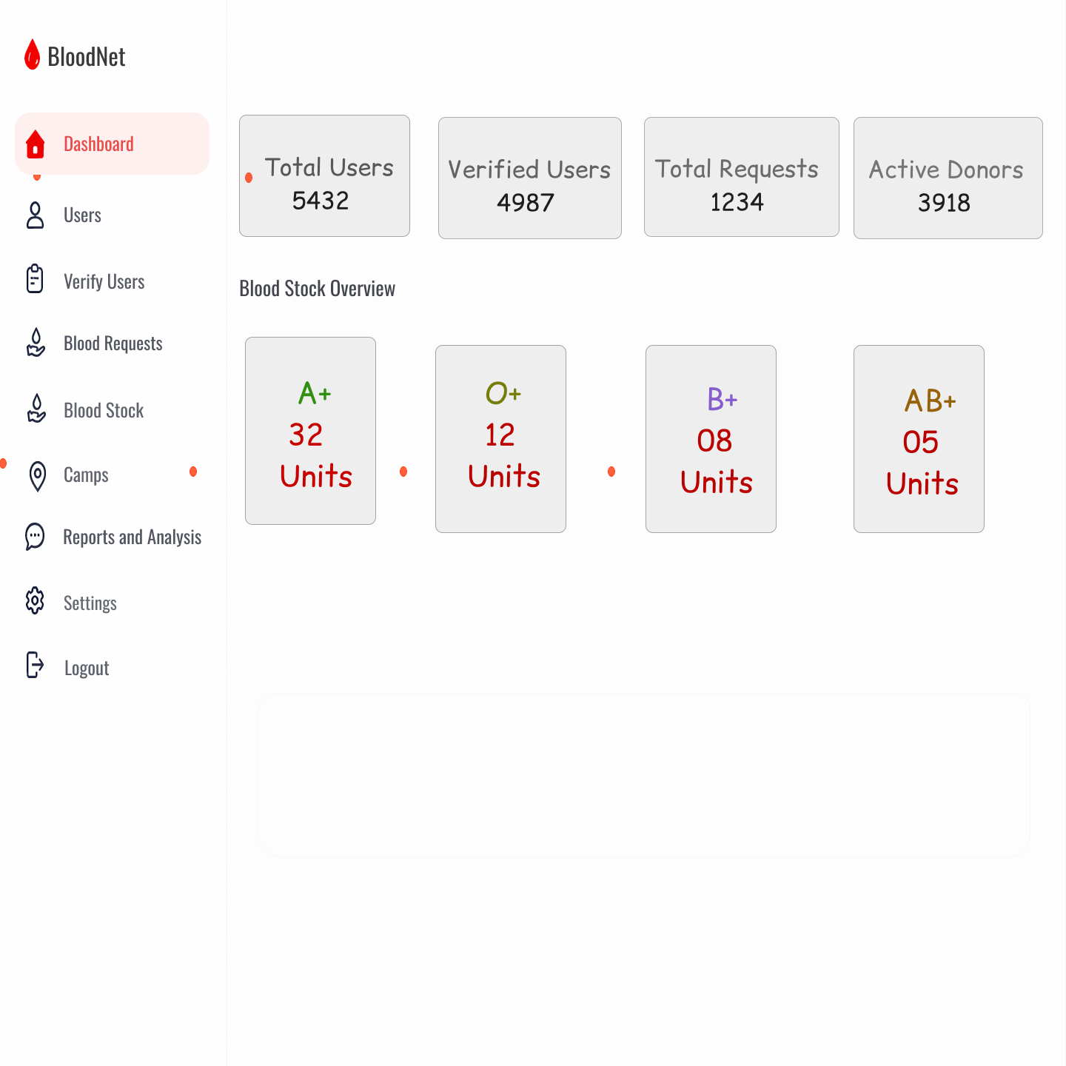

Figure 14: Prototype - PID12- Admin Dashboard

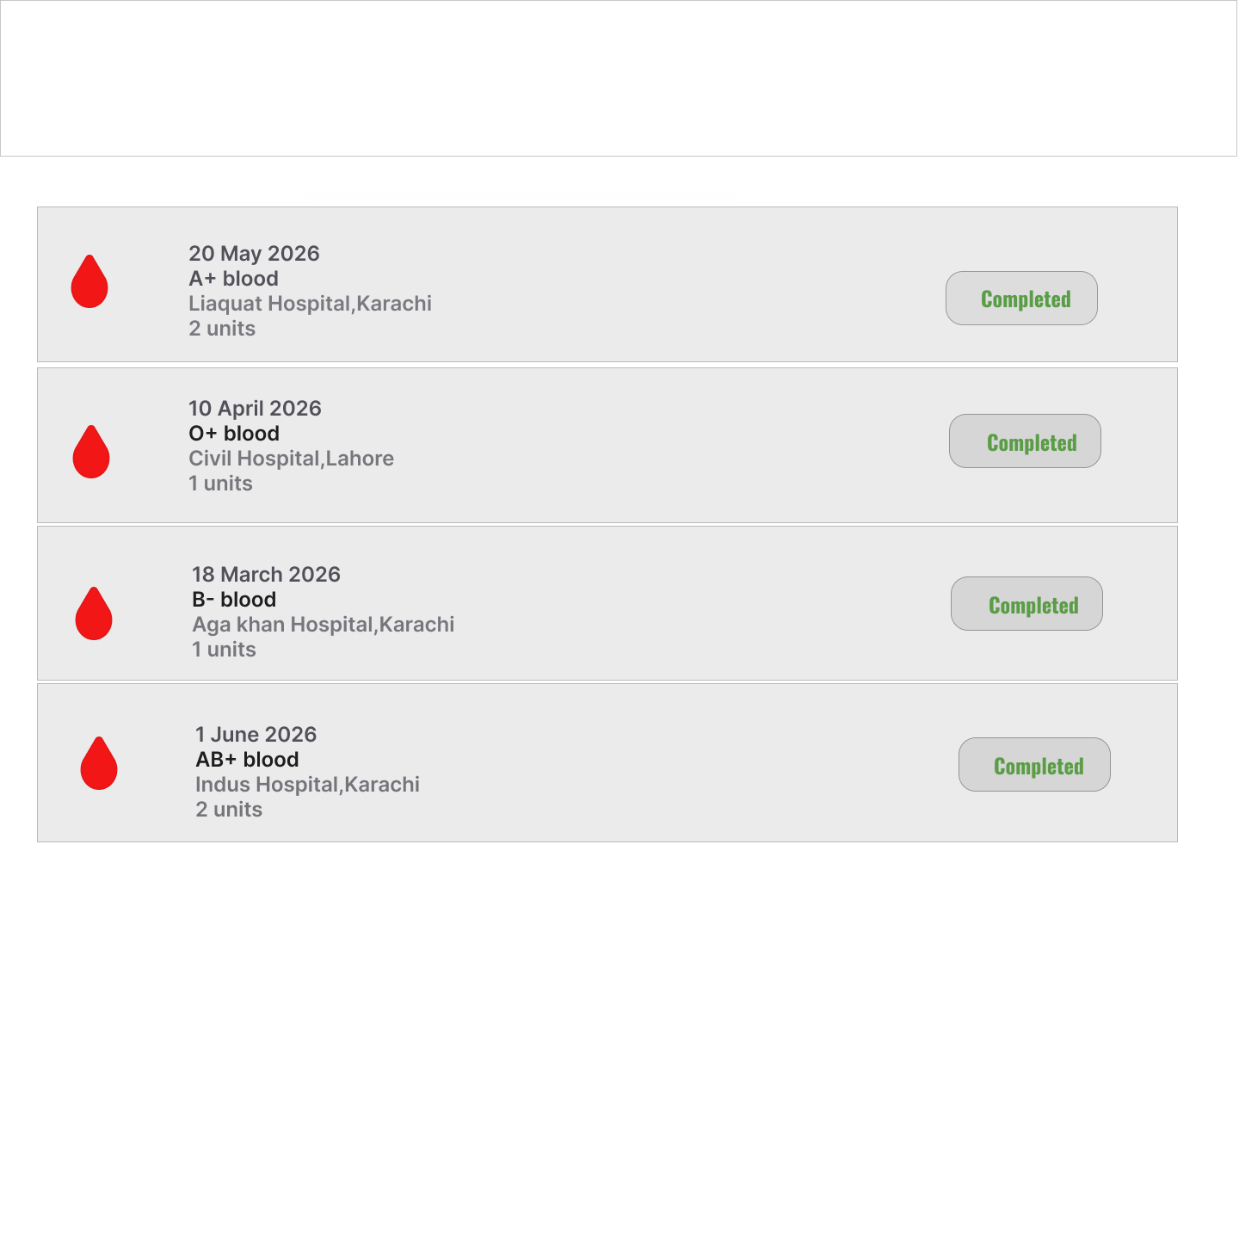
Figure 15: Prototype - PID13- Donation History

Project Planning and Execution using Sprints

Jira
https://smartblooddonation-fyp.atlassian.net/?continue=https%3A%2F%2Fsmartblooddonation-fyp.atlassian.net%2Fwelcome%2Fsoftware%3FprojectId%3D10067&atlOrigin=eyJpIjoiNDQxNzEyZGI0M2Q0NDViZWE3YWQ4NTg3MDQzNTAzMDMiLCJwIjoiamlyYS1zb2Z0d2FyZSJ9

Slack
https://join.slack.com/t/fypsmartblood-n4v1920/shared_invite/zt-3vi5wuow2-rTjTxqnWmnzY00y27dXfEA

GitHub Repository
https://github.com/minahil-murtaza/smart-blood-donation-system

Sprint 1

Sprint 1 Planning Meeting Minutes
Project Name: Smart Blood Donation Network
Sprint Name: Sprint 1 - Foundation and Core Workflow Development
Sprint Duration: 3 Weeks (17 May – 7 June)
Meeting Date: May 15th, 2026
Meeting Duration: 45 minutes
Facilitated by: Dr. Muhammad Asad Arshed
Attendees: Minahil Murtaza, Sunila Sami, Eman Ayesha , Ifreen Israr
Backlog Items with high priority, some high risk and Architecturaly Significant:
The following features are extracted from Product Backlog
Table 3: Sprint 1 - Selected Features of Product Backlog
PB-ID | Epic Name | User Story | Priority | Risk | Acceptance Criteria | Story Points | Status | Assigned To
UIM-01 | User & Identity Management | As a visitor, I want to register an account so that I can access the Smart Blood Donation Network. | High | Medium | • User enters all required information (name, email, password, role, etc.).  • System validates the entered information.  • Account is created successfully.  • Confirmation message is displayed. | 3 | Completed | Minahil Murtaza
UIM-02 | User & Identity Management | As a registered user, I want to log in using my credentials so that I can securely access my account. | High | Medium | • User enters valid credentials.  • System authenticates the user.  • User is redirected to the appropriate dashboard based on role.  • Invalid credentials display an error message. | 3 | Completed | Ifreen Israr
UIM-03 | User & Identity Management | As a registered user, I want to log out of my account so that unauthorized users cannot access my session. | High | Low | • User can log out from any page.  • Active session is terminated.  • User is redirected to the login page.  • Protected pages cannot be accessed after logout. | 2 | Completed | Eman Ayesha
UIM-04 | User & Identity Management | As a registered user, I want to reset my password if I forget it so that I can regain access to my account. | High | Medium | • User requests a password reset.  • System sends a password reset link or OTP.  • Reset link expires after a specified time.  • User successfully creates a new password. | 5 | Completed | Sunila Sami
UIM-05 | User & Identity Management | As a registered user, I want to change my password while logged in so that I can maintain my account security. | Medium | Low | • User enters the current password.  • User provides and confirms a new password.  • System validates password requirements.  • Password is updated successfully. | 3 | Completed | Minahil Murtaza
UIM-06 | User & Identity Management | As a registered user, I want to manage and update my profile information so that my personal details remain accurate. | Medium | Low | • User can edit profile details.  • Required fields are validated.  • Changes are saved successfully.  • Updated information is displayed immediately. | 3 | Completed | Ifreen Israr
UAM-01 | User Account & Role Management | As a user, I want to select my role (Donor, Recipient, or both) so that I can access the appropriate features of the system. | High | Low | • User can choose one or more roles.  • Selected role(s) are saved successfully.  • Appropriate features become accessible based on the selected role(s). | 3 | Completed | Eman Ayesha
UAM-02 | User Account & Role Management | As a user, I want to update my role preferences so that they reflect my current needs. | Medium | Medium | • User can add or remove roles.  • Changes are validated and saved.  • System updates permissions accordingly. | 3 | Completed | Sunila Sami
UAM-03 | User Account & Role Management | As a user, I want to activate my account so that I can access all system functionalities after verification. | High | Low | • Account can be activated after successful verification.  • User gains access to authorized features.  • Activation status is updated successfully. | 3 | Completed | Minahil Murtaza
UAM-04 | User Account & Role Management | As a user, I want to temporarily deactivate my account so that I can stop using the system without losing my account information. | Medium | Medium | • User can deactivate the account from account settings.  • Account status changes to inactive.  • User cannot access protected features while the account is inactive.  • Account data is retained. | 3 | Completed | Ifreen Israr
DM-01 | Donor Management | As a donor, I want to complete my donor profile so that I can participate in the blood donation network. | High | Medium | • Donor can enter personal information, blood group, contact details, and location.  • Required fields are validated.  • Profile is saved successfully. | 3 | Completed | Eman Ayesha
DM-02 | Donor Management | As a donor, I want to update my donor profile so that my information remains accurate and up to date. | Medium | Low | • Donor can edit profile information.  • Changes are validated and saved successfully.  • Updated profile is displayed. | 3 | Completed | Sunila Sami
RM-01 | Recipient Management | As a recipient, I want to complete my medical profile so that the system can maintain accurate medical information for my blood requirements. | High | Medium | • Recipient can enter personal and medical information, including blood group, medical condition, hospital, physician, and emergency contact.  • Mandatory fields are validated.  • Profile is saved successfully. | 5 | Completed | Minahil Murtaza
RM-02 | Recipient Management | As a recipient, I want to update my medical profile so that my health information remains accurate and up to date. | High | Low | • Recipient can modify medical information.  • Updated information is validated.  • Changes are saved successfully. | 3 | Completed | Ifreen Israr
ADM-01 | Administration | As an administrator, I want to view a system dashboard so that I can monitor the overall status and performance of the Smart Blood Donation Network. | High | Medium | • Dashboard displays key system statistics.  • Summary of users, blood requests, donations, emergencies, and blood banks is available.  • Dashboard updates with current system data. | 5 | Completed | Eman Ayesha

Workload Distribution:
The following table shows the distribution of sprint 1 tasks among team members:
Table 4: Workload Distribution
Member | Assigned User Stories | Story Points
Minahil Murtaza | UIM-01, UIM-05, UAM-03, RM-01 | 14
Ifreen Israr | UIM-02, UIM-06, UAM-04, RM-02 | 12
Eman Ayesha | UIM-03, UAM-01, DM-01, ADM-01 | 13
Sunila Sami | UIM-04, UAM-02, DM-02 | 11
Team Capacity:
The following table shows the estimated availability and working capacity of each team member for the sprint period:
Table 5: Team Capacity for Sprint 1
Member | Days Available | Hours/Day | Total Hours
Minahil Murtaza | 15 | 3 | 45
Ifreen Israr | 15 | 3 | 45
Sunila Sami | 14 | 3 | 42
Eman Ayesha | 15 | 3 | 45

Action Items before Sprint Starts:
- Confirm GitHub repository setup and team access permissions – Eman Ayesha
- Create and organize Jira project, epics, user stories, and Sprint 1 backlog – Minahil Murtaza
- Prepare and share Figma design templates and screen mockups – Sunila Sami
- Configure Slack workspace and communication channels – Ifreen Israr
- Install and configure development tools (VS Code, Git, Node.js, database tools, etc.) – Eman Ayesha
- Install and configure Python development environment (PyCharm and required dependencies) – Ifreen Israr
- Integrate GitHub Copilot with VS Code and verify access for team members – Minahil Murtaza
- Review Sprint 1 Figma screens and confirm implementation scope – Sunila Sami
- Design initial database schema and system architecture – Ifreen Israr
- Establish Git workflow and branching strategy for development – Sunila Sami
- Verify development environment and tool configuration on all team machines – All Team Members
- Review Sprint 1 user stories and confirm task assignments – All Team Members
- Finalize Sprint 1 goals, deliverables, and timeline – All Team Members

Sprint 1 Backlog
The following tasks are extracted from Product Backlog features:
Table 6: Sprint 1 Backlog
SP-ID | Task Name | Related Product Backlog ID | Assigned To | Status | Estimated Effort (Hours) | Actual Effort (Hours) | Comments
SP-01 | Develop User Registration Module | UIM-01 | Minahil Murtaza | Completed | 10 | 11 | Registration functionality implemented and validated successfully.
SP-02 | Develop User Login Module | UIM-02 | Ifreen Israr | Completed | 8 | 9 | User authentication implemented successfully.
SP-03 | Implement Email Verification | UIM-03 | Eman Ayesha | Completed | 6 | 7 | Email verification link and account activation completed.
SP-04 | Develop Password Reset Feature | UIM-04 | Sunila Sami | Completed | 8 | 9 | Password recovery through email reset link implemented.
SP-05 | Implement Change Password Functionality | UIM-05 | Minahil Murtaza | Completed | 5 | 5 | Users can securely change their passwords.
SP-06 | Develop Personal Profile Management | UIM-06 | Ifreen Israr | Completed | 7 | 8 | Profile information can be viewed and updated successfully.
SP-07 | Implement User Role Selection | UAM-01 | Eman Ayesha | Completed | 5 | 5 | Users can select Donor or Recipient role during registration.
SP-08 | Develop Role/Profile Update Module | UAM-02 | Sunila Sami | Completed | 7 | 8 | Users can modify profile and role information successfully.
SP-09 | Implement Account Status View | UAM-03 | Minahil Murtaza | Completed | 4 | 4 | Account status is displayed correctly to users.
SP-10 | Develop Account Deactivation Feature | UAM-04 | Ifreen Israr | Completed | 7 | 8 | Temporary account deactivation implemented successfully.
SP-11 | Develop Donor Profile Module | DM-01 | Eman Ayesha | Completed | 8 | 9 | Donor profile creation completed successfully.
SP-12 | Develop Donor Profile Update Module | DM-02 | Sunila Sami | Completed | 6 | 7 | Donor information can be updated successfully.
SP-13 | Develop Recipient Profile Module | RM-01 | Minahil Murtaza | Completed | 8 | 9 | Recipient profile creation implemented successfully.
SP-14 | Develop Recipient Profile Update Module | RM-02 | Ifreen Israr | Completed | 6 | 6 | Recipient information update feature completed successfully.
SP-15 | Develop Registered Users Dashboard | ADM-01 | Eman Ayesha | Completed | 8 | 9 | Administrator can view all registered users successfully.
Sprint Effort Summary
Total Tasks: 15
Total Estimated Effort: 113 Hours
Total Actual Effort: 125 Hours

Sprint 1 Design Class Diagram
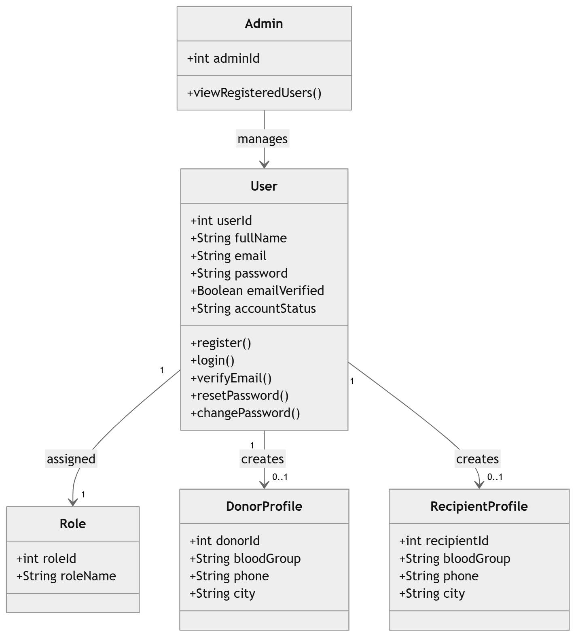
Figure 16: Class diagram of Sprint 1 features

Sprint 1 Sequence Diagram
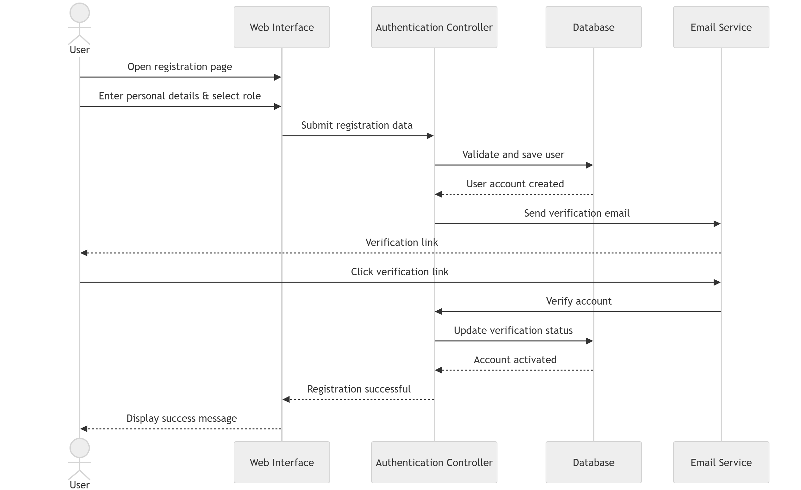
Figure 17: Sequence Diagram – User Registration and Email Verification

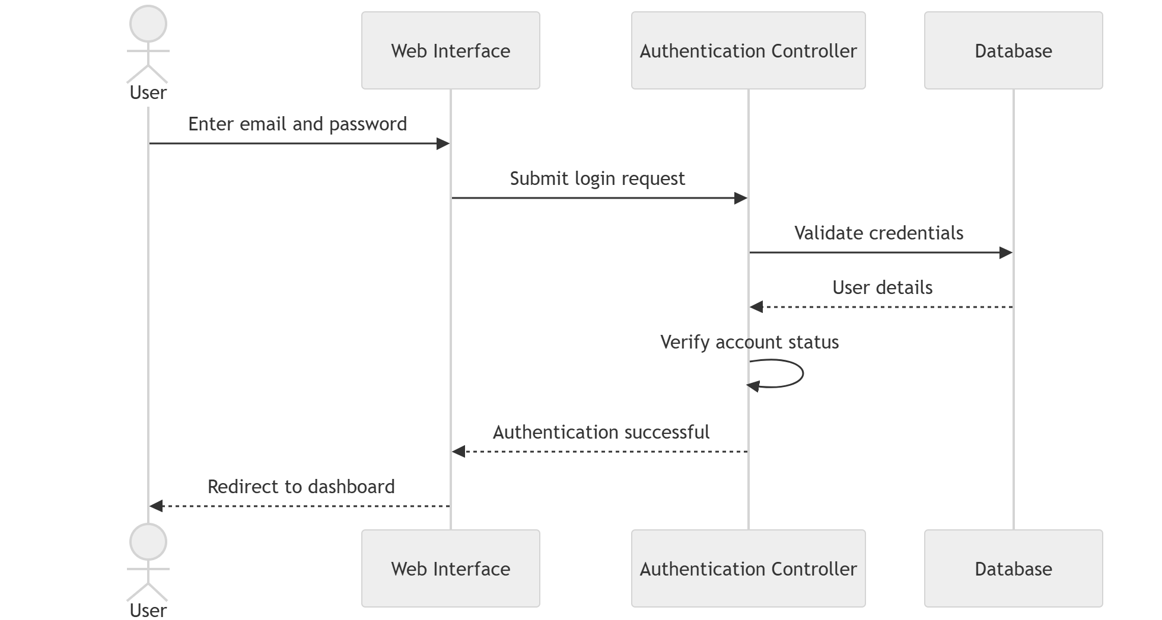
Figure 18: Sequence Diagram – User Login and Account Authentication

Figure 19: Sequence Diagram 3 - Password Recovery and Change Password
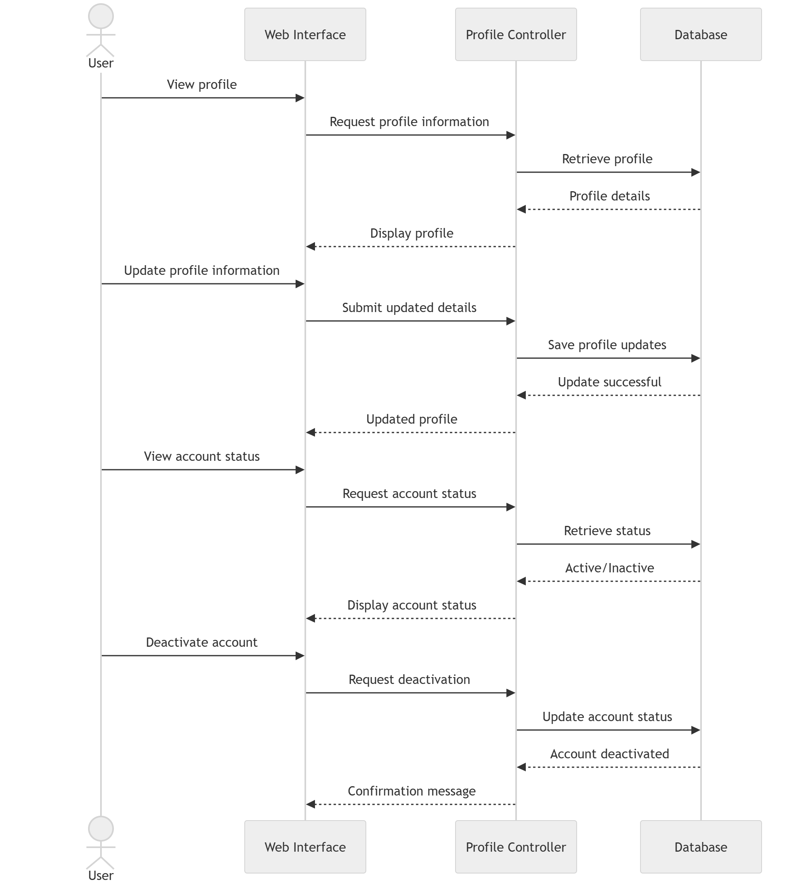
Figure 20: Sequence Diagram 4 - User Profile Management
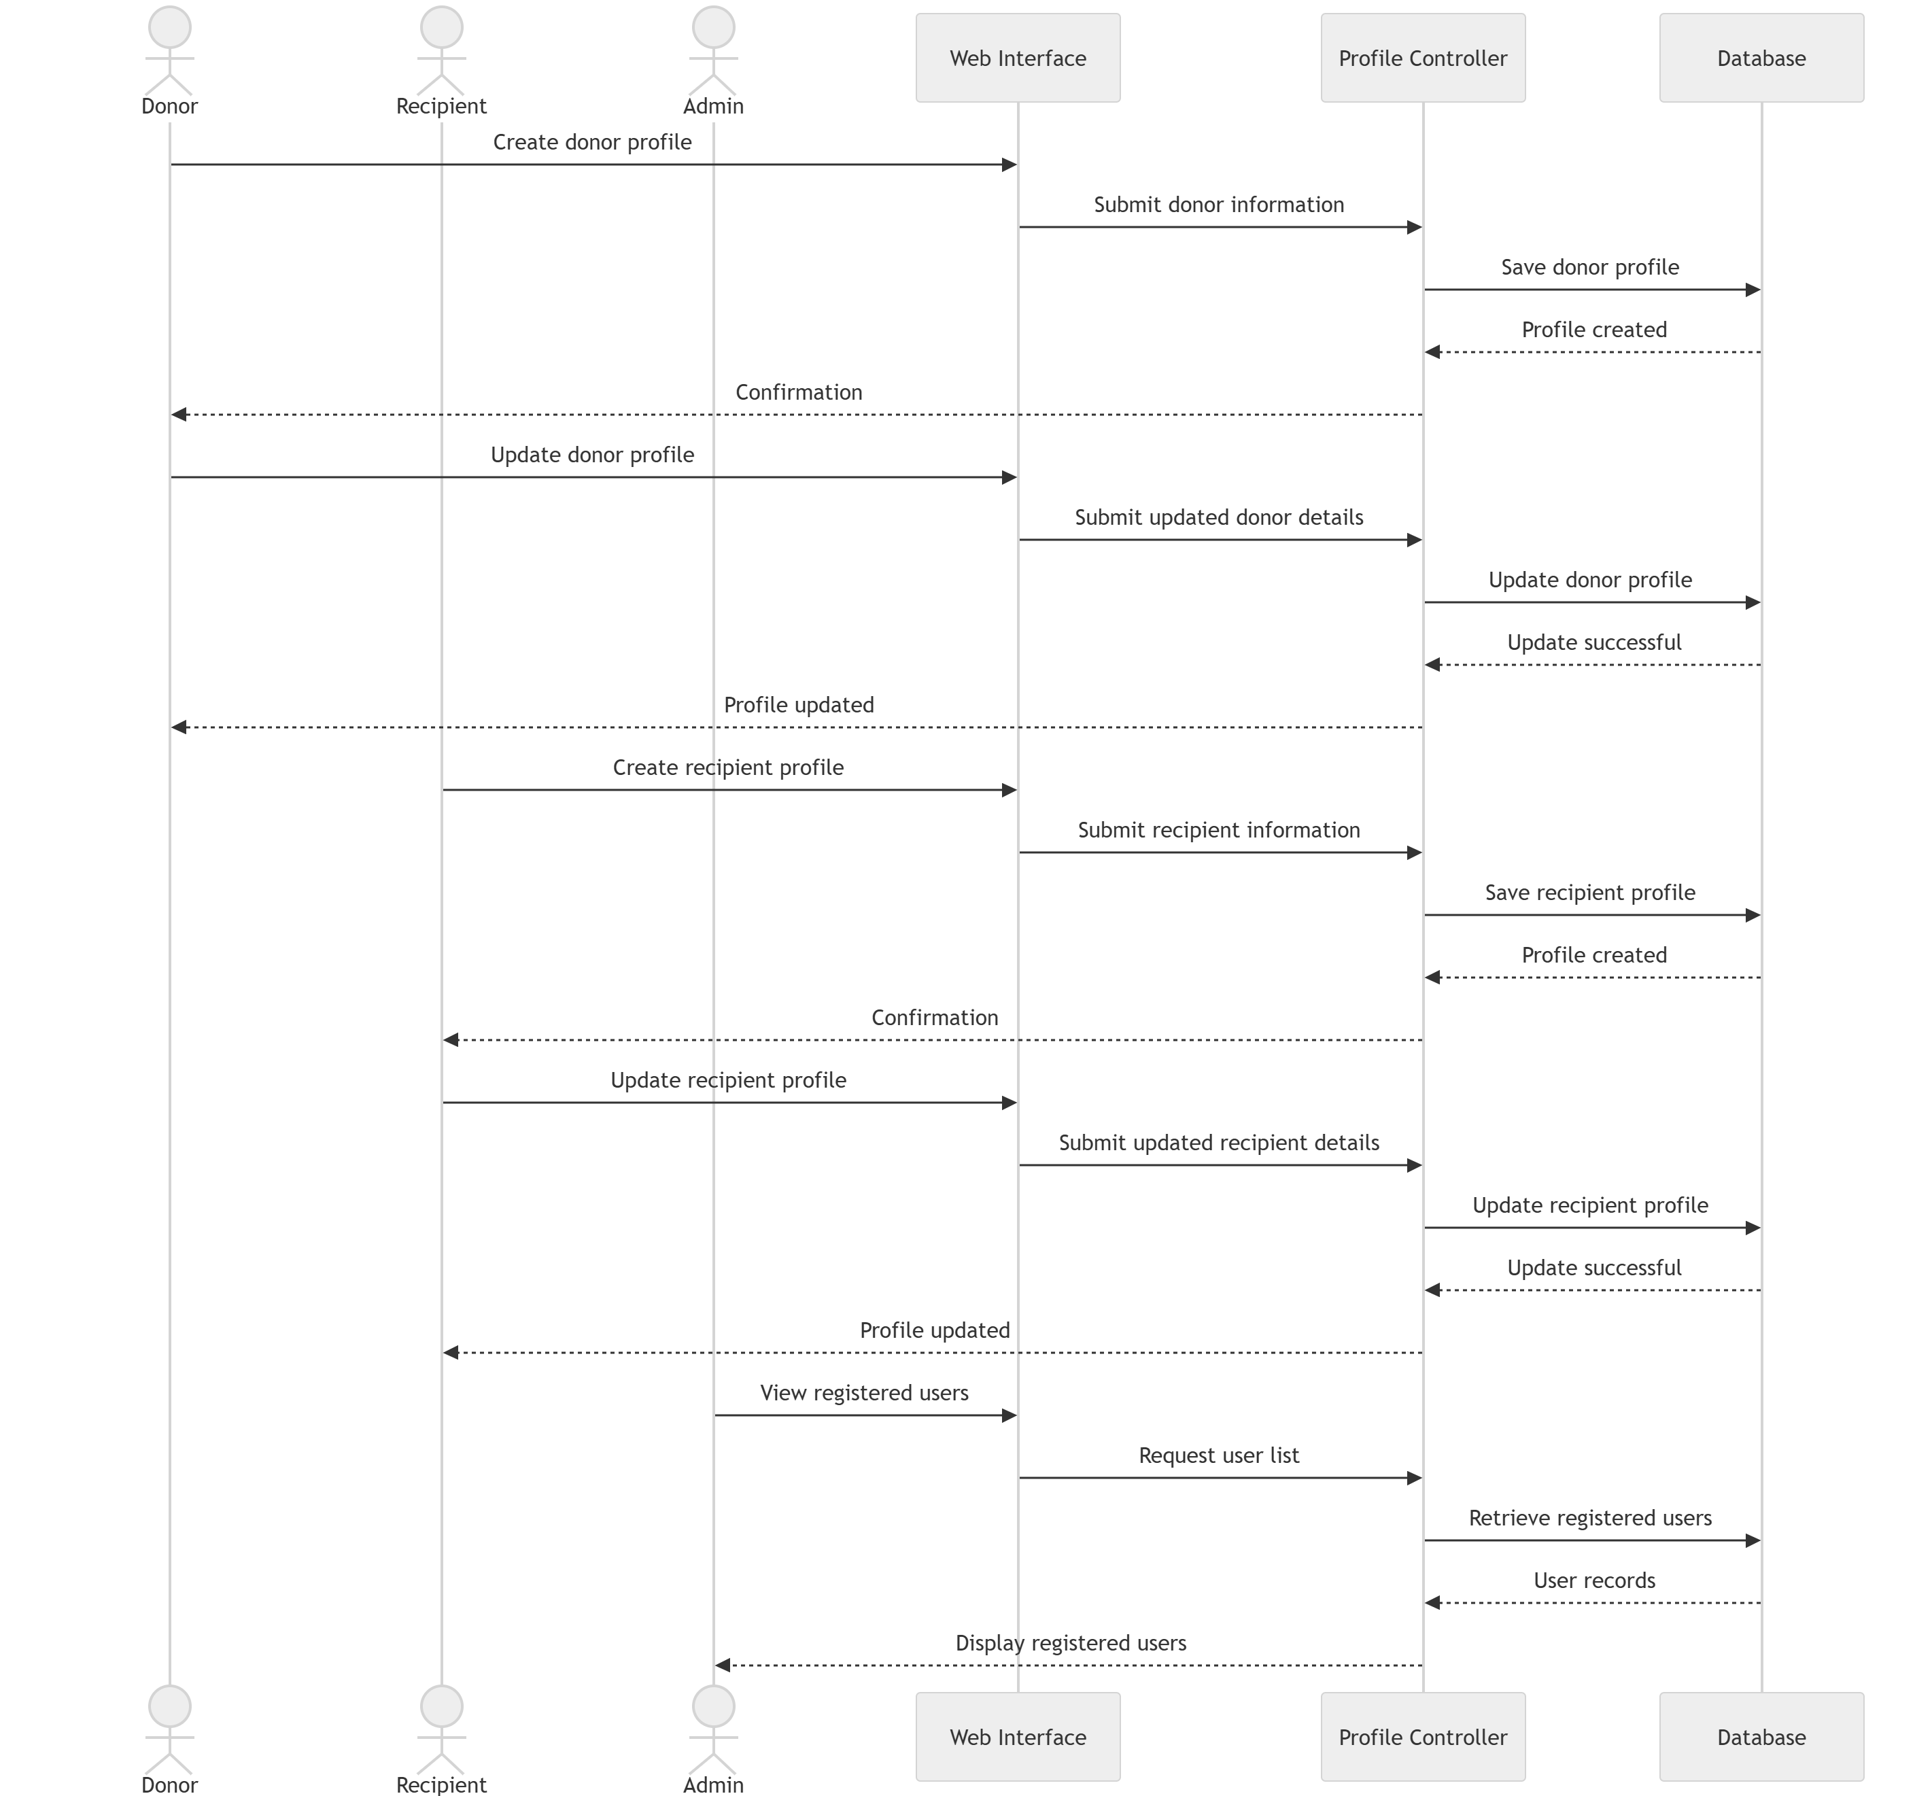
Figure 21: Sequence Diagram 5 - Donor, Recipient, and Administrator Management

Sprint 1 Decision Tables
Decision tables are used to represent the business rules implemented during Sprint 1. They define how the system responds to different conditions and ensure that validation and processing rules are applied consistently throughout the application.
Table 7: Decision Table – User Registration Validation
Conditions | Rule 1 | Rule 2 | Rule 3 | Rule 4
All required fields entered? | Y | Y | Y | N
Email already exists? | N | Y | N | -
Password meets policy? | Y | Y | N | -
Actions
Create account | ✓ | ✗ | ✗ | ✗
Display duplicate email error | ✗ | ✓ | ✗ | ✗
Display password validation error | ✗ | ✗ | ✓ | ✗
Display missing fields error | ✗ | ✗ | ✗ | ✓
Discussion: The registration process validates the user's information before creating a new account. The system ensures that all mandatory fields are completed, the email address is unique, and the password satisfies the required security policy.
Table 8: Decision Table – User Login Authentication
Conditions | Rule 1 | Rule 2 | Rule 3 | Rule 4
Email exists? | Y | Y | N | Y
Password correct? | Y | N | - | Y
Email verified? | Y | Y | - | N
Actions
Grant access | ✓ | ✗ | ✗ | ✗
Display invalid credentials | ✗ | ✓ | ✓ | ✗
Request email verification | ✗ | ✗ | ✗ | ✓
Discussion: During login, the system validates the user's credentials and verifies that the account has been activated through email verification. Access is granted only when all authentication conditions are satisfied.
Table 9: Decision Table – Password Management
Conditions | Rule 1 | Rule 2 | Rule 3 | Rule 4
Registered email exists? | Y | N | Y | Y
New password meets policy? | Y | - | N | Y
Password confirmation matches? | Y | - | Y | N
Actions
Update password | ✓ | ✗ | ✗ | ✗
Display email not found error | ✗ | ✓ | ✗ | ✗
Display password policy error | ✗ | ✗ | ✓ | ✗
Display password mismatch error | ✗ | ✗ | ✗ | ✓
Discussion: The password management process ensures that only registered users can reset or change their passwords. The system validates the new password against the defined policy and confirms that both password entries match before updating the account.
Table 10: Decision Table – User Profile Management
Conditions | Rule 1 | Rule 2 | Rule 3 | Rule 4
User authenticated? | Y | Y | N | Y
Profile data valid? | Y | N | - | Y
Account active? | Y | Y | - | N
Actions
Save profile changes | ✓ | ✗ | ✗ | ✗
Display validation error | ✗ | ✓ | ✗ | ✗
Request user login | ✗ | ✗ | ✓ | ✗
Display account inactive message | ✗ | ✗ | ✗ | ✓
Discussion: Before updating profile information, the system verifies that the user is authenticated, the submitted information is valid, and the account is active. Invalid requests are rejected with appropriate feedback.
Table 11: Decision Table – Donor and Recipient Profile Management
Conditions | Rule 1 | Rule 2 | Rule 3 | Rule 4
User authenticated? | Y | Y | N | Y
Required profile fields entered? | Y | N | - | Y
Selected role valid? | Y | Y | - | N
Actions
Save donor/recipient profile | ✓ | ✗ | ✗ | ✗
Display missing information error | ✗ | ✓ | ✗ | ✗
Request user login | ✗ | ✗ | ✓ | ✗
Display invalid role message | ✗ | ✗ | ✗ | ✓
Discussion: The system allows users to create or update donor and recipient profiles only after successful authentication. It validates that all mandatory information has been provided and that the selected user role matches the profile being created or updated.

Sprint 1 Extended Test Cases
Table 12: Extended Test Case – User Registration
Test Case ID: TC_UIM_01 |  |  | Test Designed By: Minahil Murtaza
Epic Name and Backlog ID: User & Identity Management (UIM-01) |  |  | Test Design Date: 25/05/2026
Test Priority: High |  |  | Test Executed By: Ifreen Israr
Test Title: Verify User Registration with Valid Information |  |  | Test Executed Date: 06/06/2025
Description: Verify that a new user can successfully register an account by providing valid personal information and selecting an appropriate user role.
Selenium Web Driver Test Created: Yes
Dependencies: None
Step | Test Step | Test Data | Expected Result | Actual Result | Status
1 | Open the registration page from the home screen. | Registration page URL | The registration form is displayed successfully. | Same as expected result. | Pass
2 | Enter valid personal information including full name, email address and password. | Name: Ali Khan  Email: ali.khan@gmail.com  Password: Life@2024Secure | The system accepts all entered information without validation errors. | Same as expected result. | Pass
3 | Select Donor as the user role. | Role: Donor | The selected role is accepted and displayed correctly. | Same as expected result. | Pass
4 | Click the Register button. | Valid registration data | The system creates the account and sends a verification email to the registered email address. | Same as expected result. | Pass
5 | Open the received email and click the verification link. | Verification email | The account is successfully verified and activated. | Same as expected result. | Pass
6 | Navigate to the login page after successful verification. | Verified account credentials | The user is redirected to the login page with an account activation success message. | Same as expected result. | Pass
Post Condition:
1. A new user account is successfully created.
2. The registered user can log in using the verified email address and password.
Table 13: Extended Test Case – User Login
Test Case ID: TC_UIM_02 |  |  | Test Designed By: Ifreen Israr
Epic Name and Backlog ID: User & Identity Management (UIM-02) |  |  | Test Design Date: 25/05/2026
Test Priority: High |  |  | Test Executed By: Eman Ayesha
Test Title: Verify User Login with Valid Credentials |  |  | Test Executed Date: 06/06/2026
Description: Verify that a registered and verified user can successfully log into the system using valid credentials.
Selenium Web Driver Test Created: Yes
Dependencies: User account must be registered and email verified.
Step | Test Step | Test Data | Expected Result | Actual Result | Status
1 | Open the login page from the home screen. | Login page URL | The login page is displayed successfully. | Same as expected result. | Pass
2 | Enter a registered email address. | Email: ali.khan@gmail.com | The email is accepted without validation errors. | Same as expected result. | Pass
3 | Enter the correct password. | Password: Life@2024Secure | The password is accepted correctly. | Same as expected result. | Pass
4 | Click the Login button. | Valid login credentials | The system validates the entered credentials. | Same as expected result. | Pass
5 | The system authenticates the user and checks account status. | Verified user account | The account is successfully authenticated. | Same as expected result. | Pass
6 | User is redirected to the dashboard. | Authenticated session | The dashboard is displayed successfully after login. | Same as expected result. | Pass
Post Condition:
1. The user is successfully logged into the system.
2. The user dashboard is accessible.
Table 14: Extended Test Case – Email Verification
Test Case ID: TC_UIM_03 |  |  | Test Designed By: Eman Ayesha
Epic Name and Backlog ID: User & Identity Management (UIM-03) |  |  | Test Design Date: 25/05/2026
Test Priority: High |  |  | Test Executed By: Sunila Sami
Test Title: Verify Email Address Using Verification Link |  |  | Test Executed Date: 06/06/2026
Description: Verify that a newly registered user can successfully verify their email address using the verification link sent by the system.
Selenium Web Driver Test Created: Yes
Dependencies: User account must be successfully registered.
Step | Test Step | Test Data | Expected Result | Actual Result | Status
1 | Register a new user account with valid information. | Name: Sara Ahmed  Email: sara.ahmed@gmail.com | The registration request is submitted successfully. | Same as expected result. | Pass
2 | Open the registered email inbox. | Verification email | The verification email is received successfully. | Same as expected result. | Pass
3 | Open the verification email. | Verification message | The email contains a valid verification link. | Same as expected result. | Pass
4 | Click the verification link. | Verification URL | The system verifies the user's email address. | Same as expected result. | Pass
5 | The system activates the user account. | Verified account | The account status is updated to Verified. | Same as expected result. | Pass
6 | Open the login page using the verified account. | Verified email credentials | The verified user can proceed to log into the system successfully. | Same as expected result. | Pass
Post Condition:
1. The user's email address is verified successfully.
2. The account is activated and ready for login.
Table 15: Extended Test Case – Reset Forgotten Password
Test Case ID: TC_UIM_04 |  |  | Test Designed By: Sunila Sami
Epic Name and Backlog ID: User & Identity Management (UIM-04) |  |  | Test Design Date: 25/05/2026
Test Priority: High |  |  | Test Executed By: Minahil Murtaza
Test Title: Verify Password Reset Using Registered Email |  |  | Test Executed Date: 06/06/2026
Description: Verify that a registered user can successfully reset their password using the password reset link sent to their registered email address.
Selenium Web Driver Test Created: Yes
Dependencies: User account must be registered and the registered email address must be accessible.
Step | Test Step | Test Data | Expected Result | Actual Result | Status
1 | Open the login page and click the Forgot Password option. | Login page | The password reset page is displayed successfully. | Same as expected result. | Pass
2 | Enter the registered email address. | Email: ali.khan@gmail.com | The system validates the email address and accepts the request. | Same as expected result. | Pass
3 | Open the password reset email and click the reset link. | Password reset email | The password reset page opens successfully. | Same as expected result. | Pass
4 | Enter and confirm a new password that meets the password policy. | New Password: NewLife@2024 | The new password is accepted without validation errors. | Same as expected result. | Pass
5 | Click the Reset Password button. | Valid password details | The system updates the user's password successfully. | Same as expected result. | Pass
6 | Return to the login page and log in using the new password. | Email: ali.khan@gmail.com  Password: NewLife@2024 | The user is able to log in successfully using the updated password. | Same as expected result. | Pass
Post Condition:
1. The user's password is successfully updated.
2. The user can log in using the newly created password.
Table 16: Extended Test Case – Change Password
Test Case ID: TC_UIM_05 |  |  | Test Designed By: Minahil Murtaza
Epic Name and Backlog ID: User & Identity Management (UIM-05) |  |  | Test Design Date: 25/05/2026
Test Priority: Medium |  |  | Test Executed By: Ifreen Israr
Test Title: Verify Password Change from User Profile |  |  | Test Executed Date: 06/06/2026
Description: Verify that a logged-in user can successfully change their current password by providing the correct existing password and a valid new password.
Selenium Web Driver Test Created: Yes
Dependencies: User must be logged into the system.
Step | Test Step | Test Data | Expected Result | Actual Result | Status
1 | Log into the system using valid credentials. | Email: ali.khan@gmail.com  Password: NewLife@2024 | The user dashboard is displayed successfully. | Same as expected result. | Pass
2 | Navigate to the Change Password section in the profile settings. | Profile Settings | The change password form is displayed. | Same as expected result. | Pass
3 | Enter the current password and a new password with confirmation. | Current: NewLife@2024  New: Life@Secure2024 | The entered information is accepted successfully. | Same as expected result. | Pass
4 | Click the Update Password button. | Valid password details | The system validates the current password and updates the new password. | Same as expected result. | Pass
5 | Log out of the system. | Active user session | The user is logged out successfully. | Same as expected result. | Pass
6 | Log in again using the newly updated password. | Email: ali.khan@gmail.com  Password: Life@Secure2024 | The user logs in successfully using the updated password. | Same as expected result. | Pass
Post Condition:
1. The user's password is changed successfully.
2. Future logins require the newly updated password.
Table 17: Extended Test Case – Manage Personal Profile
Test Case ID: TC_UIM_06 |  |  | Test Designed By: Ifreen Israr
Epic Name and Backlog ID: User & Identity Management (UIM-06) |  |  | Test Design Date: 25/05/2026
Test Priority: Medium |  |  | Test Executed By: Eman Ayesha
Test Title: Verify Personal Profile Management |  |  | Test Executed Date: 06/06/2026
Description: Verify that a logged-in user can successfully view and update their personal profile information.
Selenium Web Driver Test Created: Yes
Dependencies: User must be logged into the system.
Step | Test Step | Test Data | Expected Result | Actual Result | Status
1 | Log into the system using valid credentials. | Registered user account | The user dashboard is displayed successfully. | Same as expected result. | Pass
2 | Navigate to the My Profile page. | Profile menu | The user's profile information is displayed. | Same as expected result. | Pass
3 | Update personal information such as phone number and city. | Phone: 03001234567  City: Lahore | The updated information is accepted without validation errors. | Same as expected result. | Pass
4 | Click the Save Changes button. | Updated profile information | The system saves the updated profile successfully. | Same as expected result. | Pass
5 | Refresh or reopen the profile page. | Updated profile | The modified information is displayed correctly. | Same as expected result. | Pass
6 | Verify that the updated profile information is retained. | Saved profile data | The updated profile remains available after saving. | Same as expected result. | Pass
Post Condition:
1. The user's profile information is updated successfully.
2. The latest profile information is available for future sessions.

Table 18: Extended Test Case – Select User Role
Test Case ID: TC_UAM_01 |  |  | Test Designed By: Eman Ayesha
Epic Name and Backlog ID: User Account & Role Management (UAM-01) |  |  | Test Design Date: 25/05/2026
Test Priority: High |  |  | Test Executed By: Sunila Sami
Test Title: Verify User Role Selection During Registration |  |  | Test Executed Date: 06/06/2026
Description: Verify that a user can successfully select either the Donor or Recipient role during the registration process.
Selenium Web Driver Test Created: Yes
Dependencies: Registration page must be accessible.
Step | Test Step | Test Data | Expected Result | Actual Result | Status
1 | Open the registration page. | Registration page URL | The registration form is displayed successfully. | Same as expected result. | Pass
2 | Enter valid registration information. | Name, Email, Password | The entered information is accepted successfully. | Same as expected result. | Pass
3 | Select the Donor role from the available options. | Role: Donor | The selected role is highlighted and accepted. | Same as expected result. | Pass
4 | Submit the registration form. | Valid registration data | The selected role is stored with the user account. | Same as expected result. | Pass
5 | Verify the assigned role from the user profile after login. | Registered account | The profile displays the selected role correctly. | Same as expected result. | Pass
6 | Repeat the process by selecting the Recipient role. | Role: Recipient | The Recipient role is also assigned successfully. | Same as expected result. | Pass
Post Condition:
1. The selected user role is associated with the registered account.
2. The assigned role is displayed correctly in the user's profile.
Table 19: Extended Test Case – Update User Role/Profile Information
Test Case ID: TC_UAM_02 |  |  | Test Designed By: Sunila Sami
Epic Name and Backlog ID: User Account & Role Management (UAM-02) |  |  | Test Design Date: 25/05/2026
Test Priority: Medium |  |  | Test Executed By: Minahil Murtaza
Test Title: Verify Update of User Profile Information |  |  | Test Executed Date: 06/06/2026
Description: Verify that a logged-in user can successfully update their profile information associated with their account.
Selenium Web Driver Test Created: Yes
Dependencies: User must be logged into the system.
Step | Test Step | Test Data | Expected Result | Actual Result | Status
1 | Log into the system using valid credentials. | Registered user account | The user dashboard is displayed successfully. | Same as expected result. | Pass
2 | Open the profile management page. | Profile menu | The current profile information is displayed. | Same as expected result. | Pass
3 | Modify editable profile information such as contact number or city. | Phone: 03111222333  City: Islamabad | The updated information is accepted successfully. | Same as expected result. | Pass
4 | Click the Save Changes button. | Updated profile details | The system saves the modified information successfully. | Same as expected result. | Pass
5 | Refresh the profile page. | Updated profile | The latest profile information is displayed. | Same as expected result. | Pass
6 | Verify that the updated information remains available after reopening the profile. | Saved profile | The profile displays the updated information correctly. | Same as expected result. | Pass
Post Condition:
1. The updated profile information is saved successfully.
2. The user can continue using the system with the updated profile information.
Table 20: Extended Test Case – View Account Status
Test Case ID: TC_UAM_03 |  |  | Test Designed By: Minahil Murtaza
Epic Name and Backlog ID: User Account & Role Management (UAM-03) |  |  | Test Design Date: 25/05/2026
Test Priority: Medium |  |  | Test Executed By: Ifreen Israr
Test Title: Verify Viewing of Account Status |  |  | Test Executed Date: 06/06/2026
Description: Verify that a logged-in user can successfully view the current status of their account.
Selenium Web Driver Test Created: Yes
Dependencies: User must be logged into the system.
Step | Test Step | Test Data | Expected Result | Actual Result | Status
1 | Log into the system using valid credentials. | Registered user account | The user dashboard is displayed successfully. | Same as expected result. | Pass
2 | Navigate to the My Profile page. | Profile menu | The profile page is displayed successfully. | Same as expected result. | Pass
3 | Locate the Account Status section. | User profile | The current account status is visible to the user. | Same as expected result. | Pass
4 | Verify that the displayed account status is correct. | Status: Active | The system displays the correct account status. | Same as expected result. | Pass
5 | Refresh the profile page. | Active account | The account status remains unchanged. | Same as expected result. | Pass
6 | Log out and log back into the system to verify consistency. | Valid login credentials | The same account status is displayed after logging in again. | Same as expected result. | Pass
Post Condition:
1. The user successfully views the current account status.
2. The displayed account status remains consistent across sessions.
Table 21: Extended Test Case – Temporarily Deactivate Account
Test Case ID: TC_UAM_04 |  |  | Test Designed By: Ifreen Israr
Epic Name and Backlog ID: User Account & Role Management (UAM-04) |  |  | Test Design Date: 25/05/2026
Test Priority: High |  |  | Test Executed By: Eman Ayesha
Test Title: Verify Temporary Account Deactivation |  |  | Test Executed Date: 06/06/2026
Description: Verify that a logged-in user can temporarily deactivate their account and that the account status is updated accordingly.
Selenium Web Driver Test Created: Yes
Dependencies: User must be logged into the system.
Step | Test Step | Test Data | Expected Result | Actual Result | Status
1 | Log into the system using valid credentials. | Registered user account | The user dashboard is displayed successfully. | Same as expected result. | Pass
2 | Navigate to the Account Settings page. | Account Settings | The account settings page is displayed successfully. | Same as expected result. | Pass
3 | Select the Deactivate Account option. | Deactivate Account | The system asks the user to confirm the action. | Same as expected result. | Pass
4 | Confirm the account deactivation request. | Confirmation: Yes | The account status is updated to Inactive. | Same as expected result. | Pass
5 | Attempt to log into the system using the deactivated account. | Email: ali.khan@gmail.com  Password: Life@Secure2024 | The system prevents login and displays an appropriate message. | Same as expected result. | Pass
6 | Verify the account status through the administrator account. | Inactive user account | The administrator can view the account as Inactive. | Same as expected result. | Pass
Post Condition:
1. The user account is temporarily deactivated.
2. The account cannot be used for login until it is reactivated.
Table 22: Extended Test Case – Create Donor Profile
Test Case ID: TC_DM_01 |  |  | Test Designed By: Eman Ayesha
Epic Name and Backlog ID: Donor Management (DM-01) |  |  | Test Design Date: 25/05/2026
Test Priority: High |  |  | Test Executed By: Sunila Sami
Test Title: Verify Creation of Donor Profile |  |  | Test Executed Date: 06/06/2026
Description: Verify that a registered user with the Donor role can successfully create a donor profile by providing the required information.
Selenium Web Driver Test Created: Yes
Dependencies: User must be logged into the system and assigned the Donor role.
Step | Test Step | Test Data | Expected Result | Actual Result | Status
1 | Log into the system using a donor account. | Donor account credentials | The user dashboard is displayed successfully. | Same as expected result. | Pass
2 | Navigate to the Create Donor Profile page. | Donor Profile menu | The donor profile form is displayed successfully. | Same as expected result. | Pass
3 | Enter the required donor information. | Blood Group: A+  Phone: 03001234567  City: Lahore | The entered information is accepted without validation errors. | Same as expected result. | Pass
4 | Click the Save Profile button. | Valid donor profile information | The donor profile is created successfully. | Same as expected result. | Pass
5 | Open the donor profile page. | Saved donor profile | The newly entered donor information is displayed correctly. | Same as expected result. | Pass
6 | Verify that the donor profile is linked to the user account. | Registered donor account | The donor profile is associated with the logged-in user. | Same as expected result. | Pass
Post Condition:
1. A donor profile is successfully created.
2. The donor profile is linked to the registered user account.
Table 23: Extended Test Case – Update Donor Profile
Test Case ID: TC_DM_02 |  |  | Test Designed By: Sunila Sami
Epic Name and Backlog ID: Donor Management (DM-02) |  |  | Test Design Date: 25/05/2026
Test Priority: Medium |  |  | Test Executed By: Minahil Murtaza
Test Title: Verify Updating of Donor Profile |  |  | Test Executed Date: 06/06/2026
Description: Verify that a donor can successfully update the information stored in their donor profile.
Selenium Web Driver Test Created: Yes
Dependencies: A donor profile must already exist.
Step | Test Step | Test Data | Expected Result | Actual Result | Status
1 | Log into the system using a donor account. | Donor account credentials | The user dashboard is displayed successfully. | Same as expected result. | Pass
2 | Open the existing donor profile. | Saved donor profile | The donor profile information is displayed successfully. | Same as expected result. | Pass
3 | Update editable donor information. | Phone: 03111222333  City: Islamabad | The modified information is accepted successfully. | Same as expected result. | Pass
4 | Click the Update Profile button. | Updated donor information | The donor profile is updated successfully. | Same as expected result. | Pass
5 | Refresh the donor profile page. | Updated donor profile | The latest donor information is displayed correctly. | Same as expected result. | Pass
6 | Verify that the updated donor information remains available after reopening the profile. | Saved donor profile | The updated donor profile is retained successfully. | Same as expected result. | Pass
Post Condition:
1. The donor profile information is updated successfully.
2. The latest donor details are available for future use.

Table 24: Extended Test Case – Create Recipient Profile
Test Case ID: TC_RM_01 |  |  | Test Designed By: Minahil Murtaza
Epic Name and Backlog ID: Recipient Management (RM-01) |  |  | Test Design Date: 25/05/2026
Test Priority: High |  |  | Test Executed By: Ifreen Israr
Test Title: Verify Creation of Recipient Profile |  |  | Test Executed Date: 06/06/2026
Description: Verify that a registered user with the Recipient role can successfully create a recipient profile by providing the required information.
Selenium Web Driver Test Created: Yes
Dependencies: User must be logged into the system and assigned the Recipient role.
Step | Test Step | Test Data | Expected Result | Actual Result | Status
1 | Log into the system using a recipient account. | Recipient account credentials | The user dashboard is displayed successfully. | Same as expected result. | Pass
2 | Navigate to the Create Recipient Profile page. | Recipient Profile menu | The recipient profile form is displayed successfully. | Same as expected result. | Pass
3 | Enter the required recipient information. | Blood Group: B+  Phone: 03211234567  City: Faisalabad | The entered information is accepted without validation errors. | Same as expected result. | Pass
4 | Click the Save Profile button. | Valid recipient profile information | The recipient profile is created successfully. | Same as expected result. | Pass
5 | Open the recipient profile page. | Saved recipient profile | The newly entered recipient information is displayed correctly. | Same as expected result. | Pass
6 | Verify that the recipient profile is linked to the user account. | Registered recipient account | The recipient profile is associated with the logged-in user. | Same as expected result. | Pass
Post Condition:
1. A recipient profile is successfully created.
2. The recipient profile is linked to the registered user account.
Table 25: Extended Test Case – Update Recipient Profile
Test Case ID: TC_RM_02 |  |  | Test Designed By: Ifreen Israr
Epic Name and Backlog ID: Recipient Management (RM-02) |  |  | Test Design Date: 25/05/2026
Test Priority: Medium |  |  | Test Executed By: Eman Ayesha
Test Title: Verify Updating of Recipient Profile |  |  | Test Executed Date: 06/06/2026
Description: Verify that a recipient can successfully update the information stored in their recipient profile.
Selenium Web Driver Test Created: Yes
Dependencies: A recipient profile must already exist.
Step | Test Step | Test Data | Expected Result | Actual Result | Status
1 | Log into the system using a recipient account. | Recipient account credentials | The user dashboard is displayed successfully. | Same as expected result. | Pass
2 | Open the existing recipient profile. | Saved recipient profile | The recipient profile information is displayed successfully. | Same as expected result. | Pass
3 | Update editable recipient information. | Phone: 03331234567  City: Rawalpindi | The modified information is accepted without validation errors. | Same as expected result. | Pass
4 | Click the Update Profile button. | Updated recipient information | The recipient profile is updated successfully. | Same as expected result. | Pass
5 | Refresh the recipient profile page. | Updated recipient profile | The latest recipient information is displayed correctly. | Same as expected result. | Pass
6 | Verify that the updated recipient information remains available after reopening the profile. | Saved recipient profile | The updated recipient profile is retained successfully. | Same as expected result. | Pass
Post Condition:
1. The recipient profile information is updated successfully.
2. The latest recipient details are available for future use.

Table 26: Extended Test Case – Administrator Views Registered Users
Test Case ID: TC_ADM_01 |  |  | Test Designed By: Eman Ayesha
Epic Name and Backlog ID: Administration (ADM-01) |  |  | Test Design Date: 25/05/2026
Test Priority: High |  |  | Test Executed By: Sunila Sami
Test Title: Verify Administrator Can View Registered Users |  |  | Test Executed Date: 06/06/2026
Description: Verify that an administrator can successfully view the list of all registered users in the system.
Selenium Web Driver Test Created: Yes
Dependencies: Administrator account must exist and the administrator must be logged into the system.
Step | Test Step | Test Data | Expected Result | Actual Result | Status
1 | Log into the system using administrator credentials. | Admin Email: admin@lifestream.com  Password: Admin@2024 | The administrator dashboard is displayed successfully. | Same as expected result. | Pass
2 | Navigate to the Registered Users section. | Dashboard menu | The list of registered users is displayed. | Same as expected result. | Pass
3 | Review the information of registered users. | User records | The system displays user details including name, email, and assigned role. | Same as expected result. | Pass
4 | Scroll through the user list to verify all records are accessible. | Registered user list | All registered users are displayed without errors. | Same as expected result. | Pass
5 | Search for a specific registered user by email address. | Email: ali.khan@gmail.com | The matching user record is displayed successfully. | Same as expected result. | Pass
6 | Verify that the displayed information matches the registered user data. | Registered user information | The administrator can accurately view the selected user's information. | Same as expected result. | Pass
Post Condition:
1. The administrator successfully views the registered users.
2. The registered user information remains unchanged after viewing.

Sprint 1 Review Meeting
Sprint: Sprint 1 – Foundation and Core Workflow Development
Review Date: June 08, 2026
Duration: 1 hour, 20 minutes
Facilitator: Dr. Muhammad Asad Arshed
Attendees: Minahil Murtaza, Ifreen Israr, Eman Ayesha, Sunila Sami
The following table shows the status of tasks assigned to team members during Sprint 1.
Table 27: Status of Sprint 1 Backlog
ID | Task Name | Related Product Backlog | Owner | Status | Notes
SP-01 | User Registration | UIM-01 | Minahil Murtaza | Completed | User registration implemented successfully.
SP-02 | User Login | UIM-02 | Ifreen Israr | Completed | User authentication implemented successfully.
SP-03 | Email Verification | UIM-03 | Eman Ayesha | Completed | Email verification completed successfully.
SP-04 | Password Recovery | UIM-04 | Sunila Sami | Completed | Password reset functionality implemented successfully.
SP-05 | Change Password | UIM-05 | Minahil Murtaza | Completed | Password change functionality working successfully.
SP-06 | Manage Personal Profile | UIM-06 | Ifreen Israr | Completed | Users can update personal profile information successfully.
SP-07 | Select User Role | UAM-01 | Eman Ayesha | Completed | Users can select Donor or Recipient role successfully.
SP-08 | Update User Role/Profile Information | UAM-02 | Sunila Sami | Completed | Profile information updates saved successfully.
SP-09 | View Account Status | UAM-03 | Minahil Murtaza | Completed | Account status displayed correctly.
SP-10 | Temporarily Deactivate Account | UAM-04 | Ifreen Israr | In Progress | Account deactivation functionality working successfully.
SP-11 | Create Donor Profile | DM-01 | Eman Ayesha | Completed | Donor profile created successfully.
SP-12 | Update Donor Profile | DM-02 | Sunila Sami | Completed | Donor profile updated successfully.
SP-13 | Create Recipient Profile | RM-01 | Minahil Murtaza | Completed | Recipient profile created successfully.
SP-14 | Update Recipient Profile | RM-02 | Ifreen Israr | Completed | Recipient profile updated successfully.
SP-15 | Administrator Views Registered Users | ADM-01 | Eman Ayesha | In Progress | Administrator can view all registered users successfully.
Demo Highlights:
- Demonstrated the complete user registration and email verification workflow.
- Demonstrated user authentication, including login, password recovery, and password change.
- Demonstrated profile management and account status management features.
- Demonstrated donor and recipient profile creation and management.
- Demonstrated administrator functionality for viewing registered users.
- Demonstrated successful integration of the implemented Sprint 1 modules.

Sprint Goal Achievement:
The Sprint 1 goal was achieved successfully. All planned user stories were completed, tested, and demonstrated during the sprint review. The completed work provides a stable foundation for the next sprint.

Feedback from Stakeholders:

Feedback Source | Comments
Supervisor | The completed work met the planned sprint objectives and showed steady progress.
Team Members | The tasks were divided fairly, and the team worked together throughout the sprint.
Sprint Review Participants | The demonstrated features worked as expected and followed the planned workflow.
Team Feedback | Starting integration testing a little earlier would help identify issues sooner.

Metrics Overview:
Metric | Value
Committed Story Points | 50
Completed Story Points | 46
Carryover Items | 4

What Went Well:
- All planned features were demonstrated successfully.
- The completed functionality worked as expected during the review.
- Testing helped identify and resolve issues before the demonstration.
- Stakeholders were satisfied with the overall progress.
- The completed work is ready for the next sprint.
What Could Be Improved:
- Additional test scenarios can be demonstrated in future reviews.
- More edge cases can be covered during feature demonstrations.
- User interface improvements can be included in upcoming sprints.
- Additional stakeholder feedback can be collected during future reviews.
Action Items / Next Steps:
Action Item | Owner | Due Date
Complete review of remaining Sprint 1 items | Eman Ayesha | June 09, 2026
Prepare and prioritize Sprint 2 backlog | Minahil Murtaza | June 09, 2026
Review donor management and blood request workflow requirements | Sunila Sami | June 10, 2026
Review testing results and resolve identified issues | Ifreen Israr | June 10, 2026
Wrap-up
Sprint 1 was reviewed successfully, and all planned features were accepted. The team is ready to begin Sprint 2 based on the feedback received.

Sprint 1 Retrospective Meeting
Sprint: Sprint 1 – Foundation and Core Workflow Development
Retrospective Date: June 08, 2026
Duration: 1 hour
Facilitator: Dr. Muhammad Asad Arshed
Attendees: Minahil Murtaza, Ifreen Israr, Sunila Sami, Eman Ayesha
Sprint Overview
- Goal: Complete the planned Sprint 1 user stories by developing the core features of the Smart Blood Donation System, including user management, donor management, recipient management, and administrator functionality.
- Sprint Duration: May 17, 2026 – June 07, 2026 (3 Weeks)
What Went Well
- All planned user stories were completed within the sprint timeline.
- Team members communicated regularly and supported each other throughout development and testing.
- Jira helped the team track progress and manage sprint tasks effectively.
- Most issues found during testing were resolved before the sprint ended.
- The team worked well together and completed the sprint according to the project plan.

What Didn’t Go Well
- Some tasks took more time than originally estimated.
- Integration testing started later than planned.
- Documentation was sometimes updated after development instead of alongside it.
- A few implementation details required additional discussion before they were finalized.
- More regular code reviews could have helped identify issues earlier.

Suggestions for Improvement
- Improve task estimation before the sprint begins.
- Update project documentation during development instead of waiting until the end.
- Start integration testing earlier in the sprint.
- Schedule regular code review sessions.
- Discuss requirements in more detail before starting implementation.
Action Items:
Action Item | Owner | Due Date
Complete review of remaining Sprint 1 items | Eman Ayesha | June 09, 2026
Prepare and prioritize Sprint 2 backlog | Minahil Murtaza | June 09, 2026
Review donor management and blood request workflow requirements | Sunila Sami | June 10, 2026
Review testing results and resolve identified issues | Ifreen Israr | June 10, 2026
Team Health Check:
- Team morale: Good. Team members remained motivated throughout the sprint.
- Communication: Communication remained effective through regular discussions and progress updates.
- Workload distribution: Tasks were distributed fairly and completed within the sprint timeline.
- Collaboration: Team members supported each other during development and testing.
- Tools and resources: Jira, GitHub, Slack, and GitHub Copilot effectively supported sprint activities.
Wrap-up:
The team successfully achieved the Sprint 1 objectives and completed all planned work. The completed functionality provides a strong foundation for Sprint 2.

Sprint 2

4.5.1 Sprint 2 Planning Meeting Minutes
Project Name: Smart Blood Donation Network
Sprint Name: Sprint 2 – Blood Request Management and Notification Development
Sprint Duration: June 10, 2026 – June 30, 2026 (3 Weeks)
Meeting Date: June 23rd, 2026
Meeting Duration: 45 minutes
Facilitated by: Dr. Muhammad Asad Arshed
Attendees: Ifreen Israr, Eman Ayesha, Minahil Murtaza, Sunila Sami
The following features are extracted from Product Backlog for Sprint 2:
Table 28: Selected Features of Product Backlog
PB-ID | Epic Name | User Story | Priority | Risk | Acceptance Criteria | Story Points | Status | Assigned To
DM-03 | Donor Management | As a donor, I want to update my health information so that the system can accurately determine my donation eligibility. | High | Medium | • Donor can update health-related information.  • Information is validated and stored securely.  • Eligibility checks use the latest health information. | 5 | Completed | Minahil Murtaza
DM-04 | Donor Management | As a donor, I want to manage my availability status so that I only receive donation opportunities when I am available. | High | Medium | • Donor can mark themselves as Available or Unavailable.  • Availability changes are saved immediately.  • Only available donors are considered during matching. | 3 | Completed | Ifreen Israr
DM-05 | Donor Management | As a donor, I want to view my donation eligibility status so that I know whether I am currently eligible to donate blood. | High | Low | • System evaluates eligibility using health information and donation history.  • Eligibility status is displayed.  • If ineligible, the reason and next eligible donation date are shown. | 5 | Completed | Eman Ayesha
DM-06 | Donor Management | As a system, I want to enforce the mandatory donation interval so that donors cannot donate before the required recovery period has passed. | High | Low | • System checks the donor's last donation date.  • Donations are restricted during the recovery period.  • Remaining waiting period is displayed.  • Eligibility is restored automatically after the interval expires. | 5 | Completed | Sunila Sami
RM-03 | Recipient Management | As a recipient, I want to upload supporting medical documents so that my blood requests can be verified when necessary. | High | Medium | • Recipient can upload prescriptions, laboratory reports, or medical certificates.  • Supported file formats are accepted.  • Documents are securely stored and linked to the recipient profile. | 5 | Completed | Minahil Murtaza
RM-04 | Recipient Management | As a recipient, I want to create a blood request so that I can receive blood when needed. | High | Medium | • Recipient specifies blood group, blood component, units required, hospital, required date, and additional notes.  • Required fields are validated.  • Blood request is created successfully. | 5 | Completed | Ifreen Israr
RM-05 | Recipient Management | As a recipient, I want to edit my blood request before it is matched so that I can correct or update request information. | Medium | Low | • Only pending requests can be edited.  • Updated information is validated.  • Changes are saved successfully. | 3 | Completed | Eman Ayesha
RM-06 | Recipient Management | As a recipient, I want to cancel my blood request so that unnecessary processing is avoided when I no longer require blood. | Medium | Medium | • Pending requests can be cancelled.  • Request status changes to "Cancelled".  • Cancelled requests are retained in history. | 3 | Completed | Sunila Sami
RM-07 | Recipient Management | As a recipient, I want to schedule recurring blood requests so that I can automate requests for regular transfusions. | High | Low | • Recipient can define recurrence frequency and expected blood requirements.  • System creates future requests according to the schedule.  • Schedule can be modified or removed. | 8 | Completed | Minahil Murtaza
RM-08 | Recipient Management | As a recipient, I want to track the status of my blood requests so that I know whether they are pending, matched, in progress, completed, or cancelled. | High | Low | • Current request status is displayed.  • Status updates automatically throughout the request lifecycle.  • Request timeline is available. | 3 | Completed | Ifreen Israr
NOT-16 | Notification Management | As a user, I want to receive a confirmation notification after submitting a blood request so that I know it has been received successfully. | High | Low | • System sends a confirmation notification immediately after the request is submitted.  • Notification confirms that the request has been received.  • Notification is delivered successfully. | 3 | Completed | Eman Ayesha
NOT-17 | Notification Management | As a user, I want to receive blood request status updates so that I remain informed about my request. | High | Medium | • System sends a notification whenever the blood request status changes.  • Notification reflects the most recent status accurately.  • User can view the update immediately. | 5 | Completed | Sunila Sami
NOT-18 | Notification Management | As a user, I want to receive emergency notifications for urgent blood requests so that I can respond quickly if eligible. | Highest | Medium | • System sends emergency notifications to eligible users based on matching criteria.  • Notification is sent immediately when an emergency request is created.  • Eligible user can respond directly from the notification. | 5 | Completed | Minahil Murtaza
ADM-02 | Administration | As an administrator, I want to approve or reject blood bank registration requests so that only authorized organizations participate in the network. | High | Medium | • Administrator can review submitted registration requests.  • Administrator can approve or reject applications.  • Registration status is updated accordingly. | 5 | Completed | Ifreen Israr
ADM-03 | Administration | As an administrator, I want to manage user accounts so that inappropriate or inactive accounts can be controlled. | High | Medium | • Administrator can view user accounts.  • Administrator can suspend, reactivate, or delete accounts according to system policies.  • Account status changes are recorded. | 8 | Completed | Eman Ayesha
Workload Distribution:
The following table shows the distribution of sprint 2 tasks among team members:
Table 29: Workload Distribution (Sprint 2)
Member | Assigned User Stories | Story Points
Minahil Murtaza | DM-03, RM-03, RM-07, NOT-18 | 23
Ifreen Israr | DM-04, RM-04, RM-08, ADM-02 | 16
Eman Ayesha | DM-05, RM-05, NOT-16, ADM-03 | 19
Sunila Sami | DM-06, RM-06, NOT-17 | 13
Team Capacity:
The following table shows the estimated availability and working capacity of each team member for Sprint 2:
Table 30: Team Capacity for Sprint
Member | Days Available | Hours/Day | Total Hours
Minahil Murtaza | 15 | 3 | 45
Ifreen Israr | 14 | 3 | 42
Sunila Sami | 15 | 3 | 45
Eman Ayesha | 14 | 3 | 42

Action Items Completed Before Sprint 2
- Review Sprint 1 outcomes and identify pending improvements – All Team Members
- Refine and prioritize remaining product backlog items – Minahil Murtaza
- Create Sprint 2 backlog and assign user stories in Jira – Minahil Murtaza
- Review and finalize notification workflow designs – Sunila Sami
- Review escalation and emergency handling requirements – Ifreen Israr
- Review password reset workflow and security requirements – Eman Ayesha
- Verify GitHub repository structure and branch organization – Ifreen Israr
- Synchronize latest project code with GitHub repository – All Team Members
- Confirm development environment setup for Sprint 2 tasks – All Team Members
- Review database design and identify required schema updates – Eman Ayesha
- Finalize Sprint 2 goals, scope, and workload distribution – All Team Members

4.5.2 Sprint 2 Backlog
The following tasks are extracted from Product Backlog features:
Table 31: Sprint 2 Backlog
SP-ID | Task Name | Related Product Backlog ID | Assigned To | Status | Estimated Effort (Hours) | Actual Effort (Hours) | Comments
SP2-01 | Update Health Information | DM-03 | Minahil Murtaza | Completed | 8 | 9 | Health information update implemented successfully.
SP2-02 | Check Donation Eligibility | DM-04 | Ifreen Israr | Completed | 6 | 7 | Eligibility evaluation working correctly.
SP2-03 | Set Donor Availability | DM-05 | Eman Ayesha | Completed | 5 | 6 | Donor availability status updated successfully.
SP2-04 | View Donation History | DM-06 | Sunila Sami | Completed | 8 | 9 | Donation history displayed accurately.
SP2-05 | Create Blood Request | RM-03 | Minahil Murtaza | Completed | 9 | 10 | Blood request submission implemented successfully.
SP2-06 | Edit Blood Request | RM-04 | Ifreen Israr | Completed | 6 | 7 | Blood request editing working successfully.
SP2-07 | Cancel Blood Request | RM-05 | Eman Ayesha | Completed | 5 | 6 | Blood request cancellation implemented correctly.
SP2-08 | Upload Medical Documents | RM-06 | Sunila Sami | Completed | 8 | 9 | Medical document upload functioning successfully.
SP2-09 | Track Blood Request Status | RM-07 | Minahil Murtaza | Completed | 6 | 7 | Request status tracking implemented successfully.
SP2-10 | View Previous Requests | RM-08 | Ifreen Israr | Completed | 4 | 5 | Previous request history displayed correctly.
SP2-11 | Request Confirmation Notification | NOT-16 | Eman Ayesha | Completed | 5 | 6 | Confirmation notifications sent successfully.
SP2-12 | Request Status Notifications | NOT-17 | Sunila Sami | Completed | 8 | 9 | Status update notifications working correctly.
SP2-13 | Emergency Notifications | NOT-18 | Minahil Murtaza | Completed | 9 | 10 | Emergency notification feature implemented successfully.
SP2-14 | View Active Blood Requests | ADM-02 | Ifreen Israr | Completed | 6 | 7 | Administrator can view active blood requests successfully.
SP2-15 | Monitor Request Progress | ADM-03 | Eman Ayesha | Completed | 8 | 9 | Administrator can monitor request progress successfully.
Sprint 2 Effort Summary
Total Tasks: 15
Total Estimated Effort: 107 Hours
Total Actual Effort: 122 Hours

4.5.3 Sprint 2 Design Class Diagram
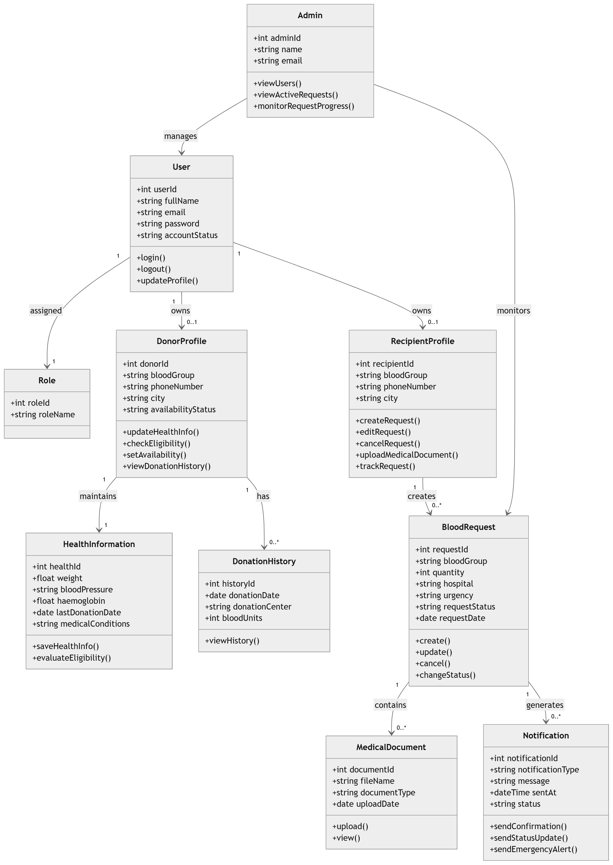
Figure 22: Sprint 2 Design Class Diagram

4.5.4 Sprint 2 Sequence Diagram
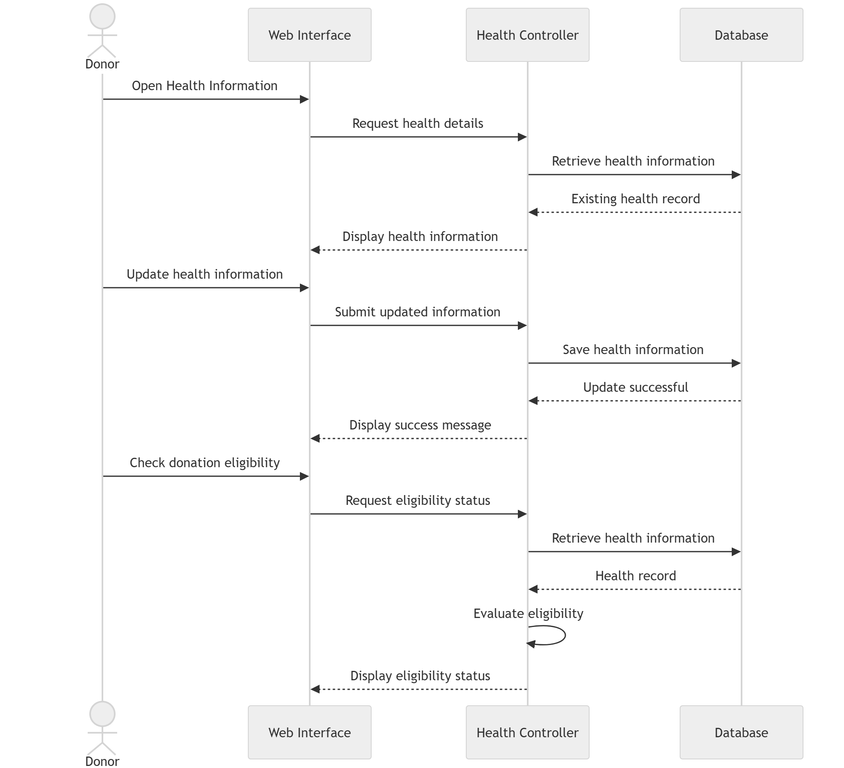
Figure 23: Sequence Diagram – Donor Health Information and Eligibility
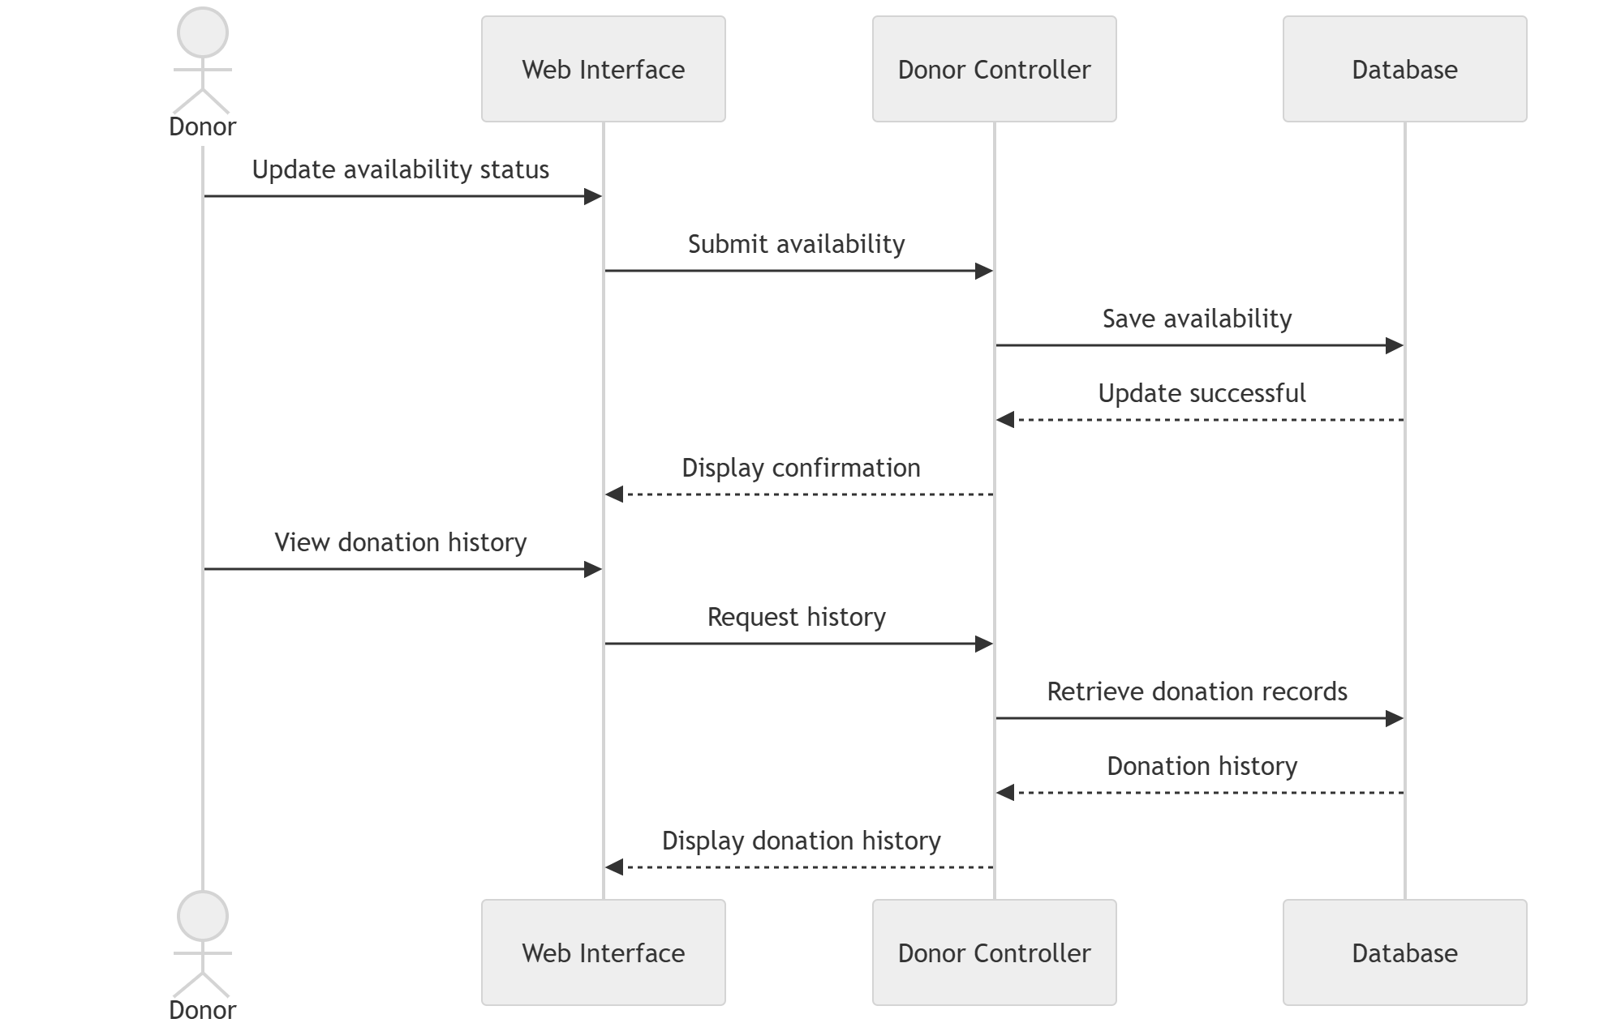
Figure 24: Sequence Diagram – Donor Availability and Donation History
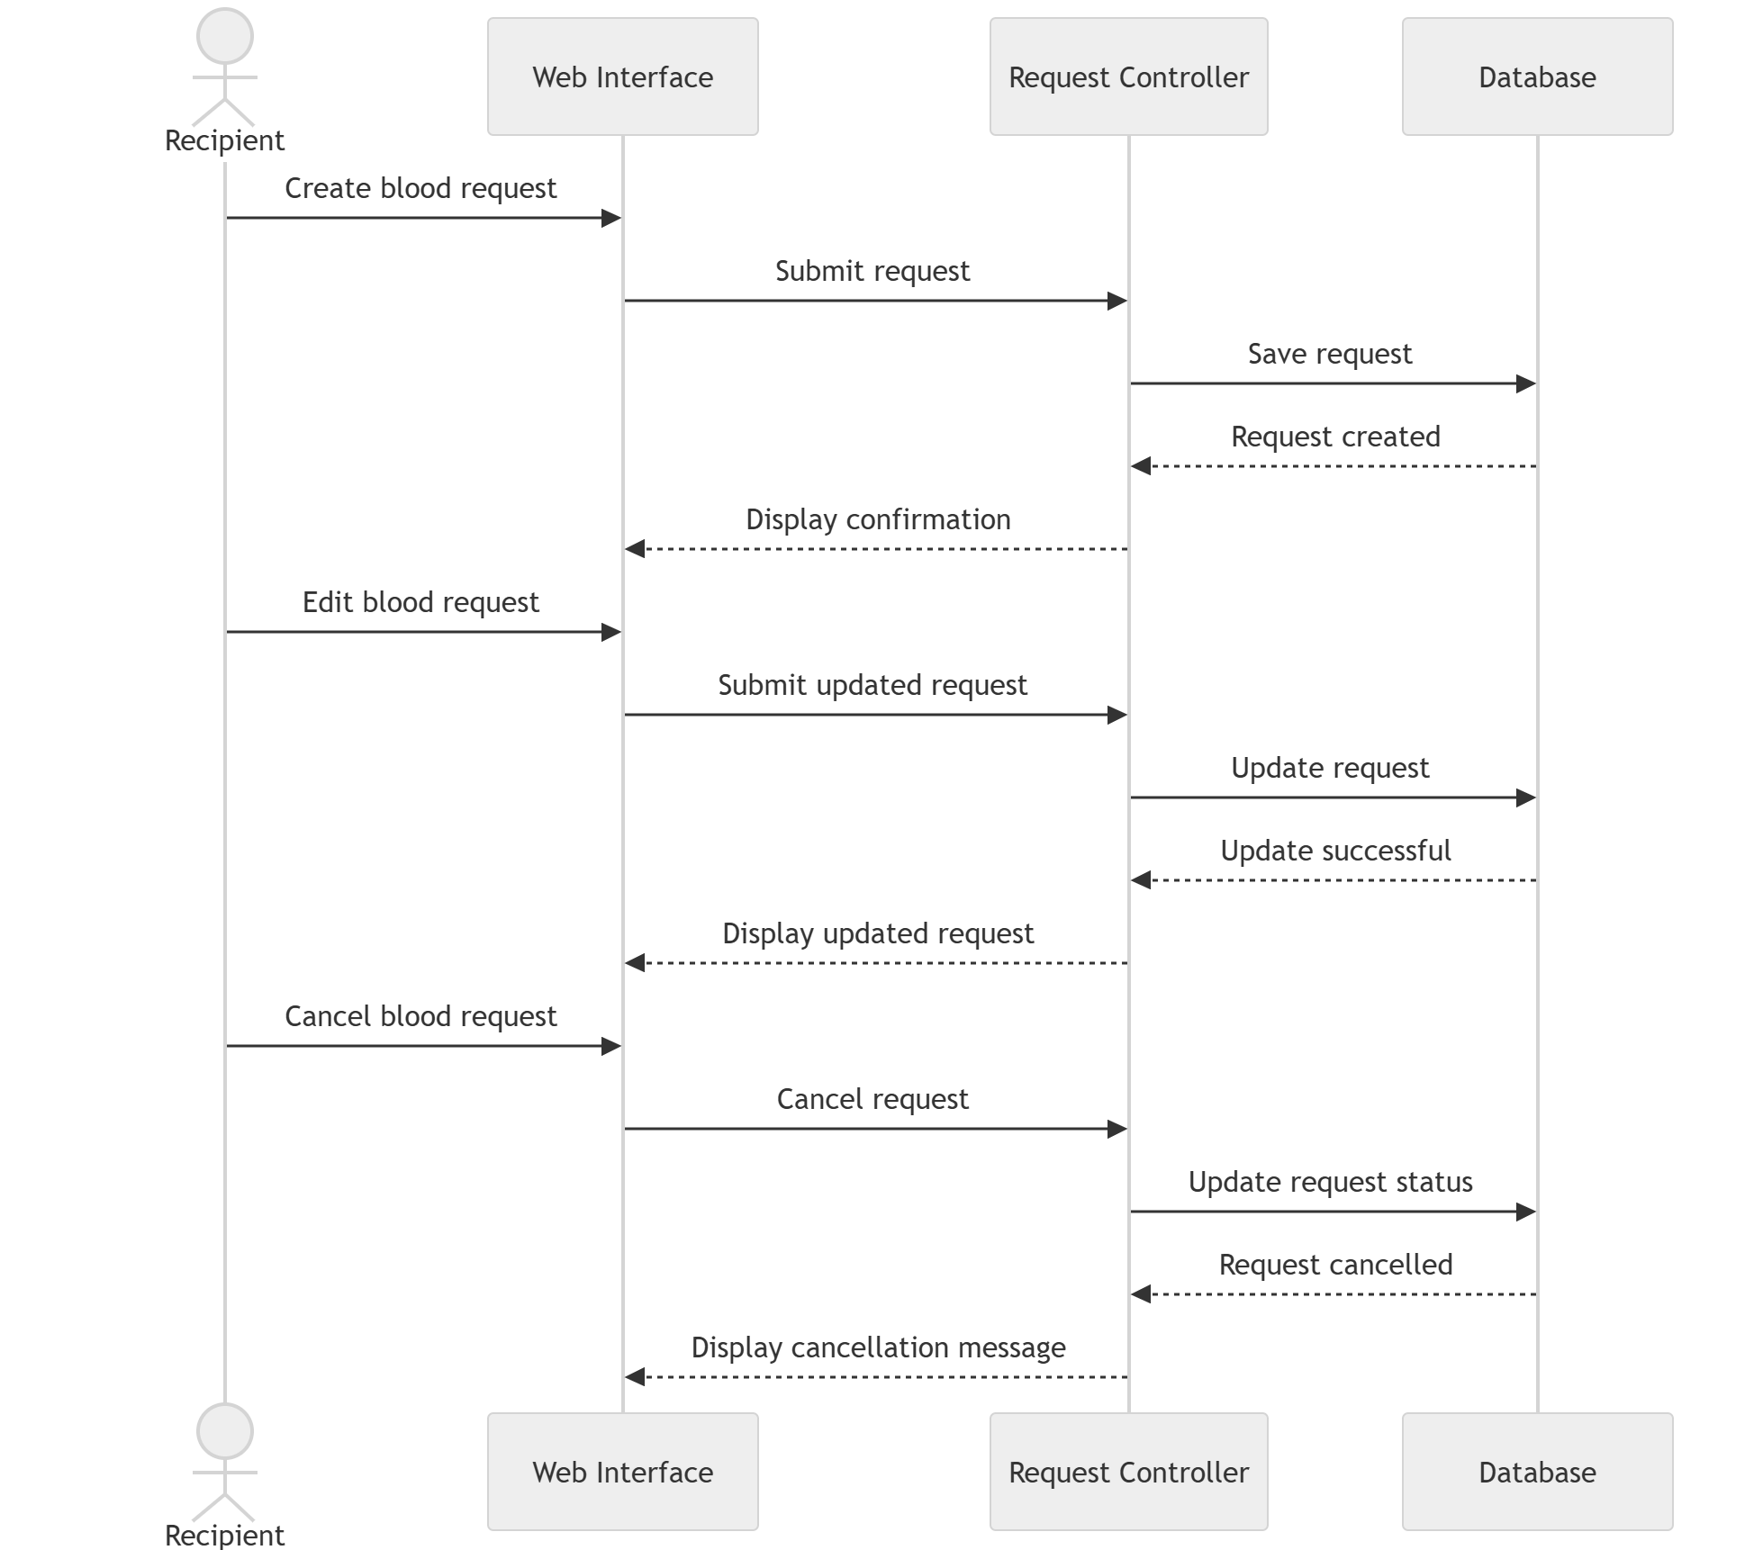
Figure 25: Sequence Diagram – Blood Request Management
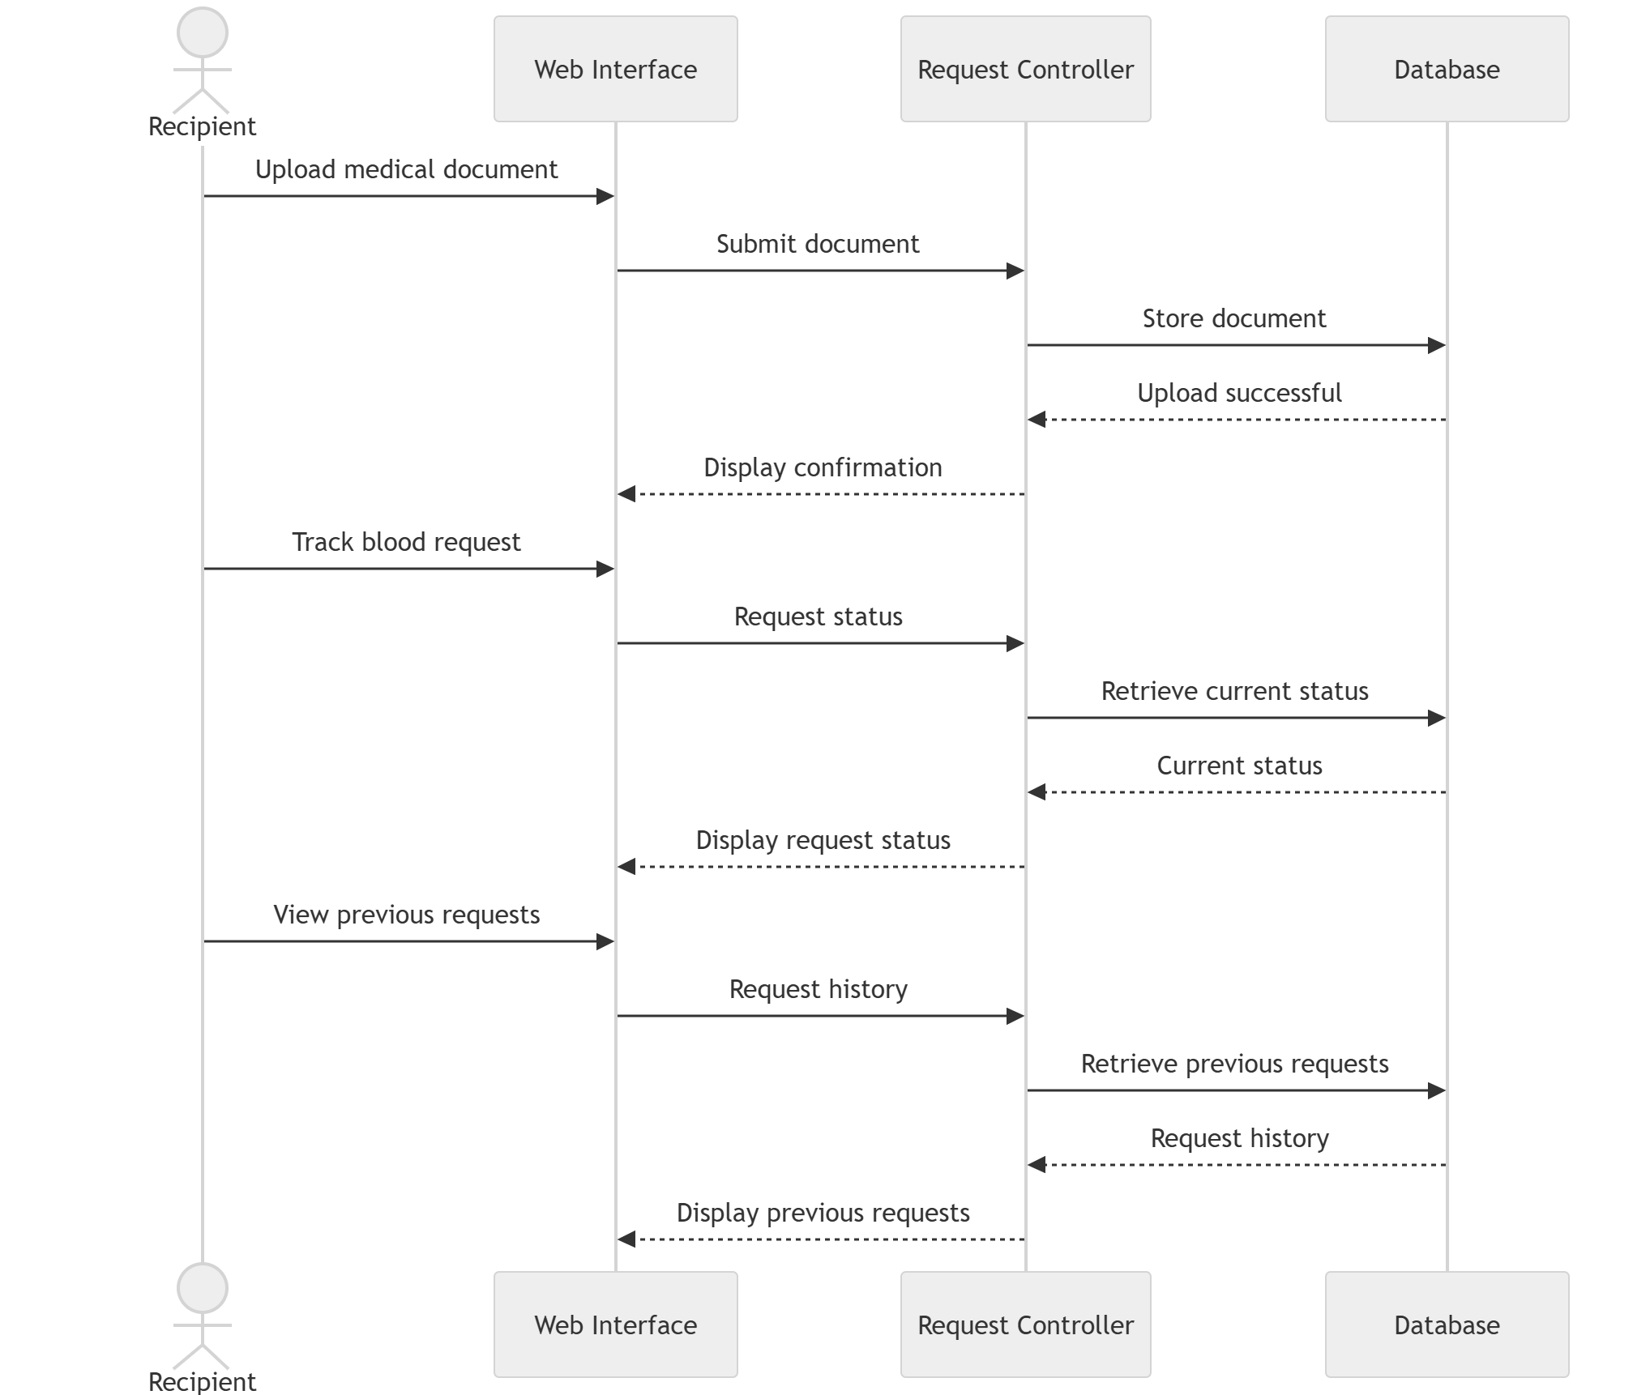
Figure 26: Sequence Diagram – Medical Documents and Request Tracking
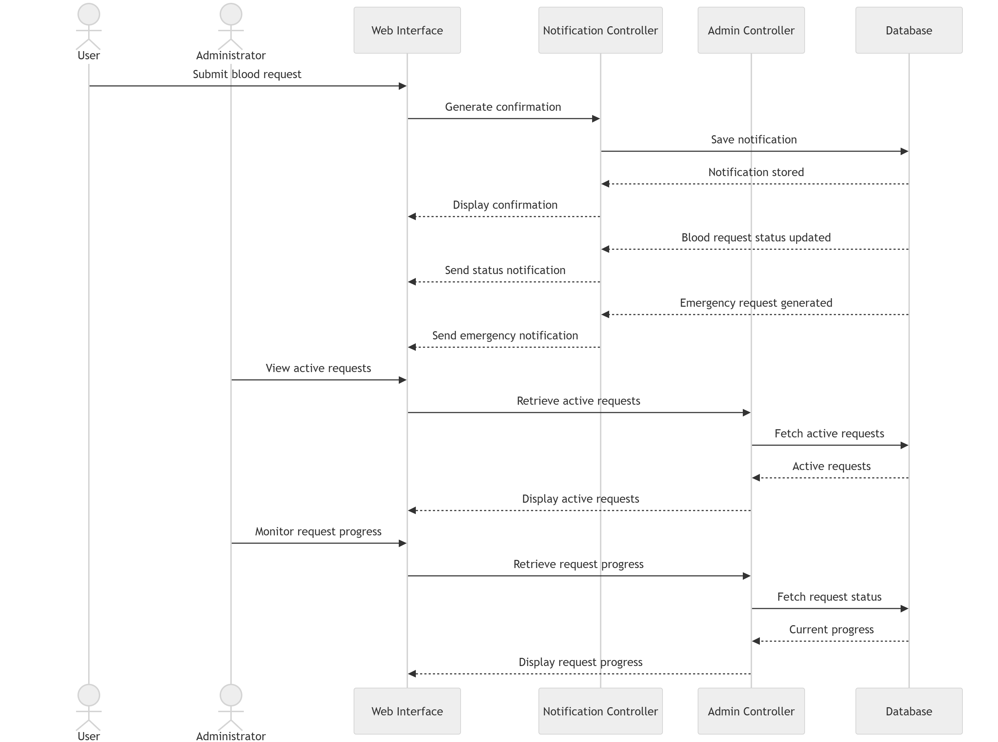
Figure 27: Sequence Diagram – Notifications and Administration

4.5.5 Sprint 2 Decision Tables
Decision tables are used to represent the business rules implemented during Sprint 2. They define how the system processes donor management, blood requests, notifications, and administrative operations by applying consistent validation and processing rules.
Table 32: Donor Health and Eligibility Decision Table
Conditions | Rule 1 | Rule 2 | Rule 3 | Rule 4
User logged in? | Y | Y | Y | N
Health information complete? | Y | N | Y | -
Eligibility criteria satisfied? | Y | - | N | -
Actions
Save health information | ✓ | ✗ | ✓ | ✗
Display eligible status | ✓ | ✗ | ✗ | ✗
Display not eligible status | ✗ | ✗ | ✓ | ✗
Display login required message | ✗ | ✗ | ✗ | ✓
Discussion: This decision table defines how the system updates donor health information and evaluates donation eligibility based on the donor's health details and login status.
Table 33: Donor Availability and Donation History Decision Table
Conditions | Rule 1 | Rule 2 | Rule 3
User logged in? | Y | Y | N
Availability status updated? | Y | N | -
Donation history available? | Y | N | -
Actions
Save availability status | ✓ | ✗ | ✗
Display donation history | ✓ | ✗ | ✗
Display no donation history message | ✗ | ✓ | ✗
Display login required message | ✗ | ✗ | ✓
Discussion: This decision table defines the business rules for updating donor availability and viewing donation history.
Table 34: Blood Request Management Decision Table
Conditions | Rule 1 | Rule 2 | Rule 3 | Rule 4
Recipient logged in? | Y | Y | Y | N
Blood request already exists? | N | Y | Y | -
Cancel request selected? | N | N | Y | -
Actions
Create blood request | ✓ | ✗ | ✗ | ✗
Update blood request | ✗ | ✓ | ✗ | ✗
Cancel blood request | ✗ | ✗ | ✓ | ✗
Display login required message | ✗ | ✗ | ✗ | ✓

Discussion: This decision table describes the rules for creating, editing, and cancelling blood requests within the system.
Table 35: Medical Documents and Request Tracking Decision Table
Conditions | Rule 1 | Rule 2 | Rule 3
Blood request exists? | Y | Y | N
Medical document uploaded? | Y | N | -
Request status available? | Y | Y | -
Actions
Store uploaded medical document | ✓ | ✗ | ✗
Display request status | ✓ | ✓ | ✗
Display previous requests | ✓ | ✓ | ✗
Display request not found message | ✗ | ✗ | ✓
Discussion: This decision table defines the business rules for uploading supporting medical documents, tracking request status, and viewing previous blood requests.
Table 36: Notifications and Administration Decision Table
Conditions | Rule 1 | Rule 2 | Rule 3 | Rule 4
Blood request submitted? | Y | N | N | N
Request status changed? | N | Y | N | N
Emergency request generated? | N | N | Y | N
Administrator logged in? | N | N | N | Y
Actions
Send confirmation notification | ✓ | ✗ | ✗ | ✗
Send status update notification | ✗ | ✓ | ✗ | ✗
Send emergency notification | ✗ | ✗ | ✓ | ✗
Display active requests and progress | ✗ | ✗ | ✗ | ✓
Discussion: This decision table defines the rules for sending notifications after blood request activities and allowing administrators to monitor active blood requests and their progress.

4.5.6 Sprint 2 Extended Test Cases
Table 37: Test Case - Password Reset
Test Case ID: TC-14 |  |  | Test Designed By: Minahil Murtaza
Epic Name and Backlog ID:  User and Identity Management (UIM-03) |  |  | Test Design Date: June 26, 2026
Test Priority: High |  |  | Test Executed By: Ifreen Israr
Test Title:  Verify Password Reset Functionality |  |  | Test Executed Date: July 10, 2026
Description:
Verify that a registered user can successfully reset their password using a valid password reset link.
Selenium Web Driver Test Created:
No
Dependencies:
Registered user account must exist.
Step | Test Step | Test Data | Expected Result | Actual Result | Status
1 | Open login page | N/A | Login page displayed | Login page displayed successfully | Pass
2 | Click Forgot Password | N/A | Password reset form displayed | Password reset form displayed | Pass
3 | Enter registered email | donor@test.com | Email accepted | Email accepted | Pass
4 | Submit reset request | N/A | Reset link generated | Reset link generated | Pass
5 | Open reset link | Valid Link | Reset password page displayed | Reset password page displayed | Pass
6 | Enter new password and submit | NewPass123 | Password updated successfully | Password updated successfully | Pass
Post Condition:
1. User password is updated successfully.
2. User can log in using the new password.
Table 38: Extended Test Case – Check Donation Eligibility
Test Case ID: TC_DM_04 |  |  | Test Designed By: Ifreen Israr
Epic Name and Backlog ID: Donor Management (DM-04) |  |  | Test Design Date: 17/06/2026
Test Priority: High |  |  | Test Executed By: Minahil Murtaza
Test Execution Date: 29/06/2026 |  |  | Test Status: Pass
Requirements Covered: DM-04 – Check Donation Eligibility |  |  | Dependencies: User account exists and donor health information has already been updated.
Test Description: Verify that the system correctly evaluates a donor's eligibility for blood donation based on the stored health information and displays the appropriate eligibility status.
Preconditions: • The donor is registered and logged into the system.
• Health information has already been completed.
• The donor profile is available.
Selenium WebDriver Test Created: Yes
Remarks: The system successfully determines donor eligibility using the available health information and displays the correct eligibility status without modifying existing donor records.
Step No. | Action | Test Data | Expected Result | Actual Result | Status
1 | Log in to the LifeStream system. | Valid donor account | Dashboard is displayed successfully. | Same as expected result. | Pass
2 | Open the Donor Profile section. | Donor profile | Donor profile page is displayed. | Same as expected result. | Pass
3 | Select Check Donation Eligibility. | Eligibility option | System retrieves the donor's health information. | Same as expected result. | Pass
4 | Allow the system to evaluate the donor's health details. | Stored health information | Eligibility rules are applied successfully. | Same as expected result. | Pass
5 | View the eligibility result displayed by the system. | Eligibility status | Current eligibility status is displayed correctly. | Same as expected result. | Pass
6 | Close the eligibility screen. | Eligibility page | User returns to the donor dashboard successfully. | Same as expected result. | Pass
Postconditions:
• The donor's eligibility status is displayed successfully.
• No donor health information is modified during the eligibility check.
Table 39: Extended Test Case – Set Donor Availability
Test Case ID: TC_DM_05 |  |  | Test Designed By: Eman Ayesha
Epic Name and Backlog ID: Donor Management (DM-05) |  |  | Test Design Date: 17/06/2026
Test Priority: Medium |  |  | Test Executed By: Sunila Sami
Test Execution Date: 29/06/2026 |  |  | Test Status: Pass
Requirements Covered: DM-05 – Set Donor Availability |  |  | Dependencies: User account exists and donor profile has been created.
Test Description: Verify that a donor can update their availability status and that the system saves and displays the updated status correctly.
Preconditions: • The donor is registered and logged into the system.
• The donor profile has already been created.
• The donor has permission to update their availability status.
Selenium WebDriver Test Created: Yes
Step No. | Action | Test Data | Expected Result | Actual Result | Status
1 | Log in to the LifeStream system. | Valid donor account | Dashboard is displayed successfully. | Same as expected result. | Pass
2 | Open the Donor Profile section. | Donor profile | Donor profile information is displayed. | Same as expected result. | Pass
3 | Select the Availability Status option. | Availability settings | Availability settings are displayed. | Same as expected result. | Pass
4 | Change the availability status (Available or Unavailable). | Availability: Available | Selected availability status is accepted by the system. | Same as expected result. | Pass
5 | Click the Save button. | Updated availability | Updated availability status is saved successfully. | Same as expected result. | Pass
6 | Refresh or reopen the donor profile. | Updated donor profile | The updated availability status is displayed correctly. | Same as expected result. | Pass
Postconditions:
• The donor's availability status is updated successfully.
• The latest availability status is stored in the donor profile.
Table 40: Extended Test Case – View Donation History
Test Case ID: TC_DM_06 |  |  | Test Designed By: Sunila Sami
Epic Name and Backlog ID: Donor Management (DM-06) |  |  | Test Design Date: 17/06/2026
Test Priority: Medium |  |  | Test Executed By: Eman Ayesha
Test Execution Date: 29/06/2026 |  |  | Test Status: Pass
Requirements Covered: DM-06 – View Donation History |  |  | Dependencies: Donor profile exists with at least one previous donation record.
Test Description: Verify that the donor can view their previous donation history accurately.
Preconditions: • The donor is registered and logged in.
• The donor profile contains previous donation records.
Selenium WebDriver Test Created: Yes
Step No. | Action | Test Data | Expected Result | Actual Result | Status
1 | Log in to the LifeStream system. | Valid donor account | Dashboard is displayed successfully. | Same as expected result. | Pass
2 | Open the Donor Profile section. | Donor profile | Donor profile is displayed. | Same as expected result. | Pass
3 | Select Donation History. | Donation history | System retrieves previous donation records. | Same as expected result. | Pass
4 | Wait for the records to load. | Donation records | Donation history is displayed correctly. | Same as expected result. | Pass
5 | Review the displayed donation details. | Donation records | All previous donations are shown accurately. | Same as expected result. | Pass
6 | Return to the dashboard. | Dashboard | Dashboard is displayed successfully. | Same as expected result. | Pass
Postconditions:
• Donation history is viewed successfully.
• No donor records are modified.

Table 41: Extended Test Case – Create Blood Request
Test Case ID: TC_RM_03 |  |  | Test Designed By: Minahil Murtaza
Epic Name and Backlog ID: Recipient Management (RM-03) |  |  | Test Design Date: 17/06/2026
Test Priority: High |  |  | Test Executed By: Ifreen Israr
Test Execution Date: 29/06/2026 |  |  | Test Status: Pass
Requirements Covered: RM-03 – Create Blood Request |  |  | Dependencies: Recipient account and profile already exist.
Test Description: Verify that a recipient can successfully create a new blood request.
Preconditions: • The recipient is registered and logged in.
• Recipient profile has already been completed.
Selenium WebDriver Test Created: Yes
Step No. | Action | Test Data | Expected Result | Actual Result | Status
1 | Log in to the LifeStream system. | Valid recipient account | Dashboard is displayed successfully. | Same as expected result. | Pass
2 | Open the Blood Requests section. | Blood Requests | Blood request page is displayed. | Same as expected result. | Pass
3 | Click Create New Request. | Request form | Blood request form opens successfully. | Same as expected result. | Pass
4 | Enter the required blood request details. | Valid request data | Information is accepted successfully. | Same as expected result. | Pass
5 | Click Submit. | Blood request | Blood request is created successfully. | Same as expected result. | Pass
6 | View the request list. | Request list | Newly created blood request appears in the list. | Same as expected result. | Pass
Postconditions:
• A new blood request is created successfully.
• The request is stored in the system for further processing.
Table 42: Extended Test Case – Edit Blood Request
Test Case ID: TC_RM_04 |  |  | Test Designed By: Ifreen Israr
Epic Name and Backlog ID: Recipient Management (RM-04) |  |  | Test Design Date: 17/06/2026
Test Priority: Medium |  |  | Test Executed By: Minahil Murtaza
Test Execution Date: 29/06/2026 |  |  | Test Status: Pass
Requirements Covered: RM-04 – Edit Blood Request |  |  | Dependencies: A blood request already exists.
Test Description: Verify that a recipient can update an existing blood request successfully.
Preconditions: • The recipient is logged in.
• At least one blood request already exists.
Selenium WebDriver Test Created: Yes
Step No. | Action | Test Data | Expected Result | Actual Result | Status
1 | Log in to the LifeStream system. | Valid recipient account | Dashboard is displayed successfully. | Same as expected result. | Pass
2 | Open the Blood Requests page. | Existing requests | Existing blood requests are displayed. | Same as expected result. | Pass
3 | Select a blood request to edit. | Existing request | Edit form opens successfully. | Same as expected result. | Pass
4 | Update the required request information. | Modified request | Modified information is accepted. | Same as expected result. | Pass
5 | Click Save Changes. | Updated request | Updated request is saved successfully. | Same as expected result. | Pass
6 | View the updated request. | Updated request | Modified blood request details are displayed correctly. | Same as expected result. | Pass
Postconditions:
• Blood request information is updated successfully.
• The modified request is stored in the system.
Table 43: Extended Test Case – Cancel Blood Request
Test Case ID: TC_RM_05 |  |  | Test Designed By: Eman Ayesha
Epic Name and Backlog ID: Recipient Management (RM-05) |  |  | Test Design Date: 17/06/2026
Test Priority: Medium |  |  | Test Executed By: Sunila Sami
Test Execution Date: 29/06/2026 |  |  | Test Status: Pass
Requirements Covered: RM-05 – Cancel Blood Request |  |  | Dependencies: A blood request already exists and is active.
Test Description: Verify that a recipient can successfully cancel an active blood request.
Preconditions: • The recipient is registered and logged into the system.
• At least one active blood request exists.
Selenium WebDriver Test Created: Yes
Step No. | Action | Test Data | Expected Result | Actual Result | Status
1 | Log in to the LifeStream system. | Valid recipient account | Dashboard is displayed successfully. | Same as expected result. | Pass
2 | Open the Blood Requests section. | Active requests | Active blood requests are displayed. | Same as expected result. | Pass
3 | Select an active blood request. | Existing request | Request details are displayed. | Same as expected result. | Pass
4 | Click the Cancel Request button. | Selected request | Confirmation message is displayed. | Same as expected result. | Pass
5 | Confirm the cancellation. | Confirmation | Blood request is cancelled successfully. | Same as expected result. | Pass
6 | View the request list. | Request list | Request status is updated to Cancelled. | Same as expected result. | Pass
Postconditions:
• The selected blood request is cancelled successfully.
• The request status is updated in the system.
Table 44: Extended Test Case – Upload Supporting Medical Documents
Test Case ID: TC_RM_06 |  |  | Test Designed By: Sunila Sami
Epic Name and Backlog ID: Recipient Management (RM-06) |  |  | Test Design Date: 17/06/2026
Test Priority: Medium |  |  | Test Executed By: Eman Ayesha
Test Execution Date: 29/06/2026 |  |  | Test Status: Pass
Requirements Covered: RM-06 – Upload Supporting Medical Documents |  |  | Dependencies: Recipient profile and blood request already exist.
Test Description: Verify that a recipient can upload supporting medical documents for a blood request.
Preconditions: • The recipient is logged into the system.
• An active blood request exists.
• A valid medical document is available for upload.
Selenium WebDriver Test Created: Yes
Step No. | Action | Test Data | Expected Result | Actual Result | Status
1 | Log in to the LifeStream system. | Valid recipient account | Dashboard is displayed successfully. | Same as expected result. | Pass
2 | Open an existing blood request. | Existing request | Blood request details are displayed. | Same as expected result. | Pass
3 | Select the Upload Medical Document option. | Upload option | File upload window opens successfully. | Same as expected result. | Pass
4 | Choose a valid medical document. | Medical document | Selected file is accepted by the system. | Same as expected result. | Pass
5 | Click the Upload button. | Selected file | Medical document is uploaded successfully. | Same as expected result. | Pass
6 | View the blood request details. | Blood request | Uploaded medical document is associated with the blood request. | Same as expected result. | Pass
Postconditions:
• The medical document is uploaded successfully.
• The uploaded document is linked to the corresponding blood request.
Table 45: Extended Test Case – Track Blood Request Status
Test Case ID: TC_RM_07 |  |  | Test Designed By: Minahil Murtaza
Epic Name and Backlog ID: Recipient Management (RM-07) |  |  | Test Design Date: 17/06/2026
Test Priority: High |  |  | Test Executed By: Ifreen Israr
Test Execution Date: 29/06/2026 |  |  | Test Status: Pass
Requirements Covered: RM-07 – Track Blood Request Status |  |  | Dependencies: At least one blood request exists.
Test Description: Verify that a recipient can view the current status of an existing blood request.
Preconditions: • The recipient is registered and logged into the system.
• At least one blood request has been submitted.
Selenium WebDriver Test Created: Yes
Step No. | Action | Test Data | Expected Result | Actual Result | Status
1 | Log in to the LifeStream system. | Valid recipient account | Dashboard is displayed successfully. | Same as expected result. | Pass
2 | Open the Blood Requests section. | Blood requests | Blood request list is displayed. | Same as expected result. | Pass
3 | Select a blood request. | Existing request | Blood request details are displayed. | Same as expected result. | Pass
4 | View the request status. | Request status | Current processing status is displayed correctly. | Same as expected result. | Pass
5 | Refresh the page. | Updated status | Latest request status is displayed. | Same as expected result. | Pass
6 | Return to the dashboard. | Dashboard | Dashboard is displayed successfully. | Same as expected result. | Pass
Postconditions:
• The latest blood request status is displayed successfully.
• No blood request information is modified.
Table 46: Extended Test Case – View Previous Requests
Test Case ID: TC_RM_08 |  |  | Test Designed By: Ifreen Israr
Epic Name and Backlog ID: Recipient Management (RM-08) |  |  | Test Design Date: 17/06/2026
Test Priority: Medium |  |  | Test Executed By: Minahil Murtaza
Test Execution Date: 29/06/2026 |  |  | Test Status: Pass
Requirements Covered: RM-08 – View Previous Requests |  |  | Dependencies: The recipient has submitted one or more blood requests.
Test Description: Verify that the recipient can view the history of previously submitted blood requests.
Preconditions: • The recipient is registered and logged into the system.
• At least one previous blood request exists.
Selenium WebDriver Test Created: Yes
Step No. | Action | Test Data | Expected Result | Actual Resuslt | Status
1 | Log in to the LifeStream system. | Valid recipient account | Dashboard is displayed successfully. | Same as expected result. | Pass
2 | Open the Blood Requests section. | Blood Requests | Blood request page is displayed. | Same as expected result. | Pass
3 | Select Previous Requests. | Previous requests | List of previous blood requests is displayed. | Same as expected result. | Pass
4 | Select a request from the list. | Selected request | Request details are displayed correctly. | Same as expected result. | Pass
5 | Review the request information. | Request details | Request details are shown accurately. | Same as expected result. | Pass
6 | Return to the previous requests list. | Previous requests | Previous requests list is displayed successfully. | Same as expected result. | Pass
Postconditions:
• Previous blood requests are displayed successfully.
• No request information is modified.

Table 47: Extended Test Case – Receive Request Confirmation
Test Case ID: TC_NOT_16 |  |  | Test Designed By: Eman Ayesha
Epic Name and Backlog ID: Notification Management (NOT-16) |  |  | Test Design Date: 17/06/2026
Test Priority: Medium |  |  | Test Executed By: Sunila Sami
Test Execution Date: 29/06/2026 |  |  | Test Status: Pass
Requirements Covered: NOT-16 – Receive Request Confirmation |  |  | Dependencies: A blood request has been submitted successfully.
Test Description: Verify that the system sends a confirmation notification immediately after a blood request is submitted.
Preconditions: • The recipient is registered and logged into the system.
• A valid blood request is ready for submission.
Selenium WebDriver Test Created: Yes
Step No. | Action | Test Data | Expected Result | Actual Result | Status
1 | Log in to the LifeStream system. | Valid recipient account | Dashboard is displayed successfully. | Same as expected result. | Pass
2 | Submit a new blood request. | Blood request | Blood request is created successfully. | Same as expected result. | Pass
3 | Wait for system processing. | Submitted request | System processes the request successfully. | Same as expected result. | Pass
4 | Open the Notifications section. | Notifications | Latest notifications are displayed. | Same as expected result. | Pass
5 | Check the most recent notification. | Notification | Confirmation notification is displayed. | Same as expected result. | Pass
6 | Verify the notification details. | Notification details | Request confirmation information is accurate. | Same as expected result. | Pass
Postconditions:
• A confirmation notification is generated successfully.
• The notification is stored in the user's notification history.
Table 48: Extended Test Case – Receive Request Status Updates
Test Case ID: TC_NOT_17 |  |  | Test Designed By: Sunila Sami
Epic Name and Backlog ID: Notification Management (NOT-17) |  |  | Test Design Date: 17/06/2026
Test Priority: Medium |  |  | Test Executed By: Eman Ayesha
Test Execution Date: 29/06/2026 |  |  | Test Status: Pass
Requirements Covered: NOT-17 – Receive Request Status Updates |  |  | Dependencies: An existing blood request is available and its status has been updated.
Test Description: Verify that the system notifies the recipient whenever the status of a blood request changes.
Preconditions: • The recipient is logged into the system.
• A blood request exists in the system.
• The request status has been updated.
Selenium WebDriver Test Created: Yes
Step No. | Action | Test Data | Expected Result | Actual Result | Status
1 | Log in to the LifeStream system. | Valid recipient account | Dashboard is displayed successfully. | Same as expected result. | Pass
2 | Open the Notifications section. | Notifications | Notification list is displayed. | Same as expected result. | Pass
3 | Refresh the notification list. | Notification list | Latest notifications are retrieved. | Same as expected result. | Pass
4 | Select the newest notification. | Updated notification | Updated request status notification is displayed. | Same as expected result. | Pass
5 | Verify the notification details. | Notification details | Updated request status is shown correctly. | Same as expected result. | Pass
6 | Return to the dashboard. | Dashboard | Dashboard is displayed successfully. | Same as expected result. | Pass
Postconditions:
• The latest request status notification is displayed successfully.
• The notification history remains updated.
Table 49: Extended Test Case – Receive Emergency Notifications
Test Case ID: TC_NOT_18 |  |  | Test Designed By: Minahil Murtaza
Epic Name and Backlog ID: Notification Management (NOT-18) |  |  | Test Design Date: 17/06/2026
Test Priority: High |  |  | Test Executed By: Ifreen Israr
Test Execution Date: 29/06/2026 |  |  | Test Status: Pass
Requirements Covered: NOT-18 – Receive Emergency Notifications |  |  | Dependencies: An emergency blood request has been created in the system.
Test Description: Verify that the system sends emergency notifications to users when an emergency blood request is generated.
Preconditions: • The user is registered and logged into the system.
• An emergency blood request has been created.
Selenium WebDriver Test Created: Yes
Step No. | Action | Test Data | Expected Result | Actual Result | Status
1 | Log in to the LifeStream system. | Valid user account | Dashboard is displayed successfully. | Same as expected result. | Pass
2 | Wait for an emergency blood request to be generated. | Emergency request | System detects the emergency request. | Same as expected result. | Pass
3 | Open the Notifications section. | Notifications | Latest notifications are displayed. | Same as expected result. | Pass
4 | Select the emergency notification. | Emergency notification | Emergency request details are displayed. | Same as expected result. | Pass
5 | Verify the notification information. | Notification details | Emergency notification contains accurate request details. | Same as expected result. | Pass
6 | Return to the dashboard. | Dashboard | Dashboard is displayed successfully. | Same as expected result. | Pass
Postconditions:
• The emergency notification is delivered successfully.
• The emergency notification is stored in the notification history.

Table 50: Extended Test Case – View Active Blood Requests
Test Case ID: TC_ADM_02 |  |  | Test Designed By: Ifreen Israr
Epic Name and Backlog ID: Administration (ADM-02) |  |  | Test Design Date: 17/06/2026
Test Priority: High |  |  | Test Executed By: Minahil Murtaza
Test Execution Date: 29/06/2026 |  |  | Test Status: Pass
Requirements Covered: ADM-02 – View Active Blood Requests |  |  | Dependencies: One or more active blood requests exist in the system.
Test Description: Verify that the administrator can view all active blood requests.
Preconditions: • The administrator is registered and logged into the system.
• At least one active blood request exists.
Selenium WebDriver Test Created: Yes
Step No. | Action | Test Data | Expected Result | Actual Result | Status
1 | Log in as an administrator. | Administrator account | Administrator dashboard is displayed successfully. | Same as expected result. | Pass
2 | Open the Blood Requests module. | Blood Requests module | Blood request management page is displayed. | Same as expected result. | Pass
3 | Select Active Blood Requests. | Active requests | Active blood requests are retrieved. | Same as expected result. | Pass
4 | Review the displayed requests. | Request list | All active requests are listed correctly. | Same as expected result. | Pass
5 | Select an active request. | Selected request | Detailed request information is displayed. | Same as expected result. | Pass
6 | Return to the active requests list. | Request list | Active blood requests list is displayed successfully. | Same as expected result. | Pass
Postconditions:
• Active blood requests are displayed successfully.
• No blood request information is modified.
Table 51: Extended Test Case – Monitor Request Progress
Test Case ID: TC_ADM_03 |  |  | Test Designed By: Eman Ayesha
Epic Name and Backlog ID: Administration (ADM-03) |  |  | Test Design Date: 17/06/2026
Test Priority: High |  |  | Test Executed By: Sunila Sami
Test Execution Date: 29/06/2026 |  |  | Test Status: Pass
Requirements Covered: ADM-03 – Monitor Request Progress |  |  | Dependencies: Blood requests exist with different processing statuses.
Test Description: Verify that the administrator can monitor the progress of blood requests throughout their processing lifecycle.
Preconditions: • The administrator is logged into the system.
• Blood requests with different statuses exist.
Selenium WebDriver Test Created: Yes
Step No. | Action | Test Data | Expected Result | Actual Result | Status
1 | Log in as an administrator. | Administrator account | Administrator dashboard is displayed successfully. | Same as expected result. | Pass
2 | Open the Blood Requests module. | Blood Requests module | Blood request management page is displayed. | Same as expected result. | Pass
3 | Select a blood request. | Existing request | Request details are displayed. | Same as expected result. | Pass
4 | View the request progress. | Request progress | Current processing stage is displayed accurately. | Same as expected result. | Pass
5 | Review the request status information. | Status information | Progress details are shown correctly. | Same as expected result. | Pass
6 | Return to the request list. | Request list | Blood request list is displayed successfully. | Same as expected result. | Pass
Postconditions:
• The administrator successfully monitors the progress of blood requests.
• Blood request records remain unchanged.

4.5.7 Sprint 2 Review Meeting
Sprint: Sprint 2 - Blood Request Management and Notification Development
Review Date: July 01, 2026
Duration: 1 hour, 20 minutes
Facilitator: FYP Supervisor - Dr. M. Asad Arshed
Attendees: Minahil Murtaza, Ifreen Israr, Eman Ayesha, Sunila Sami
The following table shows the status of tasks assigned to team members during Sprint 2.
Table 52: Status of Sprint 2 Backlog
ID | Task Name | Related Product Backlog | Owner | Status | Notes
SP2-01 | Update Health Information | DM-03 | Minahil Murtaza | Completed | Health information updated successfully.
SP2-02 | Check Donation Eligibility | DM-04 | Ifreen Israr | Completed | Eligibility evaluation completed successfully.
SP2-03 | Set Donor Availability | DM-05 | Eman Ayesha | Completed | Donor availability updated correctly.
SP2-04 | View Donation History | DM-06 | Sunila Sami | Completed | Donation history displayed accurately.
SP2-05 | Create Blood Request | RM-03 | Minahil Murtaza | Completed | Blood request created successfully.
SP2-06 | Edit Blood Request | RM-04 | Ifreen Israr | Completed | Blood request updated successfully.
SP2-07 | Cancel Blood Request | RM-05 | Eman Ayesha | Completed | Blood request cancelled successfully.
SP2-08 | Upload Medical Documents | RM-06 | Sunila Sami | Completed | Medical documents uploaded successfully.
SP2-09 | Track Blood Request Status | RM-07 | Minahil Murtaza | Completed | Request status tracking working correctly.
SP2-10 | View Previous Requests | RM-08 | Ifreen Israr | Completed | Previous request history displayed correctly.
SP2-11 | Request Confirmation Notification | NOT-16 | Eman Ayesha | Completed | Confirmation notifications delivered successfully.
SP2-12 | Request Status Notifications | NOT-17 | Sunila Sami | Completed | Status notifications functioning correctly.
SP2-13 | Emergency Notifications | NOT-18 | Minahil Murtaza | Completed | Emergency notifications generated successfully.
SP2-14 | View Active Blood Requests | ADM-02 | Ifreen Israr | Completed | Active blood requests displayed successfully.
SP2-15 | Monitor Request Progress | ADM-03 | Eman Ayesha | Completed | Request progress monitored successfully.
Demo Highlights:
- Demonstrated the complete donor management workflow, including health information updates, eligibility evaluation, availability management, and donation history.
- Demonstrated recipient operations such as creating, editing, cancelling, and tracking blood requests.
- Demonstrated medical document upload and previous request history.
- Demonstrated notification features for request confirmation, status updates, and emergency alerts.
- Demonstrated the administrator dashboard for viewing active blood requests and monitoring request progress.
- Demonstrated successful integration between donor, recipient, notification, and administration modules.
Sprint Goal Achievement:
The Sprint 2 goal was successfully achieved by implementing the planned donor management, recipient request management, notification, and administrative monitoring features. All Sprint 2 backlog items were completed and demonstrated successfully.
Feedback from Stakeholders:
- The implemented workflows were easy to understand and aligned well with the documented requirements.
- Blood request management and request tracking provided a smooth user experience.
- Notification features were considered useful for improving communication between users and the system.
- Stakeholders recommended enhancing validation messages and improving the user interface in the next sprint.
Metrics Overview:
Metric | Value
Committed Story Points | 71
Completed Story Points | 71
Carryover Items | 0

What Went Well:
- All planned Sprint 2 features were completed within the sprint.
- The demonstrated workflows performed as expected during the review.
- Integration between donor, recipient, notification, and administration modules was completed successfully.
- All demonstrated functionalities operated according to the defined acceptance criteria.

What Could Be Improved:
- Improve input validation and error handling across all forms.
- Enhance the user interface for better usability and consistency.
- Optimize system performance for handling larger numbers of blood requests.
- Increase testing coverage before future demonstrations.
Action Items / Next Steps:
Action Item | Owner | Due Date
Finalize Sprint 2 review findings | Eman Ayesha | July 02, 2026
Prepare and prioritize Sprint 3 backlog | Minahil Murtaza | July 02, 2026
Review blood matching and emergency request requirements | Sunila Sami | July 03, 2026
Review testing results and resolve identified issues | Ifreen Israr | July 03, 2026
Wrap-up
Sprint 2 was reviewed successfully, and all planned features were accepted. The team is ready to begin Sprint 3 based on the feedback received.

4.5.8 Sprint 2 Retrospective Meeting
Sprint: Sprint 2 – Blood Request Management and Notification Development
Retrospective Date: July 01, 2026
Duration: 1 hour
Facilitator: Dr. Muhammad Asad Arshed
Attendees: Minahil Murtaza, Ifreen Israr, Sunila Sami, Eman Ayesha
Sprint Overview
- Goal:
Complete the planned Sprint 2 user stories by implementing donor management, blood request management, notification services, and administrative monitoring features.
- Sprint Duration:
June 10, 2026 – June 30, 2026 (3 Weeks)
What Went Well
- The donor management and blood request workflows were integrated successfully.
- Notification features worked correctly with the implemented request workflow.
- Team members completed their assigned tasks within the planned sprint.
- Testing confirmed that the implemented features met the expected requirements.
- The team gained better experience in integrating multiple system modules.
What Didn’t Go Well
- Some notification scenarios required additional testing before completion.
- A few user interface changes were made after stakeholder feedback.
- Integration between modules required additional debugging and verification.
- Some validation rules were refined after implementation.
- Performance optimization for larger datasets was identified for future work.
Suggestions for Improvement
- Improve consistency of the user interface across all modules.
- Increase testing for notification and request workflows.
- Include more boundary and exception test cases.
- Review system integration earlier during development.
- Continue improving workflow efficiency before adding new features.
Action Items:
Action Item | Owner | Due Date
Prepare Sprint 3 backlog and assign user stories | Minahil Murtaza | July 02, 2026
Review blood matching and recommendation requirements | Sunila Sami | July 02, 2026
Expand testing scenarios for matching and notifications | Ifreen Israr | July 03, 2026
Review Sprint 2 feedback and update project documentation | Eman Ayesha | July 03, 2026
Team Health Check:
- Team morale: Very good. The team remained motivated throughout Sprint 2.
- Communication: Communication improved through regular discussions and progress updates.
- Workload distribution: Tasks remained balanced and were completed within the sprint timeline.
- Collaboration: Team members worked together effectively during integration and testing.
- Tools and resources: Jira, GitHub, Slack, and GitHub Copilot continued to support sprint activities effectively.
Wrap-up:
The team successfully achieved the Sprint 2 objectives and completed all planned work. The lessons learned will be applied in Sprint 3 to further improve development and testing.

