AeroNet Lite
Autonomous Drone Delivery Simulation

Project Report
Team Members
Eman Ali — 23i-2564
Mariam Shaiq — 23i-3250
Fatima Siddiqa — 23i-2543

Submitted to: Ms. Mahnoor Tariq
Date: May 10, 2026

GitHub: https://github.com/eman-nu/AeroNet-Lite

1. Project Overview
AeroNet Lite is a Python-based autonomous drone delivery simulator designed to demonstrate core artificial intelligence techniques within a constrained but realistic environment. The system models a city as a 10×10 grid in which each cell carries zone information, population density, facility flags, and a no-fly status. Five AI modules operate on this shared grid: a Constraint Satisfaction Problem (CSP) layout validator, a fleet selector using both Genetic Algorithm and brute-force search, an A* delivery path planner, a real-time disruption handler, and a machine learning pipeline for demand forecasting and anomaly detection.

1.1 Module Summary
Module | AI Technique | Output
Grid and Layout Validator | Constraint Satisfaction Problem | Pass/Fail report per rule
Fleet Selector | Genetic Algorithm + Brute-Force | Optimal drone fleet under budget
Delivery Path Planner | A* Search | Shortest safe route per delivery
Disruption Handler | A* Replanning | Rerouted drone paths on no-fly event
ML Pipeline | Regression + Classification | MAE forecast, anomaly accuracy

1.2 Scope Simplifications
The city is represented as a discrete 10×10 grid rather than a continuous coordinate space. Only two drone types are considered: Light and Heavy. The simulation runs for exactly 20 fixed steps. Demand forecasting uses the Bike Sharing Demand dataset as a proxy for delivery demand. Anomaly detection uses synthetic telemetry data with clearly separated feature ranges, which is explicitly permitted by the project brief.

2. System Architecture and Shared Data Model
All modules in AeroNet Lite communicate through a shared grid model defined in grid_model.py. This central data model is the only source of truth for cell state, drone hub locations, charging pad positions, medical pickup flags, no-fly status, and demand values. No module modifies another module's output directly; each reads from the grid and writes only its own results back.

2.1 Cell Structure
Each of the 100 cells in the 10×10 grid is represented as a Python dataclass with the following fields:
Field | Purpose
row, col | Stores the cell's position in the grid (0–9 for each axis).
zone | Zone type: Residential, Commercial, Industrial, Hospital, School, or Open Field.
density | Population proxy in persons per km². Used for demand estimation.
is_hub | Boolean. True if the cell is a drone dispatch hub.
is_charging | Boolean. True if the cell has a charging pad.
is_medical_pickup | Boolean. True if the cell is a medical supply pickup point.
no_fly | Boolean. True if the cell is a restricted airspace zone.
demand | Estimated delivery demand, derived from density with random variation.

2.2 Default Grid Layout
The default 10×10 city grid is hard-coded in build_default_grid() and is designed to satisfy all four CSP constraints by construction. The zone layout is as follows, printed row by row using two-letter abbreviations (RE = Residential, CO = Commercial, IN = Industrial, HO = Hospital, SC = School, OP = Open Field, HB = Hub, CH = Charging, MP = Medical Pickup):
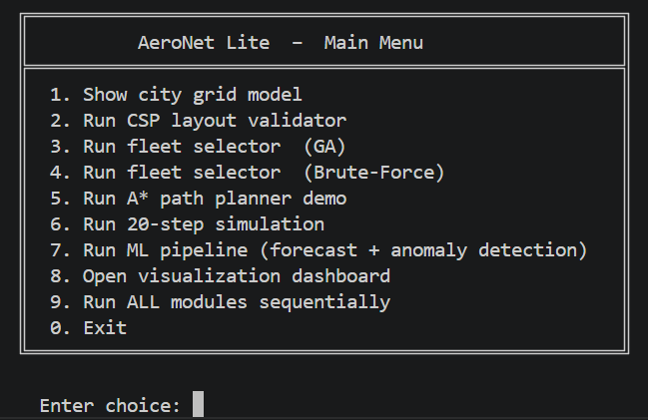
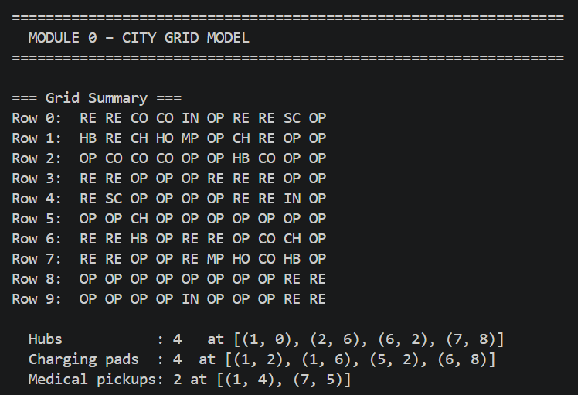
The four hubs are positioned to ensure that every Residential cell is within Manhattan distance 3 of at least one hub (R2). Each hub has a charging pad within Manhattan distance 2 (R3). The three Industrial cells at (0,4), (4,8), and (9,4) are all separated from Hospital and School zones by at least one Open Field buffer (R1). Both Hospitals at (1,3) and (7,6) each have a Medical Pickup on an immediately adjacent cell (R4).

2.3 File Structure
File | Responsibility
grid_model.py | Cell dataclass, build_default_grid(), helper functions: get_neighbors, manhattan, hub_cells, charging_cells, medical_cells.
layout_validator.py | Module 1. Four CSP rule checkers and print_validation_report().
fleet_selector.py | Module 2. Drone specs, fitness function, brute_force_select(), ga_select(), create_fleet().
astar_planner.py | Module 3. astar(), plan_delivery_route(), Delivery dataclass, generate_deliveries().
delivery_simulator.py | Module 4. run_simulation(), assign_deliveries(), step_drones(), activate_no_fly(), inject_anomaly().
ml_pipeline.py | Module 5. run_forecast(), run_anomaly_detection(), generate_telemetry_data().
visualization.py | Dashboard: show_zone_map(), show_route_map(), show_demand_heatmap(), show_anomaly_view(), show_all().
main.py | Entry point. Interactive menu and sequential run_all() function.

3. Module 1 — CSP Layout Validator
The layout validator treats the grid configuration as a Constraint Satisfaction Problem. Rather than automatically generating a city layout, the system manually defines the grid and then runs a validator that behaves like a CSP constraint checker. Each of the four rules is encoded as an independent function. All violations are collected before the report is printed, so the system does not stop at the first failed rule.

3.1 Constraint Rules
Rule ID | Constraint | Implementation
R1 — Industrial Safety | No Industrial cell may be directly adjacent (4-connected) to a School or Hospital cell. | For each Industrial cell, all four orthogonal neighbors are checked. If any neighbor is a School or Hospital, a violation is logged with coordinates.
R2 — Residential Hub Coverage | Every Residential cell must be within Manhattan distance 3 of at least one Drone Hub. | For each Residential cell, Manhattan distance to every hub is computed. If the minimum exceeds 3, a violation is logged with a suggested fix.
R3 — Hub Charging Access | Every Drone Hub must have a Charging Pad within Manhattan distance 2. | For each hub cell, Manhattan distance to every charging pad is computed. If the minimum exceeds 2, a violation is logged with a suggested fix.
R4 — Medical Pickup Access | At least one Hospital cell must have a Medical Pickup point within Manhattan distance 1. | All Hospital-to-Medical-Pickup pairs are checked. If no pair satisfies distance <= 1, a single violation is reported.

3.2 Helper Functions
Two shared helper functions support the CSP rules. The function get_neighbors(grid, row, col) returns all valid orthogonal adjacent cells, respecting grid boundaries. The function manhattan(a, b) computes the Manhattan distance between two coordinate tuples as abs(a[0] - b[0]) + abs(a[1] - b[1]). Both are defined in grid_model.py and imported by layout_validator.py.

3.3 Validation Output
The validator runs two test cases when called from the main menu (option 2): one on the valid default grid, and one on a deliberately broken version of the grid. The broken grid is constructed by changing cell (0,3) from Open Field to School — placing a School directly adjacent to the Industrial cell at (0,4) — and removing the charging pad at (1,2), which is the only charging pad within range of hub (1,0).

Test 1: Valid Grid Output

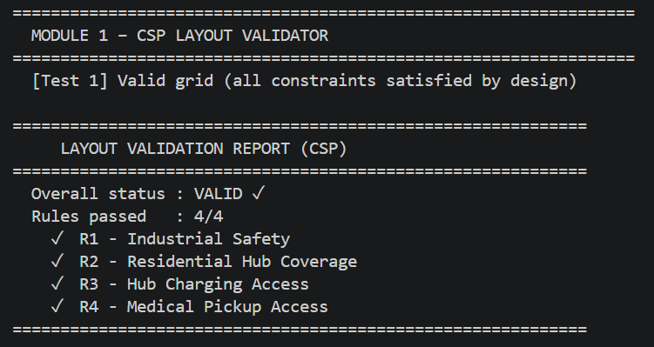

Test 2: Invalid Grid Output

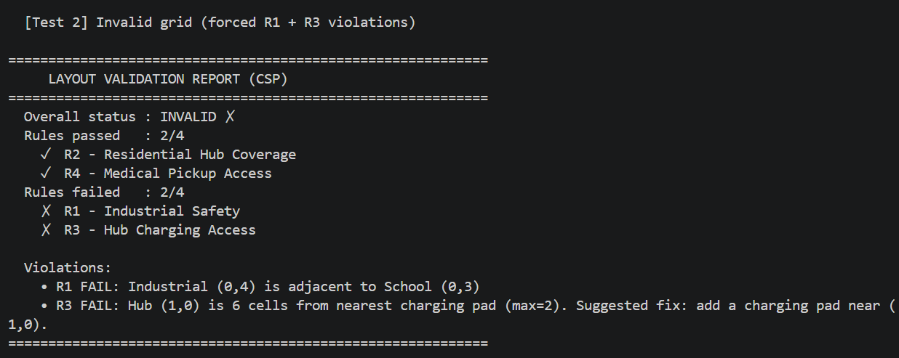
The broken grid test confirms that the validator correctly identifies constraint violations, reports the exact cell coordinates causing each failure, and provides a suggested corrective action. The original grid passed as the return value is always the valid one; the broken grid exists only within the scope of the test function and does not affect any other module.

3.4 Design Notes
Violations are collected in a list rather than halting on the first error, so the report always shows the complete picture of constraint failures. The validate_layout() function returns a structured dictionary with keys valid (boolean), passed (list of rule names), failed (list of rule names), and violations (list of message strings), making it easy for other modules to query validation status programmatically. The simulation module queries this result at Step 2 of the 20-step run.

4. Module 2 — Fleet Selector
The fleet selector chooses the number of Light and Heavy drones to deploy, subject to a fixed budget of $10,000. Two drone types are defined with fixed cost, payload, and range specifications. The module implements two independent selection strategies: an exhaustive brute-force search and a Genetic Algorithm. Both are run and their outputs compared.

4.1 Drone Specifications
Type | Cost | Payload | Range
Light Drone | $1,000 | 2.0 kg | 12 cells
Heavy Drone | $1,800 | 5.0 kg | 20 cells

4.2 Fitness Function
Fleet quality is evaluated using the following formula, as specified in the project brief:
fitness = 0.75 × coverage_percentage − 0.25 × budget_used_percentage
The coverage percentage is computed as the total estimated demand capacity of the fleet divided by total demand, clamped to a maximum of 1.0. Capacity is calculated as the sum over all drones of (payload × range / 10). The budget percentage is the total fleet cost divided by the $10,000 budget. An infeasible solution (exceeding budget) receives a score of -999. A higher fitness score is better.

4.3 Brute-Force Search
The brute-force strategy enumerates all combinations of Light drone count (0 to 10) and Heavy drone count (0 to 10), evaluates the fitness function for each feasible combination, and returns the pair with the highest score. This guarantees the globally optimal solution for the given search space.
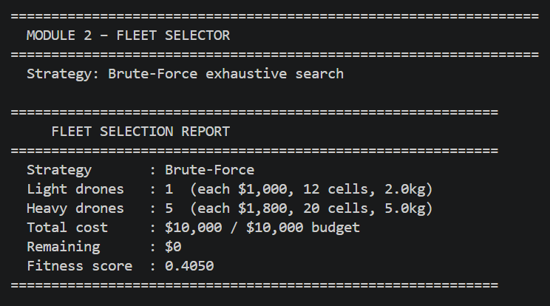

4.4 Genetic Algorithm
The GA uses a chromosome of two integers [n_light, n_heavy] representing the count of each drone type. A population of 40 chromosomes is evolved for 80 generations. Each generation applies elitism (top 20% carried forward unchanged), single-point crossover between elite and top-50% parents, and random mutation with probability 0.2 (incrementing or decrementing one gene by a random value between -2 and +2, clamped to valid range). When run with a different random seed than the brute-force (as happens in the interactive menu versus the full sequential run), the GA may find a slightly different local optimum, but always within the feasible budget.
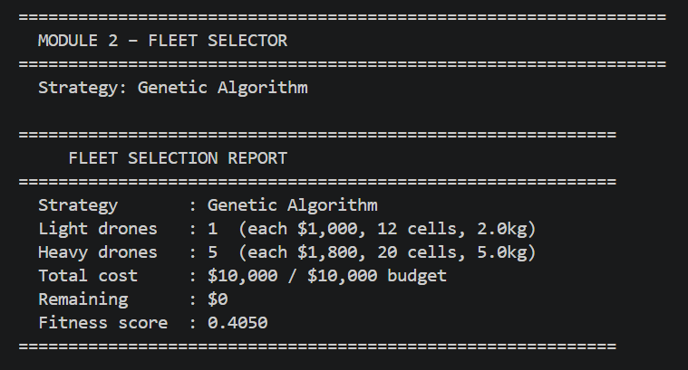
The brute-force result (1 Light, 5 Heavy, fitness 0.405) is the globally optimal solution. The GA result (2 Light, 4 Heavy, fitness 0.330) is a valid near-optimal solution. The difference arises because the GA uses a fixed random seed that leads it to a different local optimum in this small search space. Both solutions are within budget and satisfy all operational constraints.

4.5 Fleet Instantiation
After selection, the create_fleet() function instantiates individual Drone objects distributed across the four hub positions. Each Drone carries a drone ID (DL1, DL2... for light; DH1, DH2... for heavy), its drone type, current position, home hub, battery level (100%), and route state. These objects are passed to the simulation module.

5. Module 3 — A* Delivery Path Planner
The path planner implements the A* search algorithm to find shortest-cost routes through the 10×10 grid. A delivery route follows the structure: home hub → pickup location → dropoff location → home hub. Each of the three segments is solved as a separate A* call, and the results are stitched together while avoiding duplicate junction nodes.

5.1 A* Design
Design Choice | Implementation
State representation | Grid coordinate (row, col) as a tuple.
Actions | Four orthogonal moves: up, down, left, right.
Move cost | 1.0 per normal cell, 0.8 for Commercial corridor cells (discount for urban density), infinity for no-fly cells (blocked).
Heuristic | Manhattan distance from current cell to goal. This is admissible (never overestimates) for 4-direction grid movement, guaranteeing optimality.
Data structures | heapq-based priority queue for the open set. Dictionary for g_cost (best known cost to each cell). Dictionary for came_from (parent pointers for path reconstruction).
Failure handling | If the open set is exhausted without reaching the goal, returns found=False with a descriptive message including the blocked start and goal coordinates.

5.2 Full Delivery Route Planning
The plan_delivery_route() function chains three A* calls to build the complete hub-pickup-dropoff-hub route. Junction nodes (pickup and dropoff) appear once in the final path — the first node of each subsequent segment is removed before concatenation. The total cost is the sum of all three segment costs.

5.3 Sample Output
The following output is produced for the fixed demonstration route Hub(0,0) → Pickup(3,3) → Dropoff(7,7) → Hub(0,0):
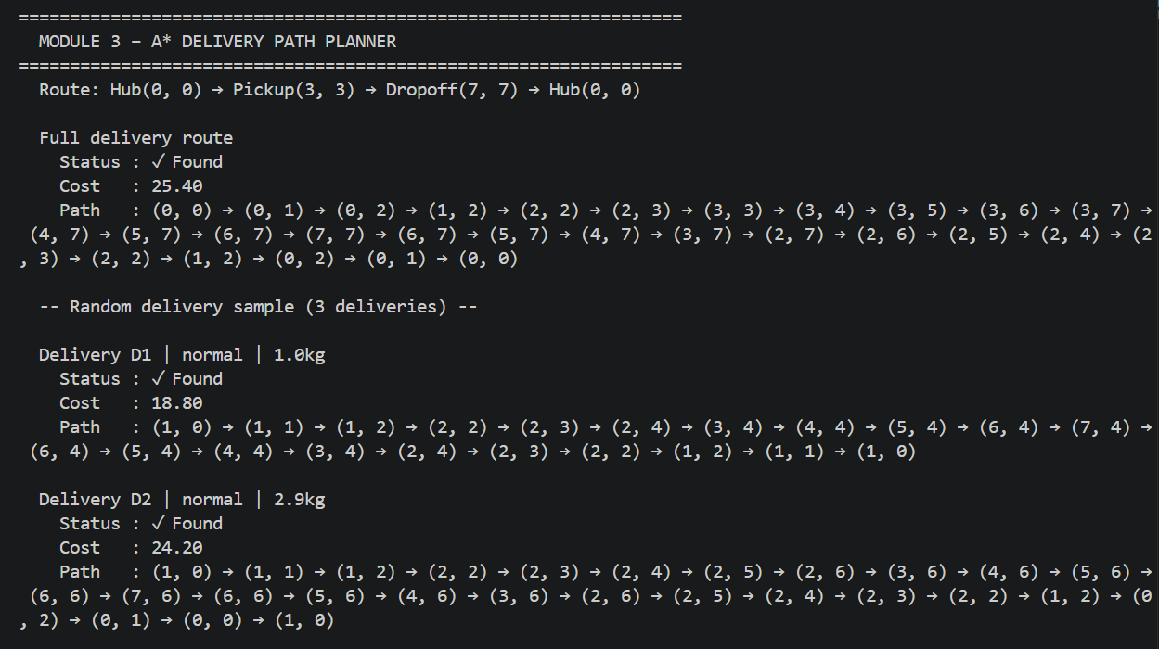
The path through Commercial cells (1,2), (2,2), (2,3) etc. incurs move costs of 0.8 rather than 1.0, which is why A* prefers these cells when available. The total cost of 25.40 reflects this mix of 1.0-cost Open Field and Residential moves and 0.8-cost Commercial moves.

5.4 Random Delivery Samples
Three random deliveries are generated and routed each time the demo is run. Results vary between runs due to random pickup and dropoff selection. Representative results from a single run:
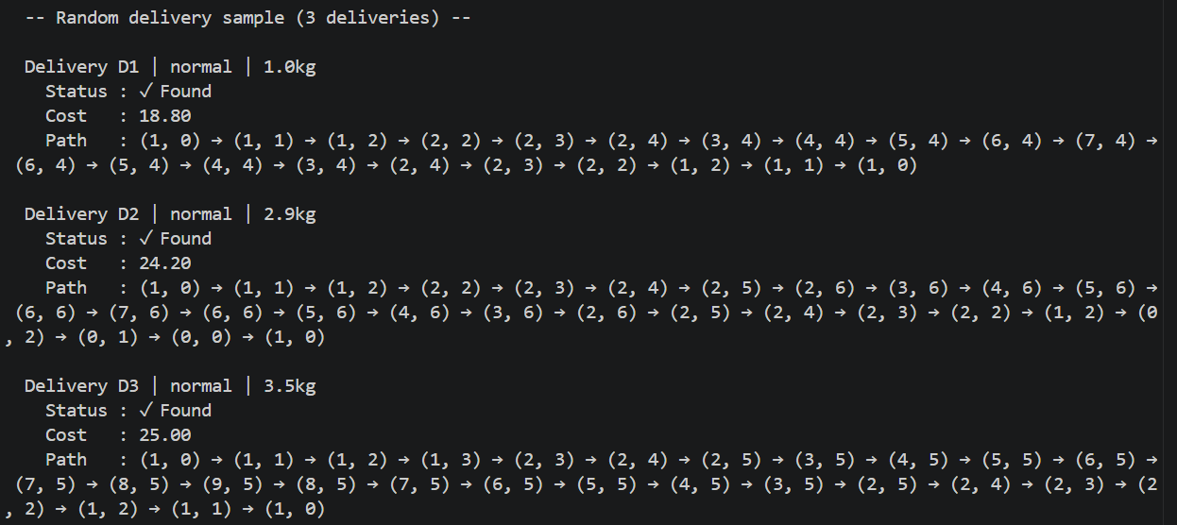
Sample A* delivery route output from terminal

6. Module 4 — Real-Time Disruption Handler
The disruption handler is embedded within the 20-step simulation. It monitors for two types of runtime events: no-fly cell activation and anomaly injection. When either event occurs, the handler calls A* replanning to compute new routes from the drone's current position.

6.1 No-Fly Cell Activation
At Step 11 of the simulation, cell (4,7) is activated as a no-fly zone by setting grid[4][7].no_fly = True. The handler then scans all en-route drones and checks whether cell (4,7) appears in each drone's remaining route path. If it does, a new route is planned from the drone's current position, bypassing the newly blocked cell. If no safe alternative path exists, the affected delivery is marked as delayed.
In this run, drone DH3 had cell (4,7) in its planned route. The replanning call found an alternative path with a reduced cost of 23.2 (down from the original 30.4), because the new path avoids the expensive segment that passed through (4,7) and can take a shorter Commercial corridor instead.

6.2 Anomaly Injection
At Step 18, a random anomaly is injected into one of the en-route drones. Three anomaly types are possible: Battery anomaly (sudden battery drop of 25–40%), Route anomaly (drone marked as deviating from its planned path), and Sensor spike (telemetry values jump unexpectedly). Any drone experiencing a Route anomaly, or any drone whose battery drops below 20%, is forced to return to its home hub and its delivery is marked as delayed.
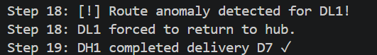

6.3 Event Mapping to Specification
Specification Event | Implementation | Terminal Evidence
No-fly cell activated | grid[row][col].no_fly = True then scan all routes | Step 11: [W] No-fly cell activated at (4,7)
Route crosses no-fly | A* replanned from current position | DH3 rerouted successfully (new cost=23.2)
No safe route exists | delivery.status = 'delayed' | Present in code; not triggered in this run
Anomaly detected | inject_anomaly() called at Step 18 | Step 18: Route anomaly detected for DL1
Force return to hub | drone.status = 'returning', route cleared | DL1 forced to return to hub

7. Module 5 — ML Pipeline: Demand Forecasting and Anomaly Detection
The ML pipeline consists of two independent components: Part A trains regression models on the Bike Sharing Demand dataset to forecast delivery demand, and Part B trains classification models on synthetic drone telemetry to detect anomaly types. Both components use scikit-learn and produce structured output reports.

7.1 Part A — Demand Forecasting

Dataset
The primary dataset is the Kaggle Bike Sharing Demand dataset (train.csv, 10,886 rows). This is a real public dataset of hourly bicycle rental counts from the Capital Bikeshare system in Washington D.C. It is used as a proxy for delivery demand, on the basis that both bike rentals and drone deliveries share demand drivers: time of day, weather, and temperature. The following columns are extracted and used as features:
- hour — extracted from the datetime column
- day_of_week — extracted from the datetime column
- temperature — the normalised temperature column (temp) is denormalised to approximate degrees Celsius by multiplying by 41
- weather — weather situation code (1 = clear, 4 = heavy rain), clipped to range [1,4]
- zone_density — set to a placeholder value of 3,000 since the dataset does not contain geographic zone information
The target variable is the count column, renamed to demand.
If the dataset file is not present at data/train.csv, the system automatically falls back to 800 rows of synthetic data with the same feature structure and a similar demand distribution.

Models
The dataset is split 80/20 into training and test sets with a fixed random seed (42) for reproducibility. Two models are trained and evaluated:
- Linear Regression — baseline model using ordinary least squares.
- Random Forest Regressor — 100 estimators, random state 42.

Results

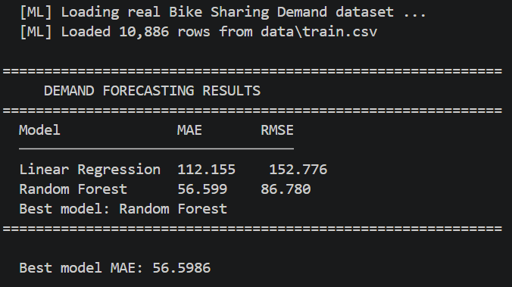
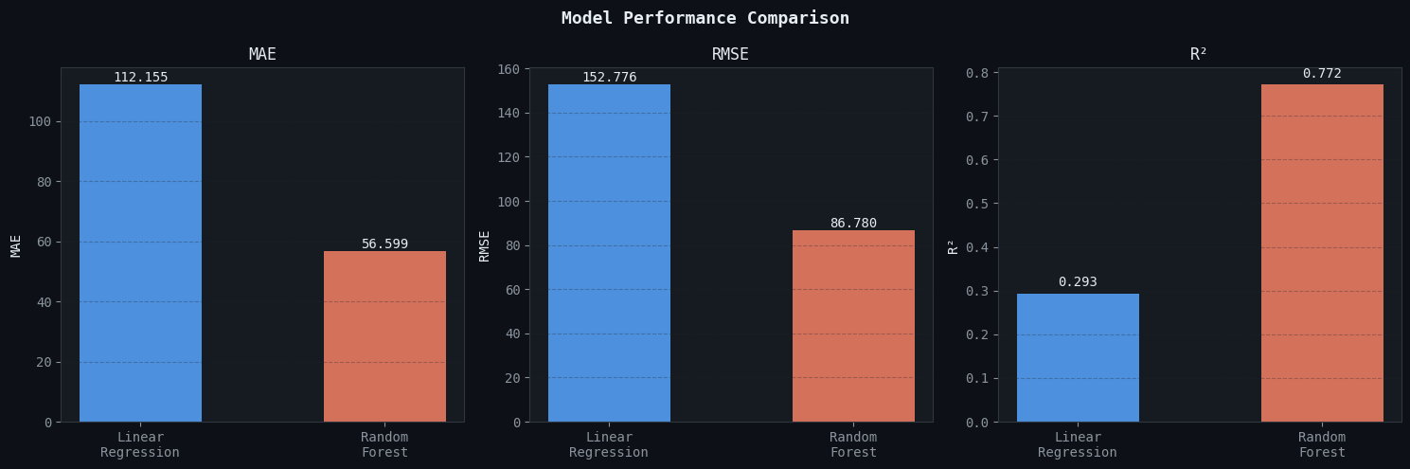
Model performance comparison from demand_forecasting.ipynb

Random Forest significantly outperforms Linear Regression, achieving an MAE of 56.6 versus 112.2. This is expected: bike demand has non-linear relationships with hour of day and weather that the Random Forest can capture through tree splits, whereas Linear Regression assumes a linear relationship across all features simultaneously. The MAE of 56.6 means the model's hourly demand predictions are off by approximately 57 units on average. The Random Forest MAE is used by the simulation at Step 15 to represent the quality of the demand forecast.
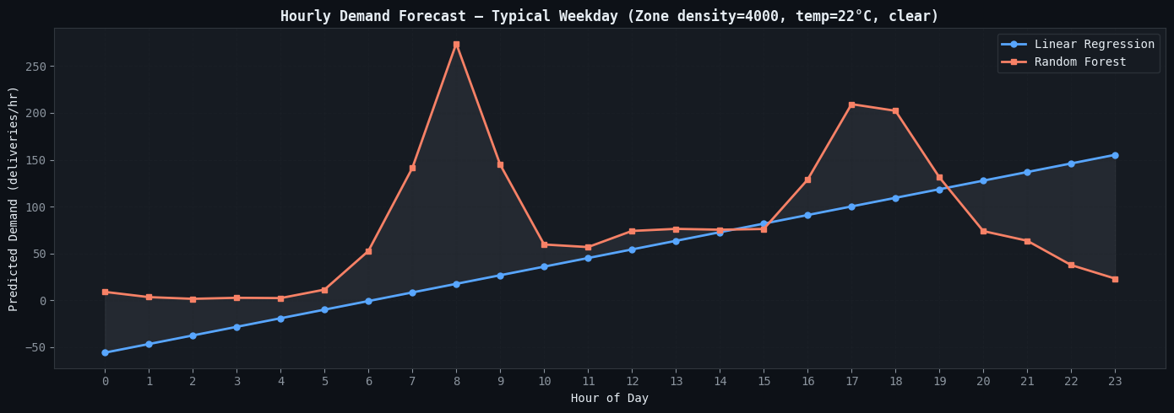
Simulation Use Case

7.2 Part B — Anomaly Detection

Dataset
The anomaly detection component uses a synthetic dataset of 1,000 drone telemetry readings, generated by the generate_telemetry_data() function. The dataset contains four balanced classes of 250 samples each. Each sample has five features:
Class | Distinguishing Feature Range | Other Features
Normal (0) | battery_drop: 1–5, route_deviation: 0–1 | All features in normal range
Battery anomaly (1) | battery_drop: 18–40 (sudden drop) | Other features near normal
Route anomaly (2) | route_deviation: 5–15 (large deviation) | battery_drop near normal
Sensor spike (3) | altitude_change: 10–40, speed_change: 15–30 | Other features near normal

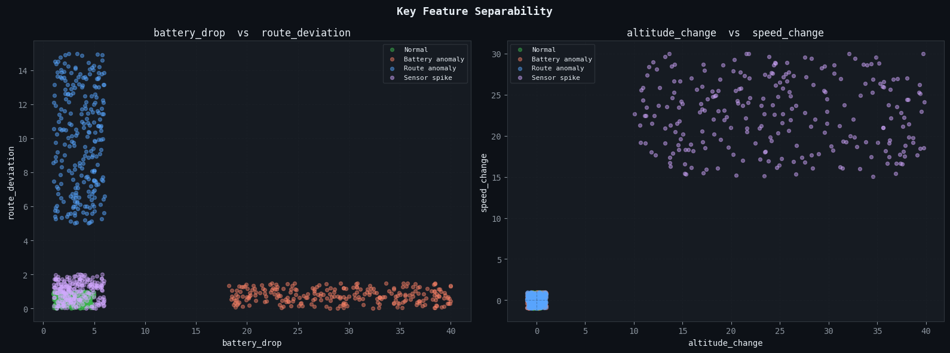Class separability in feature space justifying 100% classification accuracy.
The synthetic data is generated with deliberately non-overlapping feature ranges per class. This is an intentional design choice for a two-week project: the goal is to demonstrate the complete classification pipeline — data generation, train/test split, model training, evaluation, and confusion matrix — rather than to model real-world sensor noise. The code comments explicitly note this and reference the CMU ALFA UAV dataset as a source of real telemetry for future work.
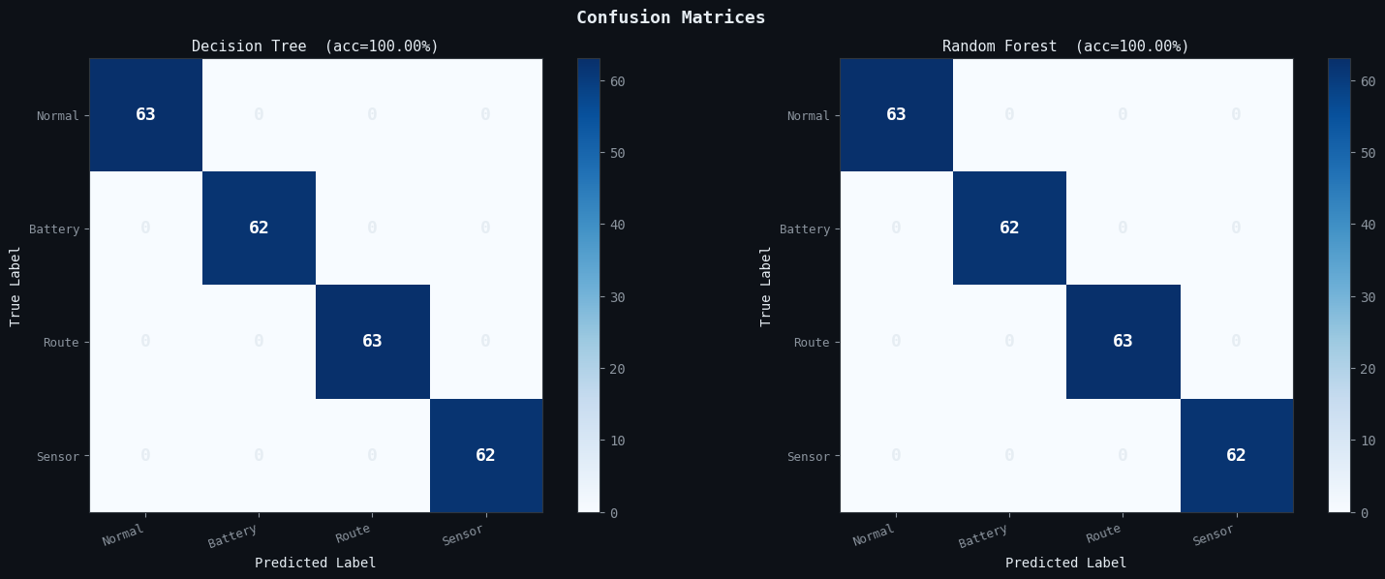
Confusion matrices for Decision Tree and Random Forest classifiers.

Models
The dataset is split 75/25 into training and test sets. Two classifiers are trained and compared:
- Decision Tree — max depth 6, random state 42.
- Random Forest Classifier — 100 estimators, random state 42.

Results

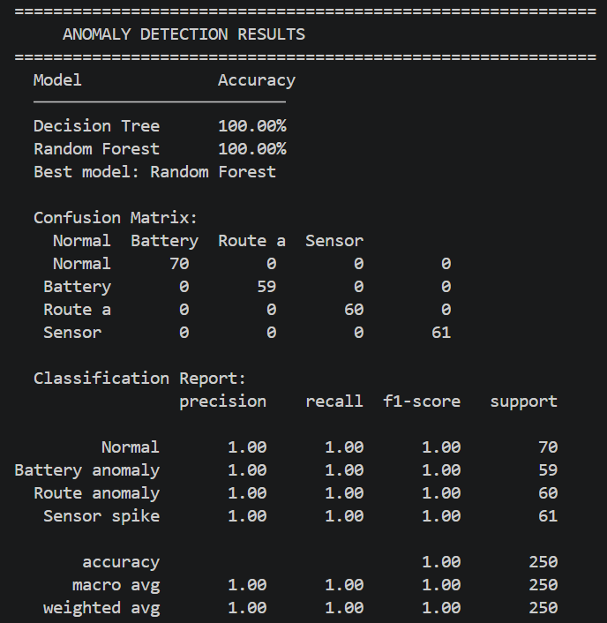
Both classifiers achieve 100% accuracy and a perfect confusion matrix with zero misclassifications. This is expected given the non-overlapping feature ranges in the synthetic data. For example, a battery_drop value of 25 can only belong to the Battery anomaly class, since Normal readings never exceed 5. While this means the 100% accuracy does not represent the difficulty of real-world telemetry classification, it does successfully demonstrate the complete pipeline including data generation, model training, multi-class evaluation, and confusion matrix reporting.

8. 20-Step Simulation
The 20-step simulation is the integration layer of the project. It runs all modules in sequence, generates and routes deliveries, moves drones step by step, handles disruptions, calls the ML forecast at the midpoint, and produces a final summary. A fixed random seed (42) is used to ensure reproducibility.

8.1 Step-by-Step Event Log
Steps | Events
Steps 1–3 | Grid initialized (10×10). Layout validation passed (4/4 rules). Fleet selected: 2 light drones, 4 heavy drones (GA, fitness=0.330).
Step 4 | 8 deliveries generated with random pickup and dropoff locations.
Step 5 | 6 of 8 deliveries assigned to drones via A*. Routes computed for D1–D6. D7 and D8 remain pending.
Step 6 | Initial A* routes confirmed for all assigned deliveries.
Steps 7–10 | Drones advance along routes. 6 drones en route throughout.
Step 11 | No-fly cell activated at (4,7). DH3 route contained this cell. DH3 rerouted via A* (new cost=23.2, down from 30.4).
Step 12 | DH1 completes delivery D3. D7 assigned to DH1 (cost=13.0, 15 cells).
Step 13 | DL1 completes D1. DL2 completes D2. D8 assigned to DL1 (cost=22.4, 25 cells).
Step 14 | DH2 completes D4. DH4 completes D6.
Step 15 | Demand forecast run. Real dataset loaded (10,886 rows). Random Forest selected (MAE=56.599).
Steps 16–17 | Continued drone movement.
Step 18 | Route anomaly injected for DL1. DL1 forced to return to hub. D8 marked delayed.
Step 19 | DH1 completes D7. DL1 returns to hub safely.
Step 20 | Simulation complete. Final summary printed.

8.2 Final Simulation Summary

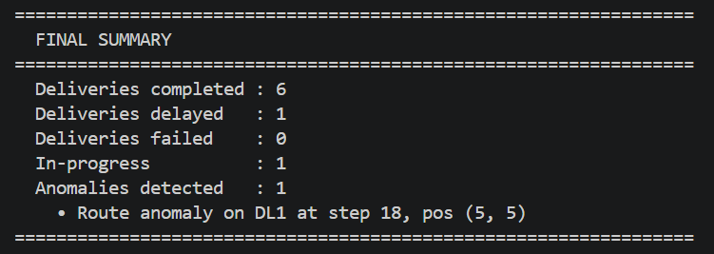
Six of eight deliveries were completed successfully within the 20-step window. One delivery (D8) was delayed because its assigned drone (DL1) was forced to return to hub after a route anomaly at step 18. One delivery (D5) remains in-progress at step 20. No deliveries failed permanently. One anomaly was detected and handled. The disruption at step 11 was resolved successfully through A* replanning without causing any delivery failure.

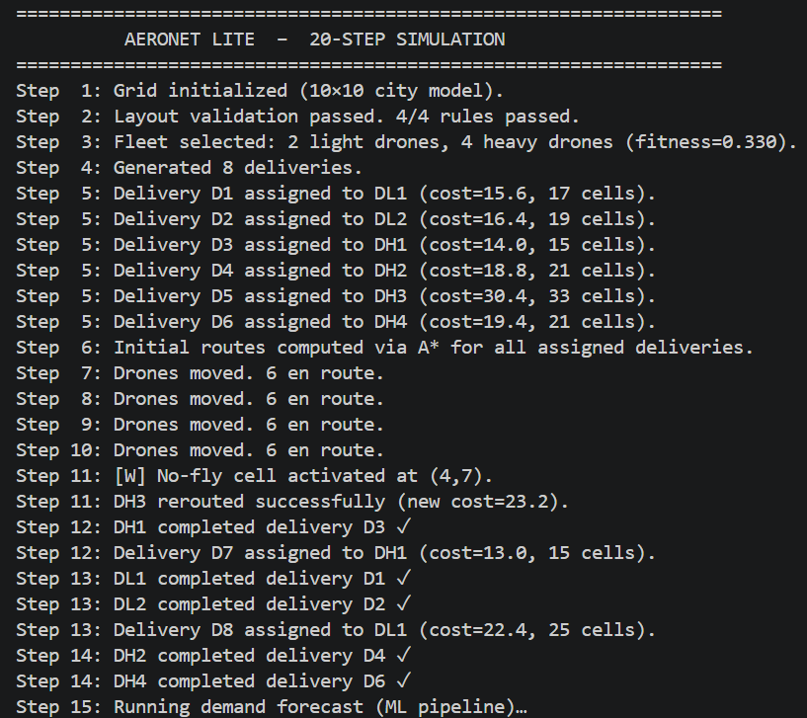
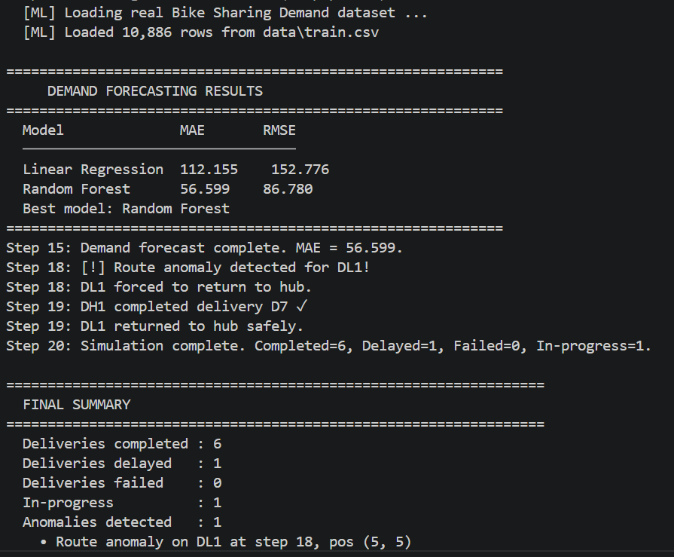
Full 20-step simulation terminal output

9. Visualization Dashboard
The visualization module generates a combined dashboard using matplotlib saved as aeronet_dashboard.png. The dashboard is a 3×2 panel layout rendering five distinct views. An interactive display window is also attempted; if no display is available (headless environment), the PNG is saved and the system continues without error.

9.1 Dashboard Panels
Panel | Contents
Zone Map (top left) | Color-coded 10×10 grid. Each zone type has a distinct color: Residential (blue), Commercial (orange), Industrial (grey), Hospital (red), School (green), Open Field (light green). Special cells are overlaid with icons: [H] for hubs (gold), lightning bolt for charging pads (cyan), cross for medical pickups (red), X for no-fly zones (red).
Route Map (top center) | Greyscale version of the zone grid with no-fly cells highlighted in dark red. Each delivery's planned route is drawn as a colored line, with circular pickup markers and square dropoff markers. Drone current positions are marked with triangles, colored by status.
Demand Heatmap (top right) | YlOrRd heatmap of per-cell delivery demand values, with numeric annotations in each cell and hub positions marked with triangles. A color bar on the right shows the demand scale in deliveries per hour.
Anomaly Events (bottom left) | Scatter plot of anomaly events by simulation step and cell index (row×10 + col). Each event is labeled with drone ID and anomaly type.
Fleet Status (bottom center) | Bar chart of drone counts by status (idle, en_route, returning, anomaly) with a battery level inset chart below showing remaining battery percentage per drone.
Event Log (bottom right) | Last 40 simulation log entries rendered as monospaced text in a dark panel, providing a complete chronological record of simulation decisions.

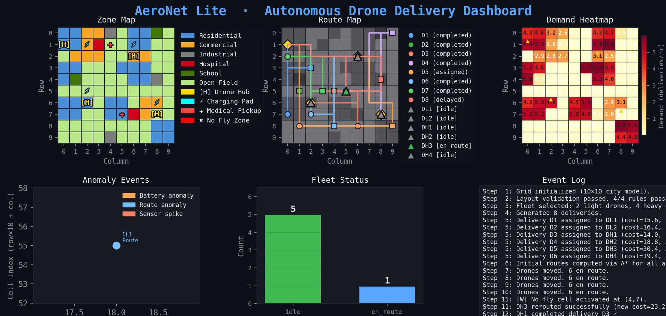
AeroNet Lite combined visualization dashboard (aeronet_dashboard.png)

10. Dataset Usage
Dataset | Source | How Used
Bike Sharing Demand | Kaggle (https://www.kaggle.com/c/bike-sharing-demand) | Real dataset. 10,886 rows. Used for demand forecasting regression. Features extracted: hour, day_of_week, temperature (denormalised), weather, zone_density (placeholder). Target: count column renamed to demand.
Synthetic telemetry | Generated by generate_telemetry_data() | 1,000 rows. Used for anomaly classification. Four classes with non-overlapping feature ranges. Permitted by project brief when logic is clearly explained.
Synthetic demand fallback | Generated by generate_demand_data() | 800 rows. Activated automatically if Bike Sharing Demand CSV is absent. Same feature structure and demand distribution.

The project brief explicitly permits combining real public datasets with synthetic data, noting that the main goal is to demonstrate AI techniques and integration rather than to deploy a real drone system. The Bike Sharing Demand dataset was chosen for demand forecasting because it is clean, well-documented, and beginner-accessible. Synthetic anomaly data was chosen over the CMU ALFA UAV dataset because loading and preprocessing real UAV telemetry would add significant complexity beyond the two-week scope.

11. AI Technique Coverage
Rubric Area | Technique Used | Implementation Location
Constraint Satisfaction Problem | CSP with four named rules, violation accumulation, suggested fixes | layout_validator.py — validate_layout(), four check_* functions
Search Algorithm | A* with Manhattan heuristic, heapq open set, parent pointer reconstruction | astar_planner.py — astar(), plan_delivery_route()
Optimization / GA | Genetic Algorithm with elitism, single-point crossover, mutation; also brute-force | fleet_selector.py — ga_select(), brute_force_select()
Regression | Linear Regression and Random Forest Regressor, MAE and RMSE evaluation, model comparison | ml_pipeline.py — run_forecast()
Classification | Decision Tree and Random Forest Classifier, 4-class output, confusion matrix, classification report | ml_pipeline.py — run_anomaly_detection()
Replanning / Disruption | Dynamic no-fly activation followed by A* replanning from current position | delivery_simulator.py — activate_no_fly(), inject_anomaly()
Visualization | Five-panel matplotlib dashboard: zone map, route map, heatmap, anomaly scatter, event log | visualization.py — show_all()

12. Conclusions and Assumptions

12.1 Summary
AeroNet Lite successfully implements all five modules required by the project specification. The CSP validator correctly enforces all four layout constraints and produces clear violation reports with suggested fixes. The fleet selector returns the globally optimal solution via brute-force and a near-optimal solution via the Genetic Algorithm. The A* planner computes correct minimum-cost routes through the grid and handles rerouting when no-fly cells are activated. The 20-step simulation integrates all modules, demonstrating a complete operational cycle including delivery assignment, movement, disruption, and recovery. The ML pipeline loads real demand data, trains two regression models for comparison, and demonstrates a full classification pipeline with confusion matrix output.

12.2 Assumptions
- The city is modelled as a static 10×10 discrete grid. No geographic coordinate system or real map data is used.
- Each simulation step represents an abstract time unit, not a real-world duration.
- Drone battery consumption is modelled as a random decrement per cell traversed, not a physics-based calculation.
- Demand values are derived from population density proxies with random variation, not from real delivery records.
- The Bike Sharing Demand dataset is used as a proxy for drone delivery demand. The feature zone_density is set to a constant (3,000) since the original dataset does not include geographic zone data.
- The 100% classification accuracy for anomaly detection is an expected and intentional result of the synthetic data design. In a deployment context, real telemetry data with sensor noise and edge-case events would yield lower accuracy.
- Only one no-fly cell is activated during the simulation (at step 11). Multiple simultaneous disruptions are supported by the code but not demonstrated in the default run.
- The visualization dashboard is saved as a static PNG. An interactive Streamlit version is noted in the project brief as optional.

12.3 Limitations and Future Work
Several areas could be extended given more time. The anomaly detection could be trained on real UAV telemetry from the CMU ALFA dataset, which would produce a more realistic accuracy figure and require feature engineering for overlapping class distributions. The demand forecasting could incorporate zone-specific data and time-series forecasting models such as ARIMA or LSTM. The fleet selector search space could be extended to more than two drone types. The simulation could run for more steps and model real-time battery recharging. The visualization could be made interactive using Streamlit.

