Name: Eman Kashif
Course: Cloud Computing
Department: Software Engineering
Registration Number: FA24B1-SE-073
Section: A
GitHub username: eman25-wq
Lab 01: GitHub Identity, Student Portal Registration, and Ubuntu Server Installation
Lab Objective: In this lab, you will create and correctly configure your GitHub account, register yourself in the Student Marks Portal, install Ubuntu Server in VMware Workstation Pro, verify your required Linux identity, and connect to the server remotely from Windows.
GitHub & Student Portal
- lab01_folder_structure.png — Shows the required CC/Labs/Lab01 folder structure.
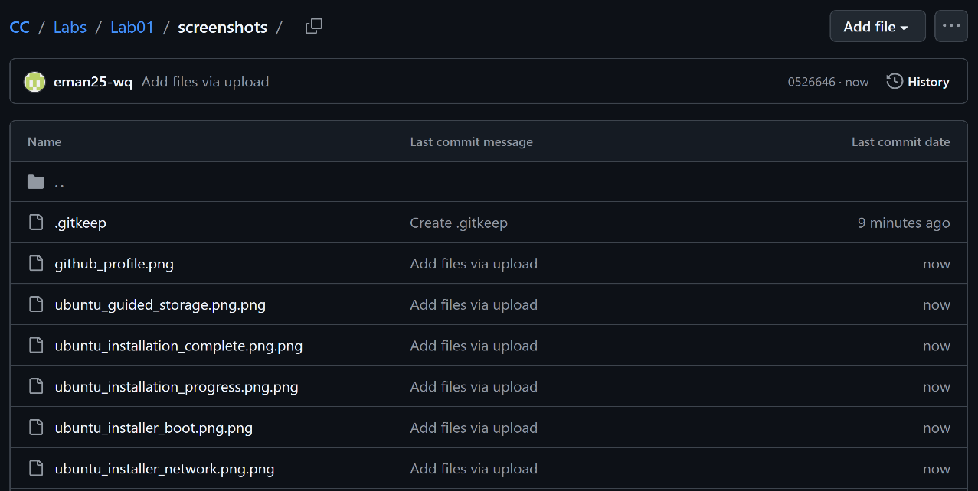
- github_profile.png — Shows the GitHub profile configured with the student's identity.
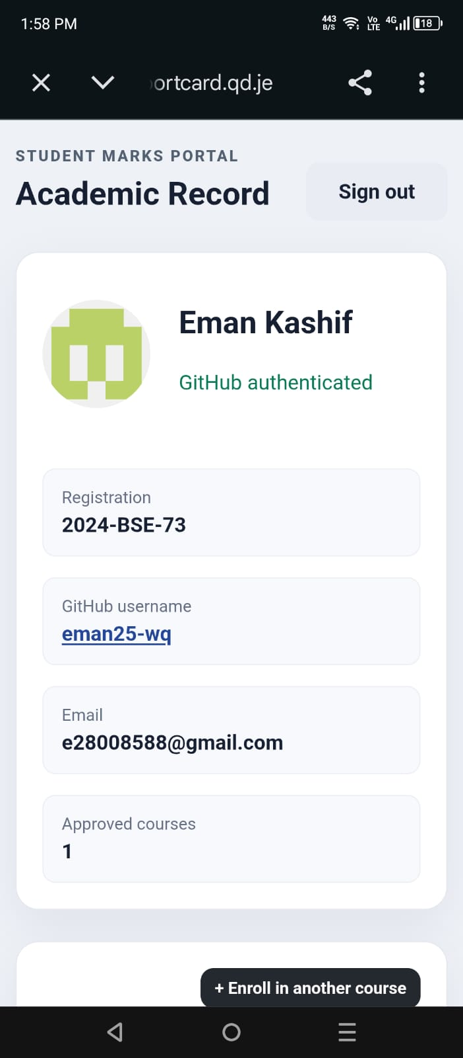
VMware & VM Creation
- vmware_workstation.png — Shows VMware Workstation Pro installed and ready to create the virtual machine.
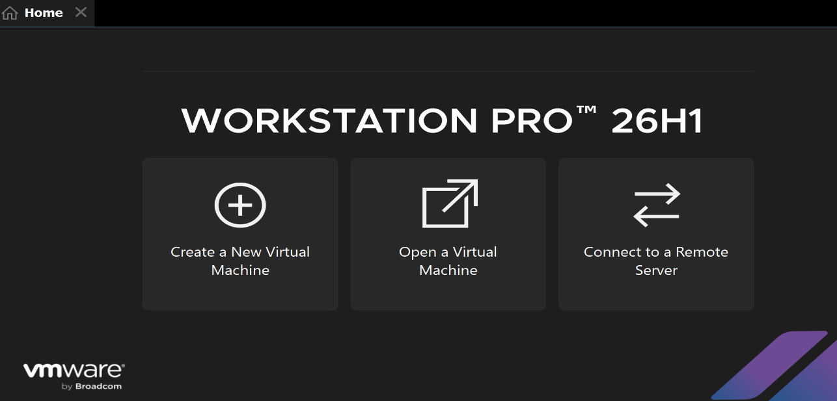
- ubuntu_server_iso.png — Shows the downloaded Ubuntu Server ISO.
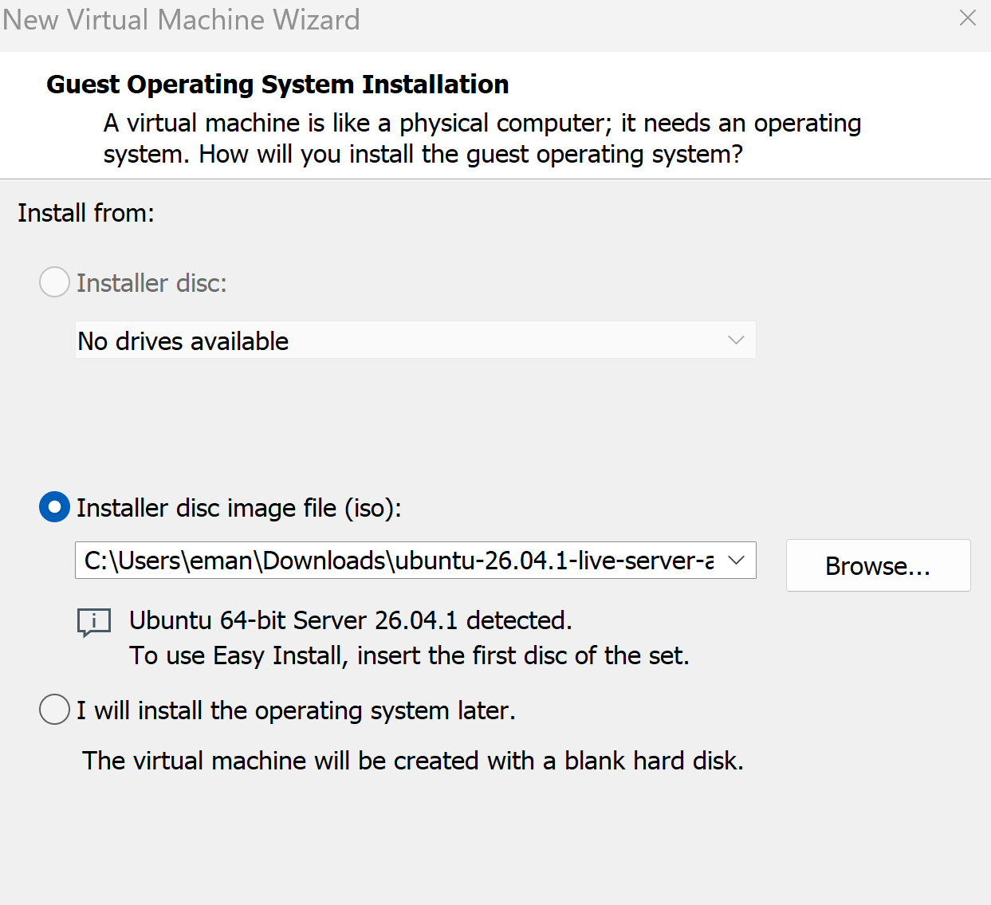
- available_storage.png — Shows the available storage for the virtual machine.
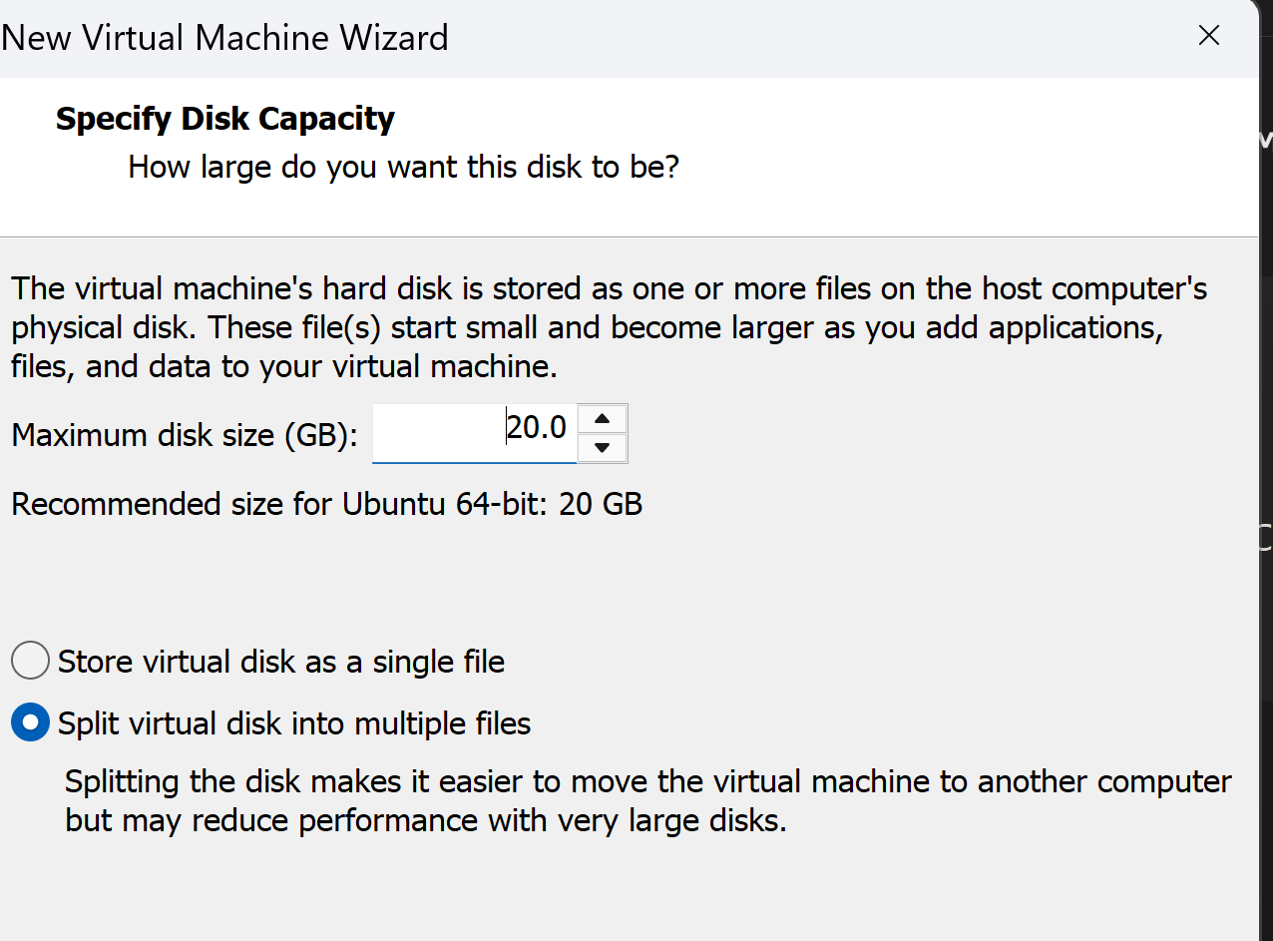
- vm_creation_wizard.png — Shows the VMware New Virtual Machine Wizard.
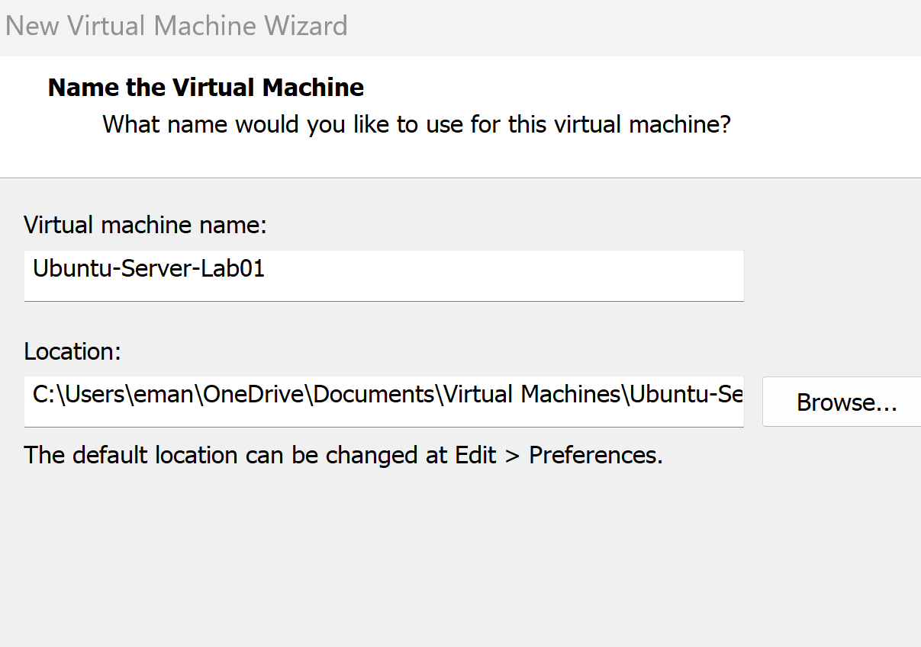
- vm_configuration_summary.png — Shows the final VM configuration before creation.
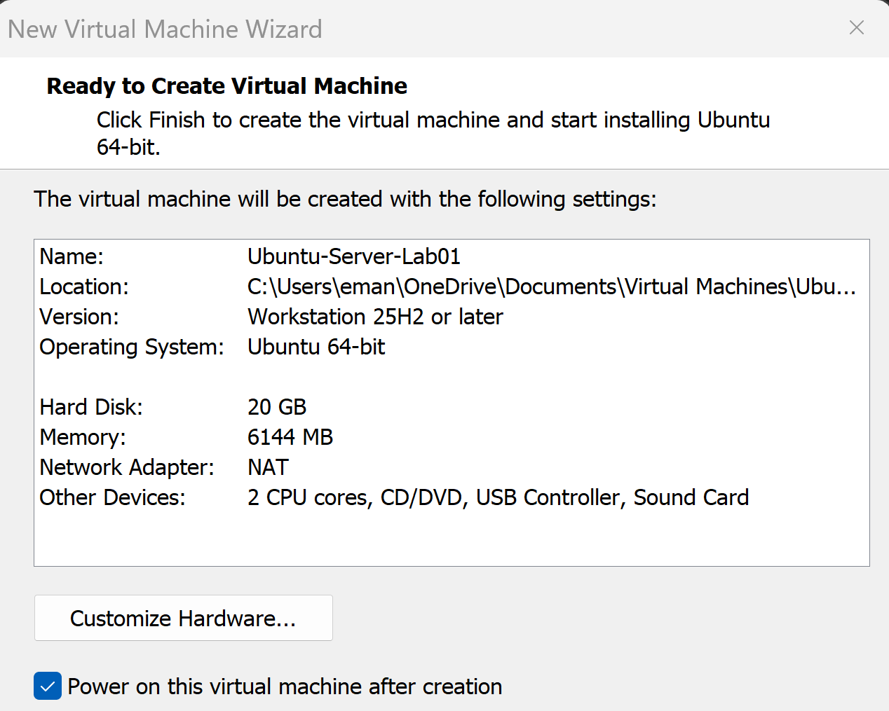
Ubuntu Installation
- ubuntu_installer_boot.png — Shows the Ubuntu Server installer boot screen.
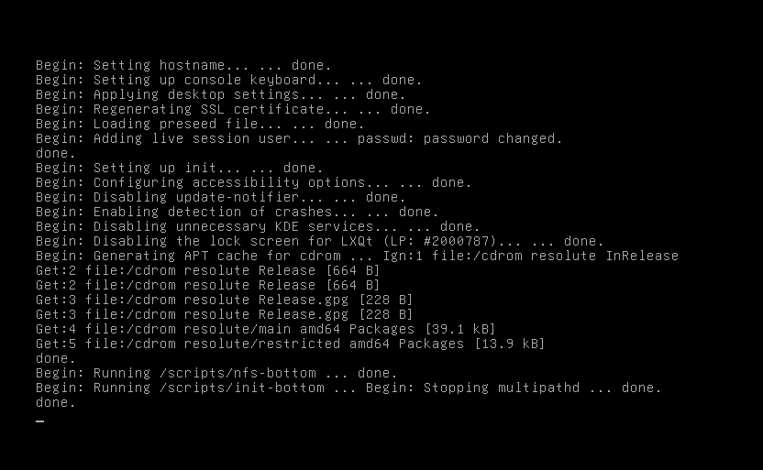
- ubuntu_language.png — Shows English selected as the installation lang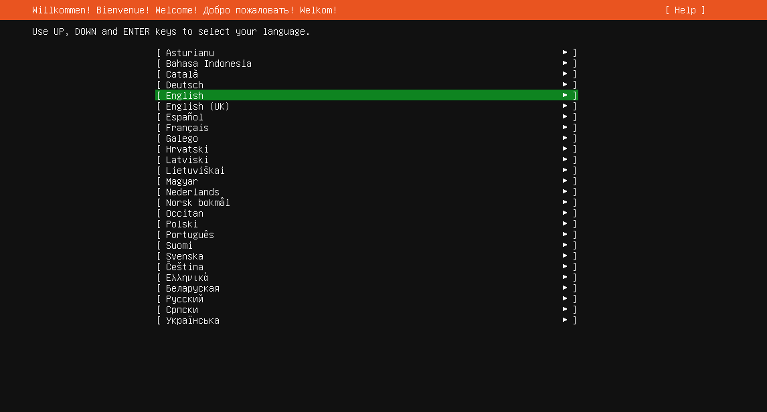
- ubuntu_keyboard_layout.png — Shows the selected keyboard layout.
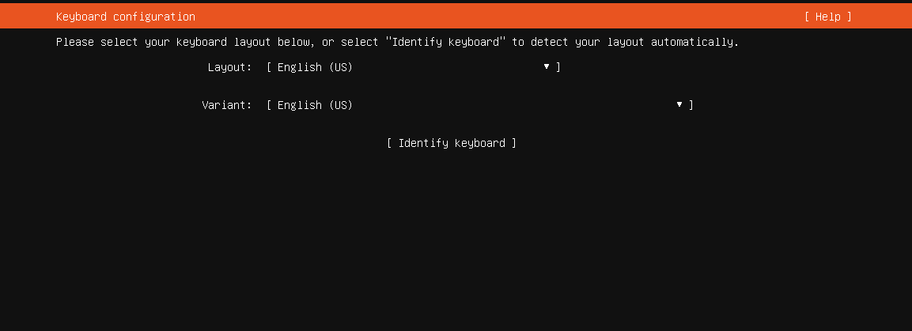
- ubuntu_network_interface.png — Shows the detected network interface.
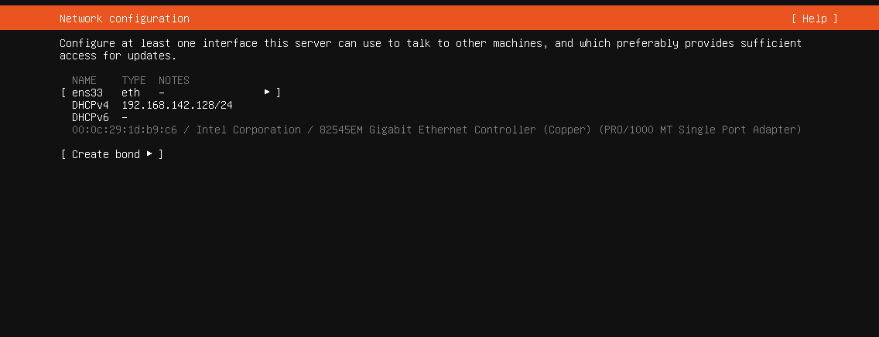
- ubuntu_installer_network.png — Shows the Ubuntu installer network configuration.
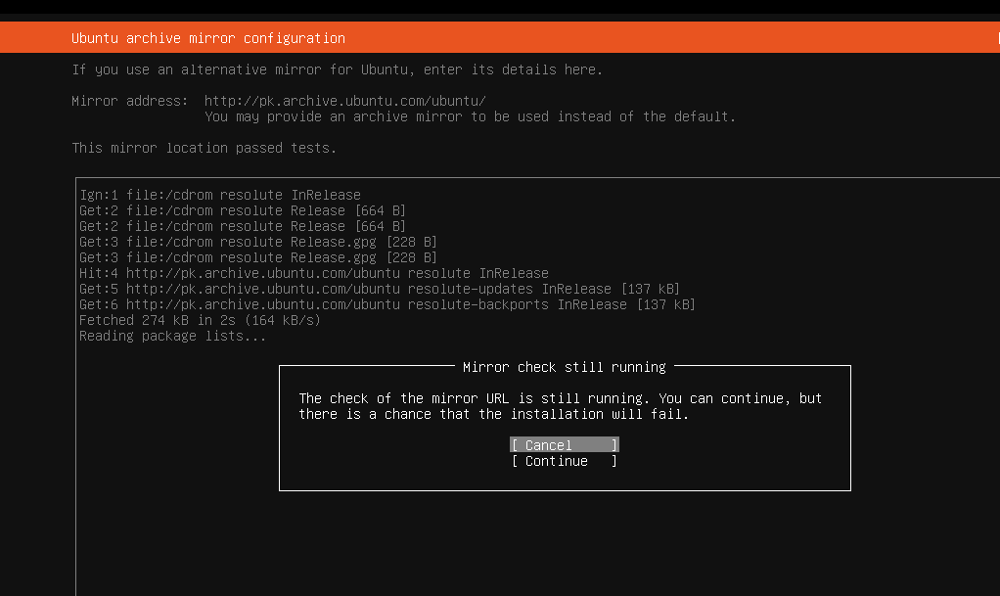
- ubuntu_guided_storage.png — Shows guided storage with the virtual disk selected.
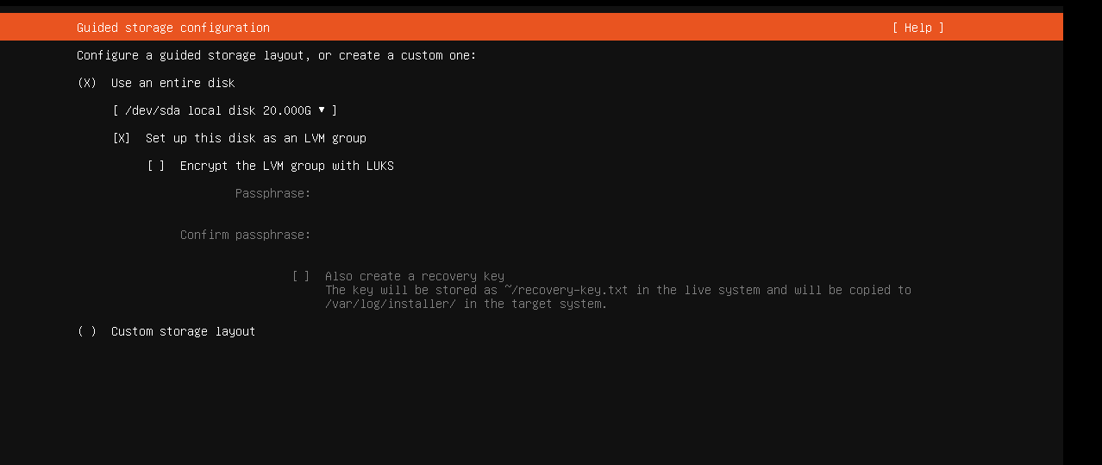
- ubuntu_storage_configuration.png — Shows the configured partitions and LVM storage.
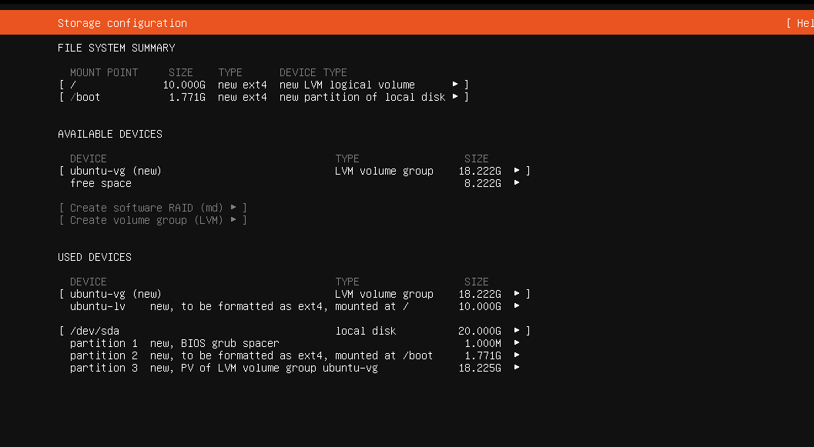
- ubuntu_storage_warning.png — Shows the confirmation warning before applying storage changes.
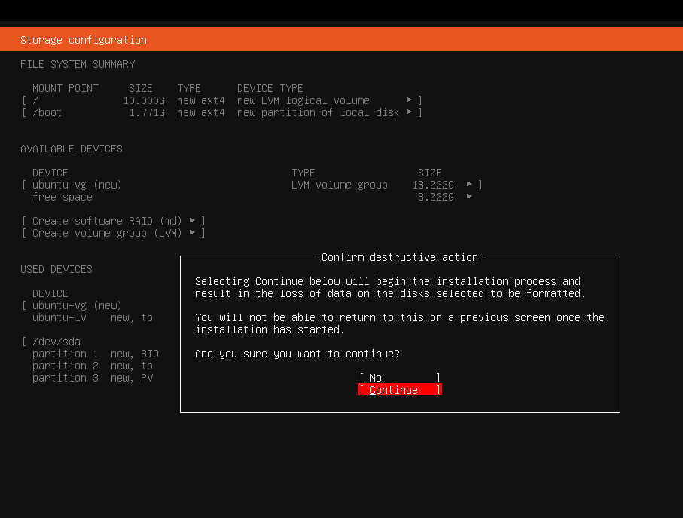
- ubuntu_profile_setup.png — Shows the completed Ubuntu profile configuration.
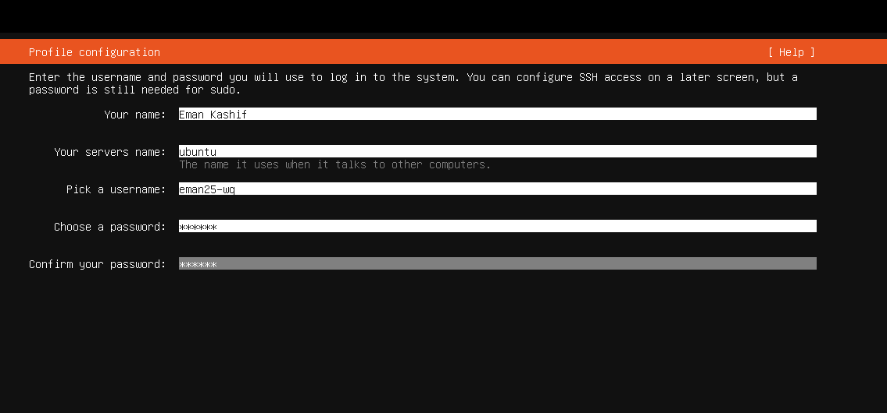
- ubuntu_installation_progress.png — Shows Ubuntu Server installation in progress.
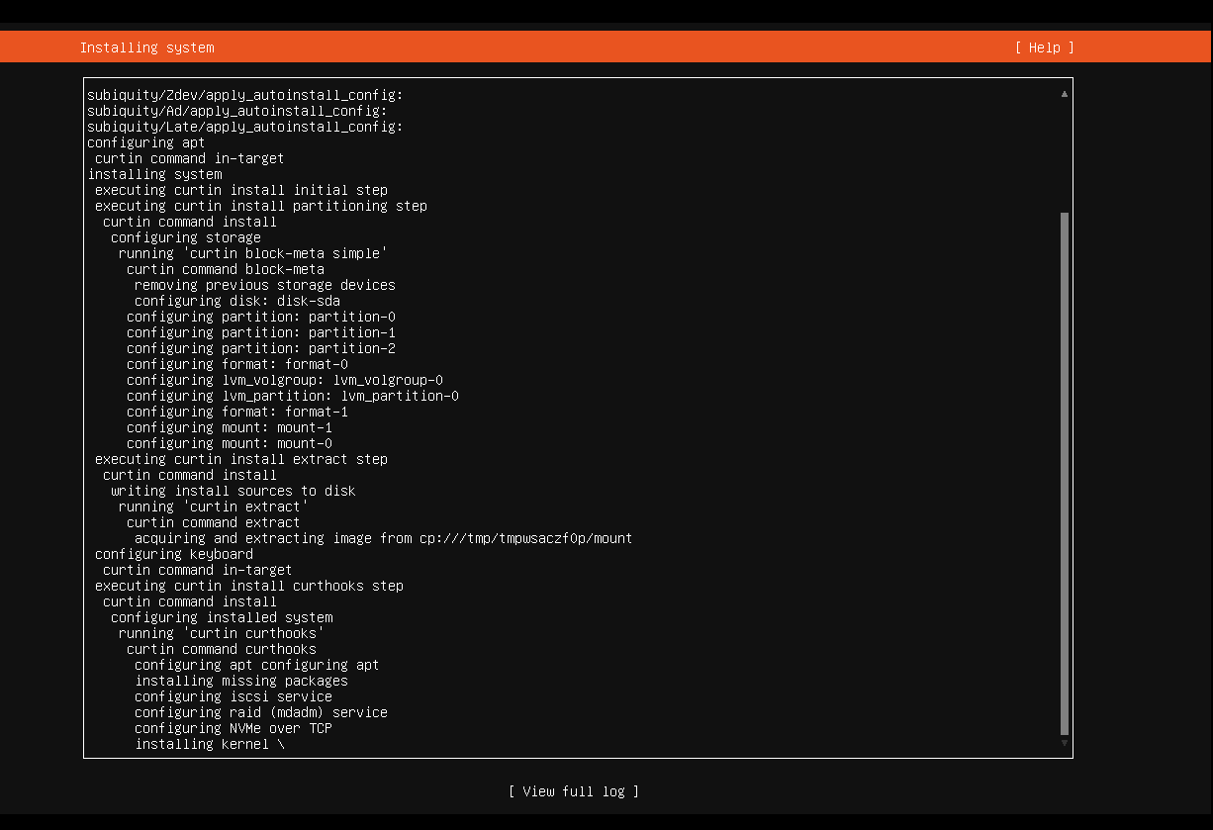
- ubuntu_installation_complete.png — Shows successful completion of the Ubuntu installation.
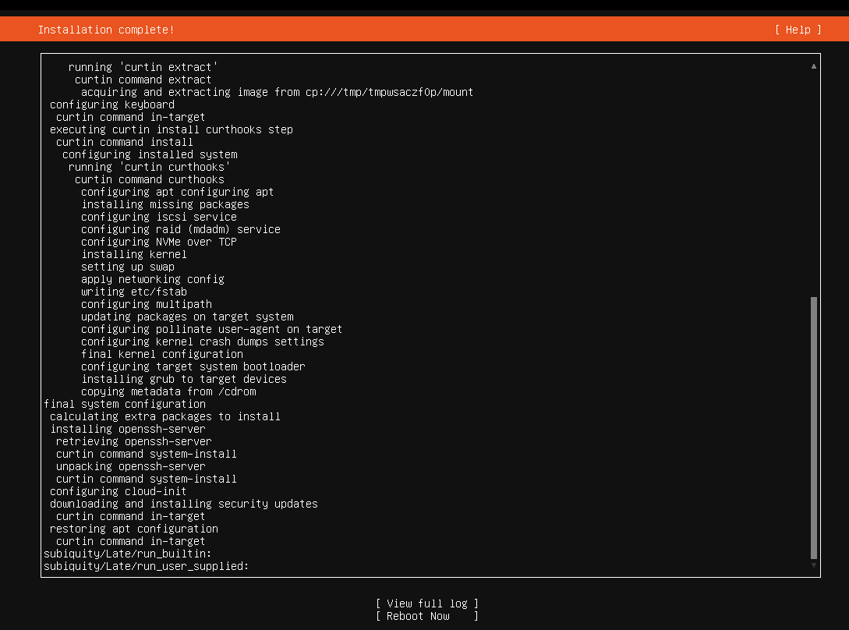

Ubuntu Verification
- ubuntu_login_screen.png — Shows the Ubuntu Server login screen.
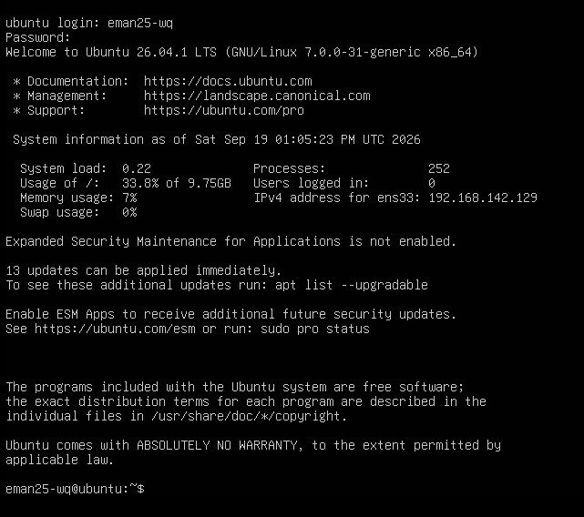
- ubuntu_identity_verified.png — Verifies the username eman25-wq and hostname ubuntu.
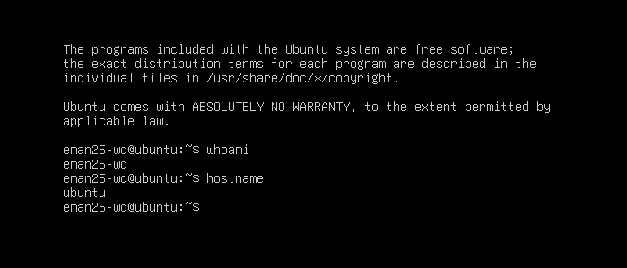
- ubuntu_ip_addr_command.png — Shows the ip addr command used to identify the network address.
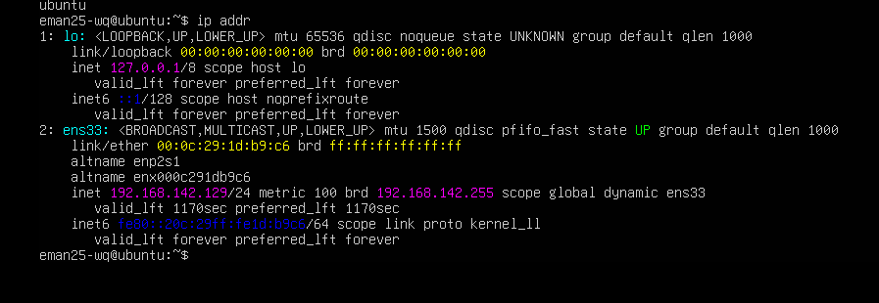
Windows SSH
- windows_ssh_command.png — Shows the SSH command used to connect from Windows.
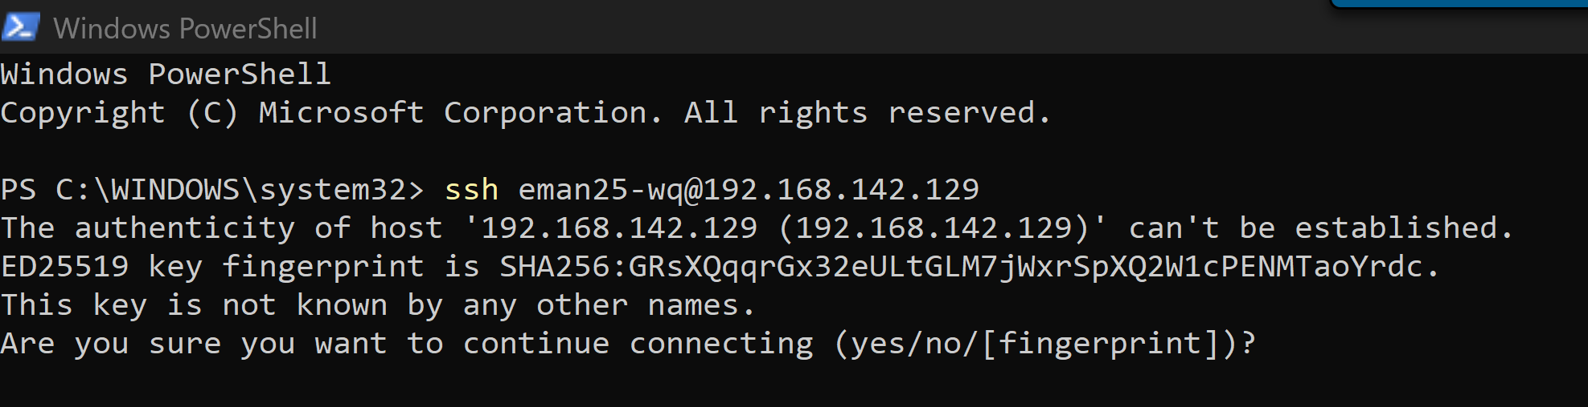
- windows_ssh_fingerprint.png — Shows the SSH host fingerprint confirmation.
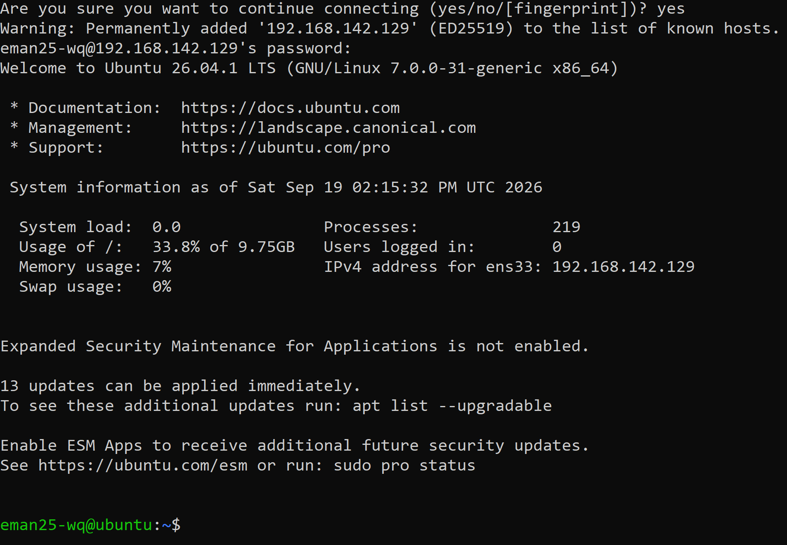
PDF
- solution_title_page.png — Shows the title page of the completed lab solution.
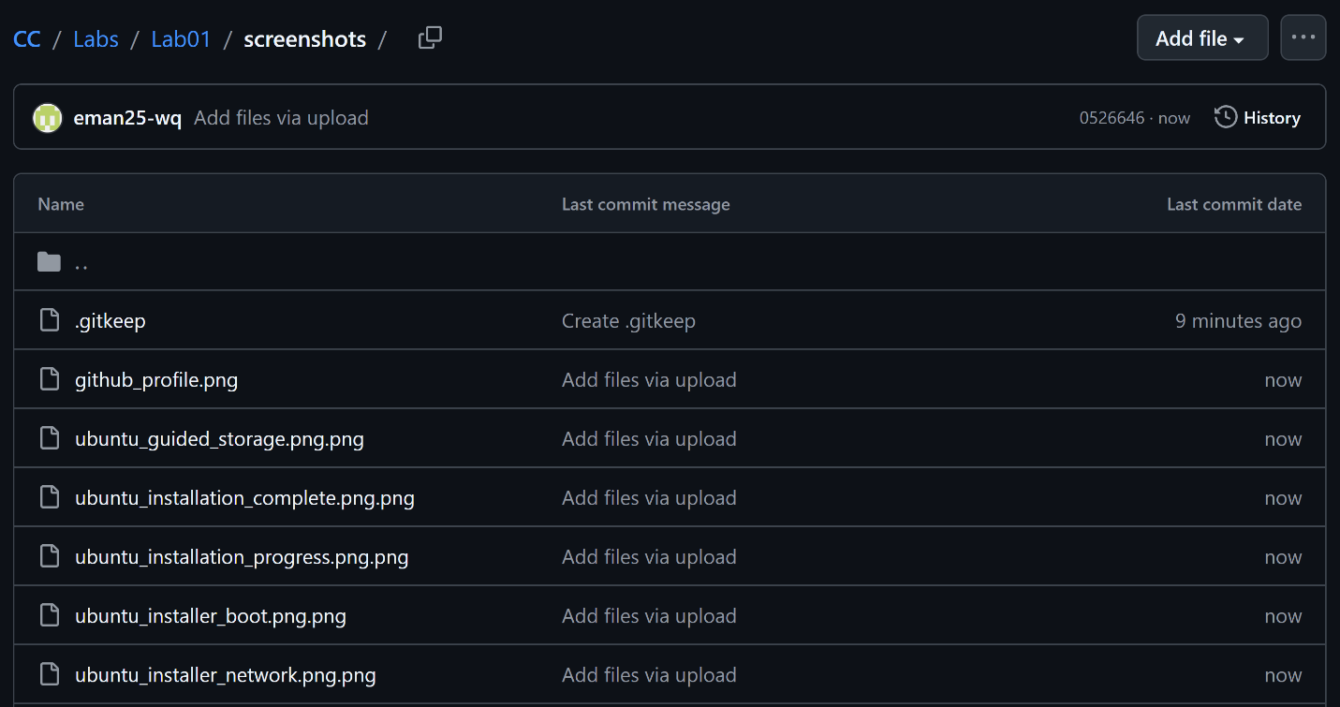
- lab1_solution_pdf.png — Shows the completed Lab1_Solution.pdf.
