Assignment 01: Git, Gitea, GitHub, Git LFS, and GitHub Pages
Name: Eman Kashif
Course: Cloud Computing
Department: Software Engineering
Registration Number: FA24B1-SE-073
GitHub Username: eman25-wq
Operating System: Ubuntu Server (VMware)

1. Introduction
The objective of this assignment was to gain practical experience with Git, Gitea, GitHub, Git Large File Storage (LFS), and GitHub Pages. The assignment involved setting up a self-hosted Git server, managing repositories, uploading large files, and deploying a personal portfolio website.

2. Task 1: Gitea Installation and Repository Setup
Procedure
- Installed Docker and Docker Compose on Ubuntu Server.
- Downloaded the Gitea configuration files.
- Started Gitea using Docker Compose.
- Accessed the Gitea web interface and created an account.
- Created a public repository named Assignment01.
- Initialized a local Git repository and created README.md containing student information.
- Committed the README and pushed it to Gitea.
Commands used:
docker compose up -d
docker compose ps

mkdir ~/Assignment01
cd ~/Assignment01
git init
git branch -M main
git add README.md
git commit -m "Add student information"
git push -u gitea main
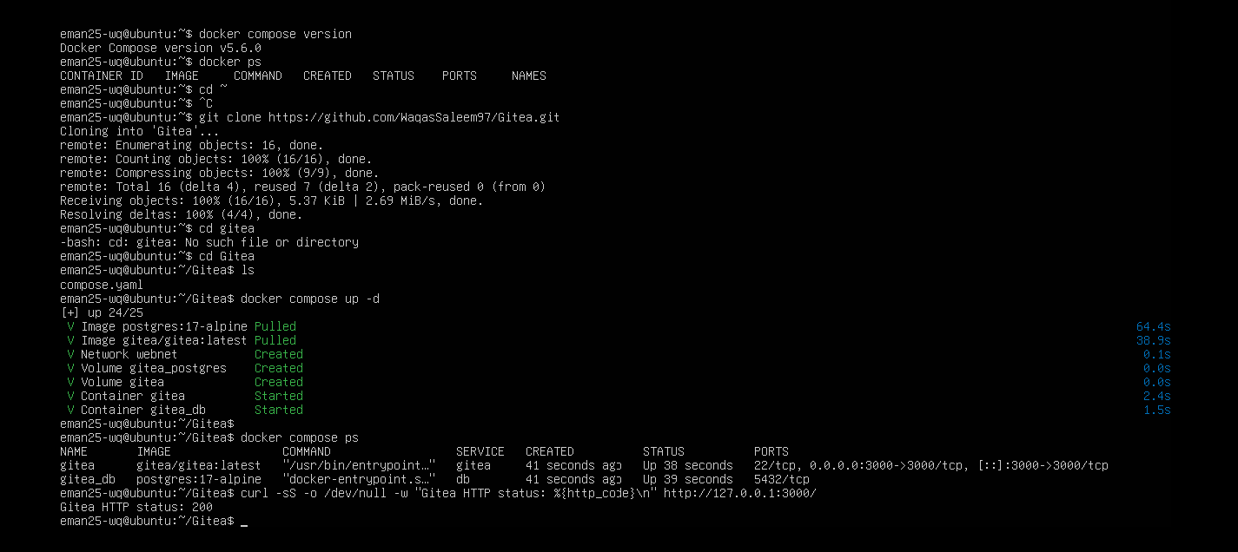
Figure 1: Gitea running successfully using Docker.
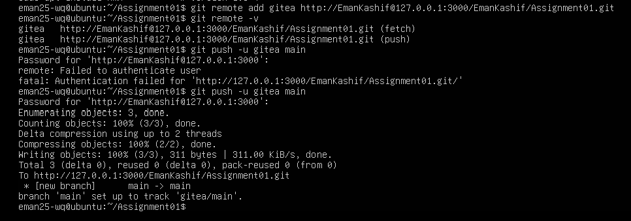
Figure 2: Successful push from Ubuntu to Gitea.
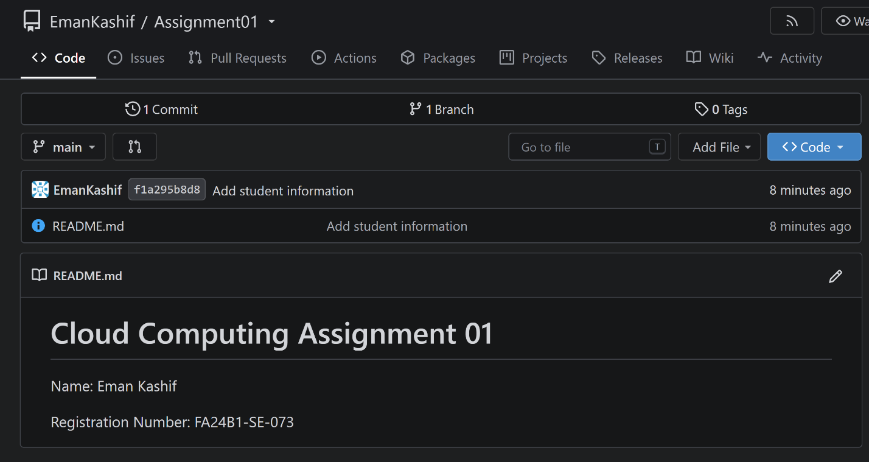
Figure 3: Public Gitea repository containing README.md.
Result: Gitea was successfully deployed, and the local Git repository was uploaded to the self-hosted server.

3. Task 2: GitHub Repository Integration
Procedure
- Created a public GitHub repository named Assignment01.
- Connected the existing Ubuntu repository to GitHub using a second remote.
- Authenticated using GitHub CLI.
- Pushed the local repository to GitHub.
- Verified that the README was displayed correctly.
Commands used:
git remote add github https://github.com/eman25-wq/Assignment01.git
git remote -v
git push -u github main
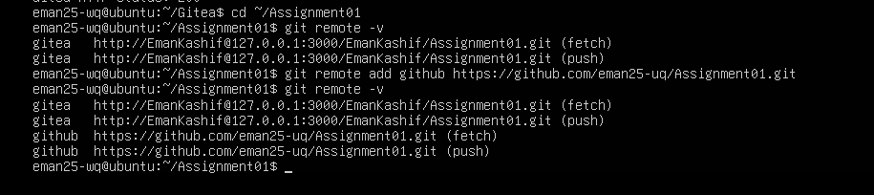
Figure 4: Git remote configuration showing Gitea and GitHub.
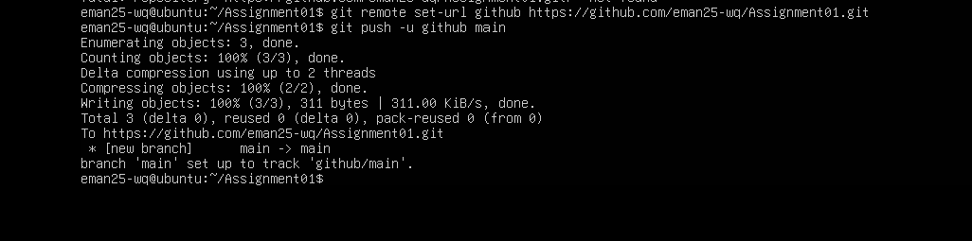
Figure 5: Successful push to GitHub.
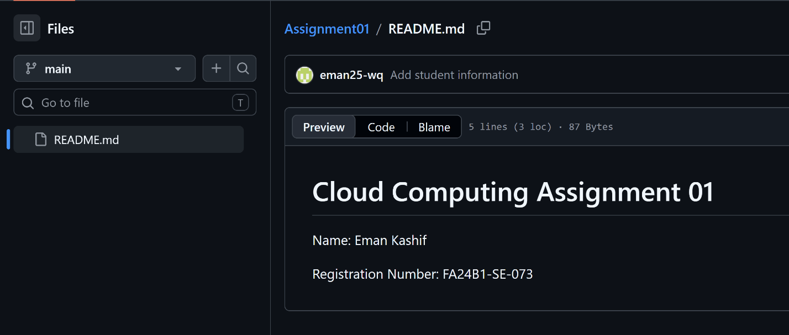
Figure 6: GitHub repository displaying student information.
Result: The same local Git repository was successfully connected to both Gitea and GitHub.
Repository: Assignment01 on GitHub

4. Task 3: Git Large File Storage (LFS)
Procedure
- Installed and initialized Git LFS.
- Configured Git LFS to track .bin files.
- Created three binary files larger than 100 MiB.
- Added and committed the files.
- Uploaded the files to GitHub using Git LFS.
Commands used:
git lfs install
git lfs track "*.bin"
truncate -s 101M large-file-1.bin
truncate -s 102M large-file-2.bin
truncate -s 103M large-file-3.bin
git add .gitattributes *.bin
git lfs ls-files --size
git commit -m "Add three large files using Git LFS"
git push github main
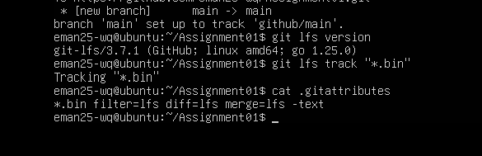
Figure 7: Git LFS installation and configuration.
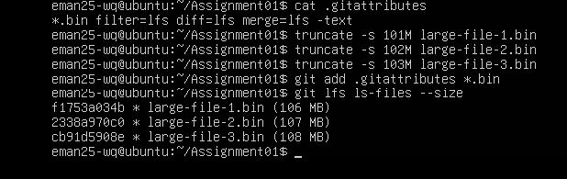
Figure 8: Three large binary files tracked using Git LFS.
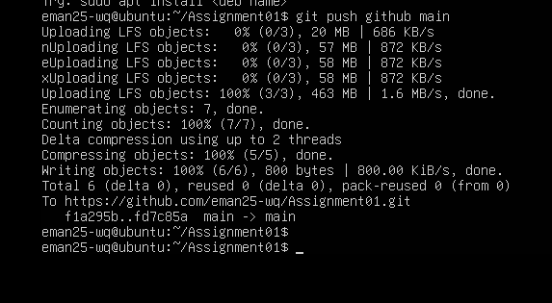
Figure 9: Successful upload of large files to GitHub.
Result: Three files of 101 MiB, 102 MiB, and 103 MiB were created and uploaded using Git LFS.

5. Task 4: Personal Portfolio Using GitHub Pages
Procedure
- Created a public repository named eman25-wq.github.io.
- Created index.html for the website structure.
- Created styles.css for styling.
- Added the following portfolio sections:
  - About Me
  - Education
  - Skills
  - Projects
- Configured GitHub Pages to deploy from the main branch and root directory.
- Opened the published website to verify deployment.
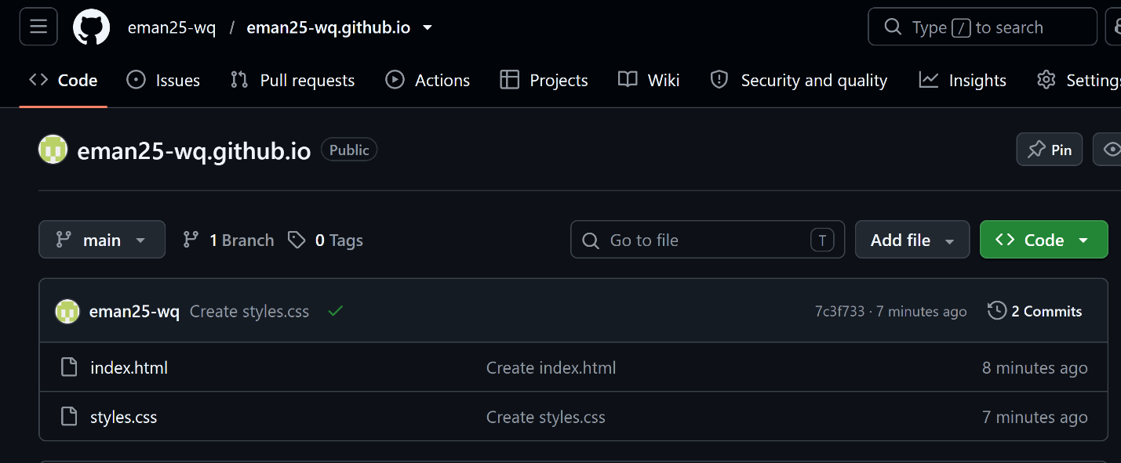
Figure 10: Portfolio repository containing HTML and CSS files.
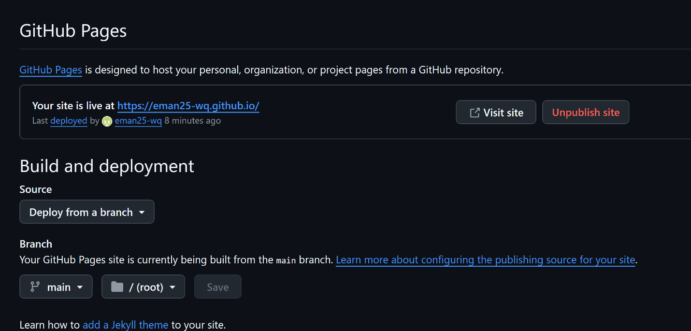
Figure 11: GitHub Pages deployment configuration.
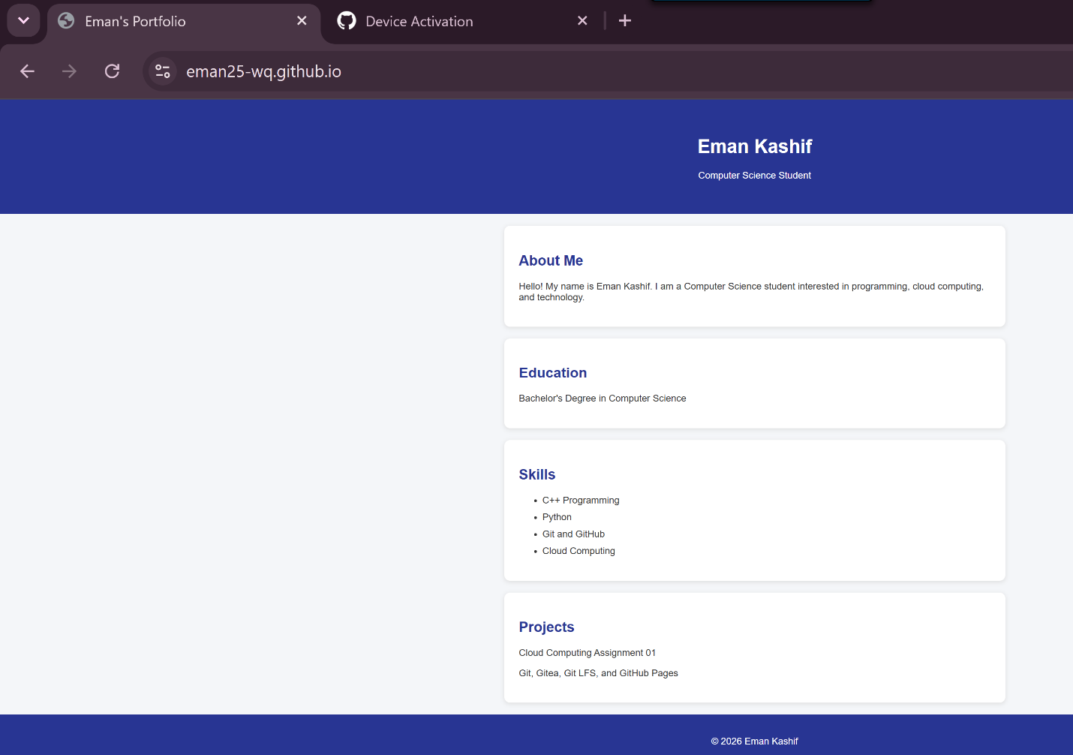
Figure 12: Successfully deployed personal portfolio website.
Result: The personal portfolio website was successfully published using GitHub Pages.
Live Website: Eman's Portfolio

6. Conclusion
This assignment provided practical experience in version control, repository management, and website deployment. Gitea was used for self-hosted repository management, GitHub for remote repository hosting, Git LFS for handling large files, and GitHub Pages for publishing a personal portfolio. All four technical tasks were completed successfully.

