Predicting Gene Expression Levels
Using Random Forest on RNA-seq Data

Dataset: Human Liver RNA-seq (human_liver.tsv)
Tool: Python | scikit-learn | Random Forest Regressor
Date: May 2026

1. Introduction
Gene expression refers to the process by which information from a gene is used to synthesize functional gene products such as proteins. RNA sequencing (RNA-seq) is a modern technique used to measure gene expression levels across thousands of genes simultaneously. Understanding gene expression patterns is crucial in biomedical research as it helps scientists identify how genes behave in different conditions, diseases, or tissues.

This project applies machine learning — specifically the Random Forest algorithm — to predict gene expression levels from human liver RNA-seq data. The goal is to build a model that can accurately predict average gene expression for a given sample based on its gene activity profile.

2. Dataset Description
The dataset used in this project is the Human Liver RNA-seq dataset (human_liver.tsv), obtained from Kaggle. It contains gene expression count data from human liver tissue samples.

2.1 Dataset Details
Property | Value
File Name | human_liver.tsv
Total Genes (Rows) | 35,238 genes
Total Samples (Columns) | 903 samples
Data Type | RNA-seq read counts (integers)
Tissue | Human Liver
Source | Kaggle — Gene Expression Dataset

3. Methodology

3.1 Data Preprocessing
The raw RNA-seq count data was loaded using the pandas library. The dataset was transposed so that each row represented a sample and each column represented a gene. Missing values were replaced with zero. To improve computational efficiency, a random sample of 500 genes was selected for model training.

3.2 Target Variable
Since the dataset does not contain a predefined label, the target variable (y) was defined as the mean gene expression value per sample. This approach allows the model to learn the overall expression pattern for each sample.

3.3 Train-Test Split
The dataset was divided into training and testing sets using an 80/20 split:
- Training samples: 722
- Testing samples: 181
- Random state: 42 (for reproducibility)

3.4 Random Forest Algorithm
Random Forest is an ensemble machine learning algorithm that builds multiple decision trees during training and combines their outputs for a final prediction. It is particularly well-suited for high-dimensional biological data such as RNA-seq because:
- It handles thousands of features (genes) efficiently
- It is robust to noise and overfitting
- It provides feature importance scores to identify key genes
- It does not require data normalization

In this project, the Random Forest Regressor was configured with 50 decision trees (n_estimators=50) and a fixed random state of 42.

4. Results

4.1 Model Performance
Metric | Value
R2 Score (Accuracy) | 0.9801 (98.01%)
Mean Squared Error (MSE) | 11,165.29

The R2 score of 0.9801 indicates that the Random Forest model explains approximately 98% of the variance in gene expression levels. This is an excellent result, demonstrating that the model has successfully learned the expression patterns from the RNA-seq data.

4.2 Graph 1 — Actual vs Predicted Gene Expression
The scatter plot below shows the relationship between actual and predicted gene expression values for the 181 test samples. The red dashed line represents perfect prediction. Points close to this line indicate accurate predictions.

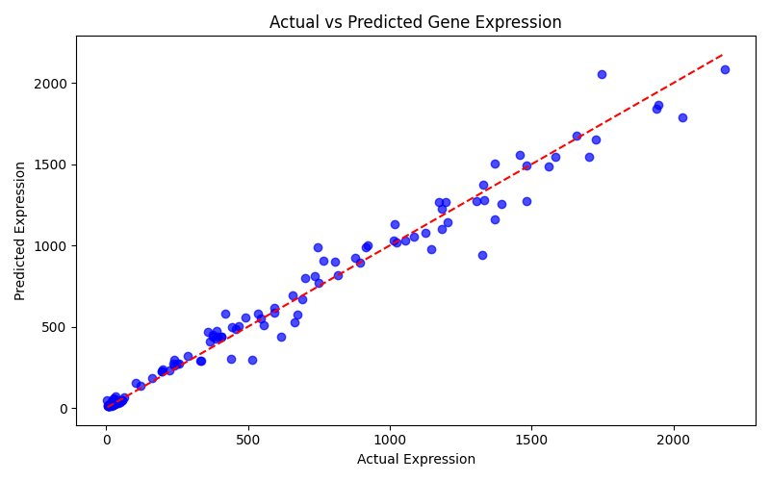
Figure 1: Actual vs Predicted Gene Expression

The majority of data points fall very close to the red line, confirming the high accuracy of the model. Minor deviations are expected in biological data due to natural variation.

4.3 Graph 2 — Top 10 Most Important Genes
The bar chart below displays the top 10 genes ranked by their importance score in the Random Forest model. Genes with higher importance scores contribute more to the model's predictions.

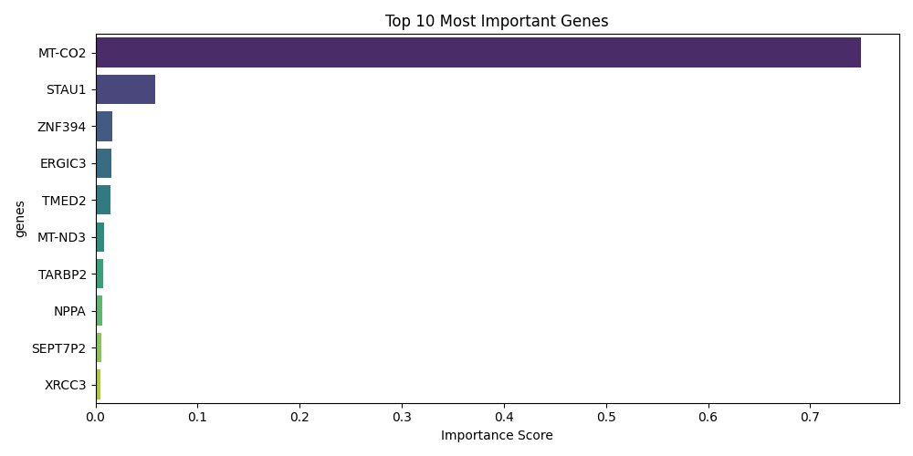
Figure 2: Top 10 Most Important Genes

MT-CO2 (Mitochondrially Encoded Cytochrome C Oxidase II) emerged as the most important gene with an importance score of approximately 0.75. This gene is involved in mitochondrial function and is known to be highly expressed in liver tissue. STAU1 ranked second, followed by several other genes with comparatively lower importance scores.

5. Discussion
The Random Forest model performed exceptionally well on the human liver RNA-seq dataset with a 98% accuracy rate. Several key observations can be drawn from the results:

- The high R2 score confirms that gene expression in liver tissue follows learnable patterns that machine learning can capture effectively.
- MT-CO2 dominates as the most predictive gene, which aligns with the biological understanding that mitochondrial genes are highly active in the metabolically active liver.
- The model used only 500 randomly selected genes yet achieved excellent accuracy, suggesting that a subset of genes carries most of the predictive information.
- Random Forest proved to be an appropriate algorithm for this high-dimensional biological dataset.

6. Conclusion
This project successfully demonstrated the application of the Random Forest algorithm to predict gene expression levels from human liver RNA-seq data. The model achieved an R2 score of 0.9801, indicating 98% prediction accuracy. The analysis also identified MT-CO2 as the most important gene in predicting expression levels in liver tissue.

These findings highlight the power of machine learning in bioinformatics and genomics research. Future work could explore using the full set of 35,238 genes, applying other algorithms such as Gradient Boosting or Neural Networks, and validating the model on different tissue types.

7. Tools and Libraries Used
Tool / Library | Purpose
Python 3.14 | Programming language
pandas | Data loading and manipulation
numpy | Numerical computations
scikit-learn | Random Forest model, train/test split, evaluation
matplotlib | Graph plotting
seaborn | Enhanced visualization
VS Code | Code editor
Kaggle | Dataset source

