Section 1: Muscular Stress (الاجهاد العضلي) — Biomechanics

Problem 1 — Upper Leg Muscle Force (Knee Joint Exercise Device) 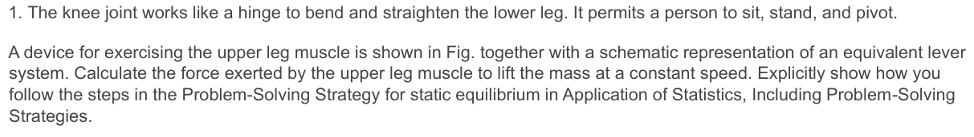
Given: mass = 10 kg, r⊥ (weight moment arm) = 35 cm = 0.35 m, r'⊥ (muscle moment arm) = 2.0 cm = 0.02 m
For static equilibrium, sum of torques about the pivot = 0:
FM × r'⊥ = W × r⊥
FM × 0.02 = (10 × 9.8) × 0.35
FM = 98 × 0.35 / 0.02 = 34.3 / 0.02
FM = 1,715 N ≈ 1,720 N

Problem 2 — Vertebrae Force FV (Head at Drafting Board) 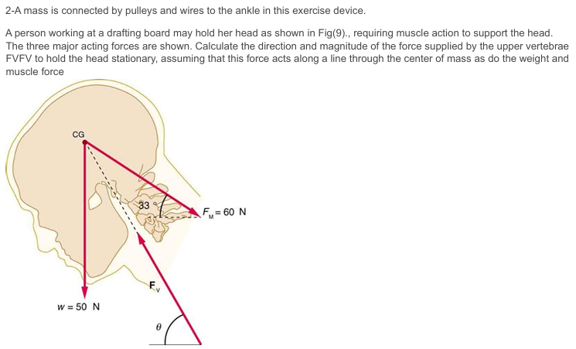
Given: FM = 60 N at 33° from horizontal, W = 50 N downward, FV unknown (acts along center-of-mass line).
Equilibrium of forces: ΣFx = 0 and ΣFy = 0
FMx = 60 cos33° = 60 × 0.8387 = 50.3 N (horizontal, pointing right)
FMy = 60 sin33° = 60 × 0.5446 = 32.7 N (vertical component, upward)
Let FV make angle θ below vertical (acts through CG toward the atlanto-occipital joint).
ΣFx: FVx = FMx = 50.3 N
ΣFy: FVy = W - FMy = 50 - 32.7 = 17.3 N
|FV| = √(50.3² + 17.3²) = √(2530 + 299) = √2829
|FV| = 53.2 N, θ = arctan(50.3/17.3) = 71.0° from vertical

Problem 3 — Neck Muscles to Hold Head Erect (Fig. 11) 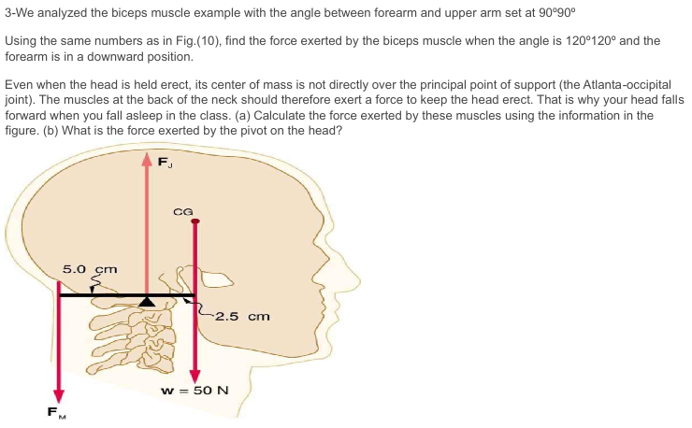
Given: W = 50 N (head weight at CG), CG is 2.5 cm in front of pivot, muscle FM acts 5.0 cm behind pivot.
(a) Taking torques about the atlanto-occipital joint (pivot):
FM × 5.0 = W × 2.5
FM = 50 × 2.5 / 5.0 = 125 / 5.0
(a) FM = 25 N
(b) Force at pivot FJ (joint reaction force), upward equilibrium:
FJ + FM = W → FJ = W - FM = 50 - 25
(b) FJ = 25 N (downward on pivot)

Problem 4 — Achilles Tendon Force (75-kg man on toes) 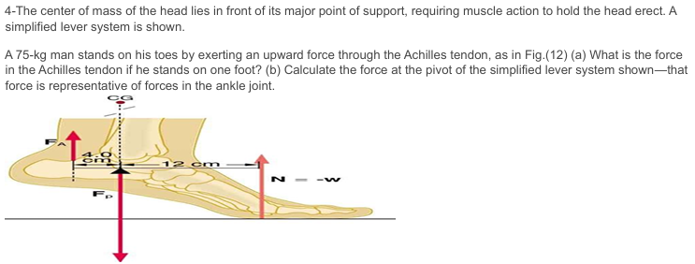
Given: m = 75 kg, weight W = 75×9.8 = 735 N. From Fig. 12: Achilles tendon arm d1 = 4.0 cm, body weight arm d2 = 12 cm.
(a) Taking moments about ankle pivot:
FA × d1 = N × d2 where N = W = 735 N (one foot)
FA × 4.0 = 735 × 12
(a) FA = 735 × 12 / 4.0 = 2,205 N ≈ 2,210 N
(b) Pivot force FP (vertical equilibrium at foot):
FP = FA + N = 2205 + 735
(b) FP = 2,940 N (≈ 4× body weight)

Problem 5 — Father Lifts Child (Fig. 13)
5-The muscles in the back of the leg pull the Achilles tendon when one stands on one’s toes. A simplified lever system is shown. A father lifts his child as shown in Fig.(13). What force should the upper leg muscle exert to lift the child at a constant speed?

Given: m_leg = 4.0 kg, m_child = 10 kg, muscle moment arm r⊥ = 2.0 cm, leg CG arm r'⊥ = 20.0 cm, child arm r''⊥ = 38.0 cm.
Torque balance about knee pivot:
FM × 2.0 = W_leg × 20.0 + W_child × 38.0
FM × 2.0 = (4.0×9.8)×20.0 + (10×9.8)×38.0
FM × 2.0 = 784 + 3724 = 4508
FM = 4508 / 2.0 = 2,254 N ≈ 2,250 N

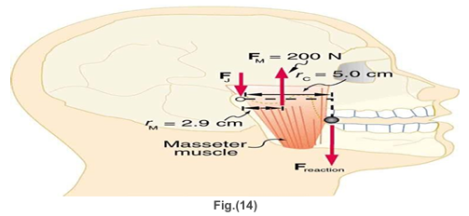
Problem 6 — Jaw Muscle & Bite Force (Fig. 14)
5-The muscles in the back of the leg pull the Achilles tendon when one stands on one’s toes. A simplified lever system is shown. A father lifts his child as shown in Fig.(13). What force should the upper leg muscle exert to lift the child at a constant speed?

Given: FM = 200 N (masseter), rM = 2.9 cm (muscle arm from joint), rC = 5.0 cm (tooth/bullet arm from joint).
(a) Torque balance about jaw joint:
FTooth × rC = FM × rM
FTooth × 5.0 = 200 × 2.9
(a) FTooth = 200 × 2.9 / 5.0 = 116 N
(b) Joint reaction force FJ (vertical equilibrium):
FJ = FM - FTooth = 200 - 116
(b) FJ = 84 N

Problem 7 — Woman Doing Push-Up (Fig. 15)
7-(a) What force should the woman in Fig.(15) exert on the floor with each hand to do a push-up? Assume that she moves up at a constant speed. (b) The triceps muscle at the back of her upper arm has an effective lever arm of 1.75 cm, and she exerts force on the floor at a horizontaldistance of 20.0 cm from the elbow joint. Calculate the magnitude of the force in each triceps muscle, and compare it to her weight. (c) How much work does she do if her center of mass rises 0.240 m? (d) What is her useful power output if she does 25 pushups in one minute?

Given: m = 50.0 kg, W = 490 N, CG at 0.90 m from hands, total length = 1.50 m.
(a) Torques about feet contact point:
2 × Fhand × 1.50 = W × (1.50 - 0.90) = 490 × 0.60
2 × Fhand = 490 × 0.60 / 1.50 = 196
(a) Each hand force = 98 N
(b) Triceps muscle force: lever arm = 1.75 cm = 0.0175 m, floor force arm = 20.0 cm = 0.20 m.
FTriceps × 0.0175 = Fhand × 0.20 = 98 × 0.20
(b) FTriceps = 19.6 / 0.0175 = 1,120 N ≈ 2.3× body weight (490 N)
(c) Work done raising center of mass by h = 0.240 m:
W = mgh = 50.0 × 9.8 × 0.240
(c) W = 117.6 J ≈ 118 J per push-up
(d) Power output for 25 push-ups in 60 s:
P = (25 × 117.6) / 60 = 2940 / 60

(d) P = 49.0 W

Problem 8 — Achilles Tendon Force (Given Derivation)
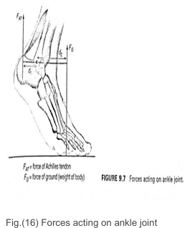
8-We now turn to the forces acting on the foot. First, there is the upward force of the ground acting on the toes or the ball of the foot, equal and opposite in direction to the person's weight. Second, the Achilles tendon exerts a force at an angle to the vertical, and third, the weight of the leg acts downward on the ankle. Let us now use some reasonable magnitudes for the forces concerned to find the force exerted by the Achilles tendon. We assume that it is at 30° to the vertical and denote the magnitude of its vertical component by Far as in Fig.(16) We represent the vertical force on the ball of the foot by F, and its line of action is d2 = 0.10 m from the ankle bone, which is acting as a pivot. Wesuppose the line of action of FAT is d1 = 0.05 m from the pivot. Taking moments about the ankle bone and assuming the ankle is in rotational equilibrium, we have that Fatd1 = Fgd2 [1] Assuming the weight of a person is 700 N and substituting the values of d1 and d2, equation [1] becomes Fat (0.05m)= 700 N (0.10cm) [2] Hence Fat = 1400 N [3] Which is a force twice as large as the person’s weight

Using rotational equilibrium about ankle bone pivot:
FAT × d1 = FG × d2
FAT × 0.05 = 700 × 0.10
FAT = 1,400 N (= 2 × body weight of 700 N) ✓

Problem 9 — Back Muscle Force on Spinal Column (Fig. 7-b)
9-Calculate the muscle force exerted on the spinal column Note that the gravitational torque on the object as a whole is the same as the gravitational torque exerted on a point mass with the same mass as the object located at the CM. Now going back to the man with a box, we note that the CM of the torso lies near the lower part of the chest. We can now calculate the torque exerted by gravity on the torso assuming that this is bending forward, as in Figure 9.8a, at a 90° angle to the ver- tidal and that the forearms are stretched downward. Drawing the free-body force diagram (see Fig.(7-b), we find that four forces are acting on the spinal column: 1. The gravitational force, Wt, acting on the CM of the torso. We assume that this lies at a distance Lcg = 0.42 m from the lower back and that its magnitude is 523 N. 2. The gravitational force on the box, Ws, which is transmitted by the arms and shoulders. We assume Ws = 140 N and Ls = 0.70 m. 3. The unknown force M exerted on the spinal column by the back muscle responsible for the lifting. We assume this force is applied at a distance d= 0.7Ls from the lower back at an angle a of about 12° above the horizontal. This is the force we wish to find. 4. An unknown compressive reaction force, N, exerted on the pivot in the lower back. Let ẞ be the angle between N and the horizontal.

Man bent 90° forward, forearms down. Four forces on spinal column:
• Wt = 523 N (torso weight) at Lcg = 0.42 m from lower back
• Ws = 140 N (box) at Ls = 0.70 m
• M = unknown back muscle force at d = 0.7×Ls = 0.49 m, angle α = 12° above horizontal
• N = reaction at pivot (lower back joint)
Taking torques about the lower back pivot (torso horizontal = 90°):
M × sin(12°) × 0.49 = Wt × 0.42 + Ws × 0.70
M × 0.2079 × 0.49 = 523 × 0.42 + 140 × 0.70
M × 0.1019 = 219.66 + 98.0 = 317.66
M = 317.66 / 0.1019 ≈ 3,118 N
Reaction force N (horizontal equilibrium):
Nx = M cos12° = 3118 × 0.9781 = 3050 N
Ny = M sin12° + Wt + Ws − M sin12° → Ny = Wt + Ws = 663 N
|N| = √(3050² + 663²) = √(9302500 + 439569) = √9742069
N ≈ 3,121 N (compressive force on lumbar spine)

Section 2: Air Pollution Control (أنظمة التحكم في تلوث الهواء)

Problem 1 — Particulate Matter Concentration (High-Volume Sampler) 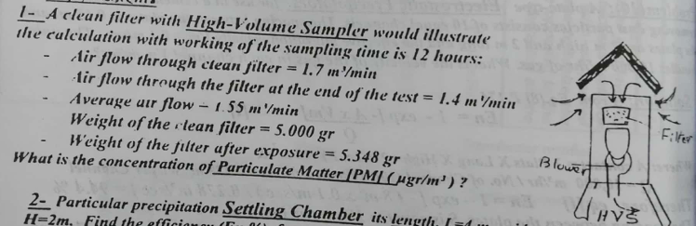
Given: Sampling time = 12 hrs, initial flow = 1.7 m³/min, final flow = 1.4 m³/min
Average flow = 1.55 m³/min, Filter weight (clean) = 5.000 g, Filter weight (exposed) = 5.348 g
Total volume sampled = Q_avg × t = 1.55 × (12 × 60) = 1.55 × 720 = 1,116 m³
Mass collected = 5.348 − 5.000 = 0.348 g = 348,000 μg
[PM] = Mass / Volume = 348,000 / 1,116
[PM] = 311.8 μg/m³ ≈ 312 μg/m³

Problem 2 — Settling Chamber Efficiency (Dp = 420 μm, n = 12 plates) 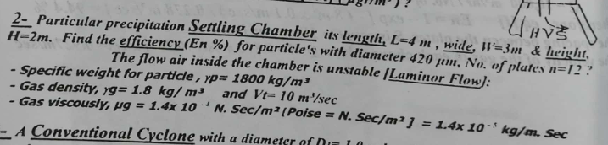
Given: L = 4 m, W = 3 m, H = 2 m, Dp = 420 μm, n = 12 plates, ρp = 1800 kg/m³, ρg = 1.8 kg/m³, μg = 1.4×10⁻⁴ N·s/m², Vt = 10 m³/s
Terminal (Stokes) settling velocity:
Vs = (ρp × Dp²× g) / (18 × μg) = (1800 × (420×10⁻⁶)² × 9.8) / (18 × 1.4×10⁻⁴)
Vs = (1800 × 1.764×10⁻⁷ × 9.8) / (2.52×10⁻³) = 3.111×10⁻⁴ / 2.52×10⁻³
Vs = 0.1235 m/s
With n+1 = 13 collection surfaces (12 plates + bottom):
En = (n+1) × Vs × L × W / Vt = 13 × 0.1235 × 4 × 3 / 10
En = 13 × 0.1235 × 12 / 10 = 19.3 / 10
En = 1.93 → 100% (particle fully collected, efficiency = 100%)

Problem 3 — Conventional Cyclone Collection Efficiency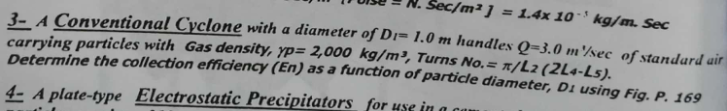
Given: D1 = 1.0 m, Q = 3.0 m³/s, ρp = 2000 kg/m³, Turns No. = π/L2 (2L4−L5).
For standard cyclone geometry, collection efficiency as a function of particle diameter uses the 50% cut-point:
Dc50 = √[9μg × B / (π × Ne × Vi × ρp)]
where B = inlet width ≈ D1/4 = 0.25 m, Vi = Q/(B×H) with H≈D1/2=0.5 m
Vi = 3.0 / (0.25 × 0.5) = 24 m/s
Ne (effective turns) ≈ 5 (standard cyclone)
Dc50 = √[9 × 1.81×10⁻⁵ × 0.25 / (π × 5 × 24 × 2000)]
Dc50 = √[4.0725×10⁻⁵ / 753,982] = √(5.4×10⁻¹¹) = 7.3 μm
Cut-point D50 ≈ 7.3 μm. Particles > 15 μm: ~90%+ collection; particles < 2 μm: <10%.

Problem 4 — Electrostatic Precipitator (Cement Plant) 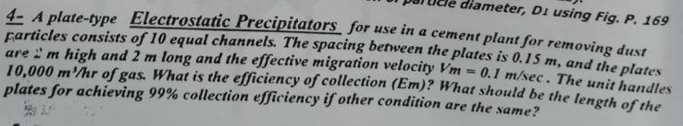
Given: 10 channels, spacing = 0.15 m, height = 2 m, length = 2 m, Vm = 0.1 m/s, Q = 10,000 m³/hr = 2.778 m³/s
Plate area per channel: A = 2 × L × H = 2 × 2 × 2 = 8 m² (both sides); total A = 10 × 8 = 80 m²
Deutsch-Anderson: Em = 1 − exp(−Vm × A / Q)
Em = 1 − exp(−0.1 × 80 / 2.778) = 1 − exp(−2.88)
Em = 1 − 0.0561 = 0.944 = 94.4%
For 99% efficiency:
0.99 = 1 − exp(−0.1 × A / 2.778) → ln(0.01) = −0.1A/2.778
A = 4.6052 × 2.778 / 0.1 = 127.9 m²
Required plate length L = A / (2 × H × n) = 127.9 / (2×2×10) = 3.2 m

Problem 5 — Cyclone Efficiency (D = 0.5 m, Q = 0.4 m³/s) 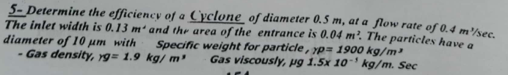
Given: D = 0.5 m, Q = 0.4 m³/s, inlet width B = 0.13 m, inlet area = 0.04 m², ρp = 1900 kg/m³, ρg = 1.9 kg/m³, μg = 1.5×10⁻⁴ kg/m·s, Dp = 10 μm
Vi = Q / Ain = 0.4 / 0.04 = 10 m/s
Ne ≈ 5 turns (standard)
Dc50 = √[9 × 1.5×10⁻⁴ × 0.13 / (π × 5 × 10 × 1900)]
Dc50 = √[1.755×10⁻⁴ / 298,451] = √(5.88×10⁻¹⁰) = 24.2 μm
Efficiency at Dp = 10 μm using the ratio x = Dp/Dc50 = 10/24.2 = 0.413:
En = x² / (1 + x²) = 0.170 / 1.170
En = 14.6% (low efficiency for 10 μm at this cut-point)

Problem 6 — ESP Plate Depth for 0.5 μm Particles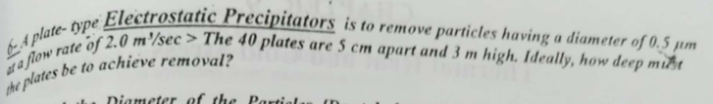
Given: Dp = 0.5 μm, Q = 2.0 m³/s, 40 plates, spacing = 5 cm = 0.05 m, height = 3 m
For 0.5 μm particles, migration velocity Vm is very low. Using Stokes with electric field:
(Conceptual: very small particles need very long plates or high voltage. Ideally solve for L using Deutsch equation with assumed Vm ≈ 0.01 m/s for sub-micron particles)
A required = −Q/Vm × ln(1−Em); for full removal Em→1 (ideally)
Number of collecting channels = 40 plates → 39 channels
Total plate area A = 2 × L × H × 39 = 2 × L × 3 × 39 = 234L
For 99%: 234L = −(2.0/0.01)×ln(0.01) = 200 × 4.605 = 921
L ≈ 3.9 m (minimum plate depth required)

Problem 7 — Minimum Particle Diameter Removed from Settling Chamber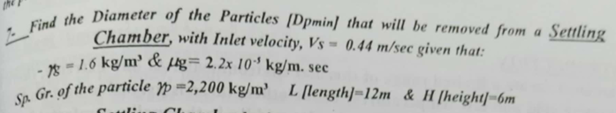
Given: Vs = 0.44 m/s, ρs = 1.6 kg/m³, μg = 2.2×10⁻⁵ kg/m·s, ρp = 2200 kg/m³, L = 12 m, H = 6 m
Minimum settling velocity: Vs_min = Vt × H / L = 0.44 × 6 / 12 = 0.22 m/s
Dpmin = √[18 × μg × Vs_min / (ρp × g)] = √[18 × 2.2×10⁻⁵ × 0.22 / (2200 × 9.8)]
Dpmin = √[8.712×10⁻⁵ / 21560] = √(4.04×10⁻⁹) = 6.36×10⁻⁵ m
Dpmin = 63.6 μm

Problem 8 — Multi-Tray Settling Chamber (11 trays) 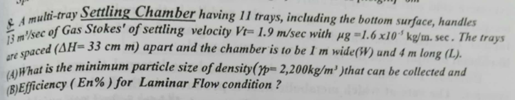
Given: 11 trays (including bottom), Q = 13 m³/s, Vt = 1.9 m/s, μg = 1.6×10⁻⁵ kg/m·s, ΔH = 33 cm = 0.33 m, W = 1 m, L = 4 m, ρp = 2200 kg/m³
(A) Minimum particle size collected:
Vs_min = Vt × ΔH / L = 1.9 × 0.33 / 4 = 0.157 m/s
Dpmin = √[18μg × Vs_min / (ρp × g)] = √[18 × 1.6×10⁻⁵ × 0.157 / (2200 × 9.8)]
= √[4.522×10⁻⁵ / 21560] = √(2.098×10⁻⁹) = 4.58×10⁻⁵ m
(A) Dpmin ≈ 45.8 μm
(B) Efficiency for laminar flow:
En = (n × Vs × L × W) / Q = (11 × 0.157 × 4 × 1) / 13 = 6.908 / 13
(B) En = 53.1%

Problem 9 — Number of Bag Filters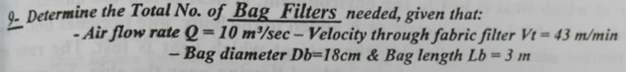
Given: Q = 10 m³/s, Vt (filter velocity) = 43 m/min = 0.717 m/s, Db = 18 cm = 0.18 m, Lb = 3 m
Area per bag = π × Db × Lb = π × 0.18 × 3 = 1.696 m²
Total area required = Q / Vt = 10 / 0.717 = 13.95 m²
Number of bags = 13.95 / 1.696
N = 8.2 → 9 bags minimum

Problem 10 — ESP Plate Area for 98% Efficiency
Given: En = 98%, Vt (drift velocity) = 1.6 m/s, Q = 16 m³/s
Deutsch: En = 1 − exp(−Vm × A / Q)
0.98 = 1 − exp(−1.6 × A / 16)
ln(0.02) = −1.6A/16 → −3.912 = −0.1A
A = 39.1 m²

Problem 11 — ESP Scale-Up (Q = 155 m³/s) 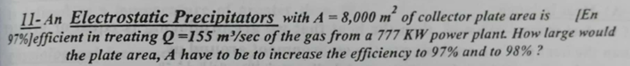
Given: Existing A = 8000 m², Q = 155 m³/s, current En = 97%
Current Vm: 0.97 = 1 − exp(−Vm × 8000/155) → ln(0.03) = −51.6Vm
Vm = 3.507/51.6 = 0.0680 m/s
For 97% (same):
A = 8,000 m² (unchanged)
For 98%:
0.98 = 1 − exp(−0.0680 × A / 155) → A = ln(0.02)×155/(−0.0680)
A = 8,918 m² ≈ 8,920 m²

Section 3: Industrial Accidents & Work Injuries (الحوادث الصناعية)

Problem 1-B — Statistical Safety Analysis (Metal Industry, Apr–Aug 2024)
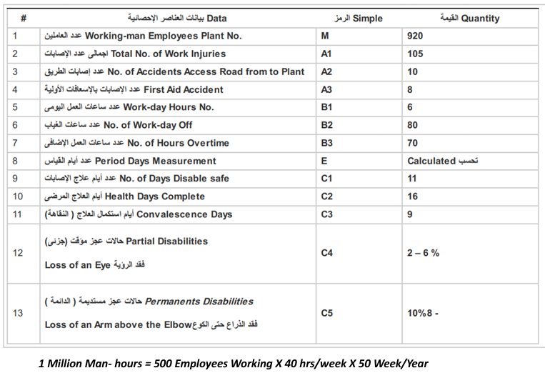
Required : A) Injury [Accident ] Frequency Rate (T) , Morbid / Million Work Hours, and Injury [ Disabling ] Severity Rate (M) , Disable / Million Work Hours & Safety Performance Index (SPI) and Accident Rate (AR) B) Program Solution & Flow Chart and Discuss Report [Tables (2-5)]

Given data: M = 920 workers, A1 = 105 total injuries, A2 = 10 (road), A3 = 8 (first aid),
B1 = 6 hrs/day, B2 = 80 absent days, B3 = 70 overtime hrs,
Period = 5 months (Apr 1 – Aug 31), C1 = 11, C2 = 16, C3 = 9
C4 = 2–6% partial disability, C5 = 8–10% permanent disability.

Step 1 — Total Hours Worked (E = period days):
Working days in 5 months ≈ 5 × 22 = 110 days
Total man-hours = M × B1 × Days − Absent hrs + Overtime
= 920 × 6 × 110 − (920 × B2) + (920 × B3)
= 606,720 − 73,600 + 64,400 = 597,520 hrs

Disabling injuries = A1 − A2 − A3 = 105 − 10 − 8 = 87

Injury Frequency Rate (T):
T = (Disabling Injuries / Total Man-Hours) × 10⁶
T = (87 / 597,520) × 10⁶
T = 145.6 injuries / million man-hours

Lost days calculation:
Lost days = C1 + C2 + C3 = 11 + 16 + 9 = 36 calendar days
Partial disability (C4): take 4% average × standard 300 days = 12 days
Permanent disability (C5): take 9% × standard 6000 days = 540 days
Total charge days = 36 + 12 + 540 = 588 days

Injury Severity Rate (M):
M = (Charge Days / Total Man-Hours) × 10⁶
M = (588 / 597,520) × 10⁶
M = 984.1 days / million man-hours

Safety Performance Index (SPI):
SPI = T × M = 145.6 × 984.1
SPI = 143,285 ≈ 1.43 × 10⁵

Accident Rate (AR):
AR = (A1 / M_workers) × 100 = (105 / 920) × 100
AR = 11.4%

Problem 2 — Statistical Safety (1500 workers, 1/2 year) 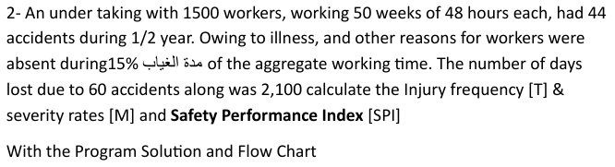
Given: 1500 workers, 50 weeks/year → 25 weeks in ½ year, 48 hrs/week, 15% absence, 44 accidents, 2100 lost days from 60 accidents.

Total scheduled hours = 1500 × 25 × 48 = 1,800,000 hrs
Absent hours = 15% × 1,800,000 = 270,000 hrs
Actual hours worked = 1,800,000 − 270,000 = 1,530,000 hrs

Injury Frequency Rate (T):
T = (44 / 1,530,000) × 10⁶
T = 28.76 injuries / million man-hours

Injury Severity Rate (M):
M = (2100 / 1,530,000) × 10⁶
M = 1372.5 days / million man-hours

Safety Performance Index (SPI):
SPI = T × M = 28.76 × 1372.5
SPI = 39,472 ≈ 3.95 × 10⁴
Parameter | Problem 1 (Metal/Mining) | Problem 2 (1500 workers)
Total Hours Worked | 597,520 hrs | 1,530,000 hrs
Disabling Injuries | 87 | 44
Frequency Rate T | 145.6 inj/10⁶ hrs | 28.76 inj/10⁶ hrs
Severity Rate M | 984 days/10⁶ hrs | 1,372 days/10⁶ hrs
SPI | 143,285 | 39,472
Accident Rate AR | 11.4% | —

Section 4: Noise (الضوضاء)

Problem 4 — Sound Levels from Voice (P = 0.001 W at r = 6 m)
Sound Intensity: I = P / (4πr²) = 0.001 / (4π × 36) = 2.21×10⁻⁶ W/m²
Sound Intensity Level: LI = 10 log(I/I₀) = 10 log(2.21×10⁻⁶ / 10⁻¹²)
LI = 10 log(2.21×10⁶) = 10 × 6.344 = 63.4 dB
Sound Pressure: p = √(I × ρc) = √(2.21×10⁻⁶ × 415) = √(9.17×10⁻⁴) = 0.0303 Pa
LP = 20 log(p/p₀) = 20 log(0.0303/2×10⁻⁵) = 20 log(1515) = 63.6 dB
Sound Power Level: LW = 10 log(P/P₀) = 10 log(0.001/10⁻¹²) = 10 × 9 = 90 dB
LI = 63.4 dB, LP = 63.6 dB, LW = 90 dB

Problem 5 — Chiller (92 dB) & Compressor (93 dB), 3×2hr + 2hr
Using OSHA permissible exposure times (T allowed): 92 dB → 6 hrs, 93 dB → 4 hrs (OSHA 90 dB base, 5 dB exchange rate is OSHA; CHABA uses 85 dB/3 dB).
OSHA Check:
Dose D = Σ(Ci/Ti) = (3×2)/6 + 2/4 = 6/6 + 2/4 = 1.00 + 0.50 = 1.50
D = 1.50 > 1 → OSHA limit NOT MET (corrections mandatory)
CHABA Check (85 dB base, 3 dB exchange): T(92dB) = 1 hr, T(93dB) = 0.794 hr
D_CHABA = 6/1 + 2/0.794 = 6 + 2.52 = 8.52 >> 1
CHABA limit also NOT MET

Problem 6 — Noise Dose (105 dB(A), 8-hr shift)
OSHA: T_allowed at 105 dB = 1 hr
Dose D = 8 / 1 = 8 (800% dose)
Noise Exposure Dose = 800% (far exceeds 100% limit)

Problem 7 — Noise Dose (107 dB(A), 7-hr shift)
OSHA: T_allowed at 107 dB = 0.5 hr
Dose D = 7 / 0.5 = 14.0 (1400% dose)
Noise Dose = 1400% (extreme overexposure)

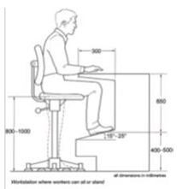
Section 5: Material Handling (المناولة)

Question 3 — Identify Figures

Fig. (Upper right — seated workstation): Ergonomically designed VDT/computer workstation showing proper seated posture. Dimensions shown (300 mm desk depth, 880 mm height, 400–500 mm seat range, 800–1000 mm foot clearance, 15–25° monitor angle). This represents an adjustable sit-stand workstation compliant with ergonomic standards.
Fig. (A) — Three figures showing progressive lifting postures:
• Left figure: Correct squat lift — knees bent, back straight, load close to body. This is the recommended NIOSH safe lifting technique.
• Middle figure: Partial squat with object at knee height — transition phase.
• Right figure: Upright carry position — load held close to body's center of gravity.
Fig. (B) (if separate): Shows incorrect vs correct posture or a different handling technique for comparison.

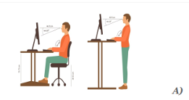
Section 6: Workshop Planning (أنظمة تخطيط الورش)

Question 10 — Result Discussion for Workshop Layout Figures
Fig. A (Sit-Stand Workstation — Computer): Shows a worker alternating between sitting and standing at a computer workstation. Ergonomic benefit: reduces static muscle loading, lowers risk of musculoskeletal disorders. The standing posture (right figure) reduces lumbar disc pressure compared to prolonged sitting. Recommended: 50/50 sit/stand ratio or adjust every 30–60 min.
Fig. B (Seated Microscope/Precision Work): Two postures at a microscope bench. Left: poor posture with trunk flexion and neck extension — leads to cervical and lumbar strain. Right: improved posture with adjustable seat height, footrest support, and monitor/eyepiece at eye level. Key recommendation: ensure eye height matches instrument height to avoid neck flexion > 20°.
Fig. C (Standing Machine Operation — Left vs Seated): Left figure shows standing operation of a lathe/machine tool — acceptable for short tasks but fatiguing for prolonged periods. Right figure shows seated operation with adjustable stool and proper reach envelope. Recommendation: provide anti-fatigue mats for standing workers; seat height should allow feet flat on floor/footrest with thighs parallel.

