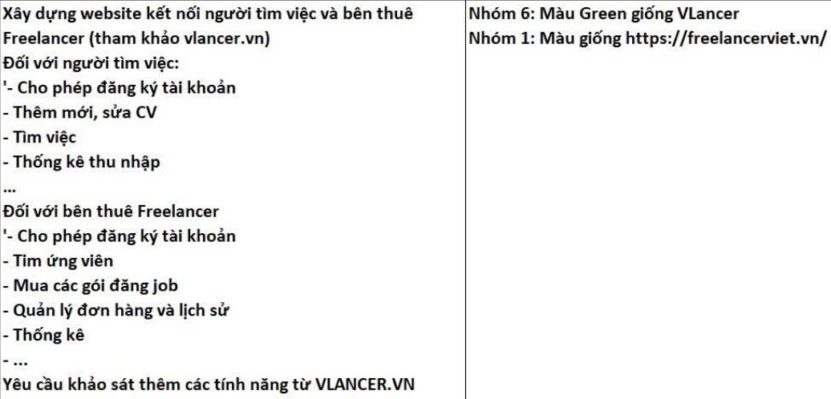
+ User() | - userID  - userName  - userCode  - userPhone  - userMail  - nameUserAccount  - passUsserAccount  - registration date  - status
+ UserRole() | - userID  - userCode  - userRol  - nameRole
+ Role() | - userCode  - nameRole
+ profileFreelancer() | - profileID  - userID  - birthday  - gender  - address  - experienceYear  - eduction  - hoouylyRate  - totalEarnings  - rating  - cvID  - jobID
+CV() | - cvID  - profileID  - jobID  - status  - timeCreate  - skillID_name
+SkillUser() | - id  - name
+employerProfile() | - emloyerID  - userID  - companyName  - companySize  - companyDescription  - taxCode  - address  - rating
+ jobCategory() | - categoryID  - categoryName
+ job() | - jobID  - employerID  - categoryID  - description  - budget_min_max  - deadline  - experienceRequired  - status  - timeCreate
+ jobSkill() | - id  - jobID  - skillID
+ proposal() | - proID  - jobID  - frelancerID  - coverLetter  - status  - createTime  - messge
+ Contract() | - contractID  - jobID  - freelanceID  - employID  - price  - timework(start end)  - status
+ Payment() | - paymentID  - contractID  - amount  - paymentMethor  - maymentStatus  - time
+ paymentMethor | - paymetID  - methorID
+ transactionHistory() | - tranID  - methortID  - amount  - description  - createTime
+ packageEmployer() | - pacID  - pacName  - phone  - adreess  - username  - userID  - price
+ review() | - rewID  - contracID  - userID  - rating  - comment  - creatTime
+ conversation() | - conID  - createTime  - felanceID  - empoyID  - messageID
+ message() | - messageID  - converID

