SLAB Assignment 3 - First Sprint

Description:
Business task organizer for the Academic Program Managers, separated into different categories including, but not limited to: importance, due date, department, quarter, task difficulty, estimated time to complete, task lead, and notes. The software will be used as a central location that houses key information regarding the Academic Program Managers’ job responsibilities and helping onboard potential new hires.

User Stories:
As a ____, I need _____ so that _____.

- As a user, I need a landing page so that I can easily navigate the site.
- As a user, I need a login feature so that I can securely access the site.
- As a user, I need a table view so that I can view my assigned tasks.

Task | Corresponding Story # | Duration | Priority (1-Lowest 10-Highest) | Complexity (Low- Average- High) | Lead Person
Create remote repo (GitHub) | 1 | 30 Minutes | 10 | Low | Lizzy
Track Burndown Chart Throughout Sprint | All | 4 Hours | 10 | Average | Anna
JustinMind Prototype (Landing Page) | 1 | 2 Hours | 9 | Average | Stephanie
JustinMind Prototype (Table View) | 3 | 2 Hours | 5 | Average | Stephanie
Create an HTML Landing Page | 1 | 1 Hour | 10 | Average | Brady
Add Java features to Landing Page | 1 | 2 Hour | 7 | High | Brady
CSS Design File (Landing) | 1 | 2 Hours | 4 | Average | Anna
CSS Design File (Table View) | 3 | 2 Hours | 3 | High | Anna
User Verification (Login) | 2 | 3 Hours | 9 | High | Brady
Create Table View HTML File | 3 | 3 Hours | 5 | High | Lizzy
Input Sample Tasks (Table View) | 3 | 2 Hours | 3 | Average | Lizzy
Task Completed Check Boxes (Table View) | 3 | 2 Hours | 2 | High | Lizzy
Schedule a Client Meeting | All | 30 Minutes | 9 | Low | Anna
Troubleshooting / Debugging Prior to Client Meeting | All | 30 Minutes | 6 | Average | Anna/Stephanie
Prepare presentation for client meeting (include prototype) | All | 1 Hour | 8 | Low | Anna/Stephanie

Screenshots of Burndown Chart (Day 4, 9 (actual: 7), 14 (actual: 10)):
Day 4: SUBMIT
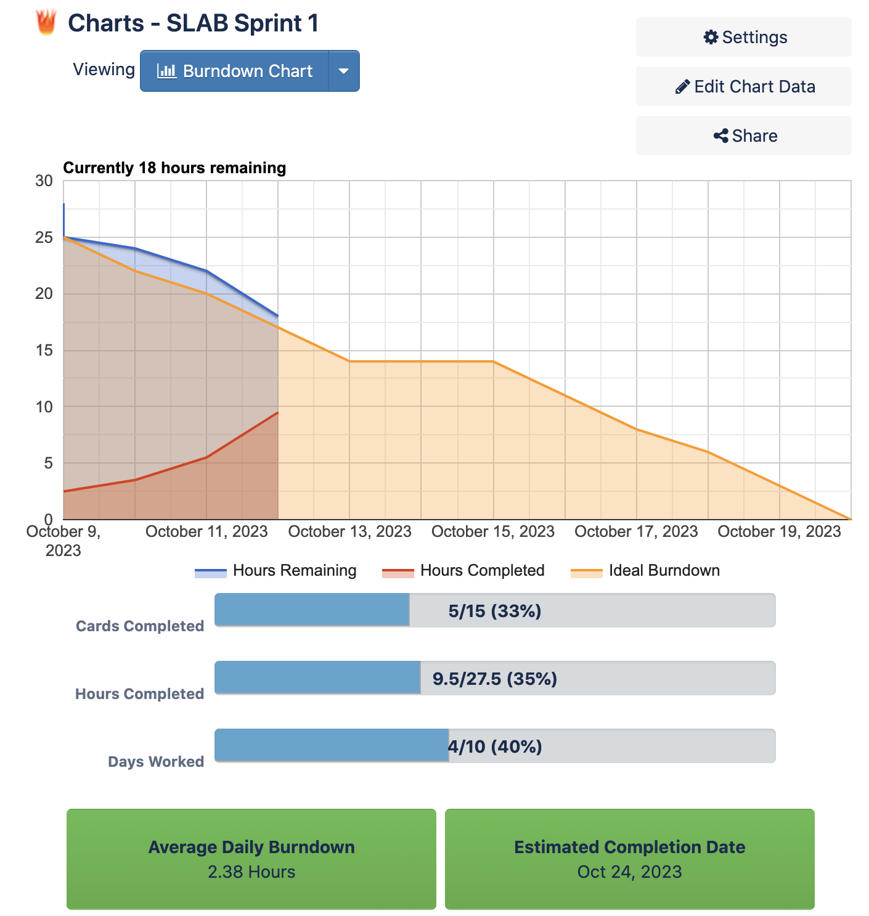
Day 7: SUBMIT
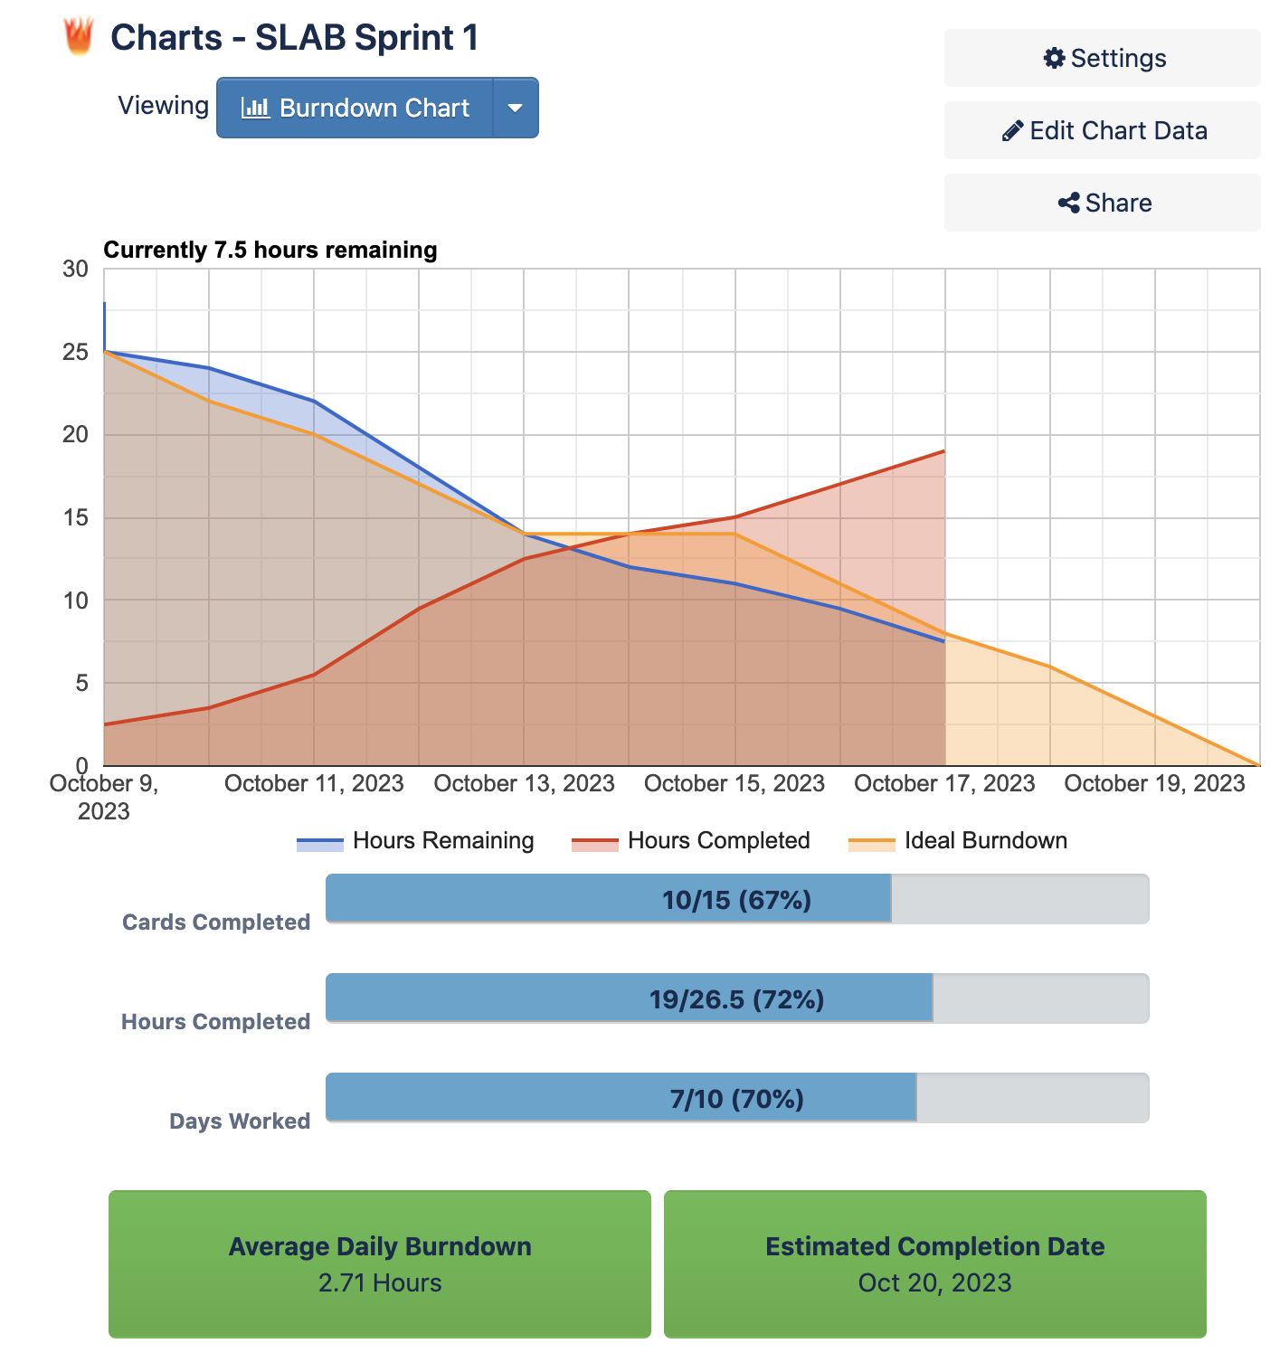
Day 10: SUBMIT
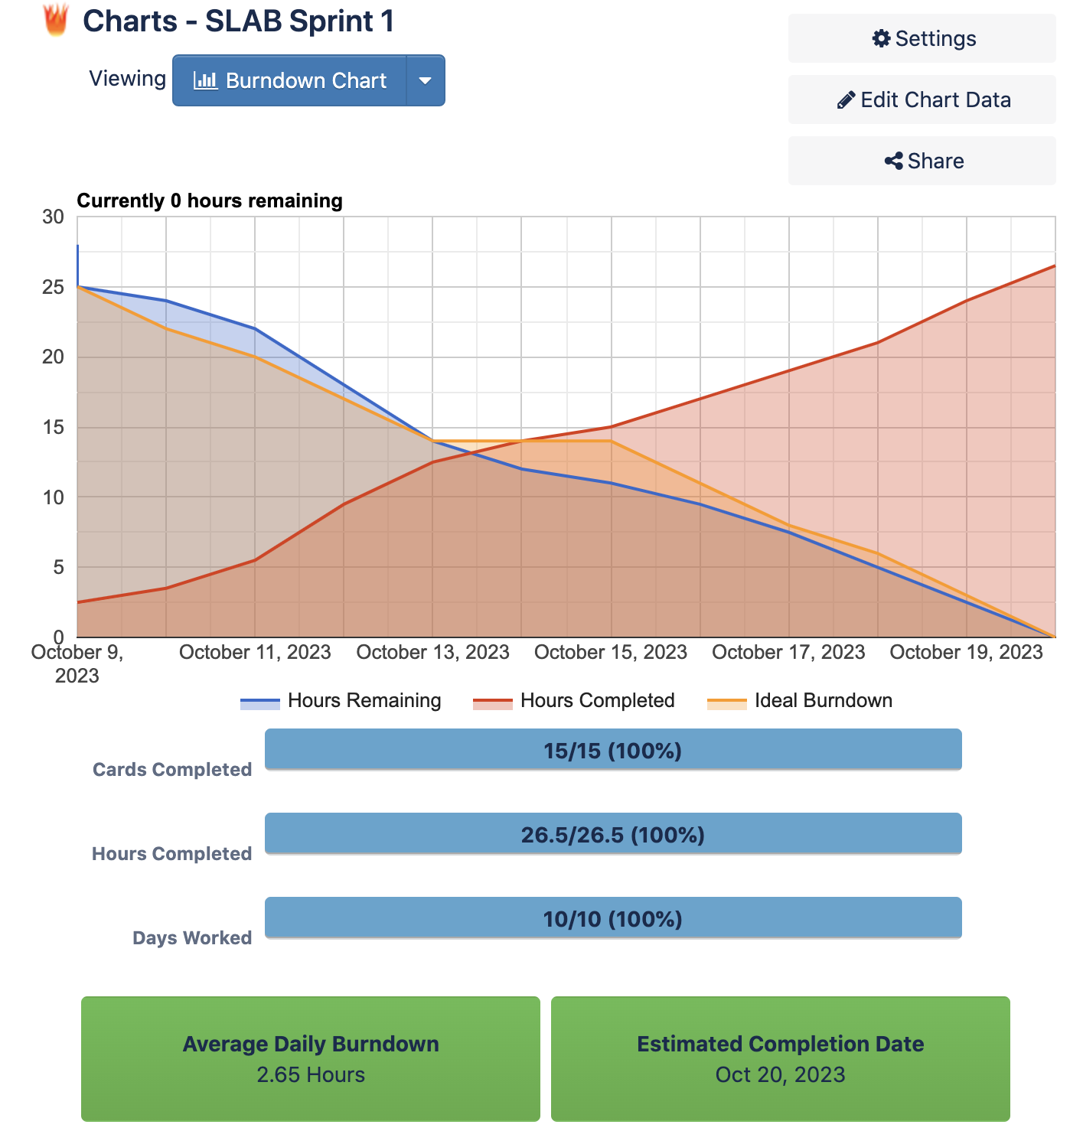

Trello Board (Link): https://trello.com/invite/b/V7PI4HWx/ATTId36d309381a46163195e24fe3af5f4bdF0ADDE86/slab-sprint-1

Repo (URL):
https://github.com/emander/TermProject

Evidence of 3 Stand-Up Meetings (Daily Scrum):
Day 1 (10/9):
- Anna
  - (Nothing to note from yesterday as the sprint began today (10/9))
  - Today, I edited the Trello Board to set some tasks in motion. I also edited the Burndown Chart to reflect this progress.
  - No issues faced today!
- Lizzy
  - (Nothing to note from yesterday as the sprint began today (10/9))
  - Today, I created the shared repo so we begin coding out website.
  - So far, I have faced no problems
- Stephanie
  - (Nothing to note from yesterday as the sprint began today (10/9))
  - Today, I created a prototype of the landing page using JustinMind.
  - No issues today.
- Brady
  - Today, I prepped my ideas as to how I want my work to come out.
  - Tomorrow I will create the Landing page
  - Thus far, I have not faced any problems.

Day 2 (10/10):
- Anna
  - Yesterday, I edited the Trello board to set some tasks in motion. I also edited the Burndown Chart to reflect this progress.
  - Today, I will showcase our progress on the Trello Board and Burndown Chart. I will begin to envision what our CSS file must contain to parallel our JustinMind prototype.
  - No problems faced thus far!
- Lizzy
  - Yesterday, I created the repo and added all group members as collaborators
  - Today, I will provide input/suggestion for the prototype and landing page
  - No problems faced
- Brady
  - Today, I created the HTML Landing page and added in images and needed buttons.
  - Tomorrow I will add in javascript features and prepare it for CSS design.
  - Thus far, I have not faced any problems.
- Stephanie
  - Yesterday, I created a prototype of the landing page using JustinMind.
  - Today, I will receive feedback on the prototype and make edits.
  - No issues today.

Day 3 (10/11):
- Lizzy
  - Yesterday, I reviewed the landing page
  - Today, I will review the prototype of the table view to start coding soon
  - No problems faced
- Anna
  - Yesterday, I showcased our progress on the Trello Board and corresponding Burndown Chart. I also began to envision what our CSS Landing Page File would look like to correspond to our JustinMind Prototype.
  - Today, I will begin to make progress on the CSS Landing Page File to parallel the design of the JustinMind prototype. I will also update the Trello Board and corresponding Burndown Chart.
  - Thus far, I have not faced any problems.
- Stephanie
  - Yesterday, I reviewed the prototype landing page done in JustinMind.
  - Today, I will start the table view prototype in JustinMind.
  - No issues today.
- Brady
  - Yesterday, I prepped my ideas for javascript features for friday.
  - Today, I am prepping more JS features.
  - Thus far, I have not faced any problems.

Sprint Review (Oct. 20th):
- What did you learn from doing our first sprint?
  - We learned how to operate as collaborators through GitHub and utilize version control to produce an optimal team deliverable. We also learned the importance of daily standup meetings to ensure everyone was staying on track and enable us to overcome obstacles in a team format. Finally, we gained a more holistic understanding of the SCRUM framework through this hands-on experience.
- What went well? Why?
  - We finished our work on time and did not face any major delays. We communicated well as a team and kept everyone in the loop as far as our individual progress. One of the keys to this success was the daily updates we would share with each other. Another aspect was our well planned schedule that we put in place to maximize our teams efficiency.
- What did not go well? Why not?
  - With the novelty of the SCRUM framework, there were a few hiccups that became learning opportunities. For example, remembering to commit to daily communication and completing daily edits of the SCRUM board came with time. Additionally, adapting to the “incremental” nature of the framework in remembering to only develop a basic draft of the system rather than a more comprehensive application.
- How can you make things better next time?
  - We can define individual feature scope more clearly.
  - We can think about our time constraints more thoroughly.
  - We could do a better job dividing up the work more evenly.
  - Spend more time brainstorming so that we have a more exhaustive list of tasks.
- Are you satisfied with what you already completed?
  - Yes, we feel satisfied with what we have already completed and feel prepared to plan tasks for our next sprint. We have accomplished the tasks that were planned to do within the time constraints that we set, so we feel that we are adequately prepared for the next sprint.
- Which group was invited? What are your observations/notes? Everybody was present?
  - Group 2 (Abby VanOoyen, etc.)
  - Everybody was present.
  - Notes:
    - “This all sounds really good. It seems like you guys learned a lot through this first sprint experience.”
    - “We ran into similar constraints throughout the whole project. It is nice to see that other groups struggled in a similar way.”

