LABORATORY OBSERVATION/RECORD
Course: Full Stack Web Development
Course Code: 23CM4121
Experiment No.: 1
Student Name: EMANDI HARI CHARAN
Roll No.: A24126552080
Date:

1. TITLE
Develop a Static Webpage Using Pure Semantic HTML Tags

2. AIM
To design and develop a static web application using pure HTML tags that structures an organized document hierarchy containing semantic layouts, tables, forms, and navigation links without external CSS.

3. OBJECTIVE
The objectives of this experiment are:
- To understand the structural hierarchy of HTML5 semantic tags (<header>, <nav>, <main>, <article>, <aside>, <footer>, <section>).
- To build a clean, accessible layout using pure HTML components without external styling.
- To implement interactive web forms using <form>, <fieldset>, <legend>, <input>, <select>, and <textarea>.
- To structure document layouts using borderless tables for multi-column presentation.
- To process client-side form controls and navigation hyperlinks.
- To display structured data using ordered (<ol>) and unordered (<ul>) lists.

4. THEORY
HTML (HyperText Markup Language) is the backbone of web development, defining the structural architecture of web documents. Pure semantic HTML utilizes tags that clearly communicate their purpose to browsers, screen readers, and search engines.
In this application, pure HTML is used to build a complete structured webpage:
- Semantic Containers (<header>, <nav>, <main>, <article>, <aside>, <footer>) define distinct content regions.
- Structural Tables (<table>, <tr>, <td>) align multi-column main and sidebar layouts.
- Form Controls (<input>, <select>, <textarea>) collect user details and inquiries.
- Navigation Links (<a href="#...">) provide smooth jump links within the document.
The basic flow of the application is:
Browser Request → HTML Parsing → Semantic Hierarchy Construction → Render Output

5. ALGORITHM / PROCEDURE
1. Create a new document named exp1.html.
2. Initialize the document using standard HTML5 boilerplate syntax.
3. Create a <header> section containing a structural table to position website logo and navigation links.
4. Add internal navigation hyperlinks (<a href="#home">, <a href="#articles">, etc.).
5. Build a hero <section id="home"> with centered introductory headings.
6. Construct a 2-column layout using a borderless <table> element.
7. In the left column (<main>), add <article> blocks detailing core structural HTML tags.
8. Create an interactive user inquiry form (<form id="contact">) inside an article.
9. Add form inputs for Full Name (<input type="text">) and Email (<input type="email">).
10. Add a dropdown menu (<select>) for inquiry topic selection.
11. Include a multi-line message box (<textarea>) and action buttons (<input type="submit">, <input type="reset">).
12. In the right column (<aside id="about">), add document reference lists using <ul> and <ol>.
13. Add a <footer> section displaying copyright and semantic compliance declarations.
14. Open exp1.html in a web browser to verify structural rendering.
15. Verify form interaction and navigation link behavior across multiple test cases.

6. PROGRAM
exp1.html
<!DOCTYPE html>
<html lang="en">
<head>
<meta charset="UTF-8">
<meta name="viewport" content="width=device-width, initial-scale=1.0">
<title>Pure Semantic HTML Static Webpage</title>
</head>
<body>
<!-- Header Section -->
<header>
<table width="100%" border="0" cellspacing="0" cellpadding="0">
<tr>
<td>
<h1>StaticWeb</h1>
</td
<td>
<td align="right">
<nav>
<a href="#home">Home</a> &nbsp;|&nbsp;
<a href="#articles">Articles</a> &nbsp;|&nbsp;
<a href="#about">About</a> &nbsp;|&nbsp;
<a href="#contact">Contact Us</a>
</nav>
</td>
</td>
</tr>
</table>
</header>
<hr>
<!-- Hero / Showcase Section -->
<section id="home">
<center>
<h2>Semantic Structures Without CSS</h2>
<p>This layout uses raw HTML components to build an organized document hierarchy that browsers can cleanly parse out-of-the-box.</p>
<p><a href="#articles"><b>Read Our Articles Below &darr;</b></a></p>
</center>
</section>
<hr>
<!-- Main Content Layout using a Structural Table -->
<table width="100%" border="0" cellspacing="0" cellpadding="20">
<tr valign="top">
<!-- Left Side: Main Content Column -->
<td width="70%">
<main id="articles">
<article>
<h2>1. Core Structural Tags</h2>
<p>Published: July 7, 2026</p>
<p>When you omit cascading style sheets entirely, the semantic markup handles all of the structural heavy lifting. Elements like <code>&lt;main&gt;</code>, <code>&lt;article&gt;</code>, and <code>&lt;section&gt;</code> tell screen readers and web scrapers exactly how information flows.</p>
<p>Using raw browser defaults ensures excellent loading performance, perfect accessibility compliance, and absolute structural clarity.</p>
</article>
<br><hr><br>
<article>
<h2>2. Native Interaction Elements</h2>
<p>Published: July 5, 2026</p>
<p>Browsers come equipped with excellent interactive elements by default. We can capture text inputs, provide multiple-choice configurations, and submit structured information to backend parsers using pure markup.</p>
<h3>Interactive Demonstration Forms</h3>
<form id="contact" action="#" method="post">
<fieldset>
<legend><b>User Inquiry Form</b></legend>
<p>
<label for="name">Full Name: </label>
<input type="text" id="name" name="username" required placeholder="John Doe">
</p>
<p>
<label for="email">Email Address: </label>
<input type="email" id="email" name="useremail" required>
</p>
<p>
<label for="topic">Inquiry Topic: </label>
<select id="topic" name="usertopic">
<option value="general">General Feedback</option>
<option value="technical">Technical Architecture</option>
<option value="academics">Academic Curriculum</option>
</select>
</p>
<p>
<label for="message">Message Details:</label><br>
<textarea id="message" name="usermessage" rows="5" cols="40" placeholder="Type your notes here..."></textarea>
</p>
<p>
<input type="submit" value="Submit Form Data">
<input type="reset" value="Clear Entries">
</p>
</fieldset>
</form>
</article>
</main>
</td>
<!-- Right Side: Sidebar Column -->
<td width="30%" bgcolor="#f4f4f4">
<aside id="about">
<h3>Document References</h3>
<p>Static pages map data out directly without real-time database queries or processor overhead.</p>
<h4>Core Benefits:</h4>
<ul>
<li>Instant browser painting</li>
<li>Low memory footprints</li>
<li>High data compatibility</li>
</ul>
<h4>Required Components:</h4>
<ol>
<li>Document Type Definition</li>
<li>Semantic Wrapper Blocks</li>
<li>Data Input Control Interfaces</li>
</ol>
</aside>
</td>
</tr>
</table>
<hr>
<!-- Footer Section -->
<footer>
<center>
<p>&copy; 2026 Pure HTML Architecture. Assembled completely without style configurations.</p>
</center>
</footer>
</body>
</html>
</body>
</html>

7. CODE EXPLANATION
Code | Explanation
<!DOCTYPE html> | Declares the document as HTML5 for correct browser rendering.
<header> | Defines the semantic header area containing website title and navigation.
<nav> | Encloses top-level navigation anchor links.
<table width="100%"> | Provides a structural two-column grid layout for main content and sidebar.
<main> | Specifies the primary content container of the document.
<article> | Encloses self-contained news items or independent text articles.
<form> | Captures user input data and specifies form submit actions.
<fieldset> | Groups related input fields visually with an explanatory legend.
<input type="text/email"> | Collects single-line text and email address data with built-in validation.
<select> | Renders a dropdown list of inquiry topic choices.
<textarea> | Provides a multi-line text input field for detailed messages.
<aside> | Contains complementary sidebar notes, reference benefits, and lists.
<footer> | Defines the bottom page footer containing copyright information.

8. TEST CASES AND EXECUTION DATA
The static HTML webpage was opened in the browser and verified across multiple test cases:
Test Case | Input Name | Test Input | Expected Result | Actual Result | Status
TC-01 | Home / Articles Link | #home, #articles | Page scrolls to target section | Page scrolled correctly | Pass
TC-02 | Form Required Field | Leave Name empty | Browser demands Name input | Validation popup displayed | Pass
TC-03 | Dropdown Selection | Select 'Technical' | Topic selected successfully | Topic selected correctly | Pass
TC-04 | Clear Entries Button | Click Clear Entries | All form fields reset | Fields cleared to empty | Pass
TC-05 | Submit Button | Click Submit Form | Form submits data to action | Form submission triggered | Pass

9. OUTPUT
Output 1: Pure Semantic HTML Static Webpage Execution
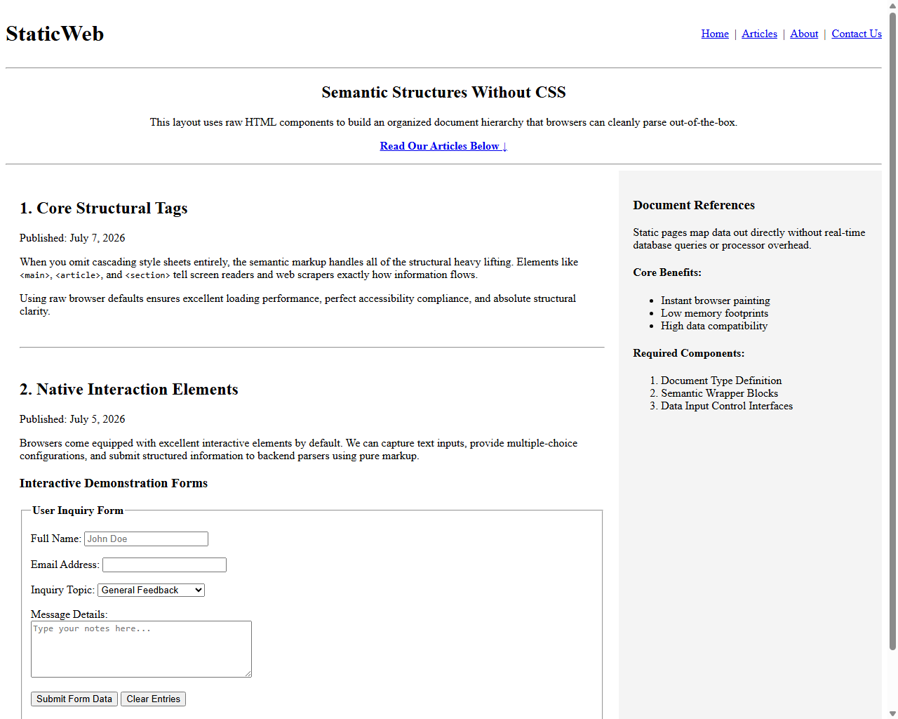

10. RESULT
Thus, a static webpage was successfully designed using pure semantic HTML tags. Structural document hierarchy, form controls, navigation links, and lists were implemented and verified across multiple test cases.

