LABORATORY OBSERVATION/RECORD
Course: Full Stack Web Development
Course Code: 23CM4121
Experiment No.: 2
Student Name: EMANDI HARI CHARAN
Roll No.: A24126552080
Date:

1. TITLE
Develop a Responsive Webpage Using HTML5 and CSS3

2. AIM
To develop a responsive Student Learning Portal using HTML5 and CSS3 styling with flexbox layouts, hover effects, CSS gradients, rounded borders, and media queries.

3. OBJECTIVE
The objectives of this experiment are:
- To understand CSS3 selectors, box model properties, and color specifications.
- To implement modern CSS linear gradients for header and welcome cards.
- To create flexible multi-column card layouts using CSS Flexbox (display: flex).
- To apply CSS hover animations (transform: scale, transition) for interactive UI elements.
- To style navigation bars, custom buttons, faculty cards, and footer sections.
- To implement media queries (@media) for responsive mobile screen adaptation.

4. THEORY
CSS3 (Cascading Style Sheets) enhances HTML elements with layout presentation, vibrant visual aesthetics, and responsive layout behavior across devices.
Key CSS3 features used in this Student Learning Portal application:
- Flexbox (display: flex) creates flexible row and column card containers.
- Linear Gradients (linear-gradient) generate vibrant color background headers.
- Box Shadows & Rounded Corners (box-shadow, border-radius) add visual depth.
- Hover Transitions (:hover, transform: scale) elevate user interactivity.
- Media Queries (@media (max-width: 700px)) adjust layout dynamically for mobile viewports.
The basic flow of the application is:
HTML Document + CSS Styling → CSS Box Model & Flex Layout Parsing → Responsive Browser Render

5. ALGORITHM / PROCEDURE
1. Create exp2.html and exp2.css files.
2. Link exp2.css inside exp2.html using <link rel="stylesheet" href="style.css">.
3. Structure the HTML document with <header>, <nav>, <main>, <section>, <article>, and <footer>.
4. In CSS, set global box-sizing: border-box and default font family.
5. Style <header> using a linear-gradient background, white centered text, and custom font sizes.
6. Style <nav> with a dark background (#17202a) and interactive link hover effects (color: #f1c40f).
7. Build a welcome banner section styled with vibrant orange-red linear gradient.
8. Create a course container using display: flex and gap: 20px for multi-column alignment.
9. Create three course cards (.python, .web, .ai) with custom background colors and rounded corners.
10. Add hover animation effect (.course:hover { transform: scale(1.05); transition: 0.3s; }).
11. Style faculty cards with left accent borders (border-left: 6px solid #1abc9c).
12. Style the contact section and footer with dark matching themes.
13. Add a media query (@media (max-width: 700px)) to stack course cards vertically on mobile screens.
14. Open exp2.html in a web browser to verify visual design.
15. Perform responsive screen test cases and verify hover interactions.

6. PROGRAM
exp2.html
<!DOCTYPE html>
<html lang="en">
<head>
<meta charset="UTF-8">
<meta name="viewport" content="width=device-width, initial-scale=1.0">
<title>Student Learning Portal</title>
<link rel="stylesheet" href="style.css">
</head>
<body>
<header>
<h1>Student Learning Portal</h1>
<p>Learn Today, Lead Tomorrow</p>
</header>
<nav>
<a href="#home">Home</a>
<a href="#courses">Courses</a>
<a href="#faculty">Faculty</a>
<a href="#contact">Contact</a>
</nav>
<main>
<section id="home" class="welcome">
<h2>Welcome Students!</h2>
<p>
Explore courses, meet our faculty and improve
your technical skills.
</p>
<button>Explore Now</button>
</section>
<section id="courses">
<h2>Our Courses</h2>
<div class="course-container">
<article class="course python">
<h3>Python Programming</h3>
<p>Learn Python programming from basics to advanced.</p>
</article>
<article class="course web">
<h3>Web Development</h3>
<p>Learn HTML, CSS and JavaScript to build websites.</p>
</article>
<article class="course ai">
<h3>Artificial Intelligence</h3>
<p>Explore AI, Machine Learning and modern technologies.</p>
</article>
</div>
</section>
<section id="faculty">
<h2>Our Faculty</h2>
<article class="faculty-card">
<h3>Dr. Ramesh Kumar</h3>
<p>Professor - Computer Science</p>
</article>
<article class="faculty-card">
<h3>Mrs. Priya Sharma</h3>
<p>Assistant Professor - Information Technology</p>
</article>
</section>
<section id="contact">
<h2>Contact Us</h2>
<p>Email: studentportal@gmail.com</p>
<p>Phone: 9876543210</p>
<p>Address: Visakhapatnam, Andhra Pradesh</p>
</section>
</main>
<footer>
<p>&copy; 2026 Student Learning Portal | All Rights Reserved</p>
</footer>
</body>
</html>

exp2.css
* {
margin: 0;
padding: 0;
box-sizing: border-box;
}
body {
font-family: Arial, sans-serif;
background-color: #f5f7ff;
color: #333;
}
/* Header */
header {
background: linear-gradient(135deg, #6a11cb, #2575fc);
color: white;
text-align: center;
padding: 40px;
}
header h1 {
font-size: 38px;
margin-bottom: 10px;
}
header p {
font-size: 18px;
}
/* Navigation */
nav {
background-color: #17202a;
padding: 18px;
text-align: center;
}
nav a {
color: white;
text-decoration: none;
margin: 0 25px;
font-size: 17px;
font-weight: bold;
}
nav a:hover {
color: #f1c40f;
}
/* Main */
main {
width: 85%;
margin: 30px auto;
}
/* Sections */
section {
background-color: white;
padding: 30px;
margin-bottom: 25px;
border-radius: 12px;
box-shadow: 0 4px 10px #d5d8dc;
}
section h2 {
text-align: center;
color: #6a11cb;
margin-bottom: 20px;
}
/* Welcome Section */
.welcome {
background: linear-gradient(135deg, #ff9966, #ff5e62);
color: white;
text-align: center;
}
.welcome h2 {
color: white;
font-size: 30px;
}
.welcome p {
margin-bottom: 20px;
font-size: 18px;
}
button {
background-color: #2ecc71;
color: white;
border: none;
padding: 12px 25px;
border-radius: 25px;
font-size: 16px;
cursor: pointer;
}
button:hover {
background-color: #27ae60;
}
/* Course Cards */
.course-container {
display: flex;
gap: 20px;
justify-content: center;
}
.course {
flex: 1;
padding: 25px;
color: white;
border-radius: 10px;
text-align: center;
}
.course h3 {
margin-bottom: 12px;
}
.python {
background-color: #3498db;
}
.web {
background-color: #e67e22;
}
.ai {
background-color: #9b59b6;
}
.course:hover {
transform: scale(1.05);
transition: 0.3s;
}
/* Faculty */
.faculty-card {
background-color: #e8f8f5;
padding: 20px;
margin: 15px 0;
border-left: 6px solid #1abc9c;
border-radius: 5px;
}
.faculty-card h3 {
color: #16a085;
margin-bottom: 8px;
}
/* Contact */
#contact {
background-color: #fff3cd;
}
#contact h2 {
color: #d68910;
}
#contact p {
margin: 10px 0;
}
/* Footer */
footer {
background-color: #17202a;
color: white;
text-align: center;
padding: 20px;
}
/* Responsive Design */
@media (max-width: 700px) {
main {
width: 95%;
}
.course-container {
flex-direction: column;
}
nav a {
display: block;
margin: 12px;
}
}

7. CODE EXPLANATION
Code | Explanation
linear-gradient() | Creates smooth color transitions for background headers and banners.
display: flex | Enables flexbox layout mode for course card containers.
gap: 20px | Sets consistent spacing between course cards.
border-radius | Rounds card corners for a modern, sleek UI appearance.
box-shadow | Applies shadow drop effects to section containers for visual depth.
:hover | Applies dynamic styles when mouse hovers over navigation links and buttons.
transform: scale() | Enlarges course cards smoothly during hover events.
@media (max-width: 700px) | Applies responsive styles when screen width is 700px or smaller.

8. TEST CASES AND EXECUTION DATA
Test Case | Feature Tested | Test Input | Expected Result | Actual Result | Status
TC-01 | Navigation Link Hover | Hover over Home/Courses | Link turns yellow (#f1c40f) | Link turned yellow | Pass
TC-02 | Course Card Hover | Hover over Python card | Card scales by 1.05x | Card scaled smoothly | Pass
TC-03 | Button Hover Effect | Hover over Explore button | Button darkens to green | Button color changed | Pass
TC-04 | Faculty Card Border | View Faculty section | Green left accent border | Accent border rendered | Pass
TC-05 | Mobile Responsive View | Resize screen < 700px | Flex cards stack vertically | Cards stacked in single column | Pass

9. OUTPUT
Output 1: Student Learning Portal Desktop Webpage Execution
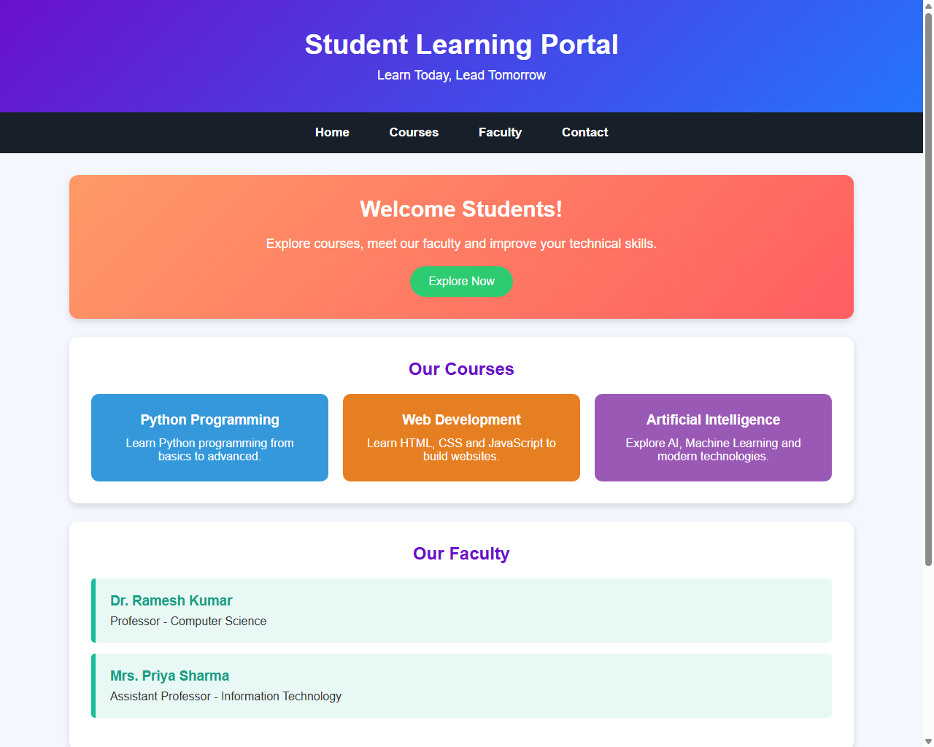

10. RESULT
Thus, a responsive Student Learning Portal webpage was successfully developed using HTML5 and CSS3. Flexbox layouts, hover effects, linear gradients, and responsive breakpoints were verified across multiple test cases.

