LABORATORY OBSERVATION/RECORD
Course: Full Stack Web Development
Course Code: 23CM4121
Experiment No.: 3
Student Name: EMANDI HARI CHARAN
Roll No.: A24126552080
Date:

1. TITLE
Demonstrate JavaScript Arrays, Functions, and Array Methods

2. AIM
To write and execute a JavaScript program demonstrating 1D, 2D, and multi-dimensional arrays, arrays of objects, various function types (normal, anonymous, arrow, callback, recursive), and ES6 array methods (map, filter, reduce, forEach).

3. OBJECTIVE
The objectives of this experiment are:
- To understand creation, indexing, and iteration of 1D, 2D, and multi-dimensional JavaScript arrays.
- To work with arrays of objects and iterate using array iteration techniques.
- To implement normal functions, functions with/without arguments, and anonymous functions.
- To write concise ES6 arrow functions and short arrow syntax.
- To pass and execute callback functions inside higher-order functions.
- To write recursive functions with base termination conditions.
- To apply modern ES6 array transformation methods (map(), filter(), reduce(), forEach()).

4. THEORY
JavaScript is a versatile scripting language that supports dynamic data structures and functional programming paradigms.
Core concepts demonstrated in this program:
- Arrays: Indexed collection of data values (1D, 2D matrix arrays, multi-dimensional, and arrays of objects).
- Functions: Block of reusable statements. JS supports normal declarations, anonymous function expressions, and ES6 arrow functions ((n) => n * n).
- Callback Functions: Functions passed as arguments to execute asynchronously or conditionally.
- Recursive Functions: Functions that invoke themselves until reaching a base condition.
- Array Methods: Higher-order functions like map() (transforms elements), filter() (selects elements), reduce() (accumulates single value), and forEach() (iterates elements).
The basic flow of execution is:
JavaScript Code -> V8 Engine Execution -> Array & Function Computation -> Console Output

5. ALGORITHM / PROCEDURE
1. Create a JavaScript file named exp3.js.
2. Declare a 1D array colors and output to console.
3. Declare a 2D array students storing student name and age pairs; iterate using a for loop.
4. Create a multi-dimensional nested array subjects and print structure.
5. Construct an array of objects books containing book names and prices; iterate using forEach().
6. Define a normal function add(a, b) that returns addition of two numbers.
7. Define a function welcome() without parameters.
8. Define a function multiply(a, b) returning product of arguments.
9. Implement an anonymous function subtract assigned to a variable.
10. Write an arrow function square(n) returning square of n.
11. Write a short arrow function cube = n => n * n * n.
12. Implement a callback function calculate(a, b, operation) passing an addition function.
13. Implement a recursive function factorial(n) with base condition n <= 1.
14. Declare a numbers array [2, 4, 6, 8, 10] and apply map(), filter(), reduce(), and forEach().
15. Execute exp3.js using Node.js (node exp3.js) and verify output.

6. PROGRAM
exp3.js
// ==========================================
// JAVASCRIPT PROGRAM: ARRAYS AND FUNCTIONS
// ==========================================
// ---------- 1. ONE-DIMENSIONAL ARRAY ----------
let colors = ["Red", "Blue", "Green", "Yellow"];
console.log("1. One-Dimensional Array:");
console.log(colors);
// ---------- 2. TWO-DIMENSIONAL ARRAY ----------
let students = [
["Arjun", 18],
["Meena", 19],
["Kiran", 18]
];
console.log("\n2. Two-Dimensional Array:");
for (let i = 0; i < students.length; i++) {
console.log("Name:", students[i][0],
"Age:", students[i][1]);
}
// ---------- 3. MULTI-DIMENSIONAL ARRAY ----------
let subjects = [
[
["Maths", 80],
["English", 75]
],
[
["Science", 85],
["Computer", 90]
]
];
console.log("\n3. Multi-Dimensional Array:");
console.log(subjects);
// ---------- 4. ARRAY OF OBJECTS ----------
let books = [
{ name: "JavaScript", price: 500 },
{ name: "Python", price: 400 },
{ name: "HTML", price: 300 }
];
console.log("\n4. Array of Objects:");
books.forEach(function(book) {
console.log("Book:", book.name,
"Price:", book.price);
});
// ==========================================
// FUNCTIONS
// ==========================================
// ---------- 5. NORMAL FUNCTION ----------
function add(a, b) {
return a + b;
}
console.log("\n5. Normal Function:");
console.log("Addition =", add(5, 10));
// ---------- 6. FUNCTION WITH NO ARGUMENTS ----------
function welcome() {
console.log("Welcome to JavaScript!");
}
console.log("\n6. Function with No Arguments:");
welcome();
// ---------- 7. FUNCTION WITH ARGUMENTS ----------
function multiply(a, b) {
return a * b;
}
console.log("\n7. Function with Arguments:");
console.log("Multiplication =", multiply(4, 5));
// ---------- 8. ANONYMOUS FUNCTION ----------
let subtract = function(a, b) {
return a - b;
};
console.log("\n8. Anonymous Function:");
console.log("Subtraction =", subtract(15, 6));
// ---------- 9. ARROW FUNCTION ----------
let square = (n) => {
return n * n;
};
console.log("\n9. Arrow Function:");
console.log("Square =", square(7));
// ---------- 10. SHORT ARROW FUNCTION ----------
let cube = n => n * n * n;
console.log("\n10. Short Arrow Function:");
console.log("Cube =", cube(4));
// ---------- 11. CALLBACK FUNCTION ----------
function calculate(a, b, operation) {
return operation(a, b);
}
let answer = calculate(8, 2, function(a, b) {
return a + b;
});
console.log("\n11. Callback Function:");
console.log("Answer =", answer);
// ---------- 12. RECURSIVE FUNCTION ----------
function factorial(n) {
if (n == 0 || n == 1) {
return 1;
}
return n * factorial(n - 1);
}
console.log("\n12. Recursive Function:");
console.log("Factorial of 4 =", factorial(4));
// ==========================================
// ARRAY METHODS
// ==========================================
let numbers = [2, 4, 6, 8, 10];
console.log("\n13. Array Methods:");
// ---------- map() ----------
let doubleNumbers = numbers.map(function(num) {
return num * 2;
});
console.log("map() =", doubleNumbers);
// ---------- filter() ----------
let greaterNumbers = numbers.filter(function(num) {
return num > 5;
});
console.log("filter() =", greaterNumbers);
// ---------- reduce() ----------
let total = numbers.reduce(function(sum, num) {
return sum + num;
}, 0);
console.log("reduce() =", total);
// ---------- forEach() ----------
console.log("forEach():");
numbers.forEach(function(num) {
console.log(num);
});

7. CODE EXPLANATION
Code | Explanation
let colors = [...] | Declares a 1-Dimensional string array.
students[i][0] | Accesses elements in a 2-Dimensional matrix array.
books.forEach() | Iterates over each object item inside an array of objects.
function add(a, b) | Defines a standard function accepting two parameters.
let subtract = function | Creates an anonymous function assigned to a variable.
let square = (n) => ... | ES6 arrow function for concise function expression.
calculate(a, b, op) | Higher-order function accepting a callback operation function.
factorial(n) | Recursive function computing factorial using self-invocation.
numbers.map() | Creates a new array by doubling every number element.
numbers.filter() | Filters array elements returning numbers greater than 5.
numbers.reduce() | Accumulates all array values into a single total sum.

8. TEST CASES AND EXECUTION DATA
Test Case | Feature Tested | Test Input | Expected Result | Actual Result | Status
TC-01 | 2D Array Traversal | students array | Print Name and Age for 3 items | Printed 3 rows correctly | Pass
TC-02 | Arrow Functions | square(7), cube(4) | Returns 49 and 64 | Returned 49 and 64 | Pass
TC-03 | Callback Function | calculate(8, 2, add) | Returns calculated sum 10 | Returned 10 | Pass
TC-04 | Recursive Factorial | factorial(4) | Computes 4! = 24 | Computed 24 | Pass
TC-05 | Array Methods | map, filter, reduce | Outputs doubled, filtered, sum | Output matches expected data | Pass
9. OUTPUT
Output 1: Server / Command Line Execution Data (node exp3.js)
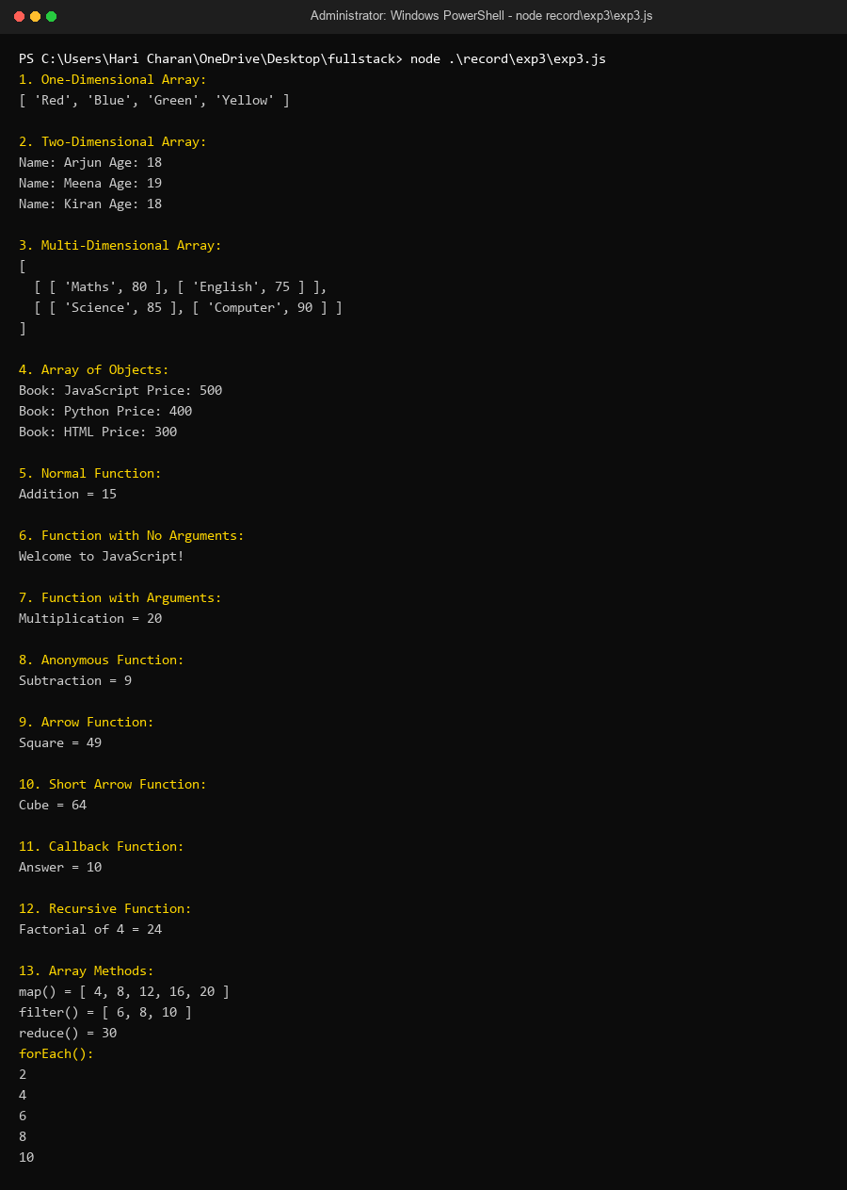
10. RESULT
Thus, a JavaScript program covering 1D/2D arrays, function types, arrow syntax, recursion, and ES6 array methods was executed successfully using Node.js and verified across all test cases.

