LABORATORY OBSERVATION/RECORD
Course: Full Stack Web Development
Course Code: 23CM4121
Experiment No.: 4
Student Name: EMANDI HARI CHARAN
Roll No.: A24126552080
Date:

1. TITLE
Dynamic Webpage Manipulation Using JavaScript DOM

2. AIM
To develop a dynamic webpage that modifies document content (innerHTML) and styling (style.backgroundColor) dynamically using JavaScript DOM manipulation methods and event handlers.

3. OBJECTIVE
The objectives of this experiment are:
- To understand the JavaScript Document Object Model (DOM) tree architecture.
- To select specific HTML elements dynamically using document.getElementById().
- To modify element text and HTML content dynamically using innerHTML.
- To manipulate CSS body background styling dynamically using document.body.style.
- To bind user interaction events (onclick) to custom JavaScript functions.
- To verify client-side interactive DOM updates without full page reloads.

4. THEORY
The DOM (Document Object Model) is an application programming interface for HTML documents. It represents web pages as a structured tree of objects that JavaScript can dynamically inspect and modify.
Key DOM properties and methods used:
- document.getElementById(id): Selects a unique DOM node by its ID attribute.
- innerHTML: Gets or updates the HTML content contained inside an element.
- style.backgroundColor: Directly updates inline CSS background color attributes.
- onclick Event: Triggers JavaScript function execution upon user mouse click.
The basic flow of the dynamic application is:
User Button Click → Event Trigger → JS Function Execution → DOM Element Update → Browser Re-paint

5. ALGORITHM / PROCEDURE
1. Create exp4.html and exp4.js files.
2. Structure exp4.html with a centered container card (<div class="box">).
3. Add a heading element <h1 id="title">Welcome</h1>.
4. Add a paragraph element <p id="message">Click a button to change the webpage.</p>.
5. Add two action buttons: Change Text and Change Color.
6. Bind button 1 click event to changeText() and button 2 click event to changeColor().
7. Link exp4.js script using <script src="exp4.js"></script>.
8. In exp4.js, write function changeText() to target #title and #message via document.getElementById().
9. In changeText(), update innerHTML of #title to 'Hello Students!' and #message to 'This is a Dynamic Webpage.'.
10. In exp4.js, write function changeColor() to update document.body.style.backgroundColor = '#ffe6cc'.
11. Open exp4.html in a web browser.
12. Observe the initial static state of the webpage.
13. Click Change Text button and verify text DOM updates.
14. Click Change Color button and verify dynamic background color change.
15. Verify dynamic interaction performance across test cases.

6. PROGRAM
exp4.html
<!DOCTYPE html>
<html lang="en">
<head>
<meta charset="UTF-8">
<meta name="viewport" content="width=device-width, initial-scale=1.0">
<title>Dynamic Webpage</title>
<style>
body {
font-family: Arial, sans-serif;
text-align: center;
background-color: #e8f4ff;
padding: 50px;
}
.box {
background-color: white;
width: 400px;
margin: auto;
padding: 30px;
border-radius: 10px;
box-shadow: 0 0 10px gray;
}
h1 {
color: #3366cc;
}
p {
font-size: 18px;
color: #444;
}
button {
background-color: #ff6600;
color: white;
border: none;
padding: 12px 20px;
margin: 10px;
border-radius: 5px;
cursor: pointer;
}
button:hover {
background-color: #cc5200;
}
</style>
</head>
<body>
<div class="box">
<h1 id="title">Welcome</h1>
<p id="message">
Click a button to change the webpage.
</p>
<button onclick="changeText()">
Change Text
</button>
<button onclick="changeColor()">
Change Color
</button>
</div>
<script src="exp4.js"></script>
</body>
</html>

exp4.js
// Function to change the text
function changeText() {
document.getElementById("title").innerHTML =
"Hello Students!";
document.getElementById("message").innerHTML =
"This is a Dynamic Webpage.";
}
// Function to change background color
function changeColor() {
document.body.style.backgroundColor = "#ffe6cc";
}

7. CODE EXPLANATION
Code | Explanation
document.getElementById() | Locates and returns the specific DOM element matching the specified ID.
innerHTML | Replaces the inner text/HTML content of the targeted DOM element.
document.body.style | Accesses the style object of the body element to mutate inline CSS.
onclick="changeText()" | Event handler binding mouse click to the changeText JavaScript function.
onclick="changeColor()" | Event handler binding mouse click to the changeColor JavaScript function.

8. TEST CASES AND EXECUTION DATA
Test Case | Feature Tested | Test Input | Expected Result | Actual Result | Status
TC-01 | Initial Load State | Load exp4.html | Displays Welcome & instruction | Rendered Welcome text | Pass
TC-02 | Change Text Button | Click Change Text | Heading updates to 'Hello Students!' | Heading updated correctly | Pass
TC-03 | Change Color Button | Click Change Color | Background turns light peach (#ffe6cc) | Background color changed | Pass
TC-04 | Combined Interactions | Click both buttons | Text and background update together | Both DOM updates applied | Pass

9. OUTPUT
Output 1: Initial Page Render State


Output 2: State After Clicking 'Change Text' Button



Output 3: State After Clicking 'Change Color' Button

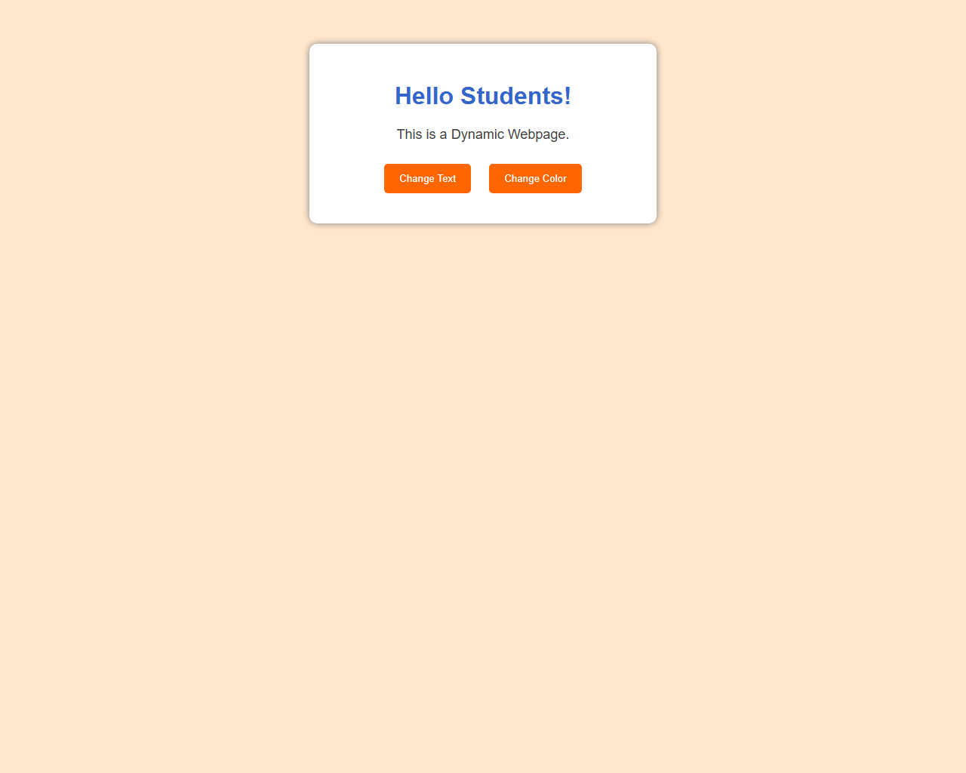

10. RESULT
Thus, a dynamic webpage manipulating DOM element text content (innerHTML) and CSS body background color via interactive click event handlers was successfully developed and verified across all test cases.

