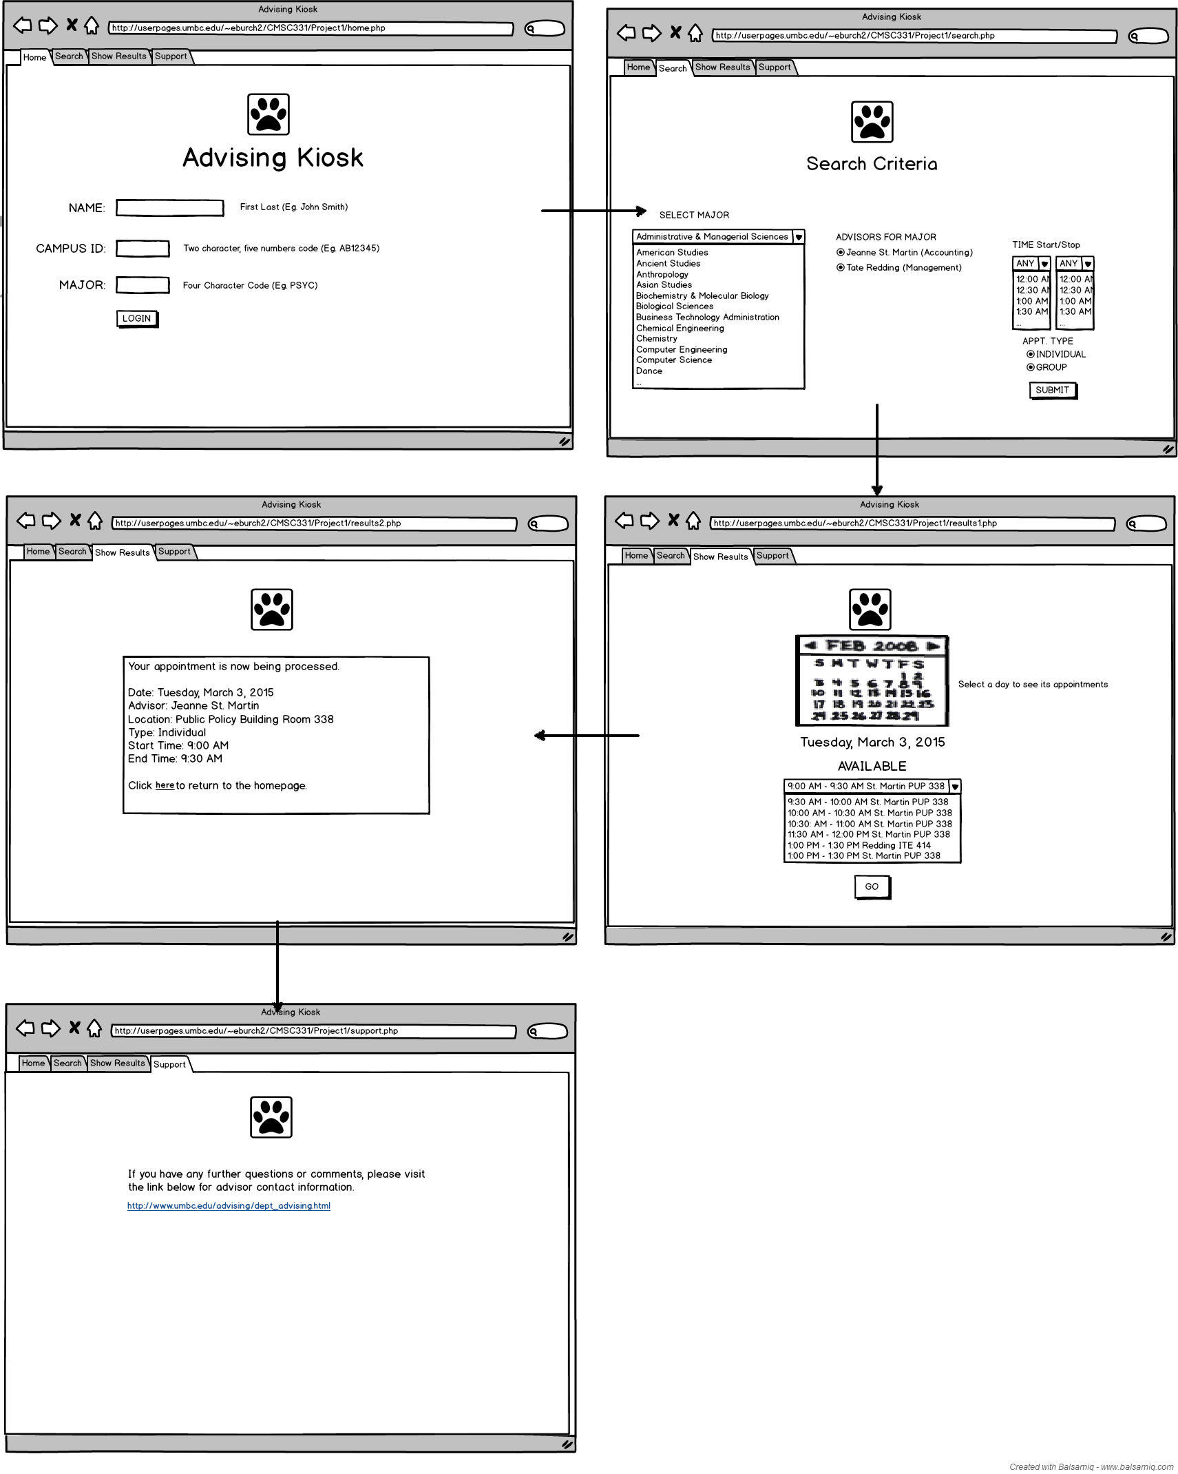

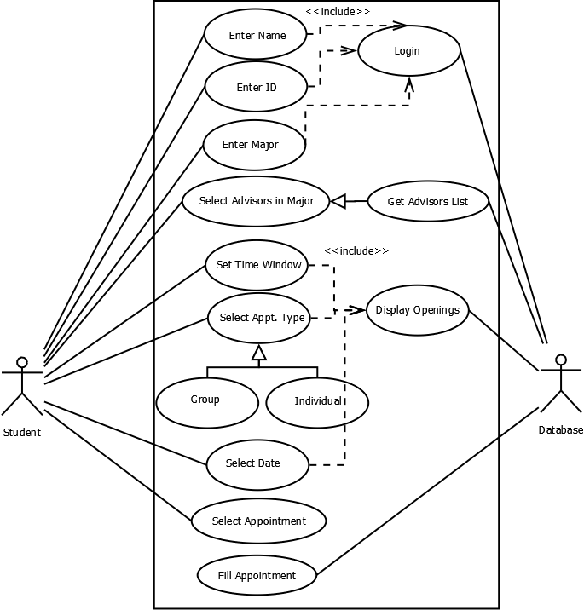

Challenges: It was very difficult learning how to send data from one page to another. I also found that I needed to learn CSS to properly align objects. I also found that event programming was difficult when passing arrays to other pages, making me learn serialization. Overall, the amount of work I had to learn outside of the classroom was a lot more than expected.

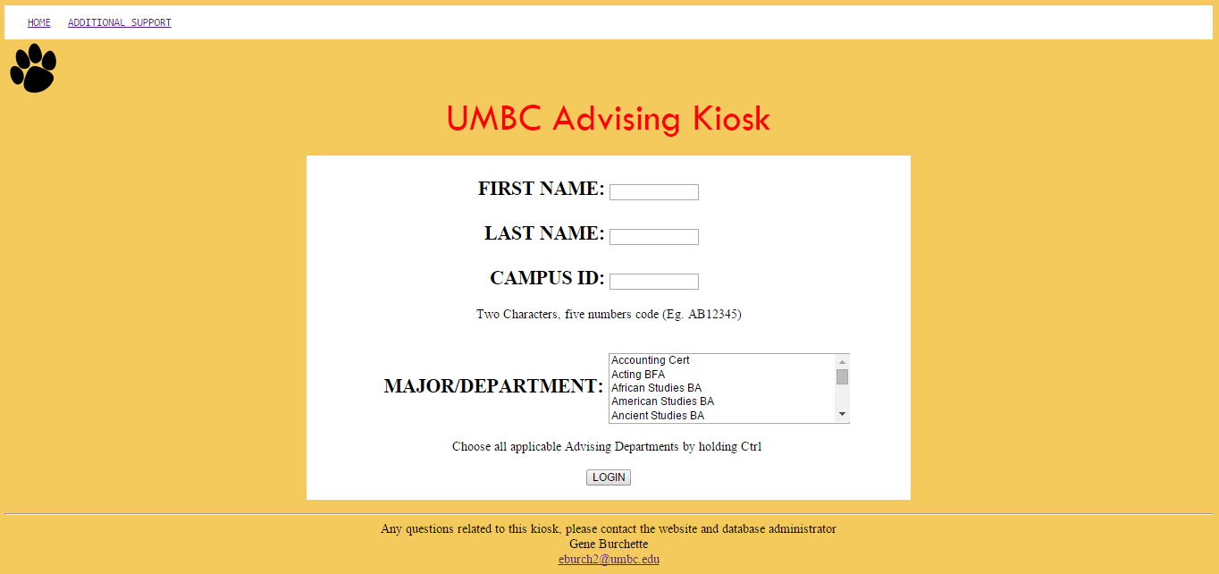

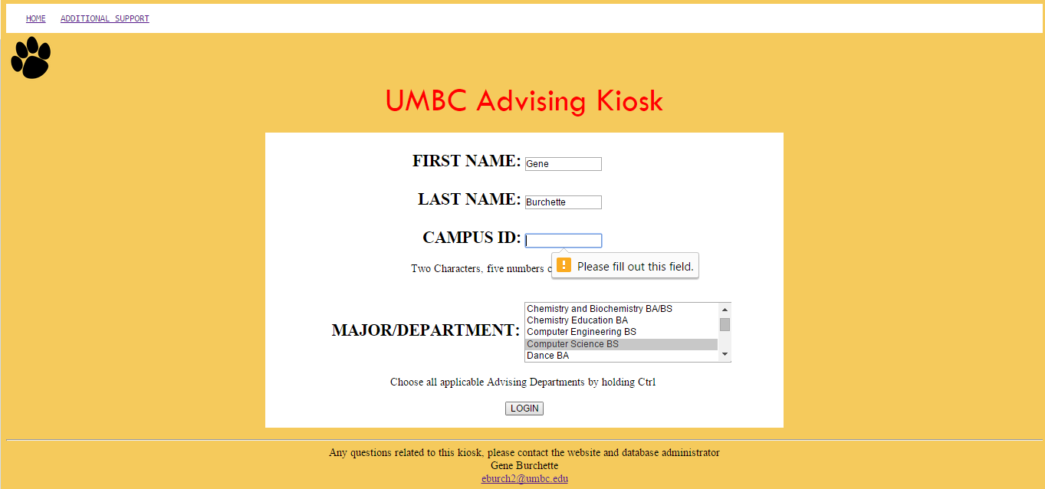

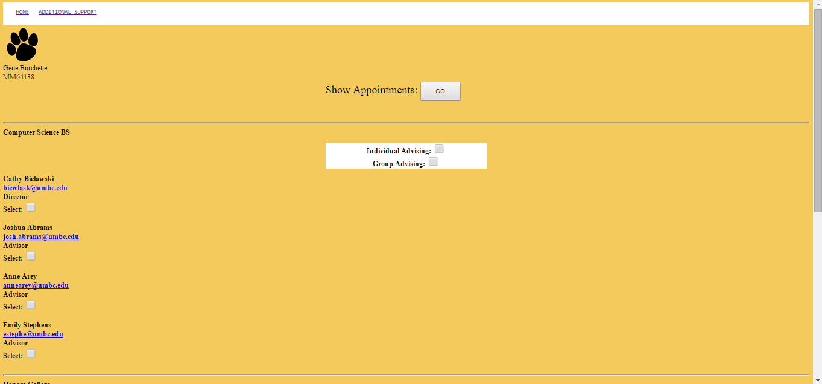

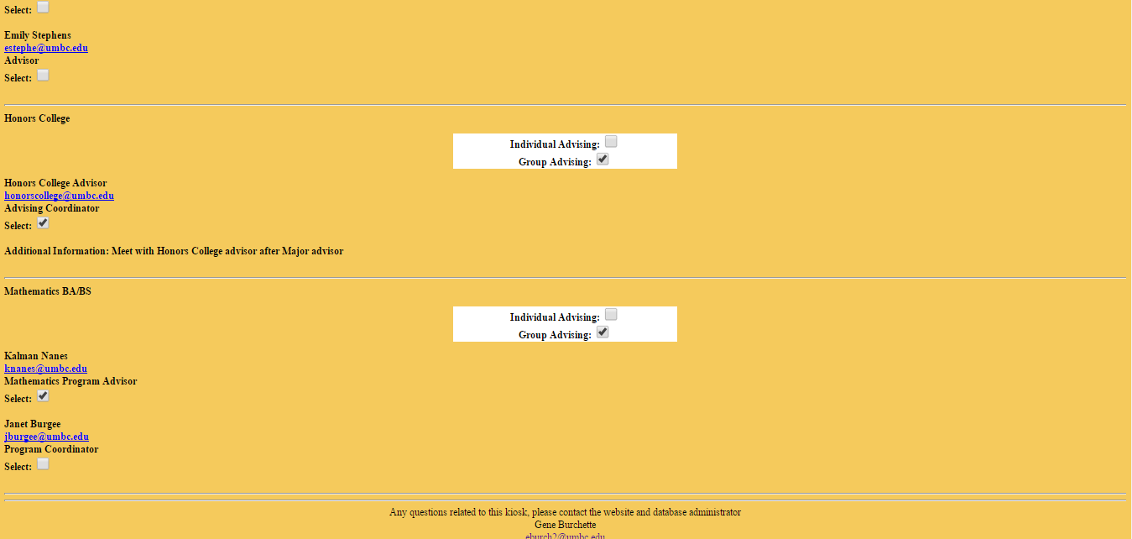

Ability to schedule all appointments at once

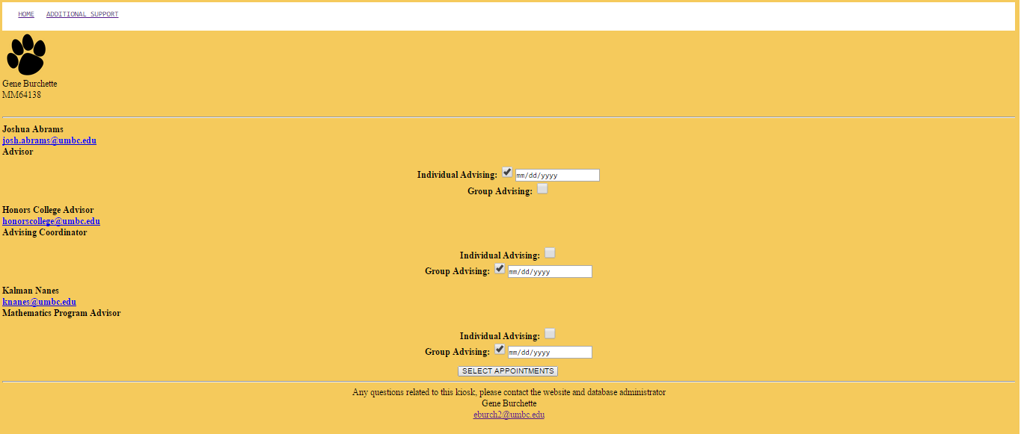

Drop down arrow allows a Calendar to pop up!

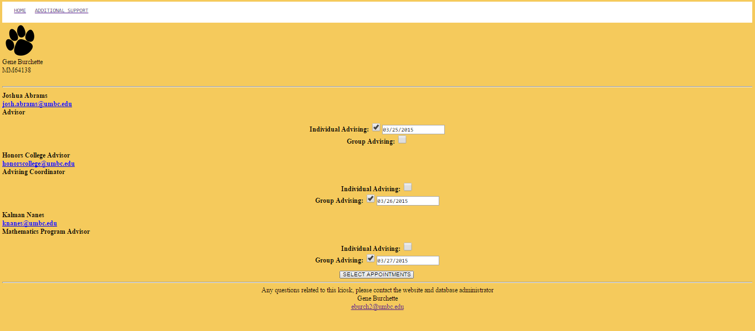

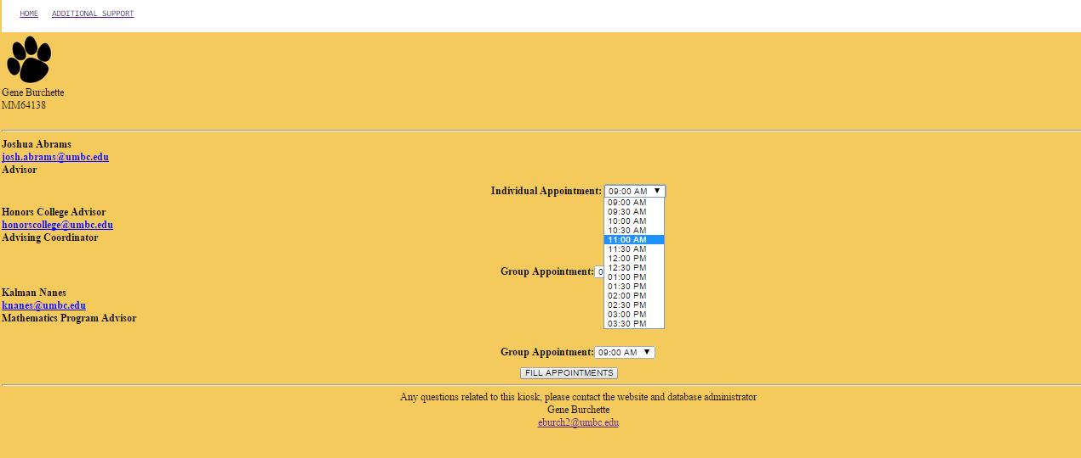

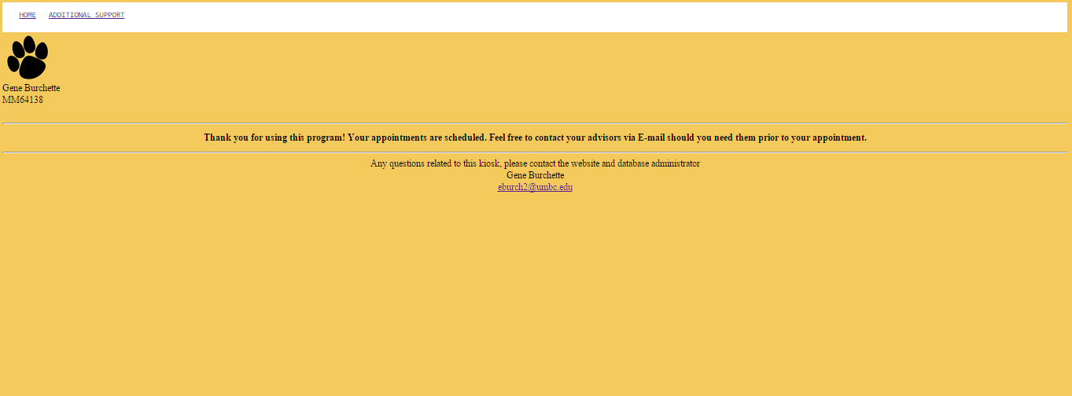

The end!

Advisor Table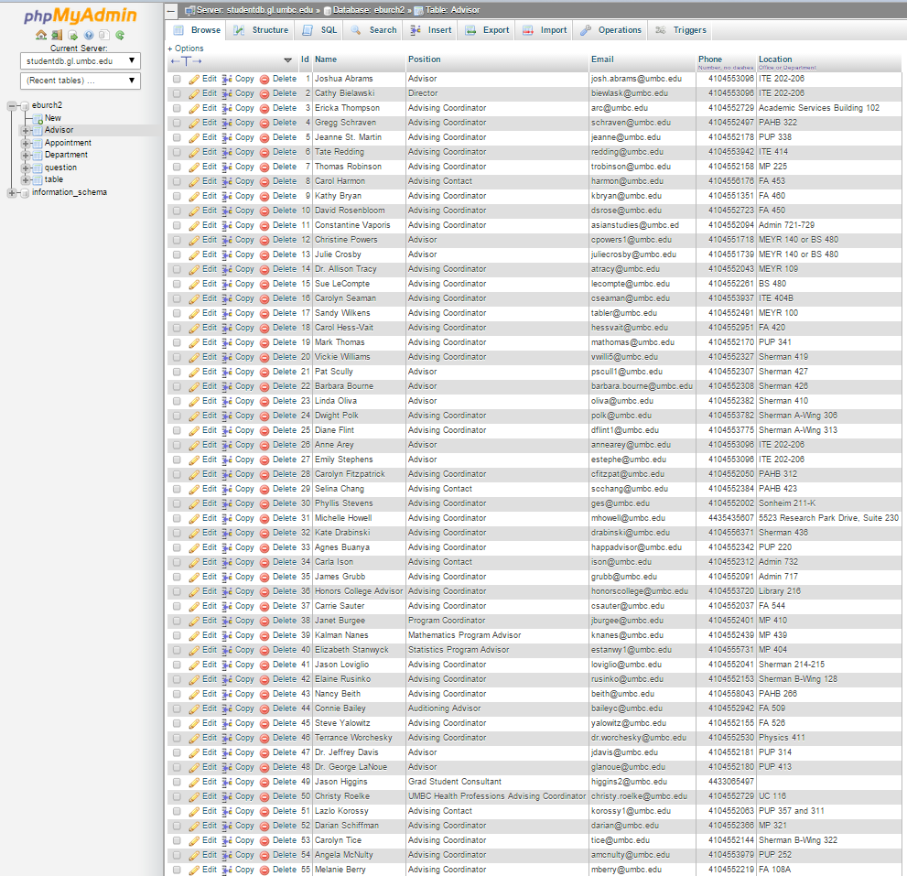

All the advisors for every major/pre-professional program

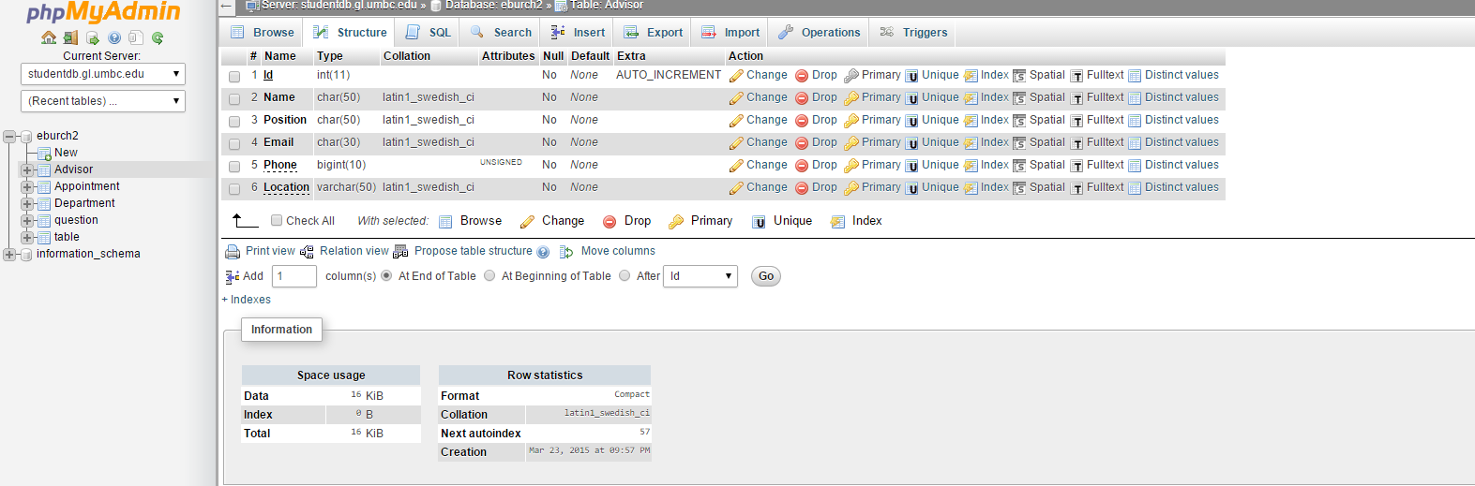

Department Table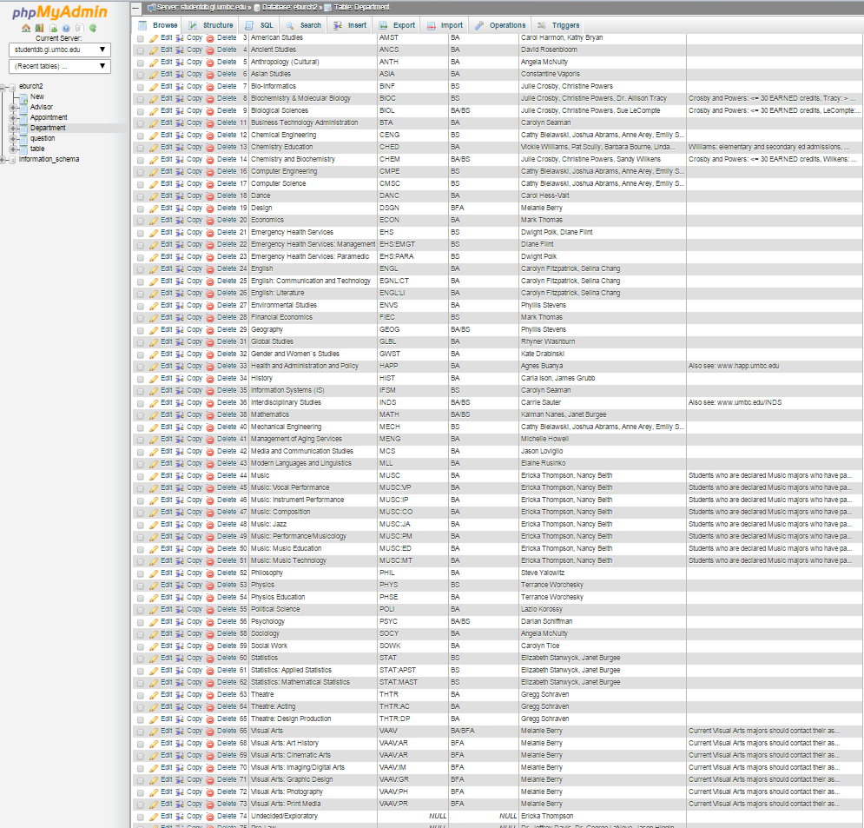

Every Major/track and Pre-professional path and also a few certification programs at UMBC as of 2015

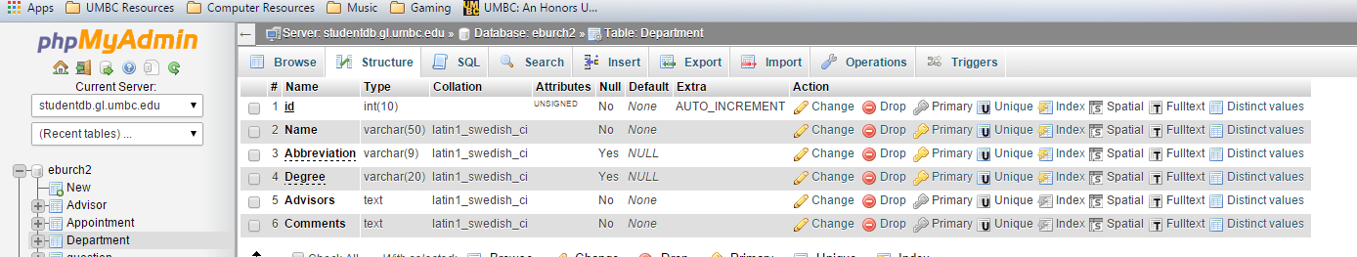

Before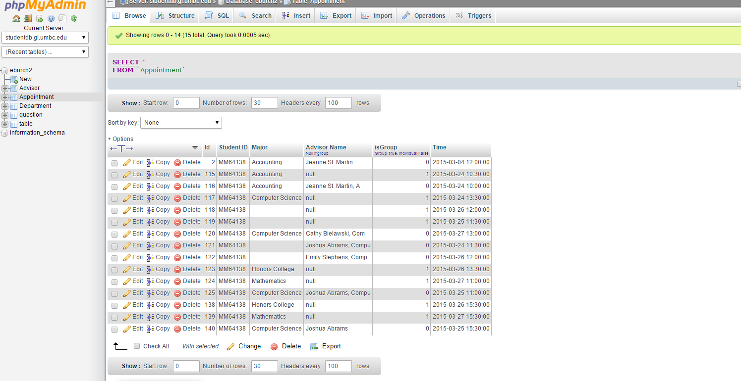

After

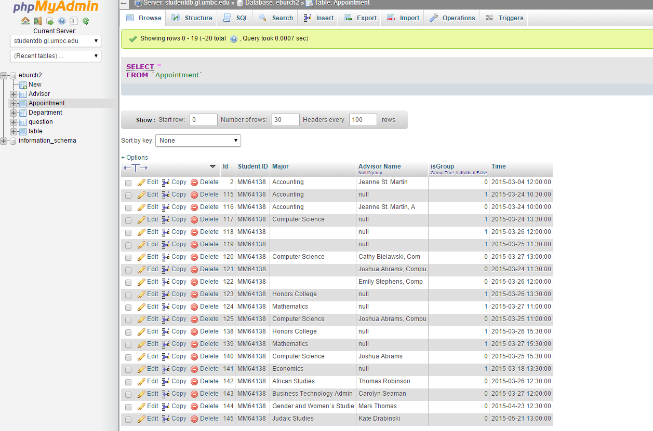

Demo Video: <https://www.youtube.com/watch?v=HIpl7JPXAAw>