Lab 10 – GH CLI Codespaces + AWS + Terraform: CLI Automation of VPC/Subnet Creation

Name: Emaan Hanif

Reg no: BSE017

Task 1 — GitHub CLI Codespace Setup & Authentication

Goal
The purpose of this task is to install the GitHub CLI, authenticate it with the required permissions, and connect to a GitHub Codespace using SSH. This setup allows us to work inside a cloud-based development environment directly from our terminal.

1. Installing GitHub CLI
GitHub CLI (Command Line Interface) is required so we can interact with GitHub directly from the terminal.
Using GH CLI, we can authenticate, manage repositories, and connect to Codespaces.
Command Used:
winget install --id GitHub.cli

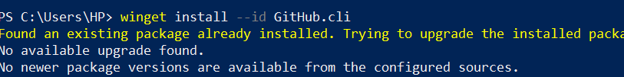
After running this command, Winget downloads and installs the latest version of GitHub CLI on the system.
Screenshot Required:
task1_gh_install.png

2. Authenticating GitHub CLI for Codespaces
In order to access Codespaces through GH CLI, authentication is needed with specific permissions.
We run:
gh auth login -s codespace

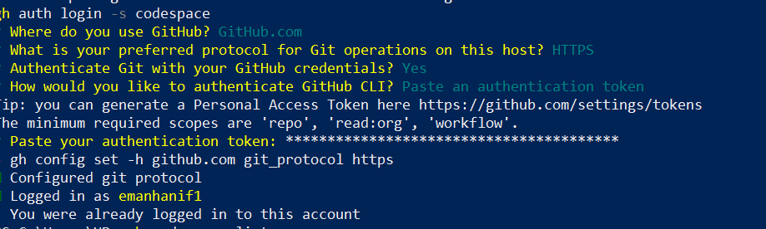

Explanation:
- gh auth login starts the login process.
- The -s codespace flag ensures that GH CLI requests the Codespace scope, which allows us to list, create, and connect to Codespaces.
After running this command:
- GitHub asks us to generate a Personal Access Token (classic).
- We must select the following scopes:
  - admin:org – allows organizational access if needed.
  - codespace – required to connect and interact with Codespaces.
  - repo – ensures read/write access to the repository inside the Codespace.
Once authenticated, GitHub CLI is ready to communicate with the Codespace environment.
Screenshot Required:
task1_gh_auth_login.png

3. Listing Available Codespaces
To connect to a Codespace, we first need to check what Codespaces exist in our account.
Command Used:
gh codespace list

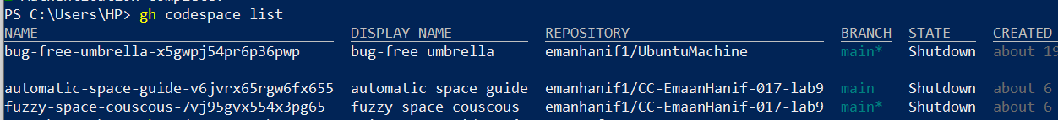

Explanation:
- This command displays all Codespaces linked to the authenticated GitHub account.
- It shows:
  - Codespace name (important for SSH)
  - Repository
  - Branch
  - State (Available / Shutdown)
  - Created date
From this list, we select the Codespace we want to connect to.
Screenshot Required:
task1_codespace_list.png
(The output must include the codespace name.)

4. Connecting to a Codespace via SSH
• First, create a new repository CC-EmaanHanif-017-lab10 on GitHub.
• Open the repository and manually create a Codespace from the Code → Codespaces → Create Codespace option.

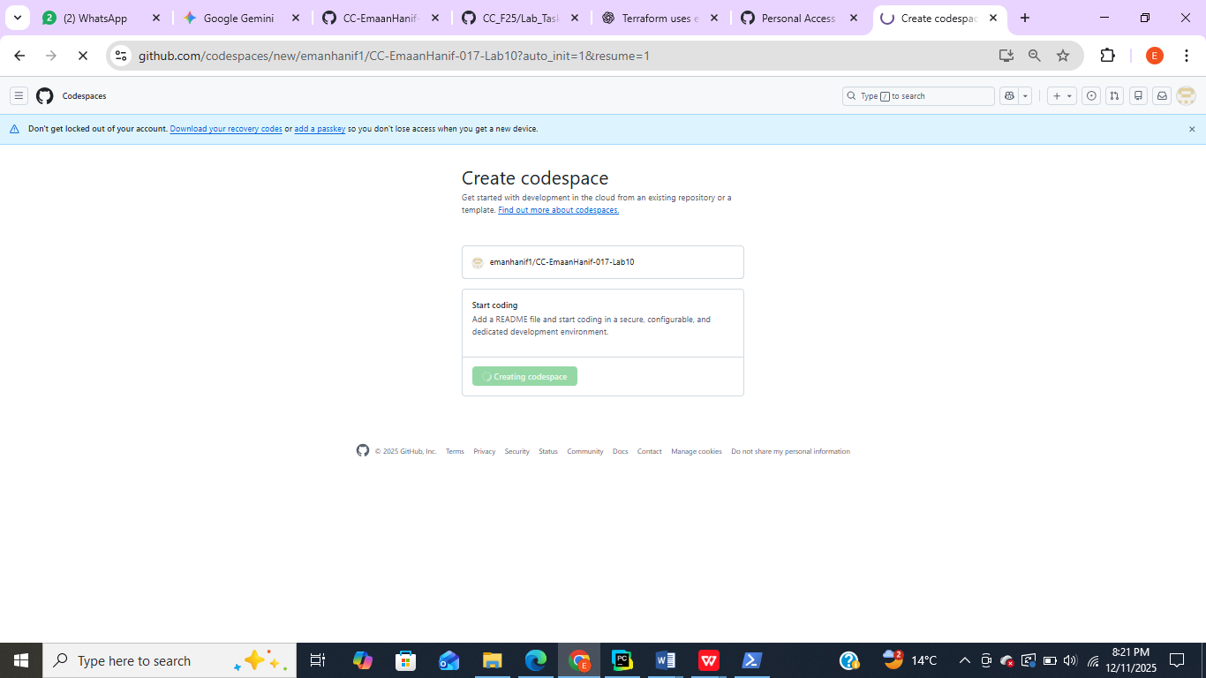
After identifying the Codespace name, we connect using SSH:
Command:
gh codespace ssh -c <name_of_codespace>

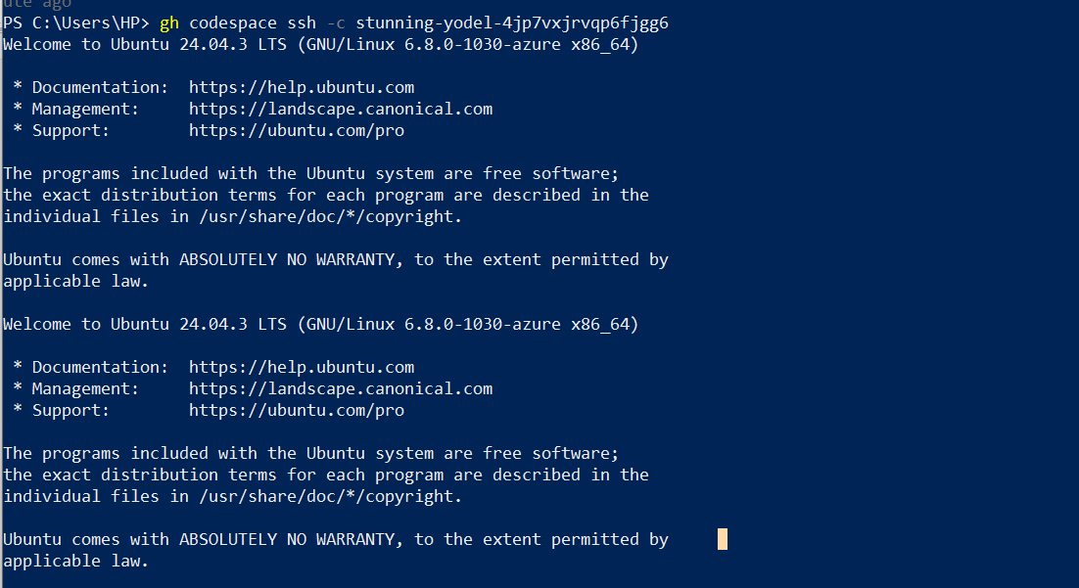

Explanation:
• gh codespace ssh initiates an SSH session to a GitHub Codespace.
• The -c option specifies the name of the Codespace to connect to.
• After a successful connection, the terminal prompt changes to :
codespace ➜ /workspaces/CC-EmaanHanif-017-lab9
• This prompt indicates that you are now inside the remote development environment of the Codespace and can execute commands directly within it.
Screenshot Required:
task1_codespace_ssh_connected.png

Task 2 — Install AWS CLI, Terraform CLI, and Provider Setup

Goal
The purpose of this task is to install AWS CLI inside the Codespace, configure it with proper credentials, and verify connectivity. This ensures the environment is ready to interact with AWS resources using Terraform or CLI commands.

A. Install AWS CLI
Step: Open your Codespace shell and run the following commands:

curl "https://awscli.amazonaws.com/awscli-exe-linux-x86_64.zip" -o "awscliv2.zip"
unzip awscliv2.zip
sudo ./aws/install
aws –version

Explanation
- curl downloads the AWS CLI installer from the official AWS website.
- unzip extracts the downloaded ZIP file.
- sudo ./aws/install installs AWS CLI with administrative privileges.
- aws --version confirms that AWS CLI is installed and displays the version.

- 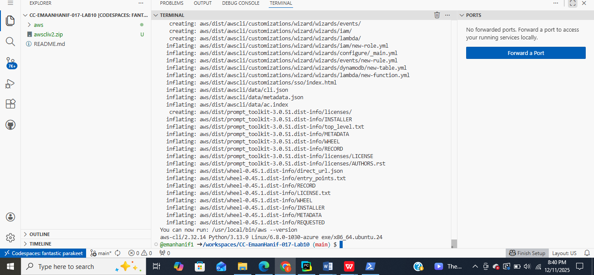

Screenshot Required:
task2_aws_install_and_version.png — Show the terminal output with the AWS CLI version.

B. Configure AWS CLI
Run the configuration command:

aws configure

Explanation

Prompts for:
- AWS Access Key ID → Unique identifier for your AWS account credentials.
- AWS Secret Access Key → Secret key associated with your account (keep it private!).
- Default region → AWS region for commands (example: us-east-1, us-west-2).
- Default output format → How command output is displayed (json, text, table).

Configuration saves:
- Credentials in ~/.aws/credentials
- Default settings in ~/.aws/config

Ensure sensitive values are redacted in screenshots.

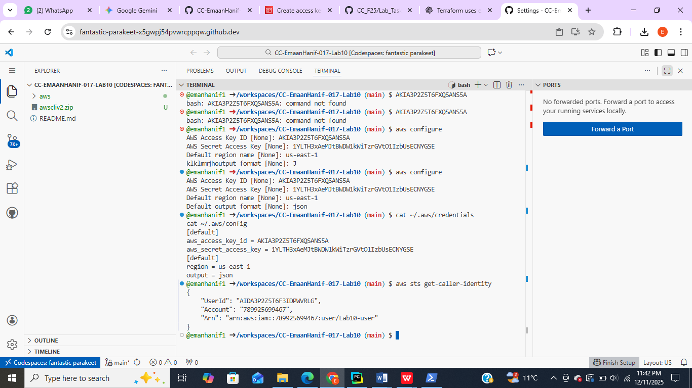

2. Check if AWS CLI is Configured
Run these commands to see if configuration exists:

cat ~/.aws/credentials
- This file stores AWS credentials for the user.
- Purpose:
  - Confirms that AWS Access Key ID and Secret Access Key were saved correctly during aws configure.
  - Allows AWS CLI to authenticate your commands without entering keys every time.
- Important: Never share this file or your keys publicly.

cat ~/.aws/config
- This file stores AWS configuration settings
- Purpose:
  - Ensures your CLI commands run in the correct AWS region.
  - Sets default output format (json, table, or text) for easier readability

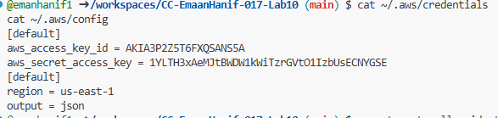

3. Check Connectivity to AWS

If CLI is installed and credentials exist, verify you can access AWS:
aws sts get-caller-identity
- If it returns UserId, Account, and Arn, credentials are working.
- If it returns an error, the keys may be missing or incorrect.

- UserId → Unique identifier for your AWS user.
- Account → Your AWS account number.
- Arn → Amazon Resource Name for your user; identifies the AWS user or role.

B.Install Terraform CLI

Goal
To install Terraform CLI in the Codespace and verify that it is working correctly. Terraform is used to provision and manage cloud infrastructure in a declarative way.

A. Add HashiCorp GPG Key
Command:
wget -O - https://apt.releases.hashicorp.com/gpg | sudo gpg --dearmor -o /usr/share/keyrings/hashicorp-archive-keyring.gpg
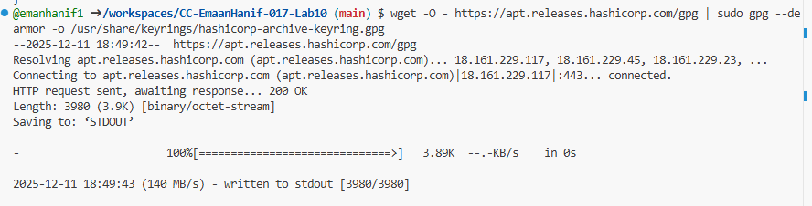

Explanation
- Downloads the official HashiCorp GPG key.
- Converts it to a format usable by apt to verify the authenticity of Terraform packages.
- curl -fsSL <URL> → Downloads the GPG key file from HashiCorp’s official website.
- sudo gpg --dearmor → Converts the key to a format that can be used by the system’s package manager.
- -o /usr/share/keyrings/hashicorp-archive-keyring.gpg → Saves the key in the system keyrings directory.

B. Add Terraform Repository

Explanation
- Adds the official HashiCorp APT repository to your system’s sources list.
- Ensures that you can install Terraform using apt and get updates automatically.

C. Update Package List
Command:
sudo apt update
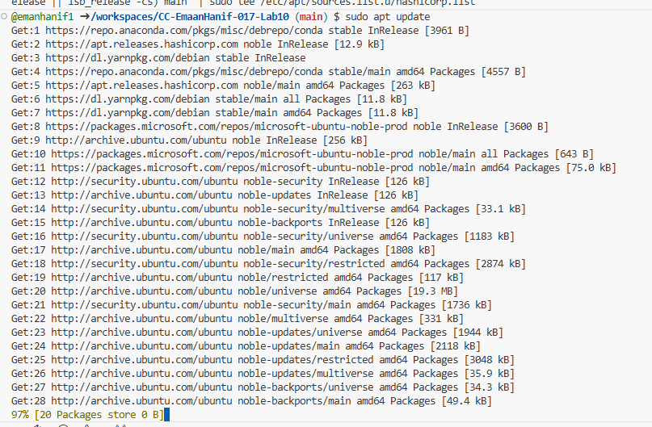

Explanation
- Updates your package list to include the newly added HashiCorp repository.

D. Install Terraform
Command:
sudo apt install terraform
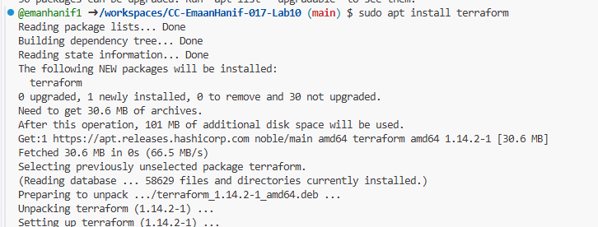

Explanation
- Installs the latest Terraform version from the official HashiCorp repository.

E. Verify Installation
Commands:
which terraform
terraform –version
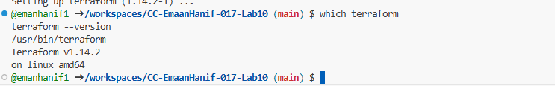

Explanation
- which terraform shows the path where Terraform is installed.
- terraform --version displays the installed version and confirms that Terraform is working.
Screenshot Required:
task2_terraform_install_and_version.png — Show terminal output of installation path and version.

Summary
- Added HashiCorp GPG key for security.
- Added the Terraform APT repository.
- Updated package list and installed Terraform CLI.
- Verified installation by checking path and version.

Terraform Provider Configuration

Goal
To configure Terraform to use AWS as the provider, initialize Terraform, and verify setup. This enables Terraform to provision AWS resources using the credentials and configuration already set in the Codespace.

A. Create main.tf File
Command:
vim main.tf

Explanation
- main.tf is the main Terraform configuration file.
- Using vim (or any editor), you create this file to define the provider and resources for your project.
Screenshot Required:
task2_provider_file_creation.png — Terminal showing vim main.tf open.

B. Add AWS Provider Block
Inside main.tf, write:
provider "aws" {
shared_config_files = ["~/.aws/config"]
shared_credentials_files = ["~/.aws/credentials"]
}

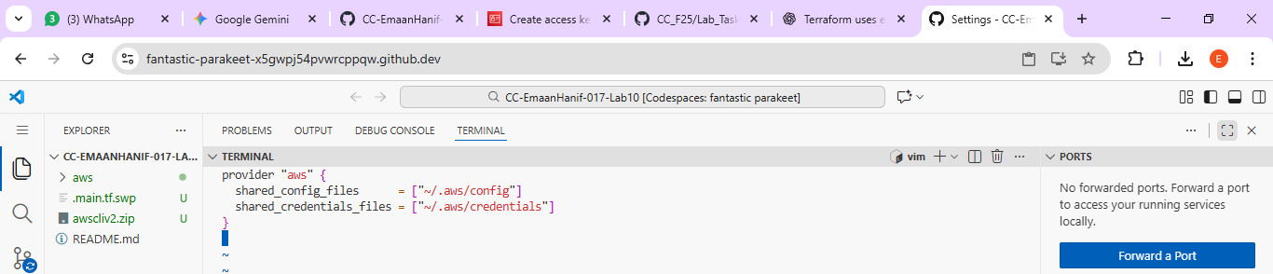

Explanation
- provider "aws" tells Terraform to use AWS as the cloud provider.
- shared_config_files points to the AWS config file.
- shared_credentials_files points to the AWS credentials file.
- This setup ensures Terraform uses your preconfigured AWS CLI credentials for all operations.
Screenshot Required:
task2_provider_block.png — Show the saved provider block in main.tf.

C. Save and Exit Vim
- Press ESC then type :wq and press Enter to save changes and quit Vim.
Screenshot Optional:
task2_vim_save_main_tf.png — Confirmation of file saved.

D. Initialize Terraform
Command:
terraform init
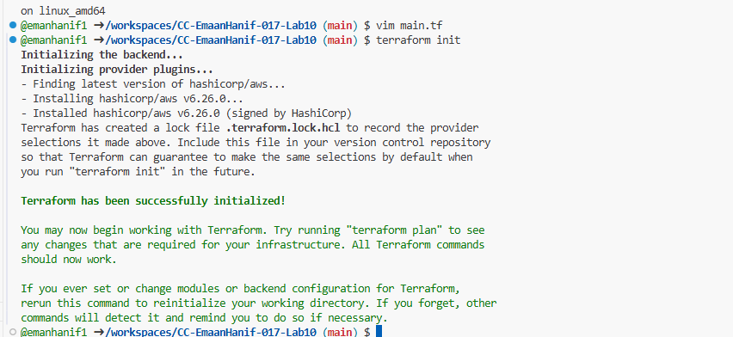

Explanation
- terraform init initializes the Terraform working directory.
- Downloads provider plugins (in this case, AWS) and sets up .terraform/ directory for managing state and modules.
Screenshot Required:
task2_terraform_init_output.png — Show output of terraform init.

E. Check Terraform Lock File
Command:
cat .terraform.lock.hcl
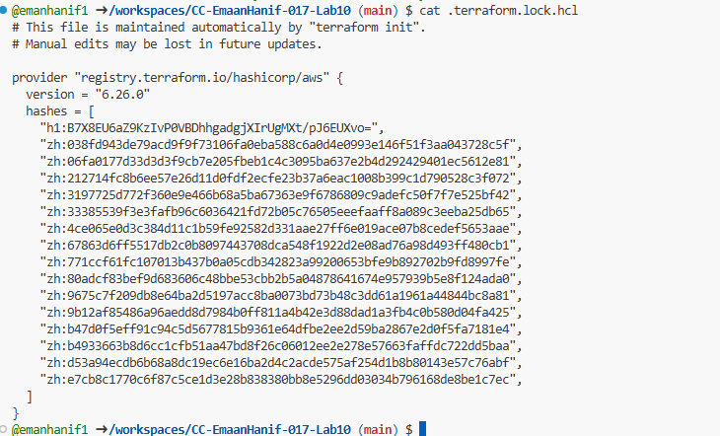

Explanation
- .terraform.lock.hcl locks provider versions used in this configuration.
- Ensures consistent Terraform behavior across environments and team members.
Screenshot Required:
task2_terraform_lock_hcl.png — Show contents of .terraform.lock.hcl.

F. List Terraform Directory
Command:
ls .terraform

Explanation
- Shows the internal Terraform directory created after terraform init.
- Contains provider plugins and other initialization files.
Screenshot Required:
task2_terraform_dir_ls.png — Output of ls .terraform/.

Summary
- Created main.tf for AWS provider configuration.
- Added provider block pointing to AWS CLI credentials and config files.
- Initialized Terraform using terraform init.
- Verified provider lock file and internal .terraform/ directory.

Task 3 — VPC/Subnet Creation, Initialization, Verification

Goal
To use Terraform to create an AWS VPC and Subnet, apply the changes, and verify the resources using AWS CLI.

A. Edit main.tf to Add VPC and Subnet Resources
Step: Open your Terraform configuration file:
vim main.tf

Add the following code inside main.tf:
resource "aws_vpc" "development_vpc" {
cidr_block = "10.0.0.0/16"
}

resource "aws_subnet" "dev_subnet_1" {
vpc_id = aws_vpc.development_vpc.id
cidr_block = "10.0.10.0/24"
availability_zone = "me-central-1a"
}
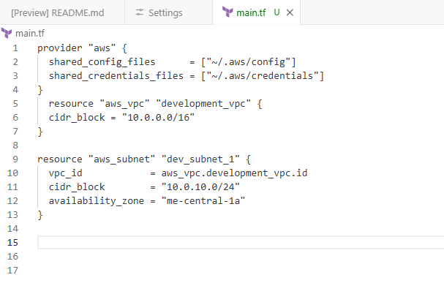

Explanation
- resource "aws_vpc" → Creates a new VPC named development_vpc with CIDR 10.0.0.0/16.
- resource "aws_subnet" → Creates a subnet dev_subnet_1 inside the above VPC.
- vpc_id = aws_vpc.development_vpc.id → Links the subnet to the VPC created by Terraform.
- availability_zone = "me-central-1a" → Ensures the subnet is created in a specific AZ.
Screenshot Required:
task3_main_tf_resource_add.png — Terminal showing the added VPC and Subnet resources in main.tf.

B. Apply Terraform Configuration
Step: Run:
terraform apply
- Terraform will show a plan describing the changes it will make.
- Type yes when prompted to confirm.
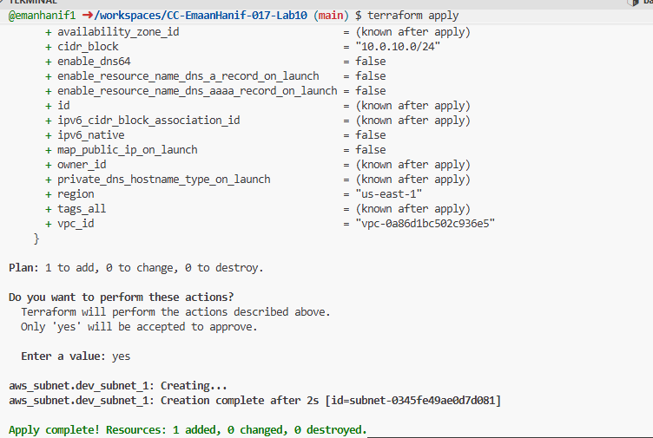

Explanation
- Terraform provisions the VPC and subnet in your AWS account.
- After successful execution, Terraform outputs the resource IDs and attributes.
• Terraform is going to create 1 resource: the subnet.
• Nothing else will be modified or destroyed.

Screenshot Required:
task3_terraform_apply_vpc_subnet.png — Show successful terraform apply output with created resource IDs.

C. Verify Resources Using AWS CLI

1. Verify Subnet
aws ec2 describe-subnets --filter "Name=subnet-id,Values=<subnet-id>"
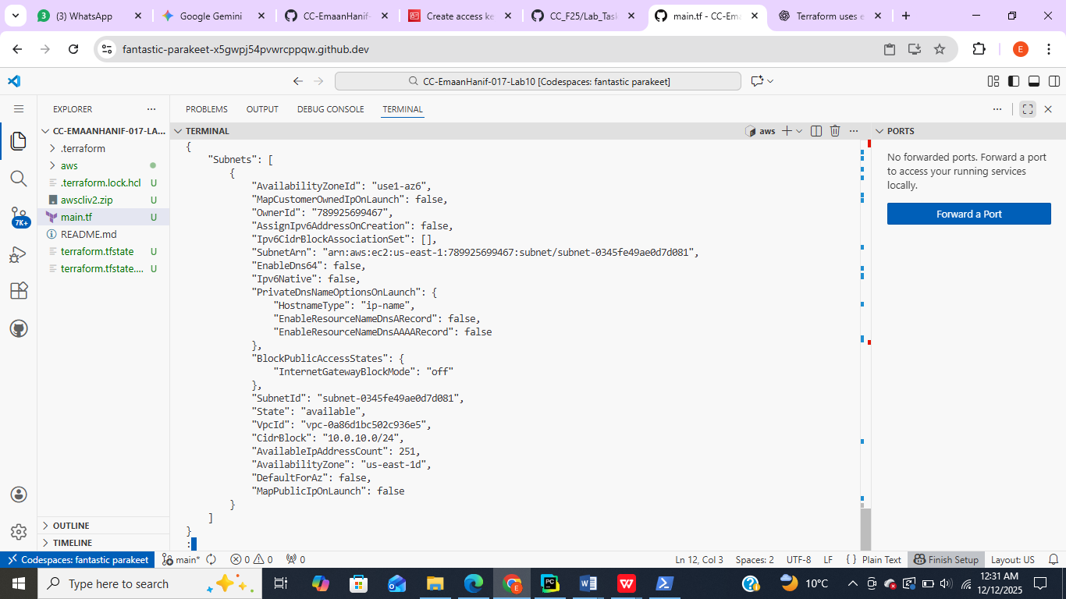
- Replace <subnet-id> with the ID output by Terraform for dev_subnet_1.
Screenshot Required:
task3_aws_cli_verify_subnet.png — Show AWS CLI output verifying the subnet exists.

2. Verify VPC
aws ec2 describe-vpcs --filter "Name=vpc-id,Values=<vpc-id>"
- Replace <vpc-id> with the ID output by Terraform for development_vpc.
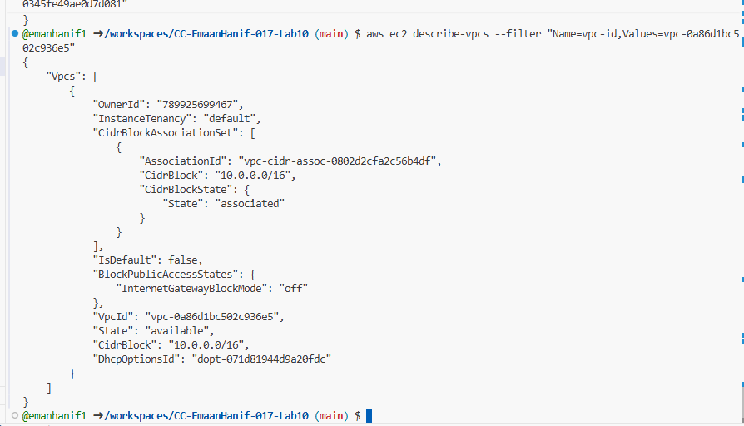
Screenshot Required:
task3_aws_cli_verify_vpc.png — Show AWS CLI output verifying the VPC exists.

Summary
- Edited main.tf to add AWS VPC and subnet resources.
- Applied Terraform configuration to create resources.
- Verified the existence of VPC and subnet using AWS CLI comman

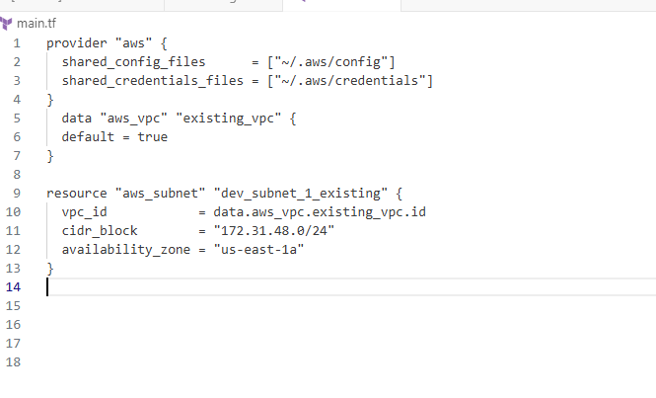

Task 4 — Data Source, Targeted Destroy, Tags

A. Add Data Source + New Subnet Resource

1. Open file
vim main.tf
So write this:
data "aws_vpc" "existing_vpc" {
default = true
}

resource "aws_subnet" "dev_subnet_1_existing" {
vpc_id = data.aws_vpc.existing_vpc.id
cidr_block = "172.31.48.0/24"
availability_zone = "us-east-1a"
}

3. Save file
Press:
ESC
:wq
Take screenshot → task4_main_tf_datasource_resource_add.png
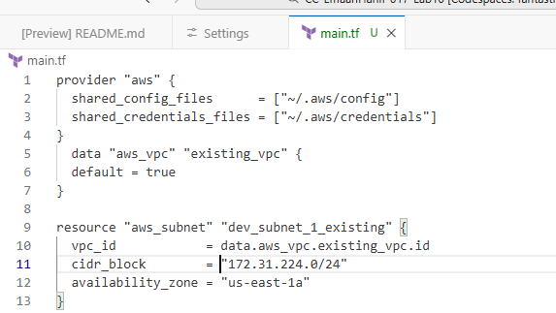

Use a CIDR block that does NOT conflict

B. Apply Only These Changes
Run:
terraform apply
Type:
yes
This should show:
- 1 resource to add
- Only aws_subnet.dev_subnet_1_existing created
(because VPC is a data source, not created)
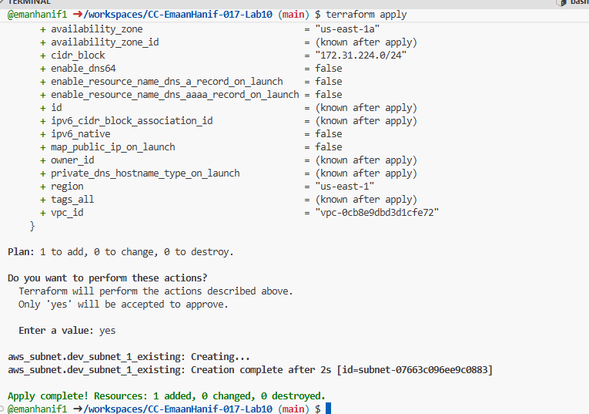
Take screenshot → task4_terraform_apply_datasource_resource.png

Targeted Destroy (Destroy ONLY ONE Resource)
You are destroying ONLY the subnet created with data source:
terraform destroy -target=aws_subnet.dev_subnet_1_existing
🎯 This destroys only this resource, not your whole Terraform environment.
📸 Screenshot name: task4_terraform_destroy_targeted.png
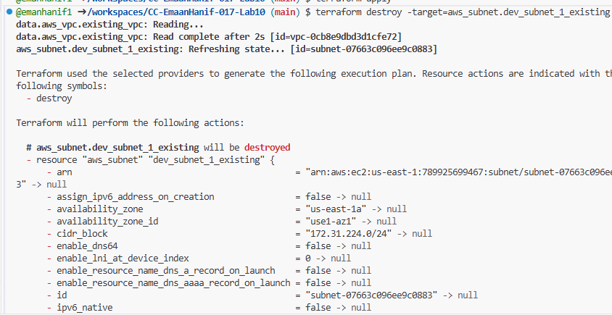

Refresh State
After destroying one resource, Terraform must sync state with AWS:
terraform refresh
This updates the .tfstate file to match AWS.
📸 Screenshot name: task4_terraform_refresh_state.png

Re-apply Configuration
Now recreate whatever is in main.tf:
terraform apply
Type:
yes
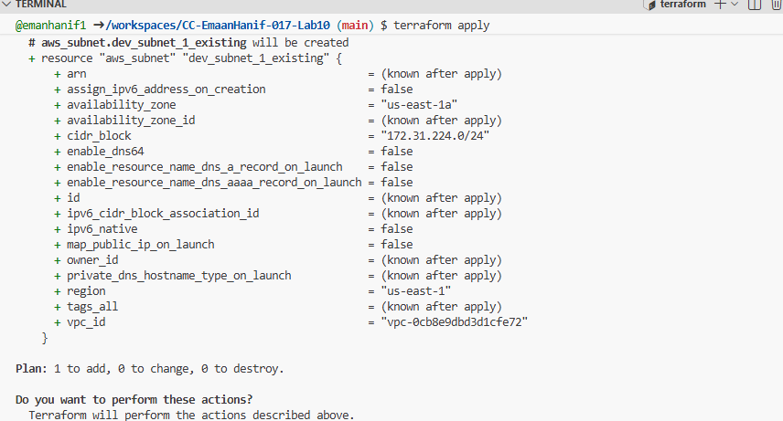 📸 Screenshot name: task4_terraform_apply_after_refresh.png

Destroy ALL Resources
Now completely remove everything Terraform created:
terraform destroy
Type:
Yes

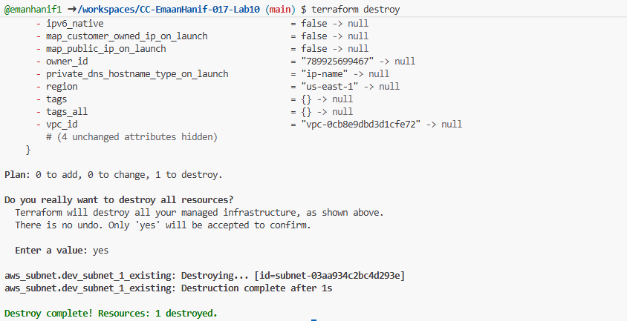
📸 Screenshot name: task4_terraform_destroy_all.png

Run Terraform Plan
See what Terraform wants to create now:
terraform plan

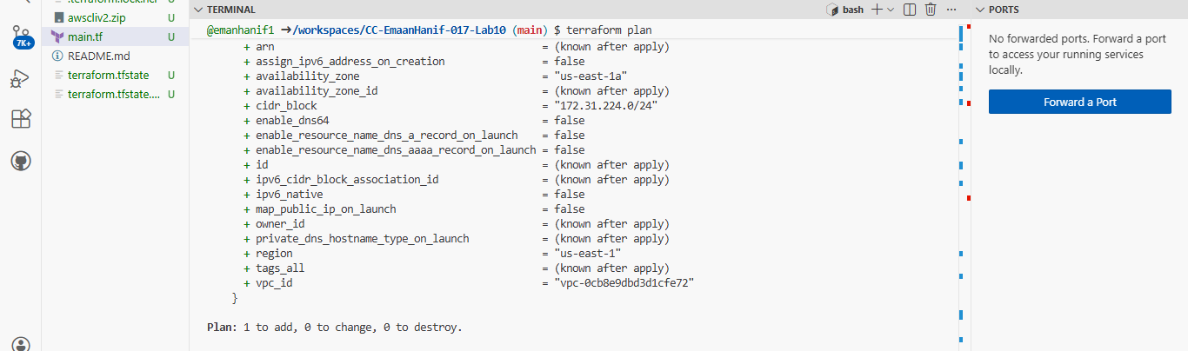
📸 Screenshot name: task4_terraform_plan_output.png

Apply Again (Re-create Everything)
terraform apply
Type:
Yes

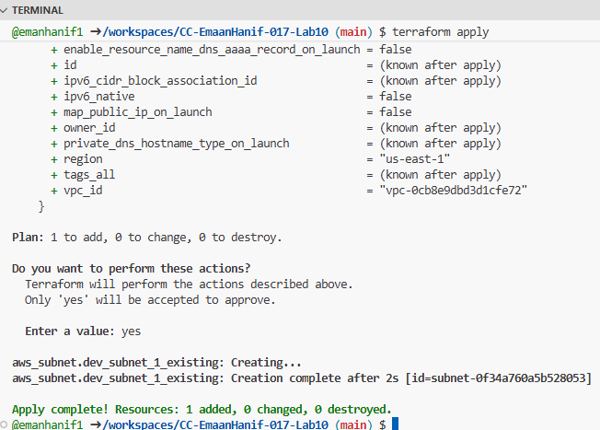

📸 Screenshot name: task4_terraform_apply_after_destroy.png

update main.tf — Add Tags
Open main.tf:
vim main.tf

Add the tag blocks exactly like this:

✔ If keeping your previous resources, your main.tf should look like:
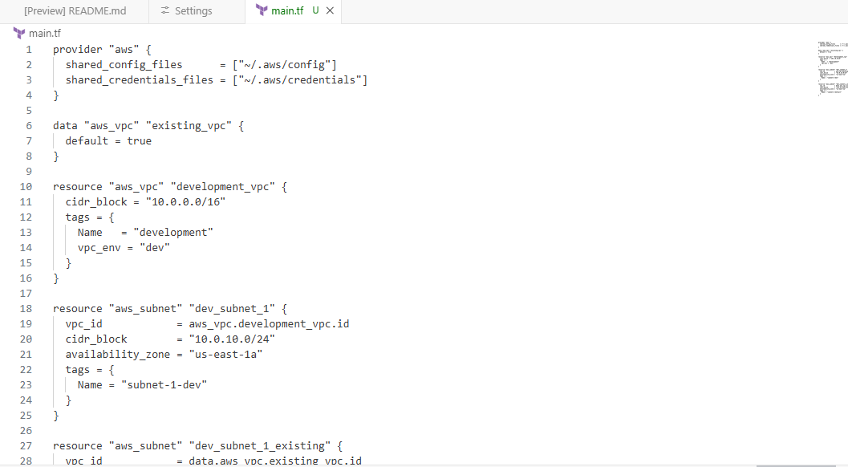 📸 Save screenshot:
task4_main_tf_tagging.png

Run Refresh
terraform refresh

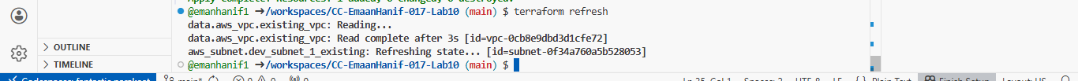
📸 Save screenshot:
task4_terraform_refresh_tagging.png (optional)

Apply the updated configuration
terraform apply -auto-approve
This will apply the tag changes.

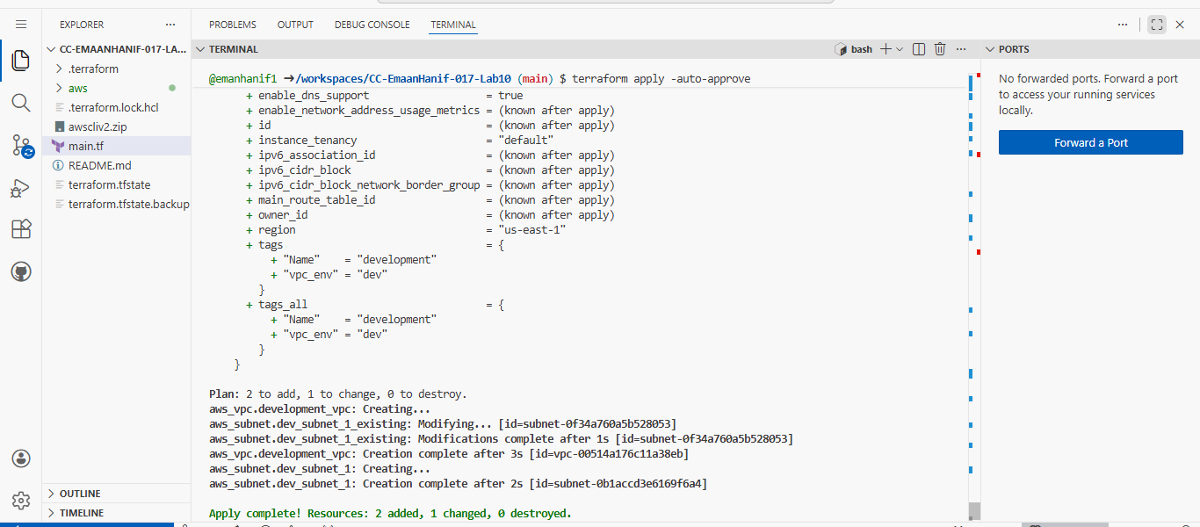
📸 Save screenshot:
task4_terraform_apply_tagging.png

Remove vpc_env tag
Now edit main.tf again and REMOVE this line:
vpc_env = "dev"
So the VPC block becomes:

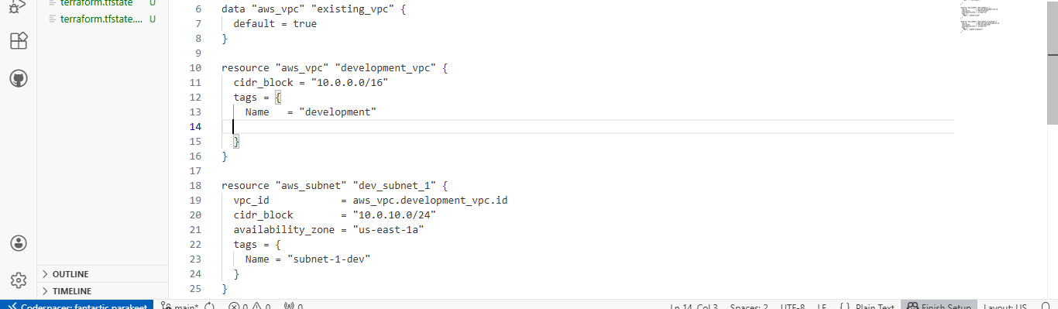 📸 Save screenshot after editing:
task4_main_tf_remove_tag.png (optional)

Re-plan to show tag removal
terraform plan
- Terraform will update in-place, meaning no new VPC is created and nothing is destroyed.
- Only the tags are changed.
- The tag vpc_env = "dev" will be removed.
- Everything else stays the same.
- 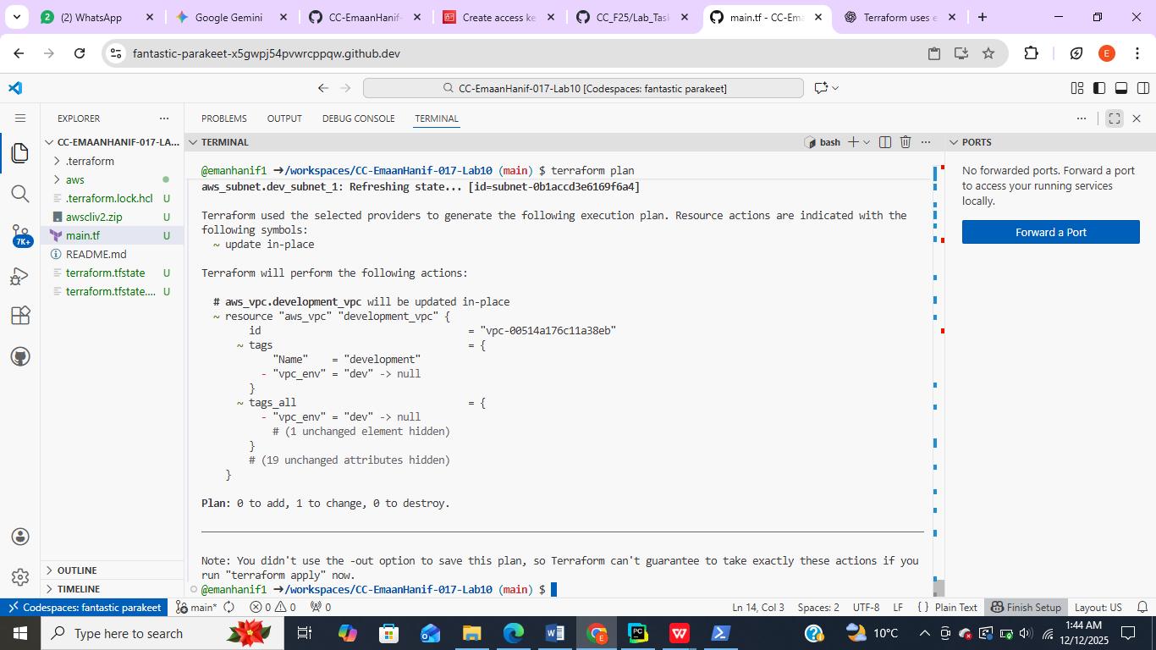

📸 Save screenshot:
task4_terraform_plan_remove_tag.png

Apply the tag removal
terraform apply -auto-approve
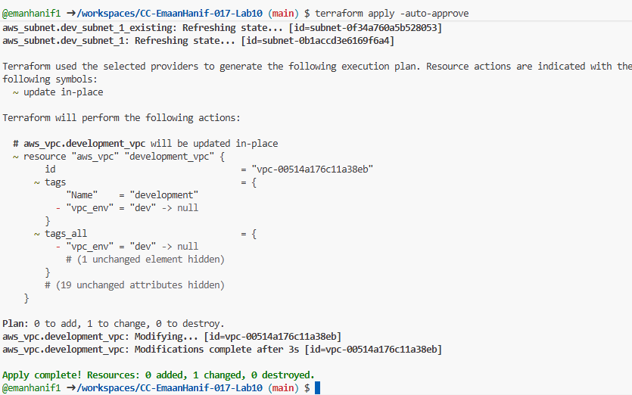
📸 Save screenshot:
task4_terraform_apply_remove_tag.png

Task 5 — State File Inspection & Terraform State Commands

destroy all resources
terraform destroy
- Type yes to confirm.
- This deletes all resources managed by Terraform.

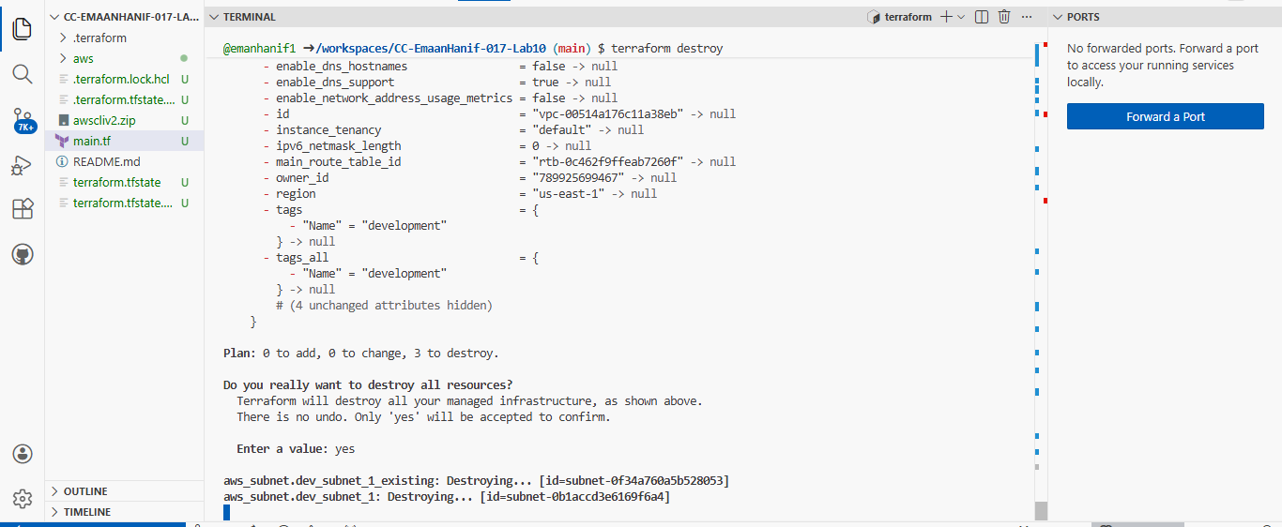
📸 Screenshot → task5_terraform_destroy.png

Inspect state files after destroy

Check main state file
cat terraform.tfstate
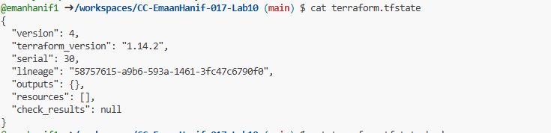
- After destroy, this file should be empty or only contain metadata.
📸 Screenshot → task5_terraform_state_file_empty.png

Check backup state file
cat terraform.tfstate.backup
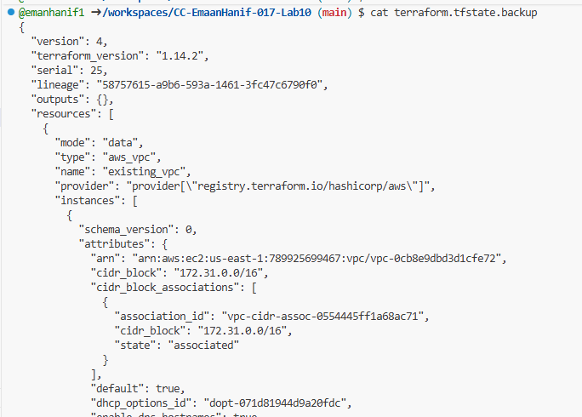
- This file keeps the previous state before destroy.
📸 Screenshot → task5_terraform_state_backup_prev.png

Recreate resources
terraform apply
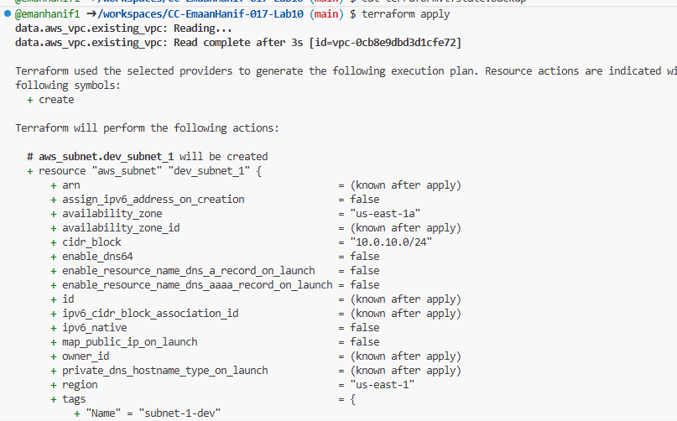
- Type yes (or use -auto-approve).
- All resources defined in main.tf will be recreated.
📸 Screenshot → task5_terraform_apply_recreated.png

View state files after recreate

Main state file
cat terraform.tfstate
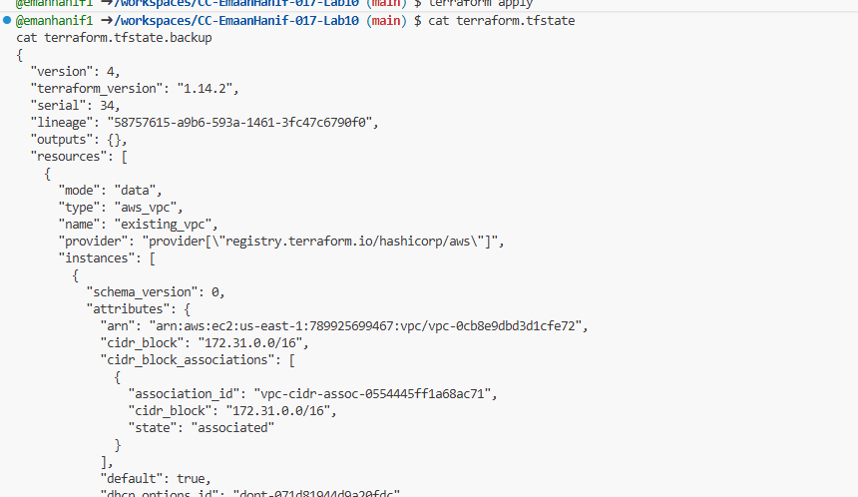
- Should now be populated with all current resources.
📸 Screenshot → task5_terraform_state_file_populated.png

Backup file
cat terraform.tfstate.backup
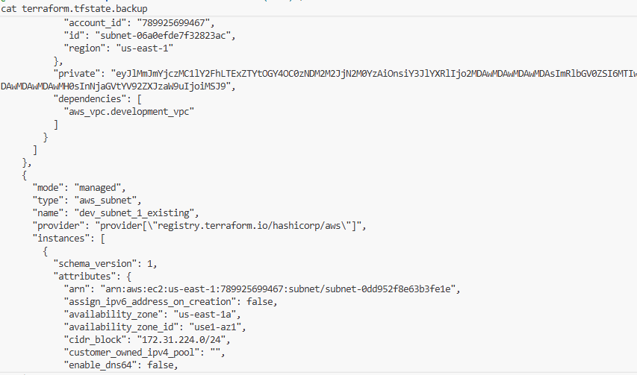
- After recreation, this backup may now be empty or contain minimal metadata.
📸 Screenshot → task5_terraform_state_backup_empty.png

List all resources
terraform state list
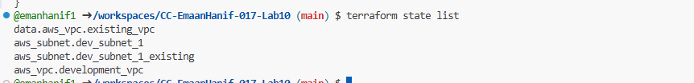
- Lists all resources managed by Terraform in the current state.
📸 Screenshot → task5_terraform_state_list.png

Show full attributes of a resource
terraform state show <resource-name>
- Replace <resource-name> with a resource, e.g.:
terraform state show aws_vpc.development_vpc
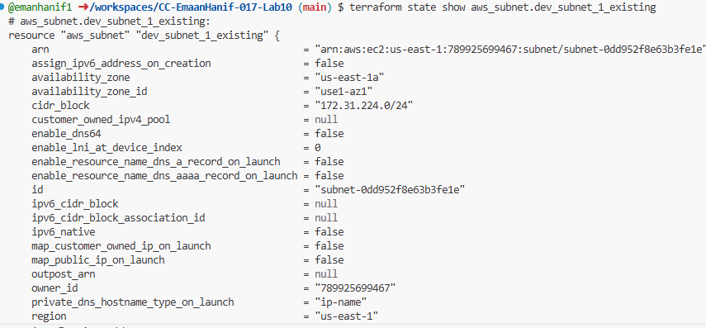
- Shows all attributes of that resource from the state file.
📸 Screenshot → task5_terraform_state_show_resource.png

Task 6 — Terraform Outputs & Attributes Reporting

What Terraform Outputs Are
In your main.tf, you defined outputs like this:
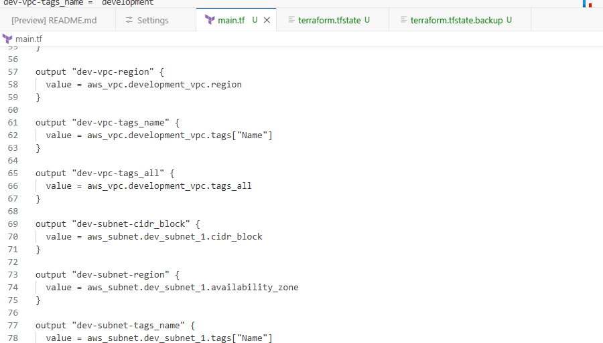
• aws_vpc.development_vpc.id → Terraform shows the VPC ID, e.g., vpc-0fdc2b0a2759cbb73.
• aws_vpc.development_vpc.cidr_block → The VPC IP range, e.g., 10.0.0.0/16.
• aws_subnet.dev_subnet_1.tags["Name"] → The Name tag of the subnet, e.g., "subnet-1-dev".
• tags_all → Shows all tags, even if you added more later.

Apply the configuration
Run:
terraform apply
✅ Terraform will create/update resources (if needed) and print all the outputs at the end.

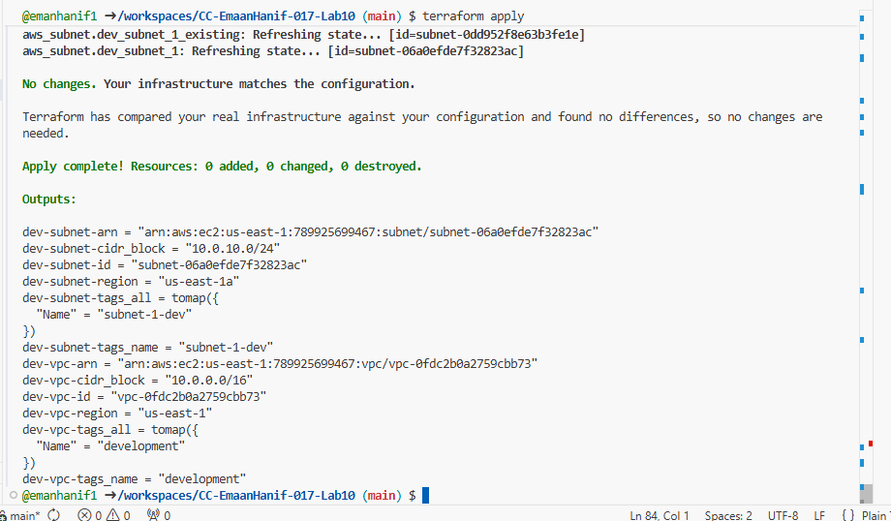
- Each line corresponds to one output you defined.
- For tags_all, Terraform prints it in HCL map format { "Name" = "subnet-1-dev" }.
- region for subnet shows availability zone, not just the AWS region (us-east-1a vs us-east-1).

Apply the configuration
Run:
terraform apply -auto-approve
Terraform will create/update resources (if needed) and print all the outputs at the end.
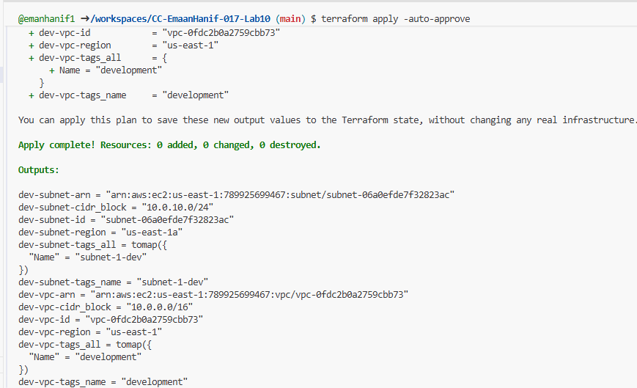

Cleanup — Delete Resources & State Verification

Destroy All Resources
Run:
terraform destroy
- Terraform will list all resources to destroy (VPCs, subnets, etc.).
- Confirm by typing yes when prompted.
- Screenshot: Save the terminal output as cleanup_destroy_resources.png.

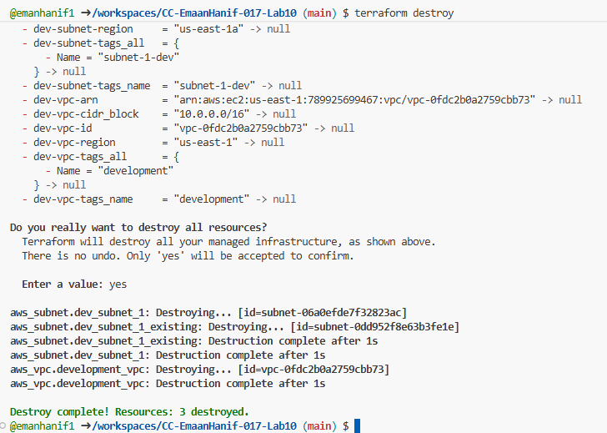
After completion, Terraform should report:
Destroy complete! Resources: X destroyed.

Inspect Terraform State Files
Check the content of your state files after destruction:
cat terraform.tfstate
cat terraform.tfstate.backup
- terraform.tfstate → should now be empty (no resources).
- terraform.tfstate.backup → will still have a backup of previous resources (from before destroy).
- Screenshot: Save output as cleanup_state_files.png.
This shows Terraform keeps a backup even after destruction.
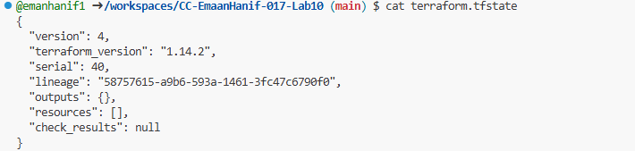

- This file is empty of resources, meaning Terraform currently sees no managed infrastructure.
- After terraform destroy, all your VPCs and subnets are gone from the active state.
- outputs is also empty because Terraform removed the resources, so there’s nothing to output.
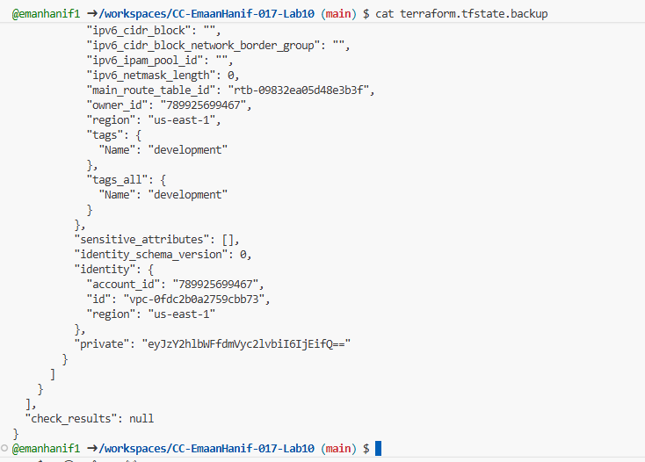

- The backup file still contains all previous resources and their output values.
It includes:
- dev-vpc-id, dev-subnet-id, dev-vpc-arn, dev-subnet-arn, etc.
- Full resource attributes (CIDR block, region, tags) from before you destroyed them.
- This allows Terraform (or you) to recover or reference the previous state if needed.

THE END

