Lab 13 – Terraform IAM Management with AWS

Task 0 Lab Setup (Codespace & GH CLI)

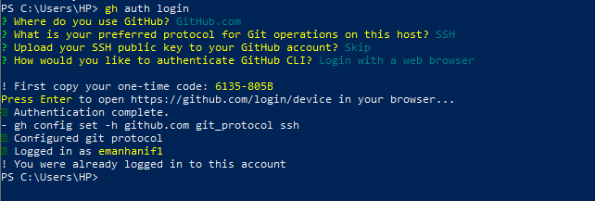
Starts the login process
You can authenticate via:
- Web browser (recommended)
- Personal Access Token (PAT)
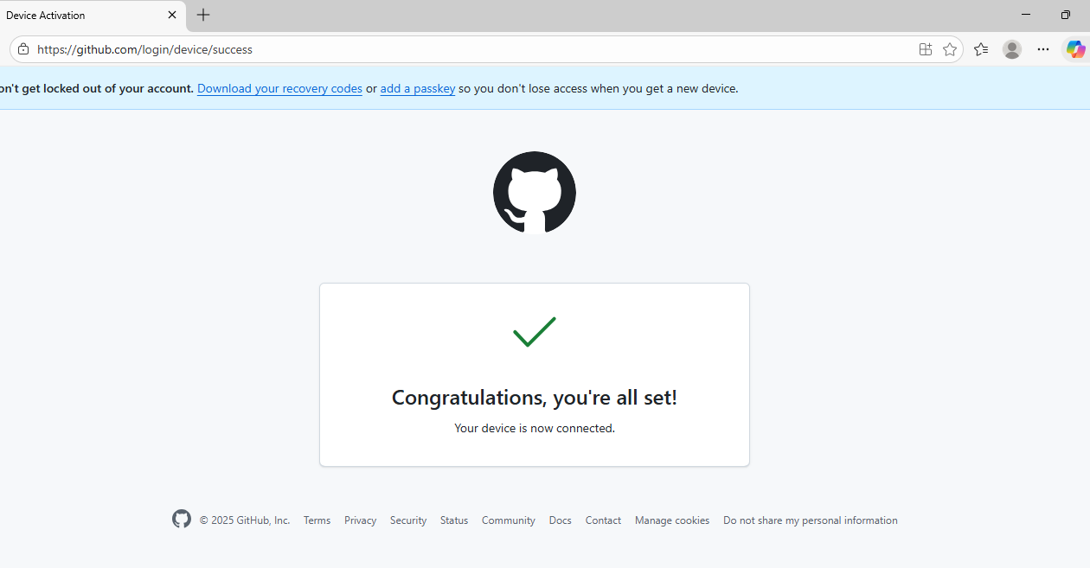

Create repo via GH CLI
gh repo create CC_<YourName>_<YourRollNumber>/Lab13 --public
- This creates a GitHub repository for your lab work.
- --public makes the repo public
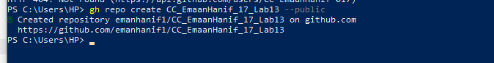

Clone the Repo Locally
git clone https://github.com/emanhanif1/CC_EmaanHanif_17_Lab13.git
cd CC_EmaanHanif_17_Lab13

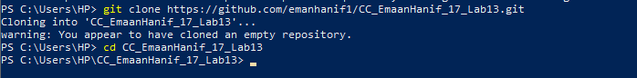

Create a First Commit
echo "# Lab 13" > README.md
git add README.md
git commit -m "Initial commit"
git push origin main

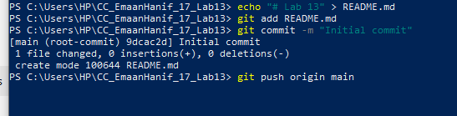

Create Codespace Again
Now run:
gh codespace create --repo emanhanif1/CC_EmaanHanif_17_Lab13

gh codespace create --repo <user_name>/Lab13

- This command creates a Codespace for the repository.
- <user_name> is your GitHub username.
- Codespace is essentially a cloud-based development environment preconfigured for coding.

Codespace list
- This lists all Codespaces associated with your account.
- You’ll see the Codespace name, repository, and status.
- Screenshot required: taskA_codespace_create_and_list.png
- Connect to the Codespace via SSH
gh codespace ssh -c <your_codespace_name>

- <your_codespace_name> is the name you got from the previous list command.
- This opens a terminal inside the Codespace shell.
- You can now run code, Git commands, and other lab operations.

Now you can connect to the Codespace via SSH:
gh codespace ssh -c reimagined-carnival-4jp7vxjrvgrw3qrvr
- The terminal will open inside the Codespace shell.

task0_codespace_ssh_connected.

Install AWS CLI using curl (Linux / macOS)
# Download AWS CLI v2 bundle
curl "https://awscli.amazonaws.com/awscli-exe-linux-x86_64.zip" -o "awscliv2.zip"

# Unzip the bundle
unzip awscliv2.zip

# Install AWS CLI
sudo ./aws/install

# Verify installation
aws --version

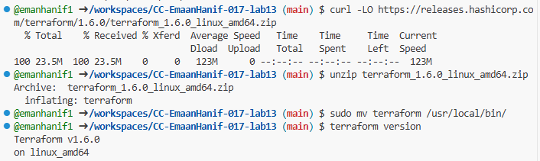

Install Terraform using curl (Linux / macOS)
# Download Terraform zip (replace version if needed)
curl -LO https://releases.hashicorp.com/terraform/1.6.0/terraform_1.6.0_linux_amd64.zip

# Unzip the Terraform binary
unzip terraform_1.6.0_linux_amd64.zip

# Move it to /usr/local/bin to make it executable globally
sudo mv terraform /usr/local/bin/

# Verify installation
terraform version

Task 1 — Create IAM Group and Output Details

Create Project Directory
- Created a new project directory named Lab13 using the following commands:
- mkdir -p ~/Lab13
- cd ~/Lab13
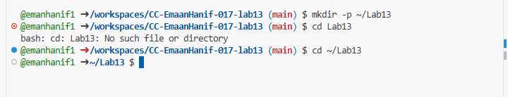
- Verified that the directory was successfully created and accessed.
- Captured a screenshot of the terminal and saved it as task1_project_directory.png.

Create Main Terraform File
- Created the main Terraform configuration file using:
- touch main.tf
- This file will be used to define IAM resources and outputs.
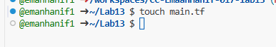

create main.tf for IAM Group

Create main.tf with AWS Provider
Opened main.tf in the project directory.
Added the AWS provider configuration to use local AWS credentials:
provider "aws" {
shared_config_files = ["~/.aws/config"]
shared_credentials_files = ["~/.aws/credentials"]
}
Created an IAM group named developers:
resource "aws_iam_group" "developers" {
name = "developers"
path = "/groups/"
}
Added an output block to display group details after deployment:
output "group_details" {
value = {
group_name = aws_iam_group.developers.name
group_arn = aws_iam_group.developers.arn
unique_id = aws_iam_group.developers.unique_id
}
}
Saved the file and captured a screenshot as task1_main_tf.png.

Initialize Terraform
- Run the following command to initialize the Terraform project:
terraform init

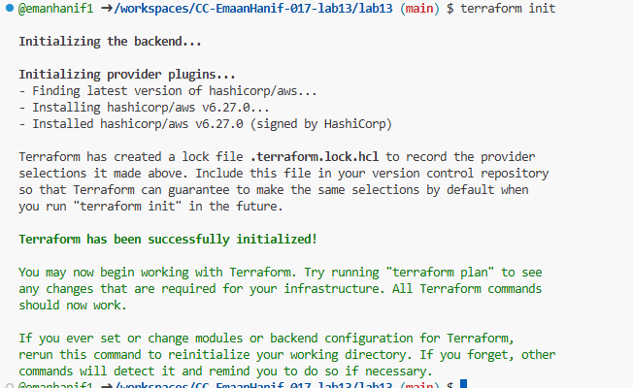
- Verified that Terraform successfully initialized the backend and downloaded required AWS provider plugins.

Apply the Terraform Configuration
Command:
terraform apply -auto-approve

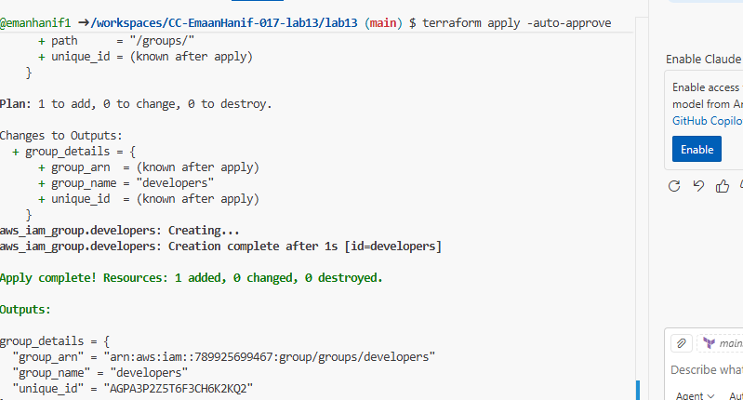
- This command creates all resources defined in main.tf automatically, without asking for manual confirmation (-auto-approve).
- In this task, it creates the IAM group developers in AWS.

Display the Terraform Output
Command:
terraform output
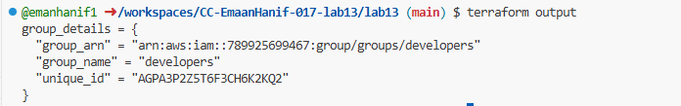
- Terraform outputs allow us to see the attributes of the created resources.
- In this task, it displays the IAM group details:
  - group_name → Name of the group
  - group_arn → Amazon Resource Name (unique identifier in AWS)
  - unique_id → Unique ID assigned by AWS

- Verify the group in AWS Console:
- Navigate to IAM → Groups in AWS Console

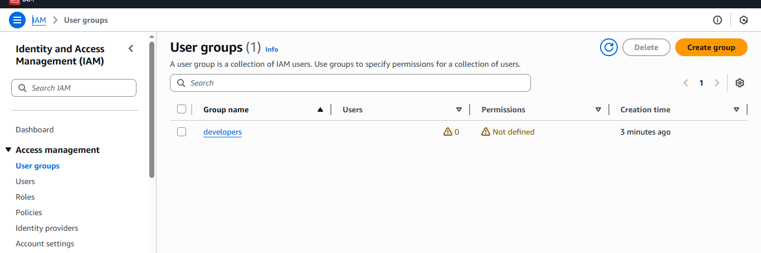

Task2
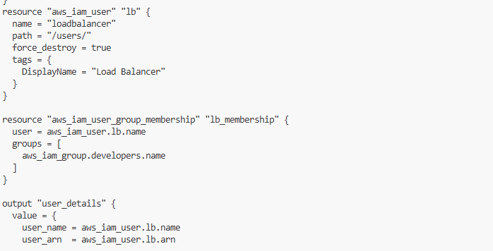

• aws_iam_user → creates a new user in AWS.
• aws_iam_user_group_membership → automatically adds the user to the developers group.
• output "user_details" → allows us to view user info after deployment.

Apply the Terraform Configuration
terraform apply -auto-approve

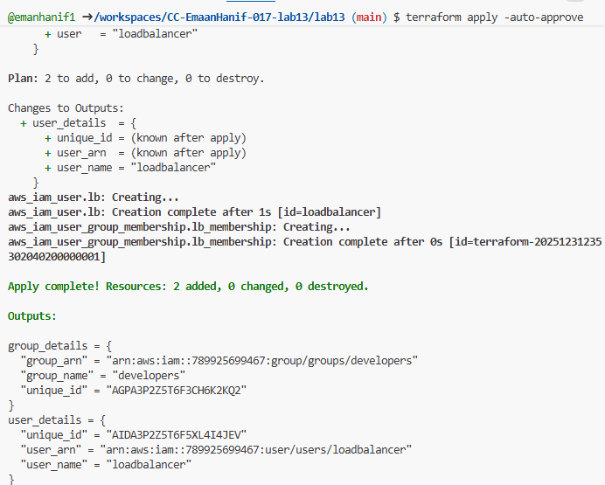
- Applies the changes and actually creates the user and adds it to the group in AWS.
- The -auto-approve flag avoids manual confirmation.
📸 Screenshot: Save as task2_terraform_apply.png

Display the Outputs
terraform output
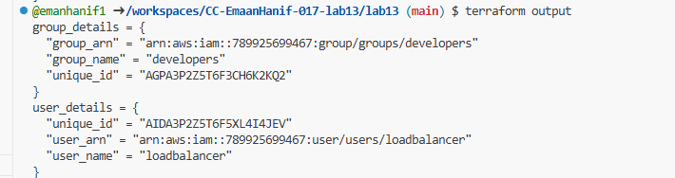

Shows the details of both the IAM group and the new IAM user.
- Confirms that Terraform created the resources correctly.

Verify the User in AWS Console
- Log in to AWS Management Console.
- Navigate to IAM → Users.
- Click on the loadbalancer user.

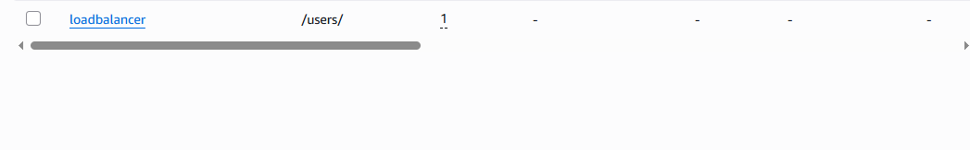
So loadbalancer user. exists
- Check the Groups tab to confirm membership in developers.

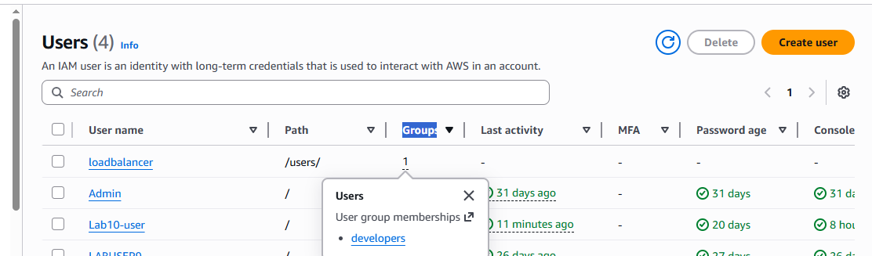

- main.tf now manages both IAM group and IAM user with group membership.
- Terraform handles creation, membership assignment, and outputs.
- Verification via AWS Console ensures everything is correctly applied.

Task 3 — Attach Policies to IAM Group

Update main.tf to Attach Policies
- Open main.tf in your project directory.

- Added resources to attach AWS managed policies to the developers group:

- 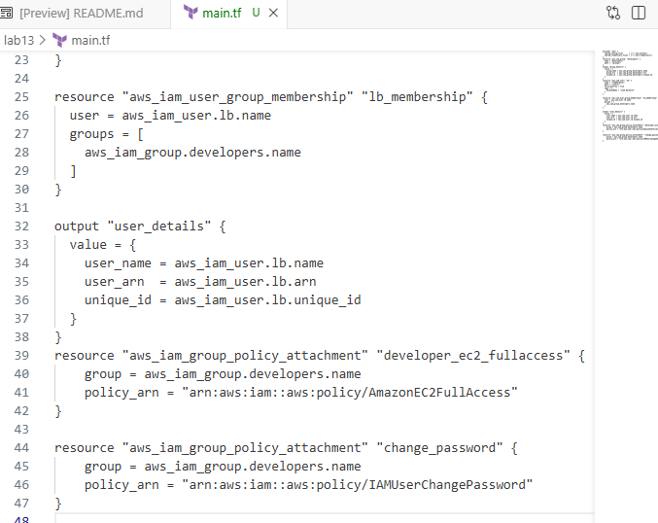
- AmazonEC2FullAccess → allows the developers group to fully manage EC2 instances.
- IAMUserChangePassword → allows users in the group to change their own passwords.
- Terraform manages the policy attachment automatically.
📸 Screenshot: Save as task3_main_tf_policies.png

Apply the Terraform Configuration
terraform apply -auto-approve

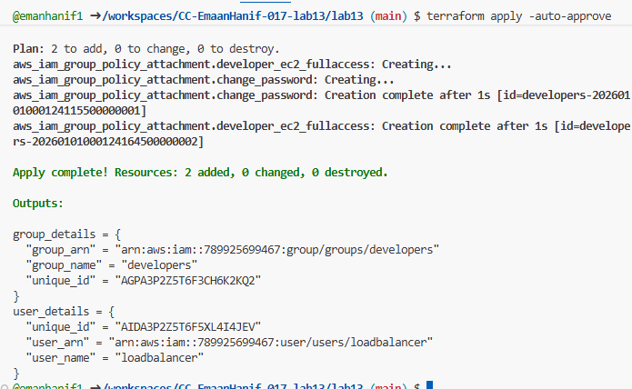
- Applies the changes and attaches the policies to the developers group.
- -auto-approve avoids manual confirmation.
📸 Screenshot: Save as task3_terraform_apply.png

Verify Policies in AWS Console
- Open AWS Management Console.
- Navigate to IAM → Groups → developers → Permissions tab.
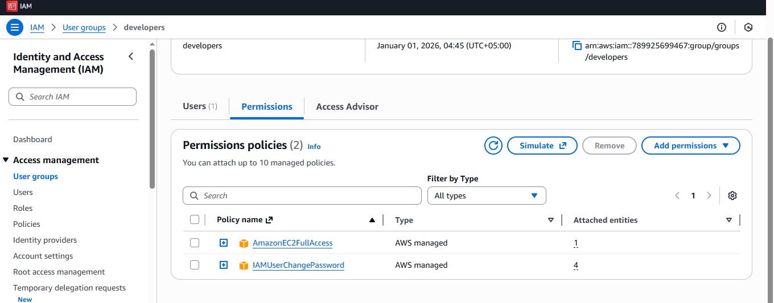
- Verify that the following policies are attached:
  - AmazonEC2FullAccess
  - IAMUserChangePassword
📸 Screenshot: Save as task3_aws_console_policies.png

Summary
- Updated main.tf to include policy attachments for the developers group.
- Terraform applied the configuration and attached policies automatically.
- Verified policy attachments in AWS Console for confirmation.

Task 4 — Create Login Profile for IAM User

Create variables.tf for IAM Password
- Created a variable to store a temporary password for the IAM user:

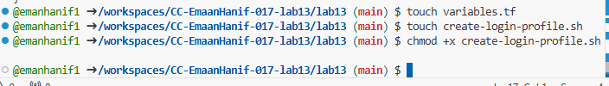
- 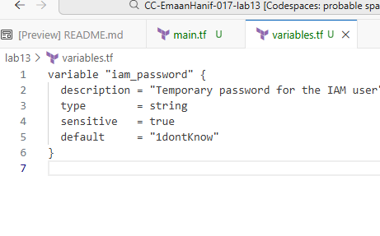
- This allows Terraform to pass a password securely to the script.
- Marked sensitive = true so it doesn’t show in plain text in outputs.
Screenshot: Save as task4_variables_tf.png

Create Bash Script create-login-profile.sh
- Created a bash script to create the login profile if it doesn’t exist:

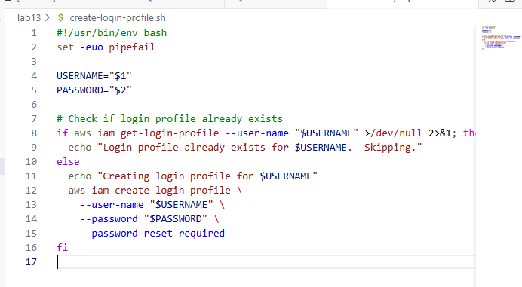

- Automates creating a login profile for the IAM user.
- Checks if it already exists to avoid errors.
- Enforces password reset on first login.
Screenshot: Save as task4_create_login_script.png

Make Script Executable
chmod +x create-login-profile.sh

- Makes the bash script runnable by Terraform.
📸 Screenshot: Save as task4_chmod_script.png

Update main.tf to Use null_resource
- Added the following resource after the IAM user creation
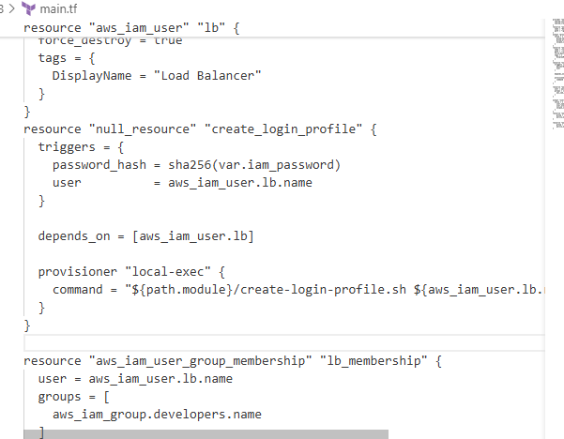

- null_resource with local-exec allows Terraform to run the bash script locally.
- triggers ensures Terraform re-runs the script if password changes.
- depends_on ensures the script runs after the user is created.

Upgrade Providers
terraform init -upgrade
This will:
  - Download the latest compatible version of the null provider.
  - Update .terraform.lock.hcl to match the new configuration.

Step 2: Apply Again
terraform apply -auto-approve -var="iam_password=MySecurePass123!"

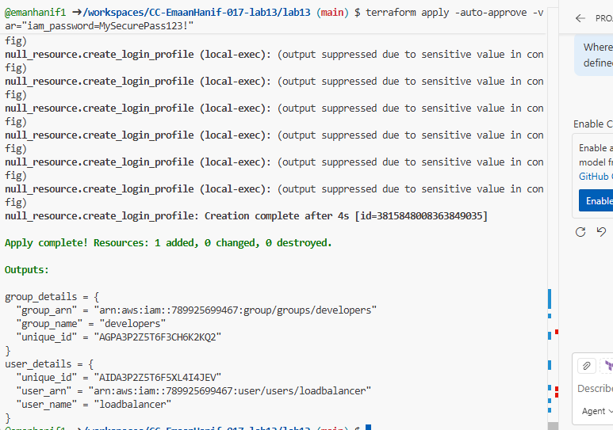
- Now Terraform will successfully run your null_resource and create the IAM login profile.

Step 3: Verify
terraform output

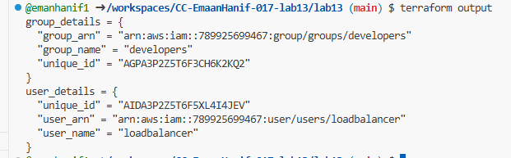

Verify Login Profile Using AWS CLI
aws iam get-login-profile --user-name loadbalancer

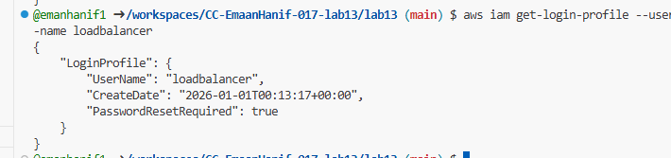
- Confirms that the IAM user now has a login profile and can sign in.
📸 Screenshot: Save as task4_aws_cli_verify.png

Test Login in AWS Console
- Open AWS Console login page.
- Sign in as IAM user:
  - Username: loadbalancer
  - Password: MySecurePass123!
- You should be prompted to reset the password.

Task 5 — Generate Access Keys for IAM User

Update main.tf to Add Access Keys
- Added a resource to create an access key for the IAM user loadbalancer:
resource "aws_iam_access_key" "lb_access_key" {
user = aws_iam_user.lb.name
}

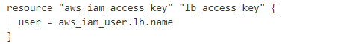

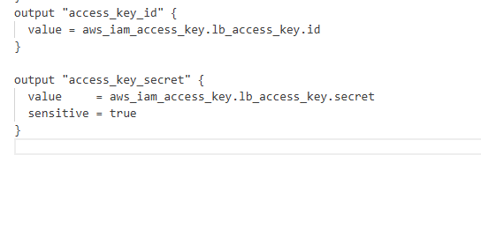

Why we do this:
- Access keys allow programmatic access to AWS for the IAM user.
- access_key_secret is marked sensitive so it doesn’t display in plain text during Terraform output.
📸 Screenshot: Save as task5_main_tf_access_keys.png
Apply the Terraform Configuration
terraform apply -auto-approve -var="iam_password=MySecurePass123!"

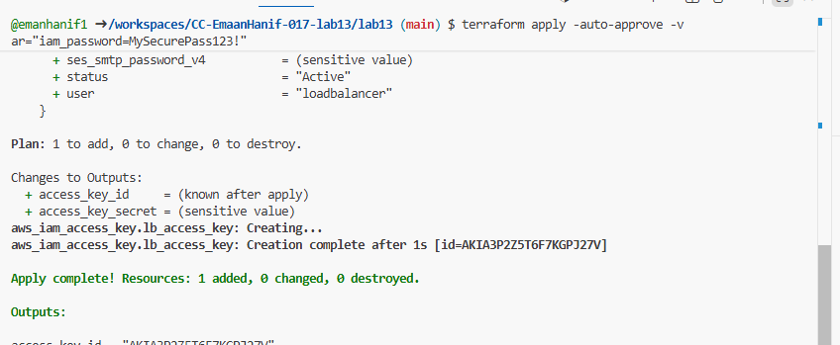
- Creates the access key for the IAM user automatically.
- Ensures Terraform manages both creation and state tracking.
📸 Screenshot: Save as task5_terraform_apply.png

Display the Terraform Outputs
terraform output

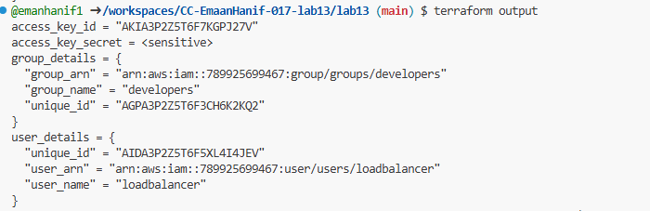
- Shows the access_key_id but hides the secret for security.
📸 Screenshot: Save as task5_terraform_output.png

View Secret in Terraform State
cat terraform.tfstate | grep -A 10 "access_key_secret"

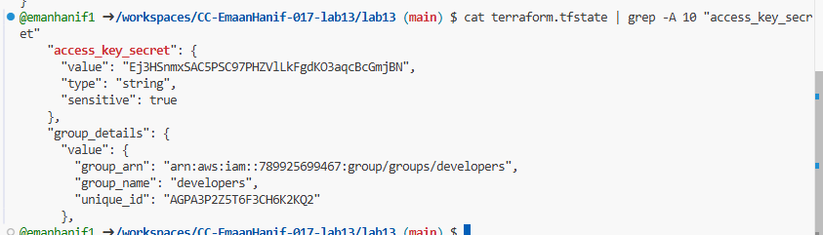

- The actual secret access key is stored in Terraform state (terraform.tfstate).
- Useful for retrieving the secret if needed (but keep it safe!).
📸 Screenshot: Save as task5_tfstate_secret.png

Verify Access Key in AWS Console
- Open AWS Management Console.
- Navigate to IAM → Users → loadbalancer → Security credentials.
- Verify the access key exists for the user.

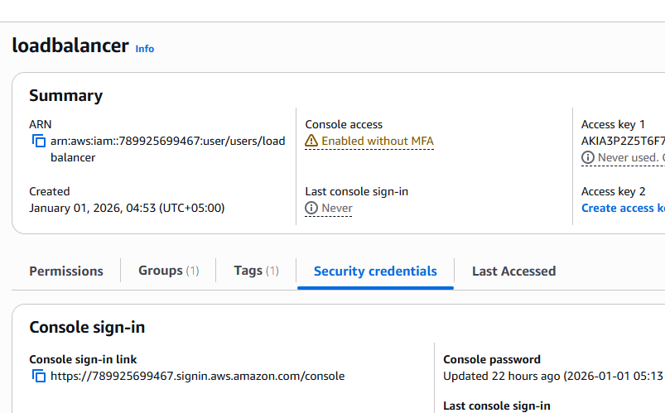
📸 Screenshot: Save as task5_aws_console_access_keys.png

Summary
- aws_iam_access_key resource generates programmatic access for the IAM user.
- Sensitive information is hidden in Terraform outputs but stored in state.
- Verification via AWS Console ensures keys are correctly created.
- Terraform ensures full lifecycle management: creation, updates, and tracking.

Task 6 — Implement Terraform Remote State with S3

Step 1: Open AWS Console
- Go to AWS Management Console
- Log in to your AWS account

Step 2: Navigate to S3
- In the search bar at the top, type S3
- Click S3 from the services list
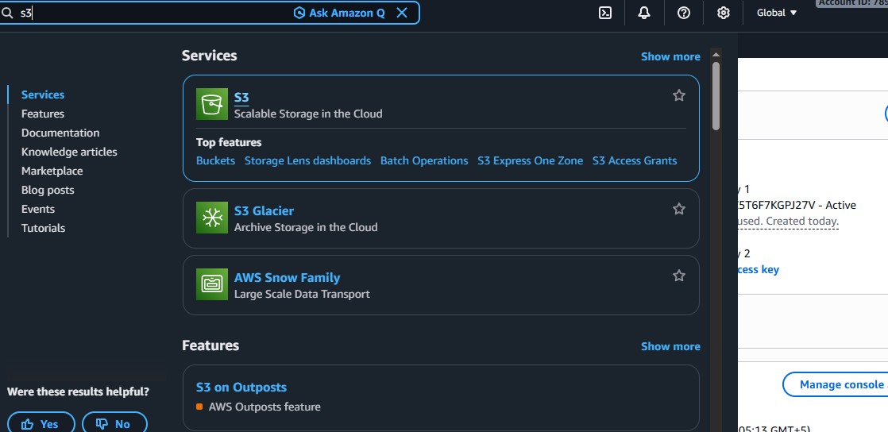

Step 3: Click Create Bucket
- On the S3 dashboard, click the Create bucket button
📸 Screenshot 1 (IMPORTANT)
➡️ Take screenshot of this Create bucket page
task6_s3_bucket_create.png

Step 4: Enter Bucket Details
- Bucket name:
myapp-s3-bucket-demo-13
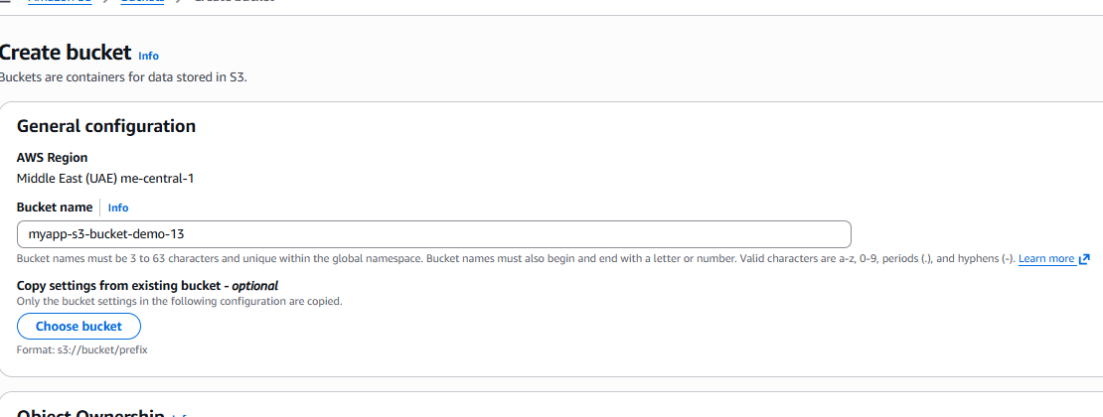

Region: Select me-central-1

Step 5: Enable Versioning
- Scroll down to Bucket Versioning
- Select Enable

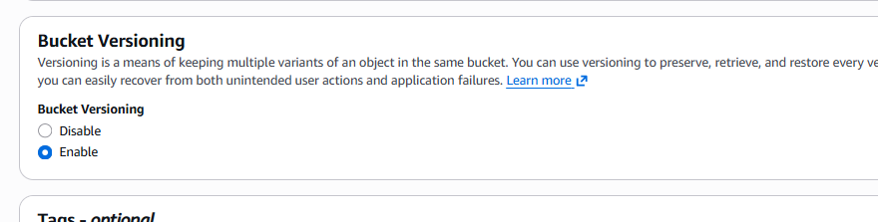

Step 6: Keep Other Settings Default
- Do not change:
  - Object Ownership
  - Block Public Access
  - Encryption
- Leave everything else as default

Step 7: Create the Bucket
- Scroll to the bottom
- Click Create bucket

Step 8: Verify Versioning
- Click on your bucket name
- Go to the Properties tab
- Check Bucket Versioning → it should show Enabled
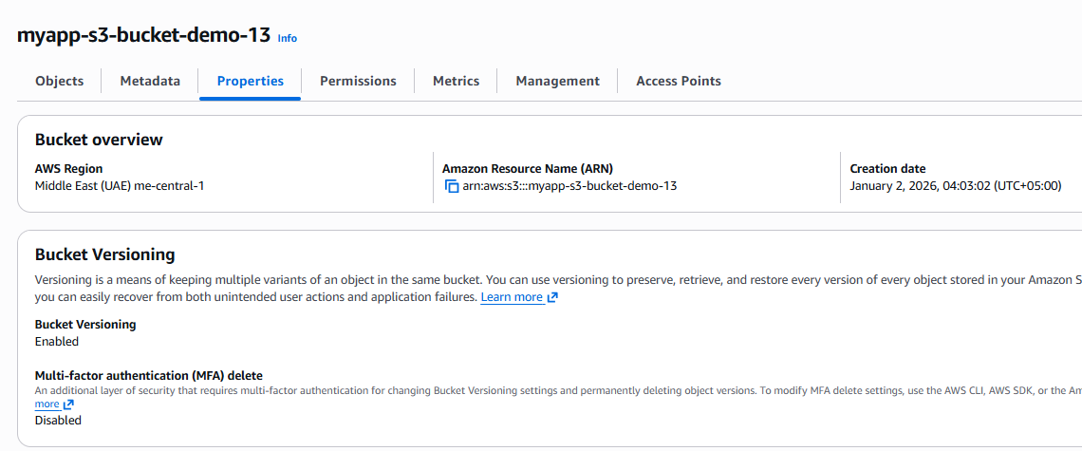

- s3-bucket was created in the AWS Console to store the Terraform state file remotely.
- Bucket versioning was enabled to keep track of state file changes and allow recovery if needed.

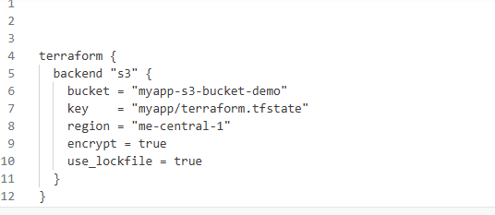

Clean and Retry
Sometimes Terraform gets "stuck" on a failed initialization. After checking the above, run these commands:
rm -rf .terraform
terraform init -migrate-state

- Reinitialize Terraform with the backend:
terraform init -migrate-state
- Type yes when prompted to migrate state

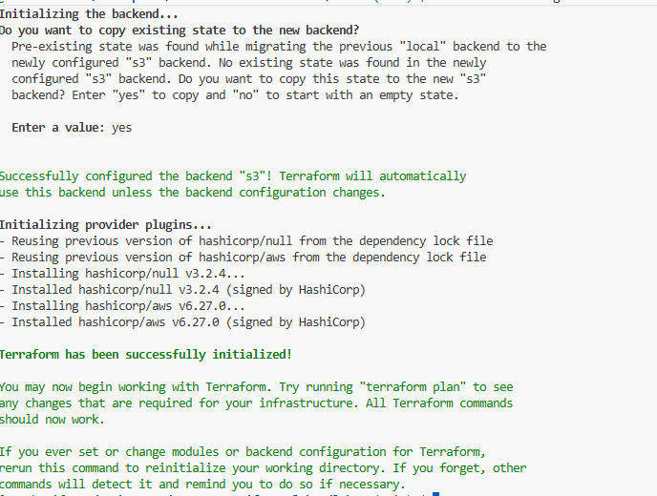

where it says Enter a value:, you must:
- Type yes and press Enter.
- Terraform will then migrate your state from your local machine to the S3 bucket myapp-s3-bucket-demo-13.
- You should see a message saying "Terraform has been successfully initialized!"

- Apply the configuration:
terraform apply -auto-approve -var="iam_password=MySecurePass123!"
- Save screenshot as: task6_terraform_apply.png — terraform apply with remote state.
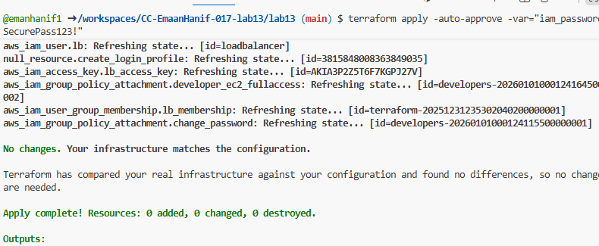
- Verify state file in S3:
- Navigate to S3 → myapp-s3-bucket-demo → myapp/
- You should see terraform.tfstate file

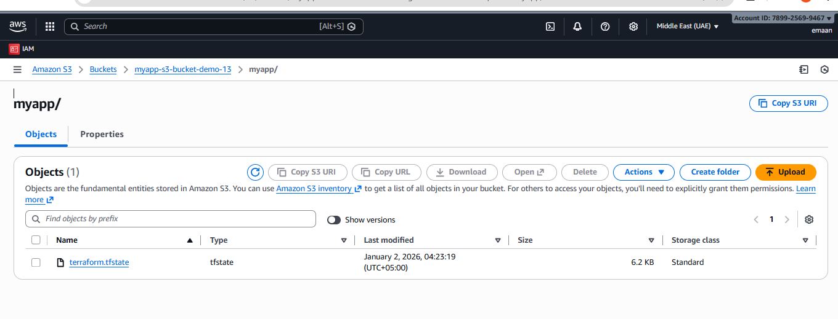

- Save screenshot as: task6_s3_tfstate_file.png — S3 bucket showing terraform.tfstate file.
- Go back to your S3 Console for bucket myapp-s3-bucket-demo-13.
- Click the Refresh button (circular arrow) on the right side of the "Objects" tab.
- You should now see a folder named myapp/.
- Click into myapp/ to find the terraform.tfstate file.

- Check local state file:
ls -la terraform.tfstate*

- Save screenshot as: task6_local_state_backup.png — showing local state backup file.
Your terminal output for ls -la terraform.tfstate* confirms the migration was successful:
- terraform.tfstate: This file is now 0 bytes. This is exactly what should happen because the actual state data has been moved to the cloud.
- terraform.tfstate.backup: This file contains your previous local state data (6315 bytes), kept as a safety backup.

- Destroy resources and verify state change:
terraform destroy -auto-approve

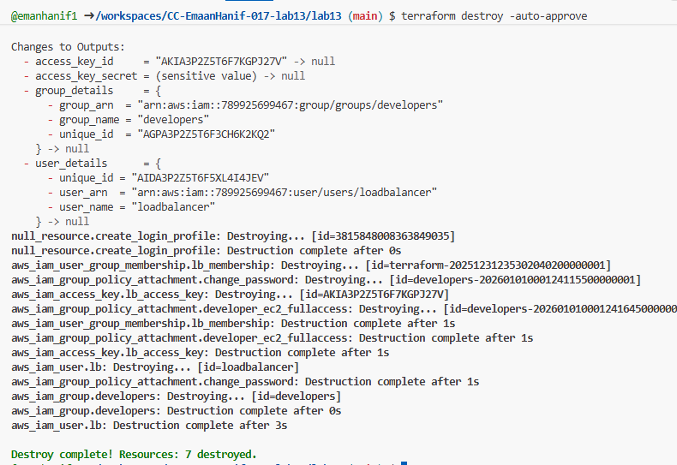
- Save screenshot as: task6_terraform_destroy.png — terraform destroy output.
- Verify updated state in S3:
- Refresh S3 bucket view
- Check the terraform.tfstate file (it should show empty resources)
- Save screenshot as: task6_s3_tfstate_destroyed.png — S3 state file after destroy.

Task 7 — Create Multiple Users from CSV File

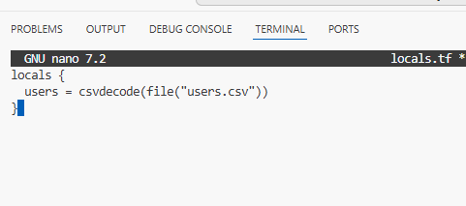
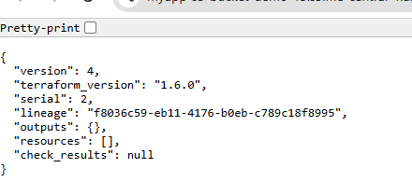
If you click on the file and select "Open" or "View," you will see that the "resources": [] section is now an empty list. This is because there are no longer any active resources in your AWS account managed by this configuration.

- Create the file: In your terminal, run touch users.csv.
- Add the content: Open the file and paste the list below exactly as shown.
- The first line must be user_name with no spaces, as your main.tf logic expects this header to map the values.
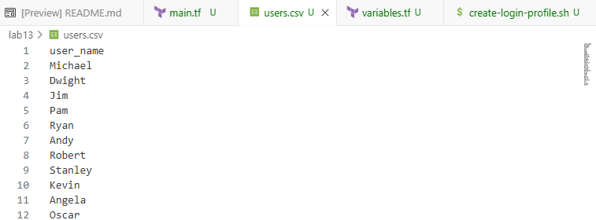

- Open main.tf in your editor.
- Remove or Comment Out the old aws_iam_user, aws_iam_access_key, and aws_iam_user_group_membership blocks you used for the single user in previous tasks.
- Paste the New Code provided in your instructions.
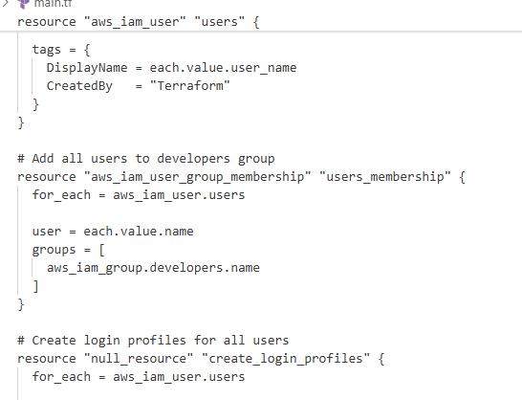

- The line { for user in local.users : user.user_name => user } takes the list from your CSV and turns it into a Map. Terraform requires a map or a set of strings to use for_each.

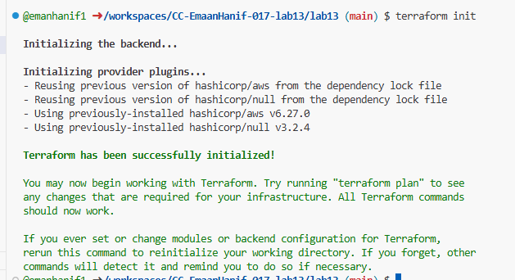

The errors you are seeing (exit status 127) are happening because of small typing errors (spaces) in your main.tf code. These spaces are breaking the file paths and the names of the variables, so Linux cannot find your script.

1. Fix the local-exec Command
In your error message, it says ./create-login-profile. sh (with a space). This makes Linux think the file name is just create-login-profile..
Find this block in main.tf:
Terraform
provisioner "local-exec" {
# CHANGE THIS:
command = "${path.module}/create-login-profile.sh ${each.value.name} '${var.iam_password}'"
}
- Remove the space between .sh and the rest of the file name.

- Apply the configuration to create all users:
terraform apply -auto-approve -var="iam_password=MySecurePass123!"
- Save screenshot as: task7_terraform_apply.png — terraform apply output showing all users being created.
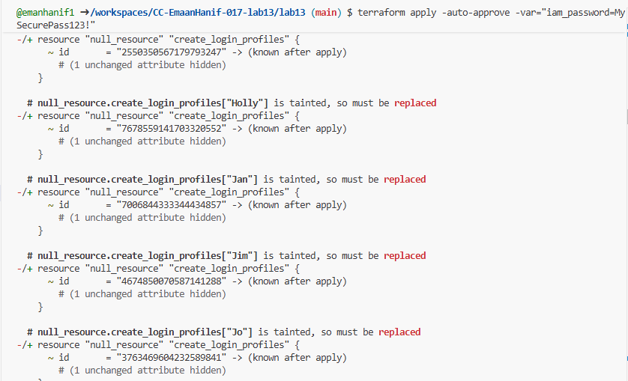
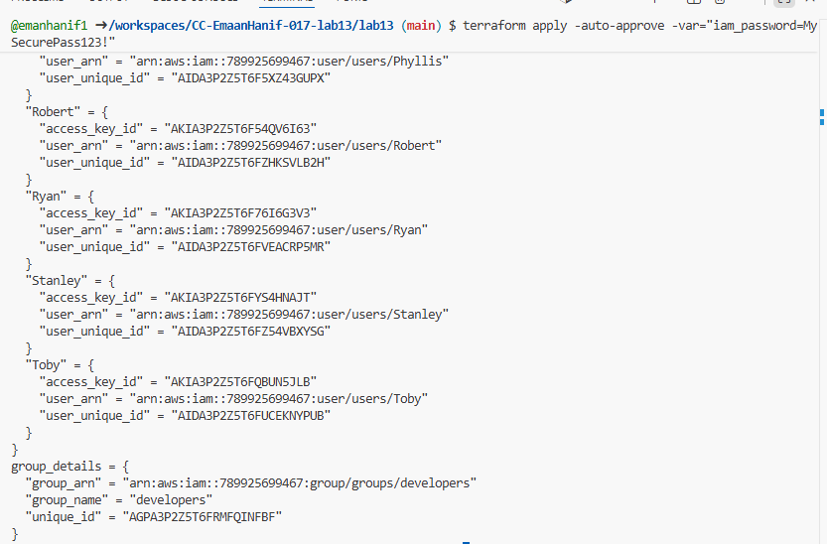

1. Display the Outputs
Run the following command in your terminal:
terraform output
- What to expect: You will see a large block of data under all_users_details listing the ARN and Access Key ID for all 26 users (Michael, Dwight, Jim, etc.).
- Sensitive Data: Notice that all_access_key_secrets will say <sensitive>. This is because you marked it as sensitive in your main.tf to prevent secrets from printing in clear text in the terminal logs.
- Screenshot: Save this as task7_terraform_output.png.
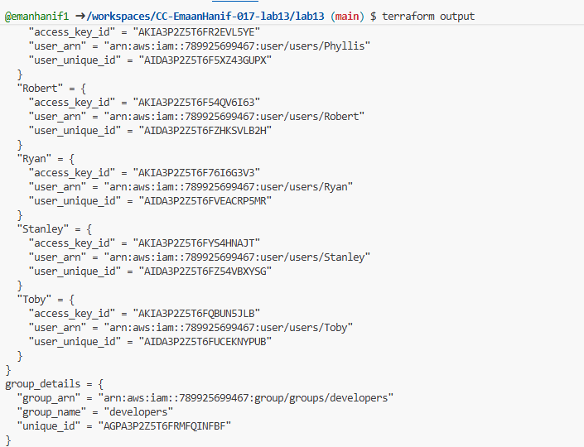

View Secrets in State
Since you are using an S3 Backend, the local terraform.tfstate file is empty (0 bytes). To see the secrets, you must pull the state from S3:
Bash
terraform state pull | grep -A 5 "all_access_key_secrets"
- Screenshot: Capture the terminal showing the raw secret keys and save it as task7_tfstate_secrets.png.
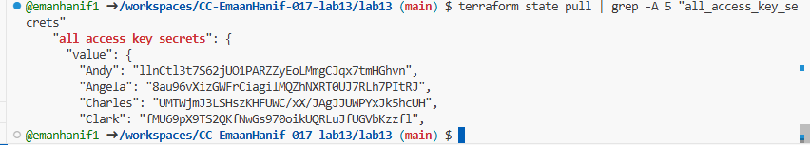

AWS Console Verification
Log in to your AWS Management Console to confirm the resources exist:
- Users List: Go to IAM > Users. You should see the full list of names from your CSV (Angela, Oscar, etc.).

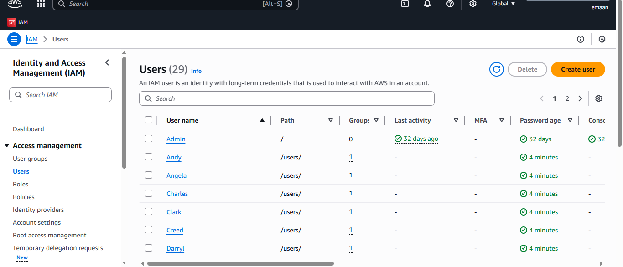
- Save as task7_aws_console_all_users.png.
- Group Membership: Go to IAM > User Groups > developers > Users tab. Confirm all 26 users are members.

- 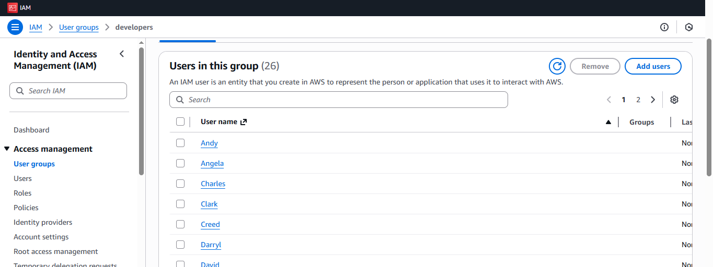

- Save as task7_aws_console_group_members.png.
- Access Keys: Click on Michael, go to the Security credentials tab, and find the "Access keys" section. Save as task7_aws_console_user_access_key.png.

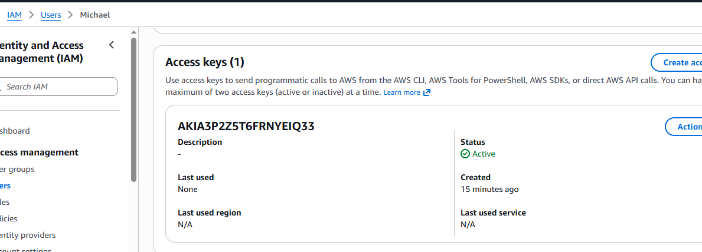

S3 State Verification
- Navigate: Go to your S3 bucket myapp-s3-bucket-demo-13.
- Check File: Open the myapp/ folder and look at the terraform.tfstate file.
- Observation: You will notice the file size is much larger now than it was in Task 6 because it now tracks 26 users, 26 memberships, and 26 access keys.

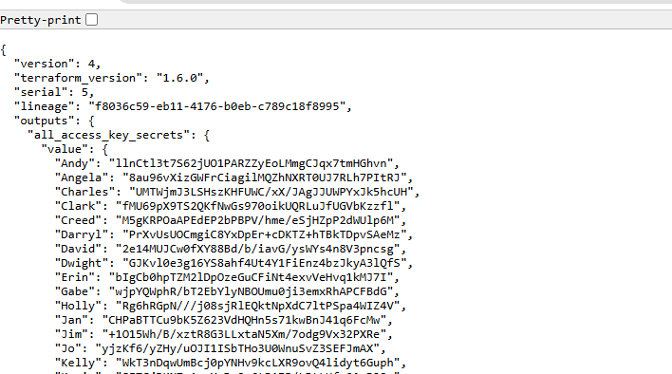

- Check Status: Run git status to make sure all the correct files are in green (staged) and your state files/folders are ignored.
- Commit: Run your first commit to save the version
- Verify: Run ls -la one last time to ensure your project structure is clean before you run your final terraform destroy.

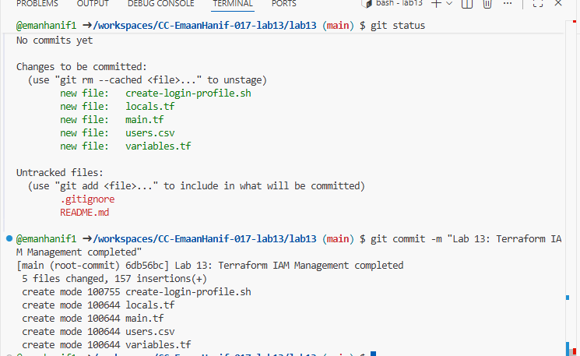

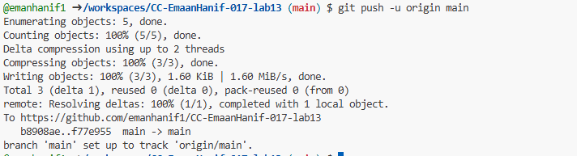

Cleanup

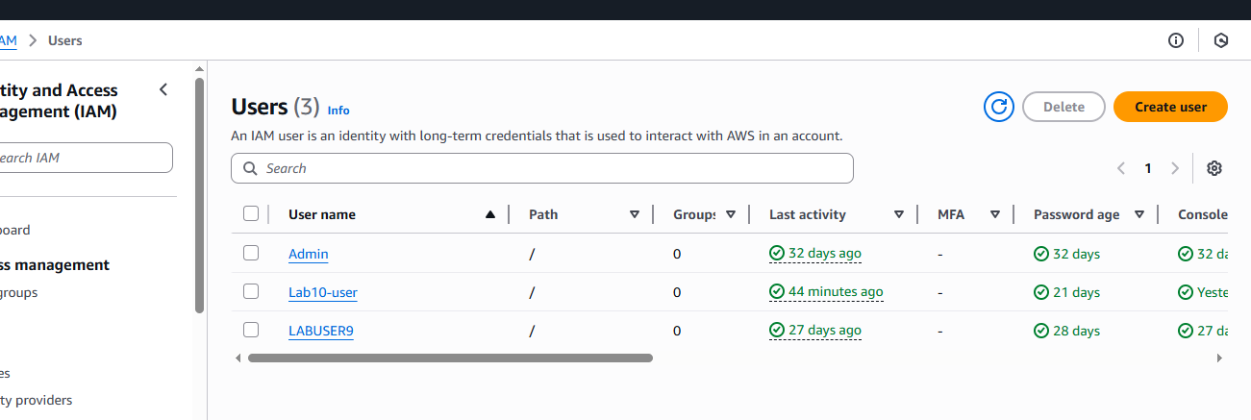

My old users are left only
- Verify users deleted in AWS Console:
- Navigate to IAM → Users
- Save screenshot as: cleanup_aws_console_users_deleted.png — AWS Console showing no users.
- Verify group deleted in AWS Console:
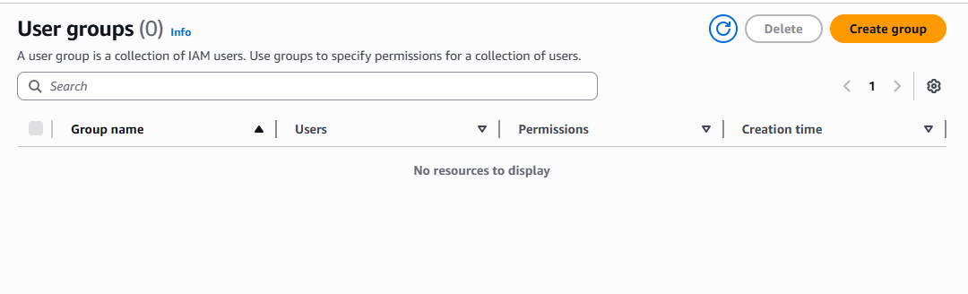

- Empty the Bucket: S3 will not let you delete a bucket that has files in it. You must first go inside the bucket and delete the myapp/terraform.tfstate file.
- Delete the Bucket: Once it is empty, go back to the "General purpose buckets" list, select the bucket, and click the Delete button.
- Confirm: You will have to type the name of the bucket to confirm you want to permanently remove it.
