Lab Project – Terraform + Ansible Roles: Nginx Frontend with 3 Backend HTTPD Servers (HA + Auto-Config)

Name: Emaan Hanif
Reg no: BSE 017

Terraform – Networking & Common Settings (Architecture Definition)

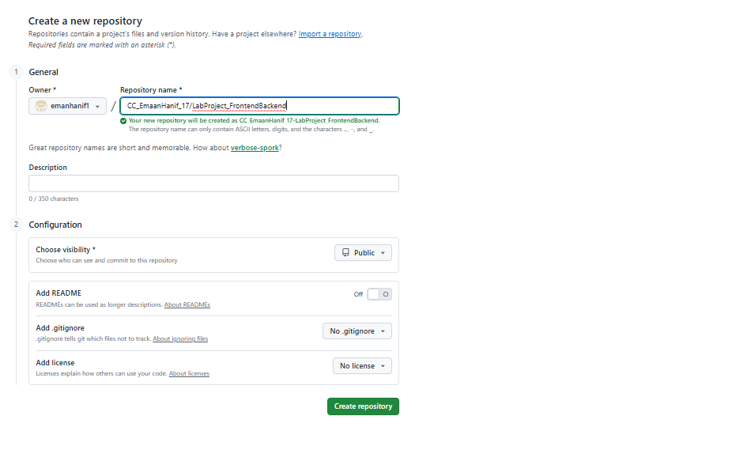
- Go to GitHub → New Repository
Repository name:
- CC_EmaanHanif_17/LabProject_FrontendBackend

Install AWS CLI

In Codespace shell, install AWS CLI:
- curl "https://awscli.amazonaws.com/awscli-exe-linux-x86_64.zip" -o "awscliv2.zip"
- unzip awscliv2.zip
- sudo ./aws/install
aws --version

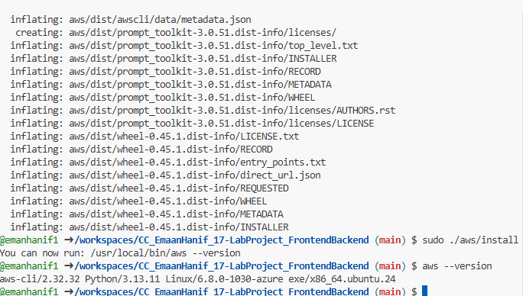

Configure AWS CLI:

aws configure

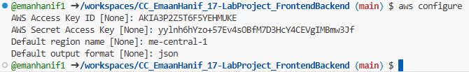

Install Terraform CLI
- wget -O - https://apt.releases.hashicorp.com/gpg | sudo gpg --dearmor -o /usr/share/keyrings/hashicorp-archive-keyring.gpg
- echo "deb [arch=$(dpkg --print-architecture) signed-by=/usr/share/keyrings/hashicorp-archive-keyring.gpg] https://apt.releases.hashicorp.com $(grep -oP '(?<=UBUNTU_CODENAME=).*' /etc/os-release || lsb_release -cs) main" | sudo tee /etc/apt/sources.list.d/hashicorp.list
- sudo apt update
- sudo apt install terraform
terraform --version

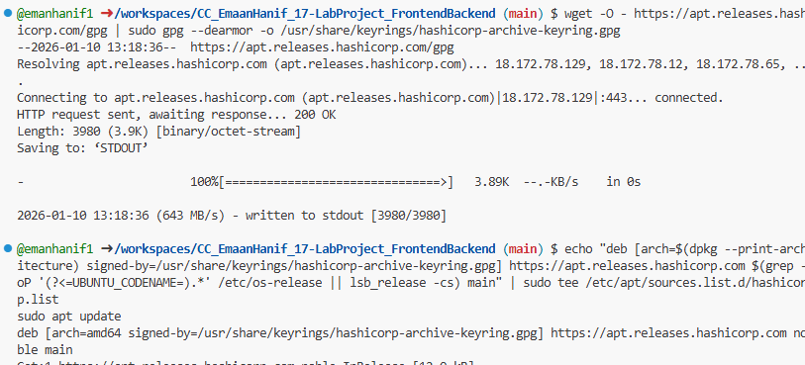

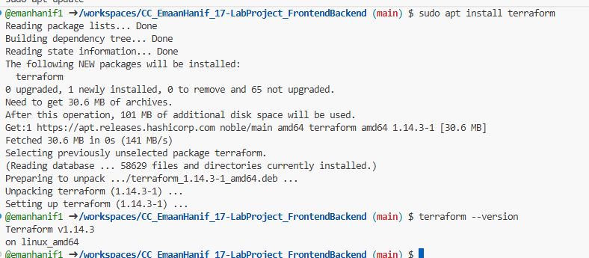

Update Package Lists
sudo apt update

Install Python3 and pip
sudo apt install -y python3 python3-pip

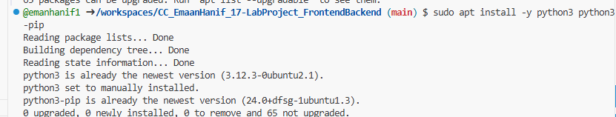

Verify Installation
python3 --version
pip3 --version

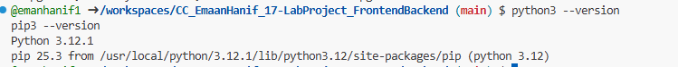

- Install Ansible (core) using pipx:
pipx install ansible-core
ansible --version

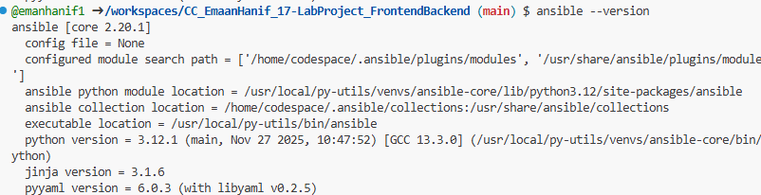

Task1
- Variables setup (variables.tf):
  - vpc_cidr_block, subnet_cidr_block, availability_zone, env_prefix, instance_type, public_key, private_key.
- Locals (locals.tf):
  - Determine your public IP:
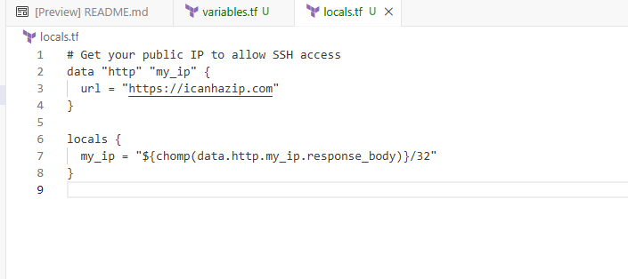

- VPC & Subnet:
  - Either inline in main.tf or via modules/subnet.
  - VPC must have:
    - CIDR from var.vpc_cidr_block.
    - Internet gateway and default route for 0.0.0.0/0.
- Subnet must be public (map public IPs on launch or use IGW + route table).

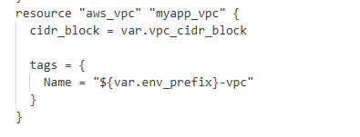

Internet Gateway
- An Internet Gateway is attached to the VPC.
- It enables communication between the VPC and the public internet.
- Required for accessing web services and system updates.

Route Table Configuration
- A route table is created for the public subnet.
- A default route (0.0.0.0/0) is configured to forward traffic to the Internet Gateway.
- This ensures outbound and inbound internet connectivity.

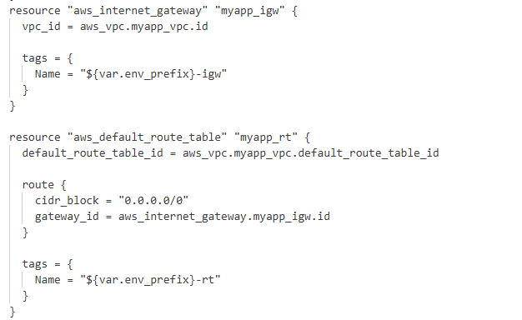
Security Group:
- SSH: port 22 from local.my_ip.
- HTTP: port 80 from 0.0.0.0/0.

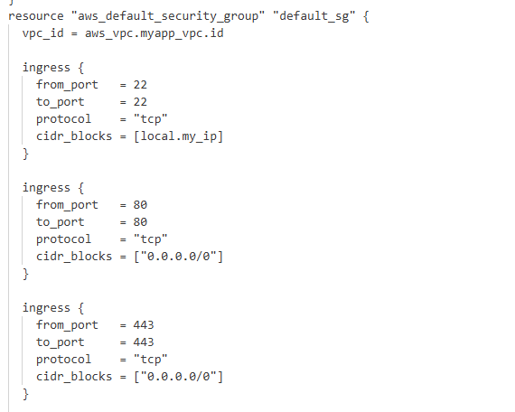

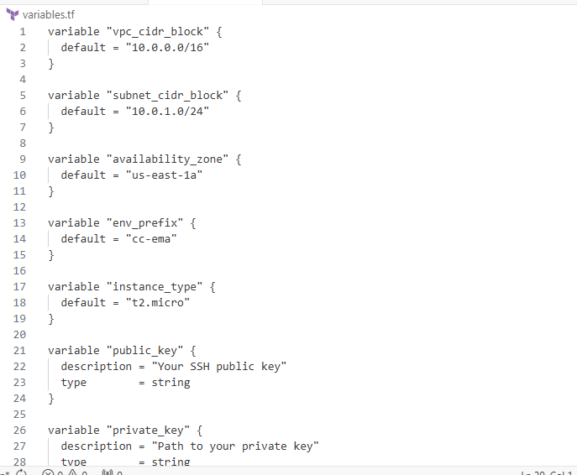

Virtual Private Cloud (VPC)
- A VPC is created to provide an isolated network environment.
- The VPC CIDR block is defined using a variable for flexibility.
- All frontend and backend servers are deployed inside this VPC.

Public Subnet
- A public subnet is created within the VPC.
- Public IP addresses are automatically assigned to instances launched in the subnet.
- This allows EC2 instances to be accessed from the internet.

Route Table Association
- The public subnet is associated with the route table.
- This ensures that all instances in the subnet follow the internet routing rules.

Security Group Configuration
- A security group is created to control inbound and outbound traffic.
- It acts as a firewall for all EC2 instances.

SSH Access Rule
- SSH access (port 22) is allowed only from the user’s public IP address.
- This improves security by preventing unauthorized access.

HTTP Access Rule
- HTTP access (port 80) is allowed from anywhere (0.0.0.0/0).
- This allows public access to the Nginx frontend and backend web servers.

Outbound Traffic Rules
- All outbound traffic is allowed from the instances.
- This enables software installation, updates, and external communication.
Bottom of Form

TASK 2 Terraform – Frontend & Backend EC2 Instances

Create a key pair
Run this in your Codespace terminal:

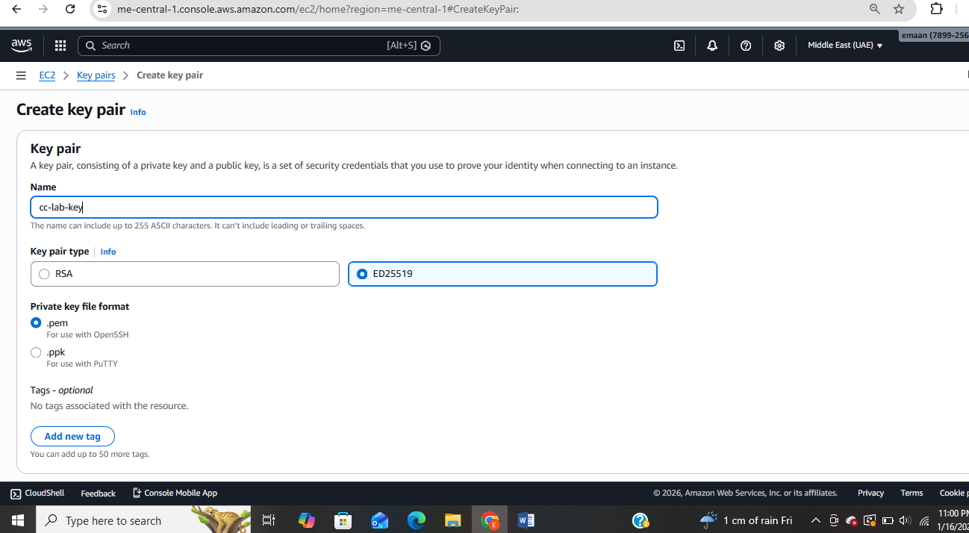
• An SSH key pair is associated with the instance using the public key provided via Terraform variables.

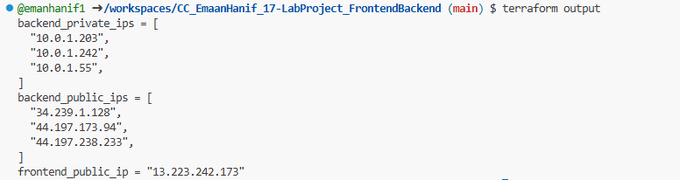

Terraform output ip addreses
backend_private_ips = [
"10.0.1.203",
"10.0.1.242",
"10.0.1.55",
]
backend_public_ips = [
"34.239.1.128",
"44.197.173.94",
"44.197.238.233",
]
frontend_public_ip = "13.223.242.173"

Backend EC2 Instances
- Three EC2 instances are created to act as backend servers.
- These instances run Apache HTTPD.
- Terraform uses count = 3 to create multiple identical instances.
- All backend instances use:
- Same instance type
- Same subnet
- Same SSH key
- Each backend instance gets a unique name tag:
- backend-0
- backend-1
- backend-2
- The same security group is reused:
- This is allowed and keeps the setup simple.

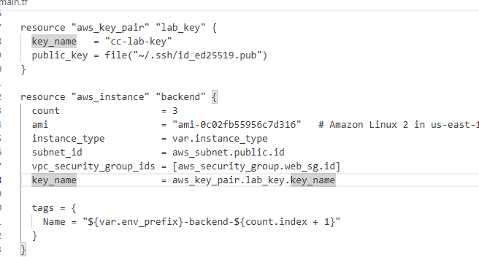
Frontend EC2 Instance
- A single EC2 instance is created to act as the frontend server.
- This instance will later run Nginx using Ansible.
- aws_instance resource is used to create the EC2 instance.
- The instance type is taken from a variable so it can be changed easily.
- The instance is launched inside the public subnet.
- A security group is attached to:
Allow SSH access
Allow HTTP traffic
- An SSH key pair is attached so Terraform and Ansible can log in.
- A tag is added for easy identification:
- Name = "<env-prefix>-frontend"
- This frontend instance acts as the single entry point for use

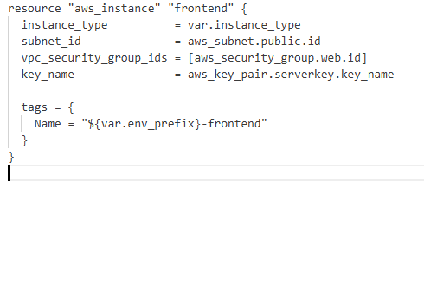

Frontend Public IP Output
- This output shows the public IP address of the frontend EC2 instance.
- The public IP is used to:
  - Access the Nginx load balancer from the browser.
  - Verify load balancing behavior.
- After terraform apply, this IP is printed automatically.

Backend Public IPs Output
- This output shows the public IP addresses of all backend servers.
- Public IPs are useful to:
  - Test each backend individually.
  - Confirm Apache HTTPD is running correctly.
- Outputs are returned as a list.

Backend Private IPs Output
- This output shows the private IP addresses of backend servers.
- Private IPs are used by:
  - Nginx upstream configuration.
  - Internal communication inside the VPC.
- Using private IPs is:
  - More secure
  - Faster
  - Best practice for internal load balancing.

3. Ansible – Global Config & Inventory

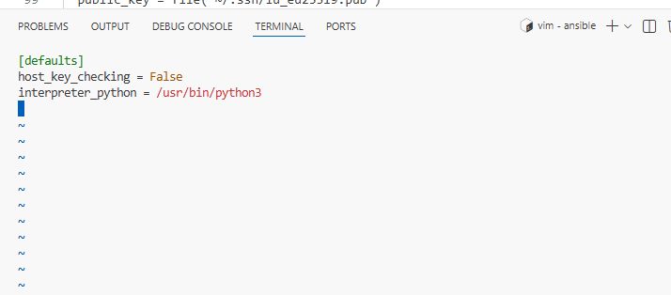
host_key_checking = False
- Prevents SSH host key confirmation prompts.
- Allows Ansible to connect automatically to new EC2 instances.
- Required for fully automated Terraform + Ansible execution.
interpreter_python = /usr/bin/python3
- Forces Ansible to use Python 3 on target machines.
- Ensures compatibility with Amazon Linux.

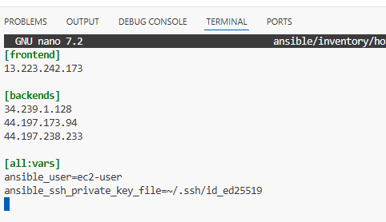

ansible_user=ec2-user
- Default SSH user for Amazon Linux EC2 instances.
ansible_ssh_private_key_file=~/.ssh/id_ed25519
- Private SSH key used by Ansible for authentication.
- Matches the key pair created in Terraform.
These variables:
- Avoid repetition in playbooks.
- Ensure consistent access across all hosts.

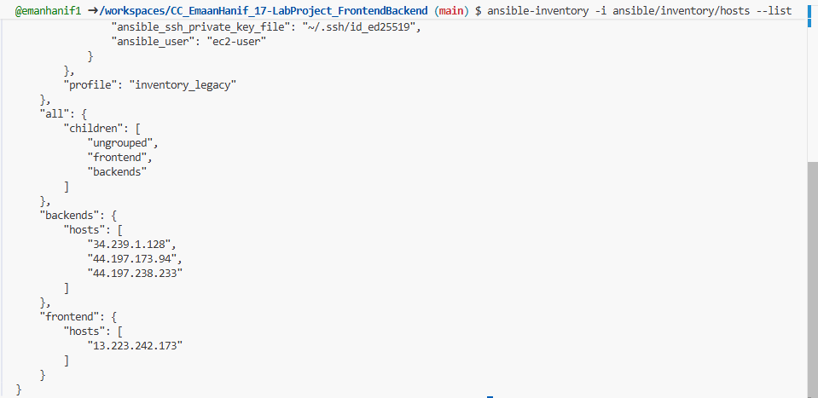

Inventory Type Used
- A static inventory file is used.
- Backend and frontend IPs are taken from Terraform outputs.
- Static inventory is preferred because:
  - It is easier to understand.
  - It simplifies marking and verification.

Task 4 Define the Tasks (roles/backend/tasks/main.yml)
Copy the following into your main.yml. This handles the installation, service management, and the deployment of your dynamic index page 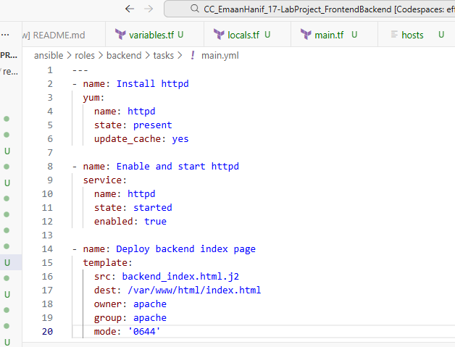

- Installs the Apache web server package (httpd).
- Uses the yum module because the instances run Amazon Linux.
- state: present ensures Apache is installed.
- update_cache: yes refreshes the package list.

Create the Template (roles/backend/templates/backend_index.html.j2)
The requirement asks for a distinct index page per backend. We use Jinja2 variables (like ansible_hostname or inventory_hostname) so that each server identifies itself.

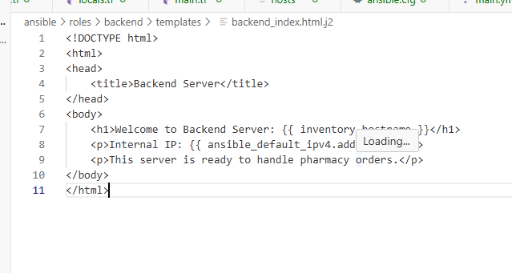

Deploy Backend Index Page (Template)
- Copies a templated HTML file to /var/www/html/index.html.
- Uses template instead of copy to insert dynamic values.
- Sets correct ownership and permissions for Apache.

templates/backend_index.html.j2

Dynamic Backend Page
- Displays the backend server name using:
  - {{ inventory_hostname }}
- Displays the private IP address using:
  - {{ ansible_default_ipv4.address }}
- Confirms traffic is reaching different backend servers.
- Shows internal IPs used by Nginx upstream.
- Makes backend behavior clearly visible during testing

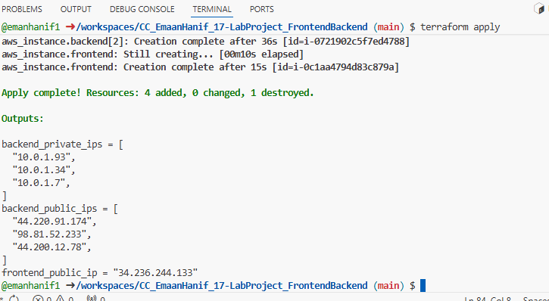

Update your Main Playbook (ansible/site.yml)
Now, tell Ansible to apply this role to your backends group. Update your site.yml (or create it) in the root ansible/ folder:
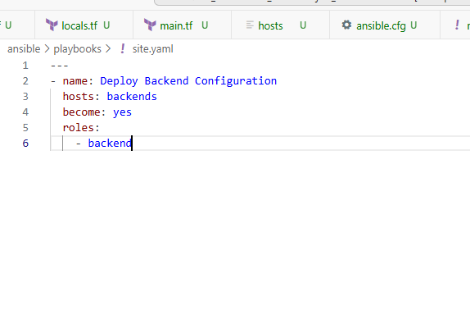
Ansible file

create the file in the ansible/ folder:
touch site.yml
Then paste this content into it:

Add Backend Role to Playbook

ansible/inventory/hosts
Open your inventory file and replace the old IPs with the new ones provided in your output.
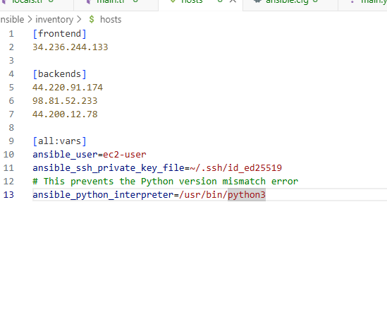

Verify Connectivity
Before running the full role deployment, verify that Ansible can reach these new instances using the specified SSH key:
cd ansible
export ANSIBLE_CONFIG=$(pwd)/ansible.cfg
ansible all -m ping
If you see "pong" in green for all four IPs, you are ready.

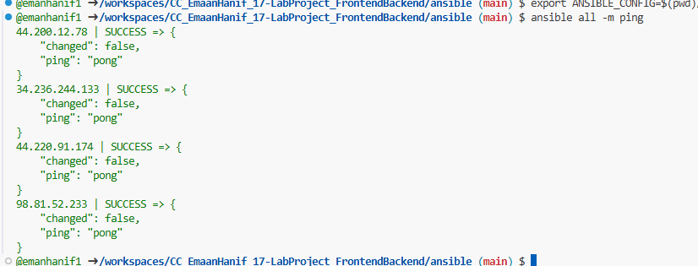

Run the Backend Role
Now, execute your site.yml playbook. This will trigger the backend role to install Apache and deploy your custom index pages to the three backend servers.

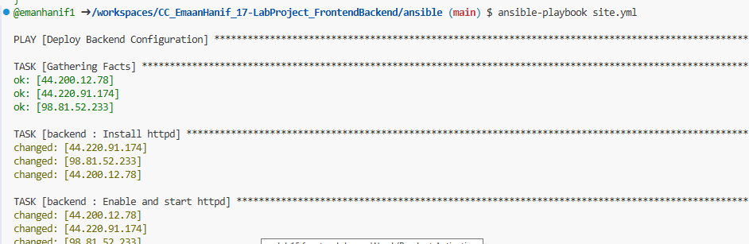

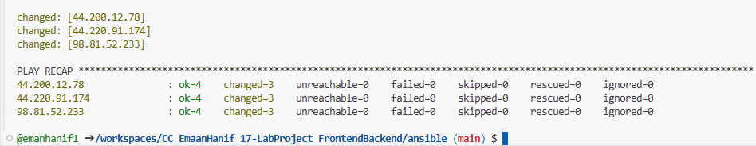

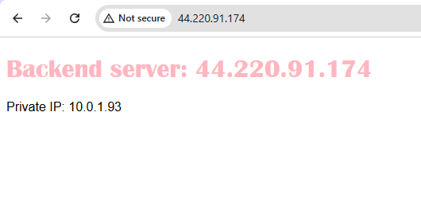

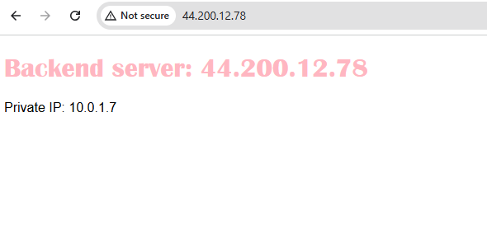

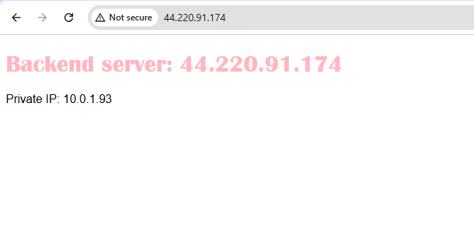

5. Ansible Roles – Frontend Nginx Role (frontend/)

Task Configuration (roles/frontend/tasks/main.yml)
Create this file and paste the following content. This follows your specific requirements for installing, enabling, and deploying the Nginx configuration.

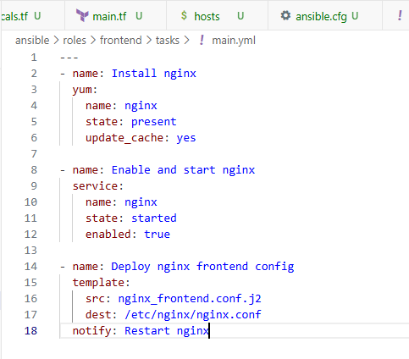

2. Handler Configuration (roles/frontend/handlers/main.yml)
You must define the handler so that Nginx restarts only when the configuration template changes.

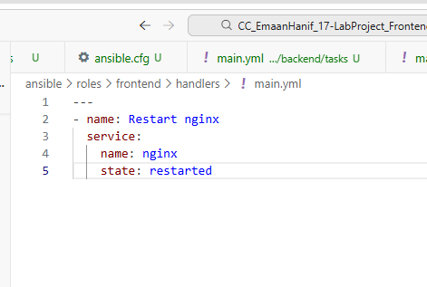
- Ensures Nginx reloads configuration only when changes occur.
- Keeps system efficient and idempotent.

Nginx Template (roles/frontend/templates/nginx_frontend.conf.j2)
Based on your Terraform output, we will use the Private IPs (10.0.1.93, 10.0.1.34, and 10.0.1.7) to fulfill the requirement.

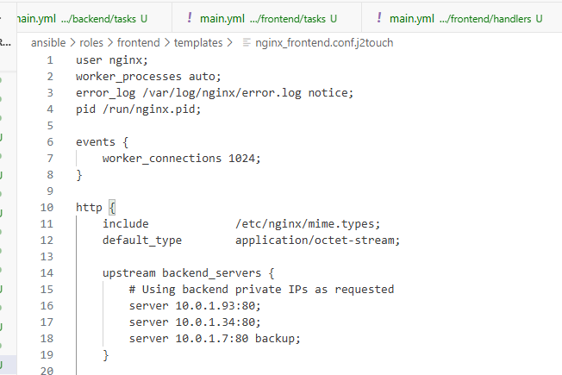
- Defines load balancing pool.
- backend1 and backend2 are primary servers.
- backup_backend is used only if primaries fail.
- Uses private IPs for internal VPC communication (safer, faster).

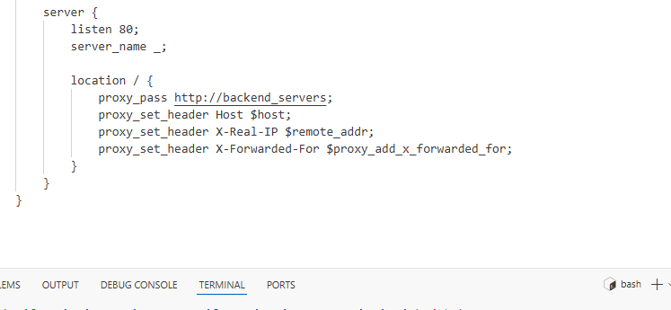

- Listens on HTTP port 80.
- Proxies all incoming requests to the upstream backend servers.
- Sets headers to preserve client IP information.

Update Playbook (site.yml)
Ensure your site.yml targets both the backends and the frontend groups.

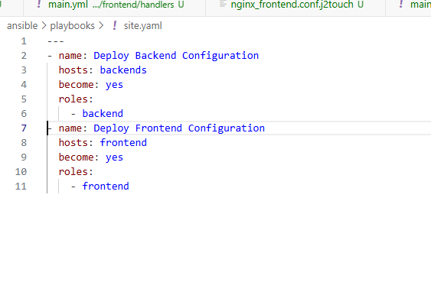

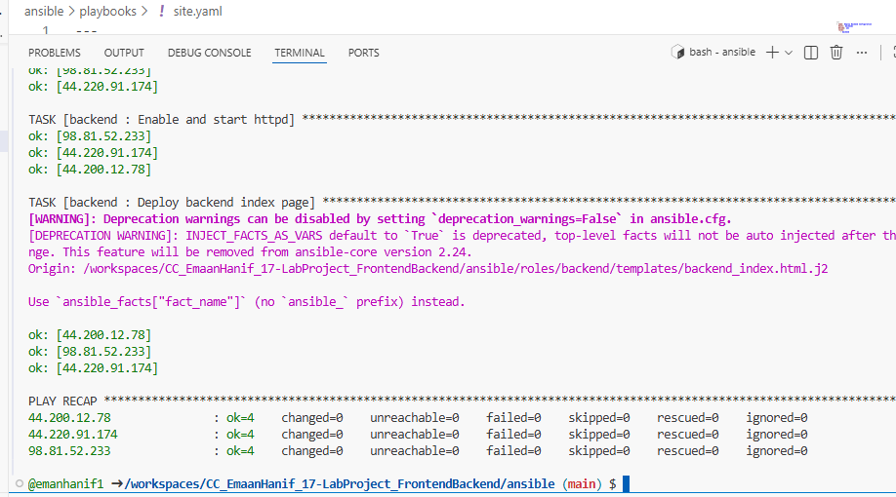

Check your vars or site.yml
Your template uses variables like {{ backend1_private_ip }}. You must define these so Ansible knows which IP belongs to which variable. The best way to do this is in your ansible/site.yml file:

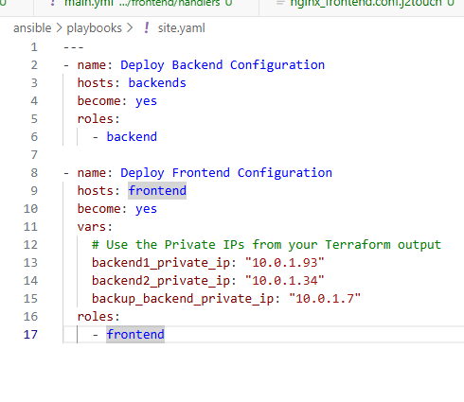

On Browser,
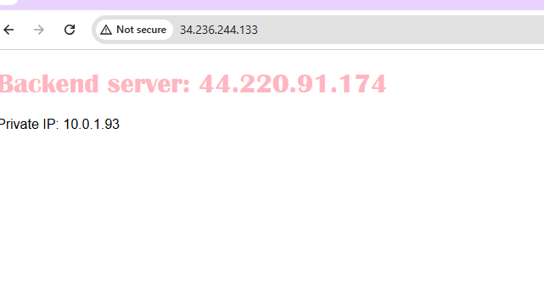

- The "Magic" of Load Balancing: Refresh the page 5–10 times. You should see the IP address switch between your first two backends.
- Note: You won't see the third backend yet because you configured it as a backup.

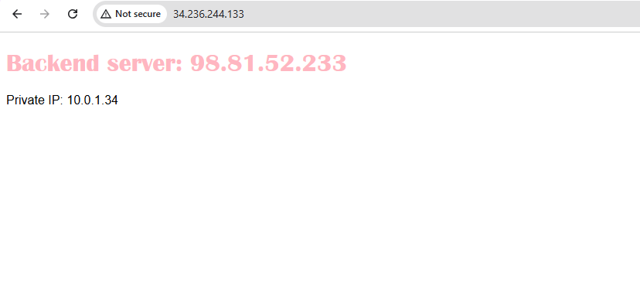

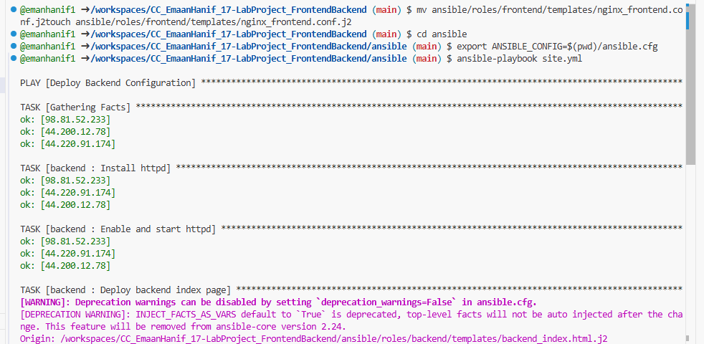

6. Ansible Main Playbook Using Roles

Play 1 Configure Backend HTTPD Servers

Hosts Declaration
- Targets the backends inventory group.
- Ensures all backend EC2 instances are configured together.

Privilege Escalation
- become: true is used.
- Required to:
  - Install packages
  - Start services
  - Modify system files

Role Usage
- The backend role is applied.
- This role:
  - Installs Apache HTTPD
  - Starts and enables the service
  - Deploys a unique HTML page

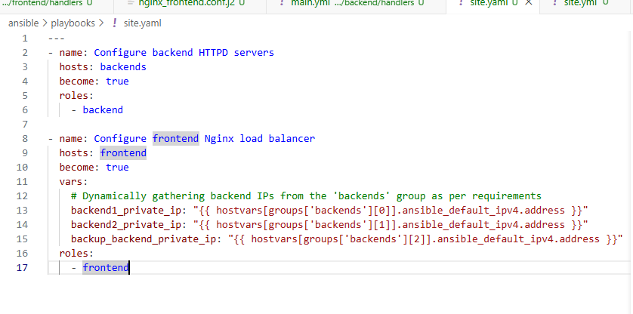

Why this satisfies Task Requirements:
- Mandatory Roles: It clearly uses the roles: keyword for both backend and frontend.
- Dynamic IPs: It uses the hostvars and groups logic to pull Private IPs automatically from the inventory rather than hardcoding them.
- Private Network: It fulfills the requirement to use backend private IPs in the Nginx upstream instead of public ones.
- Backup Configuration: By passing backup_backend_private_ip, your frontend role template can correctly apply the backup flag to the third server.

Final Execution Steps
Once you have saved this file as ansible/site.yml, run the deployment:
- Navigate to your folder: cd /workspaces/CC_EmaanHanif_17-LabProject_FrontendBackend/ansible
- Run the playbook:
Bash
export ANSIBLE_CONFIG=$(pwd)/ansible.cfg
ansible-playbook site.yml
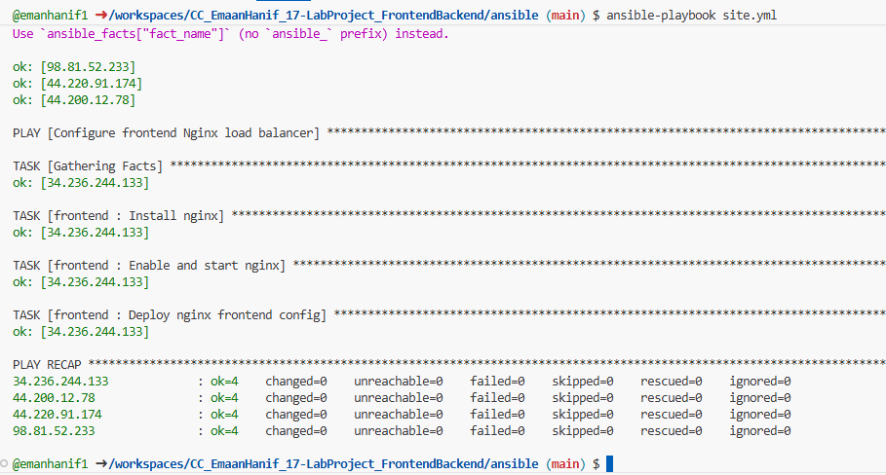

Verify Nginx Configuration
To ensure the Dynamic Gathering of IPs worked correctly, run this command to see the generated config file on the frontend:
ansible frontend -m shell -a "cat /etc/nginx/nginx.conf"
Check the upstream backend_servers section. It should contain the three Private IPs from your inventory instead of the curly-brace variables.
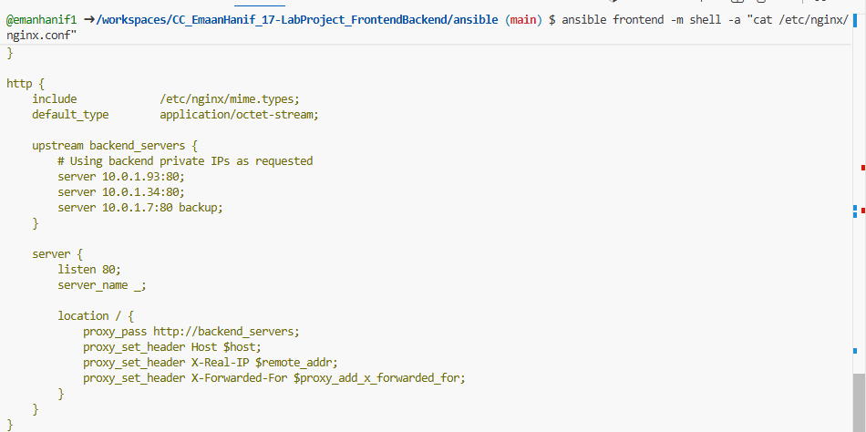

Refresh the browser at 34.236.244.133.
Result: The frontend should now show the page for the Backup Server (10.0.1.7).

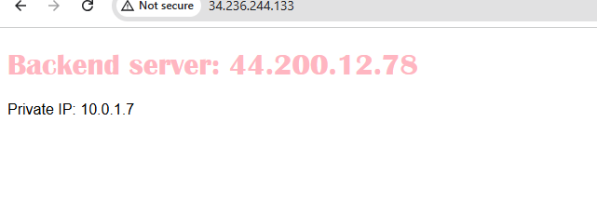

Restart them when finished:
ansible backends -m service -a "name=httpd state=started" -b

TASK7TERRAFORM–ANSIBLE INTEGRATION (AUTOMATION)

Use of null_resource
- Terraform does not manage software configuration directly.
- null_resource allows execution of external commands.
- It acts as a bridge between Terraform and Ansible.

Triggers Block
- The triggers block tells Terraform when to re-run Ansible.
- Any change in trigger values forces the null_resource to re-execute.

Used Triggers
- frontend_ip
  - Tracks the frontend EC2 public IP.
- backend_ips
  - Tracks all backend EC2 public IPs.

Why This Matters
- If an instance is recreated or IP changes:
  - Ansible automatically runs again.
- Helps maintain idempotence.
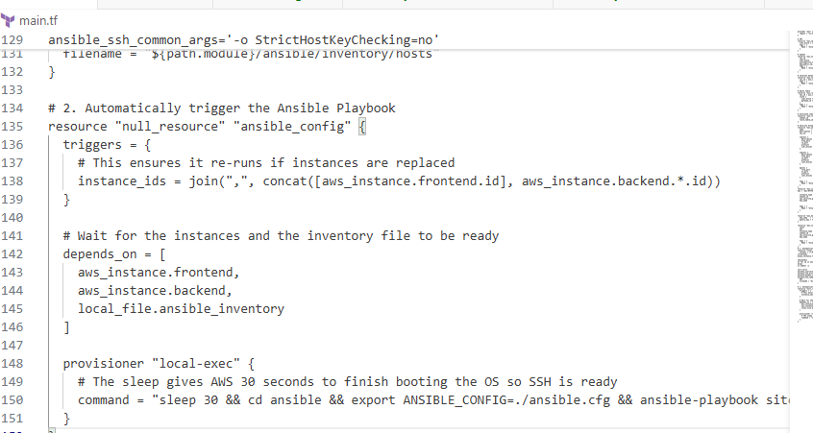

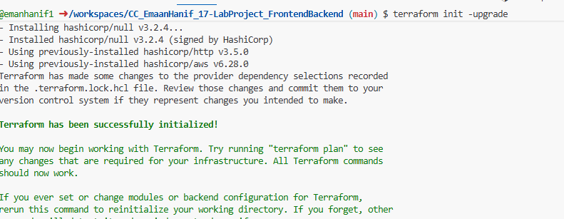

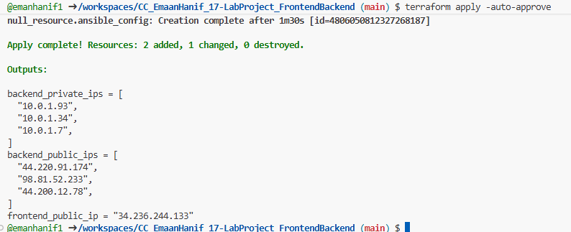

After running:
- terraform apply -auto-approve
No manual Ansible command is required.
- All configuration must already be applied.

1. The "Live Site" Test
Open your browser and navigate to the Frontend Public IP (e.g., http://34.236.244.133).
- Check: Do you see your pharmacy backend page with the pink header?
- Check: Refresh the page. Does it cycle between your different backend private IPs?
- Verification: If this works, it proves Terraform successfully triggered Ansible and Ansible successfully configured Nginx.

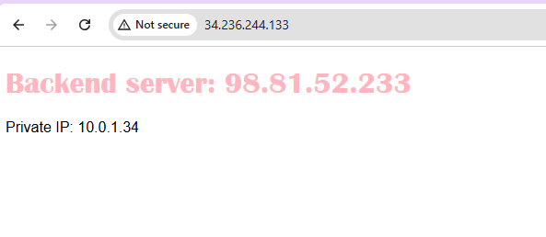

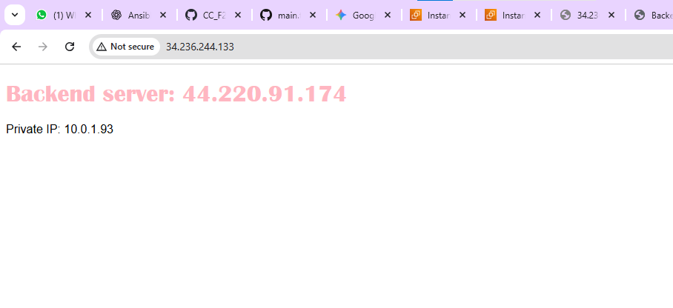

2. Verify the Generated Inventory
Check your ansible/inventory/hosts file (or generated_hosts.ini).
- Check: Does it contain the correct Public IPs that match your AWS console?

