Healthcare Claims SQL Analysis Project
Emani Taylor
Overview:
This project analyzes healthcare claims data using SQL. The goal was to identify trends in claim activity, evaluate payment patterns, and assess data quality. SQL was used to extract, filter, and aggregate data to support analysis.

Queries Ran:
Claims by status
SELECT claim_status, COUNT(*)
FROM claims_data
GROUP BY claim_status;
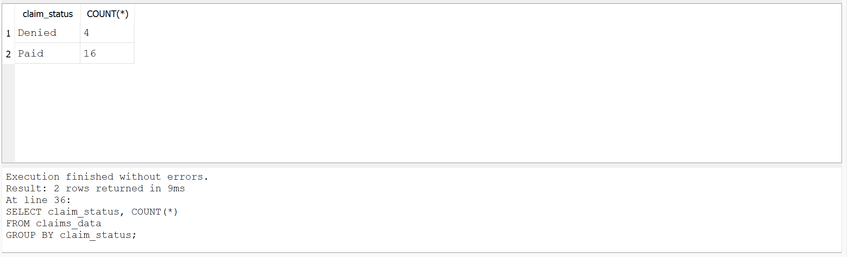

Takeaway: The majority of claims were paid, with a smaller portion denied. This reflects a typical claims processing distribution, while also highlighting opportunities to further reduce denial rates.

Total paid by claim type
SELECT claim_type, SUM(paid_amount)
FROM claims_data
GROUP BY claim_type;
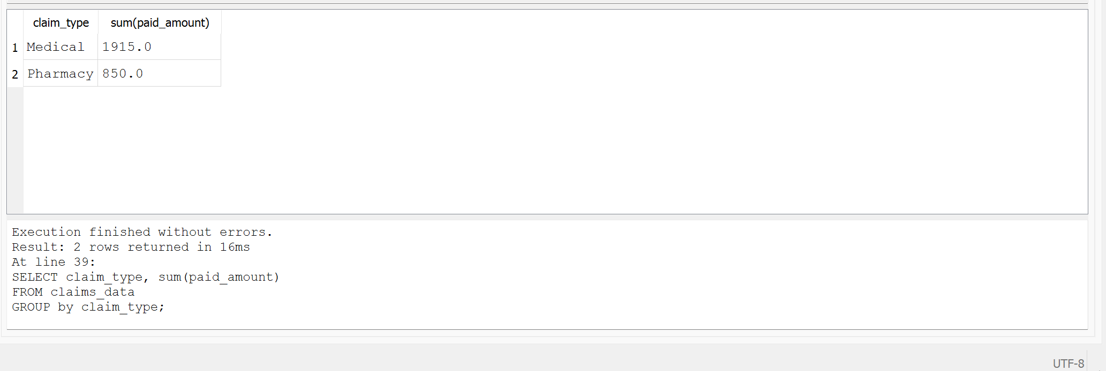

Takeaway: Medical claims accounted for the highest total paid amounts, while pharmacy claims were lower. This aligns with industry trends, as medical services typically carry higher costs than prescription claims.

Average paid by plan type
SELECT plan_type, AVG(paid_amount)
FROM claims_data
GROUP BY plan_type;
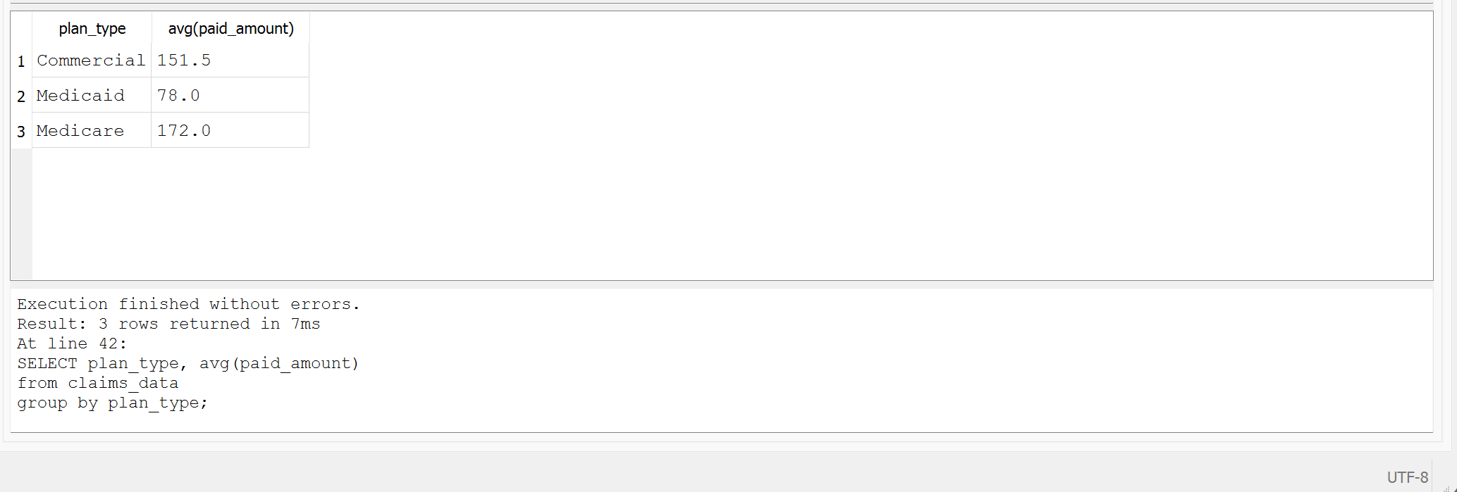
Takeaway: Differences in average payments across plan types suggest variability in reimbursement structures, coverage levels, and member populations.
Denied claims
SELECT *
FROM claims_data
WHERE claim_status = 'Denied';
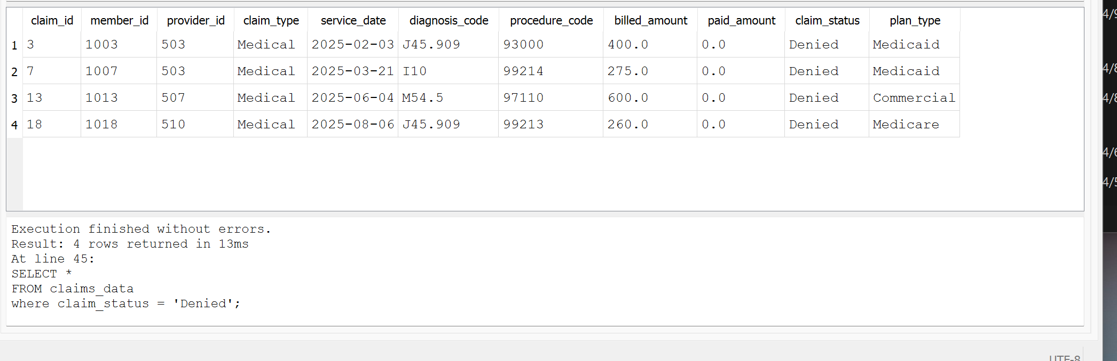
Takeaway: Denied claims occurred across multiple service dates and claim types, indicating that denials are not isolated. This may point to issues such as coding inconsistencies, documentation gaps, or policy limitations.

Diagnosis codes
SELECT diagnosis_code, SUM(paid_amount)
FROM claims_data
GROUP BY diagnosis_code
ORDER BY SUM(paid_amount) DESC;
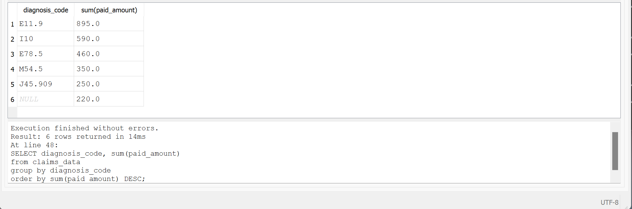
Takeaway: Certain diagnosis codes contributed disproportionately to total paid amounts, identifying them as key cost drivers. Chronic conditions such as diabetes and hypertension are likely contributing factors.
Key Findings
- Paid claims were more frequent than denied claims
- Medical claims had higher total paid amounts than pharmacy claims
- Certain diagnosis codes contributed to higher overall costs
- Denied claims appeared across multiple months
- Identified a missing diagnosis code indicating a data quality issue

