INSTALLATION
-------------------
Requirements
- Linux
- Python 3.8.5 or later versions (http://www.python.org/)
- install regex package
$ pip install regex
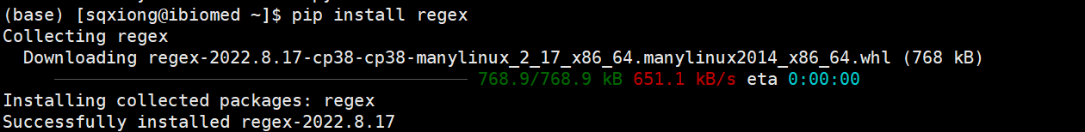
- install keras==2.4.3 package
$ pip install keras==2.4.3
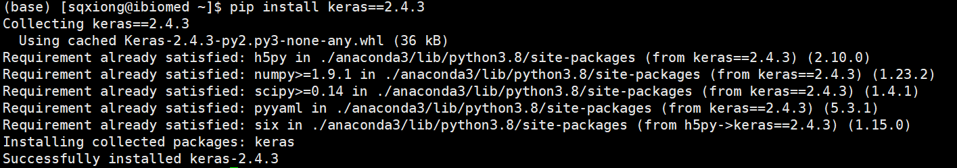
- install pandas package
$ pip install pandas
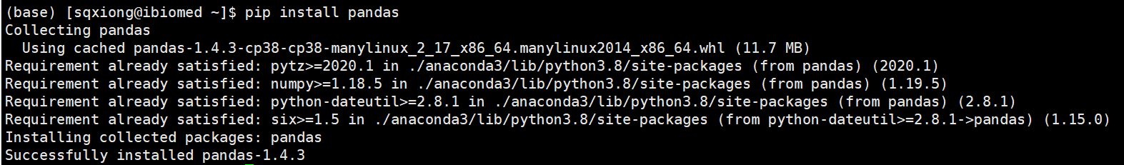
- install tensorflow==2.4.1 package
$ pip install tensorflow==2.4.1
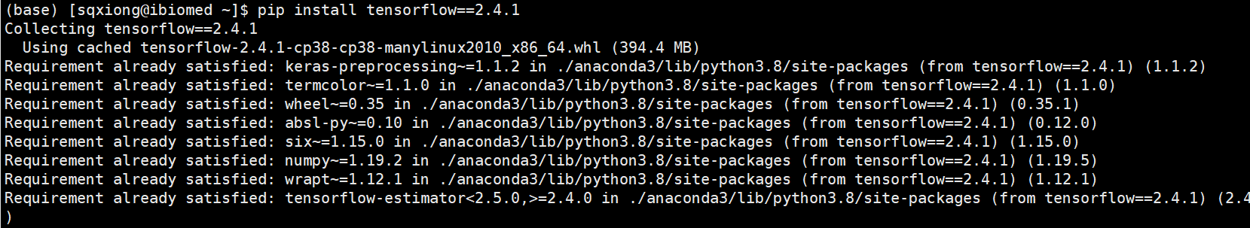
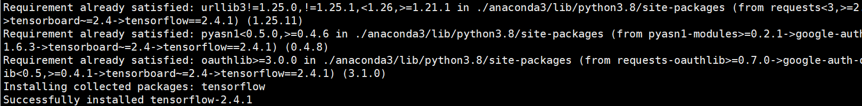
- install bio version >= 1.3.2 package
$ pip install bio
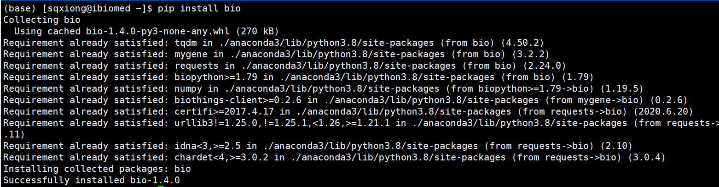
- install numpy package
$ pip install numpy==1.19.2
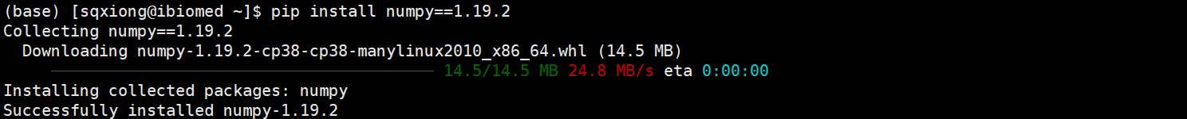
--------------------------------------------------

Steps:
- Download PLEK.2.1.tar.gz from https://sourceforge.net/projects/plek2/files/ and decompress it.
$ tar zvxf PLEK.2.1.tar.gz
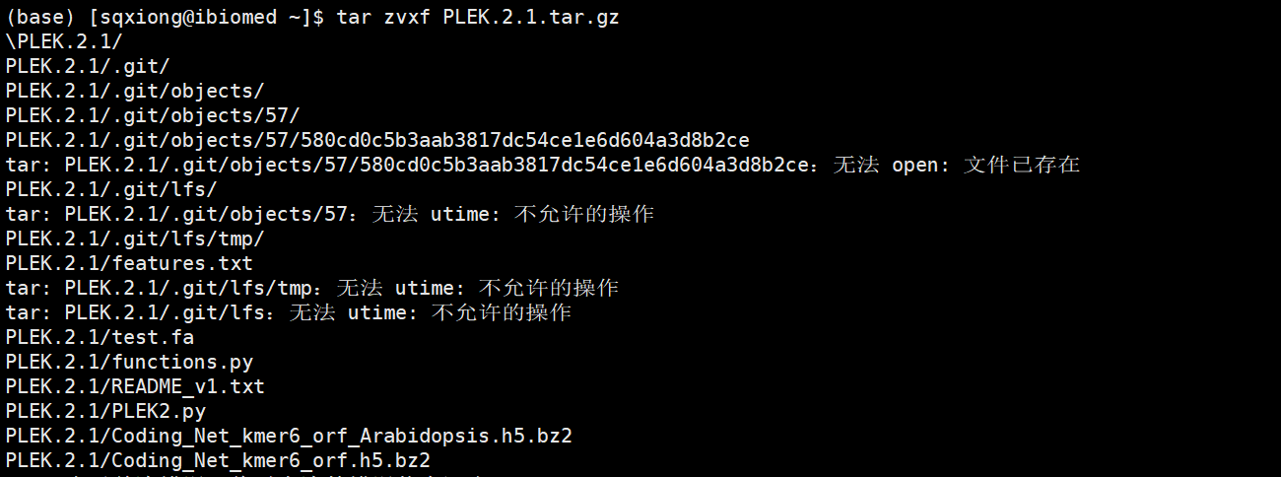
2. Compile PLEK2.1
$ cd PLEK.2.1
3. decompress Coding_Net_kmer6_orf.h5.bz2 model
$ bunzip2 Coding_Net_kmer6_orf.h5.bz2
4. decompress Coding_Net_kmer6_orf_Arabidopsis.h5.bz2 model
$ bunzip2 Coding_Net_kmer6_orf_Arabidopsis.h5.bz2

USAGE
Python PLEK2.py -i fasta_file -m model(ve: vertebrate , pl: plant)

Examples:
$ python PLEK2.py -i test.fa -m ve
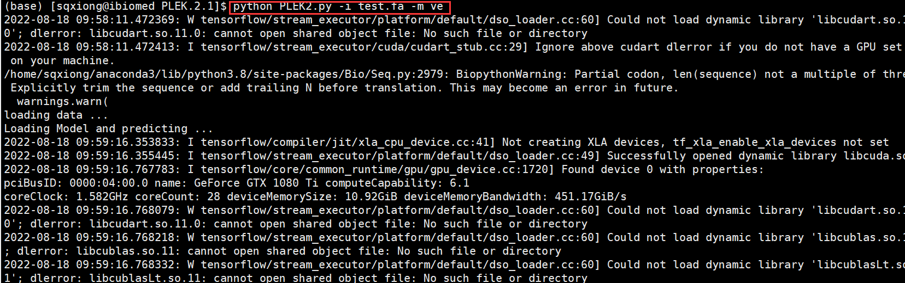
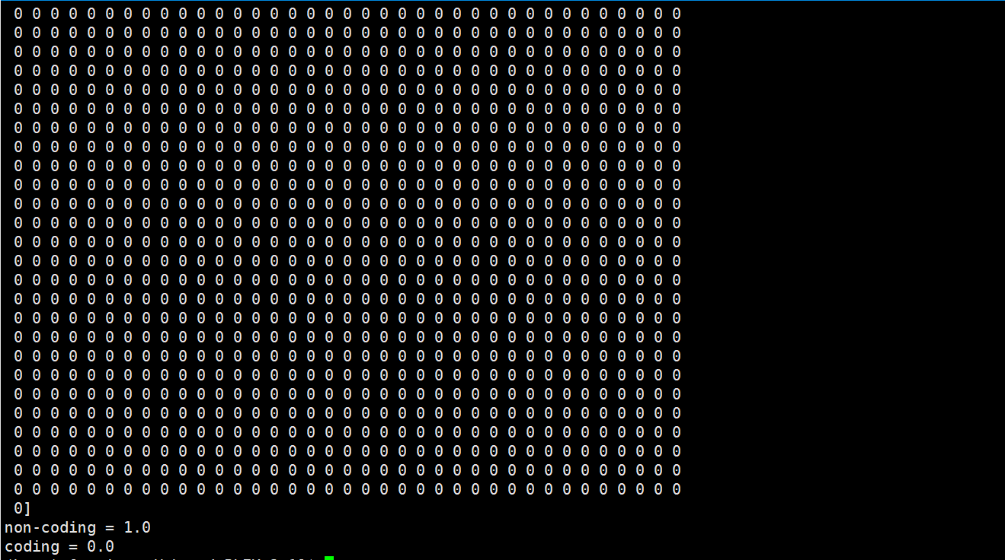

*The result file saved the prediction results.
==============
Siqi Xiong, Masters
School of Computer Science and Engineering,
Xi'an University of Technology,
5 South Jinhua Road,
Xi'an, Shaanxi 710048, P.R China

Aimin Li, PhD
School of Computer Science and Engineering,
Xi'an University of Technology,
5 South Jinhua Road,
Xi'an, Shaanxi 710048, P.R China

xsq1315459270@163.com (163.com)

liaiminmail AT gmail.com
emanlee815 AT 163.com

