Import vs Require in React

-Webpack has a feature called *tree shaking*, and it reduces the size of your javascript bundle

Ex:

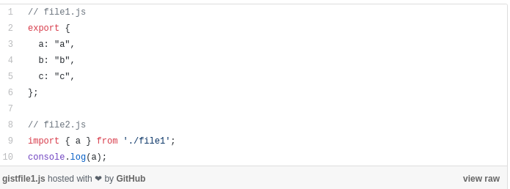

-Since exports b and c aren’t used, webpack doesn’t even put them in the build

-However, this can eliminate exports that MAY NEED to be imported later

-This is where require() comes in

*const getCompany = require(‘./companies’).getCompany;*

-The second method is

*import { getCompany } from ‘./companies’;*

*-*The ES2015 Modules disallow dynamic importing (importing from within a function)

-All imports must be outside of a function so that webpack knows to include the files in the build