**Deliverable:01**

**Possible error finding/syntax and solutions**

**E-commerce app**

**Submitted by:**

|  |  |
| --- | --- |
| 21l-6082 | Eman mohsin |
| 21l-6092 | Abdul hadi butt |
| 21l-5824 | Shumail kazmi |
| 21l-5783 | Waleed Irfan |

Problem:01

1.make the databasenamechnage in jtproject folder

**2.#database.url=jdbc:mysql://localhost:3306/ecomjava—error**

**--springboot.sql**

**It should be ecommjava**

3. Connection con = DriverManager.getConnection("jdbc:mysql://localhost:3306/**ecommjava**","root","");

==

Connection con = DriverManager.getConnection("jdbc:mysql://localhost:3306/**springboot**","root","");

in admin.control

4. .try

{

Class.forName("com.mysql.jdbc.Driver");

Connection con = DriverManager.getConnection("jdbc:mysql://localhost:3306/ecommjava","root","");

PreparedStatement stmt = con.prepareStatement("select * from users where username = ?"+";");

stmt.setString(1, usernameforclass);

ResultSet rst = stmt.execute();

**stmt.execute should be replaced by stmt.executeQuery();**

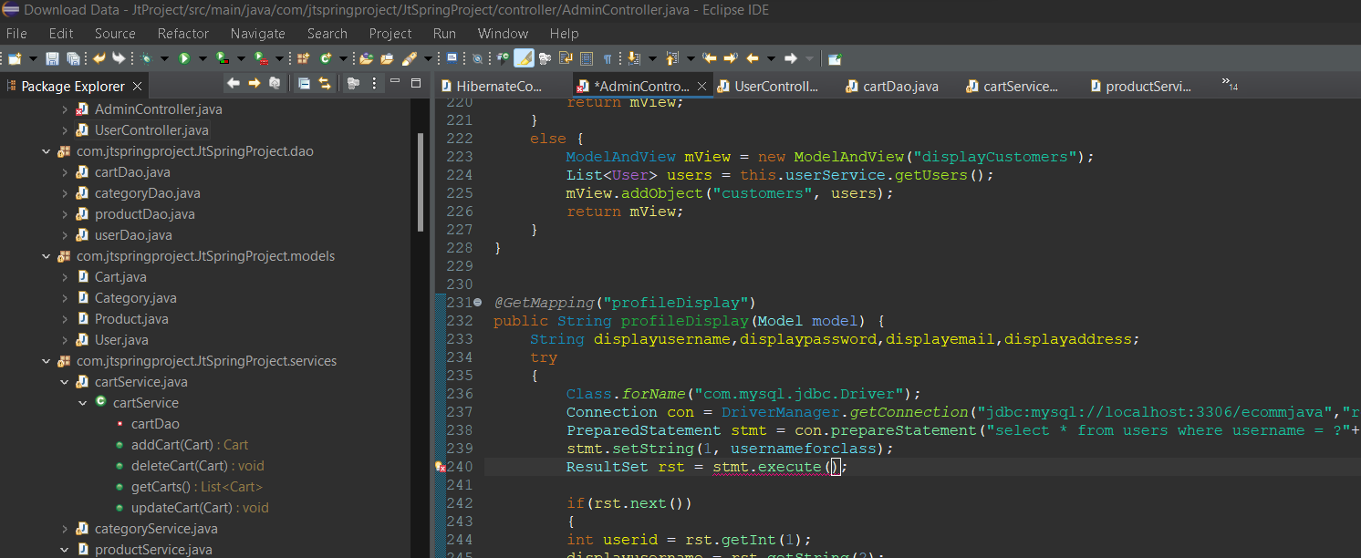

Correct one:

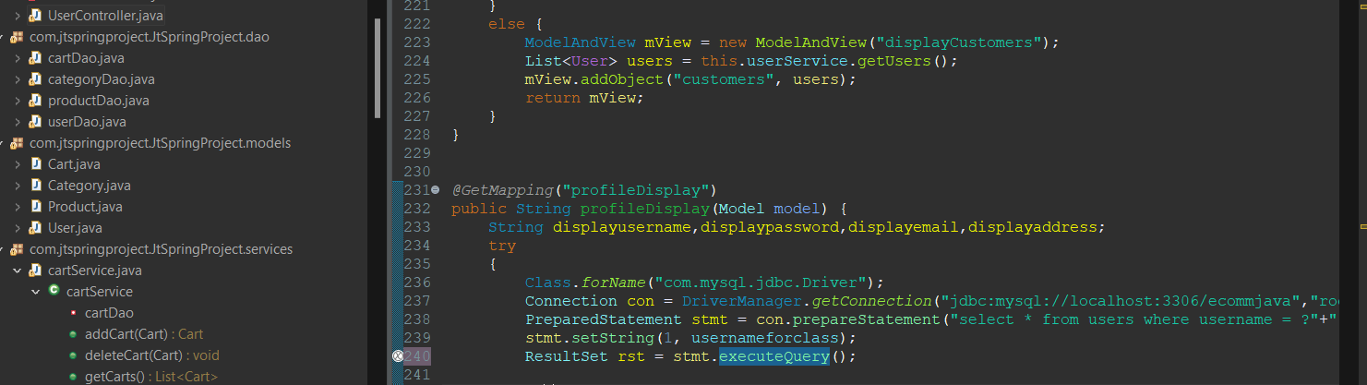

Whenever I was running my xampp to run mysql I was having these errors.

Problem detected!

19:16:38 [mysql] Port 3306 in use by "Unable to open process"!

19:16:38 [mysql] MySQL WILL NOT start without the configured ports free!

19:16:38 [mysql] You need to uninstall/disable/reconfigure the blocking application

19:16:38 [mysql] or reconfigure MySQL and the Control Panel to listen on a different port

19:16:38 [main] Starting Check-Timer

19:16:38 [main] Control Panel Ready

19:17:15 [mysql] Problem detected!

19:17:15 [mysql] Port 3306 in use by "Unable to open process"!

**Reason:**

19:17:16 [mysql] This may be due to a blocked port, missing dependencies,

19:17:16 [mysql] improper privileges, a crash, or a shutdown by another method.

19:17:16 [mysql] Press the Logs button to view error logs and check

19:17:16 [mysql] the Windows Event Viewer for more clues

19:17:16 [mysql] If you need more help, copy and post this

19:17:16 [mysql] entire log window on the forums

19:17:17 [mysql] Problem detected!

19:17:17 [mysql] Port 3306 in use by "Unable to open process"!

19:17:17 [mysql] MySQL WILL NOT start without the configured ports free!

Identify the Process Blocking Port 3306 (MySQL) and Port 80 (Apache):

For Port 3306 (MySQL): It seems that another application is using port 3306. You need to find out which application is using this port. You can use the following command to identify the process:

**netstat -ano | findstr :3306**

**This will provide you with the Process ID (PID) of the application using port 3306.**

**This xampp database issue can be resolve by grating permissions and provding the right username and password**

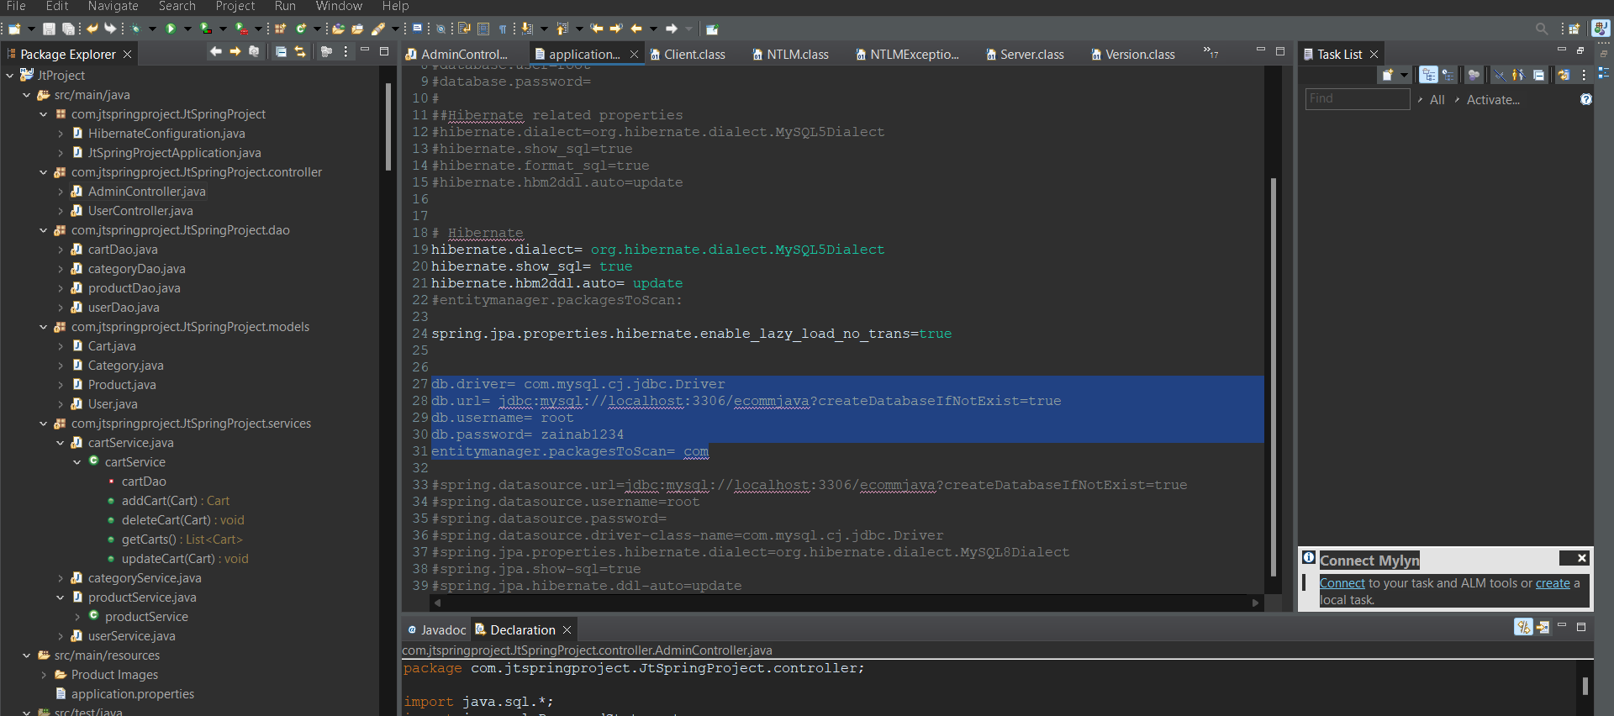

Conclusion**:  
For connecting database:**

**Make a database.**

**Add a user to that database with all permissions possible.**

**Go back to the project and open the applications.properties file. Change the username and password to the database's login credentials.**

**To fix errors:**

**In the applications.properties file, there is a typo. At one point 'econjava' is written instead of 'ecommjava'.**

**To check if the database has been connected:**

**You will find some new tables in the database after you run the code. At this point, the database has been connected but there is still a bug in the program. Somewhere a wrong function has been used. 'Execute' instead of 'executeQuery'.**