

**NATIONAL TEXTILE**

**UNIVERSITY**

DEPARTMENT OF COMPUTER SCIENCE

**SUBMITTED BY:**

Eman Faisal 23-NTU-CS-1149

**SECTION SE: 5th (A)**

**Operating System**

**SUBMITTED TO:**

Sir Nasir Mahmood

**SUBMISSION DATE:** 25/9/25

**Lab 4**

**TASK1:**

**CODE:**#include <stdio.h>

#include <pthread.h>

#include <unistd.h>

// Thread function - this will run in the new thread

void* thread_function(void* arg) {

printf("Hello from the new thread!\n");

printf("Thread ID: %lu\n", pthread_self());

return NULL;

}

int main() {

pthread_t thread_id;

printf("Main thread starting...\n");

printf("Main Thread ID: %lu\n", pthread_self());

// Create a new thread

pthread_create(&thread_id, NULL, thread_function, NULL);

// Wait for the thread to finish

pthread_join(thread_id, NULL);

printf("Main thread exiting...\n");

return 0;

}

**Output:  
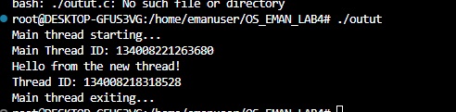**

**TASK2: Passing arguments in a thread**

Task2:  
#include <stdio.h>

#include <pthread.h>

void* print_number(void* arg) {

// We know that we've passed an integer pointer

    int num = *(int*)arg; // Cast void* back to int*

    printf("Thread received number: %d\n", num);

    printf("Square: %d\n", num * num);

return NULL;

}

int main() {

    pthread_t thread_id;

    int number = 42;

    printf("Creating thread with argument: %d\n", number);

// Pass address of 'number' to thread

    pthread_create(&thread_id, NULL, print_number, &number);

    pthread_join(thread_id, NULL);

    printf("Main thread done.\n");

    return 0;

}

**Output:**