

**NATIONAL TEXTILE**

**UNIVERSITY**

DEPARTMENT OF COMPUTER SCIENCE

**SUBMITTED BY:**

Eman Faisal 23-NTU-CS-1149

**SECTION SE: 5th (A)**

**Operating System**

**SUBMITTED TO:**

Sir Nasir mahmood

**SUBMISSION DATE:**

19/9/25

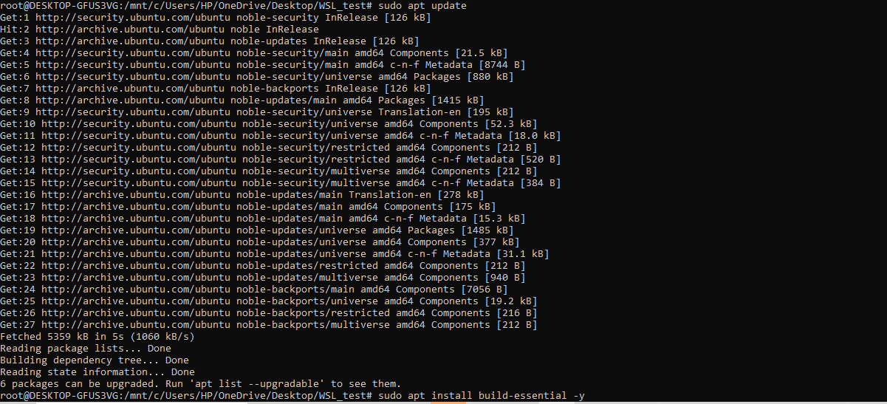**Sudo Upgrade command:**

**Build essential installation:** 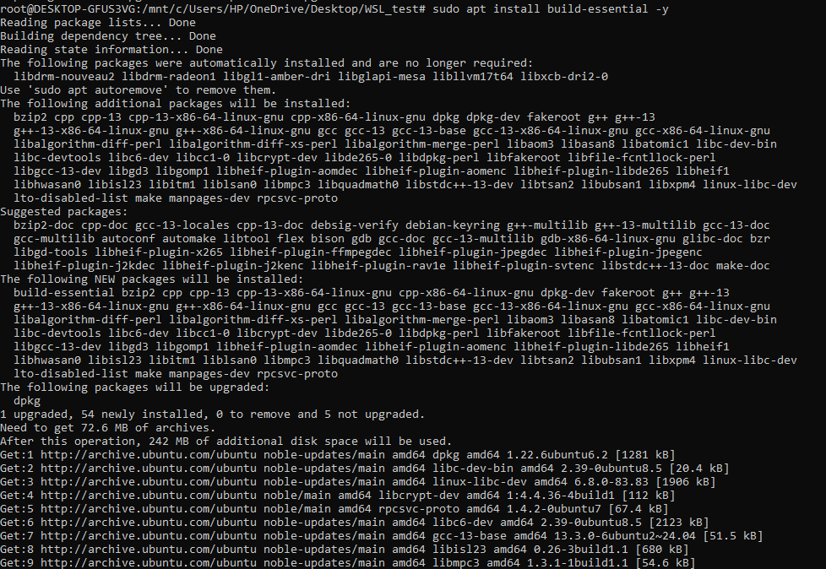

**Integration of git with ssh:**

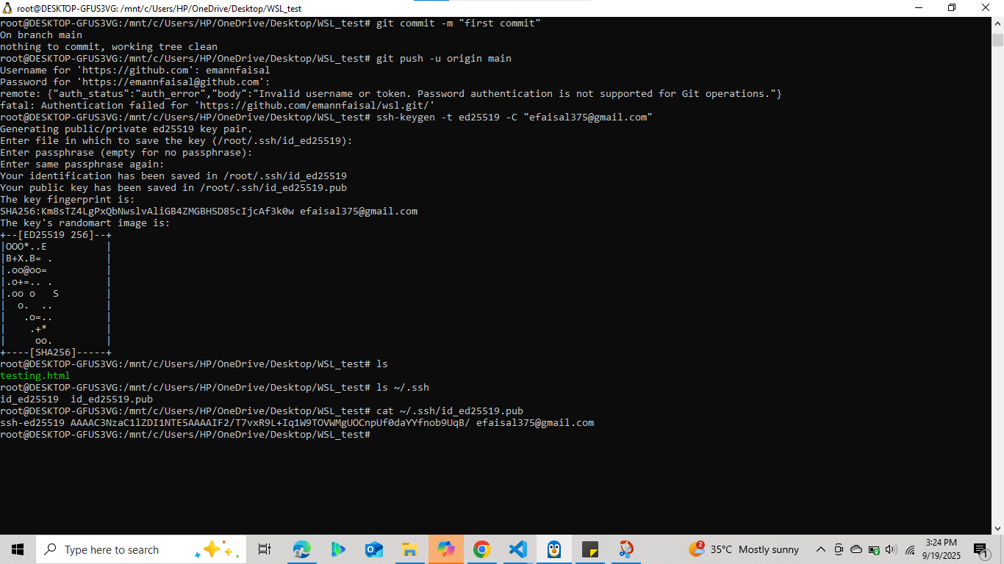



**Successful push:**