

**NATIONAL TEXTILE**

**UNIVERSITY**

DEPARTMENT OF COMPUTER SCIENCE

**SUBMITTED BY:**

Eman Faisal 23-NTU-CS-1149

**SECTION SE: 5th (A)**

**Operating System**

**SUBMITTED TO:**

Sir Nasir Mahmood

**SUBMISSION DATE:** 25/9/25

Home task week1

1. **Verify WSL2 and Ubuntu installation Verify installation by running the following command in powershell.**

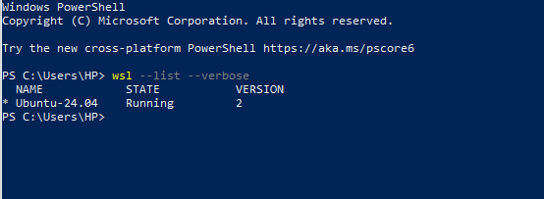

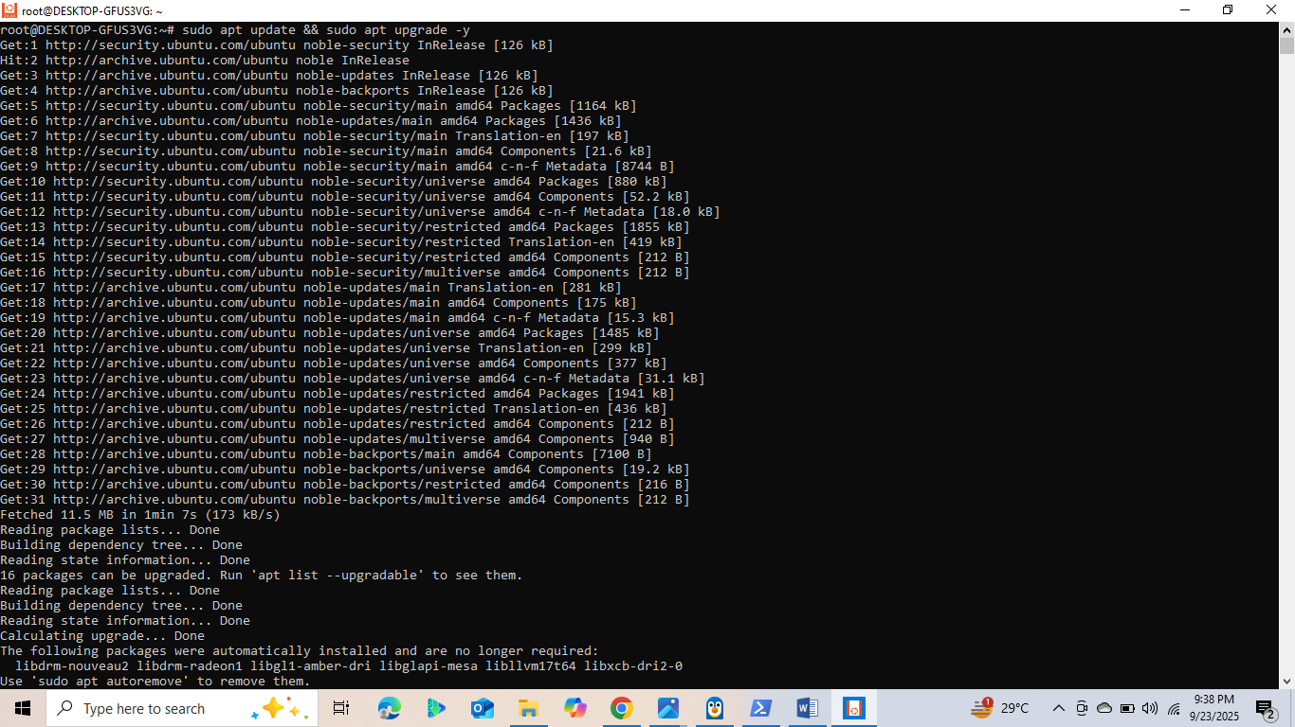

**2. Update Ubuntu environment Run the following command in Ubuntu: sudo apt update && sudo apt upgrade -y**

**PART B:  
1. Configure Git**

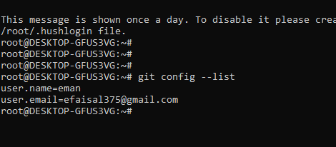

1. **Generate SSH Keys Run: ssh-keygen -t ed25519**

**Copy the public key: cat ~/.ssh/id_ed25519.pub Add this key to your GitHub account under Settings → SSH and GPG keys.**

Done

1. **Test Connection ssh -T** [**git@github.com**](mailto:git@github.com)

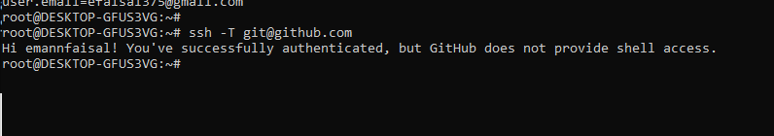 **Submit a screenshot showing successful authentication:**

**Part C: C Programming Environment & Practice**

**Step 1: Install Build Tools Before writing C programs, install the build-essential package which contains gcc , g++ , and other tools required for compiling.**

Verify installation by checking the version of gcc :

gcc –version

**Submit a screenshot of successful installation and version output.**

**Successful installation:**

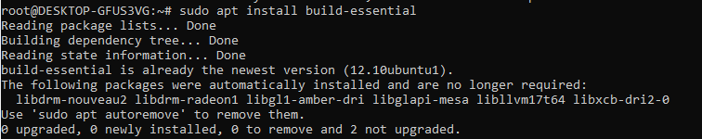

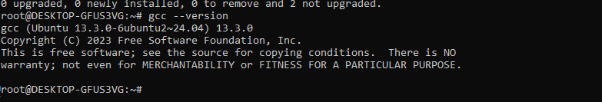V**ersion Output:**

**Step 3: Write a C Program Write a simple C program of your choice. It can be a Hello World program or any other.**

#include <stdio.h>

int main() {

    printf("Hello, World!\n");

    return 0;

}

