PRODUCT DETAILS

**SUBMARINER**

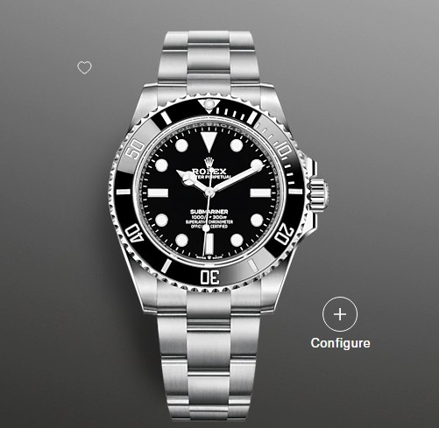

**$3570.00**

**Specifications**

**MODEL CASE**: Oyster, 41 mm, Oystersteel

**OYSTER ARCHITECTURE**: Monobloc middle case, screw-down case back and winding crown

**DIAMETER**: 41 mm

**MATERIAL**: Oystersteel

**BEZEL**: Unidirectional rotatable 60-minute graduated, scratch-resistant Cerachrom insert in ceramic, numerals and graduations coated in platinum

**WINDING CROWN**: Screw-down, Triplock triple waterproofness system

**CRYSTAL**: Scratch-resistant sapphire

**WATER RESISTANCE**: Waterproof to 300 metres / 1,000 feet

**MOVEMENT**: Perpetual, mechanical, self-winding

**CALIBRE**: 3230, Manufacture Rolex

**PRECISION**: -2/+2 sec/day, after casing

**FUNCTIONS**: Centre hour, minute and seconds hands. Stop-seconds for precise time setting

**OSCILLATOR**: Paramagnetic blue Parachrom hairspring. High-performance Paraflex shock absorbers

**WINDING**: Bidirectional self-winding via Perpetual rotor

**POWER RESERVE**: Approximately 70 hours

**BRACELET**: Oyster, flat three-piece links

**BRACELET MATERIAL**: Oystersteel

**CLASP**: Folding Oysterlock safety clasp with Rolex Glidelock extension system